**Biological assessment of Chitosan nanoparticle extracted from carapace of *Sartoriana spinigera* crab as a potent anti-cancer agent through Apoptotic and Necrotic pathway**

**ABSTRACT**

Natural products have acquired interest in the pharmaceutical industry for their various properties of being non toxic and biocompatible, and also for having the efficiency to cure various diseases. One such serious disease is Breast cancer, for the cure of which, various research work is being done. Chitosan is a natural biopolymer obtained from deacetylation of chitin found abundantly in exoskeleton of Arthropoda including crustaceans. In the present study, chitosan nanoparticle have been prepared from carapace of *Sartoriana spinigera* which is a crab found abundantly in the fresh water bodies of Jharkhand, India. Study on enhancing Caspase 3/7 activity of MCF-7 cells has been done by treatment with chitosan nanoparticle which showed that after treatment chitosan nanoparticle was able to show increased necrosis of MCF-7 cells which was significantly higher than that of control group at 5 % significance level. Analysis of Annexin V revealed that chitosan nanoparticle increased the phenomenon of early apoptosis as compared to control group at 1 % significance level, confirming chitosan nanoparticle as a potent anti cancer agent against MCF-7 cell line.

**KEYWORDS**

Annexin V, Breast cancer, Caspase 3, Chitosan nanoparticle, MCF-7, *Sartoriana spinigera*

**INTRODUCTION**

According to reports of IARC- WHO, Breast cancer accounts for more than 6.5 lacs deaths worldwide ,and that breast cancer cases and deaths are likely to rise globally [1]. Although pharmaceutical industry is progressing in terms of new anti-cancer drugs, the society is in demand of natural products that are equally effective as commercial drugs ,but with lesser side effects and lower cost consumption. One such natural product is Chitosan, which is a deacetylated form of chitin ,an abundant polymer found in the exoskeleton of crustaceans, insects, mollusks and cell wall of fungi.[2]. Chitosan is made up of about 20 % (1,4)-2 acetamido-D-glucopyranose and 80 % of (1,4)-2-amino-D- gucopyranose. [3]. Chitosan has been known to possess wound healing capacity [4] , antioxidative efficacy [5], antimicrobial activity [6] and more. Various research work on chitosan have proved it to possess anti cancer property through angiogenic mechanism. Furthermore, chitosan enhances immune system which reduces the chance of cancer occurrence [7] .

Commercially used synthetic anti cancer drugs include Doxorubicin, Cisplatin, which have severe side effects on cancer patients [8]. In such terms, chitosan being a natural product is encouraged in clinical use. Nanoparticle of any such molecule further increases its efficiency of performing a function due to its increased surface area and increased potency of target delivery.

Caspase 3 and 7 are the most important enzymes that play main role in apoptotic pathway. Caspase 3 is responsible for fragmentation of DNA and morphological changes in a cell to undergo apoptosis, whereas, Caspase 7 is important for decreasing cell viability [9]. Any molecule that has the potency to act as anti cancer agent must have the capacity to increase the activity of Caspase 3 and 7. Annexin V is a protein (Vascular anticoagulant α ),whose binding to apoptotic cells is proportional to other apoptotic activities such as changes in nucleus structure and DNA fragmentation[10].

Most of the extraction process of chitosan has taken place from exoskeletons of marine fauna. Work based on freshwater source is very less. In the present study, chitosan was extracted from carapace of a freshwater crab *Sartoriana spinigera* which is abundantly found in the fresh water bodies of Jharkhand, Odisha [12] and north eastern states of India, during the rainy season. *Sartoriana spinigera* belongs to Least Concern category as per IUCN (International union for conservation of nature) red list, and is not cultured commercially due to lack of scientific knowledge regarding its medicinal value although it is consumed by the tribals to cure various ailments and is of ethnobiological significance.

Aim of the present study is to extract chitosan from carapace of *Sartoriana spinigera*, convert it into nanoparticle form and study its anti cancer efficacy against MCF-7 (Breast cancer ) cell line by studying Caspase 3/7 activity and Annexin V activity.

**METHODOLOGY**

**Synthesis and characterization of chitosan nanoparticle ( ChNP):**

Chitosan was prepared from carapace powder of *Sartoriana spinigera* by undergoing 3 processes of Demineralization in 2N HCl, deproteinization in 4% NaOH to obtain chitin and then deacetylation of chitin in 40% NaOH to obtain chitosan [17].

Crude chitosan was converted to ChNP by sTPP (Sodium tripolyphosphate) method following Anand *et al*, 2018 [18].

Efficiency of chitosan to perform any function is based on characteristics such as Degree of Deacetylation (DD%), Particle size, crystallinity and surface morphology.

Degree of deacetylation (DD%) was calculated following Brugnerrotto *et al* (2001) [19] .Crystallinity of chitosan nanoparticle was studied by X-ray diffraction at 2ϴ. Particle size was estimated by Zeta sizer .Scanning electron microscope was used to study the morphology of surface of ChNP at different magnifications.

**Analysis of Caspase 3/7 using flow cytometry**

MCF-7 cells were plated at density of 2.5x10 5 cells per well in a 96 well plate and incubated for 24 hours at 37°C. The cells were then treated with different concentrations of ChNP for 24 hours. ChNP of concentration 131 µg/mL and 262 µg/mL were used. After treatment, trypsin was added to each well to detach cells from the well and washed with PBS and then centrifuged at 2000 RPM for resuspension. Caspase 3/7 green detection reagent was added to 1 mL cell suspension and mixed. The cells were incubated in dark for 30 minutes and then stained with 1µL of SYTOX AADvanced for 5 minutes. The 96 well plate was then read using FACS (Fluorescence -activated cell sorting) Aria.

**Analysis of Annexin V using flow cytometry**

MCF-7 cells were plated in 6 well plates at a density of 2x105 cell/well and incubated overnight. The cells were then treated with 131 µg/mL concentration of ChNP and incubated for 24 hours. They were then trypsinized and washed with PBS and resuspended with binding buffer and 5 µL of Annexin V- FITC and Propidium iodide and incubated for 15 minutes in dark. After staining, binding buffer was added and cells were filtered and analysed using flow cytometer.

**RESULTS AND DISCUSSION**

Degree of deacetylation (DD%) of ChNP (Chitosan nanoparticles) was calculated and found to be 92.25%. Crystallinity of ChNP by X-ray diffraction showed most prominent and highest peak at 20° and other peaks at 12°, 28° and 34° at 2 ϴ. Peaks at higher degree indicate high degree of deacetylation. Particle size of ChNP was found to be 297±5 nm . Surface morphology was studied by SEM which showed oval shaped molecules with smooth surface (Fig 1).

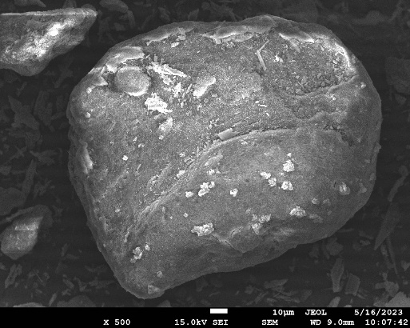

**Fig 1: SEM image of oval and smooth surface of chitosan nanoparticle extracted from carapace of *Sartoriana spinigera***

**Quantification of apoptosis and necrosis of MCF-7 cells after treatment with ChNP**

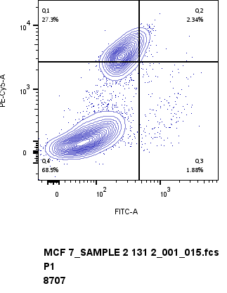

**Fig 2: Graph showing mode of MCF-7 using Caspase 3/7 detection and flow cytometry after treatment with 262 µg/mL of ChNP . Q1= necrosis,Q2=early apoptosis, Q3= late apoptosis,Q4= live cells**

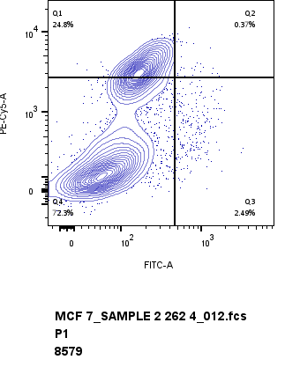

**Fig 3: Graph showing mode of MCF-7 using Caspase 3/7 detection and flow cytometry after treatment with 131 µg/mL of ChNP . Q1= necrosis,Q2=early apoptosis, Q3= late apoptosis,Q4= live cells**

Analysis of Caspase 3/7 activity revealed that ChNP extracted from carapace of *Sartoriana spinigera* was able to show decreasing cell viability with increasing concentrations. At 131 µg/mL, ChNP showed cell viability of 72.3% while at 262 µg/mL, it was found to be 68.5% (Fig 2 and 3). Statistical analysis by Student’s t test showed that both the concentrations of ChNP were able to cause decrease in cell viability as compared to the control group at 0.1% significance level. At 131 µg/mL, ChNP showed early apoptosis of 2.34%, and late apoptosis of 1.88%, whereas at 262 µg/mL, early apoptosis of 7.78% and late apoptosis of 4.02% was observed. However, no statistically significant difference was observed between the apoptosis at different concentrations. It was also observed that at 131 µg/mL, ChNP showed cell necrosis of 24.5% and at 262 µg/mL cell necrosis of 27.3% was noted.

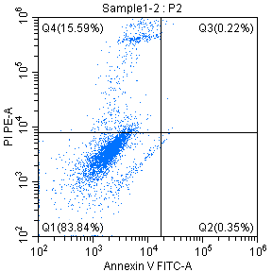

**Fig 4: Graph showing mode of MCF-7 using Annexin V detection and flow cytometry after treatment with 131 µg/mL of ChNP . Q1= live cells ,Q2=early apoptosis, Q3= late apoptosis,Q4= necrosis**

Analysis of Annexin V revealed that ChNP at concentration 131 µg/mL was able to show increased early apoptosis of 0.35% of MCF-7 cells (Fig 4), which was significantly higher than that of control group at 1% significance level, when analysed by Student’s t test. It was also observed that ChNP showed high necrosis at 15.59 % which is significantly higher than that of control group at 5% significance level.

Both results confirm the presence of apoptosis and necrosis in MCF-7 cells treated with ChNP.

Similar results were obtained by Abedian *et al*(2019) [13], in which it was found that at high concentration of 2 mg/mL, and treatment for 48 hours, ChNP was able to show increased apoptosis by 7.75% in MCF-7 cells. Necrosis was found to be increased as 15.84% in MCF-7 cells. The result of present study also corroborates with the study conducted by Jiang (2011)[14], according to which sulphated chitosan was able to show significant apoptosis of MCF-7 cells when treated for 24 hours. Analysis of caspase activity was done by Yuniardini *et al* (2014)[15], on Ca9-22 cells. Their study confirmed that apoptosis might not be the mechanism of inducing cell death by low molecular weight chitosan.It has also been reported by Zhang *et al*(2010)[16] that cancer cells are more negatively charged than normal cells, as a result of which cationic chitosan has high affinity towards cancer cells. Thus, chitosan can disrupt the tumour cell membrane by either attaching to a specific receptor or by the process of endocytosis.

**CONCLUSION**

In the present study, chitosan nanoparticle extracted from carapace of freshwater crab *Sartoriana spinigera* was able to show characters of high degree of deacetylation and satisfactory particle size. When treated with ChNP,MCF-7 cells showed decreased cell viability with increasing concentration by the process of significant necrosis, indicating that chitosan nanoparticle has anti cancer efficacy by following necrotic pathway against cancer cells. ChNP was also able to induce early apoptosis in MCF-7 cells which was significantly higher than that of control group. Carapace of *Sartoriana spinigera* is a source of chitin from which chitosan can be prepared and can be utilized for synthesis of ChNP which is a potent anti cancer agent.

**REFERENCES**

1. Kim, J., Harper, A., McCormack, V., Sung, H., Houssami, N., Morgan, E., Mutebi, M., Garvey, G., Soerjomataram, I., & Fidler-Benaoudia, M. M. (2025). (Accepted/In press). Global patterns and trends in breast cancer incidence and mortality across 185 countries. *Nature Medicine*, Article 897.
2. Tang,W., Wang,J., Hou,H., Li, Y.,Wang,J.,Fu, J., Lu,L.,Gao,D.,Liu,Z., Zhao,F.,Gao,X., Ling,P., Wang,F., Sun,F and Tan,H. ( 2023) Review: Application of chitosan and its derivatives in medical materials. *International Journal of Biological Macromolecules,* Volume 240
3. Zitouni, M., Fortin, M., Scheerle, R. K., Letzel, T., Matteau, D., Rodrigue, S., & Brzezinski, R. (2013). Biochemical and molecular characterization of a thermostable chitosanase produced by the strain Paenibacillus sp. 1794 newly isolated from compost. *Applied microbiology and biotechnology*, *97*(13), 5801–5813. https://doi.org/10.1007/s00253-012-4483-4
4. Rajinikanth B, S., Rajkumar, D. S. R., K, K., & Vijayaragavan, V. (2024). Chitosan-Based Biomaterial in Wound Healing: A Review. *Cureus*, *16*(2), e55193. <https://doi.org/10.7759/cureus.55193>
5. Ivanova, D. G., & Yaneva, Z. L. (2020). Antioxidant Properties and Redox-Modulating Activity of Chitosan and Its Derivatives: Biomaterials with Application in Cancer Therapy. *BioResearch open access*, *9*(1), 64–72. <https://doi.org/10.1089/biores.2019.0028>
6. Guarnieri, A., Triunfo, M., Scieuzo, C., Ianniciello, D., Tafi, E., Hahn, T., Zibek, S., Salvia, R., De Bonis, A., & Falabella, P. (2022). Antimicrobial properties of chitosan from different developmental stages of the bioconverter insect Hermetia illucens. *Scientific reports*, *12*(1), 8084. <https://doi.org/10.1038/s41598-022-12150-3>
7. Shakil, M. S., Mahmud, K. M., Sayem, M., Niloy, M. S., Halder, S. K., Hossen, M. S., Uddin, M. F., & Hasan, M. A. (2021). Using Chitosan or Chitosan Derivatives in Cancer Therapy. *Polysaccharides*, *2*(4), 795-816. https://doi.org/10.3390/polysaccharides2040048
8. Živanović, M.; Gazdić Janković, M.; Ramović Hamzagić, A.; Virijević, K.; Milivojević, N.; Pecić, K.; Šeklić, D.; Jovanović, M.; Kastratović, N.; Mirić, A.(2023). Combined Biological and Numerical Modeling Approach for Better Understanding of the Cancer Viability and Apoptosis. *Pharmaceutics* *15*, 1628.
9. Lakhani, S. A., Masud, A., Kuida, K., Porter, G. A., Jr, Booth, C. J., Mehal, W. Z., Inayat, I., & Flavell, R. A. (2006). Caspases 3 and 7: key mediators of mitochondrial events of apoptosis. *Science (New York, N.Y.)*, *311*(5762), 847–851. https://doi.org/10.1126/science.1115035
10. Koopman, G., Reutelingsperger, C. P., Kuijten, G. A., Keehnen, R. M., Pals, S. T., & van Oers, M. H. (1994). Annexin V for flow cytometric detection of phosphatidylserine expression on B cells undergoing apoptosis. *Blood*, *84*(5), 1415–1420.
11. Pati, P. K., Guru, B. C., & Routray, P. (2012). Habitat Ecology of a Freshwater Crab, Sartoriana spinigera (Wood-Mason, 1871) in Three Districts of Eastern Odisha. *Journal of aquaculture*, *20*, 1–13.
12. IUCN red list: IUCN 2018. The IUCN red list of threatened species .Version 2018-2. <http://www.iucnredlist.org>
13. Takiguchi ,Y .(1991). Preparation of chitosan and partially deacetylated chitin.In :*Chitin,Chitosan Jikken Manual (eds. A Otakara and M. Yabuki), Gihodou Shupan Kabushki Kaisha, Japan* p.9-17.
14. Anand, M , Sathyapriya,P., , Maruthupandy, Muthuchamy & Beevi,A (2018). Synthesis of chitosan nanoparticles by TPP and their potential mosquito larvicidal application. *Frontiers in Laboratory Medicine. 2*. 10.1016/j.flm.2018.07.003.
15. Brugnerotto,J., ,Lizardi,J.,Goycoolea,F.M., Arguellus-Monal,W.,Desbreres,J., & Rinaudo M.(2001) An infrared investigation in relation with chitin and chitosan characterization. *Polymer* 42, 3569-3580
16. Abedian., Z., Moghadamnia, A.A, Zabihi ,E., Pourbagher ,R., Ghasemi, M., Nouri, H.R., Tashakorian, & Jenabian, N.(2019). Anticancer properties of chitosan against osteosarcoma, breast cancer and cervical cancer cell lines. Caspian J Intern Med. 2019 Fall;10(4):439-446.
17. Jiang, M., Ouyang, H., Ruan, P., Zhao, H., Pi, Z., Huang, S., ... & Crepin, M. (2011). Chitosan derivatives inhibit cell proliferation and induce apoptosis in breast cancer cells. *Anticancer Research*, *31*(4), 1321-1328.
18. Wimardhani, Y. S., Suniarti, D. F., Freisleben, H. J., Wanandi, S. I., Siregar, N. C., & Ikeda, M. A. (2014). Chitosan exerts anticancer activity through induction of apoptosis and cell cycle arrest in oral cancer cells. *Journal of oral science*, *56*(2), 119–126. <https://doi.org/10.2334/josnusd.56>
19. Zhang, J., Xia, W., Liu, P., Cheng, Q., Tahirou, T., Gu, W., & Li, B. (2010). Chitosan modification and pharmaceutical/biomedical applications. *Marine drugs*, *8*(7), 1962-1987.