Composition and Longitudinal Distribution of Fish Assemblages in the Estuary and Tributary Systems in RSU San Agustin, Romblon, Philippines

Abstract

This study examines the fish species composition and distribution across the estuary and its tributaries at RSU-San Agustin Campus, Romblon, Philippines. A total of 39 fish species from 23 families were recorded across six sampling sites, with the Gobiidae family exhibiting the highest species representation. Species richness and diversity varied across the river sections, with the highest diversity observed at the river mouth, reflecting its role as a crucial transition zone between freshwater and marine ecosystems. The middle and upper reaches exhibited lower species richness, likely due to habitat specialization, environmental constraints, and anthropogenic influences. Shannon Diversity Index values indicated moderate biodiversity, while dominance indices revealed the prevalence of specific species in certain sites. The presence of commercially significant species such as Chanos chanos (milkfish) and Oreochromis niloticus (Nile tilapia) highlights the river system’s role in sustaining local fisheries. This study suggests that the estuary and its tributaries support a dynamic and ecologically valuable fish community, necessitating conservation efforts to protect critical habitats and ensure sustainable fisheries management. This study provides essential baseline data for future ecological monitoring and biodiversity conservation initiatives in estuarine environments.
Keywords: Abundance, fish diversity, species distribution,

Introduction
Estuaries are dynamic and ecologically significant ecosystems that serve as critical transition zones between freshwater and marine environments (Robins et al., 2016). These systems provide essential habitats for a diverse range of aquatic organisms, including fish, crustaceans, and mollusks, which rely on estuarine waters for feeding, breeding, and nursery grounds (Ewski & Wilkie, 2013). The high productivity of estuaries is attributed to the mixing of nutrient-rich freshwater and seawater, which supports a complex food web and sustains economically important fisheries (Flemer & Champ, 2006). However, estuarine ecosystems are also highly sensitive to environmental changes, including natural fluctuations in salinity, temperature, and hydrodynamics, as well as anthropogenic disturbances such as pollution, habitat destruction, and overfishing (Kennish, 2002; Tregarot et al., 2024).
Fish communities in estuaries are structured by a variety of biotic and abiotic factors, including salinity gradients, water depth, substrate type, and food availability (de Moura et al., 2012). Longitudinal distribution patterns, or the spatial arrangement of fish species along the length of an estuary, are influenced by these environmental variables and can provide insights into habitat preferences, species interactions, and ecological health (França et al., 2011). Typically, estuarine fish assemblages exhibit zonation patterns, with freshwater species dominating the upper reaches, euryhaline species occupying the middle sections, and marine species frequenting the lower reaches near the sea (Marshall, 2013; Martino & Able, 2003). Understanding these spatial patterns of fish distribution is essential for assessing biodiversity, monitoring ecosystem changes, and developing effective conservation and management strategies (Eduardo et al., 2018).
Romblon, an archipelagic province in the central Philippines, is home to numerous estuarine and coastal ecosystems that play a vital role in sustaining local fisheries and biodiversity (Gonzalez et al., 2023; Macalisang et al., 2023). The estuary and its tributaries at Romblon State University (RSU) San Agustin Campus represent a unique aquatic habitat where freshwater from inland sources converges with the surrounding marine environment. These tributaries support a variety of fish species that contribute to local livelihoods, ecological balance, and food security (Kura et al., 2023). Despite their importance, limited research has been conducted to document the fish composition and longitudinal distribution in these estuarine systems (Dugan et al., 2006). A comprehensive assessment of fish biodiversity in the area is necessary to establish baseline ecological data and guide future conservation efforts.
This study aims to analyze the composition and longitudinal distribution of fishes in the estuarine tributaries of RSU San Agustin Campus. Specifically, it seeks to (1) identify the fish species present in different sections of the estuarine tributary, (2) determine species richness, abundance, and diversity across the estuary and its tributaries, and (3) document the anthropogenic activities observed in the area. By investigating these aspects, the research will provide valuable information on habitat utilization and species interactions within the estuarine system. The findings of this study will have significant implications for fisheries management, biodiversity conservation, and ecological monitoring in the region. With increasing threats such as habitat degradation, pollution, and climate change, understanding the current status of fish communities in estuarine environments is crucial for ensuring their sustainability. The results will serve as a scientific basis for local stakeholders, policymakers, and conservationists in developing strategies to protect and manage estuarine fish populations effectively. Furthermore, this research will contribute to the growing body of knowledge on estuarine ecology in the Philippines, addressing gaps in the documentation of fish species distribution in lesser-studied estuarine systems.

Materials and Methods
Site and sample collection
The study was carried out at the estuary and its two tributary rivers inside the vicinity land of RSU- San Agustin Campus, Barangay Cabolutan, San Agustin, Romblon, Philippines (Figure 1). The barangay Cabolutan, San Agustin, Romblon is situated at approximately 12.6010, 122. 1924 (12.36’ North 122.8 East) in the island of Tablas. Samples were collected from six sampling sites situated across the estuary and its two tributary rivers. The river mouth or estuary was characterized by muddy substrate, river 1 and 2 lower reach were characterized by muddy and sandy substrates, river 1 and 2 middle reach were characterized by gravel, and the upper reach was characterized by gravel and boulders. The sampling was conducted in January to March 2022. All fish samples were collected using sampling materials such as modified gill nets, mosquito nets, and seine nets (Macalisang et al., 2023).
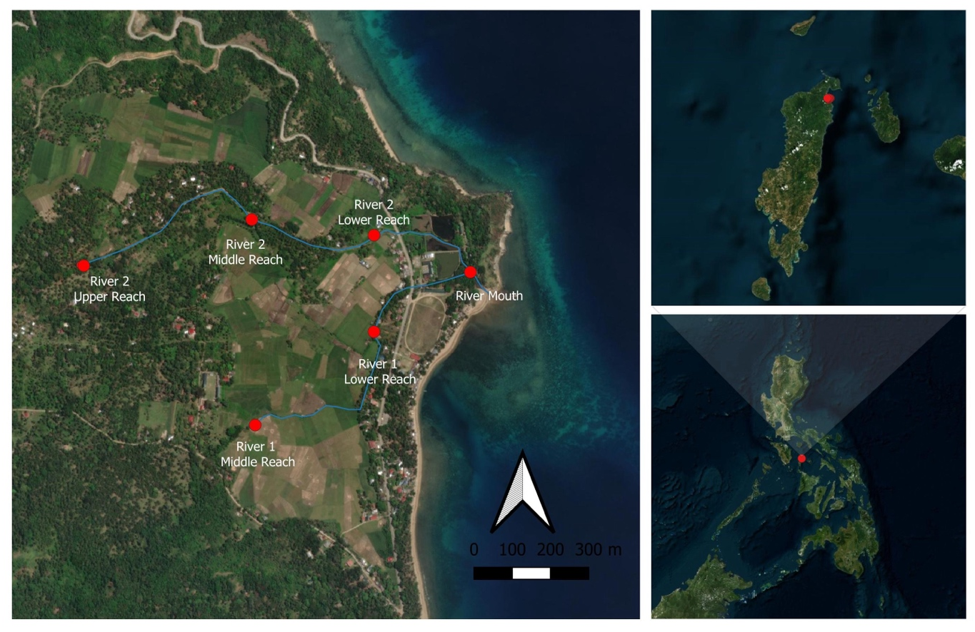
Figure 1. The map of study sites in Romblon State University-San Agustin Campus, Tablas Island, Romblon, Philippines

Preservation, identification and verification of samples
All specimens collected were placed and preserved in 5% formalin solution for 24 hours. Then, the specimens were transferred to a tight bottle with 95% isopropyl alcohol and stored in the biological repository of RSU-San Agustin Campus for identification (Gonzalez et al., 2023). The specimens were identified using published paper online (Gonzalez et al., 2023; Macalisang et al., 2023). The taxonomic identifications were then verified using the List of Freshwater Fishes in the Philippines by Fish Base.

Data analysis
The identified species were counted and recorded per sampling site, and the data were summarized in a tabular presentation. The Shannon-Wiener Diversity Index, as described by Krebs (1999), was used to assess species diversity. It is calculated using the formula:
$$H=-\sum_{i=1}^{S}{pi (In pi})$$
where H represents the Shannon Diversity Index, pi is the fraction of the total population composed of species i, S is the total number of species encountered, and ∑ denotes the summation from species 1 to species S.
The Evenness Index, based on Pielou's (1966) equation, measures how evenly individuals are distributed among species and is given by:
$$e=\frac{H}{\log{S}}$$
where S represents the total number of species.
Additionally, the Dominance Index (C) was computed to assess species dominance using the formula:
$$C= \frac{ni}{N}$$

where ni represents the percentage cover of each species, and N is the total cover value of all species. These indices provide valuable insights into species diversity, evenness, and dominance within the sampled sites.

Results and discussion
Species composition of fish in the estuary and its tributaries
The study documented 39 fish species belonging to 23 families within eight taxonomic orders. A total of 421 individual specimens were collected across the sampling sites (Table 1, Plates 1-4).
Table 1. Checklist of species composition of fishes of RSU-San Agustin Rivers, Cabolutan, San Agustin, Romblon.
Family  Name | Scientific  Name | Common  Name | Local Name
Ambassidae | Ambassis interrupta | Long Spine Glassfish | Tabagak
Gobiidae | Awaous guamensis | Goby | Biya
 | Belobranchus segura | Throatspine Gudgeon | Biya
Butidae | Butis amboinensis | Duckbill Sleeper | Pasel
Carangidae | Carangoides talamparoides | Impostor trevally | Talakitok
Chanidae | Chanos chanos | Milkfish | Bangus
Dussumieriidae | Dussumieria acuta | Sardines | Tamban
Eleotridae | Eleotris mauritiana | Widehead Gudgeon | Payo
Eleotridae | Eleotris fusca | Brown Spine Cheek | Payo
Gobiidae | Exyrias puntang | Puntang Goby | Biya
Apogonidae | Fibramia lateralis | Cardinal Fish | Muong
Gobiidae | Glossogobius aureus | Goby | Biya
Eleotridae | Guiris margaritaceus | Snakehead Gudgeon | Lawag
 | Hypseleotris cyprinoides | Tropical Carp Gudgeon | Maringyan
Leiognathidae | Leiognathus splendens | Splendid Ponyfish | Sapsap
Lutjanidae | Lutjanus johnii | John’s Snapper | Maya-maya
Syngnathidae | Microphis brachyurus | Opossum pipefish | Dayom-dayom
Monodactylidae | Monodactylus argenteus | Silver Moonfish | Bayang
Mugilidae | Mugil cephalus | Flathead Grey | Bayanak
Eleotridae | Ophiocara porocephala | Spangled Sleeper | Palos
 | Ophiocara ophicephalus | Northern Mud Gudgeon | Payo
Cichlidae | Oreochromis niloticus | Nile Tilapia | Tilapiya
Gobiidae | Oxyurichthys ophthalmonema | Goby | Biya
Oxudercidae | Periophthalmus barbarus | Mudskipper | Tambayo
Poeciliidae | Poecilia reticulata | Guppy | Mong-it mong-it
Gobiidae | Pomatoschistus minutus | Goby | Biya
Gobiidae | Rhinogobius sp. | Goby | Biya
Hemiramphidae | Rhynchorhampos georgii | Halfbeak | Bugiw
Gobiidae | Schismatogobius risdawatiae | Goby | Biya
Scorpaenidae | Scorpaenacardinalis | Scorpionfish | Lupo
Siganidae | Siganus guttatus | Rabbitfish | Danggit
 | Siganus spinus | Spotted Scat | Kikiro
Eleotridae | Stenogobius genivittatus | Dusky Sleeper | Mulug
Gobiidae | Stiphodon atroporporeus | Cobalt Blue Goby | Biya
Belonidae | Strongylura marina | Needlefish | Biyanwag
Terapontidae | Terapon jarbua | Crescent grunter | Bagaong
Tetraodontidae | Tetraodon lineatus | Pupperfish | Butete
Toxotidae | Toxotes jaculatrix | Archerfish | Kataba
Gobiidae | Tridentiger trigonocephalus | Chameleon Goby | Goby

This diverse fish assemblage reflects a rich and ecologically significant aquatic ecosystem, supporting a mixture of freshwater, estuarine, and marine species (Hao et al., 2024). Among the recorded species, the Gobiidae family had the highest species representation, with ten species indicating their dominance in the estuary and river’s fish community. Gobies are generally benthic species, thriving in freshwater and brackish environments, suggesting that the river has varied microhabitats supporting different species (Moran & Behrens, 2024). The Eleotridae family followed closely with seven species, including gudgeons and sleepers, which are also benthic fishes commonly found in soft-bottom riverine environments (Shelley et al., 2023).
Several families were represented by only one or two species, indicating either their specialized ecological roles or limited distribution within the system (Gu et al., 2023). For instance, only one species from the Hemiramphidae family, Rhynchorhamphos georgii (Halfbeak), was identified, and a single representative from the Belonidae family, Strongylura marina (Needlefish), was also recorded. Similarly, one species each was recorded from Dussumieriidae (Dussumieria acuta – Sardines), Butidae (Butis amboinensis – Duckbill Sleeper), Oxudercidae (Periophthalmus barbarus – Mudskipper), and Scorpaenidae (Scorpaena cardinalis – Scorpionfish). The limited number of species in these families suggests they may be transient, migratory, or habitat-specific species within the river system (He et al., 2022).
Commercially significant species were also observed, including Chanos chanos (Milkfish or Bangus), Oreochromis niloticus (Nile Tilapia), Siganus guttatus and S. spinus (Rabbitfish), and Mugil cephalus (Flathead Grey Mullet). These species are widely utilized in local fisheries and aquaculture, indicating that the river system plays a role in supporting local livelihoods and food security (Verdegem et al., 2022). The presence of C. chanos suggests that parts of the river serve as nursery grounds for milkfish (Bagarinao, 1991), while the identification of O. niloticus, a highly adaptable and often invasive species, may suggest human intervention through aquaculture or introductions for fisheries enhancement (Arthur et al., 2010). In fact, tilapia, milkfish, siganids, and many others are being promoted nationally by the BFAR for the aquaculture industry in the country ( Santos et al., 2014)
Ecologically, the river system appears to have a high degree of connectivity between marine, estuarine, and freshwater environments, allowing for the coexistence of species adapted to various salinity levels (Zhang et al., 2023). The presence of Periophthalmus barbarus (Mudskipper) is particularly significant, as this species is known to thrive in mangrove ecosystems and intertidal mudflats, indicating the presence of healthy brackish water zones (Santoso et al., 2020). Similarly, Microphis brachyurus (Opossum Pipefish), a member of the Syngnathidae family, is typically associated with slow-moving estuarine waters, further supporting the idea that the river system has diverse habitat types that sustain different fish communities (Frias-Torres, 2004)
The fish community structure is also indicative of varied trophic levels within the ecosystem (Shi et al., 2024). The presence of predatory species such as Lutjanus johnii (John’s Snapper) and Scorpaena cardinalis (Scorpionfish) suggests that the river supports higher-order carnivores (Moosmann et al., 2023), while the abundance of Gobies, Gudgeons, and Sleeper species reflects a strong benthic food web that relies on detritus and small invertebrates (Bouaziz et al., 2021). Herbivorous species like Rabbitfish (Siganus guttatus, S. spinus) contribute to algae regulation, preventing excessive algal growth in the system (Müller et al., 2021).
The study shows the rich biodiversity and ecological importance of the estuary and its tributaries in RSU-San Agustin Campus, providing habitat for a wide range of fish species, including commercially valuable, ecologically significant, and habitat-specialist species. The findings emphasize the need for continued biodiversity monitoring, as changes in fish composition over time could indicate environmental shifts, pollution levels, habitat degradation, or climate change impacts. Ensuring the sustainability of fisheries and the protection of critical habitats is crucial for maintaining this dynamic and productive river ecosystem.

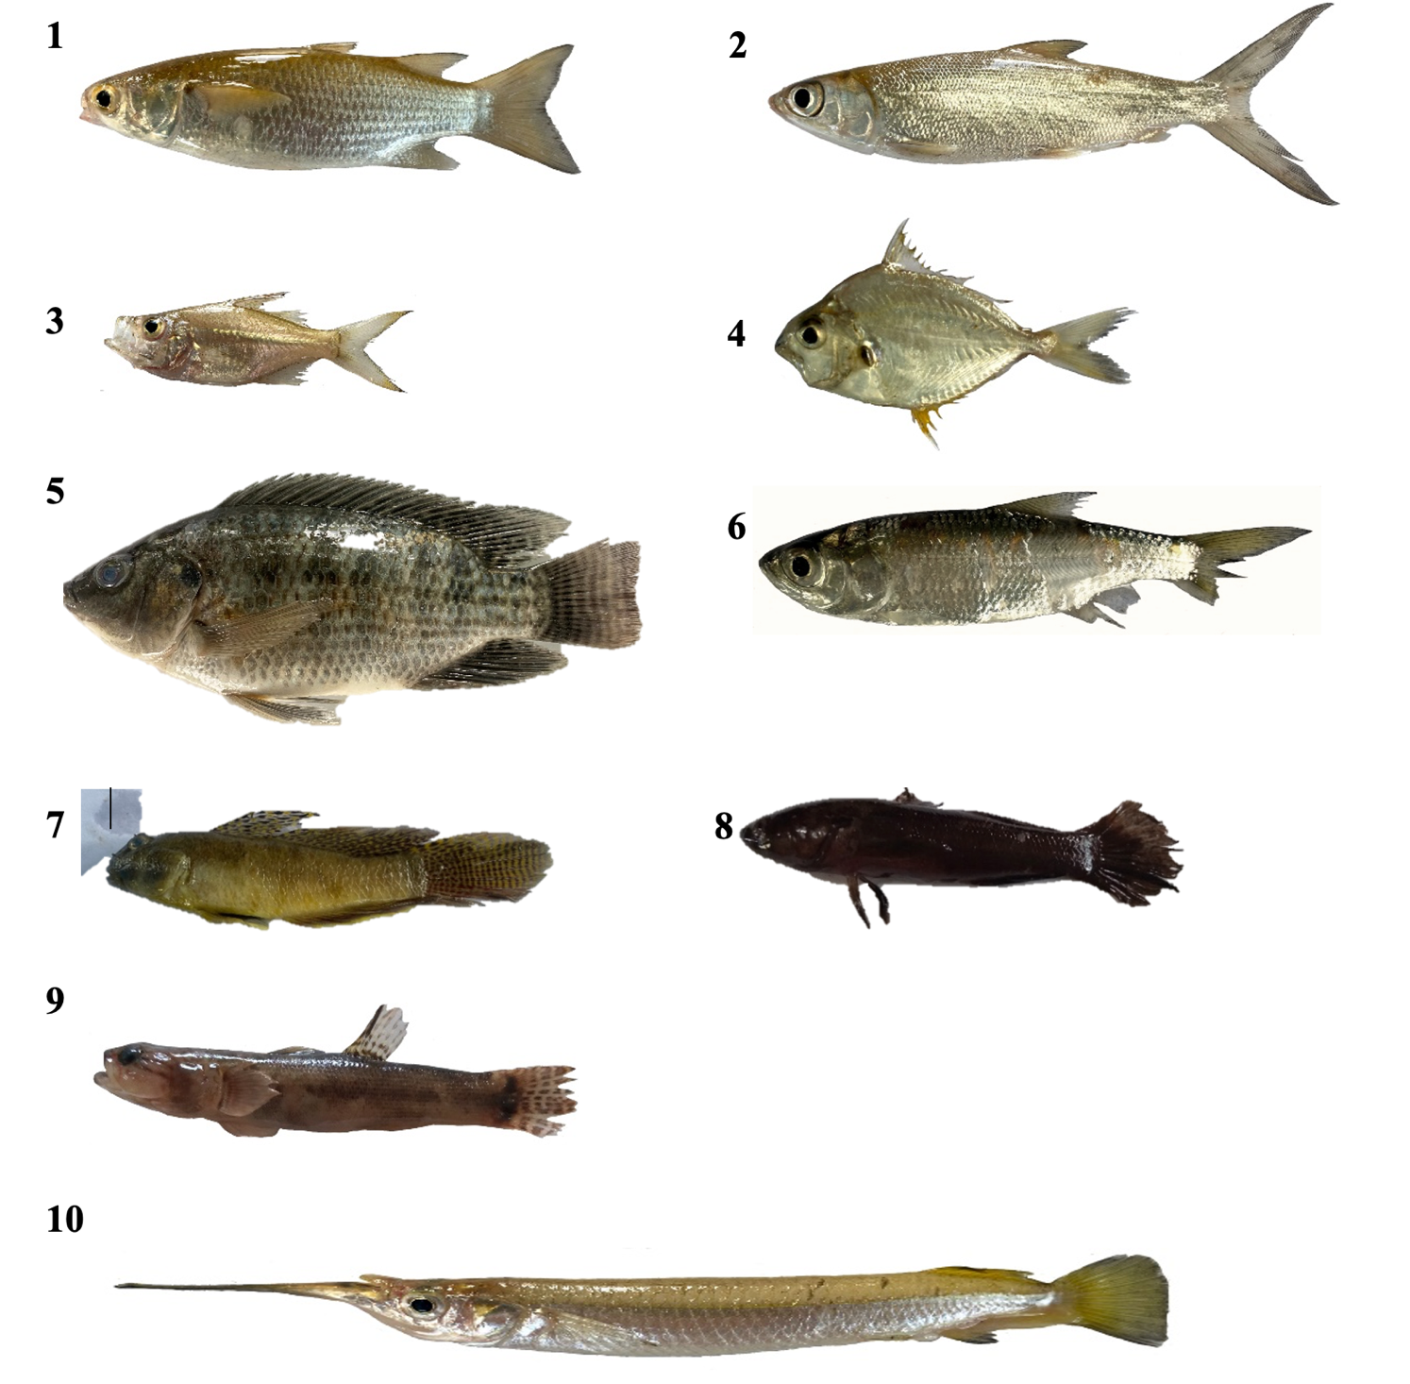

Plate 1. Photos of fishes recorded in RSU-San Agustin Rivers, Cabolutan San Agustin, Romblon. 1. Mugil cephalus, 2. Chanos chanos, 3. Ambassis interrupta, 4. Leiognathus splendens, 5. Oreochromis niloticus, 6. Dussumieria acuta, 7. Exyrias puntang, 8. Eleostris fusca, 9. Belobranchus segura and 10. Strongylura marina.
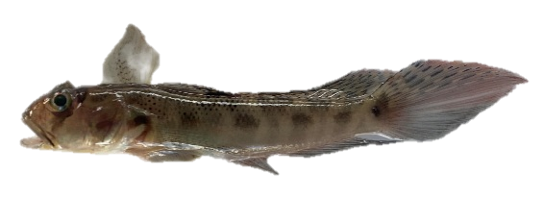

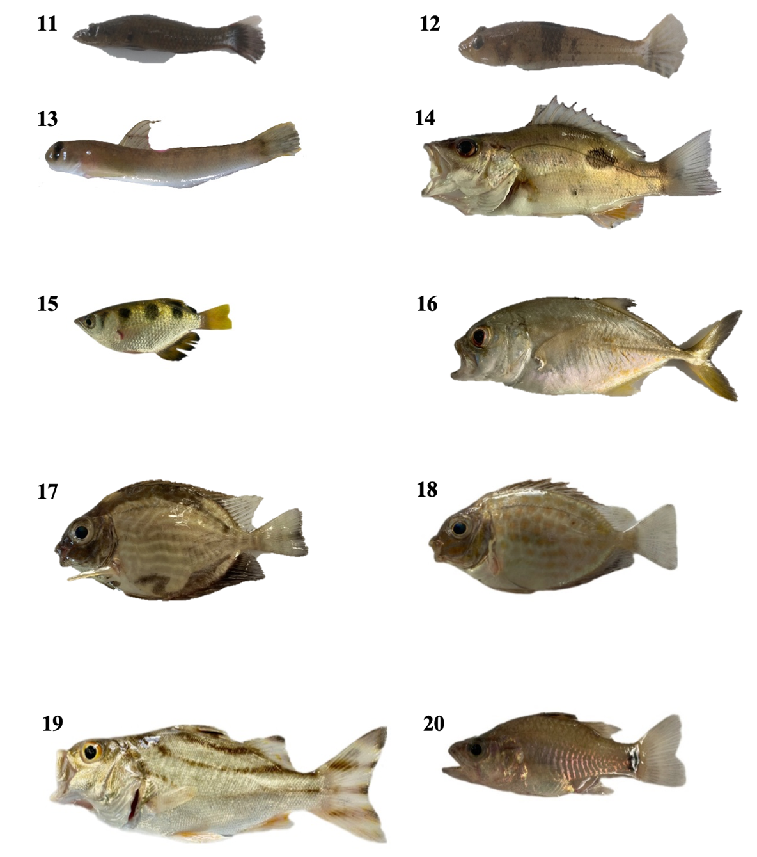

Plate 2. 11. Butis amboinensis, 12. Pomatoschistus minutus, 13. Awaous guamensis, 14. Lutjanus johnii, 15. Toxotes jaculatrix, 16. Carangoides taramparoides 17. Siganus spinus, 18. Siganus guttatus, 19. Terapon jarbua, 20. Fibramia lateralis (Continued)

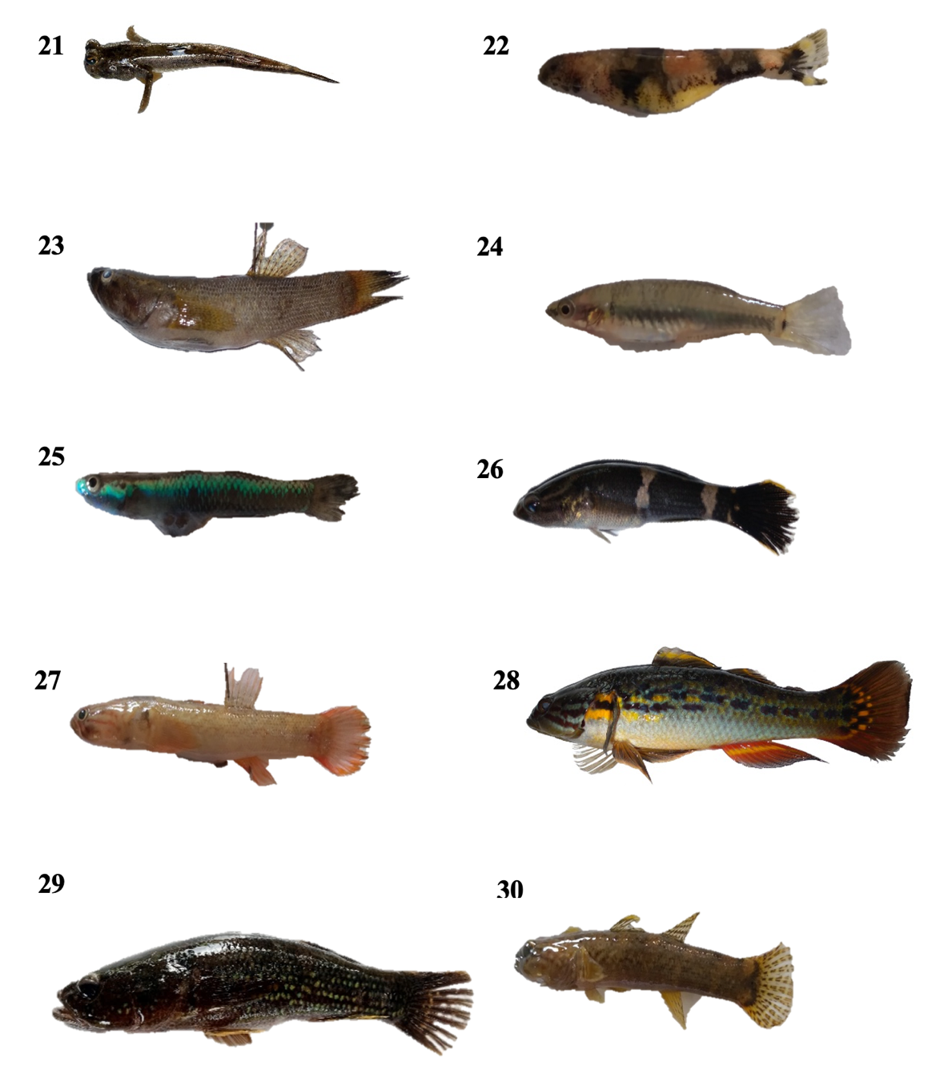
Plate 3. 21. Periophthalmus barbarus, 22. Schismatogobius risdawatiae, 23. Eleotris mauritiana, 24, Hypseleotris cyprinoides, 25. Stiphodon atropurporeus (female), 26. Ophiocara ophicephalus, 27. Rhinogobius sp., 28. Guiris margaritaceus, 29. Ophiocara porocepala, 30. Stenogobius genivittatus. (Continued)

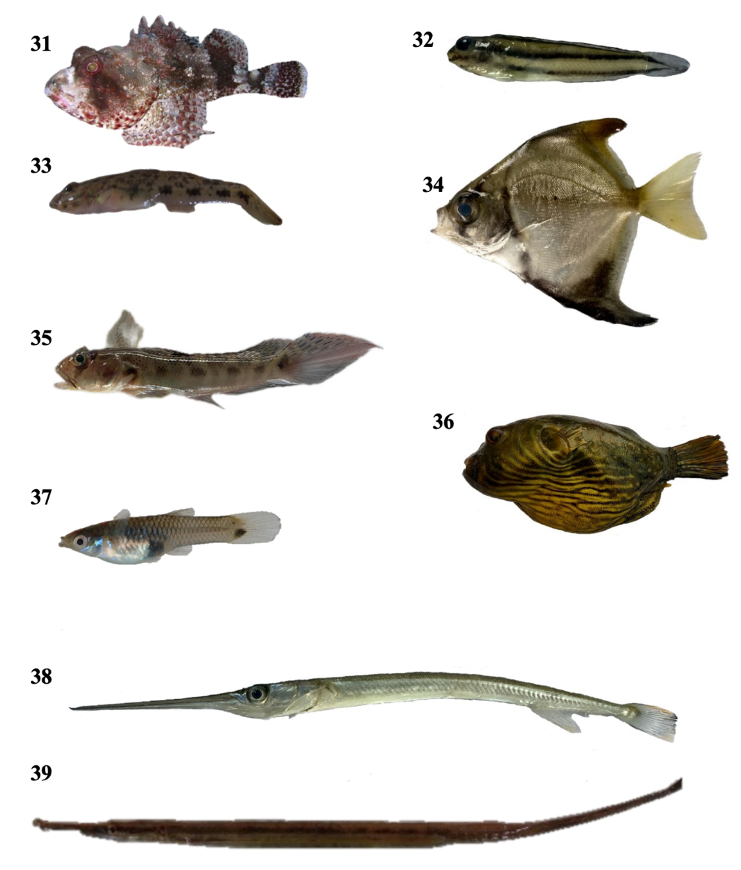

Plate 4. (31) Scorpaena cardinalis, 32. Monodactylus argenteus, 33. Glossogobius aureus 34. Tridentiger trigonocephalus, 35. Oxyuricthys opthalmonema, 36. Tetraodon lineatus, 37. Poecilia reticulate, 38. Rhynchorhamphos georgii, 39. Microphis brachyurus.

The abundance of fish in the estuary and its tributaries
Among the 39 fish species recorded in the estuary and tributary systems in RSU-San Agustin Campus, Ambassis interrupta was the most abundant species, accounting for 21% of the total fish population (Figure 2). This dominance suggests that the species thrives well in the river’s ecological conditions, likely due to favorable water parameters, abundant food sources, and suitable habitat structures (Moniruzzaman et al., 2021). Following this, Guiris margaritaceus was the second most abundant species, making up 17% of the population, indicating its significant role in the river’s ecosystem as a key component of the food web (Jargal et al., 2023).

Figure 2. Relative abundance of fish of RSU-San Agustin river, Cabolutan, San Agustin, Romblon.

Other species, such as Strongylura marina (5%), Poecilia reticulata (7%), and Oreochromis niloticus (7%) contributed moderately to the total population (Figure 2). The presence of O. niloticus (Nile Tilapia), a commercially important species, suggests human influence, as tilapia are often introduced for aquaculture or food security (Gu et al., 2015). Meanwhile, Poecilia reticulata (Guppy), a small and hardy species, thrives in freshwater and brackish environments and is often used for mosquito control (El-Sabaawi et al., 2026).
Lower relative abundances were recorded for Hypseleotris cyprinoides (3%), Microphis brachyurus (2%), Chanos chanos (2%), Periophthalmus barbarus (2%), and Eleotris mauritiana (1%). These species may be less dominant due to habitat specialization, competition, or lower reproductive rates (Mignien & Stoll, 2024). The remaining 29 species collectively made up 19% of the total fish population, highlighting a high species richness but lower individual dominance. This even distribution suggests a diverse and balanced ecosystem where no single species overwhelmingly dominates, which is a positive indicator of ecological health (Dornelas et al., 2011).
The result of the study indicates that the estuary and its tributaries provide varied microhabitats and sufficient food sources for different fish species (Cattrijsse et al., 2004). The presence of freshwater, brackish, and marine species showcases the complexity of the ecosystem (Gomes et al., 2024). However, the dominance of A. interrupta suggests that this species benefits from the river's conditions (Wahyudewantoro, 2018), while the presence of commercially significant species like O. niloticus and Chanos chanos indicates potential human influence on the fish population (Canonico et al., 2005). The relatively low abundance of certain species, such as M. brachyurus and Periophthalmus barbarus, may indicate specific habitat requirements or natural rarity, emphasizing the need for conservation efforts to protect their habitats (Murray & Lepschi, 2004).

Fish distribution in the estuary and its tributaries
The fish species distribution across different sections of two rivers, ranging from the river mouth to the upper reaches is presented in Table 2. A clear pattern emerges where certain species are confined to specific areas, while others display a broader range, reflecting their adaptability to different environmental conditions. The river mouth hosts a high concentration of species typically associated with estuarine or marine environments, including Ambassis interrupta, Carangoides taramparoides, Chanos chanos, and Monodactylus argenteus. These species thrive in brackish water conditions where freshwater mixes with seawater, indicating the river mouth’s crucial role as a nursery and feeding ground for many marine-associated fish (Vengadesan et al., 2023).
Moving upstream, the lower reaches of the rivers act as transitional zones, accommodating species that can tolerate moderate salinity fluctuations (Bice et al., 2023). Species such as Oreochromis niloticus, Periophthalmus barbarous, and Poecilia reticulata appear in these sections, showcasing their ability to adapt to both brackish and freshwater conditions. The presence of Hypseleotris cyprinoides and Microphis brachyurus in multiple sections of the river suggests they are euryhaline, meaning they can survive in a wide range of salinities (Corpuz et al., 2016). Such adaptability gives these species an advantage in environments affected by seasonal or anthropogenic changes in water salinity (Mugwanya et al., 2022). The middle and upper reaches of the rivers exhibit a different ecological profile, dominated by freshwater species that are more specialized in their habitat requirements (Ma et al., 2024). Species such as Belobranchus segura, Rhinogobius sp., Schismatogobius risdawatiae, and Stiphodon artropurpureus are found exclusively in the upper reaches, indicating their preference for fast-flowing, well-oxygenated freshwater streams (Krakowiak & Pennuto, 2008). Many of these species, particularly gobies and small-bodied fish, may have life cycles dependent on clear, unpolluted water with strong currents, which makes them sensitive to environmental disturbances such as deforestation, damming, or pollution (Lasne et al., 2007). Their restricted distribution in the upper river sections underscores the importance of conservation measures in these habitats (Krakowiak & Pennuto, 2008).
Some species, including Guiris margaritaceus, Hypseleotris cyprinoides, Microphis brachyurus, and Poecilia reticulata, exhibit a wide distribution across multiple sections of the river, demonstrating high environmental plasticity (Sunardi et al., 2012). These species may possess physiological adaptations that allow them to cope with varying levels of salinity, temperature, and oxygen availability, making them more resilient to habitat changes (Farias et al., 2024). Notably, Oreochromis niloticus, commonly known as Nile tilapia, is found in almost all sections of the rivers. This species is well-documented for its hardiness and ability to thrive in diverse aquatic environments, which has contributed to its success as an invasive species in many regions (Geletu et al., 2024). Its widespread presence raises concerns about potential competition with native fish, as Nile tilapia can outcompete local species for food and habitat, leading to shifts in ecosystem dynamics (Gozlan et al., 2024). The presence of estuarine species in the lower river sections suggests that any modifications to the river’s natural flow, such as dredging, riprapping, quarrying or pollution, could significantly alter the salinity gradient and disrupt the delicate balance of species distribution (Reid & Church, 2015). For instance, reduced freshwater inflow from upstream sources due to water extraction or dam construction could increase salinity levels, potentially driving freshwater species out of their natural habitats (Gillanders & Kingford, 2002). Conversely, excessive freshwater input from heavy rainfall or dam releases could lower salinity in estuarine regions, affecting marine-associated species that rely on brackish conditions (Reid & Church, 2015).
The result shows valuable implications for conservation planning, fisheries management, and environmental monitoring. Conservation efforts should prioritize protecting the upper river reaches, where many specialized freshwater fish are found. Preserving these habitats is crucial for maintaining biodiversity, particularly for species with limited distribution ranges (Yousefia et al., 2020). Additionally, fisheries management strategies can benefit from understanding the locations of commercially or ecologically important species, such as Mugil cephalus (mullet) and Lutjanus johnii (snapper), ensuring sustainable harvest levels (Talbot et al., 2024). Monitoring species distribution over time could also provide early warnings of ecological changes, allowing researchers and policymakers to respond proactively to threats such as habitat degradation, invasive species proliferation, or climate change effects (Chen et al., 2024). The species distribution across different sampling sites in the estuary and its tributaries was observed. The presence of specialized freshwater fish in the upper reaches, adaptable species throughout the river, and estuarine-dependent fish at the mouth illustrates the importance of maintaining ecological connectivity across these habitats (O’Mara et al., 2024). Any disruption to their habitat, whether through human activity or climate change, could have cascading effects on the river’s biodiversity and overall health (De Santis et al., 2023).
Table 2. Checklist of fishes in different sampling sites of RSU-San Agustin Rivers, Cabolutan, San Agustin, Romblon.
Scientific Name | A | B | C | D | E | F
Ambassis interrupta | x | x |  | x
Awaous guamensis |  |  |  | x
Belobranchus segura |  |  |  |  |  | x
Butis amboinensis | x
Carangoides taramparoides | x
Chanos chanos | x
Dussumieria acuta | x
Eleotris fusca |  | x
E. mauritiana |  |  |  |  | x | x
Exyrias puntang | x
Fibramia lateralis | x
Glossogobius aureus |  |  |  | x | x
Guiris margararitaceus | x |  | x | x | x
Hypseleotris cyprinoides |  |  | x | x | x | x
Leiognathus splendens | x
Lutjanus johnii | x
Microphis brachyurus |  | x |  | x | x
Monodactylus argenteus | x
Mugil cephalus | x
Ophiocara ophicephalus |  |  |  | x
Ophiocara porocephala | x |  | x
Oreochromis niloticus | x | x | x | x | x
Oxyurichthys ophthalmonema | x
Periophthalmus barbarous | x | x
Poecilia reticulata |  | x | x | x | x
Pomatoschistus minutus | x
Rhinogobius sp. |  |  |  |  |  | x
Rhynchorhampos georgii | x
Schismatogobius risdawatiae |  |  |  |  |  | x
Scorpaena cardinalis | x
Siganus guttatus | x
S. spinus | x
Stenogobius genivittatus |  |  |  |  |  | x
Stiphodon artropurpureus |  |  |  |  |  | x
Strongylura marina | x
Terapon jarbua | x
Tetraodon lineatus | x
Toxotes jaculatrix | x
Tridentiger trigonocephalus | x
Note: (A) River mouth, (B) River 1 Lower reach, (C) River 1 Middle reach, (D) River 2 Lower reach (E) River 2 Middle reach and (F) River 2 Upper reach

Species Richness across sites
A notable variation in fish species richness across different sampling sites in the estuary and its tributaries in RSU-San Agustin Campus was observed. (Figure 3). The results indicate that species distribution is influenced by habitat characteristics such as substrate type, including muddy, sandy, and boulder compositions (Ma et al., 2024). The highest species richness was recorded at the river mouth, with 26 fish species, which is expected as river mouths serve as transitional zones between freshwater and marine environments (de Moura et al., 2012). These areas offer diverse habitats and abundant food resources, making them ideal for various fish species (Maciel a et al., 2024). The lower reach of River 2 had the second-highest species count with nine species, followed by the middle and upper reaches of River 2 with seven species each. The lower reach of River 1 contained six species, while the middle reach of River 1 had the lowest species count with five species. The decreasing species richness in upstream areas suggests possible environmental constraints such as limited food availability, reduced water flow, or human-induced disturbances (López-Rodríguez et al., 2024).
The presence of different substrate types across the sampling sites plays a significant role in shaping species distribution (Mazaris et al., 2008). Muddy substrates support species that rely on organic material for food, sandy areas provide habitat for burrowing species, and boulder substrates offer shelter and breeding grounds (Altamirano et al., 2017). The combination of these substrates influences the availability of suitable habitats for different fish species, contributing to the observed variation in species richness (Pessanha et al., 2021). The high fish diversity at the river mouth highlights its ecological significance, emphasizing the need for conservation efforts to protect this critical habitat (Ma et al., 2024). In contrast, the relatively lower species richness in upstream areas suggests the need for further investigation into potential environmental stressors such as pollution, habitat degradation, or water quality changes (Ngcobo et al., 2025).

Figure 3. Distribution abundance of fishes in across sampling sites estuary and its tributaries in RSU-San Agustin Campus.

Diversity of fish in the estuary and its tributaries
The fish biodiversity assessment of the estuary and its tributaries in RSU-San Agustin Campus, reveals significant variations in species richness, diversity, evenness, and dominance across different sampling sites (Table 3). Results indicate that the river and tributary systems have low to moderate fish diversity with depressed to unstable community and moderate to high fish species dominance (Ulfah, 2019).
The River Mouth exhibits the highest species richness (26 species) and diversity (H' = 2.19), likely due to its estuarine nature, which supports a wide range of species by providing abundant food and habitat diversity (de Moura et al., 2012). However, its low evenness index (J' = 0.22) suggests that a few species dominate this area (Mancuso et al., 2023). In contrast, lower and middle reach of River 1 Middle Reach, have the lowest species richness (6 and 5 species) and diversity (H' = 1.13 and 0.77), indicating that environmental conditions such as habitat limitations, reduced resource availability, or possible human disturbances may be affecting fish populations in this river (Maceda-Veiga et al., 2022).
Evenness, which measures how evenly species are distributed, is highest in River 1 Middle Reach (J' = 0.64). This area also obtained the lowest dominance, as measured by Simpson’s Dominance Index, of 0.48, suggesting a more balanced fish community where no single species dominates (Xia et al., 2022). Conversely, high dominance index is obtained in River 2 Lower Reach (D = 0.89), where one or a few species are disproportionately abundant (Stefani et al., 2023). This could be due to favorable conditions for specific species or environmental imbalances reducing the presence of competitors ((Xia et al., 2022).). The estuary and its tributaries (H' = 2.7), indicate that, as a whole ecosystem supports a rich and varied fish community.
The observed patterns shows an important ecological trend. The greater biodiversity at the River Mouth suggests the positive influence of estuarine conditions (Molina et al., 2020), while the lower diversity in upstream areas may indicate environmental stressors such as pollution or habitat degradation (Kennish, 2002). High species dominance in certain sites could signal ecological imbalances (Ricotta et al., 2022), potentially caused by habitat fragmentation, overfishing, or competition from invasive species (Katsanevakis et al., 2014). To ensure the sustainability of fish populations in these ecosystems, conservation efforts should focus on protecting critical habitats, especially in estuarine and riparian zones. Pollution management strategies, including proper waste disposal and water quality monitoring, are crucial in maintaining a healthy aquatic environment (Trivedi et al., 2024).
Table 3. The computed value of diversity, dominance and evenness index of fishes of RSU-San Agustin Rivers, Cabolutan, San Agustin, Romblon
Sampling  Site | Species Richness | Shannon Diversity  Index | Pielou’s Evenness  Index | Simpson’s Dominance  Index
River Mouth | 26 | 2.19 | 0.22 | 0.66
River 1 Lower Reach | 6 | 1.13 | 0.46 | 0.63
River 1 Middle Reach | 5 | 0.77 | 0.64 | 0.48
River 2 Lower Reach | 9 | 1.85 | 0.2 | 0.89
River 2 Middle Reach | 7 | 1.52 | 0.29 | 0.78
River 2 Upper Reach | 7 | 1.26 | 0.45 | 0.65
Whole | 39 | 2.7 | 0.11 | 1.52
Note: H<1 Low Diversity C 0-.5 Low Dominance J 0-.5 Low Evenness
1.1-3 Moderate Diversity .15-.75 Moderate Dominance .51-.75 Moderate
>3 High Diversity .76-1 High Dominance .76-1 High Evenness

Conclusions
The study on the composition and longitudinal distribution of fishes in the estuary and its tributaries in RSU-San Agustin Campus revealed a diverse and ecologically significant fish community. A total of 39 fish species from 23 families were identified, with the Gobiidae family being the most represented, showing the dominance of benthic species in the area. The study found distinct species distribution patterns along different estuary sections, with estuarine and marine-associated species thriving at the river mouth, while freshwater specialists were restricted to the upper reaches. This study also highlights the crucial role of river mouths as a nursery and feeding ground for many marine-associated fish and in supporting local livelihoods and food security.
The highest species richness and diversity were recorded at the river mouth, reflecting its role as a critical transition zone between freshwater and marine environments. In contrast, the middle and upper reaches of the rivers had lower species richness, likely due to environmental constraints such as habitat specialization, reduced resource availability, or human-induced disturbances. Shannon Diversity Index values indicated moderate biodiversity across sites, with dominance indices revealing areas where specific species were particularly abundant. The presence of Oreochromis niloticus (Nile tilapia) suggests human influence on the fish population, while the occurrence of estuarine-dependent species emphasizes the importance of maintaining ecological connectivity.

Acknowledgement
The authors thank Ms. Rizabie Buhawe, Ms May Grace Mallen and Mr. Glenn Marc Rios for their dedicated support and significant contributions to the study.
Author’s Contribution
All authors contributed during the study conceptualization, collection and processing of data, interpretation of findings, writing, and revision of this work.
Conflict of Interest
The authors declare no competing interests.
Declaration of AI Use
During the manuscript preparation, the authors used AI assistants, Grammarly and Turnitin, to check grammar and plagiarism in the manuscript.
Ethics Statement
This study adheres to ethical standards for the collection and assessment of fish populations in riverine ecosystems. Fish sampling was conducted with utmost care minimizing the suffering of fish. Precautionary measures were also employed during the sampling to minimize disturbance and avoid damage in the aquatic habitat.

References
Altamirano, J. P., Recente, C. P., & Rodriguez, J. C. (2017). Substrate preference for burying and feeding of sandfish Holothuria scabra juveniles. Fisheries Research, 186, 514–523. https://doi.org/10.1016/j.fishres.2016.08.011
Arthur, R. I., Lorenzen, K., Homekingkeo, P., Sidavong, K., Sengvilaikham, B., & Garaway, C. J. (2010). Assessing impacts of introduced aquaculture species on native fish communities: Nile tilapia and major carps in SE Asian freshwaters. Aquaculture, 299(1–4), 81–88. https://doi.org/10.1016/j.aquaculture.2009.11.022
Bagarinao, T. U. . (1991). Biology of milkfish : Chanos-chanos forsskal. Aquaculture Dept., Southeast Asian Fisheries Development Center.
Bice, C. M., Huisman, J., Kimball, M. E., Mallen-Cooper, M., Zampatti, B. P., & Gillanders, B. M. (2023). Tidal barriers and fish – Impacts and remediation in the face of increasing demand for freshwater and climate change. Estuarine, Coastal and Shelf Science, 289. https://doi.org/10.1016/j.ecss.2023.108376
Bouaziz, R., Le Loc’h, F., Rolet, C., Veillet, G., Munaron, J. M., Rabhi, K., Djebar, A. B., Amara, R., & Ben Rais Lasram, F. (2021). Structure and seasonal variability in fish food webs in a small macrotidal estuary (Canche estuary, Eastern English Channel) based on stable carbon and nitrogen isotope analysis. Regional Studies in Marine Science, 44. https://doi.org/10.1016/j.rsma.2021.101694
Canonico, G. C., Arthington, A., Mccrary, J. K., & Thieme, M. L. (2005). The effects of introduced tilapias on native biodiversity. Aquatic Conservation: Marine and Freshwater Ecosystems, 15(5), 463–483. https://doi.org/10.1002/aqc.699
Chen, F., Jiang, F., Ma, J., Alghamdi, M. A., Zhu, Y., & Yong, J. W. H. (2024). Intersecting planetary health: Exploring the impacts of environmental stressors on wildlife and human health. Ecotoxicology and Environmental Safety, 283. https://doi.org/10.1016/j.ecoenv.2024.116848
Corpuz, M. N. C., Paller, V. G. V., (2016). Diversity and distribution of freshwater fish assemblages in Lake Taal River Systems in Batangas, Philippines. Journal of Environmental Science and Management, 19(1), 85-95.
de Moura, P. M., Vieira, J. P., & Garcia, A. M. (2012). Fish abundance and species richness across an estuarine-freshwater ecosystem in the Neotropics. Hydrobiologia, 696(1), 107–122. https://doi.org/10.1007/s10750-012-1187-9
De Santis, V., Jeppesen, E., Volta, P., & Korkmaz, M. (2023). Impacts of Human Activities and Climate Change on Freshwater Fish—Volume II. Water, 15(23). https://doi.org/10.3390/w15234166
Dornelas, M., Phillip, D. A. T., & Magurran, A. E. (2011). Abundance and dominance become less predictable as species richness decreases. Global Ecology and Biogeography, 20(6), 832–841. https://doi.org/10.1111/j.1466-8238.2010.00640.x
Dugan, P., Dey, M. M., & Sugunan, V. V. (2006). Fisheries and water productivity in tropical river basins: Enhancing food security and livelihoods by managing water for fish. Agricultural Water Management, 80(1-3), 262–275. https://doi.org/10.1016/j.agwat.2005.07.017
Eduardo, L. N., Frédou, T., Lira, A. S., Ferreira, B. P., Bertrand, A., Ménard, F., & Frédou, F. L. (2018). Identifying key habitat and spatial patterns of fish biodiversity in the tropical Brazilian continental shelf. Continental Shelf Research, 166, 108–118. https://doi.org/10.1016/j.csr.2018.07.002
El-Sabaawi, R. W., Frauendorf, T. C., Marques, P. S., MacKenzie, R. A., Manna, L. R., Mazzoni, R., Phillip, D. A. T., Warbanski, M. L., & Zandonà, E. (2016). Biodiversity and ecosystem risks arising from using guppies to control mosquitoes. Biology Letters, 12(10). https://doi.org/10.1098/rsbl.2016.0590
Farias, L., Beszteri, B., Burfeid Castellanos, A. M., Doliwa, A., Enss, J., Feld, C. K., Grabner, D., Lampert, K. P., Mayombo, N. A. S., Prati, S., Schürings, C., Smollich, E., Schäfer, R. B., Sures, B., & Le, T. T. Y. (2024). Influence of salinity on the thermal tolerance of aquatic organisms. Science of the Total Environment, 953. https://doi.org/10.1016/j.scitotenv.2024.176120
Flemer, D. A., & Champ, M. A. (2006). What is the future fate of estuaries given nutrient over-enrichment, freshwater diversion and low flows? Marine Pollution Bulletin, 52(3), 247–258. https://doi.org/10.1016/j.marpolbul.2005.11.027
França, S., Costa, M. J., & Cabral, H. N. (2011). Inter- and intra-estuarine fish assemblage variability patterns along the Portuguese coast. Estuarine, Coastal and Shelf Science, 91(2), 262–271. https://doi.org/10.1016/j.ecss.2010.10.035
Frias-Torres, S. (2004). Notes on aquarium brood release and feeding of the opossum pipefish, Microphis brachyurus lineatus. Gulf and Caribbean Research, 16, 73-75. https://www.researchgate.net/publication/209767527
Geletu, T. T., Tang, S., Xing, Y., & Zhao, J. (2024). Ecological niche and life-history traits of redbelly tilapia (Coptodon zillii, Gervais 1848) in its native and introduced ranges. Aquatic Living Resources, 37. https://doi.org/10.1051/alr/2023030
Gillanders, B., & Kingsford, M. (2002). Impact of Changes in Flow of Freshwater on Estuarine and Open Coastal Habitats and the Associated Organisms. Oceanography and Marine Biology, 40, 233–309. https://doi.org/10.1201/9780203180594.ch5
Gomes, M. A., Alves, C. M., Faria, F., Troncoso, J. S., & Gomes, P. T. (2024). Untangling Coastal Diversity: How Habitat Complexity Shapes Demersal and Benthopelagic Assemblages in NW Iberia. Journal of Marine Science and Engineering, 12(4). https://doi.org/10.3390/jmse12040538
Gonzalez, J. B., Gado, V. J. H., & Mantes, B. G. (2023). Freshwater ichthyofauna of wetlands in Tablas Island, Romblon, The Philippines. Academia Journal of Biology, 45(1), 121–138. https://doi.org/10.15625/2615-9023/17521
Gozlan, R. E., Bommarito, C., Caballero-Huertas, M., Givens, J., Mortillaro, J. M., Pepey, E., Ralaiarison, R. P., Senff, P., & Combe, M. (2024). A one-health approach to non-native species, aquaculture, and food security. Water Biology and Securit, 3(2). https://doi.org/10.1016/j.watbs.2024.100250
Gu, S., Deng, Y., Wang, P., Li, C., Shi, D., & Wang, S. (2023). Assessing riverine fish community diversity and stability by eDNA metabarcoding. Ecological Indicators, 157. https://doi.org/10.1016/j.ecolind.2023.111222
Hao, L., Gu, K., Zhou, Y., An, J., Hu, W., Wu, Z., Shao, J., Pan, J., He, G., Liu, Q., & Hu, Z. (2024). Comparing diversity and structure of freshwater fish assemblages using environmental DNA and gillnetting methods: A case study of a large deep reservoir in East China. Ecological Indicators, 166. https://doi.org/10.1016/j.ecolind.2024.112538
He, W., Xu, D., Liang, Y., Ren, L., & Fang, D. (2022). Using eDNA to assess the fish diversity and spatial characteristics in the Changjiang River-Shijiu Lake connected system. Ecological Indicators, 139. https://doi.org/10.1016/j.ecolind.2022.108968
Jargal, N., Kim, J. E., & An, K. G. (2023). New interactive functional indicator approach for river health assessment in an Asian temperate river: Comprehensive analysis of water chemistry, physical habitat, land use, and the biological disturbance of invasive alien species. Ecological Indicators, 157. https://doi.org/10.1016/j.ecolind.2023.111212
Katsanevakis, S., Wallentinus, I., Zenetos, A., Leppäkoski, E., Çinar, M. E., Oztürk, B., Grabowski, M., Golani, D., & Cardoso, A. C. (2014). Impacts of invasive alien marine species on ecosystem services and biodiversity: A pan-European review. Aquatic Invasions, 9(4), 391–423. https://doi.org/10.3391/ai.2014.9.4.01
Kennish, M. J. (2002). Environmental threats and environmental future of estuaries. Environmental Conservation, 29(1), 78–107. https://doi.org/10.1017/S0376892902000061
Krakowiak, P. J., & Pennuto, C. M. (2008). Fish and Macroinvertebrate Communities in Tributary Streams of Eastern Lake Erie with and without Round Gobies (Neogobius melanostomus, Pallas 1814). Journal of Great Lakes Research, 34(4), 675–689. https://doi.org/10.1016/s0380-1330(08)71610-1
Kura, Y., Mam, K., Chea, S., Eam, D., Almack, K., & Ishihara, H. (2023). Conservation for sustaining livelihoods: Adaptive co-management of fish no-take zones in the Mekong River. Fisheries Research, 265. https://doi.org/10.1016/j.fishres.2023.106744
Lasne, E., Bergerot, B., Lek, S., & Laffaille, P. (2007). Fish zonation and indicator species for the evaluation of the ecological status of rivers: Example of The Loire basin (France). River Research and Applications, 23(8), 877–890. https://doi.org/10.1002/rra.1030
López-Rodríguez, A., Meerhoff, M., D’Anatro, A., de Ávila-Simas, S., Silva, I., Pais, J., Teixeira de Mello, F., Reynalte-Tataje, D. A., Zaniboni-Filho, E., & González-Bergonzoni, I. (2024). Longitudinal changes on ecological diversity of Neotropical fish along a 1700 km river gradient show declines induced by dams. Perspectives in Ecology and Conservation, 22(2), 186–195. https://doi.org/10.1016/j.pecon.2024.03.003
Ma, B., Zhou, R., Zhang, F., Ru, H., Li, Y., Xu, B., & Lin, P. (2024). Relative influence of local habitat and land use/cover on the taxonomic and functional organizations of fish assemblages in the Anning River, Southwest China. Ecological Indicators, 159. https://doi.org/10.1016/j.ecolind.2024.111673
Macalisang, M. J. C. C., C. Mazo, X. J., & Gonzalez, J. B. (2023). Freshwater Fishes of Wetlands in San Agustin, Romblon, Philippines. Uttar Pradesh Journal of Zoology, 44(15), 55–63. https://doi.org/10.56557/upjoz/2023/v44i153569
Maceda-Veiga, A., Nally, R. Mac, de Sostoa, A., & Yen, J. D. L. (2022). Patterns of species richness, abundance and individual-size distributions in native stream-fish assemblages invaded by exotic and translocated fishes. Science of the Total Environment, 838. https://doi.org/10.1016/j.scitotenv.2022.155953
Maciel, E. B., Jovem-Azevêdo, D., Lima, C. S. da S., & Pessanha, A. L. M. (2024). Multiple habitats drive the functional diversity of fish assemblages in a tropical estuary. Marine Environmental Research, 195. https://doi.org/10.1016/j.marenvres.2024.106379
Mancuso, F. P., Giommi, C., Mangano, M. C., Airoldi, L., Helmuth, B., & Sarà, G. (2023). Evenness, biodiversity, and ecosystem function of intertidal communities along the Italian coasts: Experimental short-term response to ambient and extreme air temperatures. Science of the Total Environment, 858. https://doi.org/10.1016/j.scitotenv.2022.160037
Marshall, W. S. (2012). Osmoregulation in Estuarine and Intertidal Fishes. Fish Physiology, 32, 395–434. https://doi.org/10.1016/B978-0-12-396951-4.00008-6
Martino, E. J., & Able, K. W. (2003). Fish assemblages across the marine to low salinity transition zone of a temperate estuary. Estuarine, Coastal and Shelf Science, 56(5–6), 969–987. https://doi.org/10.1016/S0272-7714(02)00305-0
Mazaris, A. D., Tzanopoulos, J., Kallimanis, A. S., Matsinos, Y. G., Sgardelis, S. P., & Pantis, J. D. (2008). The contribution of common and rare species to plant species richness patterns: The effect of habitat type and size of sampling unit. Biodiversity and Conservation, 17(14), 3567–3577. https://doi.org/10.1007/s10531-008-9480-7
Mignien, L., & Stoll, S. (2024). Reproductive success of stream fish species in relation to high and low flow patterns: The role of life history strategies and species traits. Science of the Total Environment, 946. https://doi.org/10.1016/j.scitotenv.2024.174366
Molina, A., Duque, G., & Cogua, P. (2020). Influences of environmental conditions in the fish assemblage structure of a tropical estuary. Marine Biodiversity, 50(1). https://doi.org/10.1007/s12526-019-01023-0
Moniruzzaman, M., Bhowmick, A. R., Karan, S., & Mukherjee, J. (2021). Spatial heterogeneity within habitat indicates the community assemblage pattern and life strategies. Ecological Indicators, 123. https://doi.org/10.1016/j.ecolind.2021.107365
Moosmann, M., Greenway, R., Oester, R., & Matthews, B. (2024). The role of fish predators and their foraging traits in shaping zooplankton community structure. Ecology Letters, 27(2). https://doi.org/10.1111/ele.14382
Moran, N. P., & Behrens, J. W. (2024). Behavioural and trophic variation within a well-established invasive round goby population. Animal Behaviour, 215, 263–280. https://doi.org/10.1016/j.anbehav.2024.07.006
Mugwanya, M., Dawood, M. A. O., Kimera, F., & Sewilam, H. (2022). Anthropogenic temperature fluctuations and their effect on aquaculture: A comprehensive review. Aquaculture and Fisheries, 7(3), 223–243). https://doi.org/10.1016/j.aaf.2021.12.005
Müller, M., Staab, C. F. K., Puk, L. D., Schoenig, E. M., Ferse, S. C. A., & Wild, C. (2021). The rabbitfish siganus virgatus as key macroalgae browser in coral reefs of the gulf of Thailand. Diversity, 13(3). https://doi.org/10.3390/d13030123
Murray, B. R., & Lepschi, B. J. (2004). Are locally rare species abundant elsewhere in their geographical range? Austral Ecology, 29(3), 287-293.
Ngcobo, N. B., Burnett, M. J., & Downs, C. T. (2025). Influence of habitat structures on fish abundances and diversity: comparing mainstream and tributary communities in the urban uMsunduze Catchment, KwaZulu-Natal, South Africa. Urban Ecosystems, 28(2), 86. https://doi.org/10.1007/s11252-025-01688-5
O’Mara, K., Venarsky, M., Stewart-Koster, B., McGregor, G. B., Schulz, C., Marshall, J., & Bunn, S. E. (2024). Hydrological connectivity and environment characteristics explain spatial variation in fish assemblages in a wet–dry tropical river. Hydrobiologia, 851, 5207-5221. https://doi.org/10.1007/s10750-024-05676-2
Pessanha, A. L. M., Sales, N. S., da Silva Lima, C. S., Clark, F. J. K., de Lima, L. G., de Lima, D. E. P. C., & Brito, G. J. S. (2021). The occurrence of fish species in multiple habitat types in a tropical estuary: Environmental drivers and the importance of connectivity. Estuarine, Coastal and Shelf Science, 262. https://doi.org/10.1016/j.ecss.2021.107604
Pihl, L., Cattrijsse, A., Codling, I., Mathieson, S., Mclusky, D. S., & Roberts, C. (2002). Habitat Use by Fishes in Estuaries and Other Brackish Areas. In Elliott, M. & Hemingway, K. (Eds), Fishes in Estuaries (pp. 10-52). Blackwell Science Ltd.
Reid, D., & Church, M. (2015). Geomorphic and Ecological Consequences of Riprap Placement in River Systems. Journal of the American Water Resources Association, 51(4), 1043–1059. https://doi.org/10.1111/jawr.12279
Ricotta, C., Bacaro, G., Maccherini, S., & Pavoine, S. (2022). Functional imbalance not functional evenness is the third component of community structure. Ecological Indicators, 140. https://doi.org/10.1016/j.ecolind.2022.109035
Robins, P. E., Skov, M. W., Lewis, M. J., Giménez, L., Davies, A. G., Malham, S. K., Neill, S. P., McDonald, J. E., Whitton, T. A., Jackson, S. E., & Jago, C. F. (2016). Impact of climate change on UK estuaries: A review of past trends and potential projections. Estuarine, Coastal and Shelf Science, 169, 119–135. Academic Press. https://doi.org/10.1016/j.ecss.2015.12.016
Santos, M., Destura, I., & Feliciano Ordoñez, J. (2014). Milkfish and Tilapia as Biofactories: Potentials and Opportunities. In Pongsri C. & Kawamura, H. (Eds), Fish for the People(Vol. 12, pp. 21-31). Southeast Asian Fisheries Development Center.
Santoso, H. B., Suhartono, E., Yunita, R., & Biyatmoko, D. (2020). Mudskipper Fish as a Bio-indicator for Heavy Metals Pollution in a Coastal Wetland. Egyptian Journal of Aquatic Biology and Fishes, 24(7), 1073-1095. www.ejabf.journals.ekb.eg
Shelley, J. J., Delaval, A., & Le Feuvre, M. C. (2023). A revision of the gudgeon genus Hypseleotris (Gobiiformes: Gobioidei: Eleotridae) of northwest Australia, describing three new species and synonymizing the genus Kimberleyeleotris. Zootaxa, 5311(3), 340–374. https://doi.org/10.11646/zootaxa.5311.3.2
Shi, J., Wang, T., Li, C., Zhao, J., Kang, Z., Song, X., & Liu, Y. (2024). Food web structure and trophic diversity for the fishes of four islands in the pearl river estuary, china. Ecological Indicators, 160. https://doi.org/10.1016/j.ecolind.2024.111916
Stefani, F., Fasola, E., Marziali, L., Tirozzi, P., Schiavon, A., Bocchi, S., & Gomarasca, S. (2024). Response of functional diversity of fish communities to habitat alterations in small lowland rivers. Biodiversity and Conservation, 33(4), 1439–1458. https://doi.org/10.1007/s10531-024-02809-w
SUNARDI, KANIAWATI, K., HUSODO, T., MALINI, D. M., & ASTARI, A. J. (2012). Distribution of Fish in the Upper Citarum River: an Adaptive Response to Physico-Chemical Properties. HAYATI Journal of Biosciences, 19(4), 191–196. https://doi.org/10.4308/hjb.19.4.191
Talbot, E., Jontila, J. B. S., Gonzales, B. J., Dolorosa, R. G., Jose, E. D., Sajorne, R., Sailley, S., Kay, S., & Queirós, A. M. (2024). Incorporating climate-readiness into fisheries management strategies. Science of the Total Environment, 918. https://doi.org/10.1016/j.scitotenv.2024.170684
Trégarot, E., D’Olivo, J. P., Botelho, A. Z., Cabrito, A., Cardoso, G. O., Casal, G., Cornet, C. C., Cragg, S. M., Degia, A. K., Fredriksen, S., Furlan, E., Heiss, G., Kersting, D. K., Maréchal, J. P., Meesters, E., O’Leary, B. C., Pérez, G., Seijo-Núñez, C., Simide, R., … de Juan, S. (2024). Effects of climate change on marine coastal ecosystems – A review to guide research and management. Biological Conservation, 289. https://doi.org/10.1016/j.biocon.2023.110394
Trivedi, R., Upadhyay, T. K., Khan, F., Pandey, P., Kaushal, R. S., Sonkar, M., Kumar, D., Saeed, M., Khandaker, M. U., Emran, T. Bin, & Siddique, M. A. B. (2024). Innovative strategies to manage polluted aquatic ecosystem and agri-food waste for circular economy. Environmental Nanotechnology, Monitoring and Management, 21. Elsevier B.V. https://doi.org/10.1016/j.enmm.2024.100928
Vengadesan, P., Sannasiraj, S. A., & Murty Bhallamudi, S. (2023). Assessment of optimal dam release for anadromous fish migration in estuary. Ecological Indicators, 157. https://doi.org/10.1016/j.ecolind.2023.111270
Verdegem, M., Buschmann, A. H., Latt, U. W., Dalsgaard, A. J. T., & Lovatelli, A. (2023). The contribution of aquaculture systems to global aquaculture production. Journal of the World Aquaculture Society, 54(2), 206–250. https://doi.org/10.1111/jwas.12963
Wahyudewantoro, G. (2017). The fish diversity of mangrove waters in Lombok Island, West Nusa Tenggara, Indonesia. Biodiversitas, 19(1), 71–76. https://doi.org/10.13057/biodiv/d190112
Xia, Z., Heino, J., Yu, F., He, Y., Liu, F., & Wang, J. (2022). Spatial patterns of site and species contributions to β diversity in riverine fish assemblages. Ecological Indicators, 145. https://doi.org/10.1016/j.ecolind.2022.109728
Yousefi, M., Jouladeh-Roudbar, A., & Kafash, A. (2020). Using endemic freshwater fishes as proxies of their ecosystems to identify high priority rivers for conservation under climate change. Ecological Indicators, 112. https://doi.org/10.1016/j.ecolind.2020.106137
Zhang, Y., Qu, Z., Li, J., Hu, T., Chen, C., & Lin, X. (2023). From river to ocean: Connectivity and heterogeneity of aquatic ecosystems depicted by planktonic microeukaryotes. Ecological Indicators, 148. https://doi.org/10.1016/j.ecolind.2023.110136
Zydlewski, J., & Wilkie, M. P. (2012). Freshwater to Seawater Transitions in Migratory Fishes. Fish Physiology, 32, 253–326. https://doi.org/10.1016/B978-0-12-396951-4.00006-2

