**Preparation and management of abandoned sand pit ponds for aquaculture in the district of Purba Medinipur, West Bengal, India**

**ABSTRACT**

The present study was based on aquaculture possibilities in abandoned sand pits through scientific pond preparation and management. The research work was conducted at Depal, Purba Medinipur, West Bengal. In the district of Purba Medinipur sand mining activity were primarily carried out for the purpose of house construction and for land filling. In this district about 100 ha abandoned sand mining pits are present. Generally, ponds are manmade impoundments mainly used for water harvesting and for aquaculture. Now a days different types of ponds are used for aquaculture purposes such as earthen pond, cement pond, canvas pond and plastic/FRP ponds and our special consideration for sand pits pond. Pond preparation is the basic and utmost important step in freshwater aquaculture. Proper pond preparation and management practices are the basic needs to enhance the fish production of the pond. After sand mining activity abandoned low laying pits are filled by rain water and creates pond environment. Here scientific managements and higher percentage of organic manures like cow dung and mohua oil cakes were applied to increase the water holding capacity and fish production of the pond. This treatment helps to increase the average values of NPK from 16.52 mg/100gm, 1.93 mg/100gm and 1.50 mg/100gm to 28.69 mg/100gm, 5.61 mg/100gm and 11.92 mg/100gm respectively. Organic Carbon (%) and Specific Conductivity (µS/cm) was also increased. Lime was also applied in higher amount to correct the pH of both soil and water and to kill parasites. Soil pH and Free Calcium Carbonate (%) was corrected and become ideal for aquaculture.

**Key words:** Abandoned sand pits, aquaculture, pond preparation, pond management, scientific method, fish production

**INTRODUCTION**

India has huge potentiality for aquaculture development as it is blessed with vast and diverse inland fisheries resources comprising 0.28 million km of rivers and canal, 1.2 million ha of flood plain lakes, 2.45 million ha of ponds and tanks and 3.15 million ha of reservoirs. These are the backbone of our country in fisheries sector, making India 2nd largest producer in the world (Department of Fisheries Govt. of India 2025). Fish is an essential food for millions of people in developing countries and a vital source of animal protein, vitamins, and micronutrients. It is particularly important for providing protein to economically disadvantaged populations. Water serves as the physical foundation for fish to perform their life functions, including feeding, swimming, breeding, digestion, and excretion. Fish are also significant cash crop and an affordable source of protein in many parts of the world (Bronmark and Hansson, 2005).

The inland fisheries in India include both the capture and culture of fisheries. Capture fisheries have been the major source of inland fish production till mid-eighties. But, the fish production from natural waters like rivers, lakes, canals etc. followed a declining trend, primarily due to proliferation of water control structure, indiscriminate fishing and habitat degradation (Katiha 2000). The depleting resources, energy crisis and resultant high cost of fishing etc. have leading to the increased realization of the potential and versatility of aquaculture as a viable and cost effective alternative to capture fisheries. At the same time rapid rise in urbanization and construction of large-scale infrastructure projects are driving increasing demands for construction materials globally. United Nations Environment Programme estimated that between 32 and 50 billion tonnes of sand and gravel are extracted globally each year with demand increasing, especially in developing countries (Schandl et al., 2018). Environmental issues, namely ecological damage resulting from adverse effects in the form of the quantity of land harmed after mining operations are conducted (Sari and Buchori, 2015; Rizqan et al., 2016; Gavriletea, 2017).

One of the most significant steps in establishing a habitat that is ideal form IMCs is pond preparation. It entails giving careful thought to elements including liming, water source, soil quality, and pond design. In addition to increase IMC growth and survival, properly prepared pond reduces disease risk and promotes water quality (Suresh et al., 2014). The pH, water retention, texture, total organic carbon, available nitrogen, available phosphorous and other aspects of the soil all affect pond production. There are lime is used to clean the pond bottom release soil-bound phosphorous into the water, mineralize organic materials, and change the pH of the soil. The pH ideal range for a carp pond is 6.5 to 8.5. Lime products including quicklime, agricultural lime, can be used in modest quantities, typically 200-500 kg/ ha (Pandey, 2010; Kumar, 2015). Pond fertilization rate varies with temperature, pond nutrient composition and water quality. In addition to inorganic fertilizer like urea (25 kg/ha/month) and single super phosphate (20 kg/ha/month), organic manure (1000 kg/ha) is often applied in four equal instalments on cattle dung farms. Fertilization and manuring should be carried out every month (Government of Maharashtra, 2017). The primary considerations for choosing a pond are that the soil should retain water, that there should be a sufficient supply of high quality water, and that the pond should not be located in an area that is prone to flooding. But here the abandoned ponds after sand mining are converted to cultivable ponds to use them for aquaculture.

**MATERIALS AND METHODS**

**Site selection:**

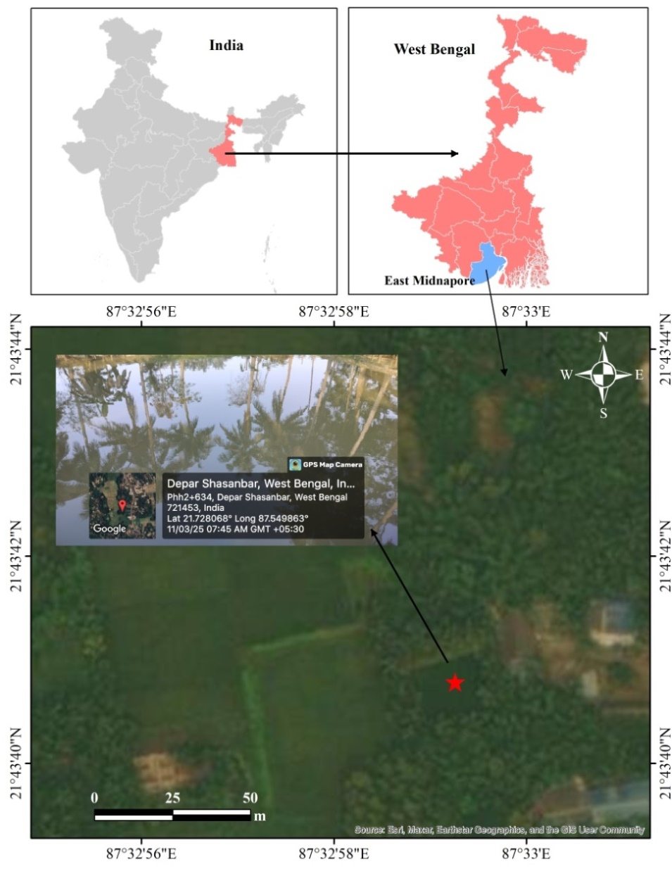The site selection is one of the most important factors that determine the success of the fish farming. Before the selection of the pond, the water holding capacity and fertility of the soil was considered to be the most crucial step in this regard as these factors influence the response to the organic and inorganic fertilization in the farming ponds. As per report by the Telegraph newspaper dated 05.1.2021 in West Bengal there are about 900 sand mines. The sand mines, are locally called as bali khadan. The bali khadan areas in Purba Medinipur district around 100 hectares. The major areas are CD-Block of Ramnagar I (about 25.08 hectare), Ramnagar - II (about 62.71 hectare), Egra - I (about 12.54 hectare) and Haldia (about 12.54 hectare). These Bali khadans are under the clutches private ownership but mining activities are regulated by the State govt. These areas after sand mining the abandoned lands are filled by rainwater and converted into ponds or Dighi. Present investigation was carried out in abandoned sand pit or bali khadan (Lat- 21.728068o and Long- 87.549863o) located at Depal under community development block of Ramnagar – II, Purba Medinipur. Total area considered for the present study was approx. 500 m2. Fig 1: Study site

**Soil and water quality assessment:**

The abandoned sand mining pond waters was unproductive as the nutrient load was poor, unsuitable for planktonic production. Therefore, the soil and water parameters of the abandoned sand mining ponds were transformed into productive ones through the periodic application of organic manures (cow dung and mohua oil cake) and continuous quality assessment. The physico-chemical characteristics of soil and water parameters were analysed in every 30 days interval to determine the variations of parameter with the change of season until the end of the experiment, following the APHA guidelines.

**RESULTS AND DISCUSSION**

**Pond bottom management:**

Most of the abandoned sand mining ponds remain unused and few of them are used as cultivable ponds, but scientific management are not there. So, if we scientifically manage them and put some efforts, covert the abandoned sand mining ponds into highly profitable cultivable fish ponds. In this study the selected pond was leased for two years. At first the sand mining pond water was completely dried up. After completely draining the pond water, bottom soil samples were collected. The organic carbon, NPK and percentage of soil particles were tested in the laboratory (Table 1). As these ponds are located in the areas where major particle of the soil is sand. So, naturally water holding capacity of the pond is poor. Cow dung was applied @100kg to increase the water holding capacity of the pond. Then Mohua Oil Cake @ 100kg and CuSO4 @ 500 gm were applied to kill the parasites, molluscs and weed fish. Lime (Cao) was applied @ 30kg to increase the pH and make the pond bottom suitable for fish culture. After that further soil samples were tested and parameters were recorded (Table 1). The soil texture (percentage of clay, silt and sand) was tested recorded both before and after the application of organic manures (Table 2).

**Table 1: Soil parameters before and after application of organic manures:**

|  |  |  |  |  |  |  |
| --- | --- | --- | --- | --- | --- | --- |
| **Soil parameters** | **Results** | | | | | |
| **Sample -1** | | **Sample-2** | | **Sample - 3** | |
| **Before** | **After** | **Before** | **After** | **Before** | **After** |
| Soil pH | 7.36 | 7.59 | 7.0 | 7.61 | 6.96 | 7.37 |
| Organic Carbon (%) | 0.03 | 0.85 | 0.06 | 1.10 | 0.09 | 1.20 |
| Available Nitrogen (mg/100gm) | 30.24 | 48.21 | 11.27 | 18.15 | 8.05 | 19.72 |
| Available Phosphate (mg/100gm) | 1.46 | 3.34 | 2.9 | 6.10 | 1.62 | 7.40 |
| Available Potassium (mg/100gm) | 1.14 | 11.92 | 2.27 | 12.39 | 1.09 | 11.46 |
| Free Calcium Carbonate (%) | 4 | 4.3 | 5 | 4.80 | 2.5 | 3.90 |
| Specific Conductivity (µS/cm) | 448 | 452 | 436 | 431 | 427 | 443 |

**Table 2: Soil texture before and after application of organic manures:**

|  |  |  |  |  |  |  |
| --- | --- | --- | --- | --- | --- | --- |
| **Soil texture** | **Results** | | | | | |
| **Sample -1** | | **Sample -2** | | **Sample -3** | |
| **Before** | **After** | **Before** | **After** | **Before** | **After** |
| Clay (%) | 1.5 | 5.8 | 2.0 | 5.5 | 1.0 | 4.0 |
| Silt (%) | 5.5 | 9.2 | 6.0 | 8.5 | 4.0 | 9.0 |
| Sand (%) | 93.0 | 85.0 | 92.0 | 86.0 | 94.0 | 87.0 |

**Water quality management:**

**Table 3: Comparison of water quality parameters between untreated and treated water**

|  |  |  |
| --- | --- | --- |
| **Experimental Details** | **Results** | |
| **Untreated (before)** | **Treated (after)** |
| pH | 7.24 | 7.15 |
| Temp (oC ) | 29.2 | 29.9 |
| Free O2 (mg/lit) | 4.3 | 5.86 |
| Free CO2 (mg/lit) | 5.55 | 4.02 |
| Alkalinity(mg/lit) | 110 | 90 |
| Total ammonia (mg/lit) | 0.48 | 0.04 |
| Nitrite (mg/lit) | 0.04 | 0.02 |

In order to get maximum production from aquaculture pond both the pond water and soil should be slightly alkaline to neutral. One of the most elements that significantly influence pond production is the soil’s hydrogen ion concentration. It affects the availability of the nutrients in the soil-water interface in addition to bacterial activity (Radheyshyam, 1988). Before treatment the soil pH was neutral to slide acidic thus lime was applied @ 30 kg to increase the pH and make the pond more familiar for culture (Fig 2).

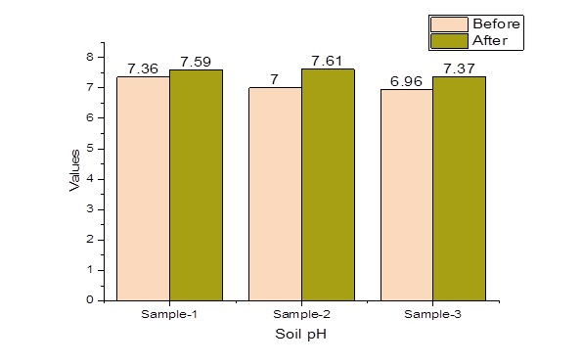

Fig 2: Comparison of soil pH before and after treatment

The majority of the organisms that live in sediment rely on the organic materials as a major source of nutrients and energy (Radheyshyam, 1988). According to Banerjea (1972) the pond sediment below 0.5% are unproductive, 0.5 to 1.5 % are productive and above 2.5% are not suitable for fish culture. The organic carbon of the pond bottom was relatively poor and unsuitable for fish culture. After the treatment of organic manures the value of soil Organic Carbon increases significantly and become suitable for fish culture (Fig 3).

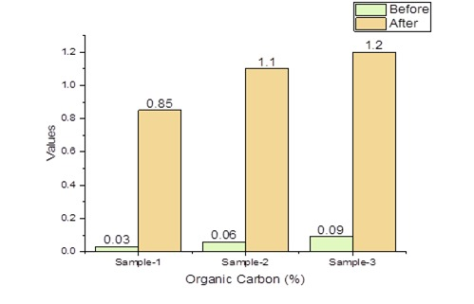

Fig 3: Comparison of soil Organic Carbon (%) before and after treatment

The optimal growth and disease resistance of fish culture pond depend upon the availability of certain elements such as Nitrogen, Phosphorus, Potassium, Calcium and Magnesium. Phosphorus and nitrogen are very important for algal growth. Phosphorus is the major nutrient for the increased level of phytoplankton in freshwater pond (Adhikari et al., 2017). The NPK values were significantly increases after the treatment of organic manures and becoming suitable for fish culture (Fig 4). The free Calcium Carbonate (%) and Specific Conductivity (Micro Siemens/cm) was relatively ideal for culture purpose and after treatment the values are more or less stable and ideal for fish culture (Fig 5 and Fig 6 respectively).

The texture of the soil is determined by the characteristics and composition of the parent materials that forms it. The exact proportion of various size fraction of the soil has a significant impact on a number of physico-chemical parameters that affect fish pond fertility. Optimum pond soil is neither too clayey to retain all of the nutrients absorbed in it nor too sandy to permit nutrient leakage. Applying large amount of organic manures is essential to prevent water seepage while building a pond on sandy soil (Adhikari et al., 2017). In this experiment after application of organic manures the percentage of clay, silt and sand considerably changes and the water holding capacity of the abandoned sand mining pond was greatly increased (Fig 7).



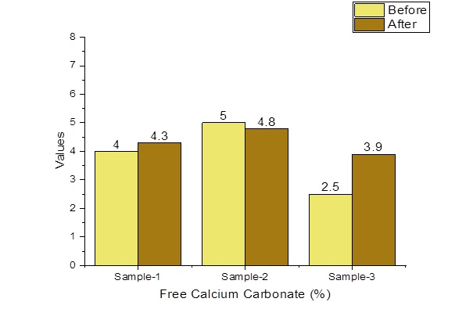

Fig 5: Comparison of free Calcium Carbonate (%) before and after treatment

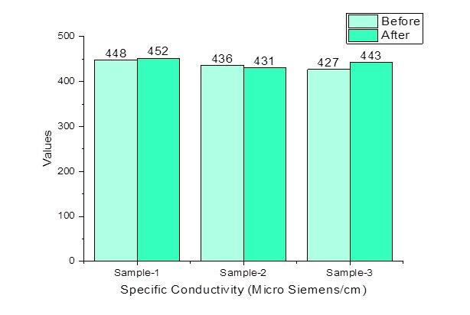

Fig 6: Comparison of Specific Conductivity (Micro Siemens/cm) before and after treatment



**CONCLUSION**

The most affordable and readily digested protein is fish, which can be farmed artificially. Maintaining ideal water quality with suitable water depth is the goal of this investigation in order to achieve the highest possible yield in the abandoned sand pit ponds. Around the world, aquaculture is considered as a lucrative business endeavour associated with agriculture. With varying degrees of success, Indian major carp and exotic carp rearing and breeding are practiced in India. Successful pond culture operation depends on maintaining a healthy aquatic environment and producing enough fish food organisms in the pond. The present study was taken up to convert over 100 ha of abandoned sand pit pond into cultivable aquaculture ponds in the district of Purba Medinipur. Thus we can produce considerable amounts of fish in near future. At the same time employment opportunity for local people can be created significantly. The local villagers may adopt this culture technique as a livelihood. A new model may be established for the aquaculture sector in these abandoned sand mining ponds or “Bali Khadan”.

**REFERENCES:**

Adhikari, S., Chakrabarti, P.P., Paul, B.N. & Sundaray, J.K. (2017). Training manual on “Nutrient management in fish culture with emphasis on soil health and carbon budget management” (11-15 December, 2017). ICAR- Central Institute of Freshwater Aquaculture, RRC, Rahara, Kolkata, West Bengal, India: pp:1- 140

Banerjea, S.M. (1972). Role of soil and water m pond fertility CIFRI Silver Jubilee Souvenir, Cent Inland Fish Res Inst, pp 56 – 62.

Bronmark, C. & Hansson, L. A., (2005). The biology of lakes and ponds, Oxford University Press, Oxford, pp 285.

Department of Fisheries, Ministry of Fisheries, Animal Husbandry & Dairying (2025). [*https://dof.gov.in/inland-fisheries*](https://dof.gov.in/inland-fisheries)*.*

Gavriletea, M.D. (2017). Environmental impacts of sand exploitation: analysis of sand market. *Sustainability* , 9(7): 118, doi: 10.3390/su9071118.

Government of Maharashtra (GoM) (2017). Inland Fishery Resources of Maharashtra: Fisheries Resources, Department of Fisheries.

Katiha, P.K. (2000). Freshwater aquaculture in India: Status, potential and constraints. In: Proceedings of the Aquaculture Development in India: Problems and Prospects Workshop (eds M. Krishnan & P.S. Birthal), pp 98–108. National Centre for Agricultural Economics and Policy Research, New Delhi.

Kumar, R.R.(2015). Carp and Pond Aquaculture. Daya Publishing House; c2015.

Pandey, A.K.(2010). Handbook on Fisheries Statistics. ICAR National Bureau of Fish Genetic Resources (NBFGR); c2010.

Radheyshyam, (1988). Physico-chemical environment, community structure and community metabolism m swamp and newly constructed ponds m swampy area Ph.D. Thesis Utkal University, VamVihar, Bhubaneswar, Orissa, 413 pp.

Rizqan, A., Mahyudin, I., Rahman, M. & Hadie, J. (2016). Status of river water quality around the sand mining area in Batang Alai River, Wawai Village, South Kalimantan. *EnviroScienteae* ,12 (1): 1-6.

Sari, D.P, & Buchori, I. (2015). The effectiveness of the post tin mining reclamation program in Merawang District, Bangka Regency. *Journal of Urban Area Development* ,11(3): 299-312.

Schandl, H., Fischer-Kowalski, M., West, J., Giljum, S., Dittrich, M., Eisenmenger, N., Geschke, A., Lieber, M., Wieland, H., Schaffartzik, A., Krausmann, F., Gierlinger, S., Hosking, K., Lenzen, M., Tanikawa, H., Miatto, A. & Fishman, T. (2018). Global material flows and resource productivity forty years of evidence. *J. Ind. Ecol*., 22 (4) (2018), pp. 827-838.

Suresh, A., Sundaray, J.K. & Rout, P. (2014). Pond Preparation and Its Importance in Aquaculture. *J Fish* , 2(3):125-132.