Stock Status of the Moonfish (Citharinus Citharus) for Management Strategies and Conservation in Oguta Lake, Imo State, Nigeria
Abstract
The fisheries stock status of Citharinus citharus in Oguta Lake was investigated from September 2023 to April 2024. Assorted fishing gears were deployed to catch fish. The standard lengths in centimeters (cm) of 32,748 specimens of C. citharus were measured. The length data were analyzed with Electronic Length Frequency II (ELEFAN II) and fitted into the Von Bertalanffy Growth Model (VBGM). The VBGM was L_{(t)} = 62.85[1 – e ^{-0.165(t – 0.87)}]. Total Mortality (Z) = 2.297yr⁻¹, Fishing Mortality (F) = 1.86yr⁻¹, Natural Mortality (M) = 0.45yr⁻¹ and Exploitation rate (E) = 0807yr⁻¹. Length at first sexual maturity (Lm) = 41.9cm. C. Citharus is experiencing overexploitation and overfishing in Oguta Lake. Conservation and Management strategies should include restrictions on the use of small mesh sizes that would reduce the catching of sexually immature individuals (of Length ≤ 41.9cm) and the closure of the fishing Season of C citharus from July to September annually.
Key words: C. citharus, Oguta Lake, Management, conservation

Introduction
Fish populations are influenced by natural control mechanisms that constantly alter their structure and numbers, as well as their life cycles, in response to various factors (Milner et al., 2003). These influences occur alongside human-induced factors such as overfishing, habitat loss, pollution, and, more recently, climate change. Stock assessments serve as a foundation for understanding shifts in fishery patterns and addressing issues like habitat degradation, predation, and optimal harvesting rates (Olopade et al., 2019). Regular stock evaluations and reference benchmarks are necessary for monitoring purposes and for assessing whether fish stocks are overfished or subject to overfishing, which aids in the development of fishery management plans (Mohamed et al., 2021). According to Kebtieneh et al. (2016), the primary aim of stock assessment is to equip decision-makers with vital information to make informed decisions regarding the ideal level of exploitation of aquatic living resources like fish. Stock assessment provides the groundwork for calculations that lead to an understanding of growth, mortality, recruitment, and other essential parameters of fish populations (Olopade et al., 2019).
Knowledge of Fisheries Stock Status, such as Recruitment (age and rate of entry into catches), growth rates, Mortality, and Exploitation rates, provides information needed in the determination of the population dynamics of a fish species. The information is utilized in formulating management strategies to improve the fishery and the conservation in that particular ecosystem. Recent Research has highlighted the importance of considering ecosystem dynamics in Fisheries management (Atal et. al., 2021). Zhang (2023) said that models are frequently employed to understand the relative impacts of various factors and predict future population trends. In Fish populations, dynamics are influenced by complex interactions of life history traits, behavior, genetics, and environmental conditions (Winemiller, 2025).
Citharinus Citharus, popularly known as the moon fish because of its oval-shaped morphology, is a freshwater Fish species in the Citharinidae Family (Skelton, 2019). It is native to Africa (Nelson, 2006) found in several Lakes and Rivers in Nigeria (Olaosebikan & Raji, 2015). It is listed in the International Union for Conservation of Nature (IUCN, 2024), Red List as least concern with serial (3:1, 182293). However, while the species as a whole is considered to be of “Least Concern”. Local population may face threats such as habitat degradation, over-fishing, or pollution, noted Froese and Pauly in FishBase (2024). Oguta Lake is the largest naturally occurring lake in South-East Nigeria (Ukagwu & Okeke, 2024.) C. Citharus is relatively abundant in the lake (Njoku, 2009). The local inhabitants cherish it as smoked fish, often used in preparing local delicacies.
Studies on C. Citharus have been done (Abdoli et. al. 2005; Kelvin, 2006; Pauly & Shaefer, 2006; Lazard, 2009; Abobi, 2012; Obirikorang et. al., 2016), but no published works on the fisheries stock assessment of C. Citharus in Oguta Lake. The aim of the study is, therefore, to investigate the fish species’ parameters in order to provide a database useful in the formulation of management strategies for the conservation and sustainability of C. citharus fishery in Oguta Lake.

Materials and Methods
Four sites within the main basin of Oguta Lake were designated as the sampling stations (Fig.1). These sampling stations were chosen because of their easy accessibility and proximity to fishing landing areas of the Lake. Assorted fishing gears with mesh sizes 1.0 to 3cm, Hooks and line, traps, and baskets were used to catch fish by professional fisher folks forthrightly from September 2023 to April 2024. This period corresponds to when there is active fishing in the lake with all available fishing gear. Catches of the Local fishmongers were regularly examined. Fishes caught were identified with the
Identification keys of Paugy (2003) and Adesulu & Sydenham (2007). The Standard Length (SL) of the samples was measured from the snout to the caudal peduncle, taken to the nearest centimeter (cm). The length Data obtained were analyzed with Electronic Length Frequency Analysis (ELEFAN II) using FISAT II (FAO–ICLARM) tools/software as explained in detail by Gayanilo et al. (2005), and fitted into Von Bertalanffy Growth Model (VBGM):
L(t) = L∞[1 – e-k(t – to)]
Where, L_{t)} = Length of fish at age, t.
L∞ = Asymptotic Length (Maximum Length the fish will attain at that particular ecosystem).
\K = growth coefficient or the growth curvature to which the fish reaches L∞.
t_{o} = theoretical time when the fish length is zero. t = age of the fish in years.
The total mortality (Z) was estimated from the length converted catch curve (Pauly,
1984). The natural Mortality (M) was also calculated using Pauly’s empirical formula (1980) incorporated in the FISAT II Software. The Fishing Mortality (F) was derived from F = Z - M. The Exploitation Rate (E) was calculated by the quotient; E = F/Z.
Relative Yield per Recruit (Y¹/R) was estimated by the model of Beverton & Holt (1966) as modified by Pauly & Soriano (1986). Following FAO (2011):
Y¹/R = 1: indicates that the fishery is operating at its maximum sustainable Yield
(MSY)
Y¹/R < 1: indicates that the fishery is not operating at its MSY and needs room for improvement.
Y¹/R > 1; is not biologically possible as it would indicate that the fishery is producing more Yield than is sustainable.
L_{c} = Length at first Capture (i.e. Recruitment) was visible at the ELEFAN II Plot. The Length at first sexual maturity (L_{m}) was computed from: Lm = 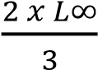(Hoggarth et. al., 2006)
𝐿𝑐
The Reproductive Load is computed from 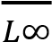 using Froese (2006):
𝐿𝑐⁄𝐿∞ < 0.5 ; indicates over-fishing as fish is being caught before they react half their maximum potential size
0.5 ≤ 𝐿𝑐⁄𝐿∞< 0.7 ; suggests moderate fishing pressure with fish being caught between half and 2/3rd of their maximum potential size.
𝐿𝑐⁄𝐿∞> 0.7 ; indicates sustainable fishery practices as fish is being caught closer to the maximum potential size.
Results and Discussion
A total number of 32,798 specimens of C. Citharus were examined ranging in size from (SL) 9 to 63cm with mean ± sd (36.5 ± 16.25cm, 95% CL). The length Data plot is shown in ELEFAN II Plot of Fig.1. The X – axis is the length classes of the fish in cm. Y – axis is the frequency or abundance of the fish in each length class. The curves represent different age group within fish population. The curves also help to determine the number of age groups present in the population as well as the shift in growth rates. In the observation, seven age groups were distinct. In Table 1 is presented the length-at-age and growth rates of C. Citharus in Oguta Lake. The fishes were growing faster at younger ages than at older ages. The growth rate between the age at 1 yr and 2 yrs is significantly different (p < 0.05), and so on is indicated on the foot-note. The length converted catch curve is shown in Fig. 3. The length catch curve was determined only for the individuals that were fully exploited. Individuals that were not fully recruited to the catches (represented as backward projected points) and groups whose lengths were close to L∞ (points on descending arm of the curve) were excluded from the regression analysis.
The VBGM for the species was
L(t) = 62.85[1 – e -0.165(t – 0.87)]
The total mortality (Z) was 2.297 yr-1. Fishing mortality (F) = 1.86yr⁻¹, Natural mortality (M) = 0.45yr⁻¹ and Exploitation rate (E) = 0.807yr⁻¹. Using the knife-edge method as shown in Fig. 4, the Exploitation maximum (Emax) = 0.80 yr-1.
Note: E_{max} helps determine the maximum quantity of fish that can be caught each year without depleting the stock. The values of the Relative Yield per Recruit (Y¹/R) were all below 0.5.
The length at first sexual maturity was computed as 41.9cm, and the Reproductive Load (𝐿𝑐⁄𝐿∞) = 0.14 yr-1. The Recruitment pattern per year is depicted in FIG.5: Indicating that the recruitment occurred throughout the year with major peaks taking place in the middle and end of the rainy season (July and September, respectively), with the lowest in December due perhaps to the Harmattan (Cold) period. The Fish spawned less during the cold period.
Evaluating the stock status of a fish is crucial for maintaining the stability of the ecosystem and ensuring long-term food security (Keddy et. al., 2010). C. citharus is a freshwater fish species that is an important resource in Oguta Lake, supporting Local Livelihoods and contributing to the regional food supply. The asymptotic length (L∞) of 62.85cm estimated in this study indicated the maximum length the fish can attain in Oguta Lake. Fishbase (2024) estimated 58cm as the maximum length, which means the fish has the propensity of growing bigger in Oguta Lake at a slow growth coefficient (k) of 0.165 yr-1. The fish lives for seven years, the same as in Sagua (2000).
The Total Mortality (Z) estimated was 2.297yr⁻¹ and fishing mortality (F) = 1.86yr⁻¹ while Natural Mortality (M) = 0.45yr⁻¹, suggesting that of the total mortality of the fish in the Lake, Natural Mortality contributes 19.59% while Fishing Mortality contribute whooping 80.97%. Fishing Mortality depicts the rate at which fish are removed from the population due to fishing activities while the Natural Mortality depicts the rate at which fish die from natural causes (diseases, debility, old age, etc).
The Exploitation rate (E) is the proportion of the Fish population that is harvested through Fishing. Fish is said to be optimally exploited when E = 0.5yr⁻¹ (Hilborn &
Walters, 2013), the Exploitation rate in the study was 0.807 yr⁻¹, which shows that C. Citharus in Oguta Lake is experiencing over-exploitation. This exploitation rate(0.807yr⁻¹) is indicative of the fact that C. Citharus is heavily exploited with the fishing effort exceeding the recommended levels (0.5yr⁻¹) for sustainable management (Hoggarth et. al., 2006).
The estimated Relative Yield per Recruit (Y¹/R) had values less than 1, which indicates that C. Citharus fishery is not operating at its maximum sustainable yield (MSY). MSY in fish is the quantity that can be harvested in a population or ecosystem without depleting the population or causing long-term harm to the ecosystem (Jamluddin et. al., 2019).
Reproductive load is a critical component of fish stock assessment as it helps ensure long-term sustainability of fish population and the ecosystem they inhabit (Morgan, 2008). In this study, the Reproductive Load (𝐿𝑐⁄𝐿∞) was 0.14 which was less than 0.5. By Froese (2006) postulation, C. Citharus was undergoing over-fishing during the period of observation, and the fish were being caught before they reached their maximum potential size. The mature adult population (spawning biomass) is depleted to a level where they no longer have the reproductive capacity to replenish themselves (not enough adults to produce young ones).

Conclusion and Recommendations
Having established that C. citharus is undergoing over-exploitation and heavy fishing in Oguta Lake using ELEFAN II and Von Bertalanffy Growth Model, the management strategies should include:
- Engaging the relevant stakeholders and informing them of the need to regulate the fishing gears and methods to minimize the capture of sexually immature individuals.
- No C. Citharus should be caught below the length of (L_{m}) = 41.9cm, which is the estimated size at the first sexual maturity.
- Seasonal Closure of Fishing of C. Citharus during the Identified Recruitment periods of July and September every year.
- Strengthen the monitoring and enforcement mechanisms to ensure compliance and prevent the collapse of C. citharus fishery.
- Government agencies, Extension workers and the non-governmental organizations should be active in disseminating of information on these management strategies to ensure C. citharus conservation status and sustainability for food security.

Table 1. Length-at-age of C. Citharus in Oguta Lake from April, 2023 to September 2024.
Age(yr) | Length (cm) | Growth rate (cm/yr)
1 | 14.11 | 11.4ª
2 | 25.51 | 9.88^{b}
3 | 35.39 | 8.20^{c}
4 | 43.59 | 6.82^{d}
5 | 50.41 | 6.98^{d}
6 | 57.39 | 2.16e
7 | 59.55 | 1.18e
8 | 60.73

Note: Value with different superscripts are significantly different (P < 0.05)

References
Abdoli, A., Kiabi, B. H. and Naderi, M. (2005). Status of the Fish Fauna in the South
Caspian basin of Iran. Zoology in the Middle East, 35(1), 57 – 65pp
Abobi, S. M. (2012). Some reproductive aspects of Citharinus Citharus in a small river flowing into the Lake Volta, Ghana. African Journal of Aquatic Science, 37(1), 51 –
57.
Adesulu, E. A. & Sydenham, D. H. J. (2007). The Freshwater Fishes and fisheries of
Nigeria. Macmillan Nigeria Publishers, Lagos, Nigeria. 397pp.
Atal, G. W., Barassa, J. E., Chemoiwa, E. J., Kaunda – Arara, B. Akoll, P and Mesembe (2021). Genetic diversity and population structure of selected lacustrine and riverine populations of African catfish ,Clarias gariepinus in Kenya. Journal of
Applied Ichthyology, 37930, 427-438
FAO (2011) Food and Agriculture Organization. Review of the state of World Marine Fishery resources. FAO Fisheries and Aquaculture Technical Paper No. 569. 334p.
ISBN: 978-92-5-107023-9.
FishBase (2024). www.fishbase.org (Retrieved 14 March 2024)
Froese, R. (2006). Cube Law, Condition factor and weight length Relationship, history, meta – analysis and recommendations. Journal of Applied Ichthyology, 22(4), 241
– 253.
Grayanilo, F. C., Sparre, P and Pauly, D. (2005). FAO – ICLARM Stock Assessment Tools II (FISAT II) User’s guide FAO computerized information series (Fisheries). No. 8, revised version, FAO, Rome 168pp.
Hilborn P. & Waters, C. J. (2013). Quantitative Fisheries stock Assessment Published by
Springer, New York NY. DOI https:Idoi.org/10.1007 eBook: ISBN 978-1-4615-3598-
0 pp XV 570
Hoggarth, D. D., Abeyabekera, S. Arthur, R., Beddington, J. F., Burn, R., Mees, C. C.,
Piling. G. M. Wakeford R and Welcomme R. L. (2006). Stock Assessment and Fishery management. A framework guide to the FMSP Stock Assessment tools.
FAO Fisheries Technical Paper No. 487, Rome, Italy, 261, pp 17.
IUCN (2024). International Union for Conservation of Nature. Red list of threatened species (Citharinus citharus. 182293.3: 1). Retrieved from www.IUCN.org 03/2024
Jamaluddin, S.A., S. Hussin, Z., Zahid, S.S.N. Khalli (2019). Estimation of Maximum Sustainable Yield (MSY) for sustainable fish catch. J. Phys. Conf. Ser.. 1366 012074 DOI: 10.1088/1742 6596/1366/1/012074.
Keddy, P. A., Fraser, L. H., Solomeshch, A. I., Junk, W. J., Campbell, D. R., Arroyo, M. T.
and Alho, C. J. (2010) Wet and Wonderful: The World’s Largest Wetlands are Conservation Priorities. Bioscience, 60(1), 39 – 51.
Kelvin, A. (2006). Some Aspects of the Reproductive Biology of Citharinus Citharus in small Lake in south eastern Nigeria. African Journal of Aquatic Science, 6(3), 78 –
82.
Lozard, J. (2009). Synopsis on biological data on Citharinus Citharus (Geoffroy Saint
Hilairs, 1827). FAO Fisheries and Aquaculture Department. PP: 178 -182.
Morgan, M. J. (2008). Integrating reproductive biology into Fisheries Management.
Marine Ecology Progress Series, 357, 291 – 302.
Kebtieneh, N.; Alemu, Y. & Tesfa, M. 2016. Stock Assessment and Estimation of Maximum Sustainable Yield for Tilapia Stock (Oreochromis niloticus) in Lake Hawassa, Ethiopia. Agric, For Fish. 5(4):97-107.
Mohamed, K.S.; Sathianandan, T.V.; Vivekanandan, E.; Kuriakose, S.; Ganga, U.; Pillai SL, et al. 2021. Application of biological and fisheries attributes to assess the vulnerability and resilience of tropical marine fish species. PLoS ONE 16(8): e0255879. https://doi.org/10.1371/journal. pone.0255879
Milner, N.J; Elliott, J.M.; Armstrong, J; Gardiner, R.; Welton, J.S. & Ladle, M. 2003. The natural control of salmon and trout populations in streams. Fisheries Res. 62:111- 125, DOI:10.1016/S0165-7836(02)00157-1
Olopade, O.A.; Dienye, H.E. & Amponsah, S.K.K. 2019. A Preliminary Study of Growth Pattern, Condition Factor and Population Structure of Sicklefin Mullet, Liza falcipinnis (Valenciennes, 1836) in the New Calabar River, Nigeria Turkish J of Sci. Techn. 14(1), 15-22.
Nelson, J.S. (2006) Fishes of the World (4 ed.) Hoboken, N.J: John Wiley & Sons. Pp 1 –
162
Njoku, D. C., Allison, M. E. and Jegede O. I. (2009). The characteristics and the morphology of Citharinus citharus (Geoffroy St. Hilaire, 1809) of Lake Oguta,
Nigeria. Animal Production Research Advances. Vol. S. NO.1 AJOL online
Obirikorang, K. A., Amisah, S., Adjei – Boateng, D., Madkour, H. A., Ofchere, F. A., and Nketiah, K. S. (2016). Accumulation of heavy metals in water, sediments and tissues of Citharinus citharus Relative to ecological factors in Lake Volta, Ghana.
African Journal of Ecology, 54(3), 235 – 243.
Olaosobikan, B, & Raji, A. (2015). Field Guide to Nigerian Freshwater Fishes p. 78.
Publication of Freshwater Fisheries Research Institute, New Bussa, Nigeria.
Paugy, D. (2003). Alestidae: In: Paugy D. Leveque, C. and Teugels, G. G. (Eds) The Fresh and Brackish water fishes of West Africa. Vol 1 p.256 – 282. Coll. Faune et flore tropicales 40. Institude recherché de development, Paris, France, Museumnational, d’histoire naturelle, Paris, France and Musee royal de l’Afrique Central, Tervaren Belgium 457pp.
Paugy, D., & Schaefer, S. A. (2007). Advances in systematics, trophic ecology and conservation of African “Citharinidae” (Characiformes). Cybium 3, (3), 295.
Pauly D (1980). On the interrelationships between natural mortality, growth performance and mean environmental temperature in 175 fish stock. Journal of Marine Science, 39(2), 175 – 192.
Pauly, D. (1984). Fish population dynamics in tropical waters: A manual for use with
Programmable calculators. ICLARM Stud. Rev., (8), 325.
Pauly, D. & Soriano, M.C. (1986). Some practical extensions to Beverton and Holt’s relative Yield for recruit model: In Maclean, J.L, Dizon, L. b., Hosillos L. V. (Eds). The First Asian Fisheries Forum, Asian Fisheries Society, Manila, Philippines. PP. 491 – 496.
Sagua, V. O. (2000). Aspects of the biology of Citharinus citharus (Pisces: Citharinidae) in
Lake Chad. Journal of Aquatic Sciences. 15(1) 33 – 40[3].
Skelton, P. (2019) Name changes and additions to the southern African Freshwater fish fauna. African Journal of Aquatic Science, 44(2), 133 – 142.
Ukagwu, J. & Okeke, P. A. (2024). Current assessment and clarification of Fishing gear and crafts deployed by fisherfolks in Oguta Lake, Nigeria. Global Journal of
Fisheries Science. Vol 2 pp 33 – 41. ISSN 2782 – 750X DOI.org/10.31248/GJF
2024.050
Winemiller, K. O. (2005). Life history strategies, population regulation and implications for fisheries management. Canadian Journal of Fisheries and Aquatic Sciences
62(4), 872 – 885
Zhang, H. (2023). Predation and habitat effects on recruitment dynamics of haddock in the North Sea. Fisheries Management and Ecology, 30(1), 76 – 89.
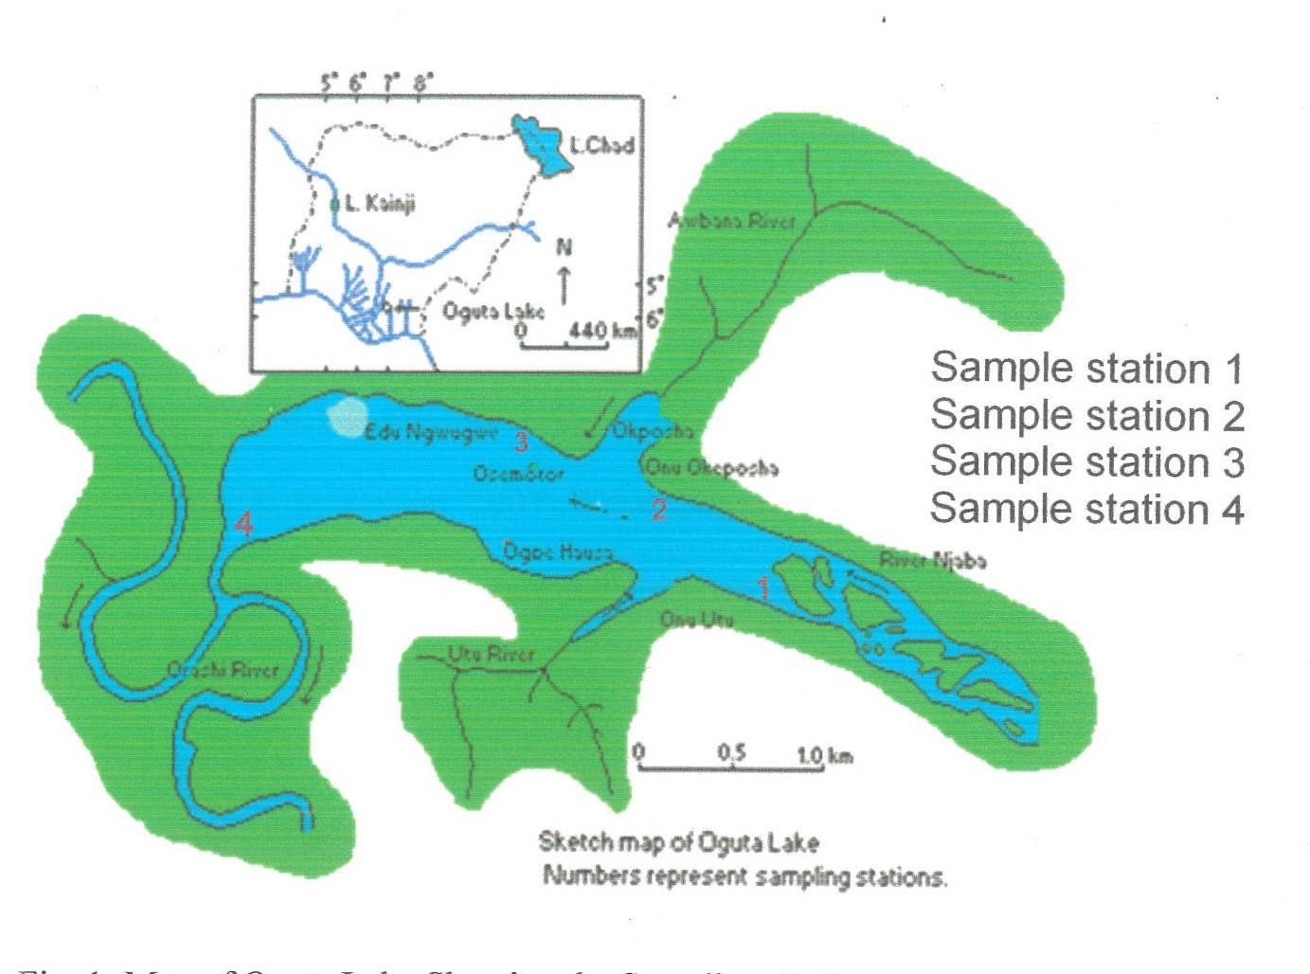
Fig 1 Map of Oguta Lake showing the sampling stations indicated with numbers (1, 2, 3,
4)
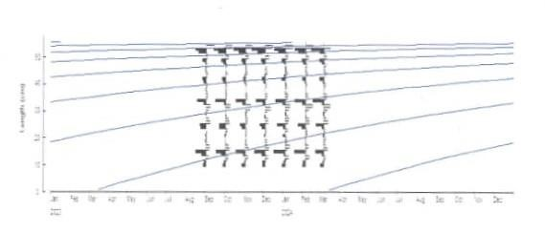

Fig 2 ELEFAN II Plot of C. citharus in Oguta Lake from September 2023 to April 2024

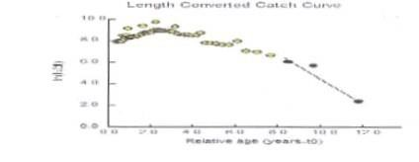
Fig 3. Length converted Catch Curve of C. citharus in Oguta Lake
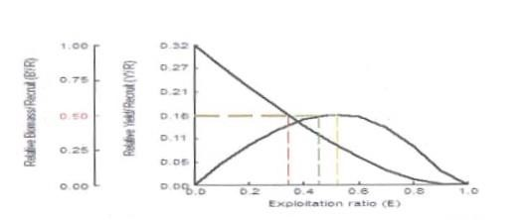
Fig 4. Stock status of C. Citharus in Oguta Lake
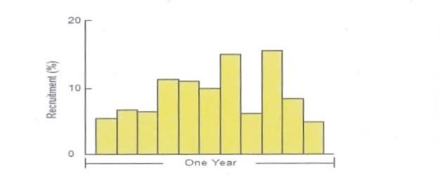
Fig 5. Recruitment rate per year of C. citharus in Oguta Lake

