Osteological variation of caudal skeleton of some barbs from Tripura

Abstract
Most barbs belong to family Cyprinidae comprising of small to medium sized fishes, distributed mostly in tropical habitats of Asian countries. Osteological study of genus Puntius (P. chola, P. sophore, P. conchonius and P. ticto) and genus Barbonymus (B. gonionotus) were studied to evaluate their caudal skeleton. The specimens were collected from different rivers of Tripura using various fishing gears like cast net, scoop net and gill net. In the present study, presence of four hypural was noticed in the upper lobe and two on the lower lobe in all the species. The morphology of hypurals exhibited variations which attribute to divide these barb species into two groups: one group where first hypural is wider, followed by fourth hypural and in other group, with wider first hypural, followed by third hypural. Lepidotricks attachment to first neural spine also exhibited some variations among the species.
Keywords: osteology, caudal skeleton, barbs, Tripura
Introduction
Tripura, with a geographical area of 10686 km ² the North-eastern hilly State of India (22 56' to 24° 22' N and 91" 0' and 92” 0’ 20'E latitude) is located in the sub-Himalayan region. Tripura has 14 rivers mostly annual in nature. Among them, the major's rivers are Gumti, Howra, khowai, Dhalai, Manu, Juri, Longai, Fenny and Muhuri rivers which drainage in Bangladesh. The state Tripura attributed with a vast diversity of fish fauna as a part of Himalayan and Indo-Burma hot spot (Gowsami et al., 2012). Several authors contributed on icthyodiversity of Tripura. Lipton (1983-84) reported 93 fish species belonging to 11 orders, 26 families and 55 genera from Tripura, while Barman (2004) recorded 129 species of fishes under 78 genera, 33 families and 11 orders. Further, Kar and Sen (2007) reported 125 species belonging to 92 genera and 41 families from different rivers (28 species from Manu River, 22 khowai, 53 Gumti, and 22 from Feni) of Tripura. Barb is the common term generally used for genus Puntius Hamilton, 1822 and Barbus (Cuvier 1817). Barbs are tropical freshwater fishes belonging to the family: Cyprinidae and inhabit mostly in tropical South and Southeast Asia (Jayaram, 1999. and Pethiyagoda et al., 2012).

Materials and methods
For osteological examinations the samples was cleared and stained following the procedure described by Dingerkus & Uhler (1977) with some modifications. Osteological terminologies and the description of osteology were mostly followed Wietzman (1962); Mo (1991) and Sanger & McCUNE (2002). Illustrations were made from images captured by a digital camera fitted to a Trinocular stereomicroscope (Leica CLS 150x). A digital X-ray image was also taken for the study of Pterygiophore insertion, counting of vertebrae and position of bones in relation to vertebral count.
Results :
Caudal skeleton of Barbonymus gonionotus
The caudal skeleton consist of uroneural (UN), six unpaired hypural (HYP1- HYP6), one unpaired parhypural (PHYP) single epural rudimentary neural arch all of cartilage bone. The last vertebrae modified into urostyle which is turned upward along with preural (PU) and 2nd preural of axial skeleton. The neural spine extending from first and second preural and support the unbranched lepidotrichs.
Neural spine (NS). The neural spine extending from first and second preural (PU2). There are two neural spine, 1st neural spine (NS1) not supported any unbranched (LEP1) lepidotrichs and 2nd (HS1) supported one.
Epural (EP). It is an elongated bone lies just above the urostyle. Anteriorly it is narrow and posteriorly wide and does not reach the posterior part of rudimentary neural arch. It was articulated with two unbranched lepidotrichs. The rudimentary neural arch anteriorly broad base and posteriorly narrow but not pointed (Fig1.A)
Uroneural(UN). One pair of small rod-like bone lies above the posterior part on either side of plurostyle and attached with two lepidotrichs.
Parhypural (PHYP). It is an elongated and broad unpaired bone which is loosely articulated to the ventral side of the urostyle. The distal end supports three branched lepidotrichs.
Hypural (HYP). Hypural are wide laterally compressed bone located between urostyle and parhypural forming broad base for the attachment of lepidotrichs. There are sixth hypural in which the hypural 1(HYP1) is the largest and hypural 6 (HYP6) is the smallest. Fourth hypural are present on upper lobe and two on the lower lobe. The anterior narrow of the first hypural is firmly attached with parhypural. The broad posterior provides attachment of three lepidotrichs. The second hypural is narrow elongated bone anteriorly attached to the urostyle and posteriorly support two branched lepidotrichs (LEP2). The third and fourth hypural loosely attached with the ventral side of urostyle. The hypural 3 (HYP3) posteriorly broad and support three branched lepidotrichs (LEP2) and hypural 4 (HYP4) is the broadest one providing attachment of three branched lepidotrich (LEP2). Hypural 5 supported two unbranched lepidotrich and hypural 6 is the smallest and rod-like structure supported one branched and one unbranched lepidotrichs. Fourth hypural is the wider followed by 3rd, 4th, 5TH and 6th. The hypural diastema between second and third is wide forming V shape, leaving a wide between them. There are nine branched rays on the upper lobe and eight on the lower lobe.
Haemal spine (HS). Spine extending from first and second preural (PU2). There are two haemal spine, first one(HS1) narrow elongated bone which is provide to attachment two unbranched lepidotrichs (LEP1). The second haemal (HS2) spine is long, wide bone which is provide to attachment two unbranched lepidotrichs (LEP1).
Caudal skeleton of Puntius chola
Neural spine (NS) - there is two neural spines which are attached 2nd and 3rd vertebrae. The first neural spine (NS1) two unbranched lepidotrichs (LEP1) and second neural spine (NS2) is supported one unbranched lepidotrichs (LEP1). First neural spine is wider than 2nd neural spine. (Fig1.B)
Uroneural (UN) – One pair of small rod-like bone lies above the posterior part on either side of plurostyle and attached with two lepidotrichs.
Epural (EP) - it is a single rod shaped bone which lies just above urostyle. The rudimentary neural arch posteriorly pointed and epural bone posteriorly narrow but not pointed, reaching beyond the posterior margin of rudimentary neural arch leaving a narrow space between and supported two unbranched lepidotrich (LEP1).
Parhypural (PHYP) – it is an elongated unpaired which loosely articulated ventral side of urostyle. Anterior part is narrow and posterior part narrow broad and supported three branched lepidotrich (LEP2) and elongated foramen present on between parhypural (PHYP) hypural (HYP1).
Hypural (HYP) - it is a wide laterally compressed bone which lies between urostyle and parhypural. There is six hypural (HYP6) among six one is smallest. Fourth hypural present on the lower lobe and two on the lower side. The anterior part is narrow first hypural firmly attached with parhypural. The broad posterior provides attachment of three branched lepidotrichs (LEP2). The second hypural elongated bone anteriorly attached the urostyle and posteriorly supported two branched lepidotrichs (LEP2). Third hypural anteriorly narrow and posterioly provide attachment three branched lepidotrichs. Fourth hypural (HYP4) supported three and Fifth hypural(HYP5) supported three branched lepidotrichs (LEP2). Six hypural (HYP6) supported two branched lepidotrichs (LEP2).
There is 17 branched ray 9 branched rays on upper side and 8 on the lower side. The first hypural is wider followed by 2nd, 3rd, 4th and 5th and 6th.
Haemal spine (HS) - there is two haemal spines which is attached on the 2nd and 3rd vertebrae. The first haemal spine (HS1) is narrow and and supported two unbranched lepidotrich (LEP1). Second haemal spine (HS) is more wider compare first one and supported three unbranched lepidotrich (LEP1).
Caudal skeleton of Puntius sophore
Neural spine (NS). The neural spine extending from first and second preural (PU2). There are two neural spine, 1st neural spine (NS1) not supported any unbranched lepidotrichs (LEP1) and 2nd (HS2) supported one.
Epural (EP). It is a single rod shaped bone which is lies just above urostyle. Posteriorly it is pointed reached up to the rudimentary arch and supported two unbranched lepidotrichs (LEP1). The rudimentary neural arch elongated bone which posteriorly pointed (Fig1.C).
Parhypural (PHYP). It is an elongated unpaired bone which loosely articulated ventral side of the urostyle. Anterior part of the parhypural is broad and supported three branched lepidotrichs (LEP2) and small elongated foramen present between parhypural (PHYP) and hypural (HYP1).
Uroneural (UN). Pair small rod like bone lies above the posterior part of either side of plurostyle and does not provide any attachment to lepidotrichs.
Hypural (HYP). It is wide laterally compressed forming broad branch of caudal skeleton. There are six hypural in which the hypural 1(HYP1) is the largest and hypural 6 (HYP6) is the smallest. Four hypural are present on the upper lobe two on the lower lobe.
First hypural is wider and anterionly narrow and articulated with parhypural and urostyle and forms one foramen between parhypural (PHYP) hypural (HYP1) and posterioly supported four branched lepidotrich (LEP2). Second hypural (HYP2) ventrally attached first hypural (HYP1) and anterioly with urostyle, it provides attachment one branched lepidotrichs (LEP2). The third hypural(HYP3) is wider anteriorly attached neurostyle and posterioly supported three branched lepidotrichs(LEP2). The hypural diastema between second and third is wide forming V, leaving a narrow gap between them. The fourth hypural (HYP4) is wider posteriorly and supported four branched lepidotrich(LEP2) but narrow anteriorly . Fifth hypural (HYP5) it provide anteriorly attachment urostyle and posteriorly supported two unbranched lepidotrich (LEP1). Sixth is smallest hypural (HYP6) usually attached urostyle and provide attachment of one branched lepidotrichs. Fourth hypural is wider followed by first, third, second, and six. There are17 branched rays which 9 on the upper lobe and 8 on the lower lobe.
Haemal spine (HS). It is extending from first and second preural (PU2). There are two haemal spine, first one(HS1) narrow elongated bone which is provide to attachment two unbranched lepidotrichs (LEP1). The second haemal spine (HS2) is long, wide bone which is provide to attachment three unbranched lepidotrichs (LEP1).
Caudal skeleton of Pethia conchonius
Neural spines (NS) - the first neural spine (NS1) is narrow elongated bone, which does not supported any unbranched lepidotrichs (LEP1). The second neural spine (NS2) is wide elongated bone which is posteriorly bifurcated. The bifurcated both each side supported one-one unbranched lepidotrich (LEP1).
Epural (EP) – it is a single rod shaped bone which lies just above the urostyle. It has posteriorly pointed end reaching beyond the posterior margin of rudimentary neural arch, leaving a narrow gap space in between. Epural supported one unbranched lepidotrichs. The rudimentary neural arch is an elongated bone with pointed posterior end. (Fig1D)
Parhypural (PHYP) - is an elongated paired bone which loosely articulated to the ventral bone which loosely articulated to the ventral side of the urostyle. parhypural and HYP I are overlapping. Paired broad posterior parhypural support three branched lepidotrichs (LEP2). Relativerly wide foramen foramen present at the base of first hypural (HYP1) plate and parhypural plate.
Hypural (HYP) - it is wide laterally compressed forming broad branch of caudal skeleton. There are six hypural (HYP6) among six hypural is smallest. Hypural present on the upper lobe two on the lower lobe. The first hypural (HYP1) anteriorly narrow and articulated with parhypural and urostyle and forms one foramen between parhypural and first hypural (HYP) and Posterioly provide attachment four branched lepidotrichs (LEP2). Second hypural ventrally attached first hypural and anterioly with urostyle, it provide attachment on two lepidotrichs. The third hypural (HYP3) wider than second anteriorly attached neurostyle and posteriorly supported two branched lepidotrich and constituted spindle shape space between second and third hypural. The fourth hypural (HYP4) is wider posteriorly and supported four branched lepidotrichs (LEP2) but narrow anteriorly and attached to urostyle. The fifth hypural (HYP5) it provides anteriorly attached urostyle and posteriorly supported two branched lepidotrichs (LEP2). Sixth hypural (HYP6) usually attached urostyle and provided attachment of one branched lepidotrichs (LEP2).
Haemal spine (HS) - there is two haemal spines which are attached on the 2nd and 3rd vertebrae. The first haemal spine (HS1) is narrow and supported two unbranched lepidotrichs (LEP1). Second haemal spine (HS) is relatively wider compare first one and supported three unbranched lepidotrichs (LEP1).
Caudal skeleton of Pethia ticto
Neural spines (NS) - the first neural spine (NS1) is narrow elongated bone, which supported one unbranched lepidotrichs (LEP1). The second neural spine (NS2) is narrow elongated bone which is supported two unbranched lepidotrich (LEP1).
Epural (EP) –it is an elongated rod shaped bone which lies above the urostyle. Posterorly is pointed not more gap up to the rudimentary arch and supported one lepidotrich (Fig1. E).
Parhypural (PHYP) – is an elongated unpaired bone which lies loosely articulated to the ventral side of the urostyle. Broad posterior parhypural supported two branched lepidotrichs (LEP2).
Hypural (HYP) - it is wide laterally compressed forming broad base of attachment branch of branched lepidotrichs of caudal skeleton. There are sixth hypural (HYP6) amongst which six is smallest. Fourth hypural (HYP4) present on the upper lobe and two on the lower lobe. First hypural (HYP1) is wider followed by 3rd, 4th, 2nd, 5th, and six. The first hypural (HYP) is anteriorly narrow but posterior wider and articulated with Parhypural and urostyle and form one foramen between parhypural and first hypural (HYP1). It supported three branched lepidotrichs. The second hypural (HYP2) ventrally attached first hypural (HYP1) and anteriorly with urostyle, its provide attachment two branched lepidotrich. The third hypural (HYP3). Posterioly wider and supported three branched lepidotrichs. There is wider elongated space between 2nd and 3rd hypural and posteriorly wider. The fourth hypural is wider posteriorly and supported three branched lepidotrichs and anteriorly attached with urostyle.
Fifth hypural posteriorly supported two branched lepidotrichs and six hypural also supported two branched lepidotrichs.
Neural spine-(NS) two neural spines supported to the lepidotrichs. The two haemal spine which is attached 1st and 3rd vertebrae. First haemal spine is wider than second and supported two lepidotrichs but second hypural supported three lepidotrichs.
Caudal skeleton of Systomus sarana
Neural spine (NS) - two neural spine first one (NS1) is wider compare second neural spine and supported one unbranched lepidotrichs. The second spine (NS2) is narrow elongated bone which lies provide to attachment two unbranched lepidotrichs.
Epural (EP) - it is a single rod shaped bone which lies just above the urostyle. It has posteriorly pointed end reaching beyond the posterior margin of rudimentary neural arch (RNA), leaving a wide space in between. Epural supported two unbranched lepidotrich (LEP1) Rudimentary neural arch it is an elongated bone with narrow pointed posterior end.
Uroneural (UNU) – A pair of small rod like bone lies over the distal end on either side of pleurostyle (Fig1.F)
Parhypural (PHYP) - it is a parhyoural is long, broad bone which is attached to the ventral side of pleurostyle. The Broad distal end of the parhypural supports three branched lepidotrichs(LEP2). On the dorsal basal side relatively larger foramen is formed by the between parhypural and HYP I.
Hypural (HYP) - it is a wide laterally compressed forming broad base of attachment branch of branched lepidotrichs of caudal skeleton. There are six hypural (HYP6) among which six is smallest. Fourth hypural (HYP4) present on the upper lobe and two on the lower lobe. First and fourth hypural (HYP1, HYP2) are broad posteriorly followed by 2nd, 3rd, 5th, and 6th. First hypural (HYP1) provides attachment of three branched lepidotrichs (LEP2) whereas second hypural (HYP2) two lepidotrichs. The 3rd, 4th and 5th, hypural are attaching three branched lepidotrichs on each side. Sixth hypural (HYP6) provides to attachement two branched lepidotrichs. There is narrow elongated space between 2nd and 3rd hypural which is closed posteriorly.
Haemal spine (HS) - the two haemal spine which is attached 1st and 3rd vertebrates. The first haemal (HS2) spine posteriorly wide and supported three unbranched lepidotrich (LEP1) The second haemal spine is narrow elongated bone which supported two unbranched lepidotrichs(LEP1).
Vertebral counts and insertion of pterygiophore of dorsal and anal fins in relation to vertebrae.
Axial skeleton and unpaired fins of B. gonionotus
The number of vertebrae and arrangement of fins with respect to vertebrae has been studied. The axial skeleton of B. gonionotus comprise of 28 vertebrae excluding complex vertebrae (Fig.1A). The number of abdominal and pre caudal vertebrae is 11+17. The first pterygiophore is inserted between fourth and fifth interneural space. The first pterygiophore of anal fin is insert0ed between 16 and 17 haemal spine.
4. 2. Axial skeleton and unpaired fins of P. Sophore
The axial skeleton of P. sophore comprise of 26-27 vertebrae excluding complex vertebrae (Fig.1C). The number of abdominal and pre caudal vertebrae is 11+16. The first pterygiophore is inserted between fifth and six interneural spaces. The first pterygiophore of anal fin is inserted between 13 and 14 haemal space ( Fig.1B).
Axial skeleton and unpaired fins of P. chola
The axial skeleton P. chola comprise of 27 vertebrae excluding complex vertebrae (Fig.1B). The number of abdominal and pre caudal vertebrae is 12-15. The first pterygiophore is inserted between fourth and fifth interneural space. The first pterygiophore of anal fin is inserted between 13 and 14 haemal space.
Axial skeleton and unpaired fins of P. conchonius
The axial skeleton of P. sophore comprise of 26 vertebrae excluding complex vertebrae (Fig.2D). The number of abdominal and pre caudal vertebrae is 11+25. The first pterygiophore is inserted between fourth and fifth interneural space. The first pterygiophore of anal fin is inserted between 14 and 15 haemal space.

Axial skeleton and unpaired fins of P. ticto
The skeleton of P. ticto comprise of 26 vertebrae excluding complex vertebrae (Fig.2E). The number of abdominal and pre caudal vertebrae is 10+16. The first pterygiophore is inserted between fifth and six interneural spaces. The first pterygiophore of anal fin is inserted between 14 and 15 haemal space.
Axial skeleton and unpaired fins of S. sarana
The axial skeleton of S. sarana comprise of 30-31 vertebrae excluding complex vertebrae (Fig.2F). The number of abdominal and pre caudal vertebrae is 12+18. The first pterygiophore is inserted between six and seventh interneural spaces. The first pterygiophore of anal fin is inserted between 17and 18 haemal space.

Discussion
Caudal skeleton plays an important role in systematic of teleost fishes, particularly in depicting phylogenetic information at different taxonomic level (Johnson and Patterson, 1996; Arratia, 1983). The Presence of four hypural in the upper lobe of the caudal fin is typical of cyprinids (Buhan, 1972) individual with three hypural can often also be found in the population (Buhan, 1972 and Eastman, 1980). In the present study, presence of four hypural in six species of Puntius has been noticed in the upper lobe and two on the lower lobe in all the six species as such supported the view of aforesaid workers. Further, Shantakumar and Vishwanath (2006) and Irfan and Gunawickrama (2011) reported six hypurals in S. sarana. Kotalawala and Jinadasa (1991) opined that cyprinids with six hypurals is considered to be primitive as such present revealed that these fishes are primitive. The morphology of hypurals exhibited variations based on this present fish species can be divided into two groups: one group where first hypural is wider followed by fourth hypural and in other group followed by third hypural. First neural spine in B. gonionotus, P. sophore and P. conchonius does not support any unbranched lepidotrichs while in P. ticto and S. sarana it supported one unbranched lepidotrich. Unlike in other species the first neural spine in P. chola supported two unbranched lepidotrichs. Eastman (1980) reported the bifurcation of neural spine is the characteristic of cyprinid fishes which tally with the finding in Pethia conchonius. A similar finding has been reported by Sanger and McCune (2002) in Danio species. The first neural spine also exhibited differences from rest of the species studied here as it is wider in B. gonionotus. Second neural spine in the B. gonionotus, P. sophore supported one unbranched lepidotrichs while in P. sophore, P, ticto and S. sarana, supported two unbranched lepidotrichs which is considered to be an important character to recognise this species from others. Hypural diastema also exhibited differences at generic level as at distal end the gap is wider in B. gonionotus. The number of lepidotrichs supported by different hypural is also species-specific character, which showed remarkable variation between the species. The first hypural supported four branched lepidotrichs in P. sophore and P. conchonius while other species it supported three branched lepidotrichs. The Second hypural supported one branched lepidotrichs in Puntius sophore while in all other species it supported two branched lepidotrichs. The third hypural supported three branched lepidotrichs in all the species except P. conchonius where it supported two branched lepidotrichs. Further, third hypural showed differences in its width as such diagnosed B. gonionotus from other species. Fourth hypural provided attachment to four branched lepidotrichs in P. sophore and P. conchonius while in all other species it supported three branched lepidotrichs. Further, Fifth hypural supported three branched lepidotrichs in P. chola and S. sarana while in all other species it supported two branched lepidotrichs. Six hypural provide attachment to one branched and one unbranched lepidotrichs in P. ticto while in P. chola and S. sarana it supported two unbranched lepidotrichs. In all other species it supported one unbranched lepidotrichs. The morphology of epural and rudimentary neural arch also exhibited species specific variations and followed the view of Sanger and McCune (2002). The size of Parhypural foramen exhibited species specific variation. Irfan and Gurawickrama (2011) reported that in S. sarana the variation is size of parhypural foramen is not related with fish size.
Conclusion
Based on osteological study, the number of vertebrae except for fused vertebrae also indicated generic variation specially for separating B. gonionotus and Systomus sarana from the rest of species species. B. gonionotus , P sophore and P Conchonius can be separated from P. Ticto and S. sarana based on thee number of lepidotrichs attached on the neural spine. B. gonionotus , P Conchonius and can be Puntius chola separated from P. ticto, and Puntius sophore based on the insertion of dorsal first Pteryiophore, anal fin Pterygiophore was also found significant for distinguishing of all the species studied. The morphology of caudal skeleton exhibited variation between the present study fish species. Character which are consider for separating either at generic or specific level include that of hypural dastema, shape of different hypural and thenumber of lepidotrich supported, size of parahypural foramen, overlapping gap between the rudimentary neural arch and epural ,shape and size of epural as well as rudimentary neural arch and bifurcation of neural spine which was observed in P. Conchonius.
On this finding, it is concluded that the osteological trait of the studied barbs would provide important taxonomic tools in the hands of taxonomist to identify and resolve the existing ambiguity between these fishes.

A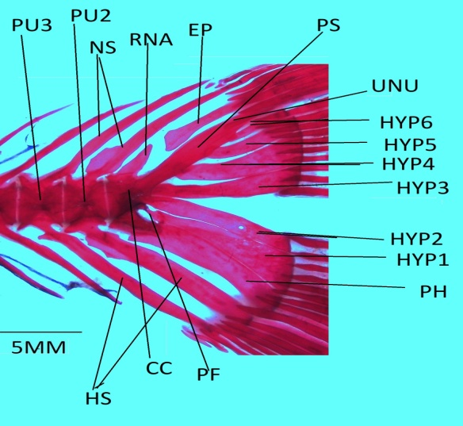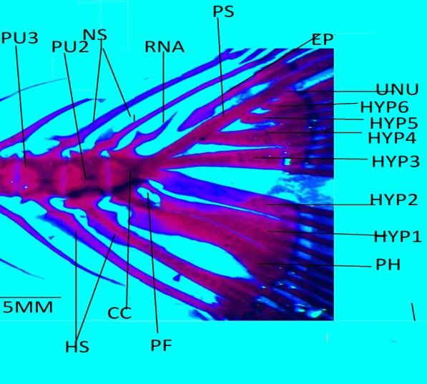B
C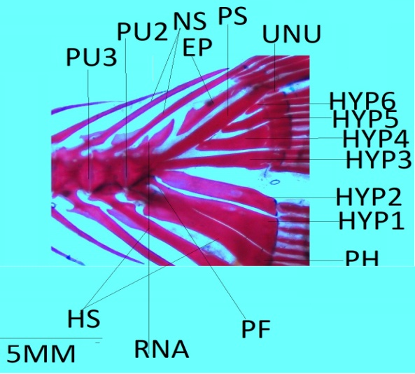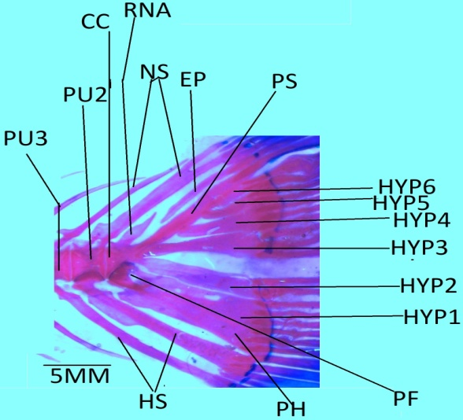D
EF
Fig.1 A Barbonymus gonionotus, B. Puntius chola. C. Puntius Sophore, D. Pethia conchonius, E. Pethia ticto, F. Systomus sarana.
A
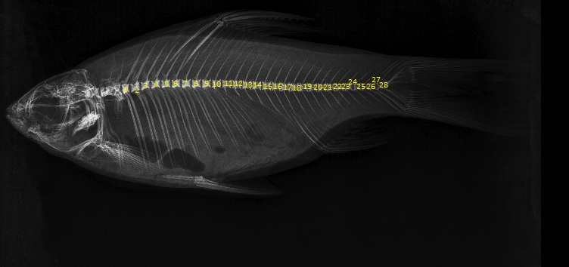
A
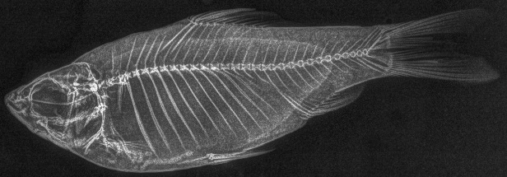
B
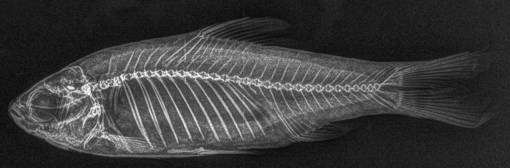
C
Fig. 2: X-ray images: A) B. gonionotus, B) P. chola, C) P. sophore.
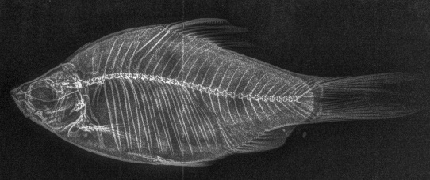
D
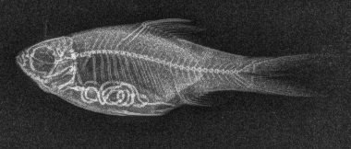
E
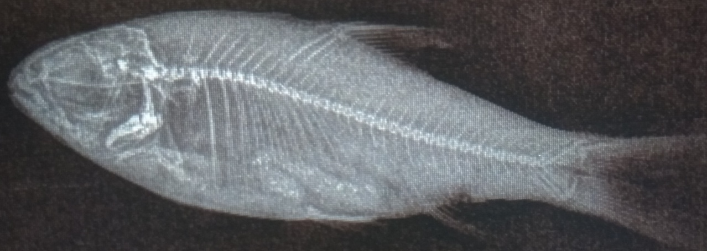
F
Fig. 3: X-ray images: D). P. conchonius, E). P. ticto, F). S. sarana.

Reference

Arratia, G. (1983). The caudal skeleton of ostariophysan fishes (Teleostei): intraspecific variation in Trichomycteridae (Siluriformes). J. Morphol., 177(2), 213-229.
Buhan, P.J. (1972). The comparative osteology of the caudal skeleton of some North American minnows (Cyprinidae). American Midland Naturalist, 88(2): 484-490.
Dingerkus, G. and Uhler, L.D. (1977). Enzyme clearing of alcian blue stained whole small vertebrates for demonstration of cartilage. Stain. Technol., 52(4): 229-232.
Eastman, J.T. (1980). The caudal skeletons of Catostomid fishes. Am. Midl. Nat., 103(1): 133-148.
Goswami, U.C., Basistha, S.K., Bora, D., Shyamkumar, K., Saikia, B. and Changsan, K. (2012). Fish diversity of North East India, inclusive of the Himalayan and Indo Burma biodiversity hotspots zones: A checklist on their taxonomic status, economic importance, geographical distribution, present status and prevailing threats. Int. J. Biodivers. Conserv., 4(15): 592-613.
Hamilton, F.,(1822). An account of the fishes found in the river Ganges and its branches. Edinburgh. p 405..
Irfan FI, Gunawickrama KBS. (2011) Osteological variation of the olive barb Puntius sarana (Cyprinidae) in Sri Lanka. J Natl Sci Found., 39(2):121-128.
Jayaram, K.C. (1991). Revision of the genus Puntius Hamilton from Indian region. Rec. Sur. India, 135: 178.
Jayaram, K.C. (1999). The freshwater fishes of the Indian region, 1st edn. Narendra Publishing House, Delhi, p. 551.
Jayaram, K.C. (2010). The freshwater fishes of the Indian region, 2nd edn. Narendra Publishing House, Delhi, pp. 1-616..
Jinadasa, J. & Kotalawala, A.B. (1991). Interrelationships among the species of the genus Puntius (Teleostei, Cyprinidae) as indicated by the caudal skeletons. VJS 3(1): 99-107.
Johnson, G. D. and Patterson, C. (1996). Relationships of lower euteleostean fishes. ln: Stiassny, M.L.J., Parenti, L.R. and Johnson, G.D., (eds.): Interrelationships of fishes. San Diego: Academic Press, pp. 251-332.
Kar, D. and Sen, N. (2007). Systematic list and distribution of fishes in Mizoram, Tripura and Barak drainage of North Eastern India. Zoo’s print journal, 22(3): 2599-2607.
Katwate, U., Paingankar, M. S., Raghavan, R. and Dahanukar, N. (2014). Pethia longicauda, a new species of barb (Teleostei: Cyprinidae) from the northern Western Ghats, India. Zootaxa, 3846(2): 235-248.
Katwate, U., Paingankar, M.S., Jadhav, S. and Dahanukar, N. (2013). Phylogenetic position and osteology of Pethia setnai (Chhapgar and Sane, 1992), an endemic barb (Teleostei: Cyprinidae) of the Western Ghats, India, with notes on its distribution and threats. Journal of Threatened Taxa, 5(17): 5214-5227.
Kotalawala, A.B. and Jinadasa, J. (1991). Interrelationships among genera of cyprinidae (teleosten as indicated by the caudal skelton). Vidyodaya J. Sci., 3(2): 47-59.
Kottelat, M. (2013). The Fishes of the Inland Waters of Southeast Asia. Raffles Bull. Zool., 27: 1-663.
Kottelat, M. and Pethiyagoda, R. (1989). Puntius asoka, a new species of cyprinid fish from Sri Lanka. Aquarium Terrarium and Zeitschrift, 8: 472-475.
Lipton, A.P. (1983-84). Fish fauna of Tripura. Matsya, 9-10: 110-118.
Mo, T. (1991). Anatomy, relationships and systematics of the Bagridae (Teleostei: Siluroidei) with a hypothesis of siluroid phylogeny, Koeltz Scientific books, p.216.
Muzaddadi, A. U. And Basu, S. (2012). Shidal – a traditional fermented Fishery product of North east India. Indian Journal of Traditional Knowledge, 11 (2): 323- 328.
Nasri, M., Eagderi, S. and Farahmand, H. (2016). Descriptive and comparative osteology of Bighead Lotak, Cyprinion milesi (Cyprinidae: Cypriniformes) from southeastern Iran. Vertebr. Zool., 66(3): 251-260.
Pethiyagoda, R., Meegaskumbura, M. and Maduwage, K., (2012). A synopsis of the South Asian fishes referred to Puntius (Pisces: Cyprinidae). Ichthyol. Explor. Freshw., 23(1): 69-95.

Talwar, P.K. and Jhingran, A.G. (1991). Inland Fishes of India and Adjacent Countries. Vol. 1, Oxford and IBH Publishing Co. Pvt. Ltd., New Delhi and Calcutta, pp. 250-295.
W. Vishwanath and K. D. Shanta. (2005). “A new fish species of the genus Garra Hamilton-Buchanan (Cypriniformes: Cyprinidae) fromManipur, India,” Journal of the Bombay Natural History Society, vol. 102, no. 1, pp. 86–88.
Wake, M. H. (1979). Hyman's Comparative vertebrate anatomy. Chicago: University of Chicago Press, 788.
Weitzman, S.H. (1962). The osteology of Brycon meeki: A generalized Characid fish, with an osteological definition of the family, Stanford University, Division of Systematic Biology, p.77.

