Habitat-Specific Assessment of Butterflies from Buxa Tiger Reserve, West Bengal, India

Abstract
Butterflies serve as vital indicators of ecosystem health, and their diversity is crucial for maintaining ecological balance. The current study was conducted in the Buxa Tiger Reserve, West Bengal, from October 27 to 29, 2024, and recorded 70 butterfly species across six families, highlighting distinct microhabitat preferences among Lepidoptera. The findings revealed that forest microhabitat harbor the highest species richness, with 53 recorded species. Result also showed that riverside microhabitat was more diverse than streamside microhabitat. Notably, approximately 11% of the documented species are legally protected under the Wildlife Protection Act (1972) of India, emphasizing the ecological significance and conservation value of the reserve. Diversity indices, including Simpson's index, Margalef's index, and the Shannon-Wiener index, were used to calculate diversity. This study underscores the importance of microhabitat conservation for maintaining butterfly diversity, emphasizing the need for targeted protection efforts to preserve these ecosystems.
Keywords: Butterfly diversity, microhabitat conservation, Buxa Tiger Reserve, ecosystem health, Wildlife Protection Act.

Introduction
Butterflies are the integral part of the ecosystem and maintain ecological balance worldwide (Saraf and Vijaykumar 2020). As herbivores, pollinators, and prey, they weave themselves into the intricate web of life, influencing both flora and fauna. Their role in pollination supports plant reproduction, while their presence sustains predator populations, creating a delicate ecological harmony (Ghazanfar et al., 2016).
Beyond their ecological functions, butterflies serve as sensitive indicators of environmental health (Thomas, 2005). Their presence or alarming absence signals the shifts in habitat conditions, making them valuable biological markers for conservation efforts (Warren et al., 2021). However, despite their significance, butterfly populations are under increasing threat. Habitat destruction, climate change, and human activities have led to alarming declines, raising concerns about the cascading effects on biodiversity (Chowdhury et al., 2023; Gordon and Kerr, 2022; Hill et al., 2021).
India, with its remarkable diversity of 1434 butterfly species (Kunte, 2025), including 129 endemics (Sidhu, 2023), stands as a crucial region for butterfly conservation. Yet, the vast North East remains to be explored and documented (Chandra et al., 2021). As these vibrant insects flutter across diverse landscapes from scorching deserts to mist-laden forests—understanding their distribution, ecology, and conservation needs becomes ever more vital (Kehimkar, 2016).
The Buxa Tiger Reserve, located in the Himalayan foothills of West Bengal, is a biodiversity hotspot that remains understudied. Previous reports suggest the presence of 408 butterfly species in the reserve (Buxa Tiger Conservation Foundation, 2020; Chakraborty et al., 2023; Das et al., 2024). However, a microhabitat specific comprehensive survey of butterfly species is still needed to empower the conservation planning of the reserve.
This study aims to a systematic survey and document the butterfly species in the Buxa Tiger Reserve, focusing on their diversity, distribution, and abundance in varied microhabitats. We believe, the study will contribute to our understanding of the butterfly fauna in different microhabitats of the reserve and would provide insights into the conservation status of these species.
Study Area
We selected Buxa Tiger Reserve of West Bengal for the present study, which took place between 27 and 29 October of 2024 (Figure 1). In this study, microhabitat specific butterfly monitoring was performed. Three distinct, dominant microhabitats—forest, streamside, and riverside were selected for this butterfly assessment.
Our selected forest microhabitat (26.757693, 89.588034) is a unique ecological zone characterized by dense, moist tropical forest interspersed with rare patches of grass cover and bamboo groves. Located at an elevation of around 1000 meters, this microhabitat experiences a subtropical climate with heavy monsoonal rainfall, resulting in a lush, multi-layered canopy. One of the significant features of this microhabitat is the dense undergrowth, composed of various small trees, shrubs, herbs, grasses, and ferns. Notably, there was no water source present beside or adjacent to the transect route fixed within the forest microhabitat.
The selected streamside microhabitat (26.762804 & 89.592669) was covered with dense vegetation, including shrubs, herbs, long grasses, and creepers. A significant feature of the transect route laid here was the presence of several narrow, slow-flowing streams, with many sections of the route remaining muddy—creating ideal conditions for mud-puddling activities. The area, located at an elevation of around 1000 meters, also contained medium to small-sized boulders, shaped by the strong water flow during the monsoon season. Throughout the transect, shrubs and herbs were dominant at ground level, while a high canopy towered above, providing a rich and diverse microhabitat for various species.
In the selected riverside microhabitat (26.752468, 89.601531), the Katlum River flowed through the area. Along the trail, several narrow streams joined the main river. At around 800 meters’ elevation, the riverside was characterized by tall bamboo-like grasses along the transect route. The trail ran parallel to the river, where the riverside was covered with pebbles and boulders of various sizes. Fine sand was observed only near the river’s edge, where the treeline began. Beside the river, slow water flows were seen seeping from mountain cracks, creating wet rock surfaces rich in minerals—ideal conditions for butterfly puddling activities. Very few plants were present directly on the riverbank due to the rocky substrate. However, beyond the riverbank where the sandy area began, diverse vegetation flourished. This zone supported short-height flora, contributing to the microhabitat's varied plant structure.
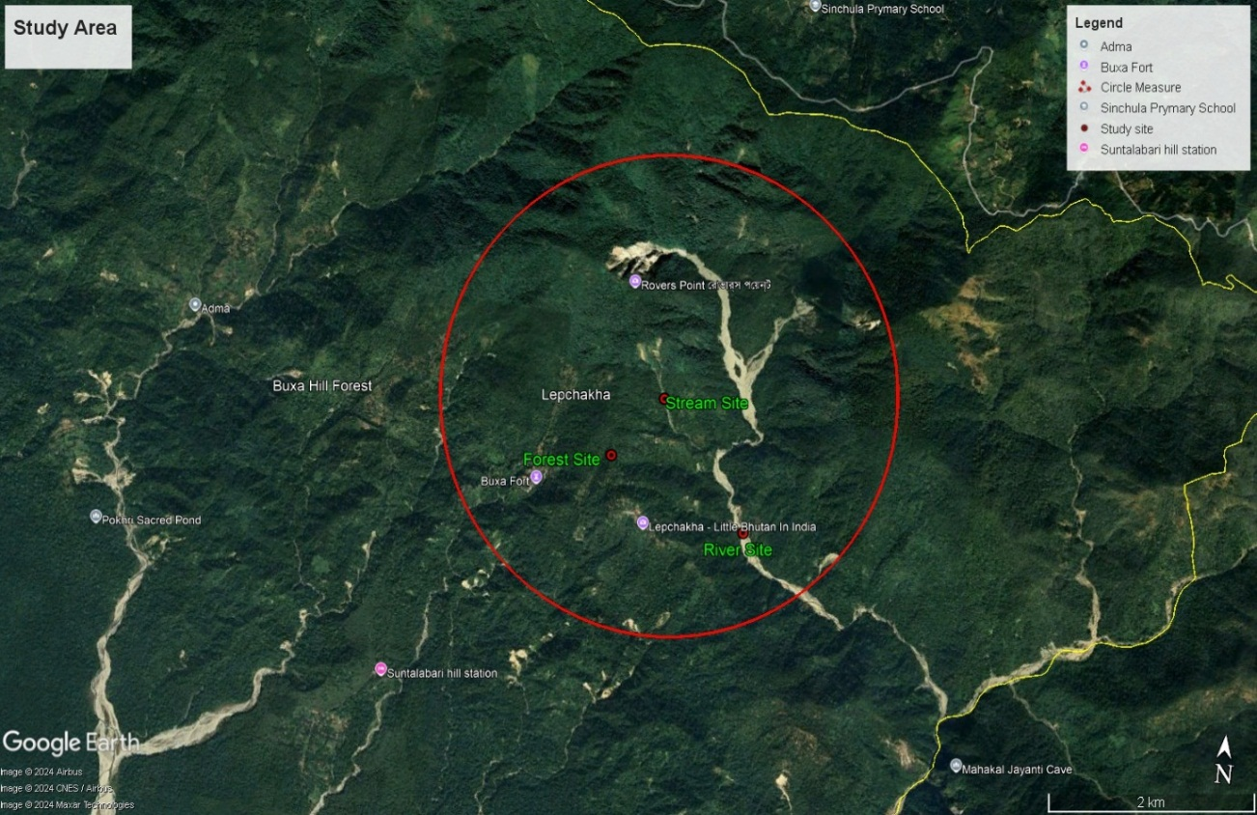
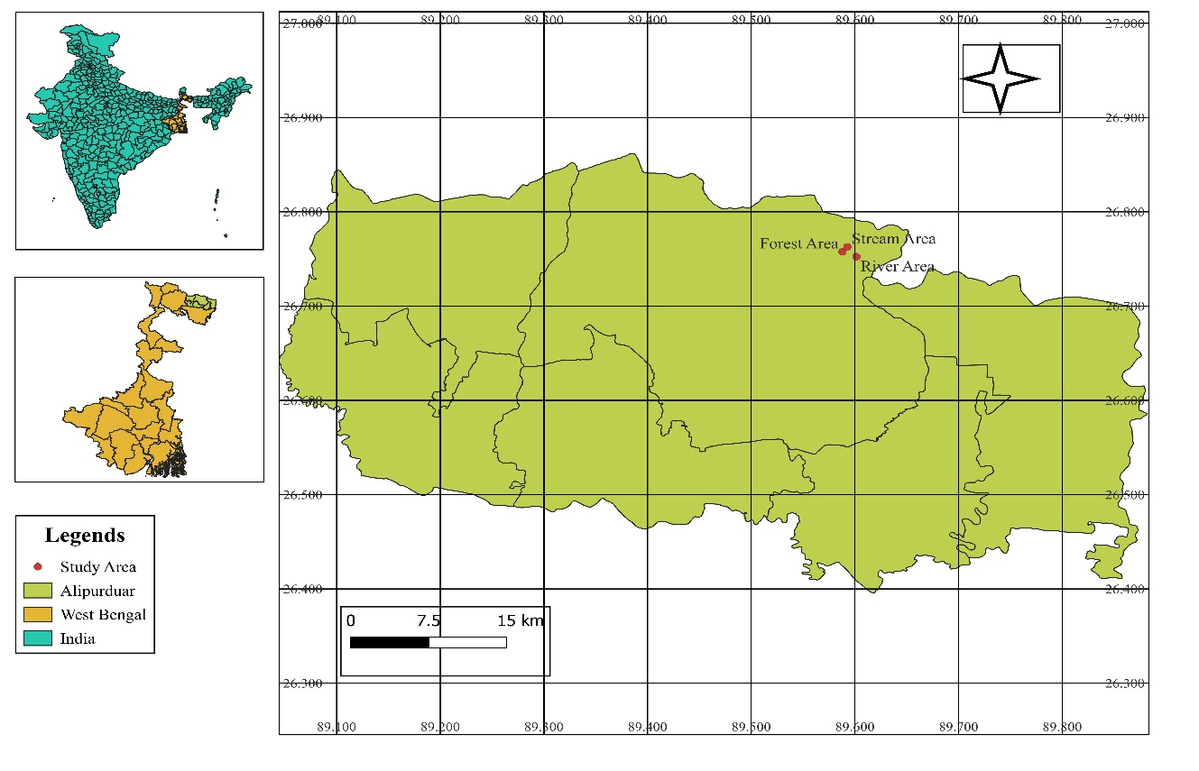
Figure 1. Map of the Study Area.
Study Methods
We performed a daylong fieldwork between 8:00 am and 3:00 pm, for getting better diversity of butterflies. In every microhabitat specific, 500 meter transect routes were selected. We spent a full day in every microhabitat, and butterflies were observed haphazardly along the fixed route. In this butterfly study, we tried to document every observed species. But we were unable to photograph some of them due to natural hindrance, and descriptions of those species were written in field notes. Butterflies were identified using authentic literature (Kehimkar, 2016). In this study, no butterflies were collected.
Analysis Methods
To understand the community structure of butterflies in the study area, we have used and analysed diverse Biodiversity indices. The analysis was performed using Microsoft Excel 2019 and PAST software (Hammer and Harper, 2001). The study site was mapped using GPS, employing Google Earth Pro and QGIS software. Species richness, abundance, and evenness were evaluated using different indices.
Species richness was analysed using the Shannon index (Shannon and Weaver, 1963), an important information-statistic index that measures species richness in a community. This index takes into account rare species with few individuals, providing a more comprehensive understanding of biodiversity. The Shannon index is calculated using the equation: HS = -∑ pi ln pi, where HS is the value of the Shannon index and pi is the proportion of the ith species in the community.
Species abundance was analysed using Simpson's index (Simpson, 1964), which measures the probability that two individuals randomly selected from a community will belong to the same species. Simpson's index was calculated using the equation: λ = ∑ pi^2, where λ is the value of Simpson's index and pi is the proportion of the ith species in the community.
Species evenness, which denotes how close the species are in a community numerically, was analysed using Pielou's index (Pielou, 1969). This index indicates the degree of species diversity and evenness of their distribution within the community. Pielou's index is calculated using the equation: E = HS / Hmax, where E is the evenness, HS is the value of the Shannon index, and Hmax is equal to ln(s), where S is the number of species in the community.
Results
This study recorded a total of 70 butterfly species across 6 families in Buxa Tiger Reserve (Table 1 and Plate 1-2). Our study recorded 1 species listed under Schedule I, 6 under Schedule II, and 1 under Schedule IV of the Wildlife Protection Act (Table 1). Species composition varied across different microhabitats. The forest microhabitat supported the highest diversity, with 7 species of Hesperiidae, 5 species of Lycaenidae, 23 species of Nymphalidae, 8 species of Papilionidae, 8 species of Pieridae, and 2 species of Riodinidae. The streamside microhabitat hosted 2 species of Hesperiidae, 3 species of Lycaenidae, 12 species of Nymphalidae, and 3 species of Papilionidae. In contrast, the Riverside microhabitat contained 6 species of Lycaenidae, 9 species of Nymphalidae, 4 species of Papilionidae, and 4 species of Pieridae. The dominant family was Nymphalidae, accounting for 43% of the total species, followed by Lycaenidae (14%), Papilionidae (14%), Pieridae (13%), Hesperiidae (13%), and Riodinidae (3%) (Figure 2-A). The majority of species (53) were found in the forest microhabitat, followed by the river microhabitat (23 species) and the stream microhabitat (20 species) (Figure 2-B).
The species individual rarefaction curve for the study site revealed a steady increase in the number of taxa (S) with the accumulation of specimens (Figure 3-A). The Shannon diversity index (H) also showed a steady increase with the accumulation of specimens, indicating a high level of diversity in the butterfly community (Figure 3-B). The exponential form of the Shannon index (H') showed a similar trend, further emphasizing the high diversity of the butterfly community (Figure 3-C). The Simpson diversity index (1/D) showed a gradual increase with the accumulation of specimens (Figure 3-D). Overall, the rarefaction curves suggest that the study site harbours a diverse and complex butterfly community.
The alpha diversity of butterfly species was analysed across three microhabitat types including Forest, Stream, and River (Figure 4). The Forest microhabitat had the highest number of family taxa (6) and individuals (53), followed by the River microhabitat with 4 family taxa and 23 individuals, and the Stream microhabitat with 4 family taxa and 20 individuals. The dominance index (D) was lowest in the Forest microhabitat (0.2617), indicating a more even distribution of species. The Stream microhabitat had the highest dominance index (0.415), suggesting a more uneven distribution of species. The Simpson diversity index (1/D) was highest in the Forest microhabitat (0.7383), indicating a higher diversity of species. The Shannon diversity index (H) was also highest in the Forest microhabitat (1.547), followed by the River microhabitat (1.326) and the Stream microhabitat (1.106). The evenness index (e^H/S) was highest in the River microhabitat (0.9416), indicating a more even distribution of species. Other diversity indices, such as Brillouin, Menhinick, Margalef, Equitability (J), Fisher-alpha, Berger-Parker, and Chao-1, also showed variations across the three microhabitat types. Overall, the results suggest that the Forest microhabitat has the highest diversity and evenness of butterfly species, followed by the River and Stream microhabitats (Table 2).
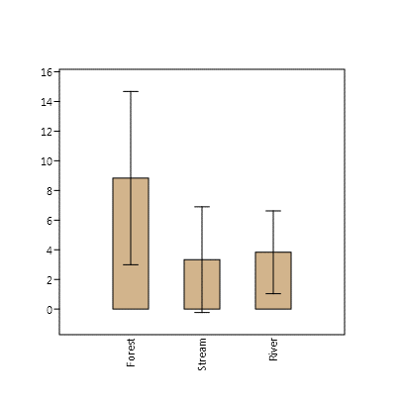
B
A

Figure 2. A. Abundance of butterfly Families and B. Microhabitat wise abundance of butterfly species in study area.
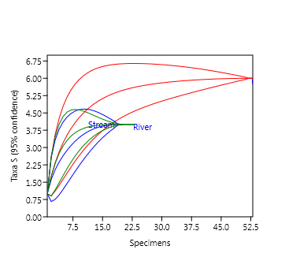
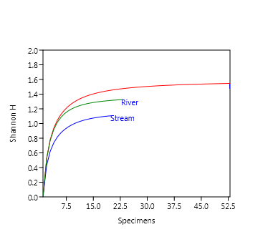
A
B

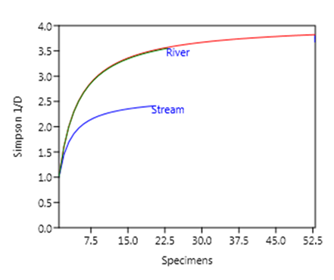
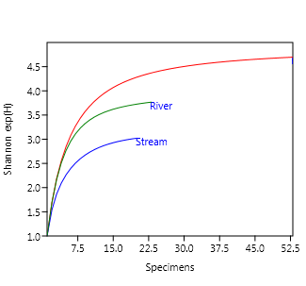
D
C

Figure 3. Species individual rarefaction curve for study site: A. Taxa (S) vs specimens, B. Shannon (H) vs specimens, C. Shannon exp (H) vs specimens, D. Simpson (1/D) vs specimens.
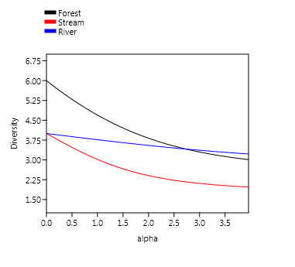

Figure 4. Microhabitat types-wise alpha diversity Profile of butterfly species in the study area.

Discussion
Buxa Tiger Reserve (BTR), with its rich ecological diversity and strategic location, plays a crucial role in the conservation landscape of North Bengal. BTR lies in the Himalayan foothills, bordering Bhutan, and is part of the rich Eastern Himalayan biodiversity hotspot. Buxa is known for its diverse landscape, ranging from dense tropical moist forests to hilly terrains. This variety of habitats supports a wide range of flora and fauna. The forest is home to 352 species of trees, 133 shrubs, 189 species of herbs, 108 species of climbers, 144 orchids, 4 species of bamboos, and 46 species of grasses. It also shelters 68 species of mammals, 246 species of birds, 41 reptiles, and around 500 species of insects etc. (NTCA, 2022).
The present study provides a preliminary assessment of microhabitat specific butterfly diversity in BTR, West Bengal, India. The study recorded a total of 70 butterfly species across 6 families, highlighting the reserve's significance as a biodiversity hotspot. The dominant family, Nymphalidae, accounted for 44% of the total species, followed by Lycaenidae, Papilionidae, Pieridae, Hesperiidae, and Riodinidae. The species composition varied across different microhabitats, with the forest hosting the highest number of species.
The diverse microhabitats, including forests, rivers, and streams, are characterized by distinct floral communities. Butterflies rely on specific host plants to complete their life cycle, while nectar plants provide essential food (Dennis et al., 2004; Koptur et al., 2005). Plants also provide shelter, and chemical compounds like alkaloids needed for their survival (Nakahama et al., 2022; Honda et al., 2025). This varied vegetation structure ensures the availability of larval host plants and nectar sources, supporting the rich butterfly diversity observed in the reserve. Due to this floral dependency, more butterflies were recorded from the forest microhabitat. The streamside microhabitat was less diverse in flora compared to the riverside. Additionally, rivers distribute more minerals than streams, which likely support richer vegetation and butterfly to puddle. This could be the reason why the riverside microhabitat supports higher butterfly diversity than the streamside.
Conclusions
This study underscores the importance of conserving the ecological integrity of the protected hill forest of BTR. It highlights the need to protect the reserve’s diverse vegetation, preserve microhabitat diversity, and mitigate the impacts of climate change. Further research is essential to gain a deeper understanding of the seasonality and dynamics of butterfly-microhabitat interactions within BTR. Such studies will help develop effective conservation strategies aimed at protecting these critical microhabitats from anthropogenic pressures and the adverse effects of climate change.
Authors’ Contributions:
The manuscript is conceptualized, drafted, data curated, data analysed, and supervised by SM, SD, and MAIM. SD, SrB and SM contributed equally for the field work. SM and ShB supervised and reviewed the manuscript. All the authors read and approved the final manuscript.
Funding:
No funding was received.
Ethical Approval:
In this study, none of the butterflies were captured, collected or euthanized and no plants were harmed. Only photographic documentation was done.
Consent for Publication:
Not applicable.
Conflict of Interests:
The authors declare that there are no conflicts of interest related to this article.
Acknowledgement:
The authors are thankful to the Research and Guidance Cell, Vijaygarh Jyotish Ray College, Kolkata; the Department of Zoology, West Bengal State University, Barasat; the Department of Life Sciences, Presidency University, Kolkata and the Buxa Tiger Reserve authority for support.
Disclaimer (Artificial intelligence)
Option 1:
Author(s) hereby declare that NO generative AI technologies such as Large Language Models (ChatGPT, COPILOT, etc.) and text-to-image generators have been used during the writing or editing of this manuscript.
Option 2:
Author(s) hereby declare that generative AI technologies such as Large Language Models, etc. have been used during the writing or editing of manuscripts. This explanation will include the name, version, model, and source of the generative AI technology and as well as all input prompts provided to the generative AI technology
Details of the AI usage are given below:
1.
2.
3.

References:
Buxa Tiger Conservation Foundation (2020). Butterflies of Buxa Tiger Reserve. Nature Mates, ISBN 9789381493755.
Chakraborty, M., Baidya P. & Roy, U. S. (2023). Butterfly diversity along a short trekking route inside Buxa Tiger Reserve (National Park), West Bengal, India. Species, 24, e18s1018. http://dx.doi.org/10.54905/disssi/v24i73/e18s1018
Chandra, K., Kosygin, L., Raghunathan, C. & Gupta, D. (2021). Faunal diversity of North-East Biogeographic Zone of India: An overview. In Faunal diversity of biogeographic zones of India: North-East. Zoological Survey of India, ISBN: 978-81-8171-565-4
Chowdhury, S., Dubey, V. K., Choudhury, S., Das A., Jeengar, D., Sujatha, B. & Kumar, V. (2023). Insects as bioindicator: A hidden gem for environmental monitoring. Frontiers in Environmental Science, 11, 1146052. https://doi.org/10.3389/fenvs.2023.1146052
Das, M., Basu, A. & Ambiya, G. (2024). A study on the diversity of butterfly (Insecta: Lepidoptera) fauna in Buxa Tiger Reserve, West Bengal, India. International Journal of Entomology Research, 9(2), 40-50.
Dennis, R. L., Hodgson, J. G., Grenyer, R., Shreeve, T. G. & Roy, D. B. (2004). Host plants and butterfly biology. Do host‐plant strategies drive butterfly status?. Ecological Entomology, 29(1), 12-26. http://dx.doi.org/10.1111/j.1365-2311.2004.00572.x
Ghazanfar, M., Malik, M. F., Hussain, M., Iqbal, R. & Younas, M. (2016). Butterflies and their contribution in ecosystem: A review. Journal of Entomology and Zoology Studies, 115, 115–118.
Gordon, S. C., & Kerr, J. T. (2022). Floral diversity increases butterfly diversity in a multitrophic metacommunity. Ecology, 103(8), e3735. https://doi.org/10.1002/ecy.3735
Hammer, Ø. & Harper, D. A. (2001). Past: paleontological statistics software package for educaton and data anlysis. Palaeontologia electronica 4(1), 1.
Hill, G. M., Kawahara, A. Y., Daniels, J. C., Bateman, C. C. & Scheffers, B. R. (2021). Climate change effects on animal ecology: butterflies and moths as a case study. Biological Reviews, 96(5), 2113-2126. https://doi.org/10.1111/brv.12746
Honda, K., Nakata, M., Yoshioka, Y. & Ômura, H. (2025). How do male danaine butterflies locate pyrrolizidine alkaloids? The foreleg as an olfactory alkaloid-sensing organ. Animal Behaviour, 123059. https://doi.org/10.1016/j.anbehav.2024.123059
Kehimkar, I. D. (2016). Butterflies of India: BNHS field guides. Bombay Natural History Society.
Koptur, S. U. Z. A. N. N. E. (2005). Nectar as fuel for plant protectors. Plant-provided food for carnivorous insects: a protective mutualism and its applications. Cambridge University Press, Cambridge, UK 75-108.
Kunte, K. (2025). A TAXONOMIC CHECKLIST OF INDIAN BUTTERFLIES. In Kunte, K., S. Sondhi and P. Roy (Chief Editors). Butterflies of India, v. 4.12. Indian Foundation for Butterflies. Acessessed on 26/3/2025.
Nakahama, N., Hayamizu, M., Iwasaki, K. & Nitta, N. (2022). Management and landscape of shelterbelts contribute to butterfly and flowering plant diversity in northern Japan. Ecological Research, 37(6), 780-790. https://doi.org/10.1111/1440-1703.12342
NTCA. (2022). National Tiger Conservation Authority. Project Tiger. Govt of India. https://ntca.gov.in/assets/uploads/briefnote/buxa.pdf. Accessed on 25/3/2025.
Pielou, E.C. (1969). An Introduction to Mathematical Ecology. Wiley, New York, 169(3940), 43-44. http://dx.doi.org/10.1126/science.169.3940.43-a
Saraf, K. K. & Vijaykumar, K. (2020). An overview on butterflies significance. International Journal of Entomology Research, 5(5), 97–104.
Shannon, C.E. & Weaver, W.W. (1963). The mathematical theory of communications. University of Illinois Press, Urbana. 117 p.
Sidhu, A. K. (2023). Lepidoptera of India: A review. Journal of Entomology and Zoology Studies, 11(2), 105–114. https://doi.org/10.22271/j.ento.2023.v11.i2b.9162
Simpson, D.R., Bulland, D.L. & Linquist, D.A. (1964). A semi microtechnique for estimation of cholinesterase activity in boll weevils. Annals of the Entomological Society of America, 57, 367-371.
Thomas, J. A. (2005). Monitoring change in the abundance and distribution of insects using butterflies and other indicator groups. Philosophical Transactions of the Royal Society B: Biological Sciences, 360(1454), 339-357. https://doi.org/10.1098/rstb.2004.1585
Warren, M. S., Maes, D., van Swaay, C. A., Goffart, P., Van Dyck, H., Bourn, N. A. & Ellis, S. (2021). The decline of butterflies in Europe: Problems, significance, and possible solutions. Proceedings of the National Academy of Sciences, 118(2), e2002551117. https://doi.org/10.1073/pnas.2002551117

Appendix:
Table 1: Checklist of butterfly species recorded during current study from BTR.
Sl. No. | Common Name | Scientific Name | WPA Status | Forest | Stream | River
Family: Hesperiidae
1 | Branded Orange Awlet | Burara oedipodea (Swainson, 1820) | NA | N | R | N
2 | Orange-Striped Awlet | Burara jaina jaina (Moore, 1866) | NA | R | N | N
3 | Spotted Snow Flat | Tagiades menaka (Moore, 1866) | NA | R | N | N
4 | Common Small Flat | Sarangesa dasahara (Moore, 1866) | NA | R | N | N
5 | Chestnut Bob | Iambrix salsala (Moore, 1866) | NA | R | N | N
6 | Purple & Gold Flitter | Zographetus satwa (de Nicéville, 1884) | NA | N | R | N
7 | Hoary Palmer | Unkana ambasa (Moore, 1858) | NA | R | N | N
8 | Figure-of-8 Swift | Baoris pagana (de Nicéville, 1887) | NA | R | N | N
9 | Indian Dartlet | Oriens goloides (Moore, 1881) | NA | R | N | N
Family: Lycaenidae
10 | Long-Banded Silverline | Spindasis lohita (Horsfield, 1829) | Schedule II | R | N | N
11 | Common Ciliate Blue | Anthene emolus (Godart, 1824) | NA | R | N | R
12 | Common Lineblue | Prosotas nora (Felder, 1860) | Schedule II | N | N | R
13 | White-Banded Hedge Blue | Lestranicus transpectus (Moore, 1879) | NA | N | N | R
14 | Purple Sapphire | Heliophorus epicles (Godart, 1824) | NA | R | N | N
15 | Common Tit | Hypolycaena erylus (Godart, 1824) | NA | R | R | N
16 | Orchid Tit | Chliaria othona (Hewitson, 1865) | Schedule I | N | N | R
17 | Fluffy Tit | Zeltus amasa (Hewitson, 1865) | NA | N | R | R
18 | Yamfly | Loxura atymnus (Stoll, 1780) | NA | R | N | N
19 | Common Imperial | Cheritra freja (Fabricius, 1793) | NA | N | R | R
Family: Nymphalidae
20 | Glassy Tiger | Parantica aglea (Stoll, 1782) | NA | R | N | N
21 | Dark Blue Tiger | Tirumala septentrionis (Butler, 1874) | NA | R | N | N
22 | Striped Tiger | Danaus genutia (Cramer, 1779) | NA | R | N | N
23 | Striped Blue Crow | Euploea mulciber (Cramer, 1777) | Schedule IV | R | N | R
24 | Common Nawab | Polyura athamas (Drury, 1770) | NA | R | N | R
25 | Spotted Palmfly | Elymnias malelas (Hewitson, 1863) | Schedule II | R | N | N
26 | Banded Treebrown | Lethe confusa (Aurivillius, 1898) | NA | R | N | N
27 | Common Five-Ring | Ypthima baldus (Fabricius, 1775) | NA | R | N | N
28 | Red Lacewing | Cethosia biblis (Drury, 1773) | NA | R | N | N
29 | Leopard Lacewing | Cethosia cyane (Drury, 1773) | NA | R | N | N
30 | Cruiser | Vindula erota (Fabricius, 1793) | NA | N | N | R
31 | Large Yeoman | Cirrochroa aoris (Doubleday, 1847) | NA | R | R | R
32 | Commander | Moduza procris (Cramer, 1777) | NA | N | N | R
33 | Staff Sergeant | Athyma selenophora (Kollar, 1844) | NA | R | N | N
34 | Common Lascar | Pantoporia hordonia (Stoll, 1790) | NA | R | R | N
35 | Clear Sailer | Neptis clinia susruta (Moore, 1872) | NA | R | R | R
36 | Small Yellow Sailer | Neptis miah (Moore, 1858) | NA | N | R | N
37 | Common Baron | Euthalia aconthea (Cramer, 1777) | NA | N | R | N
38 | Grey Count | Tanaecia lepidea (Butler, 1868) | Schedule II | R | N | N
39 | Common Earl | Tanaecia julii (Lesson, 1837) | NA | R | N | N
40 | Popinjay | Stibochiona nicea (Gray, 1846) | NA | R | R | N
41 | Black Prince | Rohana parisatis (Westwood, 1851) | NA | N | R | R
42 | Spotted Jester | Symbrenthia hypselis (Godart, 1824) | NA | N | R | N
43 | Common Jester | Symbrenthia lilaea (Hewitson, 1864) | NA | N | R | R
44 | Indian Red Admiral | Vanessa indica (Herbst, 1794) | NA | R | N | N
45 | Painted Lady | Vanessa cardui (Linnaeus, 1758) | NA | R | N | N
46 | Chocolate Pansy | Junonia iphita (Cramer, 1779) | NA | R | R | N
47 | Lemon Pansy | Junonia lemonias (Linnaeus, 1758) | NA | R | N | N
48 | Orange Oakleaf | Kallima inachus (Boisduval, 1836) | NA | R | R | R
49 | Autumn Leaf | Doleschallia bisaltide indica (Moore, 1899) | NA | R | R | N
Family: Papilionidae
50 | Common Bluebottle | Graphium sarpedon (Linnaeus, 1758) | NA | N | N | R
51 | Tailed Jay | Graphium agamemnon (Linnaeus, 1758) | NA | R | N | N
52 | Common Rose | Pachliopta aristolochiae (Fabricius, 1775) | NA | R | N | N
53 | Common Birdwing | Troides helena (Linnaeus, 1758) | NA | R | N | R
54 | Common Mormon | Papilio polytes (Linnaeus, 1758) | NA | R | N | N
55 | Red Helen | Papilio helenus (Linnaeus, 1758) | NA | R | R | N
56 | Great Mormon | Papilio agenor (Linnaeus, 1758) | NA | N | R | N
57 | Spangle | Papilio protenor (Cramer, 1775) | NA | R | N | R
58 | Lime Butterfly | Papilio demoleus (Linnaeus, 1758) | NA | R | N | N
59 | Paris Peacock | Papilio paris paris (Linnaeus, 1758) | NA | R | R | R
Family: Pieridae
60 | Common Grass Yellow | Eurema hecabe (Linnaeus, 1758) | NA | R | N | N
61 | Three-Spot Grass Yellow | Eurema blanda (Boisduval, 1836) | NA | R | N | N
62 | Yellow Orange Tip | Ixias pyrene (Linnaeus, 1764) | NA | R | N | R
63 | Great Orange Tip | Hebomoia glaucippe (Linnaeus, 1758) | NA | R | N | N
64 | Black-Veined Albatross | Appias olferna (Swinhoe, 1890) | NA | R | N | N
65 | Indian Cabbage White | Pieris canidia (Linnaeus, 1768) | NA | R | N | N
66 | Common Gull | Cepora nerissa (Fabricius, 1775) | Schedule II | R | N | R
67 | Lesser Gull | Cepora nadina nadina (Lucas, 1852) | Schedule II | R | N | R
68 | Red-Breast Jezebel | Delias acalis (Godart, 1819) | NA | N | N | R
Family: Riodinidae
69 | Dark Judy | Abisara fylla (Westwood, 1851) | NA | R | N | N
70 | Punchinello | Zemeros flegyas (Cramer, 1780) | NA | R | N | N

Table 2: Diversity indices for butterfly species from Study Area.

 | Forest | Stream | River
Taxa_S | 6 | 4 | 4
Individuals | 53 | 20 | 23
Dominance_D | 0.2617 | 0.415 | 0.2817
Simpson_1-D | 0.7383 | 0.585 | 0.7183
Shannon_H | 1.547 | 1.106 | 1.326
Evenness_e^H/S | 0.7828 | 0.7555 | 0.9416
Brillouin | 1.387 | 0.9036 | 1.125
Menhinick | 0.8242 | 0.8944 | 0.8341
Margalef | 1.259 | 1.001 | 0.9568
Equitability_J | 0.8633 | 0.7977 | 0.9566
Fisher_alpha | 1.74 | 1.504 | 1.399
Berger-Parker | 0.434 | 0.6 | 0.3913
Chao-1 | 6 | 4 | 4

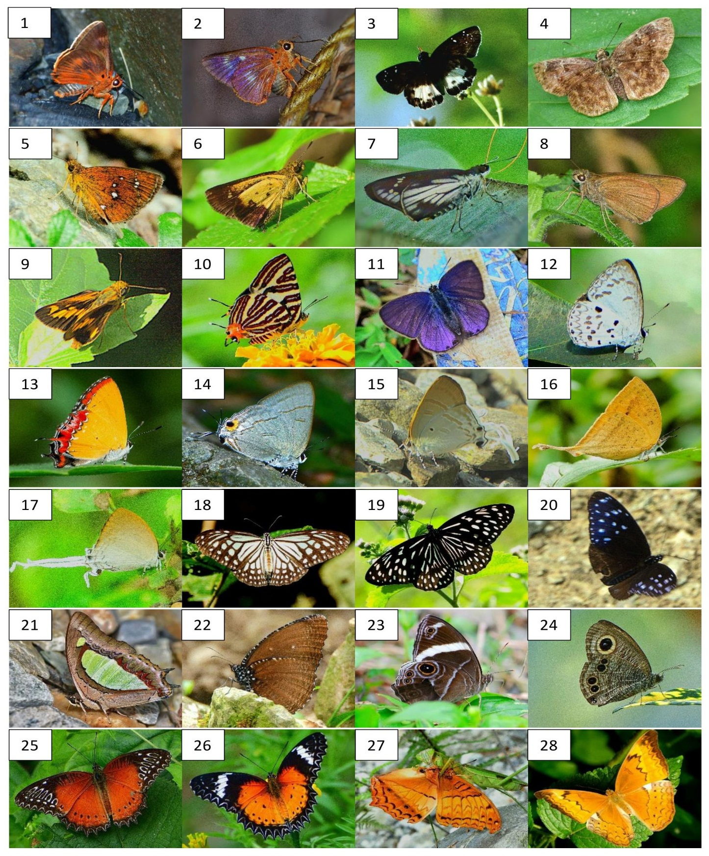
Plate 1: Butterflies recorded in study site. 1. Burara oedipodea, 2. Burara jaina jaina, 3.Tagiades menaka, 4. Sarangesa dasahara, 5. Iambrix salsala, 6. Zographetus satwa, 7. Unkana ambasa, 8. Baoris pagana, 9. Oriens goloides, 10. Spindasis lohita, 11. Anthene emolus, 12. Lestranicus transpectus, 13. Heliophorus epicles, 14. Hypolycaena erylus, 15. Zeltus amasa, 16. Loxura atymnus, 17. Cheritra freja, 18. Parantica aglea, 19. Tirumala septentrionis, 20. Euploea mulciber, 21. Polyura athamas, 22. Elymnias malelas, 23. Lethe confuse, 24. Ypthima baldus, 25. Cethosia biblis, 26. Cethosia cyane, 27. Vindula erota, 28. Cirrochroa aoris.
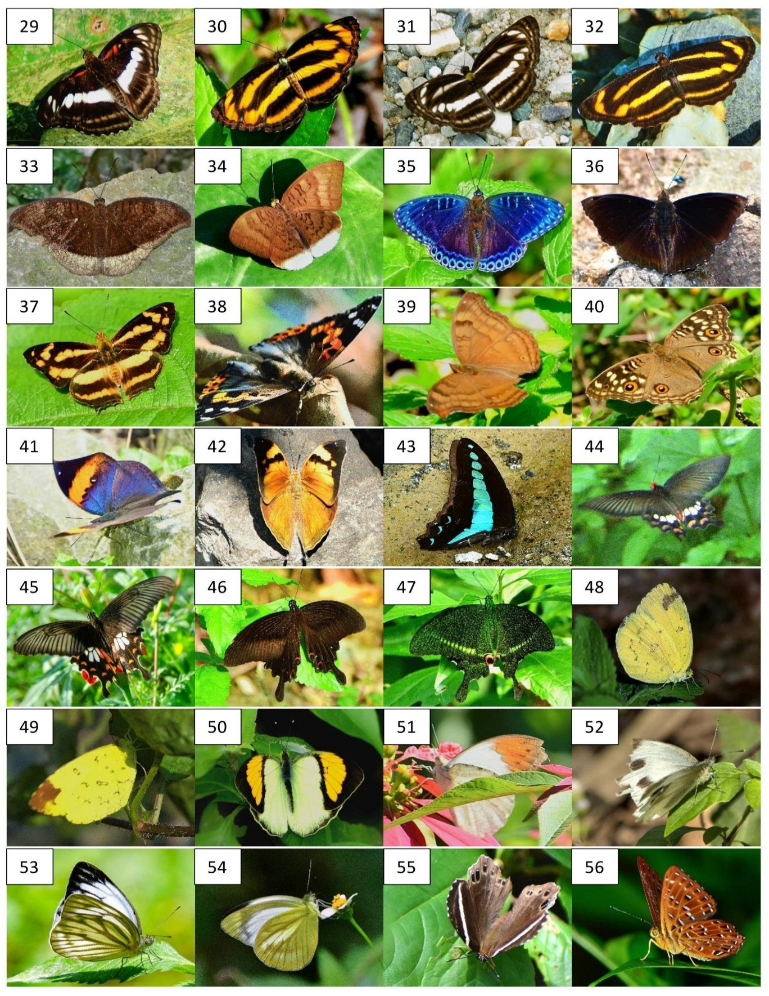

Plate 2: Butterflies recorded in study site (continue). 29. Athyma selenophora, 30. Pantoporia hordonia, 31. Neptis clinia susruta, 32. Neptis miah, 33. Tanaecia lepidea, 34. Tanaecia julii, 35. Stibochiona nicea, 36. Rohana parisatis, 37. Symbrenthia lilaea, 38. Vanessa indica, 39. Junonia iphita, 40. Junonia lemonias, 41. Kallima inachus, 42. Doleschallia bisaltide indica, 43. Graphium sarpedon, 44. Pachliopta aristolochiae, 45. Papilio polytes, 46.Papilio helenus, 47. Papilio paris paris, 48. Eurema hecabe, 49. Eurema blanda, 50. Ixias pyrene, 51. Hebomoia glaucippe, 52. Pieris canidia, 53. Cepora nerissa, 54. Cepora nadina nadina, 55. Abisara fylla, 56. Zemeros flegyas.

