Original Research Article
GONADAL BIOLOGY OF THE INDIAN NATIVE KILLIFISH
Aplocheilus lineatus

Abstract

The present study was undertaken to provide in depth information on the gonadal cycle of Aplocheilus lineatus. Oocyte-size frequency distribution was also analyzed to pin-point the spawning season. One of the defining features of a species, therefore, is its reproductive strategy, as reflected in anatomical, behavioral, physiological and energetic adaptations. The males and females of killifish A. lineatus were randomly selected and standard length (SL) and total length (TL) were measured. Total length was measured from the tip of the lower jaw to the tip of the longest ray of the caudal fin. Oocyte diameters were measured in the randomly selected female gonads. A sub-sample of the ovarian tissue was removed and the oocytes were teased apart with needles in a petri dish filled with glycerol diluted to 30% with water. The ovary of A. lineatus was a paired saccular body with the investing wall of peritoneum, which led to the formation of ovisacs. Each ovary remained suspended in the body cavity by a mesentery, called mesovarium. The developmental stage of oocytes was determined by a microscopic examination of the ovary. The oogenesis of A. lineatus was categorized into thirteen developmental stages from oogonia to atretic oocyte. The sperm duct kept the continuation of its anterior part deep inside the testis and there it gave branching and sub-branching to form a system of tubules for collecting the sperm.

Keywords: Oocyte, mesovarium, caudal fin, spawning season

INTRODUCTION
The success of any fish species is ultimately based upon the ability of its members to reproduce successfully in a fluctuating environment. One of the defining features of a species, therefore, is its reproductive strategy, as reflected in anatomical, behavioral, physiological, and energetic adaptations (Moyle and Cech, 2000; Castanedo et al., 2019; 2023). Maturation refers to cyclic morphological changes that the male and female gonads undergo to attain full growth and ripeness.
In killifishes, the development of oocytes has been observed in Australofundus limnaeus (Podrabsky, 2017), Austrolebias sp (Polacik et al., 2023), Turquoise killifish (Ritcher et al., 2025) and Fundulus heteroclitus (Sharpe et al., 2004). Spermatogenesis was studied in Fundulus heteroclitus (Fabra and Cerda, 2004) but not in Aplocheilus lineatus. Hence, the present study was undertaken to provide in-depth information on the gonadal cycle of A. lineatus. Oocyte-size frequency distribution was also analyzed to pinpoint the spawning season.
Materials and methods
Maturity analysis
The males and females of killifish A. lineatus were randomly selected and standard length (SL) and total length (TL) were measured. Data was collected for 24 months and consolidated. Total length was measured from the tip of the lower jaw to the tip of the longest ray of the caudal fin. The length measurements were taken to the nearest millimeter and weight to the nearest milligram. The criterion for the identification of the maturity stage was based on colour, texture, size, shape and extent of occupancy of gonads in the body cavity (Mc Bride et al., 2002). The GSI was calculated by using the following formula (Mc Bride et al., 2002):
GSI = GW/ (BW-GW) x 100
where GW is the weight of the gonad (g) and BW is the wet weight of the fish (g).
Histological technique
A portion of tissue was excised from the middle of either the right or left gonad fixed in Bouin’s fluid and dehydrated in a series of increasing alcohol concentrations. The tissue was embedded in paraffin wax sectioned along the transverse plane (6 - 8 μm), stained with Haematoxylin eosin or Masson’s or Mallory’s triple stain (Quintero-Hunter et al., 1991). The histological classification of maturity stages was based on changes in the diameter of unspawned ova, degree of yolk deposition and proportion of oocytes ready for ovulation.
Measurement of oocyte diameter
Oocyte diameters were measured in the randomly selected female gonads. A sub-sample of the ovarian tissue was removed and the oocytes were teased apart with needles in a petri dish filled with glycerol diluted to 30% with water. The diameters of 100 - 250 oocytes per fish were measured by means of an ocular meter fitted in a binocular microscope (Mc Bride et al., 2002).
The developmental stage of oocytes was observed in each female in increasing order, as chromatin nucleolar, peri nucleolar, cortical alveolar, vitellogenic, nucleus migration and nucleus breakdown stages (West, 1990). The degree of gamete development in crypts, the level of spermatozoa storage in the central duct, were used as criteria in staging male maturity (Mc Bride et al., 2002).
Results
Ovarian development
The ovary of A. lineatus was a paired saccular body with the investing wall of peritoneum, which led to the formation of ovisacs. Each ovary remained suspended in the body cavity by a mesentery, called mesovarium. The anterior portion of the ovisac ended blindly, but the posterior portion continued into an oviduct. The ovary having such continuity of its lumen to the oviduct was known as a cystovarian ovary.
During the breeding season, the ovisacs enlarged due to the accumulation of a large number of ova. The oviduct had separate opening from the urinary and anal openings. In immature and juvenile fishes, the ovaries were symmetrical.
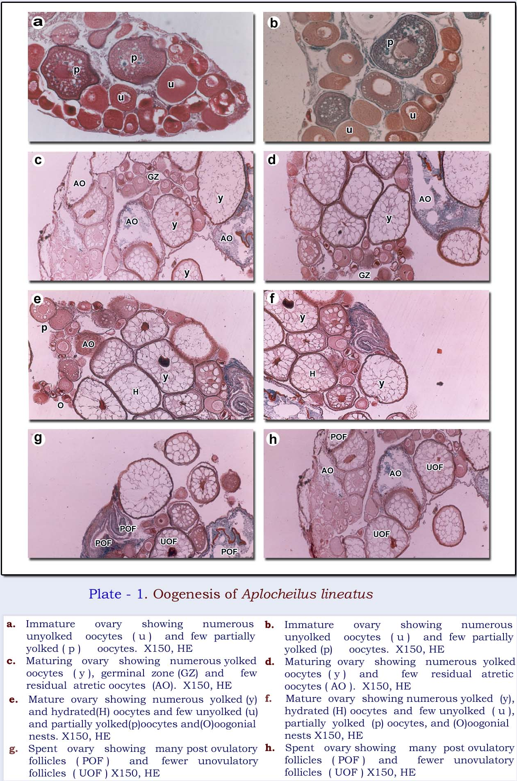
But once they became matured one lobe was shorter than the other. The morphological appearance of the ovaries of A. lineatus allowed the categorization of five maturity stages (Plate 1). The characteristics of each maturity stage are described in Table -1. Plate 2 illustrates the distinctive features of the ovarian developmental stages.

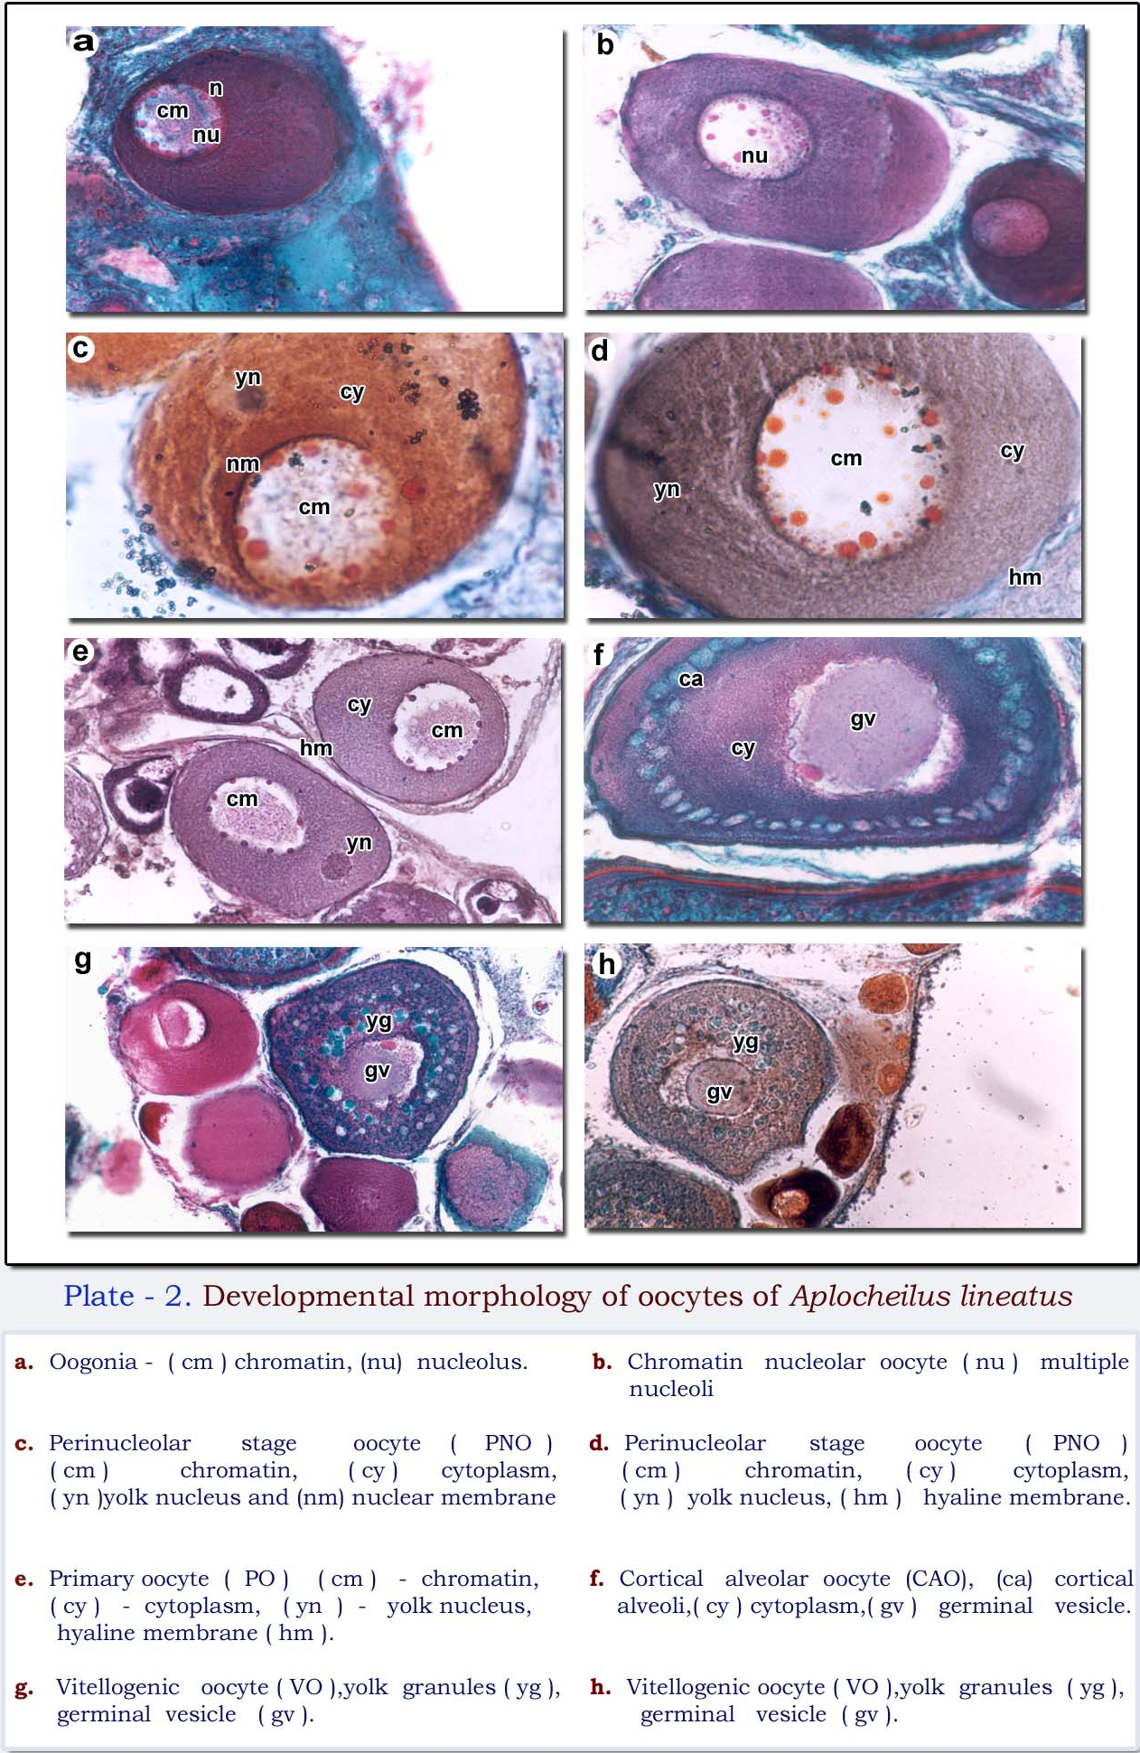

Table- 1: Aplocheilus lineatus: Gross anatomical features of the ovary
MATURITY STAGES | FISH |  | OVARY |  | GROSS ANATOMICAL FEATURES
MATURITY STAGES | TL  (mm) | WEIGHT  (gm) | LENGTH (cm)  (R / L) | WEIGHT  (gm) | GROSS ANATOMICAL FEATURES
Immature | 25 to 35 | 0.23-0.45 | 0.2 / 0.2 | 0.003-0.007 | Dull White and transparent, ribbon like and occupied 1/3rd of abdominal cavity. Both the lobes were of same length.
Maturing | 36-45 | 0.42-0.98 | 0.4 / 0.3 | 0.010-0.025 | Whitish yellow & translucent. Ovary occupied ½ of abdominal cavity. Eggs visible under the magnifying lens. One lobe was shorter.
Mature | 46-70 | 0.853-2.35 | 0.6 / 0.3 | 0.022-0.085 | Yellowish white ovary with blood capillaries, occupied 2/3rd of abdominal cavity. Eggs were large and visible to the naked eye. One lobe was half the length of the other.
Regressed | 53-65 | 2.10-2.25 | 0.4 / 0.3 | 0.007-0.015 | Dirty white, flaccid and shrunken ovary. Few translucent eggs.

- Immature: The immature ovary was small, slender, ribbon like, conical and tapering behind. It was dull white, transparent and occupied one-third of the abdominal cavity. The oocytes were invisible to the naked eye. Both the ovarian lobes were of the same length.
- Maturing: The maturing ovary was translucent and whitish yellow in colour. It was elongated and oval in transverse section. The ovary occupied half of the abdominal cavity. Eggs were visible under the magnifying lens. One lobe was shorter than the other.
- Mature: The mature ovary was yellowish white with visible blood capillaries which occupied two-thirds of the abdominal cavity. Eggs were large and visible to the naked eye. Ova were not free in the lumen. One left lobe was half the length of the right lobe.
- Partially Spent: The partially spent ovary was whitish red and the spent region appeared translucent which occupied half of the abdominal cavity. Ova were free in the lumen and they came out when a little pressure was applied on the abdomen. Few ova were seen in the spent region.
- Regressed: Ovaries were dirty white and translucent and look flaccid and shrunken and contained a few translucent eggs. Many ova were found in a reabsorbing/degenerating condition.
Table- 2: Aplocheilus lineatus: Comparative features of macroscopic and microscopic stages of the ovary
OVARIAN STAGE | MACROSCOPIC STAGES | MICROSCOPIC  STAGES | OOCYTE DIAMETER RANGE  (μm)
I | Unyolked oocyte | Immature and previtellogenic | 80 - 150
II | Partially yolked oocyte | Early vitellogenic Oocytes | 138 - 280
III | Yolked oocyte | Vitellogenic and mature Ova | 275 - 618
IV | Hydrated Oocyte | Preovulatory and  unovulatory follicles | 602 - 915
The frequency distribution of various ovarian stages in different length groups of A. lineatus during various months is depicted in Figure 1. During the pre-breeding season, maturing and mature fish of 45-48 mm TL were 40-48%. During the breeding season, mature
and gravid fish with 50-60 mm TL were 55-65%. At the post-breeding season, regressed females reached their maximum (55-68%).
Table- 3. Aplocheilus lineatus: Cytomorphological features of oocyte development

OOCYTE  STAGE | OOCYTE DEVELOPMENTAL  STAGE | NUCLEAR  FEATURES | CYTOPLASMIC FEATURES | OOCYTE DIAMETER RANGE  (μm)
I | Oogonia | Single | Thin cytoplasmic layer | 80-95
II | Chromatin Nucleolar oocyte | Single large nucleus | Thin cytoplasmic layer | 98-125
III | Perinucleolar oocyte | Large germinal vesicle, nucleoli few peripheral | Cytoplasm increased and became bulky | 137-149
IV | Cortical Alveolar oocyte | Central germinal vesicle, nucleoli many | Appearance of cortical Alveoli | 145-222
V | Early vitellogenic oocyte | Central germinal vesicle  nucleoli many | Appearance of yolk granules | 202-235
VI | Vitellogenic oocyte | Central germinal vesicle nucleoli many | Appearance of yolk vesicles in the peripheral cytoplasm | 217-243
VII | Late Vitellogenic oocyte | Central germinal vesicle nucleoli many | Appearance of yolk platelets | 235-279
VIII | Mature oocyte | Central germinal vesicle nucleoli many |  | 262-393
IX | Germinal vesicle migration (GVM) oocyte | Peripheral germinal vesicle, dissolution of the membrane. | Coalescence of yolk platelets | 386-568
X | Germinal vesicle breakdown (GVBD) oocyte | Germinal vesicle at animal pole | - | 465-623
XI | Hydrated Oocyte | - | Compaction of yolk platelets | 615-704

Oocyte development
The developmental stage of oocytes was determined by a microscopic examination of the ovary. The oogenesis of A. lineatus was categorized into thirteen developmental stages from oogonia to atretic oocyte (four sub stages). The nomenclature and classification of oocyte stages were based on West (1990). The classification of oocytes based on cytomorphological features is given in Table 2. A detailed description of the different stages of oocytes is presented in Table 3. Plate 3 illustrates the development states of oocytes.
- Oogonia: Oogonia were seen in maturing and regressed ovaries. They were found singly or in small nests. Oogonia had a diameter of 80 - 95 μm with a nucleus which stained deep orange with Mallory’s trichrome (Plate 2a; Plate 3a). They had very little cytoplasm with a prominent nucleolus.
- Chromatin nucleolar oocyte (CNO): The CNO had a large nucleus surrounded by a thin layer of cytoplasm with a diameter of 98 - 125 μm. Prefollicle cells surrounded each oocyte (Plate 2b; Plate 3b, c, d, e). The nucleus consisted of single, large nucleoli. stained uniformly (diameter 137-149 μm). The chromatin nucleolar and perinucleolar stages were referred to as primary growth phase or first growth phase.
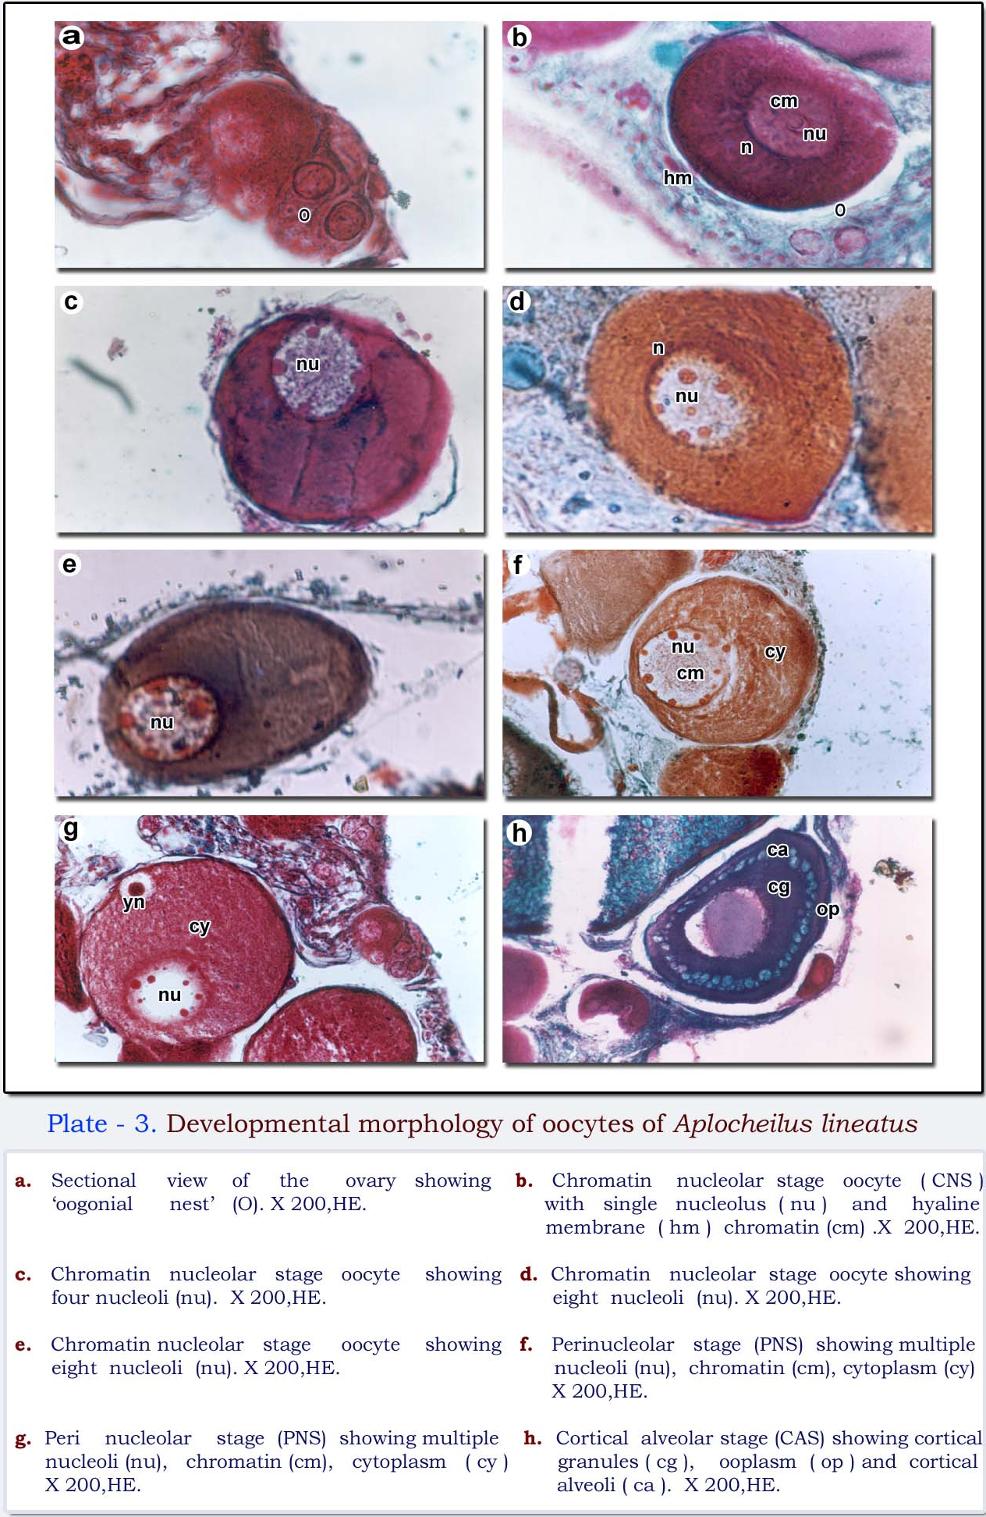

- Cortical alveolar oocyte (CAO): This stage was characterized by the appearance of vacuoles in the cytoplasm (diameter 145-222 μm). This also was termed as primary yolk stage (Plate 2f; Plate 3h). With conventional H & E preparations, these vacuoles appeared empty (Forberg, 1982). The cytoplasmic vacuoles aggregated to form cortical alveoli. The yolk granules appeared in the perinuclear region (Plate 4-7).
- Early vitellogenic oocyte (EVO): In this stage the yolk globules began to appear between the yolk granules in the peripheral cytoplasm, which marked the initiation of vitellogenesis (diameter 202 - 235μm) (Plate 2g; Plate 3a, b, c). The yolk globules were minute, spherical and acidophilic.
- Perinucleolar oocyte (PNO): Concomitant with oocyte growth, the nucleus increased in size. Many nucleoli appeared at the periphery (Plate 2c, d; Plate 3f, g). The cytoplasm

PRE-BREEDING BREEDING POST-BREEDING

Frequency of distribution (%)

Figure - 1: Aplocheilus lineatus : Seasonal occurrence of ovarian maturity stages
among different length groups of females
- Late vitellogenic oocyte (LVO): The cytoplasm was packed with acidophilic yolk globules (diameter 235 - 279μm) (Plate 2b; Plate 4d, e). As the yolk globules increased in size the oocytes became large. Lipid bodies situated in the perinuclear cytoplasm fused with one another and became large.
- Germinal vesicle migration stage (GVM): The GVM stage was indicated by the peripheral migration of the nucleus and the dissolution of nuclear membrane (diameter 386 - 568 μm). The nucleus progressively displaced towards the animal pole, where the micropyle was located (Plate 4f, g, h). The release of the first polar body occurred before the oocyte was ovulated into the lumen. The follicular layer became stretched, forming wide intercellular spaces.
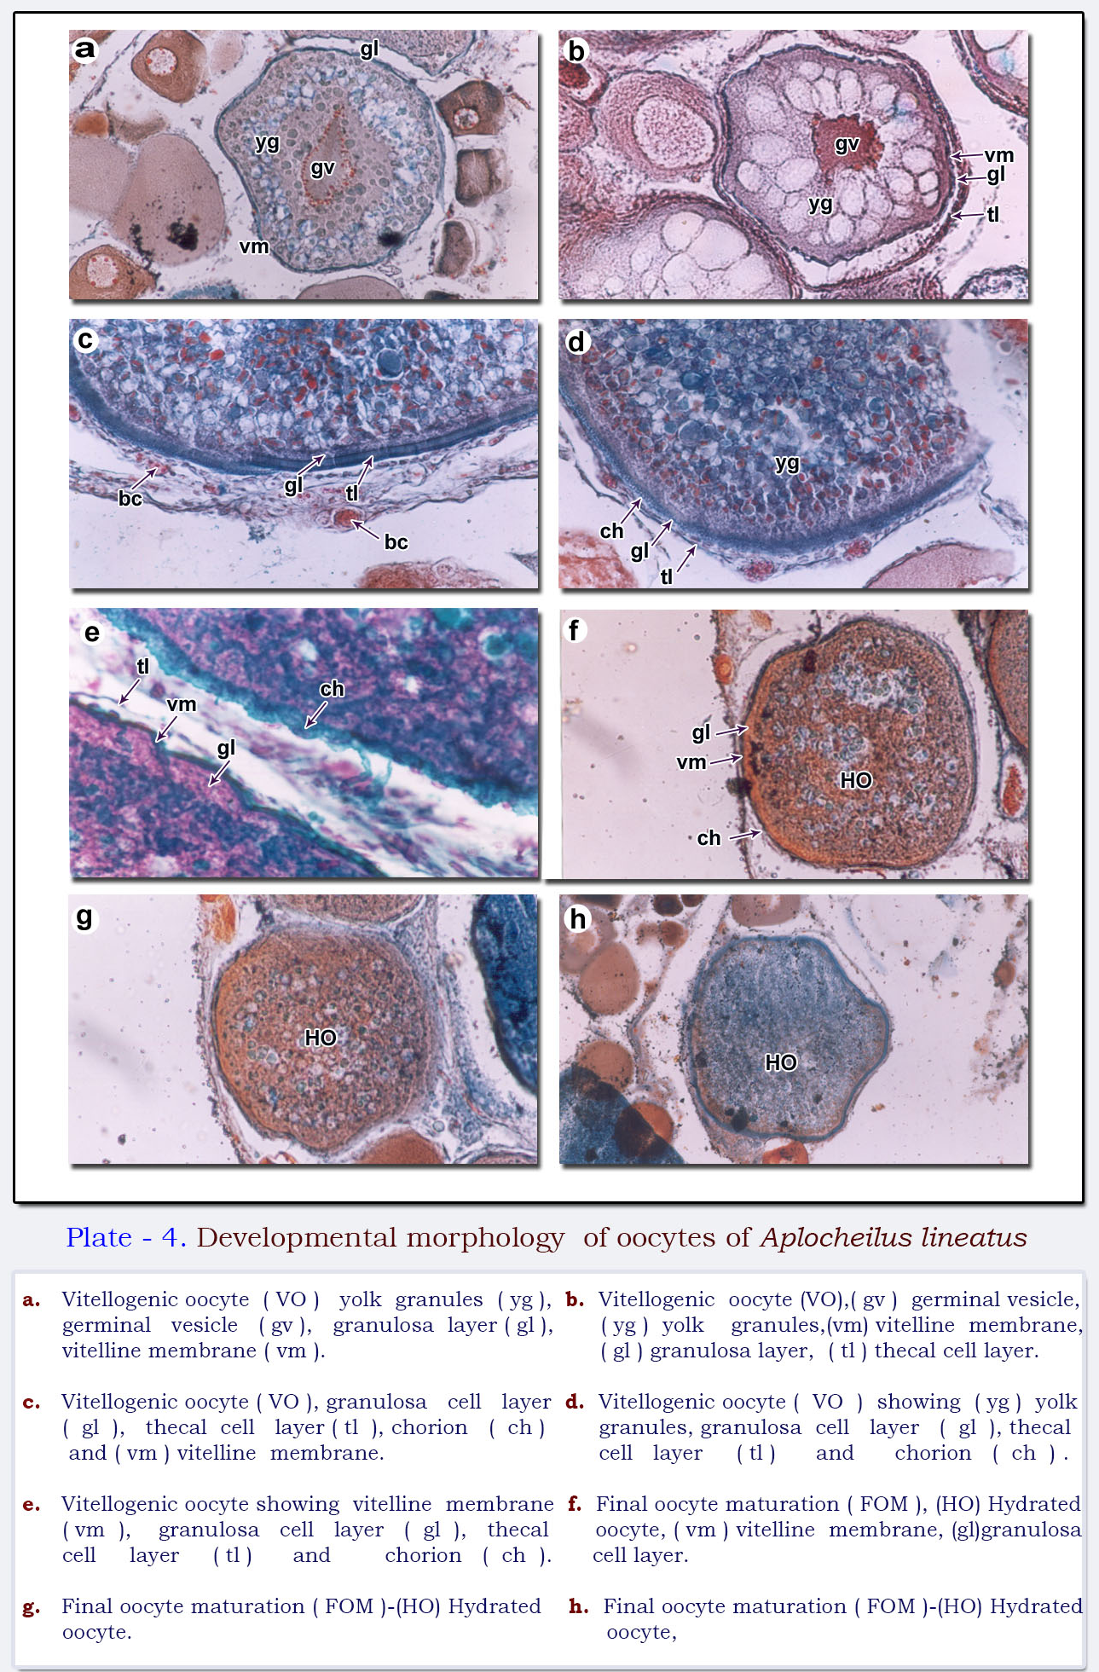

- Germinal vesicle breakdown stage (GVBD): After the migration of the nucleus to the periphery, its nuclear envelope broke down (germinal vesicle break down GVBD) (diameter 465 - 623μm) (Plate 5a, b, c). The process of coalescence further resulted in the formation of a continuous mass of yolk in the central part of the oocyte. Yolk globules of various sizes remained in the peripheral cytoplasm, but appeared to be reduced in number as the yolk mass increased.
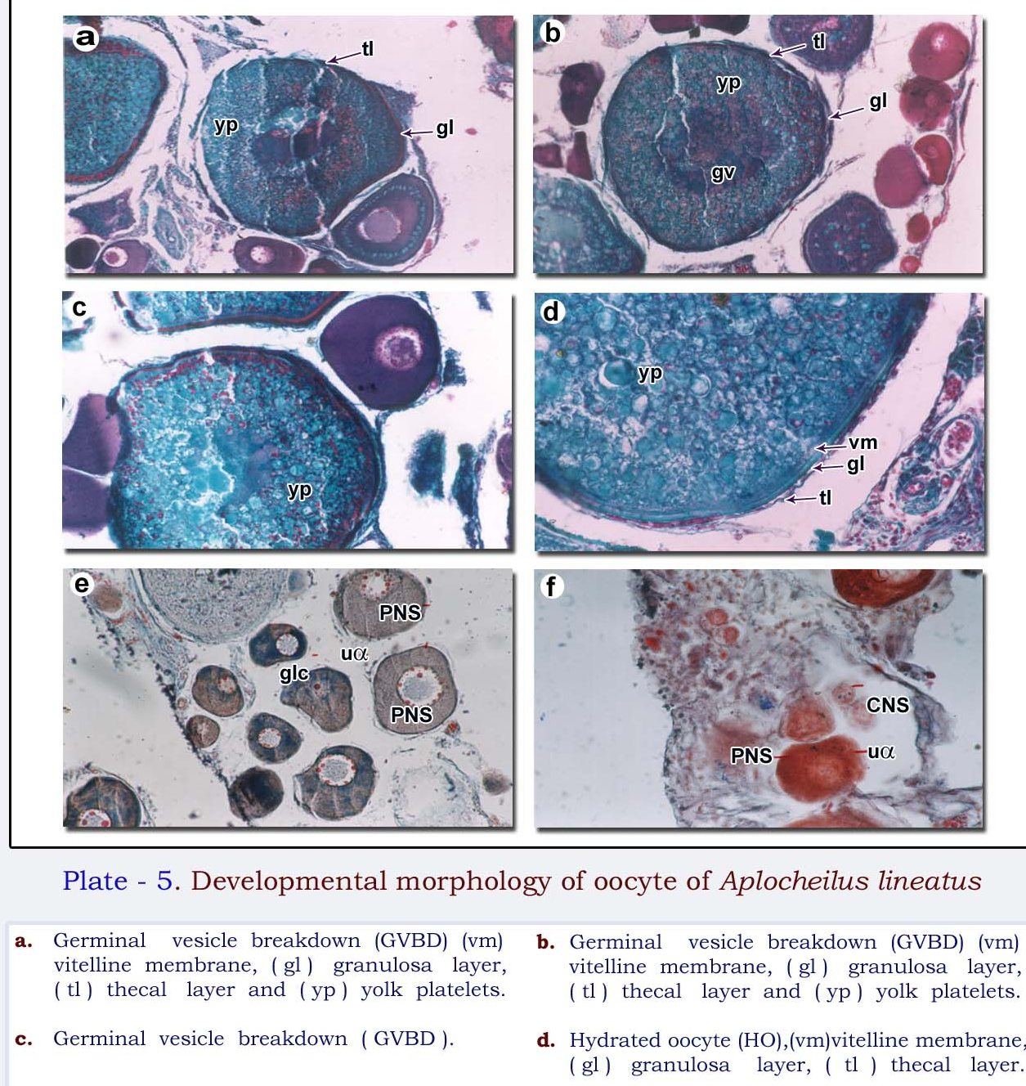

- Hydrated oocyte (HO): This was identified by the rapid uptake of fluid by the follicle. This started when the nucleus had completed its migration to the animal pole (Plate 5d). The yolk globules began to fuse, forming yolk plates. The nucleus was not visible. The nucleus having reached the animal pole, the nuclear membrane disintegrated, dispersing its contents into the cytoplasm. All yolk globules fused into plates and the oocyte expanded greatly, stretching the granulosa and thecal layers (diameter 615- 704μm).

Testicular cycle
Testes in A. lineatus were paired saccular bodies situated on either side, ventral to the kidneys along the posterior region of the abdominal cavity. A fold of peritoneum, enclosing a coelomic space, became continuous with the testis of each side, and was termed mesorchium. The sperm duct kept the continuation of its anterior part deep inside the testis and there it gave branching and sub-branching to form a system of tubules for collecting the sperm. At maturity the testes were long, tubular ribbon like structures with a maximum length of 10mm and weight of 0.012gm.
The testes of A. lineatus exhibited well marked seasonal changes and the testicular cycle was categorized into four stages. The histology of reproductive stages of A. lineatus is given in Table - 4.
Table - 4: Aplocheilus lineatus: Ovarian and testicular histology of reproductive stages

MATURITY STAGE | OVARIAN HISTOLOGY | TESTICULAR HISTOLOGY
Immature | Numerous oogonia and few primary oocytes | Only Spermatogonia seen.
Maturing | Early Vitellogenesis: many Primary oocytes, oogonia and oocytes with yolk vesicles seen | Early spermatogenesis, few scattered spermatocytes.
Mature | Late Vitellogenesis: Oogonia, Many vitellogenic and hydrated oocytes. | Late spermatogenesis, Spermatozoa collecting in tubules and central lumen, Melano macrophages also present.
Regressed | Oogonia, primary oocytes, few vitellogenic oocytes, Post ovulatory follicles and atretic oocytes seen. | -

The morphological characteristics of each maturity stage are given in Table -5.
- Immature: The testes of immature A. lineatus were thin, slender thread like translucent structures of dull white colour.
Table- 5: Aplocheilus lineatus: Gross anatomical features of the testis

MATURITY STAGE | FISH |  | TESTIS |  | GROSS ANATOMICAL FEATURES
MATURITY STAGE | TL (mm) | WT  (gm) | LENGTH  (R / L) | WEIGHT  (mg) | GROSS ANATOMICAL FEATURES
Immature | Up to 38 | 0.38-0.73 | 0.2 / 0.2 | 2.0-5.0 | Dull White and transparent. Very thin and thread like testis
Ripening | 42-55 | 0.65-2.18 | 0.4 / 0.4 | 4.0-8.0 | Creamy white, Opaque & enlarged testis
Ripe | 50-75 | 1.75-2.45 | 0.5 / 0.5 | 7.0-13.0 | Milky white, Enlarged and soft
Spent | 53-60 | 2.07-2.25 | 0.3 / 0.3 | 4.0-7.0 | Flesh coloured, Shrunken and thin testis

- Ripening: The testes were creamy white in colour and showed gradual increase in volume and became opaque. Milt did not come out even on the application of pressure on the abdomen. They extended to 1/3 ^{rd} of the abdominal cavity.
- Ripe: The testes were milky white in colour and extended to a half of the abdominal cavity. Milt oozed on application of a slight pressure on the abdomen.
- Spent: Testes were blood shot and flaccid. They appeared like inflated air sacs under the microscope.
The percentage frequency of various maturity stages of the testicular cycle as a function of total length of the male A. lineatus during the period of study is shown in Figure 2. During the pre-breeding period the immature and maturing males of 36 - 50mm TL were 55 - 60%, during the breeding season mature and ripe males of 45 - 65mm TL were 50 - 60% and during the post-breeding season the spent and partially spent males of 48 - 63mm TL with flaccid testes were 45 - 60%.
Frequency of distribution (%)
PRE-BREEDING BREEDING POST-BREEDING

Figure- 2 Aplocheilus lineatus : Frequency distribution of spermatogenic stages in different length groups

Spermatogenesis
The spermatogenesis in the testes of A. lineatus was categorized into five stages based on the histo-morphological characteristics. The histological features of the spermatogenic stages are presented in Table 6.
Table 6: Histological features of the spermatogenic stages

CYTOLOGICAL  STAGE | SPERMATOGENIC STAGE | CYTOMORPHOLOGY
CYTOLOGICAL  STAGE | SPERMATOGENIC STAGE | TESTICULAR TUBULE | GERMINAL CELL DIFFERENTIATION | INTERSTITIAL CELLS
I | Spermatogonia | Small, thick-walled | Large number of spermatogonia along periphery. Growing spermatocytes found. | A few inert cells
II | Spermatocyte | Slightly increased in diameter, thin-walled; tubules were solid | Spermatocytes in clusters, with few spermatids. | Proliferation of cells
III | Spermatid | Greatly enlarged wall became very thin. | Germ cells in various stages of active spermatogenesis; spermatids in plenty, with a few spermatozoa; least number of spermatogonia and spermatocytes. | Interstitial cells showed a moderate activity
IV | Spermatozoan | Highly distended | Filled with spermatozoa and seminal fluid; sperm maturation stages; a few spermatids found. | Slightly more prominent
V | Post-spermiation | Thick-walled and empty | Sperm resorption; spermatogonia abundant; spermatocytes absent. | Highly developed and very active.

- Spermatogonia: The testicular tubules were small, thick-walled. A large number of primary spermatogonia were seen along the periphery (Plate 6a, b, c). A few growing spermatocytes and a few inert interstitial cells were observed.
- Spermatocyte: The diameter of the seminiferous tubules increased slightly and their walls became thin and solid (Plate 6a, c, f). Spermatocytes were present in clusters. A few spermatids were also seen.
- Spermatid: The seminiferous tubules were enlarged and their walls became thin. The tubules were solid and filled with cysts of germ cells at various stages of spermatogenesis (Plate 6f, h). Spermatids were found in plenty, with a few spermatozoa in the middle region.

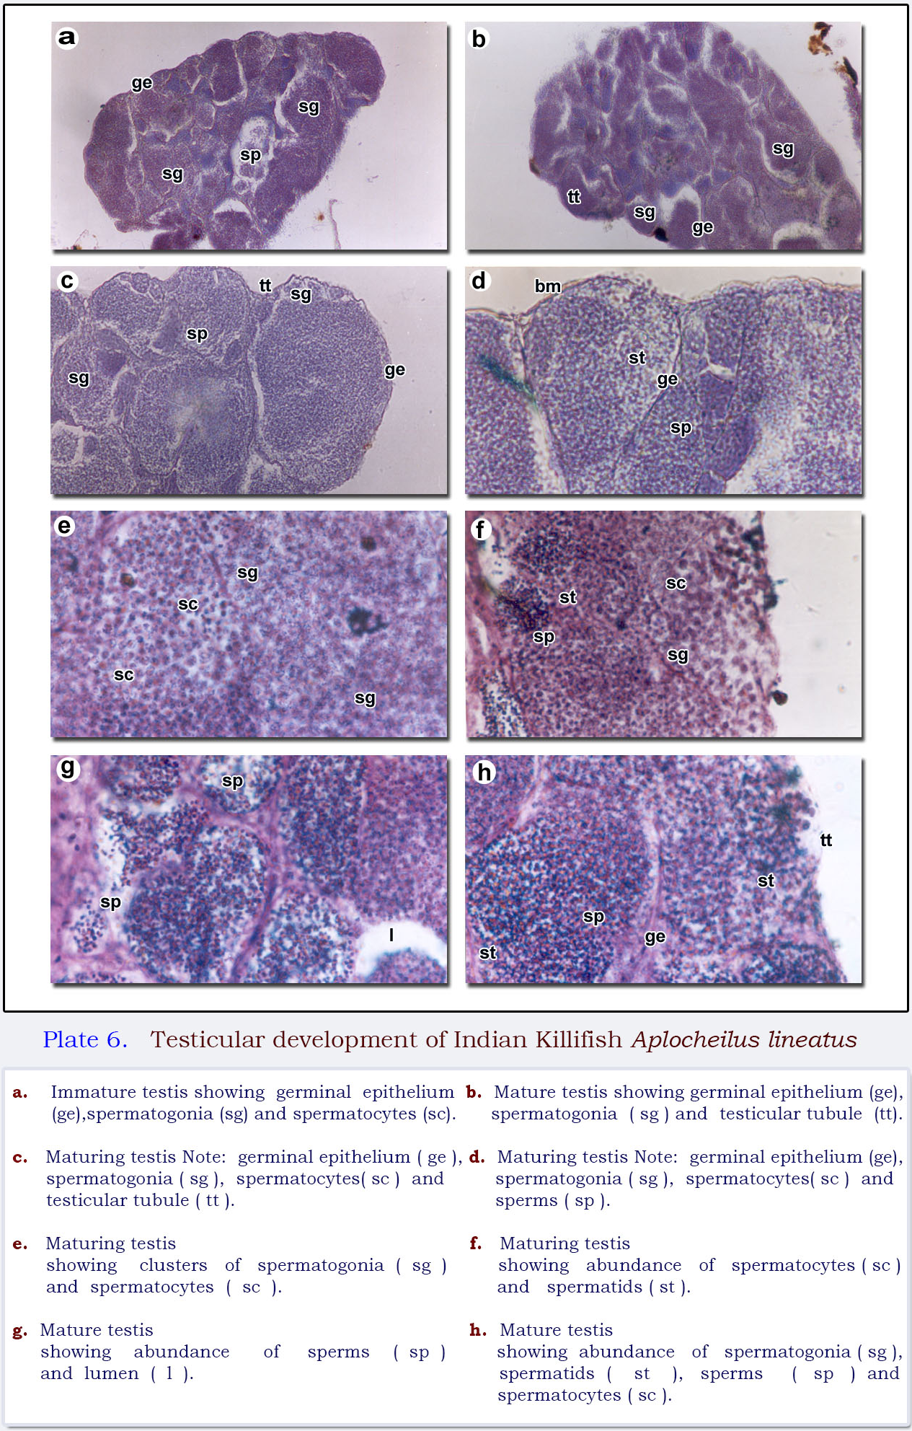

- Spermatozoa: The spermiation-stage testes were characterized by well-formed sperm ducts filled with spermatozoa and seminal fluid. Stages of matured sperms, spermatocytes and spermatids formed a lining to the ducts (Plate 7c, d, e, f). The interstitial cells were slightly prominent.
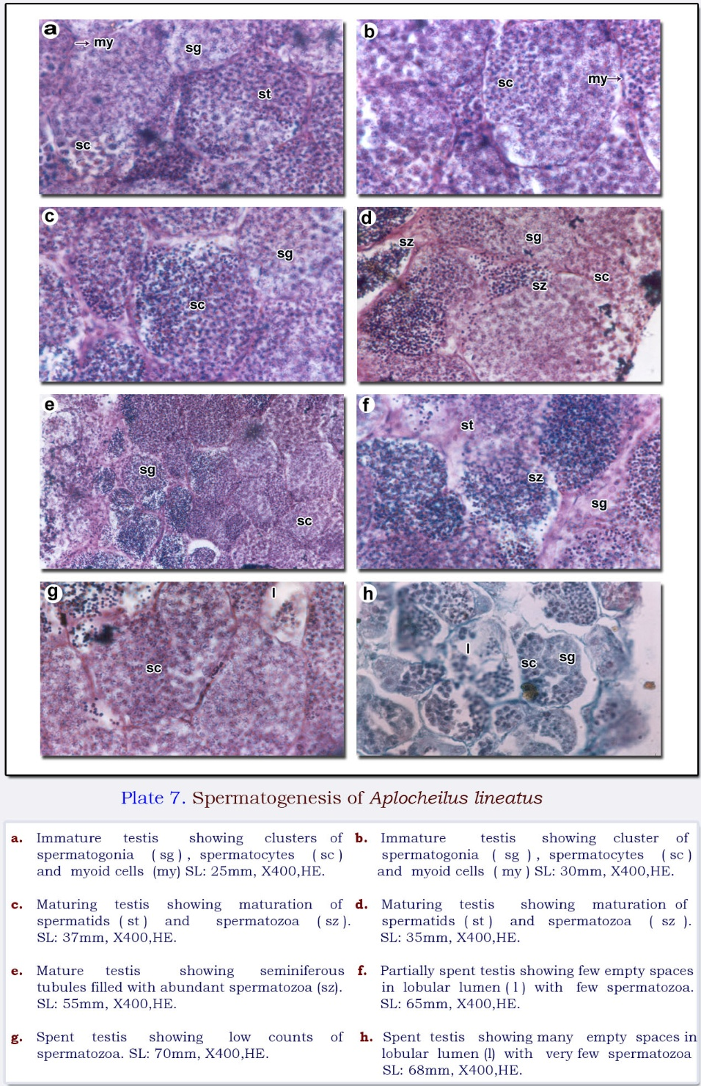

- Post spermiation: Spent testes of A. lineatus exhibited evidence of sperm resorption. The presence of a number of empty tubules was an indication that spermiation had already occurred (Plate 7f, g, h). The interstitial cells were maximally developed and were very active. A few spermatids or spermatozoa were also found.

Discussion
Ovarian cycle
The pattern of gonadal development of A. lineatus was similar to that of many teleost (Chellappa et al., 2003; Castanedo et al., 2019; 2023). The assessment of the breeding period in A. lineatus was based on the observation of gonadal maturation as in many fishes like Fundulus diaphanus (Chippett, 2003) and Fundulus grandis (Castanedo et al., 2019; 2023), Fundulus heteroclitus (Able and Hagan, 2003) and Lucania goodie (Fuller, 2001; 2002). The histological observation of the monthly samples of the ovary of A. lineatus revealed that it had an asynchronous ovary showing various developmental stages of oocytes at all the seasons. This type of ovary was recorded in Fundulus grandis (Castanedo et al., 2019; 2023), Fundulus heteroclitus (Able and Hagan, 2003) and Lucania goodie (Fuller, 2001; 2002).
The development of gonads in A. lineatus was correlated with somatic growth. The maximum gonadosomatic index value was obtained in the gravid ovary. So the GSI values of A. lineatus corresponded closely with gonadal development as in F. heteroclitus (Castanedo et al., 2019; 2023). Spawning in A. lineatus was represented by a decrease in ovarian weight as in Fundulus heteroclitus (Castanedo et al., 2019; 2023), and Fundulus diaphanus (Chipett, 2003).
Testicular cycle
The entire Aplocheilus lineatus testis was histologically identical to Nothobranchius furzeri (Chen et al., 2023); Ritcher et al., 2025) the African turquoise Killifish and F. heteroclitus (Castanedo et al., 2019; 2023). In A. lineatus, the first meiotic division was actively initiated at the onset of breeding. This was confirmed by the presence of plenty of spermatocytes. It also exhibited many peaks of testicular maturity in a year as in F. heteroclitus (Castanedo et al., 2019; 2023)
A. lineatus also exhibited a continuous spermatogenic cycle and passed through the successive stages of growth, maturation, activation, depletion and rest during the annual reproductive cycle. The spermatogenic activity started in late August, progressed through September to full maturity into spermatozoa at the end of October and April. Spermiation took place in October and late November and thereafter, spermatogenesis slowed down considerably and almost ceased by the middle of January. Again spermatogenesis started in March and ended in June. The testes remained quiescent and passed through a period of rest from January to March and June to September. In general, the testes of fishes showed an intensive phase of spermatogenic activity followed by a period of spermatogenic rest. Most of the Indian freshwater teleost’s attained maturity and bred during the monsoon season (Chippett,2003, Castanedo et al., 2019;2023, Omar, 2021). A. lineatus also spawned during the monsoon period.
In A. lineatus, the interstitial cells exhibited cytological changes in correlation with the testicular cycle. The interstitial cells became active during the periods only when meiosis and spermiogenesis occurred in the seminiferous tubules. As the spermiation occurred, the activity of the cells slowed down substantially and remained passive till the next spermatogenic cycle. It thus appeared that the hypertrophy of the interstitial cells was related to their steroidogenic activity, which caused the initiation and completion of the spermatogenic cycle. However, further experimental studies relating hormonal assay are desirable to substantially prove this phenomenon.
CONCLUSION:
This investigation on the maturity and spawning of A. lineatus was carried out by examining the gonad development, sperm and oocyte maturation, frequency distribution of maturity stages, and oocytes. It was concluded that A. lineatus had an asynchronous ovary and spawned throughout the year. Hence, A. lineatus was considered a multiple spawner. The occurrence of hydrated oocytes every alternate month indicated that there was asynchronous development of oocytes in A. lineatus. The testicular cycle showed that the maturation of males coincided with the maturation of females to enable successful fertilization and maintenance of the progeny.
Disclaimer (Artificial intelligence)
Author(s) hereby declare that NO generative AI technologies such as Large Language Models (ChatGPT, COPILOT, etc.) and text-to-image generators have been used during the writing or editing of this manuscript.

REFERENCES
- Able, K. W. & Hagan. S. M. (2003). Impact of common reed, Phragmites australis on essential fish habitat: influence on reproduction, embryological development, and larval abundance of mummichog (Fundulus heteroclitus). Estuaries 26(1), 40-50.
- Chen J, Khondker RC, Brunet A. (2023). Breeding and Reproduction of the African Turquoise Killifish Nothobranchius furzeri. Cold Spring Harb Protoc. Jun 1(6).
- Chippett. Jamie D. (2003). COSEWIC status report on the banded killifish Fundulus diaphanus, Newfoundland population in Canada, in COSEWIC assessment and update status report on the banded killifish Fundulus diaphanus in Canada. Committee on the Status of Endangered Wildlife in Canada). Ottawa 1-21 p.
- Domínguez-Castanedo, O., Uribe, M.C. (2019). Reproductive biology in males of the annual killifish Millerichthys robustus (Cyprinodontiformes: Cynolebiidae). Environ Biol Fish 102, 1365–1375 .
- Fabra, M. & Cerda, J. (2004). Ovarian cysteine proteinases in the teleost Fundulus heteroclitus molecular cloning and gene expression during vitellogenesis and oocyte maturation. Molecular reproduction and development 67(3), 282-294.
- Fuller, R. C. (2001). Patterns in male breeding behaviors in the bluefin killifish, Lucania goodei: (Cyprinodontiformes: Fundulidae). Copeia 2001 6(3), 823-828.
- Fuller, R. C. (2002). Lighting environment predicts the relative abundance of male colour morphs in bluefin killifish (Lucania goodei) populations. Proc. R. Soc. Lond. B. 269, 1457-1465.
- McBride, R. S. Stengard, F. J. & Mahmoudi, B. (2002). Maturation and diel reproductive periodicity of round scad (Carangidae: Decapterus punctatus). Marine Biology 140, 713-722.
- Moyle, P. B. & Cech. J. J, Jr (2000). Fishes. An Introduction to Ichthyology Prentice- Hall, Inc. ,123-144.
- Omar Castanedo, (2021). Perceived mate competition risk influences the female mate choice and increases the reproductive effort in the annual killifish Millerichthys robustus , Ethology, Ecology & Evolution, 10. (1-13).
- Polacik, M., Garcia, D., Arezo, M. J., Papa, N., Schlueb, H., Blanco, D., Podrabsky, J. E., & Vrtilek, M. (2023). Embryonic development of natural annual killifish populations of the genus Austrolebias: Evolutionary parallelism and the role of environment. Freshwater Biology, 68(10), 1726-1738.
- Ritcher A, Morl H, Thielemann M, Kleemann M, Geiben R, Schwarz R, Albertz C, Koch P, Petzold A, Kroll T, Groth M, Hartmann N, Herpin A, and Englert C (2025). The master male sex determination of the turquoise killifish arose through allelic neofunctionalization. Nat Commun. Jan 9:16(1):540.
- Sharpe, R. L., Deborah, M., Simon, C. & Van Der Kraak, G. (2008). Effects of a model androgen (methyl testosterone) and a model anti-androgen (cyproterone aetate) on reproductive endocrine endpoints in a short-term adult mummichog (Fundulus heteroclitus) bioassay. Aquatic Toxicology (Amsterdam) 67(3), 203-215.
- West, G. (1990). Methods of assessing ovarian development in fishes: a review. Austr. J. Mar. Fresh. Res. 41(2), 199–222.

