Weathered high density polyethylene microplastics induce proximate imbalance in the post larval stages of Litopenaeus vannamei

Abstract
Introduction: The fast rise in anthropogenic activity, particularly in the aquatic ecosystem, has resulted in microplastic contamination in recent years. A wide range of harsh environmental circumstances can cause stress to aquatic organisms.
Aim of the Works: This study aims to better understand the changes in proximate constituents that occur in the post larval stage on long term exposure by using a wide range of biomarkers to identify distinct and individual patterns of Litopenaeus vannamei responses to high density polyethylene microplastics.
Methodology: The post larval stage of Litopenaeus vannamei were exposed to wHDPE-MP for 45 days in order to evaluate changes in proximate constituents such as crude protein, fibre, amino acids ash and moisture contents were measured during the period of exposure. Similar measurements were made following a 15-day recovery interval to track any changes that might take place during depuration periods.
Results: The proximate constituents including crude protein, fats, fibre and ash contents decreased significantly following exposure of L. vannamei to 0.2 mg/L of wHDPE-MP for 45 days. These values during depuration demonstrated notable variations from the corresponding control group and did not indicate any recovery from the microplastic-induced stress.
Conclusions: The current study found a significant correlation between stress and alterations in the proximate constituents. Post larval stages exposed to wHDPE-MP had changes in the growth pattern and proximate constituents. Overall, the results indicate to post larval stages as the most vulnerable to wHDPE-MP, which will have an impact on white prawn growth and have repercussions for the aquaculture sector.
Keywords: Litopenaeus vannamei, Proximate Constituents, Weathered Microplastics, Stress, Chronic exposure

- Introduction
Plastic materials have become an indispensable component of our everyday lives due to its high strength, low weight, durability, non-porous nature, resistance to heat and water, and generally low cost (He et al., 2020). Long chain polymers comprising silicon, hydrogen, oxygen, carbon, and chloride that come from coal, natural gas, and petroleum make up plastics (Sharma and Chatterjee, 2017). Due to the significant social advantages of synthetic polymers, manufacturing has multiplied since their discovery in the 20th century. Until a very dependable alternative choice, such as bio-polymers, biodegradable plastic, etc., is provided, it will be extremely difficult to divert the entire system from utilising plastic (He et al., 2020). Because of their extensive dispersion in both aquatic and terrestrial ecosystems, microplastics are widely acknowledged as a significant environmental concern. The textile industry has been found to be a major source of microplastic pollution, mostly because of the microfibers that are released at various stages of the manufacture and use of synthetic textiles. Synthetic microfibers are released in large quantities during fabric washing, according to research, and they significantly impact water systems by getting into sewage wastewater and building up in aquatic environments (Balestra et al., 2024).
Nearly 9.1 billion tonnes of plastic have been produced worldwide in the last few decades, and the annual rate is steadily rising, producing 274 million tonnes of plastic solid waste in recent years (Dey et al., 2023). This amount is predicted to double in the near future and may surpass the mass of all fish in the marine environment by 2050, though it is still unknown how much microplastic has been released into the ocean recently (Moodley et al 2024). Furthermore, the recent COVID-19 pandemic outbreak caused a sharp rise in the manufacturing of personal protective equipment (masks, gloves, etc.), which is contributing to the amount of plastic waste in the terrestrial and aquatic environments and creating a new threat in addition to the already-existing plastic pollution (Alfaro-Núñez et al., 2021). Nearly 70% of all plastic materials produced wind up as garbage and are released into the environment, posing a major hazard to the ecosystem since plastics continue to degrade over time and generate tiny particles (Dey et al., 2023). According to Jambeck et al. (2015), the majority of plastic products are used for an average of no more than 12 minutes before entering the environment due to inappropriate management and disposal practices such as sewage disposal and waste dumping, where they eventually break down into smaller particles and cause additional contamination (Senapathi and Sekar 2023).
Subsistence fishing within the inland fisheries of India is a provider of employment, especially as the more profitable jobs are not easy to find.. In the communities surrounding the coastal region of southern India, fishing is an important source of livelihood. As the majority of families in these areas are low income earners, shrimp presents an alternative and cheap source of protein compared to other protein sources. A lot of crustacean species are caught from the coastal regions. Amongst these crustacean species Litopenaeus vannamei is an important species can be cultured economically.

Vieira Dantas Filho et al., (2023) reported that the fresh water organisms transports microplastics throughout its body and retains them in its tissue. According to Davidson and Dudas (2016), field data from in situ observations is still required to determine if environmental exposure might have any long-term impacts. There isn't yet a thorough analysis that focusses mostly on how microplastics interact with decapod crustaceans. Decapod crustaceans are classified as an accessory to shellfish and other species in the majority of assessments of marine creatures and microplastics. Decapod crustaceans may have a distinct function in the movement of microplastics between the biotic and abiotic sectors due to their distinct biological characteristics, including their physiological characteristics and living behaviours. Our knowledge of how humans are exposed to microplastics from various seafood sources will also be substantially enhanced by a single, relevant, and thorough assessment of microplastics in decapods.

Therefore, we focused on decapod crustacean field populations and compiled the frequency, quantity, and features of microplastics found in both edible and non-edible decapod crustacean sections based on field observations. In order to address the impacts and results of the interactions between microplastic pollution and the populations of decapod crustaceans, the technique selection, biological characteristics, and absorption pathways were also covered. There is ample evidence of the impact that MPs consumption has on fish (Sussarellu et al., 2016; Rodriguez-Seijo et al., 2017; Pannetier et al., 2020). The majority of biological processes, the synthesis of antioxidant enzymes, physical alterations, and even slower rates of reproduction are among these impacts. However, the consequences of weathered polyethylene (wPE) microplastics on aquatic life are difficult to comprehend due to their size, shape, and production components (Hariharan et al., 2021). We hypothesise that exposure to wHDPE-MPs may be the source of the alteration of proximate composition in the post larval stage of white prawns, based on our previous research.
Thus, our goal was to investigate the proximate analysis of Litopenaeus vannamei exposed to weathered polyethylene with a high density. Additionally, to determine whether exposure to wHDPE-MPs causes growth defects in L. vannamei during the recovery period. The findings show that wHDPE-MPs negatively affect biological systems and induce biological stress in the post-larval stage at environmental relevant concentrations.

2. Materials and Methods.

After being acquired from a commercial hatchery in Marakanam, Tamil Nadu, India, experimental post-larvae (PL-10) white leg prawns (Litopenaeus vannamei) were brought to the lab and acclimated in a 100 L glass tank with constant aeration, 20 PSU of salinity, and a 12:12 h light/dark photoperiod Every day, the culture water was replaced. The range of light intensity was 800-1200 lx. The initial salinity of 25 PSU was gradually raised by 2 PSU every 24 hours until the required salinity was achieved. Taking into account 10% of the biomass, the prawns were fed microparticulated PL-shrimp feed daily. Physiochemical parameters like pH, temperature, and salinity were regularly measured using pre-calibrated Hydro-Lab, USA-multi parameter water quality probes.

2.1 Chronic exposure of PL stage to wHDPE
The techniques of Hariharan et al. (2021) were used to create high density weathered microplastics (wHDPE). Basically, for the current investigation, somewhat aged plastic woven sacks were collected from the beaches along the Chennai coast and carefully cleaned with distilled water. Fourier Transform Infrared Spectroscopy (FTIR) (PerkinElmer Spectrum Version 10.5.4) was used to characterise the woven material and determine the type of polymer.
Post larval stage (10) of L. vannamei were acclimated, and the toxicity study methods were used from the EPA/ROC, 1998 protocol. L. vannamei were subjected to two concentrations of wHDPE microplastics in the current investigation. Each concentration was kept in a triplicate tank. As a control group, the post larvae in Group I were raised in regular seawater devoid of microplastics. Group II post larvae were exposed to 0.1 mg/L of wHDPE microplastic in saltwater, while Group III post larvae were subjected to 0.2 mg/L. For 45 days, the entire exposure experiment was carried out using the static renewal test method. Mild aeration was supplied in order to prevent the suspended wHDPE-MP from settling in the tanks. In every group, the tanks were continuously supplied with oxygen. Every two days, the seawater was replaced. Following their exposure times, the animals were kept in regular saltwater for a 15-day depuration period. Environmental factors and prior research were taken into consideration while choosing the concentrations (Hariharan et al., 2021). The experimental shrimps were housed in a light-dark cycle that lasted 12:12 hours. Additionally, a multiparameter water quality sensor (Hydrolab, USA) was used to record physicochemical data twice a day, including water temperature, salinity, pH, and dissolved oxygen (APHA. 2005). Following exposure periods the sample was taken at 15, 30 and 45 days. Sampling also done after depuration of 15 days.
2.2 Determination of crude protein
Using the Kjeldahl technique to assess nitrogen content and a conversion factor of 6.25 to get crude protein from total nitrogen, the crude protein analysis was conducted in accordance with the Analytical Methods Committee, AOAC (1995). The samples underwent titration, distillation, and digesting procedures. After weighing one gramme of the material into a Kjedahl flask, selenium catalyst was added. After carefully adding around 25 millilitres of concentrated tetraoxosulphate (VI) acid to the tube, the flask was spun. Heating in a fume cup board for at least two hours allowed the digestion process to proceed until a clear solution was produced. For the analysis, the digest was diluted to 100 mL in a volumetric flask. Following digestion, the samples were cooled for around twenty minutes before being distilled. This was accomplished by adding 35 millilitres of NaOH and 4% boric acid to the distillation flask. Four drops of indicator were added to the conical flask holding 25 millilitres of boric acid after the first drop of distillate. The flask was then titrated until a grey tint became apparent. It was noted how much acid was used in the titration. A blank was created with just a piece of paper and no sample.

2.3 Determination of Amino Acids
Following the methods of Liu et al., (2021) amino acids were identified and quantified using an automatic amino acid analyser except tryptophan. Since tryptophan is converted to ammonium by acidic hydrolysis, its amount was not quantified. Ten millilitres of 6 mol/L hydrochloric acid were added to each tube containing roughly 100 milligrams of each sample. Enough nitrogen was poured into the tubes to stop oxidative deterioration, and they were vacuum-sealed. The samples were reacted for eight hours at 110 °C. Distilled water was used to dilute the reaction product to 100 mL. Using vacuum freeze drying, 1 mL of the reaction product was extracted with HCl. Two millilitres of 0.02 mol/L HCl were used to dissolve the dry reaction product, and a 0.22 µm pore size membrane was used to filter the mixture. The automatic amino acid analyser was filled with a 20 µL aliquot of filtrate, and an internal standard method was used to quantify the amino acids and identify them using a standard method. The results for the amino acid content were given in mg/100 mg of sample.

2.4 Determination of Crude fibre
To determine the crude fibre content, the dried sample was boiled with sodium hydroxide (NaOH) and tetraoxosulphate (VI) acid (H₂SO₄). The insoluble residue that was collected at each step was then washed with distilled water. When estimating the crude fibre content, the following fundamental steps were taken. Defating the sample, digesting it with acid, digesting it with base, and then starting the ignition process (Liu et al., 2021).

2.5 Determination of Moisture content
The AOAC (1995) Analytical Methods Committee was used to determine the moisture content. The samples were dried using a moisture dish in an air oven set at 101 °C for around twenty-four hours until they reached consistent weights. They were then chilled in a desiccator and weighed again. The water content was calculated as the difference between the fresh and dry weights, and this was then translated to a percentage.

2.6 Determination of Ash content analysis
The Analytical Methods Committee, AOAC, was followed in determining the ash content (AOAC. 1995). Pre-dried samples from the moisture content analysis were heated for four hours at 550 °C in a muffle furnace. An estimate of the ash content was obtained by subtracting the end weight from the beginning weight and converting the result to a percentage.

2.7 Determination of Fat content
Five grammes of the material were fully extracted using a Soxhlet equipment and filter paper in order to produce crude fat. Petroleum ether at b.p. 40-60 °C AOAC was the extractant utilised (AOAC, 1995).

2.8 Statistical analysis
Hundred larvae were used per replicate and twenty larvae were used per time point per replicate. Three replicates were maintained per concentration (group). Mean values for three measurements were taken and subjected to analysis of variance (ANOVA) using SPSS 20.0 version to determine whether or not differences were significant and graph were plotted using Microsoft Excel software. Bartlett's test was initially used to check the data for homogeneity and normality. To find out if there were differences between control and exposure groups, one-way analysis of variance (ANOVA) was employed because all of the data were normally distributed. A significant p-value was defined as less than 0.05.
2.9 ETHICAL Consideration : For the care and use of animals, all applicable international, national, and/or institutional guidelines were followed.

3. Results and Discussion
The proximate components of the post larval stage of L. vannamei shrimp are given in the figure 1-6. From the figure, the crude protein content in L. vannamei shrimp was the highest in the control group, followed by the shrimp larvae exposed to lower concentration of HDwPE MPs. Similarly as the exposure period increased the highest concentration used produced more impact than the lower. Depuration period shows somewhat recovery in the respective parameters however which is still highly reduced level compared with respective control group.
The polypeptide chains that make up proteins might be single, as in myoglobin, or many chains. All living systems contain proteins as structural elements and as physiologically significant substances like pigments, hormones, and enzymes. There are two types of protein found in human diet: first-class and second-class. First-class proteins which are mostly derived from animals and including meat, fish, eggs, milk, and cheese, contain necessary amino acids (Pamela et al., 2015).
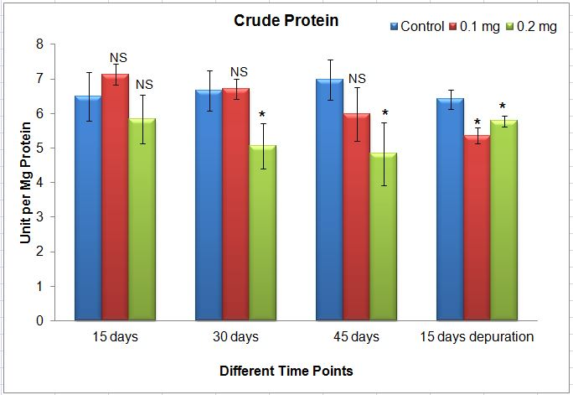
Figure 1. Crude protein content in post larval stages of L. vannamei exposed to different concentration of wHDPE-MP. Each bar represents mean ± standard deviation of six individuals. One way analysis of variance followed by Tukey's post hoc test was used. Asterisk indicate significant difference between the exposure group and respective control group. NS letters indicate no statistically significant differences ( p<0.05) between the exposure group and respective control group.

Changes in the amino acid concentration in the PL stages of L. vannamei exposed to exposed to different concentration of wHDPE-MP were given in the figure 2. The results clearly reveals that after 30 days of MPs exposure to PL stages decreased the amino acid content and the decrease in amino acid levels were statistically significant with respective control groups. 45 days exposure showed a similar trend in both exposed concentration. Depuration of PL stages showed the PL larvae doesn’t recovered from the stress due to MPs exposure.
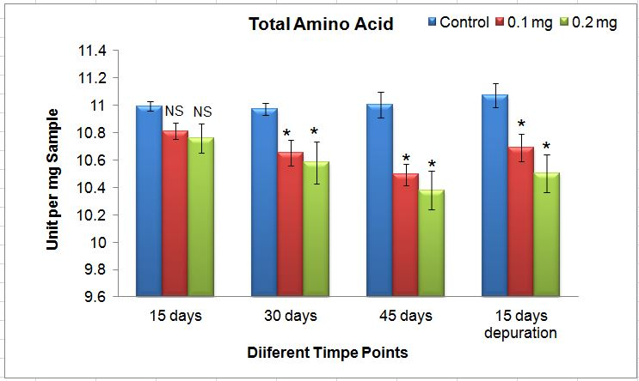
Figure 2. Total amino acid content in post larval stages of L. vannamei exposed to different concentration of wHDPE-MP. Each bar represents mean ± standard deviation of six individuals. One way analysis of variance followed by Tukey's post hoc test was used. Asterisk indicate significant difference between the exposure group and respective control group. NS letters indicate no statistically significant differences (p<0.05) between the exposure group and respective control group.

Similarly the shrimp exposed to microplastics showed a significant difference (p < 0.05) was in the content of crude fat. For the highest exposure concentration a significant difference (p < 0.05) was also found in the content of crude fat as the exposure period increased (Figure 3). The content of crude fat in control group does not changed much as the exposure period increased, however a sharp increase in the levels was observed due to growth factor. The current interest in the possible impact of diet in human nutrition led to the determination of the composition of crude fibre. Excess fibre can bind trace elements, which can lead to iron and zinc deficits. Fibre also helps to maintain the health of the gastrointestinal system. Furthermore, fibre reduces cholesterol levels in the body, which in turn lowers the risk of cardiovascular disease (Onwuka, 2015).
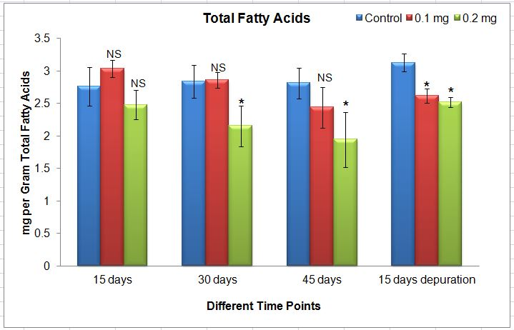
Figure 3. Total fatty acid content in post larval stages of L. vannamei exposed to different concentration of wHDPE-MP . Each bar represents mean ± standard deviation of six individuals. One way analysis of variance followed by Tukey's post hoc test was used. Asterisk indicate significant difference between the exposure group and respective control group. NS letters indicate no statistically significant differences ( p<0.05) between the exposure group and respective control group.

Changes in the fibre content in the PL stages of L. vannamei exposed to exposed to different concentration of wHDPE-MP were given in the figure 4. The results clearly reveals that after 30 days of MPs exposure to PL stages decreased the crude fibre content especially in the longer exposure period and in the higher concentration of MPs used and the decrease in crude fibe levels were statistically significant with respective control groups. 30 and 45 days exposure showed a similar trend in both exposed higher concentration. Depuration of PL stages showed the PL larvae doesn’t recovered from the stress due to MPs exposure.

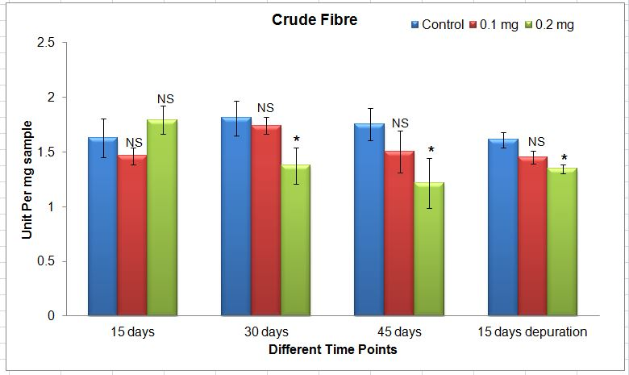
Figure 4. Crude fibre content in post larval stages of L. vannamei exposed to different concentration of wHDPE-MP . Each bar represents mean ± standard deviation of six individuals. One way analysis of variance followed by Tukey's post hoc test was used. Asterisk indicate significant difference between the exposure group and respective control group. NS letters indicate no statistically significant differences ( p<0.05) between the exposure group and respective control group.

The biochemical components, including protein, amino acids, moisture content, crude fibre, and fat content, were found to be considerably (p < 0.05) lower in L. vannamei exposed to both microplastic concentrations than in the corresponding control prawn larvae in the current study. Among the different exposure concentrations, prawns exposed to 0.2 mg of microplastics showed the greatest reduction in biochemical components. The amount of moisture in samples is crucial because it affects many biochemical, chemical, and physiological changes in food and other related substances. The moisture content of prawns exposed to both microplastiic concentrations was significantly (p<0.05) modulated when compared to the corresponding control groups (Figure 5).

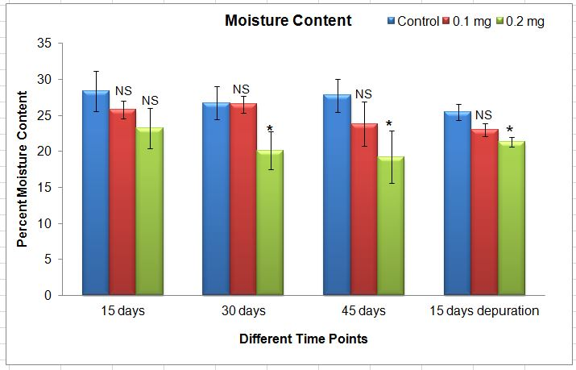
Figure 5. Total moisture content in post larval stages of L. vannamei exposed to different concentration of wHDPE-MP. Each bar represents mean ± standard deviation of six individuals. One way analysis of variance followed by Tukey's post hoc test was used. Asterisk indicate significant difference between the exposure group and respective control group. NS letters indicate no statistically significant differences (p<0.05) between the exposure group and respective control group.

Plastic trash decomposes into microscopic pieces in aquatic environments as a result of physical-chemical interactions with sunshine, waves, and creatures. Materials that decompose to the microplastic level may inadvertently be consumed as food by aquatic organisms (Ziani et al., 2023). In particular, estuarine and marine environments exhibit higher levels of microplastics, and freshwater and marine species are ingesting various microplastics (Yang et al., 2021). When microplastics enter an aquatic animal's gastrointestinal tract (GIT), they can be removed through the lining of the gut epithelium and then removed in the the animal's urine, faeces, and other tissues. After being absorbed into the stomach and potentially entering the gut's anaerobic environment, microplastics are mostly deposited in the adipose tissues of animals. The exposure route (e.g., food or waterborne) and aquatic habitat (e.g., freshwater or marine) affect the bioaccumulation of microplastics (Ghosh, 2024).
When evaluating the amount of mineral contained in a sample, the ash content serves as a good indicator of the mineral components present in the sample. Organic components oxidise to volatile substances like carbon (IV) oxide and sulphur (IV) oxide when materials are burned in a furnace at temperatures higher than 500 ºC. To a certain degree, the amount of ash in biological samples corresponds to the amount of inorganic substances present. When prawns were exposed to both MP concentrations, their ash content was considerably lower (p< 0.05) than in the corresponding control group (Figure 6). According to this result, prawns were abundant in mineral elements, which differed between the experimental and control groups. Chitin, which is mostly present in shrimp PL, makes up the majority of the crude fibre in shrimp. There were notable variations in the crude fibre composition between the experimental and control groups; the impact was larger for the shrimp exposed to the greatest concentration of MPs. Crude fiber-derived chitosan has beneficial biological qualities in addition to being biodegradable and biocompatible. These qualities have been utilised to create coating films that successfully preserve seafood with longer shelf lives and higher quality thanks to their antimicrobial and antioxidant effects. In general, digestibility, necessary amino acid content and proportion, and protein content determine the quality of protein in diet (Liu et al., 2021). In our investigation, we found that both protein and amino acids showed comparable outcomes; as MP concentration rose, the levels of amino acids in the post-larval stage of shimp were considerably lower.
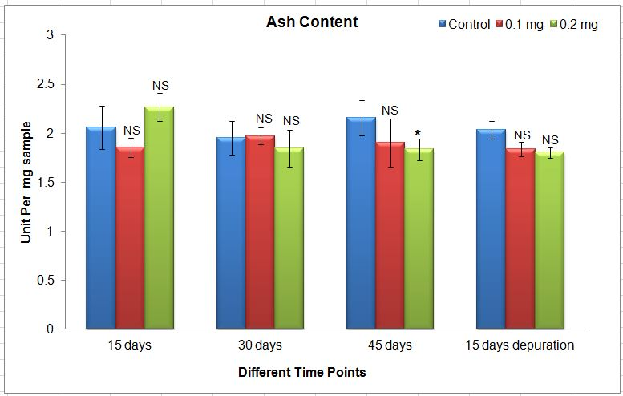
Figure 6. Ash content in post larval stages of L. vannamei exposed to different concentration of wHDPE-MP . Each bar represents mean ± standard deviation of six individuals. One way analysis of variance followed by Tukey's post hoc test was used. Asterisk indicate significant difference between the exposure group and respective control group. NS letters indicate no statistically significant differences (p<0.05) between the exposure group and respective control group.

The overall mineral composition of the tissue is measured by the ash content. It also aids in the growth and development of the organism. Ash concentration was lowest in experimental group and greatest in control group for the long term exposure of L. vannamei to microplastics. The crustacean species' high ash value indicates that it contains a lot of minerals, including zinc, calcium, magnesium, and potassium which may be indirectly effected due to microplastics exposure in L. vannamei. Physical impediments and inflammatory reactions are caused by the absorption and bioaccumulation of microplastics in the aquatic fauna's GIT. Gut perforation and ulcerative lesions are examples of internal injury resulting from such impairments. Additionally, there is a chance of stomach deformation and rupture, which can be lethal. Additional detrimental consequences that can lead to mortality include endocrine system disruption, decreased growth and reproduction, oxidative stress, cell lesions, metabolic problems, genotoxicity, neurotransmission-related illnesses, and weakened immunity (Ghosh, 2024). Furthermore, organic pollutants like metals, polycyclic aromatic hydrocarbons, organochlorine pesticides, and polychlorinated biphenyls may be absorbed on the surface of microplastics as they move through an aquatic ecosystem. This can negatively impact the health of aquatic fauna whether spike pollutants are present or not (Weis and Alava, 2023). Human food security is heavily reliant on both the amount and quality of aquaculture output. The release of new pollutants into the aquatic environment, such as antibiotics and microplastics, poses a major threat to human health and aquacultural productivity (Bhuyan, 2022).
Microplastics eventually absorb pollutants and offer a home for microbial development because of their small size and large surface area, which could result in increased toxicity. By swallowing them or indirectly through prey, MPs have an impact on several fish species, crustaceans, and plankton that live in saltwater. Furthermore, due to their larger surface area, these microscopic plastic particles can also serve as a vector for other harmful substances and microorganisms. Shrimp that consume and accumulate MPs may experience altered gut microbiota, lower immunity, increased oxidative stress, tissue deformation (such as gills), altered appetite, and altered immunity (Bora et al., 2024).
Consuming shrimp or fish that contain microplastics exposes one to these particles and the chemicals they carry, which have been connected to a number of health issues. Shrimp muscle, which is primarily consumed by humans, was also discovered to contain MPs (Barboza et al., 2020; Thiele et al., 2021; Alberghini et al., 2022). Given that fish, prawns, and crabs are important human protein sources, aquatic food security may be impacted by the ecotoxicological effects and prevalence of MPs in these organisms (Wright and Kelly, 2017; Barboza et al., 2018).
Shrimp are the most primary source of protein and fat, and their makeup may be used to indicate an organism's nutritional state. L. vannamei's proximate composition revealed that the control group had higher crude protein amounts than the exposed group. In comparison to the exposure group, the results showed that all of the examined characteristics in L. vannamei were excellent sources of proximal composition in the control group. The L. vannamei species' high protein content in the tissue from this investigation would indicate improved exposure conditions free from microplastic stress.
Further research on the harmful effects of MPs on shrimp is desperately needed. The efficiency of MPs accumulation and the rate of transmission throughout the food chain up to consumable items (shrimp) should be the focus of future research. These studies are essential for predicting the possible long-term health impacts of prawn intake on people since they provide valuable information on the bioaccumulation and biomagnification of MPs throughout aquatic habitats.

Conclusion
In conclusion the phases of prawn larvae that follow the mysis stage but before they are placed in grow-out ponds are referred to as PL (Post Larvae). The PL stage is the most important as it signifies the change from larval to juvenile prawns, and the age and quality of the PL have a direct effect on the farming cycle's performance. These stages are numbered consecutively. The development of these larvae will be impacted by any external stressors or polluted environments that might impair the larval stages. The findings make it abundantly evident that wHDPE-MP significantly affects the proximate composition of the post larval stage of L. vannamei, and if left unchecked, these polluted environments may indirectly affect the aquaculture sector. Furthermore, we propose that a more thorough comprehension of the effects of wHDPE-MPs may be possible through biochemical analysis and histological evaluations to comprehend oxidative stress and antioxidant response.

Disclaimer (Artificial intelligence)
Author(s) hereby declare that NO generative AI technologies such as Large Language Models (ChatGPT, COPILOT, etc.) and text-to-image generators have been used during the writing or editing of this manuscript.

REFERENCES
Alberghini L, Truant A, Santonicola S, Colavita G, Giaccone V (2022). Microplastics in Fish and Fishery Products and Risks for Human Health: A Review. Int J Environ Res Public Health. 20(1):789. doi: 10.3390/ijerph20010789. PMID: 36613111; PMCID: PMC9819327.
Alfaro-Núñez A, Astorga D, Cáceres-Farías L, Bastidas L, Soto Villegas C, Macay K, Christensen JH. Microplastic pollution in seawater and marine organisms across the Tropical Eastern Pacific and Galápagos. Sci Rep. 2021 Mar 19;11(1):6424. doi: 10.1038/s41598-021-85939-3. Erratum in: Sci Rep. 2022 Feb 25;12(1):3502. doi: 10.1038/s41598-022-07504-w. PMID: 33742029; PMCID: PMC7979831.
AOAC (Ed.), 1995. Official Methods of Analysis, 16th ed. AOAC International Publishers, Arlignton VA.
APHA (American Public Health Association), 2005. Standard Methods for the Examination of Water and Wastewater, 21st ed. .
Balestra V, Galbiati M, Lapadula S, Barzaghi B, Manenti R, Ficetola GF, Bellopede R. The problem of anthropogenic microfibres in karst systems: Assessment of water and submerged sediments. Chemosphere. 2024 Sep;363:142811. doi: 10.1016/j.chemosphere.2024.142811. Epub 2024 Jul 8. PMID: 38986785.
Barboza, L. G. A., Dick Vethaak, A., Lavorante, B. R. B. O., Lundebye, A.-K., and Guilhermino, L. (2018). Marine Microplastic Debris: An Emerging Issue for Food Security, Food Safety and Human Health. Mar. Pollut. Bull. 133, 336–348. doi:10.1016/j.marpolbul.2018.05.047
Barboza, L. G. A., Lopes, C., Oliveira, P., Bessa, F., Otero, V., Henriques, B., et al. (2020). Microplastics in Wild Fish from North East Atlantic Ocean and its Potential for Causing Neurotoxic Effects, Lipid Oxidative Damage, and Human Health Risks Associated with Ingestion Exposure. Sci. total Environ. 717, 134625. doi:10.1016/j.scitotenv.2019.134625.
Bhuyan MS (2022) Effects of Microplastics on Fish and in Human Health. Front. Environ. Sci. 10:827289. doi: 10.3389/fenvs.2022.827289.
Bora SS, Gogoi R, Sharma MR, Anshu, Borah MP, Deka P, Bora J, Naorem RS, Das J, Teli AB (2024). Microplastics and human health: unveiling the gut microbiome disruption and chronic disease risks. Front Cell Infect Microbiol. 14:1492759. doi: 10.3389/fcimb.2024.1492759. PMID: 39669275; PMCID: PMC11635378.
Davidson K, Dudas SE. Microplastic Ingestion by Wild and Cultured Manila Clams (Venerupis philippinarum) from Baynes Sound, British Columbia. Arch Environ Contam Toxicol. 2016 Aug;71(2):147-56. doi: 10.1007/s00244-016-0286-4. Epub 2016 Jun 3. PMID: 27259879.
Dey TK, Rasel M, Roy T, Uddin ME, Pramanik BK, Jamal M. Post-pandemic micro/nanoplastic pollution: Toward a sustainable management. Sci Total Environ. 2023 Apr 1;867:161390. doi: 10.1016/j.scitotenv.2023.161390. Epub 2023 Jan 5. PMID: 36621482; PMCID: PMC9814273.
Ghosh T. Microplastics bioaccumulation in fish: Its potential toxic effects on hematology, immune response, neurotoxicity, oxidative stress, growth, and reproductive dysfunction. Toxicol Rep. 2024 Dec 9;14:101854. doi: 10.1016/j.toxrep.2024.101854. PMID: 39802604; PMCID: PMC11720882.
Hariharan G., Purvaja R., Anandavelu I., Robin R. S., Ramesh R. (2021). Accumulation and ecotoxicological risk of weathered polyethylene (wPE) microplastics on green mussel (Perna viridis). Ecotoxicol. Environ. Saf. 208, 111765. doi: 10.1016/j.ecoenv.2020.111765.
He B, Wijesiri B, Ayoko GA, Egodawatta P, Rintoul L, Goonetilleke A. Influential factors on microplastics occurrence in river sediments. Sci Total Environ. 2020 Oct 10;738:139901. doi: 10.1016/j.scitotenv.2020.139901. Epub 2020 Jun 2. PMID: 32531603.
Jambeck JR, Geyer R, Wilcox C, Siegler TR, Perryman M, Andrady A, Narayan R, Law KL. Marine pollution. Plastic waste inputs from land into the ocean. Science. 2015 Feb 13;347(6223):768-71. doi: 10.1126/science.1260352. PMID: 25678662.
Liu Z, Liu Q, Zhang D, Wei S, Sun Q, Xia Q, Shi W, Ji H, Liu S. Comparison of the Proximate Composition and Nutritional Profile of Byproducts and Edible Parts of Five Species of Shrimp. Foods. 2021 Oct 27;10(11):2603. doi: 10.3390/foods10112603. PMID: 34828883; PMCID: PMC8619515.
Moodley T, Abunama T, Kumari S, Amoah D, Seyam M. Applications of mathematical modelling for assessing microplastic transport and fate in water environments: a comparative review. Environ Monit Assess. 2024 Jun 27;196(7):667. doi: 10.1007/s10661-024-12731-x. PMID: 38935176; PMCID: PMC11211188.
Onwunka, G. I. (2015). Food analysis and instrumentation theory and practice. Naphthalic prints, Lagos, Nigeria, pp. 219-230.
Pamela, C. C., Richard, A. H. and Denis, R. F. (2015). Lippincotts illustrated Reviews .biochemical 3rd, Lippincott William and Wilkins Philadelphia, pp. 335 – 388.
Pannetier, P., Morin, B., Le Bihanic, F., Dubreil, L., Clérandeau, C., Chouvellon, F., Van Arkel, K., Danion, M., & Cachot, J. (2020). Environmental samples of microplastics induce significant toxic effects in fish larvae. Environment international, 134, 105047. https://doi.org/10.1016/j.envint.2019.105047,
Rodriguez-Seijo, A., Lourenço, J., Rocha-Santos, T. A. P., da Costa, J., Duarte, A. C., Vala, H., & Pereira, R. (2017). Histopathological and molecular effects of microplastics in Eisenia andrei Bouché. Environmental pollution (Barking, Essex : 1987), 220(Pt A), 495–503. https://doi.org/10.1016/j.envpol.2016.09.092
Senapathi V and Sekar S. (2023). Editorial - Microplastic accumulation in different environmental matrices with focus on implications, vulnerability and management perspective. Chemosphere. 2023 Aug;332:138851. doi: 10.1016/j.chemosphere.2023.138851. Epub 2023 May 4. PMID: 37149097.
Sharma S, Chatterjee S. Microplastic pollution, a threat to marine ecosystem and human health: a short review. Environ Sci Pollut Res Int. 2017 Sep;24(27):21530-21547. doi: 10.1007/s11356-017-9910-8. Epub 2017 Aug 16. PMID: 28815367.
Sussarellu, R., Suquet, M., Thomas, Y., Lambert, C., Fabioux, C., Pernet, M. E., Le Goïc, N., Quillien, V., Mingant, C., Epelboin, Y., Corporeau, C., Guyomarch, J., Robbens, J., Paul-Pont, I., Soudant, P., & Huvet, A. (2016). Oyster reproduction is affected by exposure to polystyrene microplastics. Proceedings of the National Academy of Sciences of the United States of America, 113(9), 2430–2435. https://doi.org/10.1073/pnas.1519019113.
Thiele, C. J., Hudson, M. D., Russell, A. E., Saluveer, M., and Sidaoui-Haddad, G. (2021). Microplastics in Fish and Fishmeal: an Emerging Environmental challenge? Scientific Rep. 11 (1), 1–12. doi:10.1038/s41598-021-81499-8.
Vieira Dantas Filho J, Perez Pedroti V, Temponi Santos BL, de Lima Pinheiro MM, Bezerra de Mira Á, Carlos da Silva F, Soares E Silva EC, Cavali J, Cecilia Guedes EA, de Vargas Schons S. First evidence of microplastics in freshwater from fish farms in Rondônia state, Brazil. Heliyon. 2023 Mar 30;9(4):e15066. doi: 10.1016/j.heliyon.2023.e15066. PMID: 37082633; PMCID: PMC10112025.
Weis JS, Alava JJ. (Micro)Plastics Are Toxic Pollutants. Toxics. 2023 Nov 17;11(11):935. doi: 10.3390/toxics11110935. PMID: 37999586; PMCID: PMC10675727.
Wright, S. L., and Kelly, F. J. (2017). Plastic and Human Health: a Micro Issue? Environ. Sci. Technol. 51 (12), 6634–6647. doi:10.1021/acs.est.7b00423.
Yang H, Chen G, Wang J. Microplastics in the Marine Environment: Sources, Fates, Impacts and Microbial Degradation. Toxics. 2021 Feb 22;9(2):41. doi: 10.3390/toxics9020041. PMID: 33671786; PMCID: PMC7927104.
Ziani K, Ioniță-Mîndrican CB, Mititelu M, Neacșu SM, Negrei C, Moroșan E, Drăgănescu D, Preda OT. Microplastics: A Real Global Threat for Environment and Food Safety: A State of the Art Review. Nutrients. 2023 Jan 25;15(3):617. doi: 10.3390/nu15030617. PMID: 36771324; PMCID: PMC9920460.

