Evaluation of anthelmintic activity on cestode parasite Raillietina tetragona by using silver nanoparticles of Cucurbita maxima seeds and Punica granatum peel
Abstract:
A significant field of nanotechnology is the green synthesis of nanoparticles. In order to ascertain the effectiveness of synthesized silver nanoparticles (AgNps) against the parasite Raillietina tetragona, the current study focuses on the biosynthesis method of producing silver nanoparticles using biological compounds and evaluating their anthelmintic activities using aqueous and ethanolic extracts of Cucurbita maxima seeds and Punica granatum peel. Silver nanoparticles from 1 mM AgNO₃ solution and the Soxhlet apparatus are used to prepare the ethanolic extract of P. granatum peel and C. maxima seeds through aqueous and ethanolic extract. The sample turning brown indicates that silver nanoparticles have been produced. The UV-vis spectrophotometer and Fourier transform infrared (FTIR) spectrophotometer are used to characterize these produced silver nanoparticles. Different concentrations of Aqueous, Ethanolic, silver nanoparticles extract of C.maxima seeds and P.granatum peel are 2.5mgml⁻¹, 5mgml⁻¹, and 10mgml⁻¹ were treated against cestode parasite R. tetragona. Albendazole is taken as standard and distilled water as control. A lower concentration, 2.5mgml⁻¹ shows a slow paralytic and death rate of cestode worms compared to those in the higher concentration 10mgml⁻¹. The study results showed that the death of the worms is dose-dependent manner. Results indicate that compared to the standard drug Albendazole, C.maxima seeds and P.granatum peel extracts are more effective Anthelmintic for chicken. After performing Anthelmintic activity on R. tetragona using both extracts time taken for the death of parasites in C.maxima seed extract is shorter than P.granatum peel. Based on the data observed, this study was concluded that C.maxima seed extract is more effective anthelmintic for chicken than P.granatum peel extract.

Key Words: Cestode parasites, C.maxima seeds, Green synthesis, P.granatum peel, silver nanoparticles.

Introduction

Helminth parasites, mainly inhabiting in gastrointestinal tract are major threat in animal’s health and their eradication is majorly dependent on the use of chemical anthelmintic drugs. The most common cestode parasite Raillietina tetragona found in chicken’s small intestine. Adult parasites can cause severe infections leading to the death of the host. This parasitic infection can lead to listlessness, emaciation, diarrhea, and weight loss (Squires et. al., 2012). Chemical anthelmintic drugs like Benzimidazole, Albendazole Mebendazole, and ivermectin are used to combat helminth infections (Shalaby, 2013; Waller, 2003). However synthetic veterinary drugs are causing synthetic drug resistance and environmental issues. As a result, developing traditional botanicals hold promise in combating these parasites and have proven safer alternatives for the environment (Eguale et al., 2007a; Kamaraj et al., 2011).
In this modern era nanotechnology is one of the most active research fields in contemporary material science and technology due to their nanoscale size having unique characteristics (Vinay et. al., 2017). Silver nanoparticles can be synthesized using a variety of techniques including heat evaporation, photochemical reduction, electrochemical reduction, and biological. However, as shown in scientific literature these techniques are quite costly and require the use of environmentally harmful chemicals (Amrish Chandra et. al., 2015). The process of creating nanoparticles using biological components such as bacteria, fungi, and plants is known as “Green synthesis”. The plant extracts create precise silver nanoparticles form by acting as a capping and reducing agent (Ndikau et. al., 2017). Amino acids, enzymes, vitamins, and proteins are among the biomolecules found in the plant extract that significantly lower the concentration of Ag+ ions. C. maxima seeds are natural vermifuge, and are commonly utilized in traditional medicine for their ability to combat parasites in both human and livestock. They also have anthelmintic properties against various parasites like Aspiculuris tetraptera in mice (Ayaz et.al., 2015) and Heligmosoides bakeri both invitro and invivo (Grzybek et.al., 2016) as well as against cestode parasites like Taenia spp and Hymenolepsis species. P.granatum peel is traditionally used for thousands of years in ancient Ayurveda system to combat intestinal parasites. The peel possesses anti-cancer properties and demonstrates effectiveness against Ascaris suum invitro (Amelia et.al.,2017). The P.granatum peel is composed of alkaloids, polyphenols, flavonoids, and some anthocyanins such as delphinidins and cyanidins (Vinay et.al., 2017). Due to their Anti-cancer, Anti-oxidant, Anti-bacterial, Anti-inflammatory, Anti-ulcer, and Anthelmintic properties P.granatum peel receiving great interest in the modern era (Chen et.al., 2020).
The objective of this study is to understand and evaluate the anthelmintic properties of silver nanoparticles against cestode parasites Raillietina tetragona by using plant extracts C.maxima seeds and P.granatum peel.

Materials & Methods

Materials
C.maxima and P.granatum peel collected from local market, Distilled water, Silver nitrate, Ethanol, cestode parasites from chicken intestine.

Methods
Preparation of Aqueous extract of plants: C.maxima seeds and P.granatum peel were procured from market Koti, Hyderabad, and allowed to dry for 14 days in the shade. After that seeds and peel were ground into a fine powder using an electric blender and kept for later use in airtight containers. Add 150ml of distilled water into each of the two conical flasks and then separately add 25gms of fine powdered plant extracts into each flask. After the mixture was heated to 80 °C for three hours while being stirred in two conical flasks the extract was filtered through Whatman filter paper no.1 (Amelia et.al., 2017).
Preparation of Ethanolic extract of plants: The ethanolic extract was obtained following a standard procedure (Ayaz et.al.2015). A total of 25 grams of finely powered C.maxima seeds and P.granatum peel were placed into separate conical flasks and were processed in a Soxhlet apparatus to extract secondary metabolites using 150ml of ethanol for each plant extract. The resulting extracts were subsequently concentrated in a water bath through an evaporation method and dried at temperature between 20°C and 25°C before being placed in airtight bottles for storage and future use.
Preparation of silver nanoparticles extract of plants: In the current study, the crude Aqueous and ethanolic extracts of C.maxima and P.granatum peel were utilized for the green synthesis of silver nanoparticles carried out by the standard protocol (Venkata subbaiah et. al., 2014). The first step involves preparing a 1mM AgNO₃ stock solution by dissolving 10mg of AgNO₃ in 50 ml of distilled water. Next, take a 10ml sample of the Aqueous and ethanolic extracts of C.maxima seeds and place it into two separate conical flasks followed by adding 10ml of 1mM AgNO₃ solution into each flask. Then samples are heated in a water bath for 15 minutes until the colour shifts to brown. Similarly, take 10ml of a sample of Aqueous and ethanolic extract of P.granatum peel and place it into two separate conical flasks, adding 10ml of 1mM AgNO₃ solution to each conical flask. Heat these samples in a water bath for 15 minutes until the color turns brown.
The above prepared stock solutions of Aqueous, ethanolic and silver nanoparticle extracts of C.maxima and P.granatum peel are diluted with distilled water to produce working concentrations of 2.5mgml⁻¹, 5mgml⁻¹ and 10mgml⁻¹.
Preparation of standard drug (Albendazole): The stock solution of reference drug albendazole was used to prepare working concentrations of 2.5mgml⁻¹, 5mgml⁻¹, and 10mgml⁻¹ by diluting in distilled water and then treated against cestode parasite Raillietina tetragona.
Collection and identification of gastrointestinal parasites of chicken: The parasites are obtained from the freshly slaughtered country fowl. The chickens were humanly slaughtered by cervical dislocation and their gastrointestinal tracts dissected put and observed for cestode parasites. Parasites were removed carefully by using sterilized forceps. Later these parasites were taken into a petridish. The collected parasites were observed under microscope. Cestode parasite Raillietina tetragona were identified based on morphological features like whitesh in colour, highly longated, dosoventrally falttend, scolex bearing rostellum.

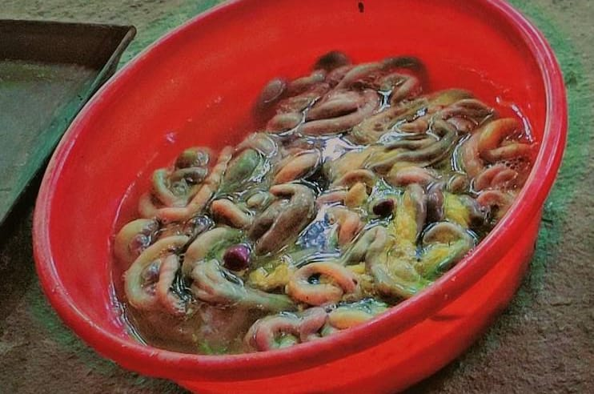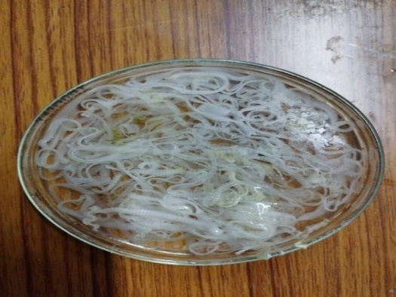
Figure 1: Intestines of chicken Figure 2: cestode parasites
Characterization
UV-visible spectroscopy: The UV-visible spectroscopy was used to investigate the functional groups of phytochemical constituents in the extracts from two different plants. The interaction of ultra violet visible radiation with molecules is revealed by molecular spectroscopy. The absorbed lights wavelength will provide information about the energy gaps which is related to functional groups.
Fourier transformed infrared analysis (F.T.I.R): Fourier transformed infrared spectroscopy is a phytochemical analytical technique. That provides a detailed picture of the metabolic constituents of plant extracts at a given time. By observing the IR spectra, it is possible to detect minor changes in the primary and secondary metabolites in the plant extract samples.
Evaluation of AgNPs Extracts of C.maxima seeds by UV -visible spectrum:
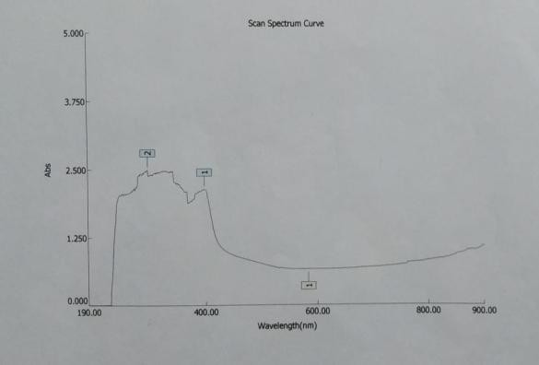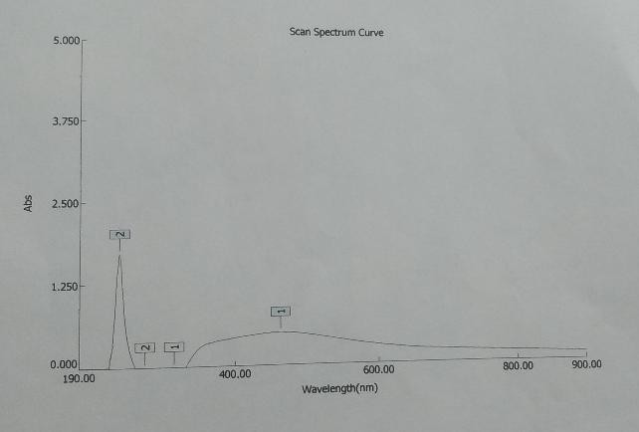
Figure 3: AgNPs of Aqueous and Ethanolic extracts of C.maxima seeds. The highest peak of aq. extract were observed at wave number 396 and 296 nm and highest peak of ethanolic extract were observed at wave number 462 and 243 nm.

Evaluation of AgNPs Extracts of P.granatum peel by UV -visible spectrum:
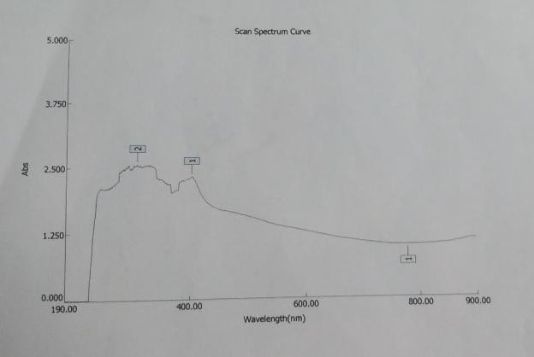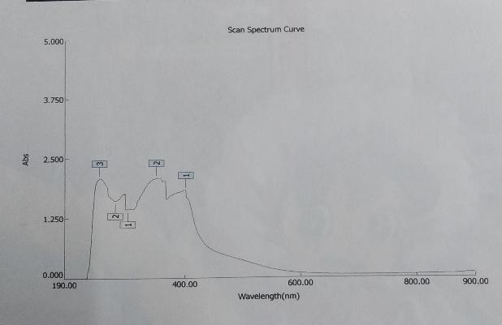
Figure 4: AgNPs of Aqueous and Ethanolic extracts of P.granatum peel. The highest peaks of Aq. extracts were observed at wave number 402 and 309 nm and the highest peak of ethanolic extracts were observed at wave number 401 and 350 nm.

Evaluation of AgNPs Extracts of C. maxima seeds by FTIR
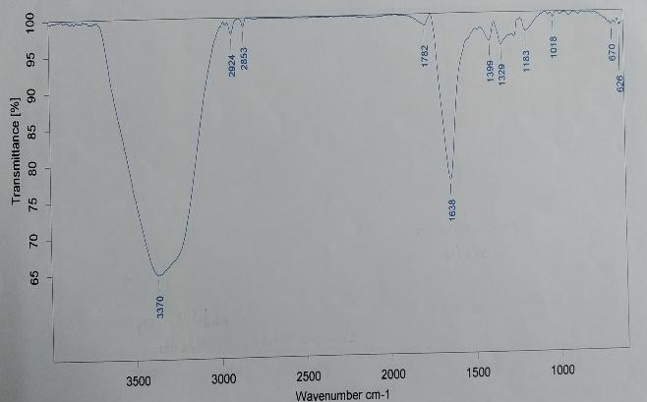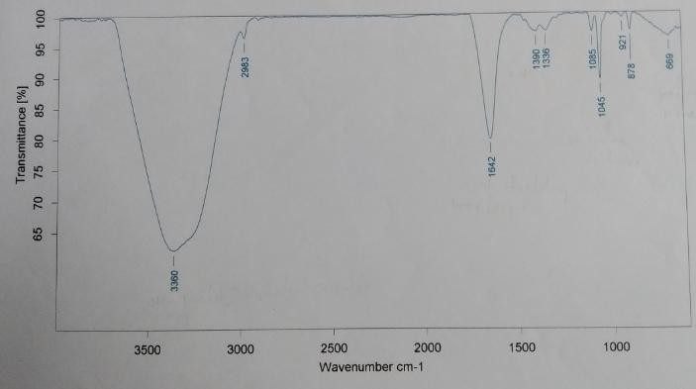

Figure 5: AgNPs of Aqueous and Ethanolic extracts of C. maxima seeds. The highest peaks of Aq. extract were observed at wave number 3370 & 1638 cm⁻¹ and highest peaks of ethanolic extracts were observed at wave number 3360 & 1642 cm⁻¹.

Evaluation of AgNPs Extracts of P.granatum peel by FTIR
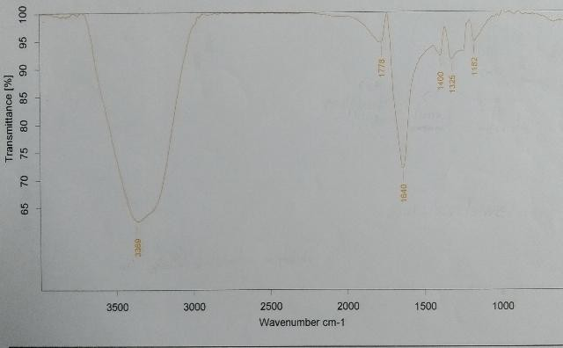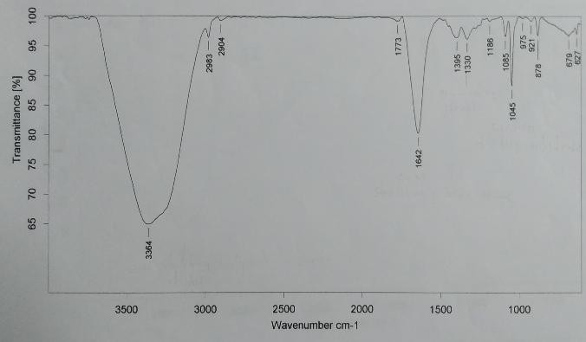

Figure 6: AgNPs of Aqueous and Ethanolic extracts of P.granatum peel. The highest peaks of Aq. extract were observed at wave number 3369 & 1640 cm⁻¹ and highest peaks of ethanolic extracts were observed at wave number 3364 & 1642 cm⁻¹.
UV-visible spectrum peaks of C.maxima seeds and P.granatum peel
Table 1: C.maxima seeds Table 2: P.granatum peel
  Observed compounds | wave length(nm)  in C.maxima seeds extract
  Flavonoids | 396 nm (peak 1 in Aq .extract)
  Phenolic compounds | 296 nm (peak 2 in Aq.extract)
  Carotenoids specially beta carotene | 462nm ( peak 1 in Ethanolic extract)
  Cucurbitacins | 243nm ( peak 2 in Ethanolic extract)
  Observed compounds | wave length(nm)
  Anthocyanins | 402nm (peak 1 in Aq.extract)
  Punicalagin | 309nm (peak 2 in Ethanolic extract)
  Bendaldehyde,Aromatic rings | 401nm (peak 1 in Ethanolic extract)
  Flavonoids | 350nm (peak 2 in Ethanolic extract)
  Gallic acid | 251nm (peak 3 in Ethanolic extract
FTIR Result peaks of C.maxima seeds and
P.granatum peel
Table 3 : C.maxima seeds Table 4 : P.granatum peel
  Functional groups | Absorption peak(cm⁻¹)
  OH stretching Alcohol and Aliphatic  compound | 3370 and 3360
  C=C stretching Alkene | 1638
  C=N Imine | 1642
  S=O Sulfoxide | 1045
  C=C bending Alkene | 669
  Functional groups | Absorption peaks (cm⁻¹)
  OH stretching of Alcohol and Aliphatic compound | 3369 and 3364
  C=O stretching of Vinyl or phenol ester | 1778
  C=N stretching of imine | 1640
  C-F stretching of Fluro compound | 1440
  S=O stretching of  Sulfonate | 1325
  C-O stretching of Ester | 1182
  OH bending phenol | 1330
  CO-O-CO stretching of anhydride | 1045
Table 5: Evaluation of anthelmintic activity of C.maxima seeds extracts against cestode parasite Raillietina tetragona.
S.no | Treating substance | Concentration (mg/ml) | Time of death (mins)
1 | Control (distilled water) | 2.5 | 0
1 | Control (distilled water) | 5 | 0
1 | Control (distilled water) | 10 | 0
2 | Standard(Albendazole) | 2.5 | 71.6± 1.24
2 | Standard(Albendazole) | 5 | 63.6±59.6
2 | Standard(Albendazole) | 10 | 60.3±1.24
3 | Aqueous Extract | 2.5 | 64.3± 0.47
3 | Aqueous Extract | 5 | 59.6±0.47
3 | Aqueous Extract | 10 | 55.6±1.24
4 | Ethanolic Extract | 2.5 | 52.3± 1.69
4 | Ethanolic Extract | 5 | 50±1.24
4 | Ethanolic Extract | 10 | 46.3±1.24
5 | AgNPs of Aqueous Extract | 2.5 | 48.6± 1.25
5 | AgNPs of Aqueous Extract | 5 | 45.6±1.24
5 | AgNPs of Aqueous Extract | 10 | 42.3±0.47
6 | AgNPs of Ethanolic Extract | 2.5 | 45.6± 1.24
6 | AgNPs of Ethanolic Extract | 5 | 42.6±1.24
6 | AgNPs of Ethanolic Extract | 10 | 37.5±0.40
Table 6: Evaluation of anthelmintic activity of P.granatum peel extracts against cestode parasite Raillietina tetragona.
S.no | Treating substance | Concentration (mg/ml) | Time of death(mins)
1 | Control (Distilled water) | 2.5 | 0
1 | Control (Distilled water) | 5 | 0
1 | Control (Distilled water) | 10 | 0
2 | Standard(Albendazole) | 2.5 | 73.6± 1.24
2 | Standard(Albendazole) | 5 | 67.6±1.24
2 | Standard(Albendazole) | 10 | 65±0.81
3 | Aqueous Extract | 2.5 | 70± 0.81
3 | Aqueous Extract | 5 | 62±1.63
3 | Aqueous Extract | 10 | 56.3±1.69
4 | Ethanolic Extract | 2.5 | 59.3± 1.24
4 | Ethanolic Extract | 5 | 52.3±1.69
4 | Ethanolic Extract | 10 | 46.6±1.24
5 | AgNPs of Aqueous Extract | 2.5 | 58.6± 1.24
5 | AgNPs of Aqueous Extract | 5 | 53±0.81
5 | AgNPs of Aqueous Extract | 10 | 48±1.63
6 | AgNPs of Ethanolic Extract | 2.5 | 48.4± 1.42
6 | AgNPs of Ethanolic Extract | 5 | 43.8±0.62
6 | AgNPs of Ethanolic Extract | 10 | 39.5 ±0.4
Every value is presented as the mean ± std of triplicate observations (n=3). The values are expressed in the minutes that represent the amount of time took for the death of the parasites. The paired t-test was performed to compare means. One way ANOVA was performed. The means were compared with standard using paired t-test and one-way ANOVA single factor the results showed that this given treatment is significant P< 0.05.
From table 5&6 cestode parasite Raillietina tetragona were treated with AgNP’s of Ethanolic extract of C. maxima and AgNP’s of ethanolic extract of P. granatum peel, average time taken for the death of parasites were less compare to AgNP’s of Aqueous extract, ethanolic extract, aqueous extracts.
It was concluded that Time taken for the death of the cestode parasite Raillietina tetragona is less in the silver nanoparticle of Ethanolic extract of C. maxima seeds compared to the silver nanoparticle of ethanolic extract of P. granatum peel.

Result and Discussion
According to the results of UV Spectroscopy C.maxima seeds contain compounds like Cucurbitacins, carotenoids, phenolic compounds, and flavonoids which are active components that exhibit anthelmintic properties. Cucurbitin is a most active compound that has great anthelmintic properties and it is known to paralyze parasites which allow the body to expel them naturally, it also acts on the nervous system of parasites causing paralysis without harming the host. Cucurbita not only damages the tegument through proteolysis, but it also helps in detaching worms from the intestine of the host (Sharma et.al., 1971; Lans et.al., 2007). It was revealed that according to various studies AgNPs of P.granatum peel shows spr peak from 400-490nm. (Vinay et.al., 2017; Nisha et.al., 2015). It connects with the current results of UV spectroscopy of P.granatum peel. The anthelmintic activity of the P.granatum peel is due to the presence of bioactive substances like polyphenols, sterols, glycosides, flavonoids, anthocyanins, tannins, alkaloids (Prakash, 2011; Tantry et al., 2009). As previously demonstrated, the peel of P.granatum contains various bioactive substances that exhibit anthelmintic effects on parasites. Antiviral, antifungal, antioxidant, anti-inflammatory, and antibacterial properties are prevalent in P.granatum peel ( Abdollahzadeh et al., 2011). The current study's findings concur with those of Labsi et al. (2019), who discovered that a combination of ethanolic extract from P. granatum peel and the widely prescribed albendazole was very beneficial in preventing outbreaks caused by the cestode parasite Echinococcus granulosus. Based on the above results of the anthelmintic assay it was concluded that green synthesis of AgNPs by using C. maxima seeds and P. granatum peel shows greater anthelmintic activity compared to the chemical drug Albendazole. Aqueous, ethanolic, and silver nanoparticle extract shows a significant effect on the cestode parasites, R. tetragona in dose dose-dependent manner. At higher concentrations, the death of the worms was more in a short period. C. maxima and P. granatum peel extracts with AgNPs combination have more effective anthelmintic activity compared to the normal plant extracts. During the synthesis of silver nanoparticles by green synthesis method silver nitrate changes into silver ions. As plant extracts are added into AgNO₃, silver ions are reduced and these silver ions are reduced into the free metallic atoms. In this current study, C. maxima seeds and P. granatum peel extracts are used as reducing agents. Due to their smaller size silver nanoparticles can easily penetrate the outer cuticle of the parasites and disrupt cellular integrity. Previous C. maxima seeds are used as anthelmintic on nematode parasites Ascaridia galli and other helminths such as larval stages of Haemonchus contortus (Marie-Magdeleine et.al., 2009), Heligmosoides bakeri invitro (Grzybek et.al., 2016). C. maxima seeds inhibit cestode parasites R. cesticillus in birds (Lahon et.al., 1978). C. maxima seeds also have an anti-protozoal effect on numerous parasites spp. Including
Entamoeba histolytica, Histomonas meleagridis, and Plasmodium falciparum. Nigella sativa, Calotropis procera, Carica papaya, and Gynandropis gynandra are given to the cestode parasites Taenia solium, Raillietina tetragona (Ravindra mali et al., 2007. Besides having anthelmintic properties on the cestode, nematode parasites also exhibit anti-bacterial properties on various gram-positive and gram-negative bacteria. P. granatum peel extracts are given against the nematode parasite Ascaridia galli invitro (Amer Abdel Aziz et.al., 2018). As reported by Jurenka (2008), pomegranate peel extract consists of antioxidant properties and has proven efficacy against Ascaris suum in vitro (Amelia et al., 2017) and has shown to be effective against the nematode and cestode parasites. As per the study results of Amer Abdel Aziz (2018) pumpkin seed extracts are more effective anthelmintic compared to the pomegranate peel extracts on nematode parasite Ascaridia galli due to the presence of phytochemical constituents that exhibit a strong anthelmintic effect on parasites. These results connect with this present study that C. maxima seed extracts are more effective than P. granatum peel extract against Raillietina tetragona. The standard drug Albendazole is less effective on R. tetragona compared to plant extracts. Medicinal Plant extracts are the best alternative to chemical drugs.
Conclusion: The present study demonstrated the biosynthesis of silver nanoparticles by plant extracts C. maxima seeds and P. granatum peel has more anthelmintic activity. Silver ions are reduced by the plant extracts of C. maxima seeds and P. granatum peel. The silver ions reduction through the plant extracts C. maxima and P. granatum peel leads to the formation of silver nanoparticles with well-defined dimensions. Various techniques are such as FTIR and UV spectroscopy used to characterize the formed silver nanoparticles. C. maxima seeds and P. granatum peel extracts show strong anthelmintic activity on cestode parasites Raillietina tetragona. Silver nanoparticles of C. maxima seed extracts are highly effective than silver nanoparticles of P. granatum peel extracts. Synthesized silver nanoparticles by using plant extracts have more effect on the death of the cestode parasite R. tetragona compared to the individual plant extract and standard drug. Plant extracts could be used as safe, effective, broadspectrum anthelmintic. The present study found that seeds and peel extracts are one of the best sources for the synthesis of silver nanoparticles. The herbal-based nanoparticles are safe, economically less costly, and eco-friendly.

DISCLAIMER (ARTIFICIAL INTELLIGENCE)
Author(s) hereby declare that NO generative AI technologies such as Large Language Models (ChatGPT, COPILOT, etc) and text-to-image generators have been used during writing or editing of this manuscript.
Conflicts of Interests: None declared.
Reference:
Abdollahzadeh SH, Mashouf RY, Mortazavi H, Moghaddam MH, Roozbahani N, Vahedi M (2011) Antibacterial and antifungal activities of Punica granatum peel extracts against oral pathogens.
Amelia M, Jasaputra DK, Tjokropranoto R, Kedokteran F, Kristen U (2017a) Effects of pomegranate peel (Punica granatum L.) extract as an anthelmintic Khasiat Ekstrak Kulit Buah Delima (Punica granatum L.)
Amer R. Abdel Aziza,1 , Mahmoud R. AbouLailab,⁎,1 , Mohammad Azizc , Mosaab A. Omard , Khaled Sultane(2018) In vitro and in vivo anthelmintic activity of pumpkin seeds and pomegranate peels extracts against Ascaridia galli.
Amrish Chandra, Seema Garg. Effect of varying concentration of herbal extract of Nyctanthes arbortristis leaf on synthesis of silver nanoparticles and its evaluation. Int J Pharm Pharm Sci, 2015.
Ayaz et al.2015 E. Ayaz, C. Gökbulut, H. Coşkun, A. Türker, S. Özsoy, K. Ceylan.
Chen,J.,Liao,Ouyang,X.,Kahramanoglu,I.Gan,Y.,LI and Rengasamy K.R.R(2020).Antimicrobial activity of pomegranate peel and its applications on food preservation.
Eguale, T., Tilahun, G., Debella, A., Feleke, A. & Makonnen, E. (2007a) In vitro and in vivo anthelmintics activity of crude extracts of Coriandrum sativum against Haemonchus contortus. Journal of Ethnopharmacology 110, 428–433.
Grzybek M, Kukula-Koch W, Strachecka A, Jaworska A, Phiri AM, Paleolog J, Tomczuk K. Evaluation of anthelmintic activity and composition of pumpkin (Cucurbita pepo L.) seed extracts – in vitro and in vivo studies. Int J Mol Sci 2016.
Jurenka, J., 2008.Therapeutic applications of pomegranate(Punica granatum I..): A review Altern.Med .Rev. 13(2),128.
Kamaraj, C., Rahuman, A.A., Elango, G., Bagavan, A. & Zahir, A.A. (2011) Anthelmintic activity of botanical extracts against sheep gastrointestinal nematodes, Haemonchus contortus. Parasitology Research 109, 37–45
Labsi M, Soufli I, Khelifi L, Amir ZC, Touil-Boukoffa C (2019) A preventive effect of the combination of albendazole and pomegranate peel aqueous extract treatment in cystic echinococcosis mice model: an alternative approach.
Lahon et al., 1978 L.C. Lahon, H.N. Khanikor, N. Ahmad, A.R. Gogoi
Lans C, Turner N, Khan T, Brauer G. Ethnoveterinary medicines used to treat endoparasites and stomach problems in pigs and pets in British Columbia, Canada. Vet Parasitol 2007.
Marie-Magdeleine C, Hoste H, Mahieu M, Varo H, Archimede H. In vitro effects of Cucurbita moschata seed extracts on Haemonchus contortus. Vet Parasitol 2009.
Ndikau ,M ., Noah, N.M.,Andala,D.M.,& Masika,E.(2017).Green synthesis and characterization of silver nanoparticles using Citrullus lanatus fruit rind extract.International journal of analytical chemistry ,2017.
Nisha MH, Tamileaswari R, Jesurani S. Analysis of anti-bacterial activity of silver nanoparticles from pomegranate (Punica granatum) seed and peel extracts. Int J Eng Res Technol 2015.
Prakash CVS, Prakash I (2011) Bioactive chemical constituents from pomegranate (Punica granatum) juice, seed and peel-a review.
Ravindra G.mali and anita A mehta 2007 , a review on anthelmintic plants.
Shalaby HA. Anthelmintics resistance: how to overcome it? Iran J Parasitol 2013.
Sharma LD, Bhaga HS, Srivastava PS. In vitro anthelmintic screening of indigenous medicinal plants against Haemonchus contortus (Rudolphi, 1803, Cobbold, 1898) of sheep and goats. Indian J Anim Res 1971.
Squires S, Fisher M,Gladstone O, Rogerson S,Martin P,Martin S, Lester H, Sygall R,Underwood N. comparative efficacy of flubendazole and a commercially available herbal wormer against natural infections of Ascaridia galli,Heterakis gallinarum and intestinal capillaria spp. In chickens.vet parasitol 2012
Tantry MA, Tantray MA, Akbar S, Khan R, Tariq KA, Shawl AS (2009) Humarain: a new dimeric gallic acid glycoside from Punica granatum L. bark.
Vinay CH, Ahmed MG, Goudanavar P, Acharya A. Development and characterization of pomegranate-based nanoparticles for drug delivery applications. Int J Pharm Sci Nanotech. 2017.
Waller, p.j(2003) The future of anthelmintic in sustainable parasite control programs for livestock.Helminthologia 40,97-102.

