***Case report***

**Diagnosis and Management of Spirocercosis in a Beagle Dog:A Case Report**

Abstract

A 2-year-old male Beagle was presented to the Referral Veterinary Polyclinic, Indian Veterinary Research Institute, Izatnagar with a history of anorexia, chronic vomiting, fever, persistent vocalisation and poor response to regular anti-emetic and antacid treatment for the past three months. **On clinical examination, the dog exhibited intermittent vomiting, lethargy and significant weight loss**. Initial diagnostics on complete blood count showed mild leucocytosis, though serum biochemistry showed no remarkable abnormalities. To investigate the persistent gastrointestinal signs, endoscopic imaging was performed, which identified a fixed glistening, space-occupying nodules in the distal thoracic oesophagus. Faecal examination further confirmed the presence of *Spirocerca lupi* eggs, leading to a definitive diagnosis of spirocercosis. The Dog was treated with subcutaneous injections of Doramectin administered every 14 days for 3 occasions along with other supportive therapy, including Ceftriaxone-Tazobactam, Ondansetron, Pantoprazole, Phenobarbitone sodium and fluid for hydration. This case underscores the importance of early diagnosis and targeted treatment of spirocercosis, as delay can lead to life-threatening complications like oesophageal obstruction or neoplastic transformation. The successful recovery in this case highlights the importance of considering *Spirocerca lupi* infection in cases of chronic vomiting unresponsive to conventional therapy, particularly in endemic regions.

.

Keywords: Spirocercosis, Dog, Chronic vomiting, Doramectin,endemic

1. **Introduction:**

Spirocercosis is a parasitic disease caused by the nematode *Spirocerca lupi*, primarily affecting dogs. The infection occurs when dogs ingest infected dung beetles containing *S. lupi* eggs. While the disease is most prevalent in tropical and subtropical regions, sporadic cases have also been reported in temperate climates (Giannelli *et al*., 2014; Wright *et al.,* 2016). Its spread is influenced by high dog population densities and environmental factors such as soil type, pH, temperature, rainfall, and sunlight exposure (Jyothi Sree & Hafeez, 2013). Spirocercosis is particularly intriguing due to the unique and severe pathological effects it induces in dogs. In mild cases, the worms form nodules in the esophagus, leading to partial obstruction and regurgitation of undigested food. In severe cases, these nodules can undergo neoplastic transformation, resulting in aggressive sarcomas that metastasize widely, often with fatal outcomes (Rojas *et al*., 2020). The lifecycle of *S. lupi* involves larval migration from the stomach to the thoracic aorta within 10 days, followed by migration to the oesophagus within 3–4 months, where they mature and form nodules. This migration can cause aortic scarring, aneurysms, and oesophageal lesions. In some cases, larvae migrate aberrantly to other organs, such as the lungs or heart. Severe complications may include spinal cord inflammation, neurological deficits, or sudden death due to aortic rupture (Yildirim *et al.,* 2007; Mylonakis *et al.,* 2008).

The hallmark clinical signs of spirocercosis include oesophageal lesions, leading to persistent regurgitation, vomiting, dysphagia (difficulty swallowing), and significant weight loss. Non-specific symptoms such as pyrexia (fever) may also occur (Dvir *et al.,* 2001; Mazaki-Tovi *et al*., 2002). This study presents a case of successful diagnosis and therapeutic management of spirocercosis in a Beagle dog.

**Case presentation**

* 1. **Clinical Presentation of animal**

A 2-year-old male Beagle was presented with a history of chronic vomiting, fever, persistent vocalisation and poor response to regular anti-emetic and antacid treatment for the past three months to the Referral Veterinary Polyclinic, Indian Veterinary Research Institute, Izatnagar. On clinical examination the dog exhibited dullness with congested mucus membrane, lethargy, intermittent vomiting and severe weight loss (approx. 40%). No abdominal pain on palpation. Slightly elevated rectal temperature with 103.2℉ while other vital parameters *viz.*, heart rate, respiration rate and lung sound were within reference panel.

* 1. **Laboratory examination**

A routine haematology revealed mild leucocytosis with 24.72 x 103/cmm (6.0-17.0 x 103/cmm). Serum biochemistry with Kidney function and Liver function test were within the normal reference panel.

* 1. **Faecal examination**

**A faecal sample was examined using a sugar flotation method, as previously described by Markovics and Medinski (1996). Approximately 1 g of faeces was placed in a plastic test tube, and 5 ml of sugar flotation solution was added. The mixture was agitated thoroughly using a wooden spatula for 30 seconds. After tightening the test tube cap, the tube was placed into a fixed-arm rotor centrifuge and spun at 1400 × g for 10 minutes. Following centrifugation, 0.1–0.3 ml of supernatant was aspirated using an adjustable micropipette and transferred onto a glass slide. A 22 mm × 22 mm coverslip was applied, and the sample was examined under a light microscope at 100× magnification, revealing embryonated eggs of**Spirocerca lupi**. (Fig.1)**



**Fig.1 Embryonated *Spirocerca lupi* egg**

(Floatation technique, 10x)

* 1. **Endoscopy**

Upper Gastro-intestinal (GI) endoscopy was performed as per routine procedure by pre-anesthetizing the animal with atropine (0.02 mg/kg SC), xylazine (1 mg/kg IM) and induced with ketamine (5 mg/kg IV). Endoscopic examination showed pale pink mucosa of oesophagus with a fixed glistening space occupying multiple nodules of variable sizes in the distal thoracic esophageal wall (Fig. 2 A and B).





**A**

**B**

**Fig. 2 A and B Esophageal nodule in the distal thoracic esophageal wall**

* 1. **Treatment**

The dog was treated with subcutaneous injection of doramectin at the dose rate **200 µg/kg** of body weight every 14th days for 3 doses. The other supportive therapy included Ceftriaxone-Tazobactam @25mg/kg bwt. IV BiD, [Ondansetron@0.5mg/kg bwt.IV](mailto:Ondansetron@0.5mg/kg%20bwt.IV) BiD, Pantoprazole@1mg/kg bwt. IV OD, Phenobarbitone sodium@2mg/kg bwt PO and fluid for hydration for 7 days.

1. **Discussion**

Most of the *Spirocerca lupi* infections are asymptomatic, affected dogs older than 6 months of age may develop clinical signs associated with oesophageal lesions such as vomition, regurgitation, pyrexia, weakness, anoxexia, weight loss, salivation and melena (Yogeshpriya *et al*., 2016). The clinical manifestations of spirocercosis vary depending on the anatomical location and extent of the lesions. Aortic involvement typically remains asymptomatic unless aneurysmal rupture occurs. **During its migration through the aortic wall, *S. lupi* causes tissue damage that leads to inflammation and scarring of the aortic wall. The scarred tissue often mineralizes, stiffening the aortic wall while developing pockets of decreased resistance that form aneurysms. These aneurysms may rupture, potentially causing sudden, life-threatening bleeding into the chest cavity (hemothorax) (**Gottlieb *et al.*,2014**)**.**The characteristic clinical signs of spirocercosis arise when the spirurid nodules obstruct the esophagus and compress intrathoracic structures. Common manifestations include vomiting, regurgitation, coughing, difficulty swallowing (dysphagia), excessive drooling (sialorrhea), fever (pyrexia), and black, tarry stools (melena). As the condition progresses to chronic stages or undergoes neoplastic transformation, affected dogs often develop generalized weakness and significant weight loss (**Christie *et al.,*2011). **Definitive diagnosis of spirocercosis is achieved via oesophageal endoscopy (the gold standard) with coproscopic** confirmation of *S. lupi* infection through faecal flotation technique. However, faecal flotation for *S. lupi* eggs has limited sensitivity due to intermittent egg shedding by female worms and the eggs' relatively heavy density, may often require specialized technique and solutions (e.g., sodium nitrate, zinc sulphate or sugar solutions). Recent advancdements, such as FLOTAC technique have demonstrated improved sensitivity compared to conventional methods by enhancing microscopic egg detection. Additionally, a PCR assay has been developed for more reliable faecal detection (Boulineau *et al.,* 2005; Lavy *et al.,* 2002). For direct visualization of Oesophageal *S. lupi* nodules endoscopy has a greater diagnostic sensitivity than radiography (Merwe *et al.,* 2008)

**Treatment with doramectin @200 µg/kg subcutaneously every 14 days for three doses has emerged as the most effective approach for achieving clinical remission (Fig.3 A and B) (Rojas *et al.,* 2017; Joubert *et al.,* 2005). Doramectin is safe and effective against**Spirocerca lupi**in naturally infected dogs (Berry, 2000). Due to its lipophilic nature, doramectin persists longer in the body than some other avermectins, providing at least 14 days of active protection in calves (Weatherley *et al.,* 1993). The drug is expected to kill larvae before they mature in the oesophagus besides delayings larval development by at least 40 days, thus reducing egg production by adult worms. These effects lead to fewer worms, smaller and fewer oesophageal nodules, and prevention of fatal aortic ruptures (Lavy *et al.,* 2003). Supportive therapy includes antibiotics (to prevent secondary infections), antiemetics, antacids (to control intermittent vomiting) and phenobarbitone sodium (2 mg/kg PO q12h) for mild sedation and pain-related persistent vocalisation)**



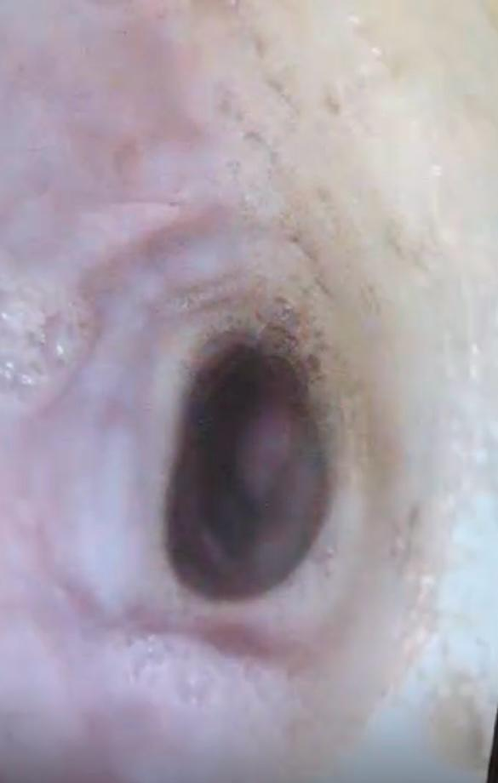

**B**

**A**

**Fig. 3 A and B Endoscopic examination after 3rd doses showed regression in the nodule size**

1. **Conclusion**

Early diagnosis and treatment of spirocercosis are **critical** to prevent life-threatening complications, including oesophageal rupture and metastatic sarcoma. Gastro-endoscopy remains the gold standard for definitive diagnosis, enabling direct visualization of pathognomonic nodules. In this case, doramectin demonstrated marked efficacy as an anthelmintic, achieving rapid parasite clearance and clinical resolution. The combination of endoscopic diagnostics, routine faecal testing, and prompt doramectin administration significantly improved outcomes, highlighting the value of integrated diagnostic and therapeutic approaches. These findings underscore the importance of maintaining high clinical suspicion in endemic regions to facilitate early intervention.

Disclaimer (Artificial intelligence)

Option 1:

Author(s) hereby declare that NO generative AI technologies such as Large Language Models (ChatGPT, COPILOT, etc.) and text-to-image generators have been used during the writing or editing of this manuscript.

Option 2:

Author(s) hereby declare that generative AI technologies such as Large Language Models, etc. have been used during the writing or editing of manuscripts. This explanation will include the name, version, model, and source of the generative AI technology and as well as all input prompts provided to the generative AI technology

Details of the AI usage are given below:

1.

2.

3.

References

1. Bailey WS*. Spirocerca lupi:* a continuing inquiry. J Parasitol. 1972;58:3–22.
2. **Berry WL.** Spirocerca lupi esophageal granulomas in 7 dogs: resolution after treatment with doramectin. J Vet Intern Med. 2000;14(6):609-12.
3. Boulineau TM, Andrews-Jones L, Van Alstine W. Spontaneous aortic dissecting hematoma in two dogs. J Vet Diagn Invest. 2005;17(5):492–7.
4. Christie J, Bodenstein LL, Van der Merwe LL, Sommerville JE, Schwan EV. The sensitivity of direct faecal examination, direct faecal flotation, modified centrifugal faecal flotation and centrifugal sedimentation/flotation in the diagnosis of canine spirocercosis. Journal of the South African Veterinary Association. 2011 Jun 1;82(2):71-5.
5. Dvir E, Kirberger RM, Clift SJ, Van Der Merwe LL. Review: challenges in diagnosis and treatment of canine spirocercosis. Isr J Vet Med. 2010;65(1):5–10.
6. Dvir E, Kirberger RM, Malleczek D. Radiographic and computed tomographic changes and clinical presentation of spirocercosis in the dog. Veterinary Radiology & Ultrasound. 2001 Mar;42(2):119-29.
7. Giannelli A, Baldassarre V, Ramos RA, Lia RP, Furlanello T, Trotta M, et al. *Spirocerca lupi* infection in a dog from southern Italy: an “old fashioned” disease? Parasitol Res. 2014;113:2391–4.
8. Gottlieb Y, Klement E, Aroch I, Lavy E, Kaufman M, Samish M, Markovics A. Temporal association of ambient temperature and relative humidity with Spirocerca lupi infection of Onthophagus sellatus: a 14-year longitudinal study. Veterinary Parasitology. 2014 Aug 29;204(3-4):238-42.
9. Joubert KE, McReynolds MJ, Strydom F. Acute aortic rupture in a dog with spirocercosis following the administration of medetomidine. J S Afr Vet Assoc. 2005;76(3):159–62.
10. Jyothi Sree Ch, Hafeez Md. A study on prevalence of spirocercosis in dogs in certain parts of Andhra Pradesh, India. Int J Agric Sci Vet Med. 2013;1(3):59–66.
11. Lavy E, Aroch I, Bark H. Evaluation of doramectin for the treatment of experimental canine spirocercosis. Vet Parasitol. 2002;109(1–2):65–73.
12. Lavy E, Harrus S, Mazaki-Tovi M, Bark H, Markovics A, Hagag A, Aizenberg I, Aroch I. Spirocerca lupi in dogs: prophylactic effect of doramectin. Research in veterinary science. 2003 Dec 1;75(3):217-22.
13. **Markovics A, Medinski B.** Improved diagnosis of low-intensity Spirocerca lupi infection by the sugar flotation method. J Vet Diagn Invest. 1996;8(4):400-1.
14. Mazaki-Tovi M, Baneth G, Aroch I, Harrus S, Kass PH, Ben-Ari T, Zur G, Aizenberg I, Bark H, Lavy E. Canine spirocercosis: clinical, diagnostic, pathologic, and epidemiologic characteristics. Veterinary Parasitology. 2002 Aug 2;107(3):235-50.
15. Mylonakis ME, Rallis T, Koutinas AF. Canine spirocercosis. Compend Contin Educ Vet. 2008;30(2):111–6.
16. Rojas A, Dvir E, Baneth G. Insights on Spirocerca lupi, the carcinogenic dog nematode. Trends in parasitology. 2020 Jan 1;36(1):52-63.
17. Rojas A, Segev G, Markovics A, Aroch I, Baneth G. Detection and quantification of *Spirocerca lupi* by HRM qPCR in fecal samples from dogs with spirocercosis. Parasit Vectors. 2017;10:1–8.
18. Van der Merwe LL, Kirberger RM, Clift S, Williams M, Keller N, Naidoo V. *Spirocerca lupi* infection in the dog: a review. Vet J. 2008;176(3):294–309.
19. **Weatherley AJ, Hong C, Harris TJ, Smith DJ, Hammet NC.** Persistent efficacy of doramectin against experimental nematode infections in calves. In: Vercuysse J, editor. Doramectin – a novel avermectin. Vet Parasitol. 1993;49(1):45-50.
20. Wright I, Stafford K, Coles G. The prevalence of intestinal nematodes in cats and dogs from Lancashire, north-west England. J Small Anim Pract. 2016;57(8):393–5.
21. Yıldırım MZ, Kutsal O, Avcıoğlu H. Spirocercosis in a dog. Ankara Üniversitesi Veteriner Fakültesi Dergisi. 2007 Mar 1;54(1):61-4.
22. Yogeshpriya S. A complete overview on spirocercosis in dogs. Int J Food Agric Vet Sci. 2016;6(3):16–20.