DIVERSITY OF PULSE BEETLES (COLEOPTERA: CHRYSOMELIDAE: BRUCHINAE) ASSOCIATED WITH STORED PULSES IN DISTRICT
KOLHAPUR, MAHARASHTRA, INDIA

Abstract
Insects are significant pests of stored pulses. It has been found that without adequate protection, Coleopteran pests, particularly beetles and weevils can quickly deteriorate stored grain and deplete entire stocks. A survey was conducted in various localities of the Kolhapur district to assess the diversity and insects infesting major stored pulses. The study indicates that six species of pulse beetles damage pulses during storage. Bruchids were the primary insect pests of legumes. Callosobruchus maculatus, Callosobruchus analis, and Callosobruchus chinensis emerged as the predominant pest of legumes and primarily attacked cowpea, green gram, and lentils. This work summarizes the importance and diversification of bruchid pests in the Kolhapur district. Understanding pest diversity is an important step in the strategy to develop a friendly and ecological control method for these harmful insects.

Key words: Stored pulses, pulse beetles, pest, legume, diversity, infestation, cowpea, Kolhapur.
Introduction
Pulses, a crucial part of the human diet, are a great source of energy, proteins, minerals, vitamins, and essential amino acids. In tropical and subtropical climates, pulse crops such as green gram, chick pea, black gram, adzuki bean, pigeon pea, and cowpea are significant crops for agriculture and the economy (Sharma et al., 2007; Bharathi et al., 2017; Arulselvi et al., 2024). India, a major producer of grain legumes, accounts for one-third of global acreage, though its domestic output has lagged behind population growth (Chalam et al., 2013). According to reports, the annual weight loss in the storage of pulses in India is between 55-60%, while the seed's protein content is lost between 45.5-66.3% (Hosamani et al., 2018). Seed beetles, 1700 species in the family Chrysomelidae, are characterized by strong plant tissue specialization, with larvae developing only inside seeds, although some species may complete development in other plant parts (Hoffmann, 1945; Johnson et al., 2004). Bruchid infestation, which feeds on grain contents and leaves only the shell, can cause seed destruction within six months, rendering them unfit for human consumption. Callosobruchus maculatus, Callosobruchus analis, and Callosobruchus chinensis are the three species of pulse beetles that are considered significant infestation of stored pulses in India, causing significant losses in Vigna crops, especially during storage, and their infestation results in both quantitative and qualitative losses (Deshpande et al., 2011; Arulselvi et al., 2024). Bruchus are not granary pests of stored legume seeds because of their strict univoltine life cycle (Southgate, 1979). A secondary infection of fungi that produces mycotoxin is caused by bruchid infestation, and as a result, seeds undergo biochemical changes during storage that render them unfit for human consumption. Additionally, the pest lowers market value and germination potential (Augustine and Balikai, 2019). Considering the significance of the diversity of pulse beetles for the management of stored pulses and their pests, it has been decided to work on pulse beetles from the Kolhapur district.

Material and Methods

Pulse beetles were collected by handpicking method from farmers' residences, marketplaces, grocery shops, and godowns between March 2019 and June 2023, and they were preserved by both wet and dry preservation methods. Using an HDMI digital camera connected to an Olympus CX31RTSF microscope, images were captured using TCapture software. The photos were stacked in Helicon Focus 7 and then edited in Photoshop CS3. The measurements were taken using Image J software. The identification of specimens was done by using identification keys given by Pratt and Scott (1962), Gorham (1991), Sengupta et al. (1996), Klimaszewski and Watt (1997), Kingsolver (2004), Serum et al. (2022), Aidbhavi et al. (2023) and literature (Southgate et al. 1957; Salunkhe and Gaikwad 2023a; 2024b).

Results and Discussion

Table 1 lists pulse beetles recorded from pulses sampled in the Kolhapur district. The present investigation reports that six species belonging to family Chrysomelidae are Callosobruchus chinensis, Callosobruchus phaseoli, Callosobruchus maculatus, Callosobruchus analis, Zabrotes subfasciatus and Bruchus pisorum (Fig.1. a-l). Following are the recorded species with their key characters used for the identification of species.
1. Callosobruchus chinensis (Linnaeus, 1758): Body length is 2.6mm to 3.3 mm. Males have black antennae, while females have dark red antennae. The species has an integument color ranging from red to black, with a red vertex and a black frons. The pronotum is convex. The elytra are red to black, with a diagonal yellow band in the basal half. The venter of the body is usually black or partly red. The male pygidium is white with dark spots.
2. Callosobruchus phaseoli (Gyllenhal, 1833): The body length is 2.3mm to 3mm. The reddish brown, pubescent body has enlarged eyes in males, with a segmented antenna, finely punctate vertex and frons, and a yellow pronotum, scutellum, and elytra. The hind leg has a distinct tooth-like angulation and a swollen pygidium; apically two dark brown spots are present.
3. Callosobruchus maculatus (Fabricius, 1775): The body length is 2.1mm to 2.9mm. The adult male is small and oval, whereas the female is elongated, with a pygidium covered by elytra and exposed due to eggs. Both have long 11 segmented antennae and sexual dimorphism according to the number of antennal sensilla. Females are blackish and larger, while males are chocolate or reddish brown.
4. Callosobruchus analis (Fabricius, 1781): Body length is 2.6mm to 3.1mm. Eyes are less deeply emarginate, flattened, and less prominent and pronotum is evenly rounded, slightly extending the median lobe beyond the posterior margin, elytra markings of both sexes are more constant, and both sexes have a median line of white pubescence on the pygidium. The hind leg femur is bicarinate ventrally, the tooth on the outer carina is large and pointed and the tooth on the inner carina is very minute or absent.
5. Zabrotes subfasciatus (Boheman, 1833): Body length is 2.3mm to 2.5mm. Males have a brown head, pronotum, elytra, reddish-brown antenna, yellowish-brown integument, and pygidium. Whereas in females, the head, pronotum, elytra, pygidium, ventral areas, antenna, and legs are grey with a variable pattern of grey and dark brown, a median white stripe, and a yellowish-brown basal band. Sexually dimorphic antennae are present, with males reaching the first abdominal segment and females reaching the metacoxa.
6. Bruchus pisorum (Linnaeus, 1758): The body length is 3.9mm to 4.2mm. Species structure is densely foveolate. The specimen is black with four basal antennanal segments, protibia and tarsi, mesotibia, and tarsus reddish orange. The head is white or mixed with yellowish-brown. Elytra are mostly yellowish brown with dark-brown maculae, long and convex, with deep imbricate striae.
Out of these six species, five species belong to the tribe Bruchini, and 1 belongs to the tribe Amblycerini. In all, C. maculatus, C. chinensis and C. analis were found to be most destructive pests of pulses in the study area because they attack many types of pulses like Cow pea, Green Gram, Pigeon pea, Chick Pea, Black gram, Moth Bean, Lentil, Pea, and Dark Red Kidney beans. Whereas C. phaseoli, Z. subfasciatus, and B. pisorum are least damaging bruchids found only on 1 or 2 seeds which are Lima bean, Lablab, Black Turtle Bean, and Angled pea. Pest populations were highest in cow pea and green gram and lowest in black gram. Among six recorded species, one species of beetles, Z. subfasciatus reported for the first time from Maharashtra as primary pests of Black Turtle Bean.

According to Kumar et al. (2005), the most common stored grain pest observed in the Dharwad district of Karnataka was the pulse beetle. Similar findings were reported by Hampanna et al. (2006) in the Raichur district of Karnataka, where C. chinensis was identified as the most significant pest of chickpeas. This study reports six species of pulse beetles affecting pulses from the Kolhapur district. More or less similar observations were made by Bhalla et al. (2009), who studied the detection of insect pests in indigenous germplasm. Several species of Callosobruchus, including C. analis, C. cajanus, C. chinensis, C. maculatus, and C. phaseoli, are significant primary pests of pulses that considerably reduce the yield of a various crops across India. Bawa et al. (2017) investigated the diversity and abundance of Callosobruchus, a major insect pest infesting cowpea in central Ghana. Five species were identified: C. maculatus, C. chinensis, C. analis, C. subinnotatus, and C. rhodesianus, with C. maculatus being the most abundant. Harish et al. (2018) surveyed six districts of the Hyderabad-Karnataka region to assess the diversity of insects infesting stored pulses. They have reported pests, namely, C. analis, C. maculatus, C. chinensis, Tribolium castaneum, and hymenopteran parasitoids collected in pulses samples by them. Based on rank abundance, C. analis was the predominant species in pigeon pea, chickpea, green gram, and black gram. Aidbhavi et al. (2023) surveyed 81 grain samples from 74 locations across 24 states in India to understand the infestation, distribution, and diversity indices of bruchids infesting edible stored pulses. Five bruchid species were identified, with C. analis being the most abundant and dominant. C. chinensis being more prevalent than C. analis and C. maculatus was smaller in numbers, with grain moisture and storage duration positively correlated with infestation and damage.

Earlier, Z. subfasciatus was recorded on the seeds of black turtle bean (Phaseolus vulgaris) from Andhra Pradesh by Bhalla et al. (2009). The present study also reports this species from Kolhapur (Halsavade) on black turtle bean (Phaseolus vulgaris), which confirms its new record for Maharashtra, as its record is not observed in the literature of Bhalla et al. (2009), https://www.zsi.gov.in accessed on 5 Mar 2025 and https://www.gbif.org/species/1048600 accessed on 5 Mar 2025.

Tables and Figures
Table 1 Diversity of pulse beetles of pulses from Kolhapur district.
Sr. No. | Insect pests | Host pulses | Tribe | Family
1. | Callosobruchus chinensis | Lentil, Pigeon pea, Pea Dark Red Kidney beans | Bruchini | Chrysomelidae
2. | Callosobruchus phaseoli | Lima bean, Lablab | Bruchini | Chrysomelidae
3. | Callosobruchus maculatus | Cow pea, Green Gram, Pigeon pea, Chick Pea, Black gram, Moth Bean | Bruchini | Chrysomelidae
4. | Callosobruchus analis | Cow pea, Chick Pea, Green Gram, Moth Bean | Bruchini | Chrysomelidae
5. | Zabrotes subfasciatus | Black Turtle Bean | Amblycerini | Chrysomelidae
6 | Bruchus pisorum | Angled pea | Bruchini | Chrysomelidae

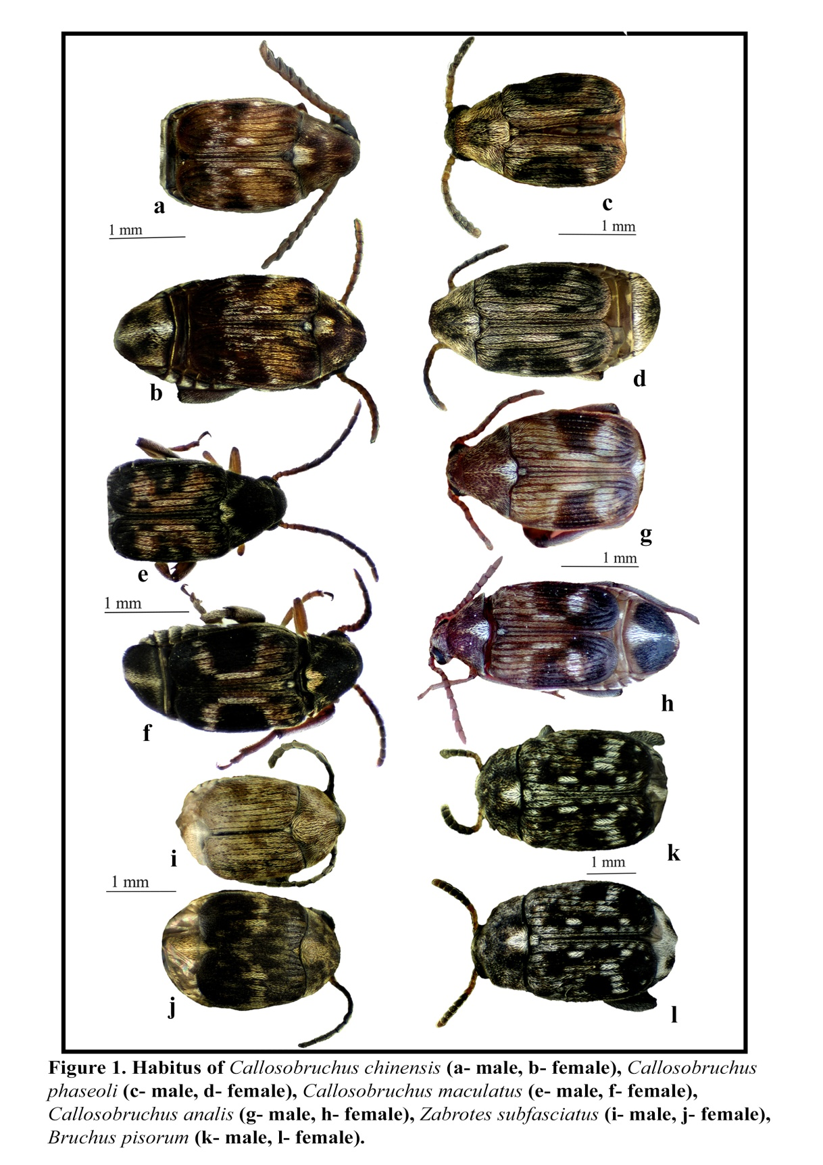

Conclusions
The present study will provide significant information on pulse beetles because there is not been a thorough investigation of pulse beetle diversity in the Kolhapur district. This study will be useful in developing control measures to prevent stored pulses from pests belonging to the pulse beetle category. If concentrated efforts are taken for a thorough investigation of pulse beetles infesting pulses for a longer duration, more pulse beetle species on stored pulses will be added to this work. One can study the life cycles of these reported pests, which will help to manage pests of pulses by effective control strategies.
Disclaimer (Artificial Intelligence)
Author(s) hereby declare that NO generative AI technologies, such as Large Language Models (ChatGPT, COPILOT, etc.) and text-to-image generators have been used during the writing or editing of this manuscript.

References

Arulselvi, S., Dharani, K., Kamalnathu, T., Kishore, S., Tamilselvi, C., Chitra, M., et al. (2024). Bruchid Resistance in Pulses: A Review. Agricultural Reviews, 45(2), 304-310.
Augustine, N., & Balikai, R. A. (2019). Biology of pulse beetle, Callosobruchus chinensis (Linnaeus) on cowpea variety DC- 15. Journal of Entomology and Zoology Studies, 7(1), 513-516.

Aidbhavi, R., Soren, K. R., Bandi, S. M., Ranjitha, M. R., & Kodandaram, M. H. (2023). Infestation, distribution and diversity indices of bruchid species on edible stored pulses in India. Journal of Stored Products Research, 101, 1-18.

Bhalla, S., Gupta, K., Kapur, M., Singh, C., Kumar, N., Meenakshi, et al. (2009). Detection of insect pests in indigenous germplasm. Indian Journal of Agricultural Sciences, 79 (2), 129-34.

Bharathi, D. T., Krishnayya, P. V., & Madhumati, T. (2017). Developmental response of Callosobruchus maculatus F. and C. chinensis L. on different pulse host grains. Chemical Science Review and Letters, 6(22), 786-792.

Bawa, S. A., Ofori, E.K., & Osae, M. (2017). Species diversity and relative abundance of Callosobruchus (Coleoptera: Chrysomelidae) in stored cowpea in four major agricultural produce markets in the central region, Ghana. Journal of Stored Products Research, 1(72), 117-20.

Chalam, V. C., Shashi, Bhalla. B., Singh, & Rajan. (eds.). (2013). Potential quarantine pests for India: grain legumes. National Bureau of Plant Genetic Resources, New Delhi, India.

Deshpande, V. K., Makanur, B., Deshpande, S. K., Adiger, S., & Salimath, P.M. (2011). Quantitative and qualitative losses caused by Callosobruchus maculatus in cowpea during seed storage. Plant Archives, 11(2), 723-731.

Gorham, J. R. (1991). Insect and mite pests in food: an illustrated key, US Government Printing Office, Washington.

Harish, G., Naganagoud, A., Sreenivas, A. G., Hiregoudar, S., & Kisan, B. (2018). Diversity and distribution of stored grain insect pests of pulses and their natural enemies. Indian Journal of Agricultural Research, 52(2), 157-161.

Hampanna, Y. L., Naganagoud, A., & Patil, B. V. (2006). Evaluation of animal origin inert materials against rice weevil and pulse beetle in stored sorghum and chickpea. Karnataka Journal of Agricultural Sciences, 19 (1), 54-57.

Hoffmann, A. (1945). Coleopteres Bruchidae et Anthribidae. In: Lechevalier, P. (Ed.), Faune de France 44, Paris.

Hosamani, G. B., Jagginavar, S. B., & Karabhantanal, S. S. (2018) Biology of pulse beetle Callosobruchus chinensis on different pulses. Journal of Entomology and Zoology Studies, 6(4), 1898-1900.

Johnson, C. D., Southgate, B. J., & Delobel, A. (2004). A revision of the Caryedontini (Coleoptera: Bruchidae: Pachymerinae) of Africa and the Middle East. Annals of the entomological society of America, 44, 1-120.

Kingsolver, J. M. (2004). Handbook of the Bruchidae of the United States and Canada (Insecta, Coleoptera) Vol II. United States Department of Agriculture, USA.

Klimaszewski, J., & Watt, J.C. (1997). Coleoptera: family-group review and keys to identification. Fauna of New Zealand, 37, 202.

Kumar, S., Naganagoud, A., & Patil, B. V. (2005). Status on indigenous storage technologies for food grains followed in Northern Karnataka. Karnataka Journal of Agricultural Sciences, 18(3), 824-826.

Pratt, H.D., & Scott, H.G. (1962). A key to some beetles commonly found in stored foods. Proceeding of Entomological Society Washington, 64(l), 43-50.

Salunkhe, D. R., & Gaikwad, S. M. (2023a). Taxonomy of stored grain pest Callosobruchus phaseoli (Gyllenhal, 1833) (Coleoptera: Chrysomelidae: Bruchinae). Species, 24, 1-5.

Salunkhe, D. R., & Gaikwad, S. M. (2024b). Life Stages of Cowpea Weevil Callosobruchus maculatus (F). Indian Journal of Entomology, 86(4), 1334-1337.

Sengupta, T., Mukhopadhyay, P., & Sengupta, R. (1984). Major beetle pests of stored food products in India. Records of the Zoological survey of India. Miscellaneous publication occasional paper no. 62, Director, Zoological Survey of India, Calcutta.

Seram, D., Natesan, S., Muthaiyan, P., Karthikeyan, A., Samuel, K. J. (2022). Differentiating Callosobruchus of South India with Special Reference to Callosobruchus maculatus - A Useful Guide for Entomologists and Non-Entomologists. Research square.

Sharma, H. C., Gowda, C. L. L., Stevenson, P. C., Ridsdill-Smith, T. J., Clement, S. L., Rao, G. V. R., et al. (2007). Host plant resistance and insect pest Management in chickpea. Chickpea breeding and management. In: Yadav, S. S., Redden, R. J., Chen, W., Sharma, B. (Eds.), Chickpea Breeding and Management. pp 520-537.

Southgate, B. J., Howe, R.W. & Brett, G.A. (1957). The specific status of Callosobruchus maculatus (F.) and Callosobruchus analis (F.). Bulletin of Entomological Research, 48(1), pp. 79-89.

Southgate, B. J., (1979). Biology of the Bruchidae. Annual Review Entomology, 24, 449-473.

