**Original Research Article**

**AN ASSESSMENT ON SEASONAL PHYSICO-CHEMICAL VARIATIONS OF CHARIPUNIA *BEEL* OF MORIGAON DISTRICT, ASSAM, INDIA**

**ABSTRACT**

The present study was conducted to evaluate the seasonal physicochemical characteristics of Charipunia *beel* (7.0 ha) in the Morigaon district of Assam over a one-year period from May 2022 to April 2023. The majority of physico-chemical parameters were found to be a favorable range for growth and reproduction within the water temperature of aquatic species ranged from 18.60o C to 29.30o C, water pH from 5.5 to 7.9, dissolved oxygen ranged from 4.5 mg/l to 7.6 mg/l, total alkalinity from 42.3 mg/l to 67.1 mg/l, total hardness from 51.3 mg/l to 70.2 mg/l, free carbon dioxide from 5.5 to 9.3 mg/l, turbidity from 3.1 NTU to 4.6 NTU, and ammonia nitrogen ranged from 0.14 mg/l to 0.32 mg/l. Although the *beel* conditions were favorable for fish production, there is an urgent need for strict imposition and monitoring of fishery regulations during the banned season. In addition, the identification and protection of feeding and breeding grounds of Indigenous fishes and awareness among fishermen are very much needed for the sustainable use of the *beel*.

***Keywords****:* Physico-chemical, charipunia *beel*, seasonal variation, water quality

**INTRODUCTION**

Assam’s biologically rich beel on Majuli Island supports various aquatic and terrestrial species, including some globally threatened ones. The local communities rely heavily on this beel for their livelihood, engaging in fishing and harvesting other wetland biological resources. Consequently, the water quality of the beel holds significant economic and environmental importance (Doimari et al., 2024). In Assam, the water quality of *beels* is closely linked to local environmental conditions, including seasonal variations, agricultural practices, and human activities, such as fishing, wastewater disposal, and chemicals in nearby farm lands. Therefore, continuous monitoring of the physicochemical parameters is crucial for understanding the health of the *beel* ecosystem and implementing effective conservation and management practices. Furthermore, the physicochemical characteristics of *beel* waters play a key role in the overall functioning of the aquatic food chain. The functioning of an aquatic ecosystem is primarily governed by the interactions between its biotic and abiotic components. Water's abiotic or physico-chemical factors determine the system's quality and productivity. These factors include water temperature, transparency, pH levels, dissolved oxygen, free carbon dioxide, alkalinity, chloride, and phosphate. Physical parameters significantly influence thermal stratification and daily and seasonal changes, affecting the presence and distribution of microorganisms. (Verma et al., 2023), (Verma, 2023), plankton, benthic organisms, fish, and even vertebrates like birds. Meanwhile, chemical characteristics directly impact the ecosystem’s physical dynamics and biological productivity. (Verma et al., 2022), (Upadhyaya S., 2016). The productivity of a water body is primarily influenced by its physicochemical and biological characteristics. This research aimed to assess the water quality of the *beel*, which is essential for understanding the ecological health and sustainability of aquatic ecosystems. These measurements help evaluate the suitability of water for supporting aquatic life and offer insights into the effects of environmental and human factors on the ecosystem. The pH levels, maintained within a narrow range by factors such as bicarbonate (HCO₃⁻), are crucial in supporting ecosystem stability and aligning with established environmental thresholds (Das and Sharma, 2024). Water is essential for all living organisms, as life and development cannot occur in its absence (Anekar & Dongare, 2021).

**METHODOLOGY**

**STUDY AREA**

The Charipunia *beel* is a perennially close *beel* located in Charipunia village in the Morigaon district with latitude 26ᵒ15’10.0” N and longitude 92ᵒ21’22.8” E. The area of the *beel* is around 7 hectares (17.297 acres). The minimum depth of this *beel i*s 5 feet and the maximum is 12 feet. Approximately 250 families depend on this *beel* for their livelihood. The *beel* is under the lease of Charipunia Goan Unnayan Samiti, established in 1988-89.

Water samples were collected monthly from the surface layer at two locations (stations 1 and 2) for the research. Samples were collected early morning, between 4:30 and 6:00 AM, to maintain measurement consistency. Samples from each station were stored in separate plastic bottles, clearly marked as Station 1 and Station 2. The study analyzed several parameters, including water temperature (°C), pH, dissolved oxygen (mg/l), total alkalinity, total hardness, free carbon dioxide, turbidity, and total ammonia-nitrogen (mg/l). These physicochemical properties were measured according to the standard methods specified in the American Public Health Association (APHA, 2010) guidelines, ensuring reliable and consistent results.

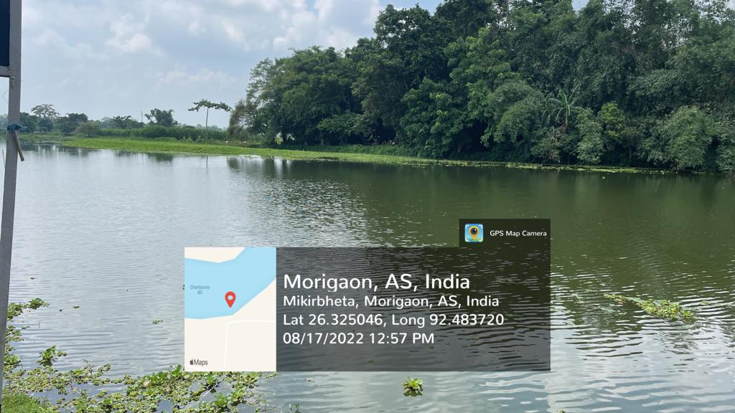 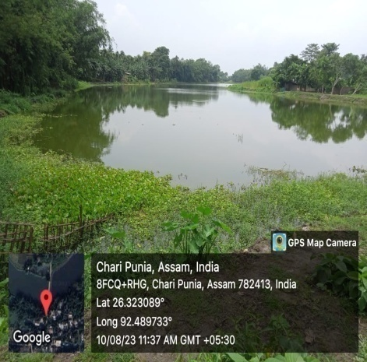

**Map 1**: GPS Map Locations of Study Sites of Charipunia *Beel*

**RESULTS AND DISCUSSION**

From May 2022 to April 2023, various water quality parameters of the Charipunia *beel*, including water temperature, pH, dissolved oxygen, total alkalinity, total hardness, turbidity, free carbon dioxide, and total ammonia-nitrogen, were measured ( Table 1). Water quality is defined as the overall relationship between a water body's physical, chemical, and biological properties. Analyzing water quality is essential for conserving natural ecosystems (Patil et al., 2012). Additionally, water quality significantly affects fish growth, maturation, reproduction, and development (Nargis & Pramanik, 2008). Human activities such as agriculture, urban development, domestic sewage disposal, and other factors can alter the physicochemical properties of water, thereby degrading water quality (Verma et al., 2011). The wetland holds excellent biological, environmental, and social significance, and any decline in water quality will negatively impact the entire wetland ecosystem (Sharma *et al, .*2024). Singh *et al.* (2017) observed the highest pH during the monsoon season and the lowest during the post-monsoon season, and recorded a pH range from 7.2 to 8.0 in the Bhara Haripota Wetland of 24 South Parganas, West Bengal. Acharjee *et al.* (2017) found dissolved oxygen values of 3.7 to 5.6 mg/l in Ghorajan beel, Assam,and 5.5 to 8.8 mg/l in Dighali *beel*, Assam. Kailash Khal wetland exhibits the spatial variations in phytoplankton community structure that were significantly correlated with specific environmental variables (pH, temperature, total hardness, TDS, and nutrients like nitrate, phosphate, and silicate), which were evident from CCA (Gogoi et. al., 2019). Water temperature ranged from 17.70ºC to 31.1ºC on the Moridikhow oxbow lake in Sivasagar district, Assam (Bora & Biswas, 2015). Dissolved oxygen ranged between 2.29 mg/l and 11.11 mg/l in Barbilla beel and 2.02 mg/l and 10.2 mg/l in Borali *beel* in Assam (Deka *et al.*, 2018). The *Beel* is widely recognized for its rich variety of native fish species, many of which hold significant value for food and ornamental purposes. Additionally, it provides an important resting habitat for numerous local and migratory bird species. However, the rise in human activities driven by a growing population has posed serious environmental threats to its biodiversity in recent years, ultimately affecting the broader ecological balance (Baruah D. and Baruah P. P., 2024). Dissolved oxygen varied from 5.13mg/l to 7.33 mg/l in 47 samples. Morakolong *beel*, Morigaon district of Assam (Tamuli *et al.,* 2018). Hussain *et al.* (2015) recorded an average turbidity of 56.5 NTU in Dhir Beel of Dhubri district of Assam.

Table 1: Seasonal Changes in the Physico-Chemical Parameters of Charipunia

|  |  |  |  |  |  |  |
| --- | --- | --- | --- | --- | --- | --- |
| **Season /**  **Parameters** | **Pre-monsoon (February 2023, March 2023, April 2023, May 2022)** | | **Monsoon (June 2022, July 2022, August 2022, September 2022)** | | **Post-monsoon (October 2022, November 2022, December 2022, January 2023)** | |
| Station 1 | Station 2 | Station 1 | Station 2 | Station 1 | Station 2 |
| Water Temperature(ºC) | 24.70± 1.58 | 24.45± 1.65 | 26.75± 1.35 | 26.82± 1.49 | 19.30± 0.35 | 19.45± 0.17 |
| Water pH | 7.37± 0.21 | 7.55± 0.13 | 6.40± 0.33 | 6.27± 0.23 | 6.70±0.15 | 6.60± 0.26 |
| Dissolved oxygen (mg/l) | 5.90± 0.57 | 6.17±0.58 | 5.42± 0.29 | 5.12± 0.13 | 5.57±0.20 | 5.80±0.20 |
| Total alkalinity (mg/l) | 46.30± 1.17 | 44.32± 1.06 | 48.67± 2.49 | 46.45± 2.65 | 57.02± 1.63 | 59.40± 3.25 |
| Total hardness (mg/l) | 60.72± 3.43 | 61.30±3.43 | 56.02± 1.94 | 55.27± 2.01 | 65.55± 0.93 | 66.65± 0.91 |
| Free CO2 (mg/l) | 6.55± 0.34 | 6.67± 0.34 | 6.00± 0.15 | 5.80± 0.15 | 8.17± 0.40 | 8.25± 0.46 |
| Turbidity (NTU) | 3.62± 0.20 | 3.47± 0.14 | 4.42± 0.08 | 4.40± 0.10 | 3.52± 0.15 | 3.52± 0.04 |
| Total Ammonia-nitrogen (mg/l) | 0.22± 0.02 | 0.23± 0.03 | 0.18± 0.01 | 0.17± 0.01 | 0.15± 0.01 | 0.16± 0.01 |

*Data are mean± Standard Error of 3 determinations

Fig. 1: Seasonal Fluctuations in Average Water Temperature (◦C) at Two Selected Stations (S1, S2)

Fig. 2: Seasonal Fluctuations in Water pH at Two Selected Stations (S1, S2)

Fig 3: Selected Variation of Dissolved Oxygen in two Selected Sampling Stations (S1, S2)

Fig.4: Selected Variation of Total Alkalinity in two Selected Sampling Stations (S1, S2)

Fig 5: Selected Variation of Hardness in two Selected Sampling Stations (S1, S2)

Fig 6: Selected Variation of Turbidity in two Selected Sampling Stations (S1, S2)

Fig 7: Selected Variation of Free Carbon Dioxide in two Selected Sampling Stations (S1, S2)

Fig 8: Selected Variation of Total Ammonia-Nitrogen at two Selected Sampling Stations (S1, S2)

**CONCLUSION**

This study assessed the physicochemical characteristics of Charipunia *beel* in Morigaon district, Assam, India, from May 2022 to April 2023. The research was conducted at two stations across three seasons: pre-monsoon, monsoon, and post-monsoon seasonal variations of physicochemical parameters in Charipunia *beel*, which can inform future management and conservation. Water temperature ranged from 18.60°C (December) to 29.30°C (July). Turbidity varied between 3.10 NTU (January) and 4.60 NTU (September). Total ammonia-nitrogen concentrations were highest in May (0.32 mg/l) and lowest in December (0.14 mg/l). Free carbon dioxide levels peaked in November (9.30 mg/l) and were lowest in September (5.50 mg/l). Total hardness ranged from 51.30 mg/l (August) to 70.20 mg/l (February). Total alkalinity was highest in November (67.10 mg/l) and lowest in March (42.30 mg/l). Dissolved oxygen concentrations were highest in February (7.60 mg/l) and lowest in May (4.50 mg/l). Water pH varied from 5.50 (July) to 7.90 (March). The chemical composition of the wetland directly impacts the survival of its biodiversity. It is essential for individuals engaged in activities related to wetland resources to be aware of the consequences of overexploitation and the improper use of these resources for their livelihoods. The study concludes that the water quality of the *beel* remains generally healthy. However, suppose anthropogenic activities such as the excessive use of fertilizers near agricultural fields and the use of detergents for washing are not regulated. In that case, the water quality may deteriorate further, potentially affecting the composition of aquatic flora and fauna. This research could contribute to the optimal use and sustainable management of the *beel*.

Disclaimer (Artificial intelligence)

Bhagyashree Das hereby declares that NO generative AI technologies such as Large Language Models (ChatGPT, COPILOT, etc.) and text-to-image generators have been used during the writing or editing of this manuscript.

**REFERENCES**

Acharjee, B. B., Das, A. N. & Das, N (2017). Fish Diversity and Fisheries Potential of Some Wetlands in Assam. *Remarking An Analisation***.,1** (12):2455-0817

Anekar, S., & Dongare, M. (2021). Study on the fluctuation in the physicochemical parameters of Shiroli Lake, Kolhapur. *International Journal of Ecology and Environmental Sciences*, ***3***(4), 46-50.

APHA (2010). Standard methods for the examination of water and wastewater, 21st Edn. Eaton, A.D., Clesceri, L.S., Rice, E.W. and Greenberg, A.E. (eds), American Public Health Association, Washington, D.C.

Baruah, D., and Baruah, P. P. (2024). Physico-chemical parameters and phytoplankton heterogeneity in different seasons of Sorbhog Beel, a pivotal floodplain wetland in the Himalayan Foothill. *Vegetos*, ***37***(1), 68-81.

Bora, S. and Biswas, S.P (2015). Water quality and ichthyofaunal diversity of an oxbow lake in upper Assam. *International Journal of Fisheries and Aquatic Studies***., 3**(1):15-18

Das, A. N., & Sharma, D. K. (2024). Behavioural Distributions of Macrophytes in an Oxbow Lake, Dhir Beel With Reference to its Water Quality in Assam, India. *Journal of Bioresource Management***, *11*(**2), 11.

Deka,U. and Sarma, S.K. (2018). An assessment of physico-chemical properties of water of two wetlands of Nalbari district of Assam, North-East India, *International Journal of Basic and Applied Research****,* 8**(12):361-371.

Doimari, R., Konwar, S., Dutta, A. J., Sinha, D., Daflari, K. D., & Das, M. J. (2024). Checklist of aquatic macrophytes and water quality assessment of Kakarikata *Beel*, Majuli District, Assam. Uttar Pradesh Journal of Zoology, **45**(19), 10-16.

Gogoi, P., Sinha, A., Das Sarkar, S., Chanu, T. N., Yadav, A. K., Koushlesh, S. K., ... & Das, B. K. (2019). Seasonal influence of physicochemical parameters on phytoplankton diversity and assemblage pattern in Kailash Khal, a tropical wetland, Sundarbans, India. *Applied Water Science*, ***9*,** 1-13.

Hussain, B. A., Chandra, B., Rand, A., & Amalesh, D. (2015). A study of the Limnology and Ichthyology of Dhir Beel at Dhubri, Assam, India. *Int. Res. J. Biological Sci****.,* 4**(8):40-48

Nargis, A., and Pramanik, S. H. (2008). Physico-chemical parameters in relation to meterological and climatic conditions in a fish pond. *Bangladesh Journal of Scientific and Industrial Research***, 43**(3): 405-410

Patil, P. N., Sawant, D. V., and Deshmukh, R. N. (2012). Physico-chemical parameters for testing of water- A review. *International Journal of Environmental Sciences***, 3**(3):1194-1207

Sharma, P., Sarkar, R., Deka, J. P., et al. (2024). Assessing water quality of Deepor *Bee*l, Assam, NE India, using water quality index: A case of Ramsar wetland. Arabian Journal of Geosciences, **17**(20).

Singha, N. and Deka, R. N.P (2017). A preliminary study on ichthyofaunal diversity of Diplai beel of Kokrajhar district of Assam, India. *International Journal of Fisheries and Aquatic Studies****,* 5**(3):269-275.

Tamuli, P., Bhagabati, S. K., Dutta, R., Zaman, A. S. N., Sarma, J., Choudhury, A. And Debnath, D. J (2018). Physico- chemical characteristics of 47 no. Morakolong *Beel*, Morigaon district, Central Brahmaputra Valley Zone, Assam. *IJCS****.,*6**(5):748-754

Upadhyaya S. (2016). Study on Physico-chemical parameters of Dighali *Beel* of Assam, India NeBIO **7**(1): 30-34

Verma, P.U., Chandawat, D.K. and Solanki, H.A (2011). Seasonal variations in physico- chemical variations and phytoplankton analysis of *Kankarai Lake. Life Sciences Leaflets***, 19**:842-854

Verma, D. K., Kumar, J., Das, B., Alam, A., Jha, D., & Thakur, V. (2023). *Importance of Periphyton to the Ecology of Subtropical River Ganga, India*. ***1***, 30–38.

Verma, D. K., Maurya, N. K., & Kumar, P. (2022). *Important Water Quality Parameters in Aquaculture: An Overview*. ***3***(3).