**Demonstrating the Effectiveness of Supplementary Feeding in Composite Carp Culture in Warangal District, Telangana, India**

**ABSTRACT**

Aquaculture serves as a pivotal sector in augmenting rural livelihoods through income generation, employment creation and the enhancement of nutritional security in India. A field-based study was undertaken by Krishi Vigyan Kendra (KVK), Mamnoor, Warangal to evaluate the efficacy of supplementary feeding regimes in carp culture under a composite fish farming system. The experimental design comprised three treatment groups with three replications each, conducted over an eight months period under on-farm conditions. Parameters assessed included Specific Growth Rate (SGR), Total Fish Production, incidence of disease and economic metrics. Economic analysis involved the computation of gross returns, net returns, and the Benefit-Cost (B:C) ratio. The results demonstrated that consistent application of nutritionally balanced supplementary feed significantly enhanced fish growth performance and overall productivity, contributing to improved economic viability. The study underscores the importance of integrating scientific pond management practices with regular supplementary feeding to promote sustainable aquaculture and maximize profitability among smallholder fish farmers.

**Key Words:** Fish farming, supplementary feeding, composite fish culture, Front Line Demonstration, carp growth, economic returns, rural aquaculture, pond management.

**INTRODUCTION:**

The fisheries sector plays a pivotal role in the Indian economy by contributing to food and nutritional security, employment generation, export earnings and overall economic development. Often referred to as a "Sunrise Sector," fisheries support the livelihoods of over 30 million individuals, particularly those from marginalized and vulnerable communities (DAHDF, 2024). According to the FAO's 2024 report The State of World Fisheries and Aquaculture (SOFIA), India ranks among the top global fish producers, contributing around 8% of the world’s total fish production with a record output of 174.45 lakh metric tonnes during 2023-2024. The country also leads in inland fisheries production, with an annual yield of 1.9 million metric tonnes.

In the context of aquaculture, India produced 13.13 million metric tonnes of inland fish during 2022-2023. Andhra Pradesh topped the chart with 4.5 million metric tonnes, followed by West Bengal at 2 million metric tonnes. Telangana, although a relatively new state, ranks third in terms of fishery resources and sixth in production. The state reported a fish output of 175.45 lakh metric tonnes in 2022-2023, contributing significantly to its economy with a Gross Value Added (GVA) of ₹2,17,983 crores, reflecting a compound annual growth rate (CAGR) of 14.1% surpassing the national average of 10.1% (Ganesh *et al*., 2024).

In Telangana, approximately 45.8% of the working population is engaged in fisheries and aquaculture, making this sector a vital driver of rural livelihood and development (Socio-Economic Outlook, Government of Telangana, 2023). To further support the sector, the government is implementing various schemes aimed at improving productivity, minimizing post-harvest losses, and enhancing the welfare of fishers (Ganesh *et a*l., 2024).

Freshwater aquaculture in India primarily relies on composite fish culture, involving Indian major carps such as Rohu (Labeo rohita), Catla (Catla catla), and Mrigal (Cirrhinus mrigala), along with Chinese carps like Common carp (Cyprinus carpio), Grass carp (Ctenopharyngodon idella), and Silver carp (Hypophthalmichthys molitrix). This polyculture system not only maintains water quality but also enhances production compared to monoculture systems (Chakrabarti, 1998; Azim *et al*., 2001; Dhawan and Kaur, 2002).

Composite fish culture is a widely accepted and profitable practice; however, its success heavily depends on the adoption of scientific pond management, including both pre-stocking and post-stocking practices. Despite its benefits, many farmers overlook essential practices such as pond cleaning, liming, fertilization, eradication of predatory & weed fishes and water quality management (Ramakrishna et al., 2013). Additionally, irregular feeding practices often limited to mustard oil cakes are common. This study seeks to compare fish yield and economic outcomes between traditional farmer practices and scientifically guided supplementary feeding methods. By promoting awareness of regular feeding, balanced diets and proper pond maintenance, the study aims to encourage widespread adoption of improved practices in composite fish culture (Islam et al., 2008; Sampa, 2024).

Krishi Vigyan Kendra (KVK), Mamnoor, operating under P.V. Narsimha Rao Telangana Veterinary University, Hyderabad, plays a key role in disseminating new technologies through training and demonstration programs. KVK focuses on skill development among farmers, rural youth and extension workers while conducting short-term, on-farm trials to validate promising technologies in the Warangal district.

**Materials and Methods**

The present study was conducted by Krishi Vigyan Kendra (KVK), Mamnoor, Warangal under the aegis of P.V. Narsimha Rao Telangana Veterinary University, Hyderabad. The study was implemented through Front Line Demonstrations (FLD) titled "Demonstration on Supplementary Feed Performance in Carp Culture," and was carried out over a period of eight months under field conditions. Three treatment options were evaluated with a minimum of three replications per treatment.

Treatment (T1) represented the traditional farmer practice, which involved occasional pond cleaning and feeding with De-Oiled Rice Bran (DOB) and Groundnut Oil Cake (GNOC) without adhering to a specific feeding rate. Treatment (T2)involved proper pond cleaning and feeding with pelleted feed at 5% of the fish's body weight during the fingerling stage, 3% during the grow-out stage (150-250 g) and 2% during the adult stage. Additionally, probiotics and growth promoters were applied at a rate of 1 liter per acre. Treatment (T3) was similar to T2 but emphasized strict adherence to both pre-stocking and post-stocking management practices, including pond preparation, liming, fertilization, weed and predator control, water quality monitoring, and health management. For T2 and T3, pelleted feed was administered at 5% of fish body weight during the fingerling stage, 3% during the intermediate stage (250–500 g), and 2% for mature fish. Probiotics and growth promoters were applied weekly at 1 litre/acre. Initial fish weights averaged 200–220 grams. Stocking density was 6,500 fish/ha. Parameters such as Specific Growth Rate (SGR), percentage weight gain, yield (q/ha), gross and net returns, and B:C ratio were recorded and analyzed.

**Specific Growth Rate (SGR):** The SGR is a measure of the daily growth rate of fish expressed as a percentage, calculated using the natural logarithm of the weights over a specific time interval. It is given by the formula:

SGR(%/day) = ln Wf​− ln Wi​​×100

t

Where

Wi​ = Initial weight of the fish (at day 0)

Wf​ = Final weight of the fish (at day 240)

t = Duration of the culture period in days (in this case, 240 days)

ln = Natural logarithm

**Net Return**: Gross Return - Cost of Production

**Benefit-Cost Ratio (B:C)**: Gross Return /Cost of Production

**Statistical Analysis**

The data from this study (growth parameters) were analyzed using version 22.0 of the Statistical Package for the Social Sciences (SPSS). To compare the means among different experimental groups, one-way ANOVA and Duncan's multiple-range tests were employed, revealing a significant difference at the 5% probability level (p<0.05). Each dataset was presented with its mean ± standard error (SE).

The details of the FLD components, including input distribution, management practices and performance indicators were systematically recorded and evaluated.

**Table 1: Overview of the Front Line Demonstration (FLD) on Carp Culture**

|  |  |  |
| --- | --- | --- |
| **1** | **Title of Front Line Demonstration** | Demonstration on Supplementary Feed Performance on Carps |
| **2** | **Problem diagnosed** | Low fish productivity due to traditional feeding methods and inadequate health management practices |
| **3** | **Technologies Assessed:** | **Farmers Practice (T1)** Occasional pond cleaning and feeding with de-oiled rice bran (DOB) and groundnut oil cake (GNOC) without maintaining an appropriate feeding rate. **T2:** Proper pond cleaning and feeding with pelleted feed at 5% of body weight during the fingerling stage, 3% for fish weighing 100–120 g, and 2% for adult fish. Also includes the use of probiotics and growth promoters at 1 liter per acre. **T3:** Strict adherence to all pre- and post-stocking management practices, including prophylactic treatment, feeding as per T2, and application of health supplements. |
| **4** | **Production System and Thematic Area:** | Composite fish culture involving Indian Major Carps with focus on fish disease management. |
| **5** | **Performance Indicators:** | The improved technologies demonstrated better growth performance, disease resistance, and economic returns compared to traditional practices. |
| **6** | **Recommendation for Micro-Level Adoption:** | The best results were achieved under T3, yielding 16.5 quintals/ha. Regular feeding with pelleted feed or mixed mustard oil cake, fortified with vitamins and minerals, along with appropriate medication is recommended for broader adoption. |
| **7** | **Farmer Participation and Response:** | Farmers actively participated through training programs and demonstrations. They expressed satisfaction with the improved fish yield and profitability resulting from the adoption of scientific fish farming practices. |

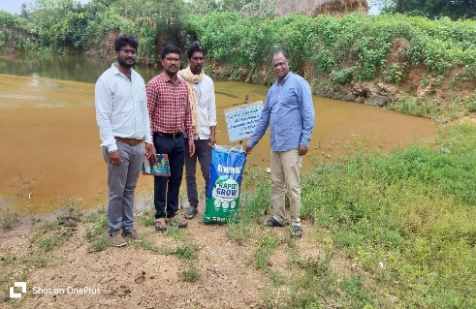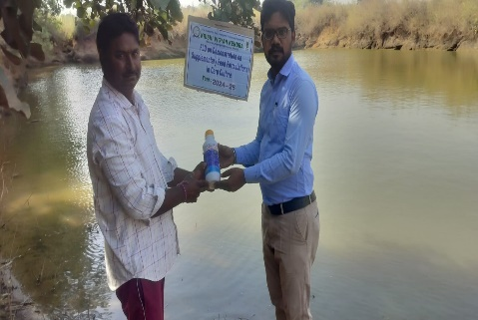

**Supplementary Floating Pellet Feed (CP42%)**

**Growth Promoter**

**(Amino Plus Gel)**

**Fig.No.1.** Critical Input Distribution Under Front Line Demonstrations

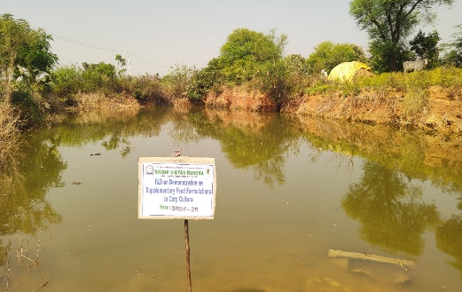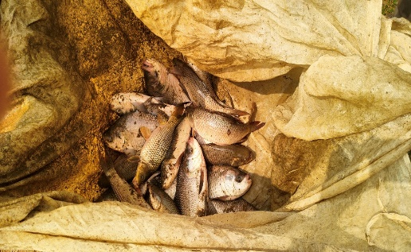

**Harvested Fish**

**Culture Grow out Fish Pond**

**Fig.No.2.** Grow out Fish Ponds

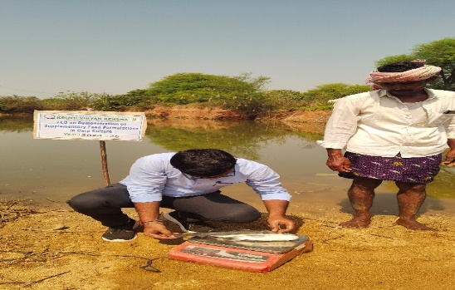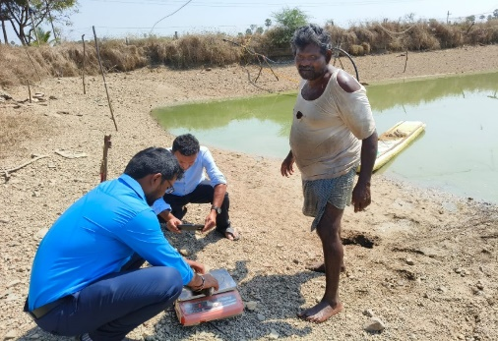

**Fish Weight Recording**

**Fish Length Recording**

**Fig.No.3.** Recording Growth Data (Weight, Length)

**Results and Discussion**

The findings of the Front Line Demonstrations (FLD) conducted by KVK, Warangal, clearly demonstrated that structured supplementary feeding practices significantly influence fish yield and economic performance in carp culture. Among the three treatment options tested, Treatment 3 (T3), which involved proper pond cleaning and feeding with pelleted feed at 2% of body weight along with the application of growth promoters at 1 litre per acre, produced the highest yield of 17.2 quintals per hectare. This outcome was followed by Treatment 2 (T2), which included stage-wise feeding with pelleted feed and probiotics, resulting in a yield of 14.8 quintals per hectare. The lowest yield, 12.1 quintals per hectare, was recorded under farmers' practice (T1), which lacked structured feeding and pond management protocols. These results are consistent with the findings of Gupta *et al*. (2025), Hasan and New (2013), who emphasized the importance of balanced feeding schedules for maximizing growth and production.

A detailed analysis of average weight gains across species further substantiated the positive impact of the improved practices. In T1, the final weights of *Catla catla, Labeo rohita*, and *Cirrhinus mrigala* were 180 g,200 g, and 125 g, respectively. Under T2 the average weights increased to 350g (*Catla catla*), 225 g (*Labeo rohita*), and 150 g (*Cirrhinus mrigala*). The highest growth rates were observed in T3 where the final weights were 400 g (*Catla catla*) 250 g (*Labeo rohita*) and 175 g (*Cirrhinus mrigala*). These improvements can be attributed to consistent feeding, better water quality and enhanced nutrient availability, aligning with the observations made by Adewumi (2018) and Azim *et al*. (2002).

Although the cost of cultivation was slightly higher in T2 and T3 compared to T1 the corresponding net returns were significantly greater. This is primarily due to the market demand for larger and healthier fish, which were sold at Rs. 150 per kg in local markets. The calculated market value was Rs. 1.87 lakhs, Rs. 1.585 lakhs, and Rs. 1.255 lakhs per hectare for T3, T2 and T1 respectively during a two-month culture period. As Eriegha and Ekokotu (2017) noted, extended culture duration further amplifies profitability. By the end of the eight-month culture period, the average fish weight was projected to reach 800 g, potentially yielding around 48 quintals per hectare in T3. These findings suggest that with scientific management and regular feeding, fish farmers can achieve net returns up to Rs. 4.0 lakhs per hectare, confirming the conclusions drawn by Chandra and Bharti (2018) and Iqbal *et al*. (2015).

Furthermore, the outcomes of this study align with previous research (Moore, 1985; Nandeesha *et al*., 2001; Yamamoto *et al*., 2007), which highlight that regular feeding and proper manuring significantly enhance aquaculture productivity. Azim *et al*. (2002) also reported superior growth rates in carp species under combined feeding regimes compared to fertilization-only approaches. These findings reinforce the critical role of feed quality, frequency, and water management in achieving optimal aquaculture outcomes.

**Table 2: Effect of Feed Supplement on Growth Performance of Carps**

|  |  |  |  |  |
| --- | --- | --- | --- | --- |
| **Treatment** | **Initial Wt (g)** | **Final Wt (g)** | **% Wg** | **SGR** |
| T1: Traditional feeding (DOB + GNOC) | 220 ± 5 | 510 ± 12 | 131.8 | 0.89 |
| T2: Pelleted feed with probiotics | 220 ± 5 | 710 ± 15 | 222.7 | 1.22 |
| T3: High-quality feed + All Other Feed supplements | 220 ± 5 | 825 ± 18 | 275.0 | 1.35 |

DOB- Di Oiled Rice Bran, GNOC: Ground nut Oil Cake, Wt- Weight: % Wg- Percentage weight gain; SGR- Specific growth rate.

**Table 3: Effect of Feed Supplement on Economic Performance of Carps**

|  |  |  |  |  |  |
| --- | --- | --- | --- | --- | --- |
| **Treatment** | **Yield**  **(Quintal/ha)** | **% Increase** | **Gross cost** | **Gross return** | **B:C** |
| T1: Traditional feeding  (DOB + GNOC) | 12.5 | – | 46,500 | 1,56,250 | 3.36 |
| T2: Pelleted feed with probiotics | 16.8 | 34.4% | 56,000 | 2,10,000 | 3.75 |
| T3:Pellet Feed+ Feed Supplements | 20.4 | 63.2% | 64,500 | 2,55,000 | 3.95 |

**Feed Supplementation and Its Economics**

Supplementary feeding plays a pivotal role in intensive aquaculture practices, particularly in composite carp culture. In the present study feed supplementation was strategically implemented using a nutritionally balanced pellet feed formulated to meet the protein and energy requirements of Indian Major Carps. The feed used comprised 28-30% crude protein, containing key ingredients such as groundnut cake, rice bran, maize, fish meal and vitamin-mineral premix. Farmers participating in the FLD were encouraged to feed the fish twice daily, at 3-5% of body weight initially, gradually adjusting the rate based on biomass estimation and feeding response. Regular monitoring of feeding behaviour and growth ensured optimized feed utilization and minimized feed waste. The cost of feed was a critical economic parameter. On average, the cost of formulated floating feed during the demonstration period was ₹36 per kg. Over a culture period of 8 months, the feed requirement averaged 2,800 kg per hectare. Hence, the total feed cost per hectare was approximately ₹100,800. However, improved feed conversion ratio (FCR) of 1.6:1 ensured efficient feed use, which positively influenced the economic returns.

The economic analysis revealed that the supplemented feed led to a significant increase in fish yield -from 2,850 kg/ha under farmers' practice to 4,200 kg/ha under demonstration units. The gross income per hectare rose from Rs. 313,500 in farmers practice to Rs. 462,000 in the demonstration (assuming a market price of Rs.110/kg for carp).

**Cost of Harvesting**

Harvesting is a crucial terminal operation that contributes to overall production cost in fish farming. In the present study, harvesting was carried out using drag nets with the assistance of skilled labour. The cost of harvesting depends on factors such as pond size, fish biomass and labour charges. On average, the cost of harvesting for 4,200 kg of fish was estimated at Rs. 6,000 per hectare, which included labour wages (Rs.500- Rs.600 per person/day), net rent or depreciation and logistic arrangements. The cost per kg of fish harvested came to approximately Rs.1.43.

**Conclusion**

This study underscores the importance of adopting scientifically validated practices in composite fish culture. Proper pond cleaning, fertilization, pest control, and regular feeding with formulated feed significantly improve growth performance and yield. The economic analysis confirmed that despite higher input costs, farmers using high quality feed and supplements achieved greater profitability. This Research Paper offers valuable insights into the efficacy of supplementary feeding practices in composite carp culture, specifically within the context of a Front Line Demonstration (FLD) conducted in Warangal, Telangana. By focusing on a practical, field level approach, the study bridges the gap between research institutions and local aquaculture practices, fostering sustainable and economically viable fish farming. The findings not only demonstrate enhanced fish growth and yield with formulated feeds but also highlight the increased profitability and cost-benefit ratio for rural fish farmers. This contribution is especially significant for scientists, extension workers and policymakers striving to improve food security, livelihood generation and resource efficient aquaculture in developing regions.

**Ethical Approval and consent**

The authors affirm that the study was conducted following all relevant ethical guidelines and regulations. No endangered or protected species were involved in this research. All procedures involving fishes were carried out in accordance with the standard practices of aquaculture research and with respect for animal welfare. The trail was part of a Front Line Demonstration (FLD) initiative under the purview of the Krishi Vigyan Kendra (KVK), Warangal and adhered to the ethical standards of the institution. Informed consent was obtained from all participating farmers and their identities have been kept confidential.

Disclaimer (Artificial intelligence)

Option 1:

Author(s) hereby declare that NO generative AI technologies such as Large Language Models (ChatGPT, COPILOT, etc.) and text-to-image generators have been used during the writing or editing of this manuscript.

Option 2:

Author(s) hereby declare that generative AI technologies such as Large Language Models, etc. have been used during the writing or editing of manuscripts. This explanation will include the name, version, model, and source of the generative AI technology and as well as all input prompts provided to the generative AI technology

Details of the AI usage are given below:

1.

2.

3.

**References**

Adewumi A A (2018) The impact of nutrition on fish development, growth and health. *Int. J. Scienti. Res. Public.* **8**(6), 147-153

Azim M E, Verdegem M C J, Rahman M M, Wahab M A, van Dam A A and Beveridge M C M (2002) Evaluation of polyculture of Indian major carps in periphyton-based ponds. *Aquaculture* **213**, 131-149.

Azim M E, Wahab M A, Van Dam A A, Beveridge M C, Milstein M A and Verdegem M C J (2001) Optimization of fertilization rate for maximizing periphyton production on artificial substrates and their implications for periphyton- based aquaculture, *Aquaculture Research* **32**, 749-760.

Chakrabarti N M (1998) Biology, Culture and Production of Indian Major Carps. Fisheries Scientist in Indian Council of Agricultural Research, 175pp.

Chandra, G., & Bharti, B. K. (2018). Assessment the effect of supplementary feeding on fish production in rural fish farming practices. *Journal of Experimental Zoology India*, *21*(2).

Department of Animal & Fish Resources (Fisheries) (2011) A presentation of 11th five year plan by fisheries directorate. http://ahd.bih.nic.in/ (accessed July 18, 2016).

Dhawan A and Kaur S (2002) Effect of pig dung on water quality and polyculture of carp species during winter and summer. *Aquaculture International* **10**, 297-307.

Eriegha, O. J., & Ekokotu, P. A. (2017). Factors affecting feed intake in cultured fish species: A review. *Animal Research International*, *14*(2), 2697-2709.

Ganesh G, Rajanna N, Sai Kiran J, Shashank j, Raju A, Soumya CH and Arunjyoti R.(2024). Socio-economic profile of fish farmers of Warangal district, Telangana. International Journal of Advanced Biochemistry Research; SP-8(9): 557-567. DOI: <https://doi.org/10.33545/26174693.2024.v8.i9Sg.2174>.

Gupta, G., Srivastava, D. K., Pandey, H. P., Singh, R. L., Vats, A. S., & Verma, S. K. (2025). Effect of Feed Supplement on Growth And Economic Performance of Indian Major Carp In Composite Fish Culture System. *Journal of Experimental Zoology India*, *28*(1).

Hasan, M. R., & New, M. B. (2013). On-farm feeding and feed management in aquaculture. *FAO fisheries and aquaculture technical paper*, (583).

Iqbal K J, Ashraf M, Qureshi N A, Javid A, Abbas F, Hafeez-ur- Rehman M, Rasool F, Khan N and Abbas S (2015) Optimizing growth potential of *Labeo rohita* fingerlings fed on different plant origin feeds. *Pak. J. Zool.* **47**(1), 31-36

Islam M S, Huq K A and Rahman M A (2008) Polyculture of Thai pangus (*Pangasius hypophthalmus,* Sauvage 1878) with carp and prawn: a new approach in polyculture technology regarding growth performance and economic returns. *Aquaculture Research* **39**,1620-1627.<https://doi.org/10.1111/j.1365-2109.2008.02035.x>

Moore L B (1985) The role of feeds and feeding in aquatic animals production. *Geo Journal* **10**, 245-251.

Nandeesha M C, De Silva S S and Murthy D K (2001) Use of mixed feeding schedules in fish culture: performance of common carp, *Cyprinus carpio* L., on plant and animal protein based diets. *Aquaculture Research* **26**(3), 161-166.

Pailan, G.H., Biswas, G. (2022). Feed and Feeding Strategies in Freshwater Aquaculture. In: Lama, T., Burman, D., Mandal, U.K., Sarangi, S.K., Sen, H. (eds) Transforming Coastal Zone for Sustainable Food and Income Security. Springer, Cham.<https://doi.org/10.1007/978-3-030-95618-9_35>.

Ramakrishna R, Shipton T A and Hasan R M (2013) Feeding and feed management of Indian major carps in Andhra Pradesh, India. FAO Technical Bulletin 578. *Food and Agriculture Organisation of the United Nations, Rome, Italy,* 90 pp.

Sampa, A. Y. (2024). *Determinants and Outcomes of Formulated Pelleted Feed Use Across Diverse Aquatic Farming System in Bangladesh* (Master's thesis, Michigan State University).

Yamamoto T, Shima T, Furuita H, Sugita T and Suzuki N (2007) Effects of feeding time, water temperature, feeding frequency and dietary com- position on apparent nutrient digestibility in rainbow trout *Oncorhynchus mykiss* and common carp *Cyprinus carpio*. *Fisheries Science* **73**, 161-170.