**QUANTIFICATION AND CHARACTERIZATION OF MICROPLASTIC CONTAMINATION IN *Pseudetroplus maculatus* (BLOCH,1795) AND *Villorita cyprinoides* GRAY,1825 COLLECTED FROM VEMBANAD LAKE KERALA: IMPLICATIONS FOR AQUATIC ECOSYSTEMS**

**ABSTRACT**

Microplastics, smaller plastic particles less than 5mm in size, pose a significant threat to the environment and human health due to their widespread presence, persistence, and potential harm to living organisms. The extensive use of plastics in human life has led to the release of substantial quantities of microplastics into the environment, resulting in widespread pollution. Microplastics are detected in diverse aquatic environments, including freshwater lakes, rivers, and marine ecosystems. Once in aquatic ecosystems, microplastics can be ingested by a wide range of aquatic organisms, including zooplankton, shellfish, and fishes. This study investigated microplastic contamination in fish (*Pseudetroplus maculatus*) and clam (*Villorita* *cyprinoides*) samples collected from Vembanad Lake, a Ramsar wetland in southern India. Microplastics were identified in both species using stereo zoom microscopy and Fourier-Transform Infrared Spectroscopy (FT-IR), with fibers being the dominant type. The present study highlights the occurrence of MPs in 60-80% of analysed samples with fibers being the foremost type followed by fragments. The microplastic contamination was higher in clams compared to those in fish samples. MPs such as Fibers and fragments were extracted from both the species collected from the marine influenced and riverine influenced sites of Vembanad lake. Clams are considered as ecological indicators, henceforth, the comparatively higher MP load in clams stands indicative of microplastic pollution, alarmingly disrupting the food chain and posing risks to human consumption. The urgent need for investigating the sources and pathways of microplastic pollution is emphasised by observing the similarity in the type and shapes of microplastics in both fish and clams. FTIR analysis of the samples revealed MPs with polyethylene, polypropylene, and nylon as the primary polymer types found in samples.

**Key words:** Microplastics, *Pseudetroplus maculatus, Villorita cyprinoides,* Vembanad lake, FTIR, Nylon, Polyethylene, Polypropylene

1. **INTRODUCTION**

Microplastic particles less than 5mm size are invisible to naked eye and are found in various environments (Kefer et al., 2022; Andrady, 2011). The wide spread occurrence and persistence of microplastics and their ability to cause potential harm to living organisms pose a great deal of threat to environment. (Abisha et al., 2024). Wide spread microplastic pollution is a cause of major concern nowadays because of the substantial release of microplastics resulting from extensive use of plastics in various aspects of human life (Jiang, 2018; Hale et al., 2020). The microscopic plastic particles arise from fragmentation of larger plastic materials from domestic debris as well as industrial sources. Microplastic particles represent most of the plastic present in aquatic environments. (Browne et al., 2010). The presence of microplastics in all aquatic environments including freshwater lakes, rivers, and marine ecosystems have been undoubtedly proved (Dris et al., 2015; Blettler et al., 2017). Once microplastics enter the aquatic ecosystems, they finds its way up in the food chain through a wide range of aquatic fauna, including zooplankton, shell fish, and fishes (Al-Thawadi 2020; Chen et al., 2021).

Fishes being an important source of protein, the presence and ecotoxicological impacts of the presence of MPs raises concern over aquatic food safety in terms of human consumption (Mercy et al., 2023). The accumulation and distribution of MPs in commercially important aquatic organisms can lead to greater exposure risk for human populations, apart from triggering possible antagonistic effects over time. Several authors reported that the accumulation and distribution of MPs in marine organisms is species-specific with a dependency to the particle size (Miller et al., 2020; Sun et al., 2021).

The Vembanad Lake is an important ecological and economic resource of Kerala. Microplastics were reported from the water, sediments, and biota of the Vembanad Lake by Sruthy and Ramasamy, (2017); Anagha et al., (2023) and Devi et al., (2024). The fish species *Pseudetroplus maculatus* (Orange Chromide) as well as the clam species *Villorita cyprinoides* (Black clam) are the two important species inhabit the Vembanad Lake. The small size, repeated breeding, higher fecundity and wide salinity tolerance of *Pseudetroplus maculatus* makes it a model organism for ecological and scientific studies (Babu *et al*.,2022). Villorita cyprinoides, commonly known as Black clam is an important fishery of the Vembanad Lake and contributes to over 70% of the total fish production from the Lake.( Laxmilatha and Appukuttan, 2002). These two species are important food sources for the local population. The urgent need for investigating the sources and pathways of microplastic pollution is emphasised by observing the similarity in the type and shapes of microplastics in both fish and clams. However, the extent of microplastic contamination in these species and its consequences for human consumption are not well understood. The study points towards the need for further research on the possibilities of MP transfer up the food chain, specifically focussing on human health and food safety. With the aim of addressing this knowledge gap, the present study seeks to provide a comprehensive assessment of microplastic contamination in these two species of Vembanad Lake.

1. **MATERIALS AND METHODS**
   1. **Study area**

The study was conducted along Vembanad Lake, a Ramsar wetland in southern India (Lat. 9º 30´- 10º 10´ N and Long. 76º 10´- 76º 25´ E) (Fig.1). The study site was selected based on the significance of Vembanad lake as the most productive coastal wetland in Kerala, spanning a length of 96 km and surface area of 1512 km2. Vembanad Lake is nourished by six rivers and joins the Arabian sea through two permanent openings at Cochin and Azhikode (Krishnakumar and Rajan, 2012). The lake is divided into brackish and freshwater zones by the Thanneermukkom bund, a man-made barrier regulating saltwater intrusion.

Based on the environmental influence, two sites were established as the sampling points to carry out the study. The first site (Site 1) was the marine-influenced area near Thanneermukkom bund (Lat. 9.678702°, Long. 76.3897°), and the second site (Site II) was the riverine-influenced area of the bund located at Muhamma (Lat. 9.628982°, Long. 76.373997°) (Fig 2a-b). Site I is characterized by tidal water exchange and diverse aquatic vegetation. The dynamic exchange of water during high and low tides affects the distribution of microplastics. The aquatic and marshy vegetation associated with the bund provides diverse habitats for organisms ranging from microbes to invertebrates. Site II, influenced by a spectrum of pollution sources including river discharge, industrial effluents, and domestic waste, offered a comprehensive picture of environmental contamination indicating the enhanced possibility of plastic accumulation which may later get degraded to microplastics.

|  |
| --- |
|  |

**Fig.1. Geographic Map showing the sampling location along Vembanad lake**

|  |  |
| --- | --- |
|  |  |
| Fig 2a-b: Sampling sites selected for the study: 2a) site I. Marine influenced area., 2b) Site II – Riverine influenced area | |

**2.2 Sample Collection**

The study was carried out for a period of seven months starting from October 2023 to April 2024. Global positioning system (GPS) was used to pinpoint the study sites. One species each of Fish (*Pseudetroplus* *maculatus*) and Clam (*Villorita cyprinoides*) (Fig 3A-B) were selected for the study, and the samples were collected from the study sites with the assistance of local fishermen. The specimens were immediately transported to laboratory in sterile ice boxes at -20°C to prevent degradation.

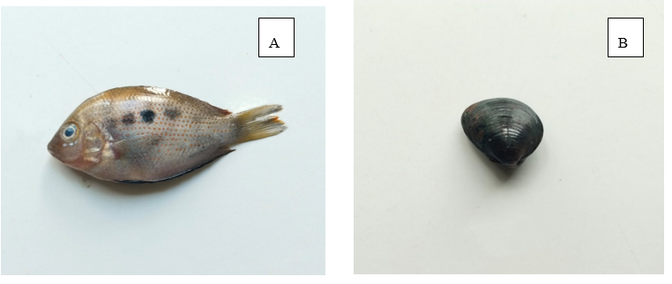

Fig 3A-B: A) *Pseudetroplus maculatus* (Bloch, *Maculatus* (Bloch,1795) B. *Villorita Cyprinoides* Gray,1825

**2.3 Sample Preparation**

Ten samples each of *Pseudetroplus maculatus* and *Villorita cyprinoides* were collected from both sites during the period and the study was conducted in triplicates of each sample. In the laboratory, samples were thawed and washed with distilled water to remove the debris adhered to the surface. Digestive tracts from the fish and whole clam tissues were dissected using sterilised metal tools and subsequently placed in a glass beaker, loosely covered with aluminium foil to avoid air borne contamination. Dissected tissues were treated with 10% potassium hydroxide (KOH) at 60°C for 24 hours to ensure digestion of dissolved organic matter (Dehaut et al., 2016). The supernatant containing floated MPs was filtered through ash-less Whatman filter paper (Grade No. 41, pore size: 20 m). The digested solution was diluted with distilled water and filtered through Whatman GF/C filter paper (47 mm) using a vacuum pump. Filter papers were dried at 30°C and stored for analysis of microplastics.

**2.4 Identification and Characterization of Microplastics**

The Microplastics adhered to filter papers were identified using a stereo zoom microscope (Leica EZ4D). Microplastics were differentiated from organic residues through a hot needle test (Beckingham et al., 2023). Microplastics were categorized based on their shape (fibres and fragments), size, and colour (D'Hont et al., 2021). Affirmation regarding the shape of the microplastic particles was done following Masura et al. (2015) and Hidalgo-Ruz et al. (2012). Polymer identification was performed using Thermo Fisher Scientific NICOLET IS50 ATR FT-IR Spectrometer (resolution 4 cm 1 range of 400–3500 cm 1) with a scan (average of 16 scans/reading) at Central Laboratory for Instrumentation and Facilitation (CLIF), University of Kerala. conformation of plastics and the identification of polymer type were ensured following polymer spectrum Library.

**3. RESULT AND DISCUSSION**

The present study analysed the Microplastic contamination in the fish species, *Pseudetroplus* *maculatus* and Clam species *Villorita cyprinoides* collected from two specific study sites along Vembanad lake. A total of 10 samples each of *Pseudetroplus maculatus* and *Villorita cyprinoides* collected from each study site (Site I and Site II) of Vembanad Lake revealed the presence of microplastics. The gut content of fish and whole tissue of clam were separately analysed for microplastics.

**3.1: Abundance of microplastics**

The current study revealed the presence of microplastics (MPs) in both fish and clam samples collected from Site I. For *Pseudetroplus maculatus*, MPs were identified in 6 out of 10 samples (60%), with a total of 22 MPs recovered, comprising 20 fibers and 2 fragments **(Table 1).** Among the MPs extracted from the gut of the fish samples, fibers constituted the predominant type, accounting for 91% of the total MPs, while fragments represented 9%. **(Fig.4).**

**Table 1. Abundance of Microplastics in Pseudetroplus *maculatus* and *Villorita cyprinoides* collected from Site I based on colour, shape and Number**

|  |  |  |  |  |
| --- | --- | --- | --- | --- |
| **COLOUR** | ***Pseudetroplus maculatus*** | | ***Villorita cyprinoides*** | |
| **FIBER** | **FRAGMENT** | **FIBER** | **FRAGMENT** |
| **BLUE** | **4** | **0** | **7** | **0** |
| **GREEN** | **2** | **0** | **3** | **0** |
| **RED** | **6** | **0** | **5** | **0** |
| **BLACK** | **3** | **0** | **6** | **0** |
| **TRANSPARENT** | **5** | **2** | **5** | **3** |
| **TOTAL** | **22** | | **29** | |

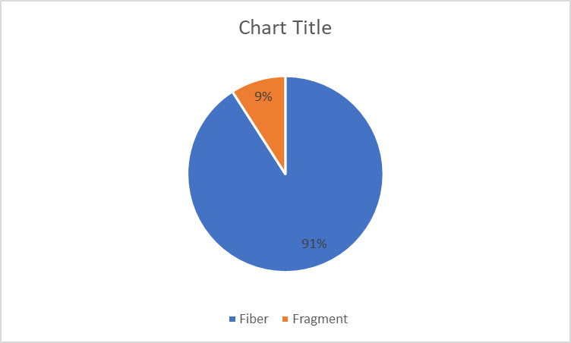

**Fig. 4. Percentage composition of Fibers and Fragments collected from *Pseudetroplus maculatus* collected from Site I**

Similarly, in the analysis of 10 clam samples of Villorita cyprinoides, collected from Site I, MPs were found in 8 samples (80%), with a total of 29 MPs recovered, including 26 fibres and 3 fragments **(Table I).** Within the MPs extracted from the clam tissues, fibres were the most abundant, making up 90% of the total MPs, followed by fragments (10%) **(Fig.5)**

**Fig. 5. Percentage composition of Fibers and Fragments collected from *Villorita cyprinoides* collected from Site I**

A comprehensive evaluation of microplastic (MP) abundance in the selected fish and clam species from Site I revealed that *Villorita cyprinoides* exhibited a higher MP load (29 MPs) compared to Pseudetroplus maculatus (22 MPs). This indicates a greater prevalence of microplastics in the clam species relative to the fish species under investigation **(Table I).**

An analysis of Microplastic contamination in 10 specimens each of *Pseudetroplus maculatus* and *Villorita cyprinoides*, randomly selected from the second sampling site (Site II) also indicated that 70% of the fish samples (n=7) and 80% of the clam samples (n=8), highlighted a substantial microplastic load. A total of 43 microplastic particles, comprising 38 fibers and 5 fragments, were recovered from the two species **(Table II).**

**Table II. Abundance of Microplastics in *Pseudetroplus maculatus* and *Villorita cyprinoides* collected from SiteII based on colour, shape and Number**

|  |  |  |  |  |
| --- | --- | --- | --- | --- |
| **COLOUR** | ***Pseudetroplus maculatus*** | | ***Villorita cyprinoides*** | |
| **FIBER** | **FRAGMENT** | **FIBER** | **FRAGMENT** |
| **BLUE** | **5** | **0** | **4** | **0** |
| **GREEN** | **0** | **0** | **3** | **0** |
| **RED** | **8** | **1** | **3** | **0** |
| **BLACK** | **2** | **0** | **7** | **0** |
| **TRANSPARENT** | **3** | **2** | **3** | **2** |
| **Total** | **21** | | **22** | |

Specifically, 18 fibers (86%) and 3 fragments (14%) were extracted from *Pseudetroplus maculatus* **(Fig: 6),** while 20 Fibers (91%) and 2 fragments (9%) were isolated from *Villorita cyprinoides* **(Fig:7).** These findings suggest a significant MP load in both species.

**Fig. 6. Percentage composition of Fibers and Fragments collected from in *Pseudetroplus maculatus* collected from Site II.**

**Fig.7. Percentage composition of Fibers and Fragments collected from *Villorita cyprinoides* collected from Site II.**

The urgent need to mitigate microplastic pollution in aquatic environments is highlighted by the fact that clams possess more microplastic load compared to fishes. Clams are very important indicators of environmental health in aquatic ecosystems (Su *et al*., 2018). A comparative analysis of Microplastic fibers and fragmets extracted from fish and clam samples collected from both sites revealed similar shapes and types across the species. The prevalence of fibres in both species points towards the importance of mitigating the sources and pathways of microplastic pollution. Earlier studies conducted by Browne et al. 2011; Magnusson and Nore´n 2014; Napper and Thompson 2016 have suggested that waste water treatment plants contribute microplastics in the form of synthetic fibres to aquatic ecosystems. The presence of fibres among MPs extracted from Marine environment was proved by Wright et al. (2013). The predominance of fibres in the samples collected from tissue, water and sediments were previously recorded in the works of Nadal et al., (2016); Pazos et al., (2017); Martin et al., (2019) and Devi et al., (2024). According to Naidu et al 2018, plastic disposal, effluent discharge, and fishing activities can contribute to the occurrence of MPs in aquatic ecosystems. The bigger plastic wastes that break down into smaller particles upon ingestion by aquatic organisms eventually reach higher trophic levels through food chain (Green 2016; Murray and Cowie 2011). A higher susceptibility of MP contamination in estuaries and rivers compared to those of marine environments can be due to the proximity to the source of MP origin (Jabeen et al., 2017; Jeevanandam et al., 2022). The physical impact of microplastic pollution in aquatic habitats is clearly illustrated by documenting the shapes and colours of microplastic fibres and fragments extracted.

**3.2: Physical and Chemical Characterisation of Microplastics**

An observation of Microplastics extracted from *Pseudetroplus maculatus* samples of Site I based on colour showed a dominance of red coloured fibres (n= 6) followed by transparent (n=5), blue (n=4), black (n=3) and green (n=2) fibres. whereas, both the fragment pieces extracted from Pseudetroplus maculatus were transparent in nature. In the case of *Villorita cyprinoides*, collected from Site I, blue coloured fibers (n=7) dominated the list followed by black (n=6), Red (n=5), transparent (n=5) and Green (n=3) Fibers **(Table I).** Irrespective of the number of MPs recovered, the colour wise distribution of ingested MPs revealed similar pattern in all the analysed fish samples with red fibres being the dominant colour and blue fibres were dominant in clam samples **(Fig.8).** The significant number of blue fibres in clams can be indicative of specific pollution sources in the lake, possibly from fishing gear, plastic waste, or textile runoff (Xu et al., 2021).

**Fig. 8. Composition of MP colours found in Pseudetroplus maculatus and Villorita cyprinoides collected from Site I of Vembanad lake**

Microplastic particles (MPs) extracted from fish samples at Site II exhibited a color distribution pattern, with red fibres (n=8) being the most prevalent, followed by blue (n=5), transparent (n=3) and Black (n=2). Green coloured fragments were apparently absent in fish samples. In contrast, fragment pieces from Pseudetroplus maculatus samples collected from Site II were red (n=1) and transparent (n = 2). Villorita cyprinoides samples from Site II showed a dominance of black fibers (n=7), followed by blue (n=4), green (n=3), Red (n=3) and Transparent (n =3) fibres **(Fig:9).** Notably, the colour distribution pattern of ingested MPs was consistent across all analyzed fish samples, with red fibers predominating, whereas blue fibres were more prevalent in clam samples **(Table II).**

**Fig. 9. Composition of MP colours found in *Pseudetroplus maculatus* and *Villorita cyprinoides* collected from Site II of Vembanad lake**

Representative microplastic (MP) shapes were visually documented with a photographic record captured for each distinct morphological type and their dimensions were measured using Leica LASEZ software **(Fig: 10).**

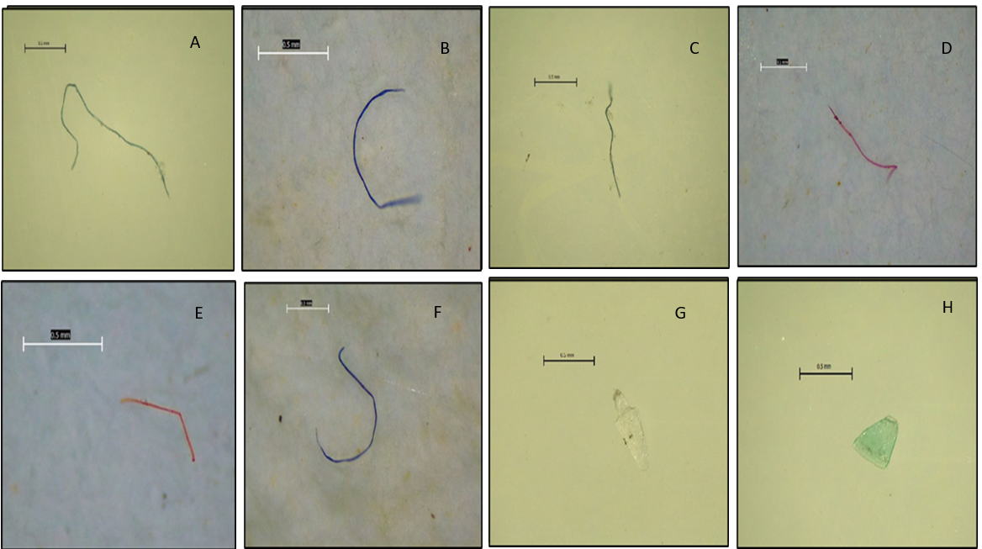

**Fig. 10. A-H. Representative photographs of MP shapes extracted from Fish and Clam samples collected from Site I and II along Vembanad lake. A-F: Fibers; G-H: Fragments**

A comparison of size classification of Microplastics in *Pseudetroplus maculatus* samples collected from site I and Site II revealed that 1-2mm size class was dominant along both the sites followed by 2-3mm, 3-4mm and 4-5mm size classes **(Fig: 11).**

**Fig.11. Size based classification of MPs extracted from Pseudetroplus maculatus collected from site I and Site II of Vembanad Lake**

*Villorita cyprinoides* also exhibited similar results from both the sites **(Fig 12).** Apparently, in both species, MPs of 1-2mm size class was dominant over other size classes. This result complies with a similar finding by Prusty *et al*., 2023. The presence of microplastics in fish and clam species can be due to a breakdown of larger plastics into smaller- sized particles (Devi *et al*., 2020; White *et al*., 2018). A study conducted by Conkle et al (2018) point towards the limitations of existing MP surveys that primarily focuses on MP ≥ 300 μm and advocates for a more comprehensive assessment of smaller particles including synthetic microfibers and to devise more effective strategies to mitigate marine plastic pollution.

.

**Fig.12. Size based classification of MPs extracted from *Villorita cyprinoides* collected from site I and Site II of Vembanad Lake**

An analysis of extracted Microplastic samples using Fourier transform infrared spectroscopy (FTIR) has yielded significant insights into the polymer compositions prevalent in the environment, identifying Polyethylene (PE), Polypropylene (PP), and Nylon as the primary constituents. The relevant wave numbers and corresponding details are illustrated in **Fig. 13.** These findings not only contribute to our understanding of microplastic pollution but also align with previous studies that have reported similar polymer types in various ecosystems (Fan et al.,2021; Muhib & Rahman 2023). The source of microplastics in marine environments can be predicted by analysing the chemical composition (Abayomi *et al*., 2017). According to Palacio-Cortés et al., 2022, the ingestion of microplastics has been widely studied among freshwater invertebrate species such as amphipods, cladocerans, and insects.

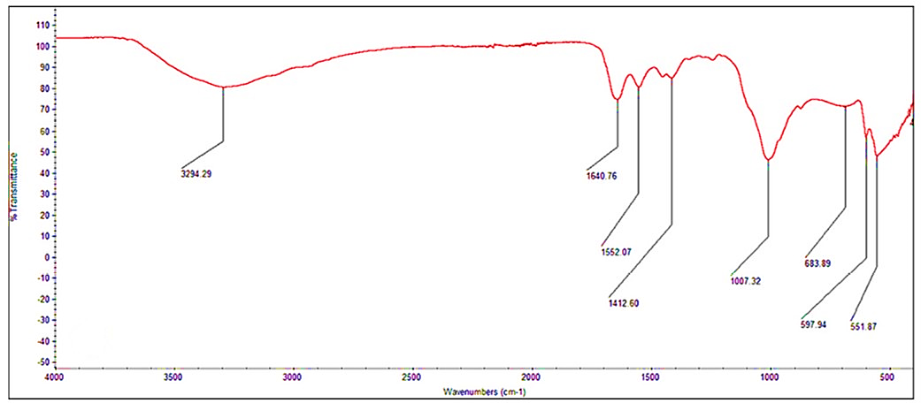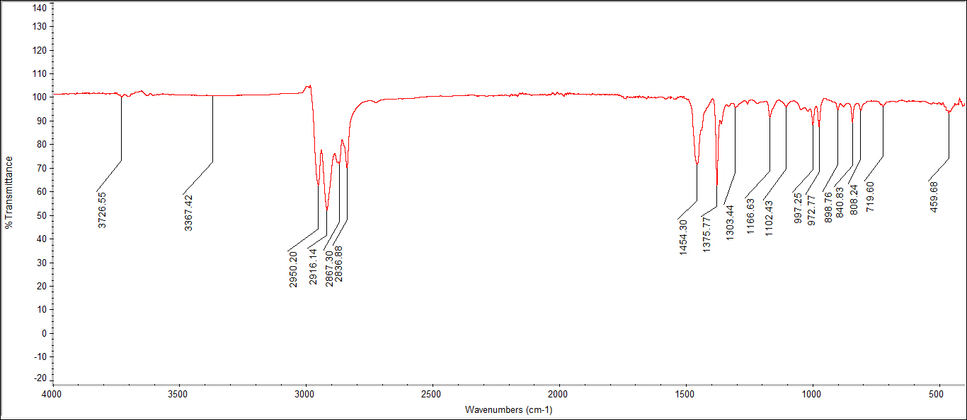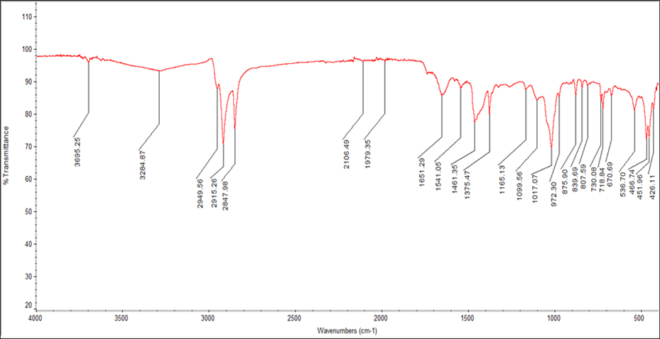

**Fig: 13 FTIR Spectrum of extracted MPs from *Pseudetroplus maculatus* and *Villorita cyprinoides* collected from Vembanad Lake - A- Polyethylene (PE), B – Nylon and C - polypropylene (PP).**

Identification of the polymer components of MPs was done using FTIR Spectrometer. FTIR spectroscopy is frequently used for the qualitative analysis of microplastics (>10 mm), as the polymer type can be quickly and directly identified when their spectra is compared with those of known plastics (Qiu *et al*., 2016). The peak values from the graph plotting wavenumber against transmittance offer detailed insights for classifying microplastics, including Polyethylene (PE), Polypropylene (PP), and Nylon, as identified in this study. Accurate identification necessitates the matching of at least four absorption bands. The polymer samples were analysed, and their absorption bands were compared to the spectra and structures described by FTIR (Andrea *et al*., 2020). The relevant wavenumbers and corresponding details are illustrated in **Fig. 12.**

Polyethylene, the most widely produced plastic globally, was the most frequently identified polymer in the present study. A study conducted by Thompson et al. (2004), revealed similar results, where PE was found in significant quantities in marine environments, likely due to its extensive use in packaging and single-use products (Hilmarsdóttir et al.,2024). The presence of PE in the samples indicates possible long term ecological challenges owing to the use and convenience of PE products in day today life (Yao et al.,2022). Polypropylene revealed from FTIR analysis in the study is also an important constituent of food containers and automotive parts, making it an accustomed commodity in daily life (Beswick, & Dunn, 2002).

Polypropylene, polyethylene together forms more than 50% of plastic produced every year in the world on average (Geyer *et al*., 2017). Presence of nylon in the FTIR results of the present study also underscores the multifaceted nature of microplastic pollution apart from being an integral component of textiles and fishing gears. Earlier studies conducted by Ramos et al. (2012), have emphasised the significant contribution of synthetic fibres to microplastic loads in aquatic habitats. UV radiations, mechanical abrasions, and natural biodegradation processes can lead to breakdown of plastics resulting in MP contamination (Paul-Pont et al., 2018; Kumar et al., 2021).

The microplastic contamination was higher in clams compared to those in fish samples. MPs such as Fibers and fragments were extracted from both the species collected from the marine influenced and riverine influenced sites of Vembanad lake. Clams are considered as ecological indicators, henceforth, the comparatively higher MP load in clams stands indicative of microplastic pollution, alarmingly disrupting the food chain and posing risks to human consumption. Ocean based activities like fishing, shipping, and aquaculture practices, dumping old and wornout nets and mass tourism can also lead to MP pollution in aquatic ecosystems (Devi et al., 2024). According to Bretas Alvim et al., (2020) road runoff, agricultural soil runoff, storm and rain events, wastewater discharge, and lake tributaries are also recognised as the key pathways that trigger the entry of microplastics into lakes. The consistency of the findings with existing literature recalls the urgent need for a collective response to mitigate plastic pollution.

1. **CONCLUSION**

The present study reveals the occurrence of microplastics in *Pseudetroplus maculatus* and *Villorita cyprinoides* collected from two selected sites of Vembanad lake, Kerala, bringing out the alarming signs of pollution in aquatic ecosystems. The occurrence of microplastic fibres and fragments in the gut of fish and and whole tissue of clam species not only underscores the need to address plastic pollution sources and pathways but also, provides a warning sign to mitigate the use of plastics in order to safe guard the diversity of aquatic habitats. Clams being significant ecological indicators, the higher load of MPs in their tissue indicative of pollution raising concerns about human consumption and food safety. The study also points towards the urgent need of studying bioaccumulation of micro plastics in the tissues and their trophic transfer through food chains and their potential impacts on human health and seafood safety.

**DISCLAIMER (ARTIFICAL INTELLIGENCE)**

Author(s) here by declare that NO generative AI technologies such as lab language models (ChatGPT, COPILOT etc) and text to image generators have been used during writing or editing of this manuscript.

**REFERENCES**

Abisha, C., Kutty, R., Gurjar, U. R., Jaiswar, A. K., Deshmuke, G., Sasidharan, A., & Xavier, K. M. (2024). Microplastic prevalence, diversity and characteristics in commercially important edible bivalves and gastropods in relation to environmental matrices. *Journal of Hazardous Materials* *Advances*, 13, 100392. <https://doi.org/10.1016/j.hazadv.2023.100392>

Al-Thawadi, S. (2020). Microplastics and nanoplastics in aquatic environments: challenges and threats to aquatic organisms. *Arabian Journal for Science and Engineering*, 45(6), 4419-4440. <https://doi.org/10.1007/s13369-020-04402-z>

Anagha, P. L., Viji, N. V., Devika, D., & Ramasamy, E. V. (2023). Distribution and abundance of microplastics in the water column of Vembanad Lake–a Ramsar site in Kerala, India. *Marine Pollution Bulletin*, 194, 115433. <https://doi.org/10.1016/j.marpolbul.2023.115433>

Andrady, A. L. (2011). Microplastics in the marine environment. *Marine Pollution Bulletin*, 62(8), 1596–1605. <https://doi.org/10.1016/j.marpolbul.2011.05.030>

Babu, P. P. S., Thomas, S. M., Anirudhan, A., Sidhick, J. N., Kandiyil, A. P., Ebeneezar, S., Ignatius, B., & Achamveetil, G. (2022). Orange Chromide, *Pseudetroplus maculatus* (Bloch., 1795): A potential euryhaline fish model to evaluate climate change adaptations in fishes. *Frontiers in Marine Science*, 99:906491. <http://dx.doi.org/10.3389/fmars.2022.906491>

Beswick, R., & Dunn, D. J. (2002). Plastics in Packaging: Western Europe and North America. Chemtech Publishing. Pp144

Blettler, M. C., Ulla, M. A., Rabuffetti, A. P., & Garello, N. (2017). Plastic pollution in freshwater ecosystems: macro-, meso-, and microplastic debris in a floodplain lake. *Environmental monitoring and assessment*, 189, 1-13. <https://doi.org/10.1007/s10661-017-6305-8>

Bretas Alvim C, Mendoza-Roca JA, Bes-Piá A. (2020) Wastewater treatment plant as microplastics release source - Quantification and identification techniques. *Journal of Environmental Management*. 1; 255:109739. <https://doi.org/10.1016/j.jenvman.2019.109739>

Browne, M.A., Galloway, T.S., Thompson, R.C., 2010. Spatial patterns of plastic debris along estuarine shorelines. Environ. Sci. Technol. 44 (9), 3404–3409. https://doi. org/10.1021/es903784e. Chen, G., Li, Y., & Wang, J. (2021). Occurrence and ecological impact of microplastics in aquacultureecosystems. *Chemosphere*, 274,129989. <https://doi.org/10.1016/j.chemosphere.2021.129989>

Conkle J, L., Báez Del Valle C.D., Turner J.W.( 2018). Are we underestimating microplastic contamination in aquatic environments?. *Environmental management*. Jan;61(1):1-8. <https://doi.org/10.1007/s00267-017-0947-8>

Dehaut, A., Cassone, A.-L., Frère, L., Hermabessiere, L., Himber, C., Rinnert, E., Rivière, G., Lambert, C., Soudant, P., Huvet, A., Duflos, G., & Paul-Pont, I. (2016). Microplastics in seafood: Benchmark protocol for their extraction and characterization. *Environmental Pollution*, 215, 223–233. <https://doi.org/10.1016/j.envpol.2016.05.018>.

Devi, S. S., Ramachandran Gouri, B., Anjali, S., & Kumar, A. B. (2024). Microplastic contamination in Ashtamudi Lake, India: Insights from a Ramsar wetland. *Journal of Contaminant Hydrology*, 264, 104367. <https://doi.org/10.1016/j.jconhyd.2024.104367>.

D'Hont, A., Gittenberger, A., Leuven, R. S. E. W., & Hendriks, A. J. (2021). Dropping the microbead: Source and sink related microplastic distribution in the Black Sea and Caspian Sea basins. *Marine Pollution Bulletin*, 173(Part A), 112982. <https://doi.org/10.1016/j.marpolbul.2021.112982>.

Dris, R., Imhof, H., Sanchez, W., Gasperi, J., Galgani, F., Tassin, B., & Laforsch, C. (2015). Beyond the ocean: contamination of freshwater ecosystems with (micro-) plastic particles. *Environmental chemistry*, 12(5), 539-550. <https://doi.org/10.1071/EN14172>

Fan, C., Huang, Y. Z., Lin, J. N., & Li, J. (2021). Microplastic constituent identification from admixtures by Fourier-transform infrared (FTIR) spectroscopy: The use of polyethylene terephthalate (PET), polyethylene (PE), polypropylene (PP), polyvinyl chloride (PVC) and nylon (NY) as the model constituents. *Environmental Technology & Innovation*, 23, 101798.

<https://doi.org/10.1016/j.eti.2021.101798>

Geyer, R., Jambeck, J.R., Law, K.L., 2017. Production, use, and fate of all plastics ever made. *Science Advances*. 3 (7), e1700782 <https://doi.org/10.1126/sciadv.1700782>.

Hale, R. C., Seeley, M. E., La Guardia, M. J., Mai, L., & Zeng, E. Y. (2020). A global perspective on microplastics. Journal of Geophysical Research.Oceans, 125(1), e2018JC014719.

<https://doi.org/10.1029/2018JC014719>

Hidalgo-Ruz, V., Gutow, L., Thompson, R. C., & Thiel, M. (2012). Microplastics in the marine environment: A review of the methods used for identification and quantification. *Environmental Science & Technology*, 46(6), 3060–3075. <https://doi.org/10.1021/es2031505>

Hilmarsdóttir, G. S., Margeirsson, B., Spierling, S., & Ögmundarson, O. (2024). Environmental impacts of different single-use and multi-use packaging systems for fresh fish export. *Journal of Cleaner Production*, 447, 141427. <https://doi.org/10.1016/j.jclepro.2024.141427>

Jabeen, K., Su, L., Li, J., Yang, D., Tong, C., Mu, J., Shi, H., 2017. Microplastics and mesoplastics in fish from coastal and fresh waters of China. *Environmental pollution*. 221, 141–149.<https://doi.org/10.1016/j.envpol.2016.11.055>

Jiang, Jia-Qian. (2018). Occurrence of microplastics and its pollution in the environment: A review. Sustainable production and consumption, 13, 16-23. <https://doi.org/10.1016/j.spc.2017.11.003>

Jeevanandam, M., Talelign, W., Biru, A., Sakthi, J. S., Silva, J. D., Saravanan, P., & Jonathan, M. P. (2022). Evidences of microplastics in Hawassa Lake, Ethiopia: A first-hand report. *Chemosphere*, 296, 133979. <https://doi.org/10.1016/j.chemosphere.2022.133979>

Karami, A., Golieskardi, A., Choo, C. K., Romano, N., Ho, Y. B., & Salamatinia, B. (2017). A high-performance protocol for extraction of microplastics in fish. *Science of the Total Environment*, 578, 485–494. <https://doi.org/10.1016/j.scitotenv.2016.10.213>

Kefer, S., T. Friedenauer, & H-C. Langowski. (2022). Characterisation of different manufactured plastic microparticles and their comparison to environmental microplastics. *Powder Technology*, 412, 117960. <https://doi.org/10.1016/j.powtec.2022.117960>

Kumar, M., Chen, H., Sarsaiya , S., Qin , S., Liu , H., Awasthi Zhang, Z., Bolan, N.S., Pandey, A., Varjani, , , M.K., Kumar S., Taherzadeh, , , S., Singh , L., M.J., 2021.Current research trends on micro8 and nano-plastics as an emerging threat to global environment: a review. *Journal of Hazardous materials.* 409, 124967. <https://doi.org/10.1016/j.jhazmat.2020.124967>

Laxmilatha, P. and Appukuttan K.K. (2002) A review of the black clam (*Villorita cyprinoides*) fishery of the Vembanad Lake. *Indian Journal of Fisheries*; 49:85-91.

Martin C, Almahasheer H, Duarte CM (2019) Mangrove forests as traps for marine litter. *Environmental Pollution* 247:499–508. <https://doi.org/10.1016/j.envpol.2019.01.067>

Masura, J., Baker, J., Foster, G., & Arthur, C. (2015).  Laboratory methods for the analysis of microplastics in the marine environment: recommendations for quantifying synthetic particles in waters and sediments, NOAA Technical Memorandum NOS-OR&R, 48

Mercy, F. T., Alam, A. K. M. R., & Akbor, M. A. (2023). Abundance and characteristics of microplastics in major urban lakes of Dhaka, Bangladesh. *Heliyon*, 9(4), e14587. <https://doi.org/10.1016/j.heliyon.2023.e14587>

Miller, M. E., Hamann, M., & Kroon, F. J. (2020). Bioaccumulation and biomagnification of microplastics in marine organisms: A review and meta-analysis of current data. *PloS one*, 15(10), e0240792. <https://doi.org/10.1371/journal.pone.0240792>

Muhib, M. I., & Rahman, M. M. (2023). Microplastics contamination in fish feeds: Characterization and potential exposure risk assessment for cultivated fish of Bangladesh. *Heliyon,* 9(9), e16789. <https://doi.org/10.1016/j.heliyon.2023.e19789>

Nadal, M. A., Alomar, C., & Deudero, S. (2016). High levels of microplastic ingestion by the semipelagic fish bogue Boops boops (L.) around the Balearic Islands. *Environmental Pollution*, 214, 517–523. <https://doi.org/10.1016/j.envpol.2016.04.054>

Palacio-Cortés, A. M., Horton, A. A., Newbold, L., Spurgeon, D., Lahive, E., Pereira, M. G., ... & Navarro-Silva, M. A. (2022). Accumulation of nylon microplastics and polybrominated diphenyl ethers and effects on gut microbial community of Chironomus sancticaroli. *Science of the Total Environment*, 832, 155089. <https://doi.org/10.1016/j.scitotenv.2022.155089>

Pazos, R. S., Maiztegui, T., Colautti, D. C., Paracampo, A. H., & Gómez, N. (2017). Microplastics in gut contents of coastal freshwater fish from Río de la Plata estuary. *Marine Pollution Bulletin,* 122(1–2), 85–90. <https://doi.org/10.1016/j.marpolbul.2017.06.007>

Paul-Pont, I., Tallec, K., Gonzalez-Fernandez, C., Lambert, C., Vincent, D., Mazurais, D., Zambonino-Infante, J.L., Brotons, G., Lagarde, F., Fabioux, C., Soudant, P., Huvet, A., 2018. Constraints and priorities for conducting experimental exposures of marine organisms to microplastics. *Frontiers in Marine Science*. 5, 252. <https://doi.org/10.3389/fmars.2018.00252>

Prusty, K., Rabari, V., Patel, K., Ali, D., Alarifi, S., Yadav, V. K., & Trivedi, J. (2023). An assessment of microplastic contamination in a commercially important marine fish, Harpadon nehereus (Hamilton, 1822). *Fishes*, 8(9), 432. <https://doi.org/10.3390/fishes8090432>

Ramos, J. A., Barletta, M., & Costa, M. F. (2012). Ingestion of nylon threads by Gerreidae while using a tropical estuary as foraging grounds. *Aquatic Biology*, 17(1), 29-34. 10.3354/ab00461

Sruthy, S., & Ramasamy, E. V. (2017). Microplastic pollution in Vembanad Lake, Kerala, India: the first report of microplastics in lake and estuarine sediments in India. *Environmental pollution*, 222, 315-322. <https://doi.org/10.1016/j.envpol.2016.12.038>

Sun, T., Zhan, J., Li, F., Ji, C., & Wu, H. (2021). Evidence-based meta-analysis of the genotoxicity induced by microplastics in aquatic organisms at environmentally relevant concentrations. *Science of the Total Environment*, 783, 147076. <https://doi.org/10.1016/j.scitotenv.2021.147076>

Su, L., Cai, H., Kolandhasamy, P., Wu, C., Rochman, C. M., & Shi, H. (2018). Using the Asian clam as an indicator of microplastic pollution in freshwater ecosystems. *Environmental pollution*, 234, 347-355. <https://doi.org/10.1016/j.envpol.2017.11.075>

Xu, X., Zhang, L., Xue, Y., Gao, Y., Wang, L., Peng, M., ... & Zhang, Q. (2021). Microplastic pollution characteristic in surface water and freshwater fish of Gehu Lake, China. *Environmental Science and Pollution Research*, 28, 67203-67213. <https://doi.org/10.1007/s11356-021-15338-8>

Yao, Z., Seong, H. J., & Jang, Y. S. (2022). Environmental toxicity and decomposition of polyethylene. *Ecotoxicology and Environmental Safety*, 242, 113933. <https://doi.org/10.1016/j.ecoenv.2022.11393>