***Original Research Article***

**Evaluation of Microplastics in the shell and soft tissues of green mussel, *Perna viridis* from N4 beach and Pulicat lake, Tamil Nadu**

**ABSTRACT**

Microplastics accumulate in the aquatic environment and are a major source for aquatic pollution in the freshwater and marine ecosystem. Mussels are well known bioindicators for pollution owing to their filter feeding habit and susceptiblity to microplastics uptake. In this preliminary study, green mussels, *Perna viridis* collected from two sites, N4 Beach (Site-1), Chennai district and Pulicat lake (Site-2), Thiruvallur district of Tamil Nadu, India were examined to isolate, identify, characterize and quantify the amount of microplastics present in the green mussel’s shell and soft tissue. Extraction and characterization of microplastics from the samples were conducted using wet peroxide oxidation method, Phase contrast microscope and FT-IR respectively. Results showed higher concentration of microplastics on an average of 228±24.463 items, in Green mussels from Site-1 with 39% in shell flushed water and 61% in the soft tissues. Most common microplastics from both the sites were fragmented shape, black colour and size range >200µm. The dominant polymers as microplastics were identified as Polyvinyl chloride [PVC] in the shell and soft tissue of Site-1 green mussels, whereas Polyurethane [PU] in Site-2. This study reveals the underlying threat to human health through an exposure to the impact of microplastics pollution as green mussels are consumed on a large scale.

*Keywords:* Green mussels, microplastics, aquatic pollution, bioindicators

**1.INTRODUCTION**

The presence of plastic debris in aquatic environment is a matter of serious concern as it affects the ecosystems in an adverse manner. Around 460 million metric tons of plastics are produced every year where [around 0.5% of plastic waste reach the ocean as end point (Ritchie H et al., 2023) and affect the aquatic ecosystems. These non-degradable pollutants are thus the most significant contributors to the disturbance of nature. Human activity is a major culprit for these plastic pollutants reaching the water bodies through their inadvertent disposal. The recent pandemic has added further to this contamination in the form of improper disposal of wastes like face masks and gloves (Dharmaraj et al., 2021). Apart from this the urban and the commercial activity of human (Yang et al., 2015) which include fishing, harbour effluents, industries, tourism or from river drainage into coastal line has also resulted in accumulation of plastics in aquatic ecosystems (Naji et al., 2017, Robin et al., 2020). Degradation of plastics results in microplastics (<5mm) which are found spread to all compartments of aquatic ecosystems (Akkajit et al., 2021), while low density particles (density: <1.02 g cm^-2) remain afloat or suspended, high density plastic particles (mostly polyvinyl chlorides and polyester) sink and accumulate in marine sediments (Mani et al., 2015). These MPs are subsequently ingested by filter and deposit feeders. Such bioaccumulation of microplastics have also been reported and well documented earlier in *Mytilus* spp. (Li et al., 2019), *Littoraria* spp. (Thushari et al., 2017), Barnacles (Xu et al., 2020) and Oysters (Patterson et al., 2019). Thereby these MPs also enter the food chain causing harm not only to the marine organism but also to human health (Patterson et al., 2019).](https://ourworldindata.org/how-much-plastic-waste-ends-up-in-the-ocean)

Bivalves have been widely used as bioindicators for monitoring environmental pollutants levels due to their wide distribution, sedentary life with limited mobility, capacity to filter a large volume of water, high tolerance level for contaminants such as microplastics, heavy metal particles and persistent organic pollutants (Phaksopa et al., 2022). Transfer of microplastics into the filter feeding organisms may occur directly by ingestion or through accidental consumption (Nelms et al., 2018), resulting in disrupted feeding, decreased feeding capacity, altered immune response, formation of tumours, and adverse changes in intestinal functioning (Wright et al., 2013, Blettler et al., 2017). Furthermore, bivalves like mussels are mainly connected to other aquatic predators on higher trophic level in food chain and also possess threat to human health (Phaksopa et al., 2022). Green mussels, *Perna viridis* are used as candidate organism for the present study as these are commercially available in the fish markets at a low cost and are consumed by the people in the coastal line for its rich protein content.

The specimen used in the present study were obtained from two locations viz. (i) N4 beach (Site-1), Kasimedu, North Chennai, where Chennai is the capital city of Tamil Nadu, India, on the coastal line with an estimated population of 4.9 million and the urban cluster, includes the city and suburbs, with 9 million people (World Population Review, 2024) and (ii) Pulicat lake (Site-2), Thiruvallur district, Tamil Nadu, with a population of 3.7 million (City Population, n.d.) comprising of urban and rural parts located almost 60kms north to Chennai city. The major sources of water based plastic pollution in Chennai are oil spillage from ships at the harbour, fishing equipments, industrial sewage and tourism (Veerasingam et al., 2016). Clean up drives organized by government and NGOs majorly focuses on mega and macro-plastics rather than micro-plastics or nano-plastics which is the major concern now. These two sites are the prime locations of fish markets where Green mussel, *Perna viridis* is available as commercially consumed bivalve species. These edible green mussels are consumed by people in a wholesome manner thereby exposing them to microplastics directly (Cherdsukjai et al., 2022). Characterisation of the plastics is important to study its hazardous impact on the aquatic ecosystem and human health (Kaile et al., 2020). Therefore, in this study the characteristics of the microplastics isolated from the soft tissue and shell of the edible green mussel, *Perna viridis* from both the sites were determined. Understanding the plastic pollution in these two sites in the view of uptake of microplastics in green mussels is a key for ecological risk as these bivalves are a part of food web in the aquatic ecosystems and can be a threat to human consumers also. Thus, in the present study we have attempted to study the characteristics of microplastics obtained from green mussels from two different locations in Tamil Nadu.

**2. MATERIALS AND METHODS**

The Green Mussels *Perna viridis* were collected alive from the Site-1 at N4 beach (13°08'02"N 80°17'56"E), Ennore, Chennai district and Site-2 at Pulicat lake (13°25'14"N 80°19'06"E), Thiruvallur district, Tamil Nadu, India (Fig. 1). Mussels were collected in varying size during the month of September from both the sites, before the onset of Northeast monsoon. The samples were collected directly from the sites and were transferred immediately to a container with 2L of unfiltered water from the respective site of collection. From each site 20 samples were collected randomly and was transported carefully to the laboratory.

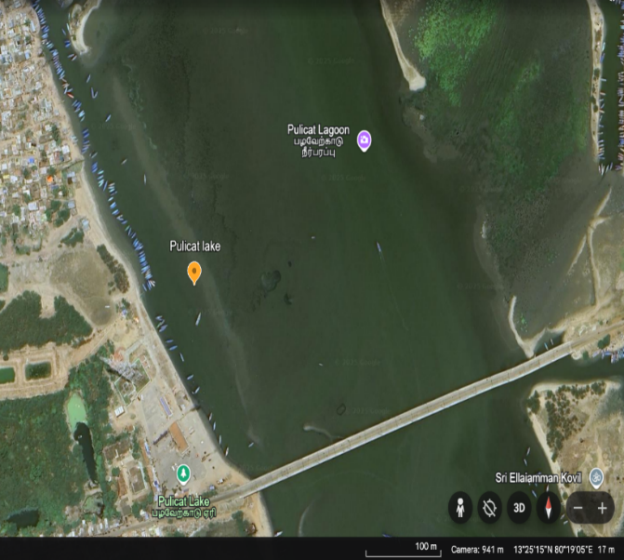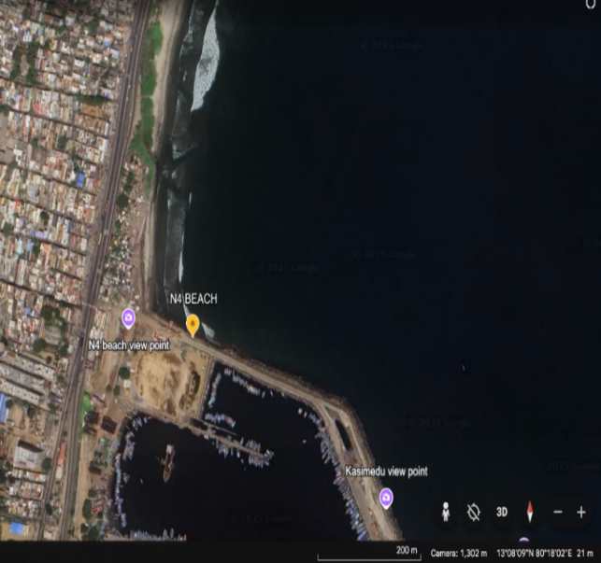 A) B)

**Fig. 1**. Sampling sites location **A)** N4 beach, Chennai district, Tamil Nadu, India **B)** Pulicat lake, Thiruvallur district, Tamil Nadu, India

**Sample analysis and extraction of microplastics**

During the process of study, glasswares and laboratory equipments were sterilized using distilled water to reduce the background contamination.

The shell length[cm], depth[cm] and width[cm] of each mussel was measured using caliper and the total weight[gm] of the mussels from both the sites were weighed using a digital weighing scale. The mussels were shelled and the whole soft tissue was dissected using forceps and stainless steel scapel from each mussel. The soft tissue and shells were rinsed thoroughly twice using distilled water in a 500ml beaker separately to remove the plastics.

Subsequently, the extraction of microplastics from soft tissue of the mussels were carried out following Wet peroxide oxidation tissue digestion method of Li et al method with some modifications (Li et al., 2015). Approximately 100ml of 30% [v/v] Hydrogen peroxide solution was measured and added to the beakers containing the shell, soft tissue for organic substance digestion. The beakers were covered with aluminium foil and incubated at 65ºC for approximately 24 hrs, followed by addition of 200ml of saturated NaCl 35g/100ml was added to the beaker. The components were mechanically stirred and kept overnight for incubation to remove the microplastic debris from the tissues during density separation )Fig.2(. This was followed by filtration of the aqueous components by Whatman filter paper )Grade-1 1µm pore size(. The filter paper containing the .residues were placed in a petri dish and allowed to dry .and kept covered for further analysis

**Assessment of microplastics**

The presence of microplastics in the mussel shell and tissues assessed by direct physical examination of the filter paper containing the residues under the MLXi Phase contrast microscope and screened at 40X magnification. The microplastics thus observed were counted, photographed and categorized based on their colour, shape and size. The assessment was performed in all the mussel samples obtained from Site-1 and Site-2. Further to analyze the microplastics for material characterization, the samples from the mussel shell and tissues were subjected to FT/IR-4x1 type A [Fourier Transform Infrared Spectroscopy] for the characterization of the polymer type of a microplastic particle. The spectrum was recorded in the range from 4000 to 300 cm⁻¹.

**Statistical analysis**

In statistical analysis, the differences in characterization of the mussels, quantification of microplastics and its effect on the neurophysiological biomarker, immunological parameters and protein estimation between mussels from Site-1 and Site-2 were assessed using IBM SPSS Statistical Version 30.0 (172) (IBM Corporation, 1989, 2024). To determine the statistical difference in the accumulation of microplastics in the *P. viridis* between the two sites, one-tail T-Test was performed.

**3. RESULTS**

**3.1 Characteristics of green mussels**

The average [Mean ± SD] of depth [cm], length [cm], width [cm], shell weight [g], soft tissue weight [gm], and the total weight [gm] of the green mussels for both the sites are given in the Table 1. According to the results, in the Site-1 green mussels, the range of depth, length, width, shell weight, soft tissue, and total weight of the green mussels were 2.4-5.1cm, 4.6-8.9cm, 1.2-2.6cm, 2.4-11.3g, 3-13.7g, 5.4-24.2g, respectively. And in the Site-2 green mussels, the range of height, length, width, shell weight, soft tissue, and total weight of the green mussels were 2.6-4.9cm, 4.6-8.5cm, 0.8-2.8cm, 4.8-12.6g, 5.7-12.9g, 11.3-24.8g, respectively. Statistical analysis showed that there were significant differences in the average shell length, width, weight of shell and soft tissue of mussel samples (p<0.05) between the Site-1 and Site-2 green mussels. The results also showed that there was no significant difference in the depth measurement between the green mussels from both sites.

**3.2 Quantification of microplastics in green mussel**

In the present study we observed the occurrence of microplastics in the shell as well as soft tissues of green mussels and quantified the same from both the N4 beach (Site-1) and Pulicat lake (Site-2). The average [Mean±SD] count of the microplastics in shell and soft tissue are given in Table 2. The total number of microplastics detected in Site-1 green mussel were with an average of 228±24.463 MPs, with an average of 137 particles (61%) found in the soft tissue and 88 particles (39%) in shell of the green mussels. Whereas from the green mussels in the Site-2 a total of 175±21.343 MPs, with an average of 75 particles (43%) in the shell and 101 particles (57%) in the soft tissue were detected. The results showed that the accumulation of the microplastics in the green mussels of the Site-1 were more compared to the green mussels collected from the Site-2.

**3.3 Microplastics characterization in green mussel**

The characterization of microplastics observed in the green mussels from Site-1 and Site-2 revealed their occurrence in a variety of colours, shapes and sizes (Fig. 2 and 3).

**3.3.1 Colours of Microplastics**

Microplastics in a range of colours were present in the shell and soft tissue of *P. viridis* (Fig.4). The ranking of colours of microplastics from the Site-1 in total was observed to be black> orange> brown> blue> white> transparent> pink> red=green> yellow. Colours of microplastics from the shell of green mussel from site 1 showed that orange colour [26%] were the dominant one and followed by brown [23%], black [18%], pink [12%], blue [9%], transparent [6%] and white [6%], while in the soft tissue black [41%] was the dominant one followed by blue [13%], orange [12%], transparent [10%], white [8%], brown [6%], red [4%], pink [4%] and yellow [2%]. In the green mussels from Site-2, ranking of colours in microplastics were observed to be black>white>red>orange>blue>green>transparent=pink, where black colour [45%] microplastics were the dominating one. Accordingly the percentage of microplastics based on their ranking of colours in the shell were black [48%], blue [15%], white [10%], orange [9%], red [8%], pink [6%] and transparent [4%], while in the soft tissue black [47%], white [14%], red [12%], orange [10%], blue [7%], green [5%], transparent [3%] and pink [2%]. In these microplastics, black colour were dominant from both the sites and there was addition of Brown and yellow color microplastics in site 1 which were completely absent in green mussels from Site-2.

**3.3.2 Shapes of microplastics**

During the present study we have observed various types of microplastics with a variety of shapes in the shell as well as soft tissue of green mussels collected from Site-1 and Site-2 (Fig.5). The ranking of the shapes observed in green mussels from Site-1 were, fragment>filament>bead>flakes>fiber>sheet. The percentage of each type of microplastics obtained from shell are fragment [52%], beads [24%], filament [12%], flakes [8%] and fiber [4%], whereas, fragment [42%], bead [20%], filament=fiber [13%], flakes [9%] and sheet [3%] were observed in the soft tissue. Sheet type of microplastic were absent in the shell of site 1 green mussels. In the green mussels from Site-2, the following ranking of type of microplastics was recorded, fragment>beads>fiber>filament>sheet. In the soft tissues the data in percentage were fragment [49%], beads [20%], fiber [17%], filament [12%] and sheet [2%] and in shell, fragment [47%], beads [22%], fiber [16%], filament [12%] and sheet [3%] were observed. Fragment shape of microplastics was dominant in the shell and soft tissue of green mussels collected from Site-1 as well as Site-2.

**3.3.3 Size of microplastics**

Size of the microplastics play a crucial role on the survival, growth and physiology of organism as they are very small it is easy to ingest as these mussels are filter feeders. In this study, the microplastics obtained from the shell and soft tissue of green mussel were grouped into four different sizes, <50µm, 50µm-100 µm, 100µm-200µm and >200µm as represented in Fig. 6. In the Site-1, >200µm [37%] size microplastics were found more followed by <50 µm [26%], 50µm-100µm [20%], and 100µm-200µm [17%], whereas in the Site-2, >200µm [31%], 50µm-100 µm [28%], 100µm-200µm [24%], <50µm [17%] were observed. In both the sites, >200µm were numerous compared to the other sizes.

**3.3.4 Identification of polymer type in green mussel using FT-IR**

All the suspected microplastics counted by microscopy were analyzed for their polymer type by using the FT/IR-4x1 type A based on matching with the spectral database as given in the Fig. 8. Particles which were identified as microplastics were composed of a variety of polymers including polyamide [nylon], polyester [PET], polyurethane [PU], acrylics, polyethylene [PE], polypropylene [PP], polystyrene [PS] and polyvinyl chloride [PVC] in Site-1 green mussels, whereas in Site-2 green mussels, polyester [PET], polyurethane [PU], polyethylene [PE], polypropylene [PP], polystyrene [PS] and polyvinyl chloride [PVC] were obtained (Fig.9).

The ranking of main types of polymers from the Site-1 in total was observed to be polyvinyl chloride [PVC]> polyester [PET]> polyethylene [PE]> polypropylene [PP]> polyamide [nylon]> acrylics> polystyrene [PS]> polyurethane [PU]. The percentage of each type of polymers obtained from the Site-1 green mussels are polyvinyl chloride [31%], polyester [15%], polyethylene [14%], polypropylene [10%], polyamide [9%], acrylics [8%], polystyrene [7%] and polyurethane [6%]. The chemical composition of the microplastic particles in Site-1 green mussel, *P. viridis*, shows the dominant presence of polyvinyl chloride [PVC] in the shell and soft tissue among the different polymers identified.

In the green mussels from Site-2, the following ranking of types of polymer was recorded, polyurethane [PU]> polyvinyl chloride [PVC]> polypropylene [PP]> polyethylene [PE]> polystyrene [PS]> polyester [PET]. Polyurethane [PU] polymer was dominant in the shell and soft tissue of green mussels collected from Site-2. In the Site-2 green mussels, the percentage of each polymer obtained are polyurethane [30%], polyvinyl chloride [24%], polypropylene [22%], polyethylene [14%], polystyrene [8%], polyester [2%]. Polyurethane [PU] was the dominant type of polymer in the Shell and soft tissue of Site-2 green mussels.

**Table 1. Characteristics of green mussels from Site-1 and Site-2**

|  |  |  |
| --- | --- | --- |
| **Characteristics** | ***Perna viridis*** | |
| **Site 1** | **Site 2** |
| **Depth [cm] [Mean± SD]** | 3.53±1.019 | 3.688±0.72 |
|
| **Length [cm] [Mean± SD]** | 6.266±1.659* | 7.011±1.396* |
|
| **Width [cm] [Mean± SD]** | 1.788±0.518* | 1.97±0.688* |
| **Shell weight [g] [Mean± SD]** | 5.966±3.849* | 9.28±2.827* |
| **Soft tissue weight [g] [Mean± SD]** | 7.044±4.466* | 10.18±2.906* |
|
| **Total weight [g] [Mean± SD]** | 13.01±8.295* | 19.4±5.782* |

* - Denotes significance (p < 0.05)

**Table 2. Quantification of microplastics from green mussel Site-1 and Site-2**

|  |  |  |  |
| --- | --- | --- | --- |
| **Site** | **Average count of microplastics**  **(Mean±SD)** | | **Total number of microplastics** |
|  | **In shell** | **In Soft tissue** |  |
| 1 | 88±13.417* | 137±11.4358* | 228±24.463* |
| 2 | 75±11.87* | 101±9.867* | 175±21.343* |

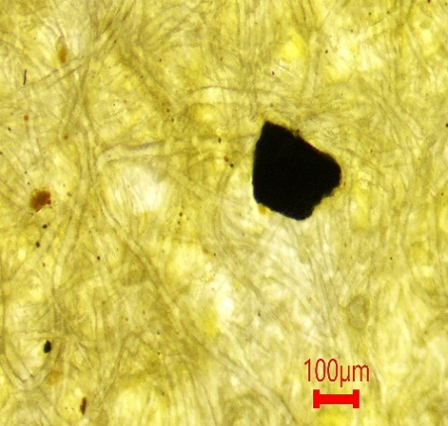* Denotes significance (p < 0.05)

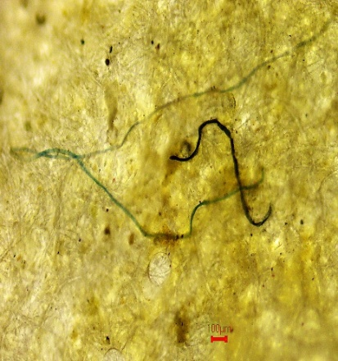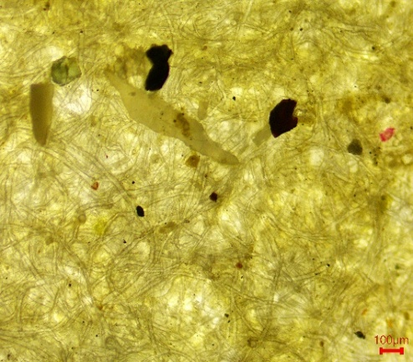

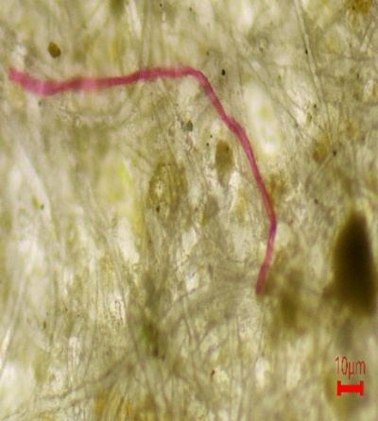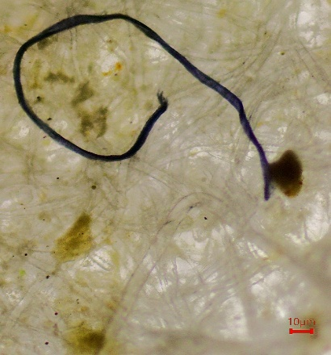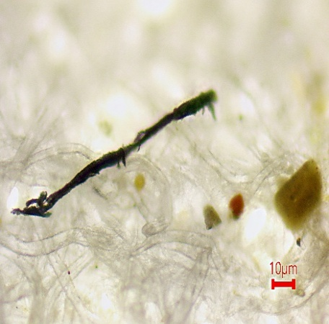**Fig. 2 Microplastics in green mussel from Site-1 observed under Phase contrast microscope (40x magnification)**

**Fig. 3 Microplastics ingreen mussel from Site-2 observed under Phase contrast microscope (40x magnification)**

**Fig. 4 Colours of microplastics (%) in green mussel from a. Site-1 b. Site-2**

**Fig. 5 Shapes of microplastics (%) in green mussel from a. Site-1 b. Site-2**

**Fig. 6 Size range of microplastics (%) in green mussel from a. Site-1 b. Site -2**

1. 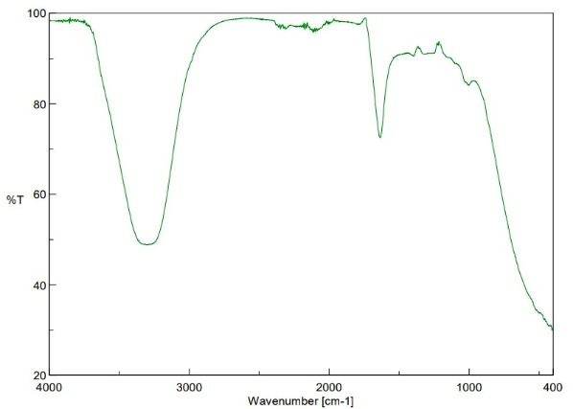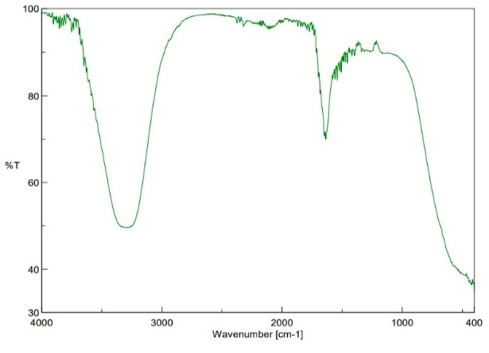 b)

**Fig. 7 Identification of microplastic polymer type using FT-IR and spectral database a. sample from Site-1 b. sample from Site-2**

**Fig. 8 Types of polymers (%) in green mussel from a. Site-1 and b. Site-2**

**4. DISCUSSION**

Microplastics have been main culprit for pollution in and around the coastal areas of Chennai, Tamil Nadu affecting the marine life and subsequently the health of mankind. The locations chosen for animal collection in the present study viz the N4 beach (Site-1) and the Pulicat lake (Site-2) are places of tourist attractions as well as traditional fishing. Apart from this, pollution from sewage, run off pesticides from agricultural fields, effluents from processing units all add to the threats of the fauna and their ecosystem. The present study on the physical characteristics of the green mussel, *P. viridis* revealed that the average length and width of the shell were significantly low (p<0.05) in the mussels collected from Site-1 than from Site-2 but no significant difference in the depth measurement between both the sites was observed. However the average difference in shell weight and soft tissue weight were moderately significant (p<0.01) in mussels obtained from Site-1 than from Site-2. The result is in accordance with the earlier studies (Noor A R *et al*., 2021, Cherdsukjai P *et al*., 2022) which concluded significant differences in the average shell length, width and depth of mussels (p<0.05). Such variation maybe attributed to the highly polluted environment these animals are exposed to. Further studies on the quantification of microplastics, which arethe major contributors to marine pollution, from the mussels collected from the two sites were performed in the present study. The results showed that the number of microplastics present in the shell and soft tissues of green mussels collected from Site-1 was significantly higher than Site-2. N4 beach (Site-1) as mentioned earlier, is a site which has its proximity to urbanized areas with prevalent human activities. Besides, the beach is close to the harbor where fishing is done and accessories associated are stationed.

An important physical characteristic of MPs is colour which is a good indicator of photo degradation and its intensity. Uptake of microplastics by organisms is also based on their colours (Lusher et al., 2020). As observed in the present study black and brown were the dominant colours of MPs in Site-1 and Site-2 suggesting their long term exposure to sea water causing discolouration. The blue coloured MPs represent the fishing gears (Piskuła et al., 2023, Ghosh et al., 2021) and the rampant use of polypropylene ropes for fishing (Bilugan et al., 2021). The source of orange, pink and red coloured microplastics are the degraded larger plastics from synthetic cloth material and other terrestrial sources (Lusher et al., 2020).

In the present study we obtained MPs from the shell and soft tissues of *Perna viridis*, belonging to categories such as fibres, fragments, filaments, sheets, flakes and beads. The distribution of these categories varied in Site-1 and Site-2 (Fig. 5). Fragment was the most dominant type of MPs present in both the sites, followed by bead type. The main source of fragment and bead are possibly degraded or abraded larger plastics from the massive use of polyethylene plastic bags widely used in urbanized cities like Chennai (Gewert et al., 2017, Wagner et al., 2014). Polypropylene ropes used for aquaculture purpose in Pulicat lake is the possible main source of fibre microplastics at Site-2.

The size of MPs obtained from the shell and soft tissue of *Perna viridis* from Site-1 and Site-2 were predominantly of >200µm size. However, MPs of 50-100µm and <50µm size were also abundant indicating the significant amount of degraded microplastics. Small sized MPs and nanoplastics have higher chances of entering the lower level of food chain (Plankton) and to be further carried to higher trophic levels (Rodríguez-Torres et al., 2024). Moreover large surface area to volume ratio of small sized MPs increase their bioavailability in the aquatic habitat (Campbell et al., 2017).

The MPs identified and counted by microscopy were subjected to analysis for their polymers by FT-IR on the basis of spectral database matching. These MPs were composed of different types of polymers such as polyamides, polypropylene (PP), polyethylene (PET), polyester, polystyrene (PS), polyurethane and polyvinyl chloride (PVC) (Fig. 8). Among these polyvinyl chloride and polyester dominated in the MPs isolated from green mussels from Site-1. These belong to the category of common synthetic plastics used for packaging, container lids, beverage bottles, detergents, etc. (Sobhani et al., 2020). Polyvinyl chloride are denser polymers which are likely to be encountered by benthic organisms (Bellasi et al., 2020). From Site-2 polyurethane, polyvinyl chloride and polypropylene were the polymers identified in the MPs isolated from green mussels. Polyurethane is dominant type in this site and used in foam coatings, adhesives and textile industries and polypropylene is used in plastics packaging and fibres. The less denser MPs such as polystyrene, polypropylene and polyethylene float in the sea water column (Arat, S. A. 2024) and get accumulated in the mussel. The high amount of MPs belonging to polyvinyl chloride and polystyrene from Site-1 mussels indicate their ubiquitous accumulation in the coastal water due to human intervention. Similarly the presence of polyurethane and polypropylene detected in the MPs from the green mussels in the Site-2 maybe attributed to the fishing nets and gears used by local fishermen.

Earlier studies on similar lines from nearby locations have also reported more or less same order of ranking of polymers isolated from green mussels (Naidu S A 2019). The present study has revealed the alarming state of coastal waters and the immensely polluted aquatic environment which the green mussel, *P. viridis* inhabits. The threat posed by these MPs accumulated in the mussels and thereby into humans by its consumption from the two sites N4 beach and Pulicat lake have been highlights for the first time through the present study.

**5. CONCLUSION**

Plastics pollution of the aquatic environment is a rapidly growing global issue and this preliminary study demonstrates the presence of harmful microplastics in mussels collected from N4 beach, Chennai district and Pulicat lake, Thiruvallur district. Bivalves such as mussels have been widely used as bioindicators for monitoring aquatic pollution level. The occurrence of microplastics was observed from both the sites, in the shell and soft tissue of green mussels. Significant differences in microplastics accumulation was also observed. The variety of colours, shapes and size in the polymers suggests that wide range of microplastics are accumulated in the aquatic ecosystems which can affect aquatic organisms from lower to higher trophic levels of the food web directly or indirectly. Polyvinyl chloride (PVC) and Polyurethane (PU) were the dominant type of polymers that had accumulated in the mussels and are commonly used in packaging materials, detergents and fish farming implements. This study highlights the potential hazardous effects of microplastics which are widely used in daily life and its accumulation in green mussels, a popular and affordable protein meat source consumed by people in and around coastal area globally. The presence of microplastics in these mussels suggests a direct entry of these pollutants into the human body, raising the potential health concerns. On emphasizing the current situation, further research is needed to understand the impact of microplastics on biological systems of green mussel, as well as biomagnification of microplastics at different trophic levels of the aquatic ecosystems and in humans.

Author(s) hereby declare that NO generative AI technologies such as Large Language Models (ChatGPT, COPILOT, etc.) and text-to-image generators have been used during the writing or editing of this manuscript.

**REFERENCES**

Akkajit, P., Tipmanee, D., Cherdsukjai, P., Suteerasak, T., & Thongnonghin, S. (2021). Occurrence and distribution of microplastics in beach sediments along Phuket coastline. *Marine Pollution Bulletin*, *169*, 112496.

Arat, S. A. (2024). An overview of microplastic in marine waters: Sources, abundance, characteristics and negative effects on various marine organisms. *Desalination and Water Treatment*, 100138.

Bellasi, A., Binda, G., Pozzi, A., Galafassi, S., Volta, P., & Bettinetti, R. (2020). Microplastic contamination in freshwater environments: A review, focusing on interactions with sediments and benthic organisms. *Environments*, *7*(4), 30.

Bilugan, Q. M., Limbago, J. S., & Gutierrez, R. L. (2021). Detection and quantification of microplastics from cultured green mussel Perna viridis in Bacoor Bay, Cavite, Philippines. *Sustinere: Journal of Environment and Sustainability*, *5*(2), 90-102.

Blettler, M. C., Ulla, M. A., Rabuffetti, A. P., & Garello, N. (2017). Plastic pollution in freshwater ecosystems: macro-, meso-, and microplastic debris in a floodplain lake. *Environmental monitoring and assessment*, *189*, 1-13.

Campbell, S. H., Williamson, P. R., & Hall, B. D. (2017). Microplastics in the gastrointestinal tracts of fish and the water from an urban prairie creek. *Facets*, *2*(1), 395-409.

Cherdsukjai, P., Vongpanich, V., & Akkajit, P. (2022). Preliminary study and first evidence of presence of microplastics in green mussel, Perna viridis from Phuket. *Applied Environmental Research*, *44*(1).

City Population. (n.d.). Cities and Towns in Thiruvallur (Tamil Nadu, India) - Population Statistics, Charts, Map, Location, Weather and Web Information. Available at: <https://citypopulation.de/en/india/tamilnadu/3301__thiruvallur/> [Accessed 18 February 2025].

Dharmaraj, S., Ashokkumar, V., Hariharan, S., Manibharathi, A., Show, P. L., Chong, C. T., & Ngamcharussrivichai, C. (2021). The COVID-19 pandemic face mask waste: a blooming threat to the marine environment. *Chemosphere*, *272*, 129601.

Gewert, B., Ogonowski, M., Barth, A., & MacLeod, M. (2017). Abundance and composition of near surface microplastics and plastic debris in the Stockholm Archipelago, Baltic Sea. *Marine pollution bulletin*, *120*(1-2), 292-302.

Ghosh, G. C., Akter, S. M., Islam, R. M., Habib, A., Chakraborty, T. K., Zaman, S., ... & Wahid, M. A. (2021). Microplastics contamination in commercial marine fish from the Bay of Bengal. *Regional Studies in Marine Science*, *44*, 101728.

Kaile, N., Lindivat, M., Elio, J., Thuestad, G., Crowley, Q. G., & Hoell, I. A. (2020). Preliminary results from detection of microplastics in liquid samples using flow cytometry. *Frontiers in Marine Science*, *7*, 552688.

Li, J., Yang, D., Li, L., Jabeen, K., & Shi, H. (2015). Microplastics in commercial bivalves from China. *Environmental pollution*, *207*, 190-195.

Li, Q., Sun, C., Wang, Y., Cai, H., Li, L., Li, J., & Shi, H. (2019). Fusion of microplastics into the mussel byssus. *Environmental pollution*, *252*, 420-426.

Lusher, A. L., Bråte, I. L. N., Munno, K., Hurley, R. R., & Welden, N. A. (2020). Is it or isn't it: the importance of visual classification in microplastic characterization. *Applied spectroscopy*, *74*(9), 1139-1153.

Mani, T., Hauk, A., Walter, U., & Burkhardt-Holm, P. (2015). Microplastics profile along the Rhine River. *Scientific reports*, *5*(1), 17988.

Naidu, S. A. (2019). Preliminary study and first evidence of presence of microplastics and colorants in green mussel, Perna viridis (Linnaeus, 1758), from southeast coast of India. *Marine pollution bulletin*, *140*, 416-422.

Naji, A., Esmaili, Z., & Khan, F. R. (2017). Plastic debris and microplastics along the beaches of the Strait of Hormuz, Persian Gulf. *Marine pollution bulletin*, *114*(2), 1057-1062.

Nelms, S. E., Galloway, T. S., Godley, B. J., Jarvis, D. S., & Lindeque, P. K. (2018). Investigating microplastic trophic transfer in marine top predators. *Environmental pollution*, *238*, 999-1007.

Noor, A. R., Shakil, A., Hoque, N. F., Rahman, M. M., Akter, S., Talukder, A., ... & Asaduzzaman, M. (2021). Effect of eco-physiological factors on biometric traits of green mussel Perna viridis cultured in the south-east coast of the Bay of Bengal, Bangladesh. *Aquaculture Reports*, *19*, 100562.

Patterson, J., Jeyasanta, K. I., Sathish, N., Booth, A. M., & Edward, J. P. (2019). Profiling microplastics in the Indian edible oyster, Magallana bilineata collected from the Tuticorin coast, Gulf of Mannar, Southeastern India. *Science of the total environment*, *691*, 727-735.

Phaksopa, J., Sukhsangchan, R., Keawsang, R., Tanapivattanakul, K., Asvakittimakul, B., Thamrongnawasawat, T., & Worachananant, S. (2022). Assessment of microplastics in green mussel (Perna viridis) and surrounding environments around Sri Racha Bay, Thailand. *Sustainability*, *15*(1), 9.

Piskuła, P., & Astel, A. M. (2023). Microplastics in commercial fishes and by-catch from selected FAO major fishing areas of the Southern Baltic sea. *Animals*, *13*(3), 458.

Ritchie, H., Samborska, V., & Roser, M. (2023). Plastic pollution. *Our world in data*.

Robin, R. S., Karthik, R., Purvaja, R., Ganguly, D., Anandavelu, I., Mugilarasan, M., & Ramesh, R. (2020). Holistic assessment of microplastics in various coastal environmental matrices, southwest coast of India. *Science of the Total Environment*, *703*, 134947.

Rodríguez-Torres, R., Rist, S., Almeda, R., Nielsen, T. G., Pedrotti, M. L., & Hartmann, N. B. (2024). Research trends in nano-and microplastic ingestion in marine planktonic food webs. *Environmental Pollution*, 125136.

Sobhani, Z., Lei, Y., Tang, Y., Wu, L., Zhang, X., Naidu, R., ... & Fang, C. (2020). Microplastics generated when opening plastic packaging. *Scientific reports*, *10*(1), 4841.

Thushari, G. G. N., Senevirathna, J. D. M., Yakupitiyage, A., & Chavanich, S. (2017). Effects of microplastics on sessile invertebrates in the eastern coast of Thailand: an approach to coastal zone conservation. *Marine pollution bulletin*, *124*(1), 349-355.

Veerasingam, S., Mugilarasan, M., Venkatachalapathy, R., & Vethamony, P. (2016). Influence of 2015 flood on the distribution and occurrence of microplastic pellets along the Chennai coast, India. *Marine pollution bulletin*, *109*(1), 196-204.

Wagner M, Scherer C, Alvarez‐Muñoz D, Brennholt N, Bourrain X, Buchinger S, Fries E, Grosbois C, Klasmeier J, Marti T, et al. 2014. Microplastics in freshwater ecosystems: What we know and what we need to know. Environ Sci Eur 26:1–9.

World Population Review. (2024). Chennai, India Population 2024. Available at: https://worldpopulationreview.com/cities/india/chennai [Accessed 18 February 2025].

Wright, S. L., Thompson, R. C., & Galloway, T. S. (2013). The physical impacts of microplastics on marine organisms: a review. *Environmental pollution*, *178*, 483-492.

Xu, X. Y., Wong, C. Y., Tam, N. F. Y., Liu, H. M., & Cheung, S. G. (2020). Barnacles as potential bioindicator of microplastic pollution in Hong Kong. *Marine Pollution Bulletin*, *154*, 111081.

Yang, D., Shi, H., Li, L., Li, J., Jabeen, K., & Kolandhasamy, P. (2015). Microplastic pollution in table salts from China. *Environmental science & technology*, *49*(22), 13622-13627.