**A Problematic Weed Water hyacinth (*Eichhornia Crassipes)* used as a Novel Substrate for the Production of β-Mannanase in Solid State Fermentation**

**Abstract**

Water hyacinth (*Eichhornia crassipes*) has drawn attention because of its startling ability to reproduce, which causes major ecological harm to water bodies worldwide. Traditional mechanical removal methods have disadvantages. These techniques result in the wastage of this valuable lignocellulosic resource. Using *Eichhornia crassipes* as a raw material in SSF (Solid substrate fermentation), reduces the production cost of the industrially significant enzyme β-mannanase while simultaneously resolving the environmental issue. Optimization of fermentation conditions such as production time, moisture content, temperature, particle size and carbon and nitrogen supplements for maximum β-mannanase production from *Aspergillus niger* was carried out. Under initial conditions 94 U/gds β-mannanase was obtained. Following the optimization of several fermentation parameters, including production time (6th day), temperature at 37°C, 100% moisture content, particle size of 0.5 mm, and the addition of locust bean gum and yeast extract as carbon and nitrogen supplements with 107 spores/ml inoculum size, a yield of 378 U/gds β-mannanase enzyme was achieved.

**Key words:** Mannanase**,** Optimization, *Eichhornia crassipes,* Enzyme, Fermentation

**Introduction**

“β-mannanases are hemicellulose degrading enzymes that randomly hydrolyses internal glycosidic bonds present in a backbone chain of β-D-1,4-mannopyranosyl linkages of mannans and heteromannans. Mannanases have been isolated from animals, plants and microbes. Most of the commercial β-mannanases have been produced from microorganisms due to their higher stability, cost effectiveness, production within limited time, and ease of genetic manipulation. This increases their market value and makes them suitable candidate for applications in various industry. In the microbial world, several microbes possess the ability to degrade mannan efficiently. β-mannanases can be produced by a variety of microbes like fungi, and bacteria, but higher production efficiency is obtained by fungi due to their more robust metabolic systems for extracellular enzyme synthesis. The production of microbial β-mannanase is promising due to its low cost, high production rate and novel properties such as activity in wide range of pH, and temperature. Recently β-mannanases have attracted noteworthy attention from both industry as well as academia because of their potential applications in various industries like oil drilling, detergent, food, animal feed, pharmaceutical, textile, and production of bioethanol” **(Dawood and Ma 2020; Norizan *et al.,* 2020: Shireen *et al.,* 2024).**

Mannan is a highly branched structural and storage polysaccharide found in yeast cell wall, seeds, and hemicellulosic fraction of softwood plants. Mannans from various sources exhibited large differences in composition, structure, and complexity. Mannan polysaccharides are a type of plant cell wall polysaccharide, primarily composed of β-1,4-linked D-mannose units, and can also contain glucose and galactose. They are classified into linear, galactomannan, glucomannan, and galactoglucomannan. Many mannan-based carbon sources have been used to produce microbial mannanase. These include pure mannans such as locust bean gum, guar gum, and konjac powder as well as low-cost substrates like copra meal, palm kernel cake, wheat bran and other agro-industrial wastes **(Chauhan *et al.,* 2012;** **Soni *et al.,* 2015).**

Water hyacinth (*Eichhornia crassipes)* is a free floating, vigorously spreading fresh water aquatic plant, exhibiting extremely high growth rates **(Sornvoraweat and Kongkiattikajorn, 2011)**. *Echhornia* is a potential pollution hazard and its management is very expensive. *Eichhornia crassipes* has many applications, including wastewater treatment, bioethanol production, bioremediation, compost production and animal feed (**Zimmels *et al,* 2006**). However, no study has been carried out so far on the use of *Echhornia* to produce β-mannanase. *Echhornia* is an excellent source of biomass, because of its magical property of propagation. It has high content of hemicelluloses 18-49% of dry weight **(Kumar *et al.,* 2009).** It can be used as a cheaper source for mannanase production due to its availability in large quantities and continuous supply to the fermentation industry, which reduces the ultimate cost of mannanase as well as solves the environmental problem. The present study focuses on optimization of β-mannanase production using *Echhornia crassipes* as substrate in SSF by *Aspergillus niger.*

**Methodology**

**Microorganism**

The mannanase producing fungi was isolated from a soil sample collected from Indore, India, and identified as *Aspergillus niger*, based on morphology, at National Fungal Culture Collection of India (NFCCI) Pune, Maharashtra. The isolate was grown on potato dextrose agar (PDA) slants at 37oC for 5 days and subsequently stored at 4oC.

**Optimization of Culture Conditions for Mannanase Production in Solid Substrate Fermentation**

**Inoculum Preparation**

*Aspergillus niger* was grown on potato dextrose agar media at 37oC for 5 days, and spores were harvested using 5 ml sterile 0.01% tween 80 with the help of sterile glass rod. Spores were counted using a counting chamber. After, autoclaving 2 ml of spore suspension (107 spores/ml) was inoculated in a 250 ml Erlenmeyer flask containing 5 grams of solid substrate powder.

**Effect of Various Solid Substrates on Mannanase Production**

The effect of solid substrates in SSF for the mannanase production from *Aspergillus niger* was studied using variety of solid substrates. For the present study, *eichhornia* stem powder, rose stem powder, saw dust, wheat bran, and rice bran were used for mannanase production in SSF. All these solid substrates were dried in sunlight and grinded to obtain their powder. 5 grams of each solid substrate powder were taken in 250 ml Erlenmayer flasks without any pretreatment. The moisture content was adjusted at 200%. After autoclaving these flasks containing solid substrate, 2 ml spore suspension (107 Spores/ml) were inoculated in it, and incubated at 37oC for 5 days. 5th day cultures were taken for enzyme extraction and a mannanase assay was performed under standard assay conditions.

**Optimization of Production Time**

Effect of fermentation period on mannanase production using solid substrate fermentation was done on a 250 ml Erlenmeyer flask containing 5 grams of solid substrate that is water hyacinth stem powder without any pretreatment. Initially 200% moisture content was taken using distilled water. After autoclaving, 2 ml spore suspension (107 Spores/ ml) were inoculated in it and incubated at 37oC for 0-8 days. 0.1 gram of sample was withdrawn from the flask each day after a 24 hours interval and dissolved in 10 ml of 50 mM citrate buffer (pH 5.3). The flask was kept in shaking condition at 150 rpm for 1h at 4oC. After this mannanase assay was performed under standard assay conditions.

**Effect of Temperature on Mannanase Production**

The effect of different temperatures ranging from 25oC to 60oC on mannanase production were studied. In this experiment 5 grams of substrate (water hyacinth stem powder) was taken in 250 ml Erlenmeyer flasks and 200% initial moisture content was adjusted. After autoclaving, spores were inoculated in it as previous experiment, and incubated at different temperatures ranging from 25oC to 60oC for 6 days. Enzyme extraction was done with 6th day old culture by adding 100 ml of 50mM citrate buffer (pH 5.3) and kept flasks at 150 rpm for 1 hour at 4oC temperature. The entire content of the flasks was squeezed through a muslin cloth and the extract was centrifuged at 10,000 rpm for 15 min at 4oC. Clear supernatant was decanted, and used as a source of mannanase. Then mannanase assay was performed under standard assay conditions.

**Effect of Different Solvents on Mannanase Extraction**

For the majority of applications, solid-liquid extraction (also known as leaching) is typically used to recover the enzymes adsorbed on the solid substrate. Both the recovery yield and the economics of fermentation depend critically on the effectiveness of the enzyme extraction **(Pal and Khanum, 2010).**

In this study, different solvents were used for extraction of mannanase namely distilled water, 10% glycerol, 50 mM Citrate buffer (pH 3.8), 10% tween 80, 10% ethanol, and 10% acetone. 6th day old culture flasks were taken for enzyme extraction. 100 ml of different solvents were added to each 6th day old fermentation flasks containing solid substrate (water hyacinth stem powder) with fungal culture and kept shaking at 150 rpm for 1 h at 4oC temperature. For extraction, the entire content of the flask was squeezed through a muslin cloth and the extract was centrifuged at 10,000 rpm for 15 min at 4oC. Clear supernatant was decanted and used as a source of mannanase. Then mannanase assay was performed under standard assay conditions.

**Effect of Extraction Time on Recovery of Mannanase**

The time of enzyme extraction is another important factor which affects the enzyme recovery, and overall cost of enzyme. For optimization of extraction time, 100 ml of 50 mM citrate buffer (pH 3.8) were added to each 6-day old culture flask containing 5 gram of solid substrate *Echhornia* stem powder with fungal culture, and kept them in shaking condition at 150 rpm, 4oC for 1h, 2h, 3h, 4h, 5h, and 6h. After this enzyme mannanase was extracted and assay was performed under standard assay conditions.

**Optimization of Moisture Content**

The effect of moisture content on mannanase production in SSF was done by using different 250 ml erlenmeyer flasks containing 5 grams of solid substrate *Eichhornia stem powder*. For this study 50%, 100%, 150%, 200%, 250%, 300%, 350%, and 400% of initial moisture content were taken. Fermentation flasks were autoclaved, and inoculated with the 2 ml spores of *Aspergillus niger* (107 Spores/ ml). All flasks were kept at 37oC for 6 days. After incubation enzyme was extracted by adding 100 ml of 50mM citrate buffer (pH 3.8) in each flask, and an assay was performed under standard conditions.

**Optimization of Particle Size**

The effect of particle size on mannanase production in SSF was done by using different 250 ml erlenmeyer flasks containing 5 grams of solid substrate *Eichhornia* stem powder having 0.5 mm, 1 mm and 2 mm sizes of particle. 100% moisture content was adjusted in each flask. After incubation with fungal culture for 6 days, mannanase enzyme was extracted from each fermentation flask and an assay was performed.

**Effect of Carbon Supplement**

Various carbon sources, such as glucose, sucrose, maltose, galactose and starch were added at 1% (w/w) separately to each fermentation flask containing 5 grams of 0.5mm particle sized substrate powder and their effects on the mannanase production were investigated.

**Effect of Nitrogen Supplement**

The effects of different nitrogen sources (urea, peptone, ammonium sulfate, ammonium nitrate and sodium nitrate; 1% w/w) were investigated.

**Enzyme Assay**

**Preparation of Substrate**

The substrate used routinely for the study of mannanase is galactomannan from locust bean gum (Ceratonia siliqua) with a mannose:galactose ratio of 4:1 **(De Nicolas-Santiago *et al.,* 2006).** 0.5% LBG (locust bean gum) as a substrate for mannanase assay was prepared by dissolving 0.5gram LBG in 50mM citrate buffer pH 3.8. Solution was kept on a magnetic stirrer for 15 min at 60oC. After this solution was centrifuged at 10,000 rpm for 10 min. Clear solution obtained from centrifugation was used for enzyme assay.

**Mannanase Assay**

0.5 % (w/v) locust bean gum dissolved in a 50 mM citrate buffer at pH 3.8 was used as the substrate mixture. 0.9 ml of the substrate mixture was added to 0.1ml of the crude enzyme solution and incubated at 75oC for 10 minutes. Afterwards 1 ml of dinitrosalicylic acid (DNS) reagent was added to each enzyme – substrate mixture and boiled for10 minutes. The absorbance of the mixture was thereafter measured at 540 nm in a spectrophotometer. The amount of mannose released was determined by the method of **Miller, (1959)**. One unit of mannanase was defined as the amount of mannanase that released 1 micro mole of mannose in one ml of the reaction mixture in one minute under the assay conditions. The mannanase activity was determined using the standard curve of mannose.

**Results**

**Optimization of Solid Substrate Fermentation Conditions for Mannanase Production from *Aspergillus niger***

**Screening of Various Solid Substrates on Mannanase Production**

Among five substrates i.e. *Eichhornia* stem powder, rose stem powder, saw dust, wheat bran, and rice bran examined for production of β-mannanase in SSF. The enzyme activity subsequently found i.e. 94, 68, 26, 46 and 43 U/gds (Fig 1). Minimum enzyme production was observed with Rice bran i.e. 43 U/gds and *Eichhornia* stem powder was observed to be the best substrate for β-mannanase production obtaining 94 U/gds of mannanase. Henceforth, *Eichhornia* stem powder was used for further studies.

**Effect of Production Time on Mannanase Production**

Effect of time course for mannanase production from *Aspergillus niger* using *Eichhornia* stem powder was studied on a daily basis i.e. 0, 1, 2, 3, 4, 5, 6, 7, and 8 days. 0, 0, 24, 52, 74, 102, 128, 110 and 92 U/gds enzyme activity were obtained subsequently (Fig 2). In this experiment, mannanase production was not observed on day 0 and day 1. From day 2 mannanase productions started and it increased until day 6, reaching a maximum of 128 U/gds. After day 6, production of mannanase slightly decreased, and became constant on subsequent days. Minimum enzyme production obtained on day 2 i.e. 24 U/gds and maximum mannanase production found on day 6 i.e. 128 U/gds.

**Effect of Temperature on Mannanase Production**

Effect of various temperature ranges from 25oC to 60oC for mannanase production from *Aspergillus niger* using *Eichhornia* stem powder were studied. The mannanase production of 92, 109, 124, 132, 122, 108, 90, 74 and 58 U/gds obtained for the temperature 25, 30, 35, 37, 40, 45, 50, 55 and 60oC subsequently (Fig 3). Optimum temperature for mannanase production was 37oC and minimum enzyme production was obtained at 60oC.

**Effect of Moisture Content on Mannanase Production**

Initial Moisture content is a significant factor in the production of β-mannanase, and it can be optimized along with other variables to increase production. In this set of experiments, 50% to 400% initial moisture content was taken, in which there was a difference of 50%. The enzyme production of 210, 276, 246, 215, 172, 138, 94 and 46 U/gds were obtained subsequently for 50%, 100%, 150%, 200%, 250%, 300%, 350% and 400% moisture contents (Fig 4). Maximum mannanase production obtained with 100% moisture content (276 U/gds). 400% moisture content showed minimum enzyme production.

**Effect of Different Solvent for Mannanase Extraction**

Different solvents such as distilled water, 50 mM citrate buffer pH 3.8, 10% glycerol, 10% tween 80, 10% acetone and 10% ethanol were used in this study and 256, 320, 276, 274, 254 and 242 U/gds enzyme production obtained subsequently (Fig 5). Among these solvents 50 mM Citrate Buffer (pH 3.8) gave maximum mannanase production of 320 U/gds, and 10% ethanol gave minimum enzyme production of 256 U/gds. This result suggested that the same buffer having the same pH used in mannanase assay is more efficient for enzyme extraction.

**Effect of Extraction Time on Recovery of Mannanase**

The soaking time 0, 1, 2, 3, 4, 5, and 6 hours were taken to obtain maximum enzyme recovery from *Eichhornia* stem powder and 179, 320, 319, 318, 320, 321, and 318 U/gds enzyme recovery obtained subsequently (Fig 6). Minimum mannanase recovery was observed at 0 hour i.e. 179 U/gds and optimum mannanase recovery was obtained at 1 hour of incubation or soaking time (320 U/gds). After 1 hour of soaking time the mannanase enzyme recovery was nearly remained constant.

**Effect of Substrate Particle Size on Mannanase Production**

Substrate particle size can affect the production of β-mannanase. Among the different particle sizes i.e. 0.5, 1.0, m 1.5 and 2.0 mm examined for production of β-mannanase and 352, 328, 314 and 285 U/gds enzyme production found subsequently (Fig 7). The smallest size 0.5 mm of substrate particle supported maximum yield of mannanase i.e. 352 U/gds, and largest size 2.0 mm supported minimum enzyme yield i.e. 285 U/gds.

**Effect of Carbon Supplements on Mannanase Production**

Carbon supplements can have a significant effect on mannanase production, with the best carbon source depending on the type of microorganism, and the substrate used. Among the various carbon supplements such as glucose, sucrose, mannose, galactose, guar gum, and LBG examined for production of β-mannanase and 234, 263, 238, 276, 338, and 361 U/gds enzyme units were obtained (Fig 8). LBG showed maximum effect on mannanase production (361 U/gds). Guar gum also has a significant effect but all other carbon sources i.e. glucose, sucrose, mannose, and galactose showed a repressive effect on mannanase production.

**Effect of Nitrogen Supplement on Mannanase Production**

Nitrogen is an essential nutrient for growth, and metabolic activity in microorganisms. It is a building block for amino acids, ribonucleic acids, proteins, and other vitamins and minerals. It is also required for energy production during anaerobic growth. The effect of nitrogen supplements on mannanase production depends on the type of nitrogen source used. Among nitrogen supplements tested i.e. yeast extract, peptone, ammonium sulfate, sodium nitrate and urea gave 378, 352, 336, 322 and 328 U/gds enzyme activity simultaneously (Fig 9). Yeast extract showed maximum mannanase production of 378 U/gds and sodium nitrate gave minimum enzyme production of 322 U/gds. Other nitrogen sources have significant effect on mannanase production but only organic nitrogen sources gave maximum enzyme production as compared to inorganic nitrogen sources.

**Discussion**

Microbial mannanases are mainly extracellular and inducible **(Dhawan and Kaur, 2007).** Galactomannan-rich substrates have been used widely as an inducer of β-mannanase. Among five substrates examined for production of β-mannanase in SSF, *Eichhornia crassipes* (Water hyacinth) was found to be the best for β-mannanase production. Because *Eichhornia crassipes* contains more enriched and readily biodegradable mannan, it produces more mannanase. Many researchers used different substrates for mannanase production including locust bean gum (LBG), apple pomace, palm kernel cake, konjac powder, copra meal and wheat bran. **(Chauhan *et al.,* 2012; Yin *et al.,* 2013 and Soni *et al.,* 2015).**

The fungal strain *Aspergillus niger* gave maximum enzyme production on the 6th day of incubation in SSF using water hyacinth stem part as substrate. The optimum temperature for mannanase production was 37oC, which indicates that the strain was a mesophilic organism. Temperature significantly impacts mannanase production in solid-state fermentation (SSF), with an optimal temperature range where maximum enzyme activity is observed; increasing temperature beyond this optimum point can lead to decreased mannanase production due to enzyme denaturation, while lower temperatures may result in slower microbial growth, and reduced enzyme synthesis **(Basmak and Turhan, 2024)**.Various researchers showed maximum mannanase production such as *Aspergillus niger* USM F-4 30oC 120h (**Rashid *et al.,* 2010**), *Aspergillus niger* LW-1 32oC 96h (**Zhang *et al.,* 2008), Sornlake *et al.* (2013)** reported β-mannanase production from *A. niger* BCC4525 in SSF at 30°C in 3 days. **Yilmazer *et al.* (2021)** found that the highest enzyme activity was at 30°C, 7 days from recombinant *Aspergillus sojae* AsT3.

“In SSF, a pertinent solvent is essential for maximum selective leaching of enzymes within lesser soaking time” **(Adhyaru *et al.,* 2015)**. “The extraction efficiency of solvent is a function of the hydrophilic/ hydrophobic nature of fungal mycelia and its bond (vander waal, hydrogen and ionic) establishment with enzymes” **(Fernandez - Lahore *et al.,* 1998)**. “Efficient recovery of enzyme from fermented substrate may depend on many factors such as type of enzyme, source of enzyme and substrates used as medium” **(Choudhary *et al.,* 2015)**. “In this investigation, distilled water and other solvents were used to extract mannanase from culture flasks. 50 mM citrate buffer pH 3.8 gave maximum enzyme yield, suggesting the convenience of citrate buffer for maximum mannanase recovery. The possible reason for this would be the high stability of mannanase at acidic pH” **(Campos *et al.,* 2024).**  “100 ml of citrate buffer (0.05M, pH 4.8) was used to extract ligninolytic enzymes produced by a fungal isolate under shaking conditions” **(Choudhary *et al.,* 2015)**. **Stoilova *et al.* (2010)** showed that ligninolytic enzymes were extracted from the fermented matter with 50 ml of distilled water mixed for 30 min at room temperature (25oC) using a shaker (220 rpm). 100 mM sodium acetate buffer (pH 5.0) was tried to leach ligninolytic enzymes from fermented biomass by **Ferdinand *et al.* (2014).** Shaking was beneficial for the recovery of the enzymes. In most of the investigations also, shaking conditions were employed for the extraction of ligninolytic enzymes. Shaking condition is quite justified because in the shaking condition, fermented substrate gets distributed uniformly in the continuous phase of solvent reducing concentration polarization **(Tunga *et al.,* 1999 and Asgher, 2011)**. Results of our present study indicate that 1-hour duration is sufficient for extraction of mannanase**.**

The synthesis of β-mannanase in solid-state fermentation (SSF) is significantly influenced by the initial moisture content. Microbial consortia growth may be impacted by moisture content since it influences heat dissipation, nutrition and oxygen availability, and more **(Wang *et al.,* 2023).** In the current study 100% initial moisture content was found optimum for mannanase production and after this production of mannanase continuously decreases. **Yin *et al.* (2013)** reported 59.2 % (w/w) initial moisture content best for mannanase production using a mixture of apple pomace and cottonseed powder (3:2 w/w). **Abdeshahian *et al.* (2010)** reported 60 % (w/w) initial moisture content best for mannanase production using palm kernel cake. **Soni *et al.* (2015)** observed moisture level of 1:1 was optimum for substrate palm kernel cake.

Among the various particle sizes used in the present study 0.5 mm particle size is favorable for maximum enzyme production. Smaller particle sizes generally support higher yields of β-mannanase. **Soni *et al.* (2015)** reported similar particle size results. In a different study, researchers found that mannanase produced best with particles < 0.5 mm, while *Sporotrichum thermophile* produced xylanase best with particles ≤ 0.6 mm **(Rashid *et al.,* 2010; Sadaf and Khare, 2014)**.

The effect of additional carbon supplements on mannanase production in solid-state fermentation (SSF) depends on the type of carbon source used. In the present study locust bean gum showed an inducible effect and various sugars showed a depressive effect on mannanase production. Similar results reported by (**Soni *et al.,* 2015** and **Norizan, *et al.,* 2020).**

The effect of additional nitrogen supplements on mannanase production in solid-state fermentation (SSF) depends on the type of nitrogen source used. In the current study yeast extract as an organic nitrogen supplement gave maximum enzyme production in SSF. On the other hand, **Soni *et al.,* 2015** and **Yin *et al.,* 2013** reported urea as best supplements for mannanase production.

**Conclusion**

The present study revealed the potential of Water hyacinth (*Eichhornia Crassipes*) as raw material to produce β-mannanase in order to make the best use of the problematic water weed and reduce the production cost of β- mannanase. The results showed that Water hyacinth (*Eichhornia Crassipes*) was the best substrate for mannanase production. Among the various carbon and nitrogen sources LBG and Yeast extract gave optimum mannanase production. Temperature, moisture content, solvent for mannanase extraction, and particle size were also optimized to get maximum yield of mannanase. The present research demonstrated optimized fermentation conditions for mannanase production, utilizing resources like water hyacinth (*Eichhornia crassipes*), leading to potential applications in various industries.

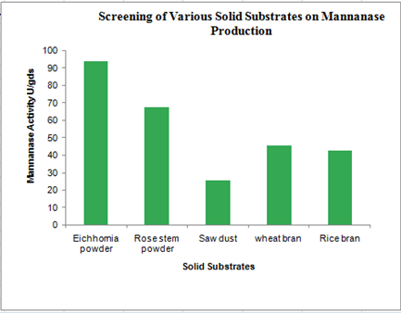

**Fig 1 : Screening of Various Solid Substrates on Mannanase Production**

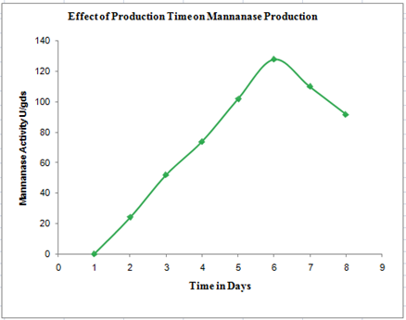

**Fig 2: Effect of Production Time on Mannanase Production**

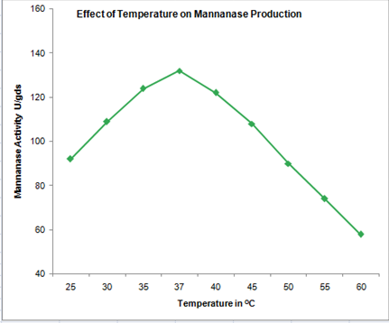

**Fig 3: Effect of Temperature on Mannanase Production**

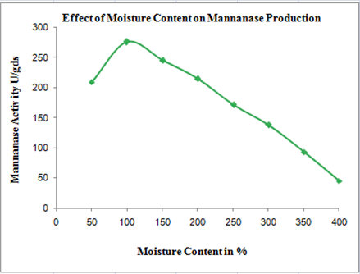

**Fig 4: Effect of Moisture Content on Mannanase Production**

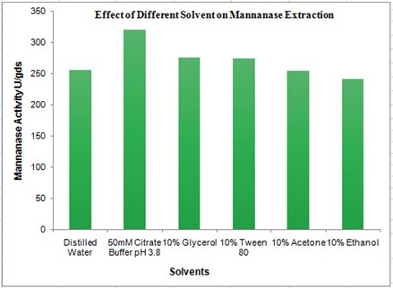

**Fig 5: Effect of Different Solvent for Mannanase Extraction**

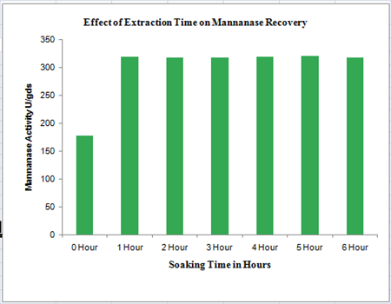

**Fig 6: Effect of Extraction Time on Recovery of Mannanase**

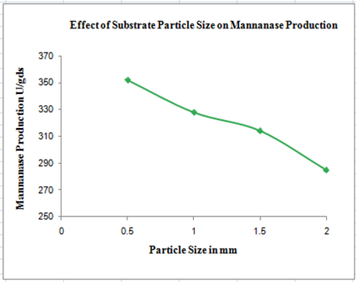

**Fig 7: Effect of Substrate Particle Size on Mannanase Production**

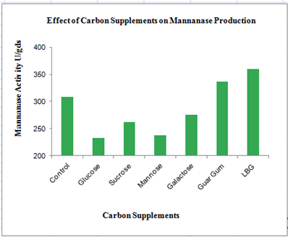

**Fig 8: Effect of Carbon Supplements on Mannanase Production**

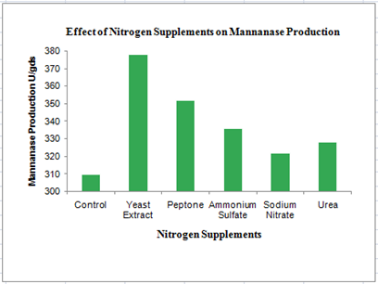

**Fig 9: Effect of Nitrogen Supplements on Mannanase Production**

Disclaimer (Artificial intelligence)

Author(s) hereby declare that NO generative AI technologies such as Large Language Models (ChatGPT, COPILOT, etc.) and text-to-image generators have been used during the writing or editing of this manuscript.

**References**

**Abdeshanian, P., Samat, N., Hamid, A. A. and Yusoff, W. M. W. (2009).** Utilization of palm kernel cake for production of β-mannanase by *Aspergillus niger* FTCC 5003 in solid state fermentation using an aerated column bioreactor. *J. Microbiol. Biotechnol.* 37:103–109.

**Adhyaru, D. N., Bhatt, N. S. and Modi, H. A. (2015).** Optimization of upstream and downstream process parameters for cellulase - poor - thermo - solvent - stable xylanase production and extraction by *Aspergillus tubingensis* FDHN1 . *Bioresour. Bioprocess.*2:3.

**Araya, M. M., Arrieta, J. J., Perez-Correa, J. R., Biegler, L. T. and Jorquera, H. (2007).** Fast and reliable calibration of solid substrate fermentation kinetic models using advanced nonlinear programming techniques. *Electron J. Biotechnol* 10:48–60.

**Asgher, M. (2011).** Characterization of a novel manganese peroxidase purified from solid state culture of *Trametes versicolor* IBL-04.*Bioresources.*  6:4317–4330.

**Basmak, S. and Turhan, I. (2024)**. Production of β-mannanase, inulinase, and oligosaccharides from coffee wastes and extracts. *International Journal of Biological Macromolecules*. 261(1).

**Campos, A. O., Asevedo, E. A., Souza Filho, P. F. and Santos, E. S. D. (2024).** Extraction of Cellulases Produced through Solid-State Fermentation by *Trichoderma reesei* CCT-2768 Using Green Coconut Fibers Pretreated by Steam Explosion Combined with Alkali. *Biomass*, *4*(1):92-106.

**Chauhan, P. S., Puri, N., Sharma, P. and Gupta, N. (2012).** Mannanases: microbial sources, production, properties and potential biotechnological applications. *Appl. Microbiol. Biotechnol.* 93:1817–1830.

**Choudhary, M., Chander Sharma P. and Neelam G. (2015).** Crop residue degradation by autochthonous fungi isolated from cropping system management scenarios, *Bioresources,* 10:5809- 5819.

**D., Nicolas-Santiago, S., Regalado-Gonzalez, C., Garcia-Almendarez, B. (2006).** Physiological, morphological, and mannanase production studies on *Aspergillus niger* uam-gs1 mutants. *Electron J Biotechnol.* 9(1):50–60.

**Dhawan, S. and Kaur, J. (2007).** Microbial mannanases: An overview of production and applications. *Crit. Rev. Biotechnol.* 27:197–216.

**Dawood, A., & Ma, K. (2020).** Applications of Microbial β-Mannanases. *Frontiers in bioengineering and biotechnology.* 8:598630.

**Ferdinandi Patrick, G.Y., SungusiaMtui, A., Mshandete, M. and Kivaisi, A.K. (2014).** Ligninolytic enzymes activities of *Pleurotus sapidus* p969 during vegetative growth and fruit development on sugarcane residues-based substrates, *Int. J. Biotechnol.* 3:58-71.

**Fernandez - Lahore, H. M.,Fraile, E. R. and Cascone, O. (1998).** Acid protease recovery from a solid - state fermentation system. *J. Biotechnol.* 62:83 – 93.

**Kote, N. V., Patil, A. G. G. and Mulimani, V. H. (2009).** Optimization of the production of thermostable endo- -1,4 Mannanase from a newly isolated *Aspergillus niger gr* and *Aspergillus flavus gr.Applied Biochemistry and Biotechnology.*152: 213-223.

**Kumar, P., Barret, D. M., Delwiche, M. J., Stroeve, P. (2009).** Methods for pretreatment of lignocellulosic biomass for eﬃcient hydrolysis and biofuel production. *Ind. Eng. Chem. Res.* 48(8):3713–3729.

**Meenakshi, Singh G., Bhalla, A. and Hoondal, G. S. (2010).** Solid state fermentation and characterization of partially purified thermostable mannanase from *Bacillus sp. MG-33*. *Bioresources* 5(3):1689–1701.

**Miller, L. (1959).** Use of dinitrosalicylic acid reagent for determination of reducing sugar. *Anal. Chem.* 31: 208-218.

**Norizan, N. A. B. M., Halim, M., Tan, J. S., Abbasiliasi, S., Mat Sahri, M., Othman, F. and Ariff, A. B. (2020).** Enhancement of *β*-Mannanase Production by *Bacillus subtilis* ATCC11774 through Optimization of Medium Composition. *Molecules*. *25*(15):3516.

**Pal, A. and Khanum, F. (2010).** Production and extraction optimization of xylanase from *Aspergillus niger* DFR-5 through solid-state-fermentation. *Bioresour Technol.* 101(19):7563-9.

**Rashid, J. I. A., Samat, N. and Yusoff, W. M. W. (2012).**Screening and optimization of medium composition for mannanase production by *Aspergillus terrus* SUK-1 in solid state fermentation using statistical experimental methods.*Research Journal of Microbiology.* 7:242-255.

**Sadaf, A. and Khare, S. K. (2014).** Production of *Sporotrichum thermophile* xylanase by solid state fermentation utilizing deoiled *Jatropha curcas* seed cake and its application in xylo oligosaccharide synthesis. *Bioresour Technol.* 153:126-30.

**Shireen A.A. Saleh, Faten A. Mostafa, Samia A. Ahmed, Eman R. Zaki, Walaa H. Salama, Walaa A. Abdel Wahab (2024).** Date nawah powder as a promising waste for β-mannanase production from a new isolate *Aspergillus niger* MSSFW, statistically improving production and enzymatic characterization. *International Journal of Biological Macromolecules*. 277(3):134447.

**Soni, H., Ganaie, M. A., Pranaw, K. and Kango, N. (2015).** Design-of-experiment strategy for the production of mannanase biocatalysts using plam karnel cake and its application to degrade locust bean and guar gum. *Biocatalysis and Agricultural Biotechnology.*Volume 4(2).

**Sornlake, W., Matetaviparee, P., Rattanaphan, N., Tanapongpipat, S. and Eurwilaichitr, L. (2013).** β‐Mannanase production by *Aspergillus niger* BCC4525 and its efficacy on broiler performance. *Journal of the Science of Food and Agriculture*. *93*(13): 3345-3351.

**Sornvoraweat, B. and Kongkiattikajorn, J., (2011).** Separated hydrolysis and fermentation of water hyacinth leaves for ethanol production. *J. Life Sci.* 5:212–219.

**Stoilova, I., Krastanov, A. and Stanchev, V. (2010).** Properties of crude laccase from Trametes versicolor produced by solid-substrate fermentation, *Adv. Biosci. Biotechnol.* 1:208–215.

**Tunga, R., Banerjee, R. and Bhattacharya, B. C. (1999).** Some studies on optimization of extraction process for protease for production in SSF, *Bioprocess Eng.* 20:485-489.

**Wang, H., Sun, C., Yang, S., Ruan, Y., Lyu, L., Guo, X., Wu, X. and Chen, Y. (2023).** Exploring the impact of initial moisture content on microbial community and flavor generation in Xiaoqu baijiu fermentation. *Food Chemistry*: 20.

**Yilmazer, C., Germec, M. and Turhan, I. (2021).** Solid‐state fermentation for the production of a recombinant β‐mannanase from *Aspergillus fumigatus* expressed in *Aspergillus sojae* grown on renewable resources. *Journal of Food Processing and Preservation*, *45*(8): e14584.

**Yin, J. S., Liang, Q. L. and Li, D. M. (2013).** Optimization of production conditions for β-mannanase using apple pomace as raw material in solid-state fermentation. *Ann Microbiol* 63:101–108.

**Zhang, M., Chen, X. L., Zhang, Z. H., Sun, C. Y., Chen, L. L., He, H. L., Zhou, B. C., Zhang, Y. Z. (2009).** Purification and functional characterization of endo-β-mannanase MAN5 and its application in oligosaccharides production from konjac flour. *Appl Microbiol Biotechnol* 83:865–873.

**Zimmels, Y., Kirzhner, F. and Malkovskaja, A. (2006).** Application of *Eichhornia crassipes* and *Pistia stratiotes* for treatment of urban sewage in Israel. *Journal of Environmental Management.* 81(4):420-428.