**Time and dose dependent effects of triazine derivatives on the survivorship of *Drosophila melanogaster***

**Abstract**

Triazine compounds are widely popular herbicides and recently, these have emerged as important therapeutic agents. Present investigation reports impact of two triazine compounds, 1,3,5-Triphenyl-[1,3,5] triazine (T1) and 1,3,5-Tris-(2-trifluoromethyl-phenyl)-[1,3,5] triazine (T2), on the survivorship of *Drosophila melanogaster,* a highly tractable and reproducible animal model for toxicological studies. We exposed adult flies to varying concentrations of T1 and T2 (125 mg/L, 250 mg/L, and 500 mg/L dissolved in DMSO) under standard culture conditions, comparing survivorship to control groups (untreated and DMSO-treated). Results indicated that both T1 and T2 do not show toxicity until day 30, however, post day 30 high dose of T1(500 mg/L) reduced survival percentage significantly. Derivative T2 was found to be non-toxic in the entire study period. One-way ANOVA and Tukey’s multiple comparison test were used to estimate the differences in mean survival percentage at specific time points using the software jamovi (v. 2.6.26). The findings highlight the differential effects of structurally related triazine compounds on *D. melanogaster* survival.

**Keywords:** 1,3,5-Triazines, Survivorship, *Drosophila*, Toxicity

**Introduction**

1,3,5-Triazines have attracted immense attention owing to their multitude of applications in pharmaceuticals, agrochemicals, and material sciences. As a privileged scaffold in drug discovery, s-triazine derivatives exhibit potent biological activities, including antimicrobial, anticancer, and anti-Alzheimer’s properties (Sharma *et al.*, 2021; Silva *et al.*, 2025; Dai *et al.*, 2023). Their role in medicinal chemistry extends to bioconjugation and targeted drug delivery, making them a crucial component in modern therapeutics (Singh *et al.*, 2021). Beyond pharmaceuticals, triazine-based porous organic polymers have been explored for environmental applications, such as reversible iodine capture and antibacterial functionalities (Mohan *et al.*, 2022). Additionally, triazine dendrimers have been widely investigated for their potential in nanomedicine and gene delivery (Simanek, 2021). However, despite their widespread utility, concerns regarding their environmental persistence and toxicity remain. Triazine-based herbicides, for instance, pose significant risks to ecosystems due to their long degradation times and potential bioaccumulation in organisms (Yao *et al.*, 2023). Studies have shown that exposure to these compounds can lead to adverse effects in model organisms such as *Drosophila melanogaster* and *Tenebrio molitor*, impacting developmental processes, cuticle melanization, and immune responses (Affleck & Walker, 2019; Naccarato *et al.*, 2023). Given their extensive use, further research into the environmental impact and safer alternatives for triazine derivatives is imperative to balance their benefits with ecological safety. This study aims to assess the effects of two triazine derivatives, T1 and T2, on the survivorship of *D. melanogaster*. The knowledge gained from *Drosophila* studies can be applied to broader toxicological and environmental contexts, providing valuable insights for understanding the effects of various compounds on living organisms and ecosystems.

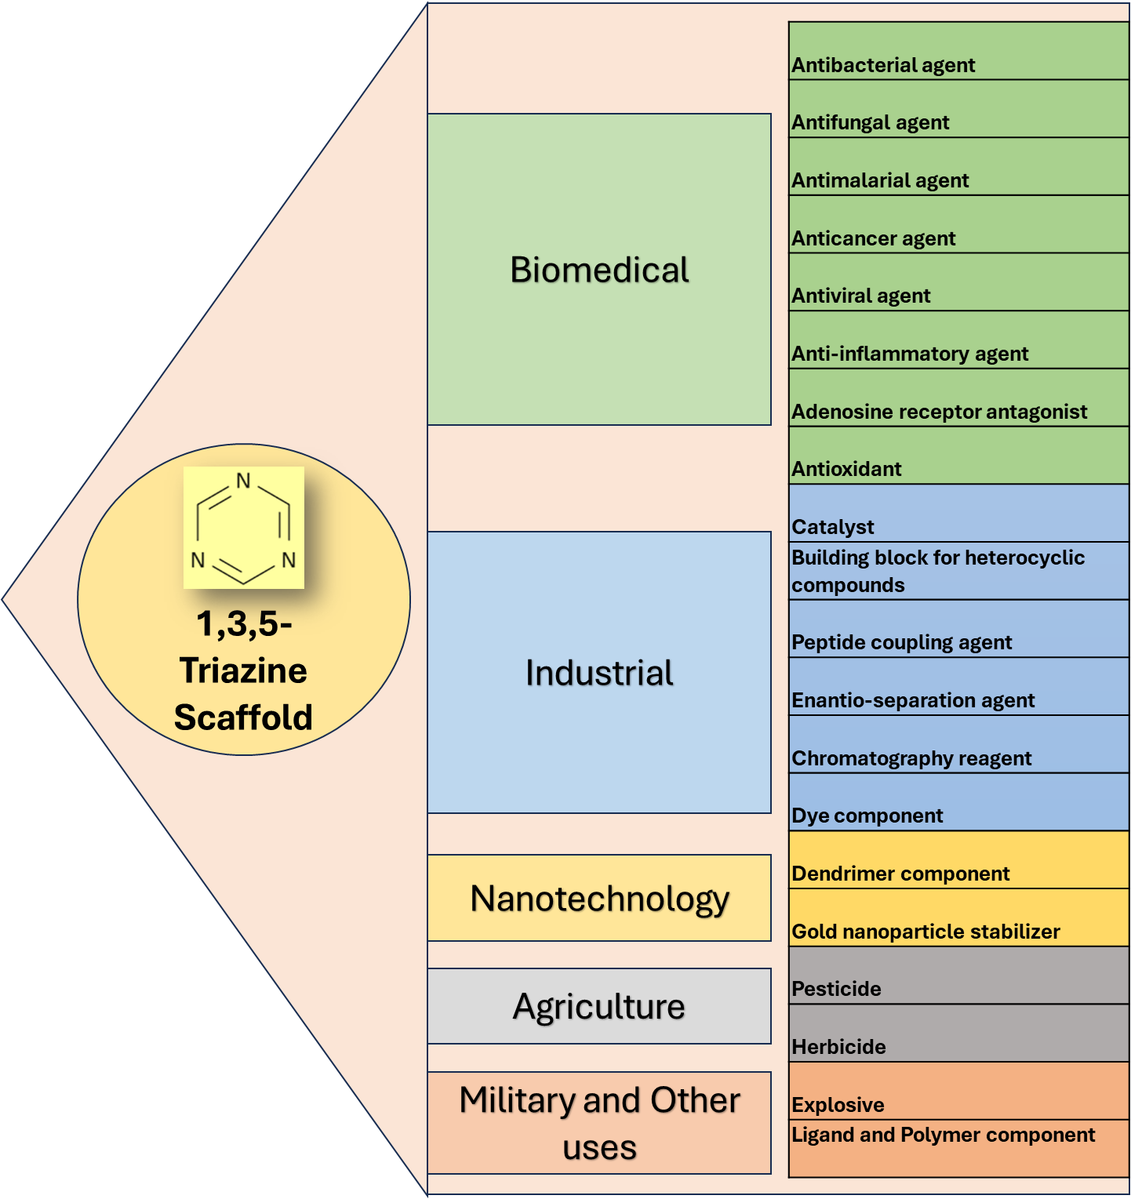

**Fig. 1** Diverse applications of triazine scaffold.

**Methodology**

***Drosophila* culture**

Wild-type *Drosophila melanogaster* (Oregon-R strain) were maintained on a standard cornmeal-yeast-sugar-agar medium supplemented with propionic acid and nipagin to inhibit mold growth. Cultures were kept at a constant temperature of 25 ± 2°C, with a consistent humidity and a 12-hour light/12-hour dark photoperiod (Ashburner and Roote, 2000).

**Compound Preparation and Exposure**

1,3,5-Triphenyl-[1,3,5] triazine (T1) and 1,3,5-Tris-(2-trifluoromethyl-phenyl)-[1,3,5] triazine (T2), compounds were obtained from Department of Chemistry (detailed characterization data is under publication somewhere else). Both the compounds were dissolved in dimethyl sulfoxide (DMSO) to create stock solutions. These stock solutions were then diluted with standard fly food to achieve the final concentrations of 125 mg/L, 250 mg/L, and 500 mg/L. Control groups included a plain control (no treatment) and DMSO controls at concentrations used to dissolve the compound (Yadav *et. al.*, 2024).

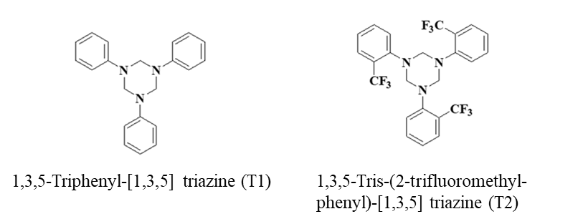

**Fig. 2.** Triazine compounds used in the study.

**Survivorship Assay**

Newly eclosed adult flies (mixed sex, 3 days old) were collected and divided into groups of 30 flies per vial. Each treatment group (including controls) consisted of five replicate vials. Flies were shifted to fresh vials containing the appropriate treatment every three days. The count of dead flies was recorded on regular intervals for a period of 60 days or until all the flies were dead. Survivorship was calculated as the percentage of flies remaining alive at each time point (Bernardes *et al.*, 2023).

**Statistical Analysis**

Data was organized and presented as mean ± std. deviation (S.D.). One-way ANOVA and Tukey’s multiple comparison test were used to estimate the differences in mean survival percentage at specific time points. A p-value of <0.05 was considered statistically significant (jamovi, v. 2.6.26).

**Results**

Under standard conditions, T1 at 125 mg/L and 250 mg/L did not significantly alter survival percentage compared to the plain and DMSO controls. However, at 500 mg/L, T1 reduced survivorship, an effect that was also observed in the 500 mg/L DMSO control, particularly after day 30. This suggests a potential contribution of DMSO to the observed toxicity at higher concentrations (Fig. 3).

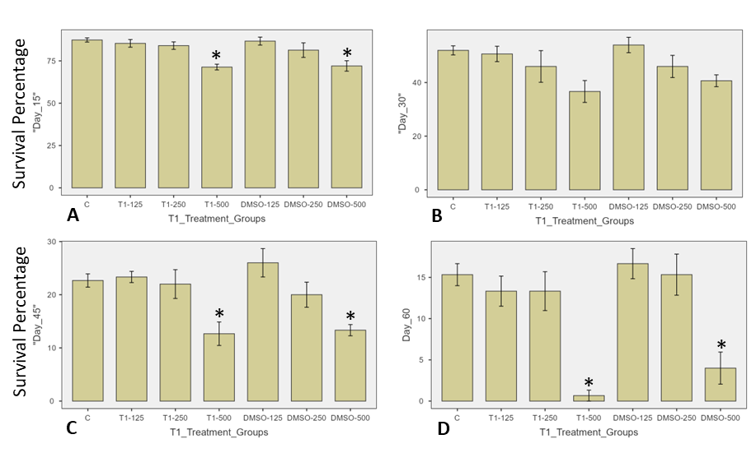

**Fig. 3. Effects of T1 on Drosophila melanogaster survivorship.** Survival (%) of wild-type *Drosophila melanogaster* (Oregon-R) exposed to different concentrations of T1 in food. Flies were treated with T1 at 125 mg/L, 250 mg/L, and 500 mg/L dissolved in DMSO, with corresponding DMSO controls and a plain control (C). The graphs show survival percentage at different time points (Day 15, Day 30, Day 45, and Day 60) under standard conditions. Error bars represent standard deviation (S.D.), and * *p* < 0.05.

Higher density regions indicate similar survivorship clustering in density distribution plots. Under standard conditions, survivorship remained high for most groups except for T1-500 and DMSO-500, which showed reduced densities over time (Fig. 4).

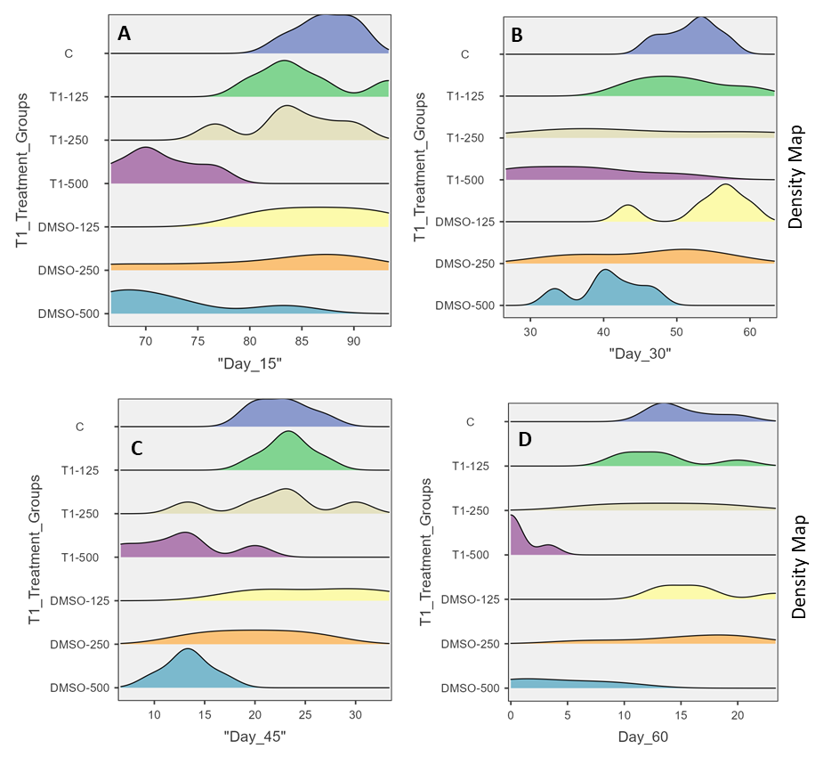

**Fig. 4. Density distribution of survival percentage in *Drosophila melanogaster* exposed to T1 under standard culture conditions.** Kernel density plots showing the distribution of survival percentages in *Drosophila melanogaster* (Oregon-R strain) treated with different concentrations of T1 over time. Flies were exposed to T1 at 125 mg/L, 250 mg/L, and 500 mg/L, along with corresponding DMSO controls and a plain control (C). Panels represent survival percentage distributions at (A) Day 15, (B) Day 30, (C) Day 45, and (D) Day 60.

T2 did not significantly reduce survivorship at any concentration. At 500 mg/L, flies treated with T2 showed better survivorship than the corresponding DMSO control. These findings suggest a potential protective effect of T2 under standard conditions against solvent induced effects (Fig. 5). Density distribution curves also show a similar trend in T2 treatment groups (Fig. 6).

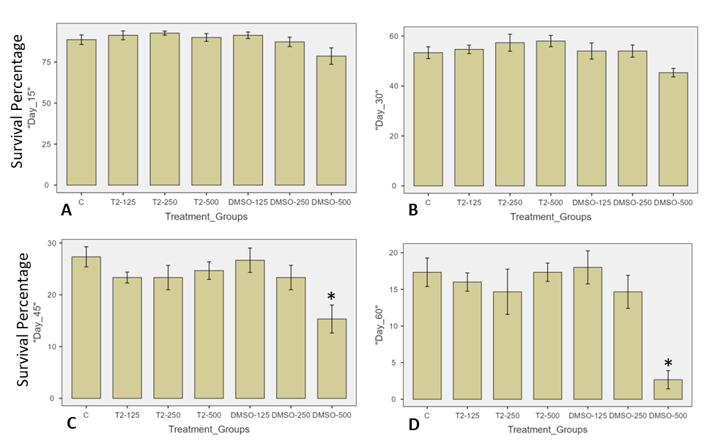

**Fig. 5. Effects of T2 on *Drosophila melanogaster* survivorship.** Survival (%) of wild-type *Drosophila melanogaster* (Oregon-R strain) exposed to different concentrations of T2 in food. Flies were treated with T2 at 125 mg/L, 250 mg/L, and 500 mg/L, with corresponding DMSO controls and a plain control (C). The graphs show survival percentage at different time points: (Top left) Day 15, (Top right) Day 30, (Bottom left) Day 45, and (Bottom right) Day 60 under standard culturing conditions. Error bars are standard deviation (S.D.), and * *p* < 0.05.

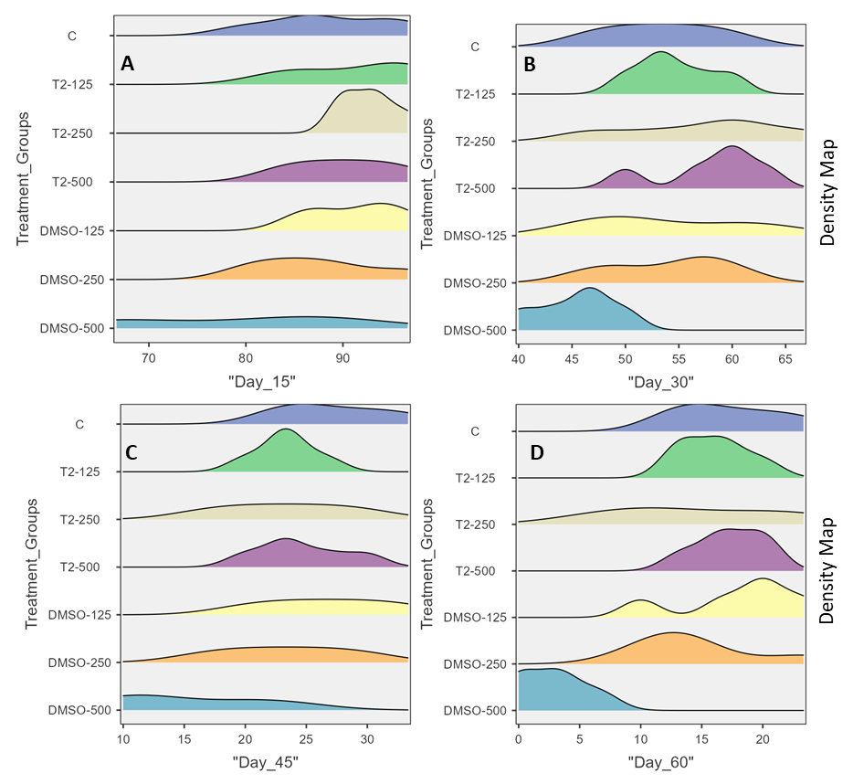

**Fig. 6. Density distribution of *Drosophila melanogaster* survivorship under T2 treatment.** Density plots representing survival percentage distribution across different time points for wild-type *Drosophila melanogaster* (Oregon-R strain) exposed to T2 at 125 mg/L, 250 mg/L, and 500 mg/L, with corresponding DMSO controls and a plain control (C). Each subplot represents survivorship distributions at (A) Day 15, (B) Day 30, (C) Day 45, and (D) Day 60.

**Discussion**

This study examines the differential toxicological effects of two triazine derivatives, T1 (unsubstituted phenyl) and T2 (2-trifluoromethyl phenyl), on *Drosophila melanogaster*. The findings highlight the significant role of substituent groups in modulating biological activity. T1 exhibited dose-dependent toxicity, especially at higher concentration (500 mg/L) and longer exposure duration, suggesting interference with metabolic pathways essential for survival in these conditions. This aligns with previous studies on triazine herbicides, which systemically disrupt metabolic processes and accumulate as toxic residues (Ahmad *et al.*, 2023).

Unlike T1, T2 showed no toxicity and even enhanced survivorship under starvation, suggesting a protective effect. The contrasting effects of T1 and T2 underscore the importance of substituent chemistry in determining biological activity. The electron-withdrawing trifluoromethyl group in T2 likely alters its interaction with biological targets, aligning with findings that halogenated triazines exhibit distinct toxicological profiles (Yadav *et al.*, 2024). Additionally, studies on trifluoromethylated fused triazinones indicate that such groups can mitigate toxicity (Sztanke *et al.*, 2021), supporting the hypothesis that T2’s structure contributes to its protective properties. The reduced survivorship in high-concentration DMSO control groups highlights solvent toxicity, reinforcing the need for cautious interpretation of toxicological results. Prior studies report DMSO-induced cytotoxicity in human cells and *Drosophila* larvae (Santos *et al.*, 2024; Cvetković *et al.*, 2015). Potential interactions between DMSO and T1 may have exacerbated toxicity, warranting alternative solvent strategies in future research. Further research should focus on elucidating the precise mechanisms through which T1 exerts toxicity and T2 confers potential protective effects, particularly by examining metabolic pathways, stress response genes, and possible molecular targets. Additionally, assessing the impact of T1 and T2 at environmentally relevant concentrations is crucial for evaluating their ecological significance.

**Conclusion**

This study demonstrates that structurally related triazine derivatives can exhibit markedly different biological effects, emphasizing the role of chemical modifications in toxicity and survivorship. T1's toxicity at high dose level suggests interference with essential metabolic pathways, while T2's protective effect implies a possible role in stress adaptation. These findings underscore the need for targeted investigations into structure-activity relationships within the triazine family. Furthermore, the impact of solvent effects on experimental outcomes highlights the necessity of careful methodological considerations in toxicological studies. Understanding these mechanisms will enhance risk assessments and inform the development of triazine-based compounds with specific biological activities.

**Consent (where applicable)**  
Not applicable.

**Ethical Approval (where applicable)**  
Not applicable.

Disclaimer (Artificial intelligence)

Author(s) hereby declare that NO generative AI technologies such as Large Language Models (ChatGPT, COPILOT, etc.) and text-to-image generators have been used during the writing or editing of this manuscript.

**References**

1. Affleck, J. G., & Walker, V. K. (2019). Drosophila as a Model for Developmental Toxicology: Using and Extending the Drosophotoxicology Model. *Methods in molecular biology (Clifton, N.J.)*, *1965*, 139–153. https://doi.org/10.1007/978-1-4939-9182-2_10
2. Ahmad, S.; Chandrasekaran, M.; Ahmad, H. W. (2023). Investigation of the Persistence, Toxicological Effects, and Ecological Issues of S-Triazine Herbicides and Their Biodegradation Using Emerging Technologies: A Review. *Microorganisms*, *11*(10), 2558. [https://doi.org/10.3390/microorganisms11102558](https://www.google.com/search?q=https://doi.org/10.3390/microorganisms11102558)
3. Ashburner, M., & Roote, J. (2000). Standardizing *Drosophila* culture. *Drosophila Information Service*, *83*, 197-198. (Include this as it was cited in the methods).
4. Bernardes, L. M. M., Malta, S. M., Rodrigues, T. S., Covizzi, L. F., Rosa, R. B., Justino, A. B., Teixeira, R. R., Espíndola, F. S., Oliveira Dos Santos, D., Vieira, C. U., & Vieira da Silva, M. (2023). Drosophila melanogaster as a model for studies related to the toxicity of lavender, ginger and copaiba essential oils. *PloS one*, *18*(9), e0291242. https://doi.org/10.1371/journal.pone.0291242
5. Cvetković, V. J., Mitrović, T. L., Jovanović, B., Stamenković, S. S., Todorović, M., Đorđević, M., & Radulović, N. (2015). Toxicity of dimethyl sulfoxide against Drosophila melanogaster. *Biologica 1 Nyssana*, *6*(2), 91-95.
6. Dai, Q., Sun, Q., Ouyang, X., Liu, J., Jin, L., Liu, A., He, B., Fan, T., & Jiang, Y. (2023). Antitumor Activity of s-Triazine Derivatives: A Systematic Review. *Molecules*, *28*(11), 4278. <https://doi.org/10.3390/molecules28114278>
7. Mohan, A., Al-Sayah, M. H., Ahmed, A., & El-Kadri, O. M. (2022). Triazine-based porous organic polymers for reversible capture of iodine and utilization in antibacterial application. *Scientific reports*, *12*(1), 2638. <https://doi.org/10.1038/s41598-022-06671-0>
8. Naccarato, A., Vommaro, M. L., Amico, D., Sprovieri, F., Pirrone, N., Tagarelli, A., & Giglio, A. (2023). Triazine Herbicide and NPK Fertilizer Exposure: Accumulation of Heavy Metals and Rare Earth Elements, Effects on Cuticle Melanization, and Immunocompetence in the Model Species *Tenebrio molitor*. *Toxics*, *11*(6), 499. https://doi.org/10.3390/toxics11060499
9. Santos, L. M., Shimabuko, D. Y., & Sipert, C. R. (2024). Dimethyl sulfoxide affects the viability and mineralization activity of apical papilla cells *in vitro*. *Brazilian Dental Journal, 35*, e24-6054. [https://doi.org/10.1590/0103-644020246054](http://dx.doi.org/10.1590/0103-644020246054)
10. Sharma, A., Sheyi, R., de la Torre, B. G., El-Faham, A., & Albericio, F. (2021). s-Triazine: A Privileged Structure for Drug Discovery and Bioconjugation. *Molecules (Basel, Switzerland)*, *26*(4), 864. <https://doi.org/10.3390/molecules26040864>
11. Sharma, A., Sheyi, R., de la Torre, B. G., El-Faham, A., & Albericio, F. (2021). s-Triazine: A Privileged Structure for Drug Discovery and Bioconjugation. *Molecules (Basel, Switzerland)*, *26*(4), 864. <https://doi.org/10.3390/molecules26040864>
12. Silva, C. F. M., Guerrinha, A. P. D. M. S., Carvalho, S., Pinto, D. C. G. A., & Silva, A. M. S. (2025). 1,3,5-Triazine: A Promising Molecular Scaffold for Novel Agents for the Treatment of Alzheimer's Disease. *International journal of molecular sciences*, *26*(3), 882. <https://doi.org/10.3390/ijms26030882>
13. Simanek E. E. (2021). Two Decades of Triazine Dendrimers. *Molecules (Basel, Switzerland)*, *26*(16), 4774. https://doi.org/10.3390/molecules26164774
14. Singh, S., Mandal, M. K., Masih, A., Saha, A., Ghosh, S. K., Bhat, H. R., & Singh, U. P. (2021). 1,3,5-Triazine: A versatile pharmacophore with diverse biological activities. *Archiv der Pharmazie*, *354*(6), e2000363. <https://doi.org/10.1002/ardp.202000363>
15. Sztanke, M., Rzymowska, J., & Sztanke, K. (2021). Anticancer active trifluoromethylated fused triazinones are safe for early-life stages of zebrafish (*Danio rerio*) and reveal a proapoptotic action. *PLoS One*, *16*(1), e0246054. <https://doi.org/10.1371/journal.pone.0246054>
16. The jamovi project (2024), jamovi. (Version 2.6) [Computer Software]. Retrieved from <https://www.jamovi.org>.
17. Yadav, M.; Kashyap, S.; Charan, S. K.; Nirmal, N. K. (2024). Effects of ingestional exposure of 1,3,5-triazine derivatives on Drosophila melanogaster. *International Journal of Entomology Research*, *9*(11), 76-83.
18. Yao, T., Sun, P., & Zhao, W. (2023). Triazine Herbicides Risk Management Strategies on Environmental and Human Health Aspects Using In-Silico Methods. *International journal of molecular sciences*, *24*(6), 5691. https://doi.org/10.3390/ijms24065691