***Short communication***

**First report of a Mermithid nematode parasite on *Coccinella transversalis* (Fabr.)**

**(Coleoptera: Coccinellidae) from Rajnandgaon, Chhattisgarh, India**

**Abstract**

Mermithids are parasitic nematodes belonging to phylum Nematoda which are generally translucent white, thin, and cylindrical in shape. Mermithids vary in length ranging from 10-100 mm and are easily detectable in host insects simply by dissection or when they leave their hosts. Mermithid infective juveniles cause significant disruption in the morphology, physiology, and behavioral responses of the various host insects. The present infection on *Cocconella transversalis* was observed during survey of crop cultivating areas during August-September 2024, in which adult beetles of *C. transversalis* were collected on the leaves of *Parthenium* weed from a Horticulture farm situated in Surgi- village of Rajnandgaon, Chhattisgarh, India. Notably, nematodes were found only in stink bugs collected from plants, not those attracted to store lights, suggesting potential host behavioral changes. DNA sequencing and morphological analysis identified the nematodes as belonging to *Hexamermis*. Mermithids belong to a family of nematodes specialized in parasitizing insects and play a significant role in regulating insect population dynamics. This finding opens new possibilities for considering mermithids as potential biological control agents for triatomine insects.

**Keywords**: Mermithids, Nematoda, DNA sequencing, biological control agents, triatomine insects

**Introduction**

Coccinellids, commonly called as ladybirds or ladybugs, belongs to the family Coccinellidae, one of the richest insect families, distributed worldwide with approximately 6000 species belonging to 360 genera (Vandenberg,2002). The insects of Coccinellidae family are very gracious and valuable. These are predators of many insects that help farmers in controlling the crop damaging insects below threshold level (Vincent, *et al*., 2007). Ladybird beetles have very distinctive shape and can be easily identified. Some species of ladybird beetles are judged as pests due to their attack on the vegetative parts of plants (Watts, 2004). *Coccinella transversalis* Fabr*.* is a potential predator on many soft bodied insects(Omkar and James, 2003 and 2004). It has significant potential and use against a variety of crop pests in combination with other insect pest management tactics.

**Survey method**

The present infection on *Cocconella transversalis* was observed during survey of crop cultivating areas during August-September 2024, in which adult beetles of *C. transversalis* were collected on the leaves of *Parthenium* weed from a Horticulture farm situated in Surgi- village (21°01'56.1"N 81°06'57.8"E) Rajnandgaon, Chhattisgarh. Collected adult beetles were taken to the Biocontrol laboratory, Pt. SKS College of Agriculture and Research Station, Rajnandgaon (C.G.) and kept in petri plates for further studies. Mermethid nematode was seen emerging from the ventral side of a dead adult beetle of *C. transversalis.*

Mermithids are parasitic nematodes belonging to phylum Nematoda which are generally translucent white, thin, and cylindrical in shape. Mermithids vary in length ranging from 10-100 mm and are easily detectable in host insects simply by dissection or when they leave their hosts. Mermithid infective juveniles cause significant disruption in the morphology, physiology, and behavioral responses of the various host insects. Many mermithid infections cause abdominal distortion, discolored cuticle/integument, and a decrease in total fat body content in the host. Sometimes, the infection leads to arrested development of host’s larval, pupal and adult stages Parasitization can also prevent metamorphosis. Inhibition of pupation associated with parasitism is probably a symptom of severe nutrient depletion rather than an active alteration of hormonal system by the infective juveniles (Condon and Gordon, 1977).

**Observation and findings**

Mermithidae is a family of nematodes that are obligate parasites of invertebrates, including insects, millipedes, crustaceans, spiders, mollusks, and earthworms (Nickle, 1972; Poinar, 1979). These nematodes can influence their hosts’ morphology, physiology, and behavior (Petersen, 1985). Their life cycle consists of five stages (Poinar and Otieno, 1974; Poinar, 1983; Poinar, 2001b). The eggs are laid in the environment, where the embryos undergo their first molt and hatch as second-stage juveniles, which serve as the infective stage. Once inside a host's haemocoel, they experience rapid growth (third stage) before exiting as post parasitic juveniles (fourth stage). They then enter a dormant phase and molt twice to reach adulthood (Poinar, 2015a). If the host is under stress, mermithids may leave prematurely (Poinar, 2015b). Since hosts typically die upon nematode emergence, mermithids have been explored as potential biological control agents, particularly against aquatic insect larvae such as mosquitoes (Petersen, 1985). Though they kill their hosts similarly to parasitoids, they are generally classified as parasites, consistent with other nematodes (De Baets*et al*., 2021a and DeBaets*et al.,* 2021b).

Tarla, 2020 collected adults of *Coccinella septempunctata* (Coleoptera: Coccinellidae) from leaf litter in overwintering sites. After preserving in alcohol, they were dissected to examine the presence of mermithid nematodes in their body cavities. *Hexamermis* sp. parasitism was observed in 13.3% of females and 13.8% of males. Among the eight examined beetles, 87.5% hosted a single nematode, while 12.5% contained two. The average body length of post-parasitic nematodes (n = 7) was 34.2 ± 8.82 mm, ranging from 23.4 to 42.2 mm. The findings suggest that *Hexamermis* sp. significantly impacts *C. septempunctata* populations in overwintering areas.

16 new mermithid nematodes were discovered in mid-Cretaceous Kachin amber, revealing previously unknown host associations with bristletails, bark lice, and perforissid planthoppers (Luo, *et al.,* 2023). These findings suggest that mermithid parasitism was already widespread in the mid-Cretaceous and played a key role in ancient ecosystems. Unlike their Cenozoic counterparts, Cretaceous mermithids were more commonly found in non-holometabolous insects, indicating that nematodes had not yet fully exploited Holometabola as hosts. This study uncovers a lost evolutionary history of nematode parasitism in early insects.

As per Lourdes, *et al.,* 2022, mermithid parasites, are known to cause mortality and behavioral changes in black flies, in Malaysia to understand their distribution and influencing factors. A total of 13,116 mid- to late-instar black fly larvae from 42 species were collected from 138 streams across East and West Malaysia. Mermithids were found in 107 larvae (0.82%) from nine species (21.4%), with an average infection rate of 1.10 ± 0.04 parasites per host. *Simulium trangense* had the highest infection rate (6.5%), followed by *S. cheongi* (5.8%) and *S. angulistylum* (2.9%), while *S. brevipar* and *S. tahanense* had the lowest (0.7%). Regression analysis linked infections to cooler, shallower, shaded streams with dense riparian vegetation, high dissolved oxygen, and lower conductivity and pH. Forward logistic regression showed *S. cheongi* infections were associated with slightly acidic, high-conductivity streams with more dissolved oxygen. These findings suggest mermithid infections in Malaysian black flies are influenced by host breeding habitats.

According to Watanabe, *et al.,* 2021, mermithid nematodes (*Mermithidae*) infect and kill various invertebrates and have been studied for their potential in insect pest control.They surveyed mermithid infections in fruit-piercing stink bugs (*Pentatomidae*) across four Japanese prefectures (Shizuoka, Mie, Tokushima, and Saga). Infection rates varied by species, with *Glaucias subpunctatus* showing higher infection than *Plautiastali* or *Halyomorphahalys*. Significant differences were observed across regions and seasons, with the highest infection in *G. subpunctatus* in Mie (May–June). Notably, nematodes were found only in stink bugs collected from plants, not those attracted to store lights, suggesting potential host behavioral changes. DNA sequencing and morphological analysis identified the nematodes as belonging to *Hexamermis*.

Martins, *et al*., 2020 discovered a juvenile mermithid nematode parasitizing a third-instar nymph of the assassin bug, *Triatoma sordid* (Hemiptera :Reduviidae) in Mato Grosso, Brazil, marking the first documented case of mermithid infection in a triatomine species. Mermithids belong to a family of nematodes specialized in parasitizing insects and play a significant role in regulating insect population dynamics. This finding opens new possibilities for considering mermithids as potential biological control agents for triatomine insects.

*Reticulitermes flavipes* termites were collected from logs in Whitehall Forest, USA, and maintained in laboratory cultures. Within two to three weeks, mermithid nematodes were discovered during dissections. The nematodes were preserved in 5% formaldehyde, processed into glycerin, and mounted on slides. As the nematodes were in parasitic or early post-parasitic juvenile stages, they lacked adult traits necessary for precise classification. Consequently, they were assigned to the collective genus *Agamomermis* Stiles 1903. Five mermithids were extracted two parasitic juveniles and three early post-parasitic juveniles that had begun shedding their third- and fourth-stage cuticles. (Poinar, *et al.,* 2020)

Rusconi ,*et al*., 2020 reported Mermithid nematodes parasitizing adult and nymph of *Hortensia similis* (Cicadellidae) in weeds from citrus orchards in Corrientes, Argentina as the first report of mermithid parasitism in South American leafhoppers.

Senthil Kumar, *et al.,* 2018 reported a mermithid nematode parasitizing *Conogethes punctiferalis*, a major pest of ginger and turmeric, was recorded in Peruvannamuzhi, Kerala, India. Infection reached epizootic levels (July–September), causing over 50% mortality, with parasitism rates of 18.2–80.6% in ginger and 17.9–66.7% in turmeric. Parasitism was positively correlated with rainfall and negatively with maximum temperature. Molecular analysis of the 18S rRNA gene placed the nematode among various genera, preventing precise classification. Pair wise Kimura 2-parameter analysis identified its closest relative as an undescribed mermithid infecting slugs (K2P distance: 0.009). The nematode’s epizootic impact highlights its potential as a biocontrol agent for *C. punctiferalis*, supporting its role in integrated pest management strategies.

An unidentified *Mermithida* species was recorded, marking the first known case of *Harmonia axyridis* naturally infested by a mermithid nematode.(Orlova-Bienkowskaja, *et al.,* 2018). Mermithid nematodes are known parasites of beetles that consume leaves and roots. Species of Psammomermis were found to infect 60% of Japanese beetles in certain regions of the former Soviet Union. Similarly, Mazza *et al.,*(2017) identified a related mermithid nematode parasitizing Papilio japonica grubs in northeastern U.S. lawns. This nematode, measuring about 20 cm in length, was observed coiled inside the host, extending from the thoracic region to the pre-ultimate abdominal segment. In Brattleboro, Vermont, mermithid infection was recorded in 60% of grubs collected from sandy soil on the town green.

Kobylinski, *et al*., 2012 detected mermithid parasite in 1.8% (10/551) of sampled adult *Anopheles* mosquitoes, specifically in *An. gambiae s.s.*, *An. funestus*, and *An. rufipes* from Ndebou, Boundoucondi, and Damboucoye. Maximum parsimony analysis confirmed their classification as mermithid nematodes, closely related to *Strelkovimermis spiculatus* based on GenBank sequences.

**Conclusion**

*Hexamermis eurygasteri* n. sp. (Nematoda: Mermithidae) as a newly described parasitic nematode infecting the sunn pest *Eurygaster integriceps* (Hemiptera: Scutelleridae) in Turkey. This is the first recorded nematode parasite of Scutelleridae and the first mermithid described from Turkey. *H. eurygasteri* shows potential for use in the biological control of the sunn pest. (Tarla, *et al.,* 2011)

Mermithid nematodes were found in four *Auchenorrhyncha* specimens from *Cicadellidae* and *Delphacidae*, marking the first recorded case of mermithid parasitism in *Auchenorrhyncha* in Europe. (Helden, 2008)

**ACKNOWLEDGEMENT**

The authors are thankful to Dr. Poorani Janakiraman, Scientist, NRC, Banana, Tiruchirappalli, Tamil Nadu, for identifying the parasitic nematode as a mermithid.

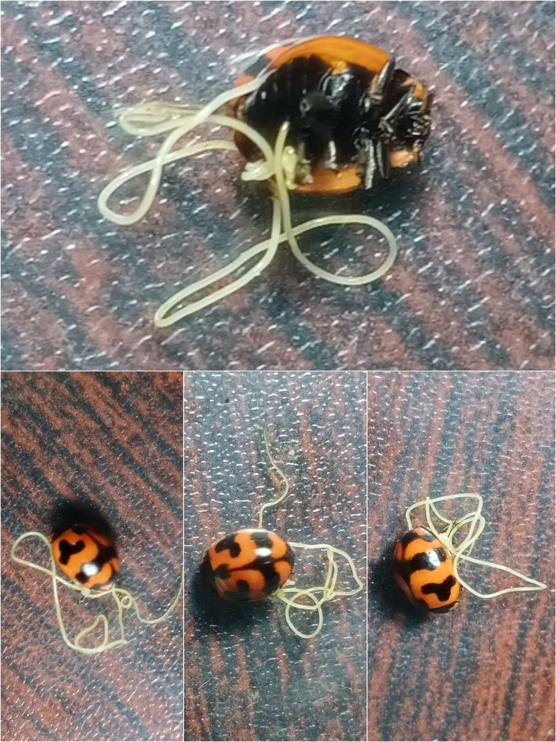

Fig.1. Emergence of Mermithid nematode from the ventral side of a dead adult beetle of *C. transversalis*

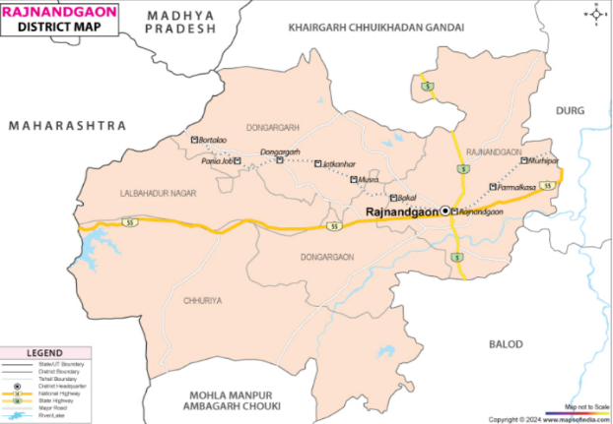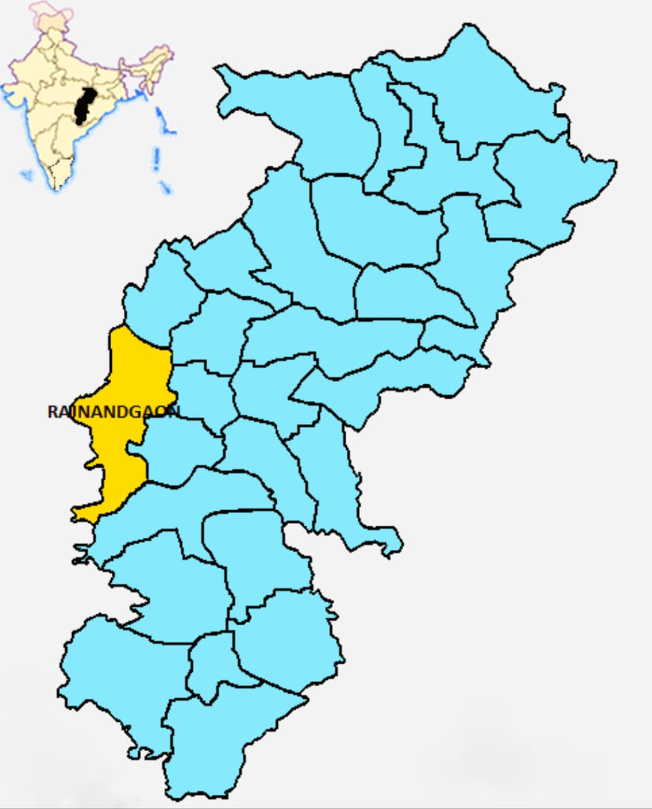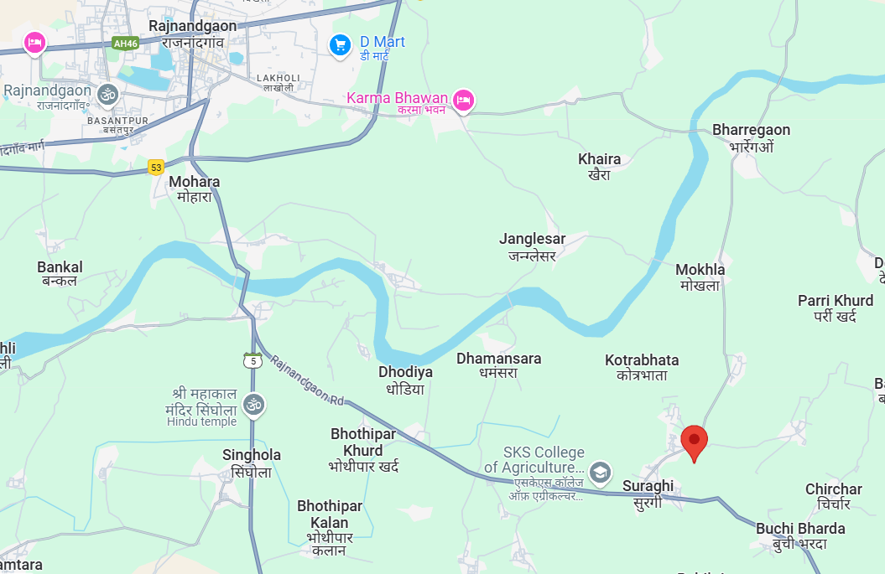

Figure 2. Map of Surgi village of Rajnandgaon district, Chhattisgarh, India showing the location from where the Mermithid nematode infected *C. transversalis* was collected*.*

Disclaimer (Artificial intelligence)

Author(s) hereby declare that NO generative AI technologies such as Large Language Models (ChatGPT, COPILOT, etc.) and text-to-image generators have been used during the writing or editing of this manuscript.

**References:-**

Condon WJ, Gordon R (1977). Some effects of mermithid parasitism on the larval black flies *Prosimulium mixtum/fuscum* and *Simulium venustum.* J. Invertebr. Pathol. 29: 56-62.

De Baets K, Dentzien-DiasP, Harrison G.W.M, Littlewood D.T.J, Parry L.A. 2021a. Fossil constraints on the timescale of parasitic helminth evolution. De Baets K, Huntley JW (Eds). *The Evolution and Fossil Record of Parasitism: Identification and Macroevolution of Parasites*. Cham, Switzerland: Springer International Publishing. p. 231–271.

De Baets K, Huntley J.W, Klompmaker A.A, Schiffbauer J.D, Muscente A.D. 2021b. The fossil record of parasitism: its extent and taphonomic constraints. De Baets K, Huntley JW (Eds). *The Evolution and Fossil Record of Parasitism: Coevolution Paleoparasitological Techniques*. Cham, Switzerland: Springer International Publishing. p. 1–50.

Helden, A.J., 2008. First extant records of mermithid nematode parasitism of Auchenorrhyn chain Europe. *Journal of invertebrate pathology*, *99*(3), pp.351-353.

Kobylinski, K.C., Sylla, M., Black, W. and Foy, B.D., 2012. Mermithid nematodes found in adult *Anopheles*from southeastern Senegal. *Parasites & Vectors*, *5*, pp.1-7.

Lourdes, E.Y., Ya'cob, Z., Low, V.L., Izwan-Anas, N., Mansor, M.S., Dawood, M.M., Takaoka, H. and Adler, P.H., 2022. Natural infections and distributions of parasitic Mermithids (Nematoda: Mermithidae) infecting larval black flies (Diptera: Simuliidae) in tropical streams of Malaysia. *Acta Tropica*, *230*, p.106386.

Luo, C., Poinar, G.O., Xu, C., Zhuo, D., Jarzembowski, E.A. and Wang, B., 2023. Wide spread mermithid nematode parasitism of Cretaceous insects. *elife*, *12*, p.e86283.

Martins, M.F., de Moraes, S.C., Cohen, S.C., Cárdenas, M.Q. and Galvão, C., 2020. First record of a mermithid worm (Nematoda, Mermithidae) parasitizing a third instar nymph of *Triatoma sordida* (Stål, 1859)(Hemiptera, Reduviidae, Triatominae) from Mato Grosso, Brazil. *ZooKeys*, *980*, p.79.

Mazza G, Paoli F, Strangi A, Torrini G, Marianelli L, Peverieri GS, Binazzi F, Bosio G, Sacchi S, Benvenuti C, Venanzio D, Giacometto E, Roversi PF, Poinar GO Jr (2017) *Hexamermis popilliae* n. sp. (Nematoda: Mermithidae) parasitizing the Japanese beetle *Popillia japonica* Newman (Coleoptera: Scarabaeidae) in Italy. Syst Parasitol 94(8) : 915-926. doi: 10.1007/s11230-017-9746-0.

Nickle W.R. 1972. A contribution to our knowledge of the Mermithidae (Nematoda). *Journal of Nematology*4:113–146.

Omkar and James,B. E. 2004. Influence of prey species on immature survival, development, predation and reproduction of *Coccinella transversalis* Fab. J. Appl. Ent. 128: 150-157.

Orlova-Bienkowskaja, M.J., Spiridonov, S.E., Butorina, N.N. and Bieńkowski, A.O., 2018. Coinvasion by the ladybird *Harmonia axyridis* (Coleoptera: Coccinellidae) and its parasites, *Hesperomyces virescens* (Ascomycota: Laboulbeniales) and *Parasitylenchus bifurcatus* (Nematoda: Tylenchida, Allantonematidae), in the Caucasus. *PLoS One*, *13*(11), p.e0202841.

Petersen, J.J. 1985. Nematodes as biological control agents: Part I. Mermithidae. Baker JR, Muller R (Eds).*Advances in Parasitology*. Academic Press. p. 307–344.

Poinar, G.O, Otieno WA. 1974. Evidence of four Molts in the Mermithidae. *Nematologica*20:370.

Poinar, G.O. 1979. *Nematodes for Biological Control of Insects* (1st ed.). Boca Raton: CRC Press.

Poinar, G.O. 1983. *The Natural History of Nematodes*. Englewood Cliffs: Prentice Hall.

Poinar, GO. 2001b. Nematoda and Nematomorpha. Thorp JH, Covich AP (Eds). *Ecology and Classification of North American Freshwater Invertebrates* New York: Academic Press. p. 255–295.

Poinar, G.O. 2015a. Phylum Nemata. Thorp J.H, Rogers D.C (Eds). *Thorp and Covich’s Freshwater Invertebrates* (Fourth Edition. ). Boston: Academic Press. p. 273–302.

Poinar, G.O. 2015b. The geological record of parasitic nematode evolution. *Advances in Parasitology* 90:53–92.

Poinar, G.O., Myer, A. and Forschler, B.T., 2020. Mermithid nematode parasites of eastern subterranean termites in North America. *Nematology*, *22*(2), pp.235-237.

Rusconi, J.M., Soledad Defea, B., Montes, M.M. and Achinelly, M.F., 2020. First record of Mermithid nematodes parasitizing leafhoppers in South America. *Caldasia*, *42*(1), pp.147-149.

Tarla, G., 2020. *Hexamermis* (Nematoda: Mermithidae) Infecting *Coccinella septempunctata* (Coleoptera: Coccinellidae) in Overwintering Areas in Turkey1. *Entomological News*, *129*(1), pp.55-62.

Senthil Kumar,C.M ;Thuruthumkara Kurian, J., Selvakaran, D., Vasudevan, H. and D'Silva, S., 2018. Mermithid parasitism of shoot borer (*Conogethes punctiferalis*) infesting ginger and turmeric and its biocontrol potential. *Annals of Applied Biology*, *173*(3), pp.243-250.

Tarla, G., Poinar, G. and Tarla, Ş., 2011. *Hexamermis eurygasteri* n. sp.(Nematoda: Mermithidae) parasitising the sunn pest *Eurygaster integriceps*Puton (Hemiptera: Scutelleridae) in Turkey. *Systematic Parasitology*, *79*, pp.195-200.

Vandenberg, N.J., 2002. 93. Coccinellidae Latreille 1807. *American beetles*, *2*, pp.371-389.

Vincent C, Goettel MS, Lazarovits G. Biological Control: A Global Perspective, Cabi, 2007.

Watanabe, S., Tsunashima, A., Itoyama, K. and Shinya, R., 2021. Survey of mermithid nematodes (Mermithida: Mermithidae) infecting fruit-piercing stink bugs (Hemiptera: Pentatomidae) in Japan. *Applied ~~e~~Entomology and ~~z~~Zoology*, *56*, pp.27-39.

Watts B. Beetles, Sea-To-Sea Publications, 2004.