**Ciprofloxacin's Antibacterial Effect on Sensitive and Resistant Isolates of *Enterococcus faecalis***

**Abstract**

An investigation was carried out to research the antibacterial properties of ciprofloxacin against susceptible and resistant isolates of *Enterococcus faecalis* and studying susceptible individuals are exposed to sub-MIC in vitro, resistance this purpose After determining the inhibitory zone and ciprofloxacin MIC, the sensitive isolates were subjected to sub-MIC continuously for 21 days. The findings demonstrated the minimum inhibitory concentrations (MICs) for susceptible and resistant *Enterococcus faecalis* were, respectively, 0.26±0.07 and 29.82±9.33 μg/ml. In concern to susceptible *E. faecalis,* the inhibition zones were (15.50 ± 0.30, 21.00 ± 0.50 and 23.50 ± 0.70 mm) with significant difference (P<0.05) save for the range of 0.5 to 1MIC, whereas those of the resistant E. faecalis were 9.80 ± 0.40, 13.00 ± 0.30 and 18.50 ± 0.60 mm. with substantial distinction (P< 0.05) all concentrations. When comparing the absorbance to those from day zero, the spectrophotometer's measurements of the bacterial density at various intervals ranging from 0 to 21 days revealed a substantial steady increase (P<0.05). Finally, after 21 days of exposure to sub-MIC, ciprofloxacin resistance developed in susceptible *Enterococcus faecalis*.

**Keywords:** Enterococcus faecalis, Ciprofloxacin, and Resistance, Antimicrobials

**Introduction**

Antimicrobials are especially significant medications, but a global concern is the growing evidence of strains resistant to both ancient and contemporary antibiotic compounds. (Davies, 2014). A significant global concern is antibiotic resistance (AR)., according to multiple sources, it's a serious issue that impacts both industrialized and developing nations. Antimicrobial resistance might have disastrous consequences for millions of people and harm the world economy between 2017 and 2050, based on a World Bank simulation. (Bank *et al.,* 2017 (has become a significant threat to public health, with estimates that it will result in 10 million deaths yearly by 2050. (Dixit *et al*., 2019). Due to sepsis resistance against first-line medicines, more than 50,000 infants every year pass away. (Dixit *et al*., 2019). O’Neil (2019) projected that by 2050, antibiotic resistance will have multiplied tenfold worldwide, with deaths expected to occur in all continents (O'Neil, 2019). and according to )Sabrina *et al.,* 2018), Genes that resist antibiotics (ARGs) are considered a new type of environmental pollution. By reducing the rate at which antibiotic resistance develops, antibiotics can be utilized more effectively and their useful life can be increased. (Laureti *et al*., 2013).

Among the sub-therapeutic doses are acknowledged causes of unsuccessful therapies or reduced effectiveness, which promotes bacteria's ability to survive or develop resistance to antibiotics. it is crucial to use antibiotics in real illnesses caused by bacteria and at dosages that will maximize the possibility that they will be beneficial. (Cantón and Morosini, 2011). According to estimates, the MSC for a wide variety of microbes falls ranging from 1/4 to 1/230 of the MIC values. In 2016, Bengtsson-Palme and Larsson. Numerous research has looked at what happens when environmental bacterial strains are exposed over an extended period of time antibiotics in insufficient doses A significant effect on bacterial genomes appears to result from such exposure., as evidenced by the discovery that roughly 5–10% of bacterial genes had their transcription levels altered as a result of this exposure. These genes are involved in numerous physiological activities, including protein synthesis and glucose metabolism, in addition to those involved in the object of antibacterial activity . (Laureti *et al*., 2013). Sub-inhibitory quantities of antibiotics can cause the bacterial repair mechanism to be activated, which increases the likelihood of mobile genetic elements, such as those causing antibiotic resistance, horizontal gene transfer, and genome mutation. (Blázquez *et al*., 2012). A study like this one sought to determine how well ciprofloxacin worked to isolate resistant and vulnerable *Enterococcus faecalis* strains and to develop resistance in susceptible strains by subjecting them to ciprofloxacin concentrations. below the inhibitory level.

**Materials and Methods**

**Microbes used for experimentation**

The antimicrobial drug ciprofloxacin was obtained from Pharmaceutical Companies. The susceptible microorganism We acquired Enterococcus faecalis from Medical city teaching Hospital, while the resistant isolates obtained from University of Baghdad / College of Medicine.

**Minimum inhibitory concentration**

The process of broth macro-dilution was employed to measure the ciprofloxacin's minimum inhibitory concentration (MIC) in accordance with the (CLSI 2000). MH broth cultures were used for the 24-hour inoculation of the microorganisms, and the suspension was adjusted to turbidity of 0.5 McFarland standard. This is roughly 1.5x108 CFU/ml. All of the culture tubes were then filled with a Two-fold serial ciprofloxacin dilution , which varied from 0.03 to 1 μg/mL for susceptible Enterococcus faecalis and from 2 to 32 μg/mL for resistant isolates. The tubes were then incubated for 24 hours at 37˚C. Following the incubation period, turbidity in the tubes was visually examined. The existence of cloudiness suggested that the medium's content of antibacterial medicine had not stopped the development of bacteria. A minimum indicated concentration of antibacterial is known as a MIC.

**Determination of the inhibition zone**

To evaluate inhibition of Enterococcus faecalis by ciprofloxacin, 500 ml of sterile Mueller Hinton agar was thoroughly mixed with 5 ml of standardised bacterial stock suspension (1.5 × 108 cfu/ml) of tested bacteria. This was done using the agar well diffusion approach, as per Kavanagh (1972) and Perez et al. (1990). Each received Sterilised Petri dishes containing 25 millilitres of the inoculated Mueller Hinton agar . In each of these plates, three wells measuring 6 mm in diameter were created, and after the agar had solidified for 10 minutes, 100 microliters of ciprofloxacin in three different concentrations were placed in each well. then left to diffuse for two hours at ambient temperature. The plates were incubated for 24 hours at 37°C. For each antibacterial dose, three repetitions were performed, and each well's inhibitory zone diameter was measured in millimetres relative to the organism under test in order to determine the activity.

**Development of resistance**

Following the establishment of the minimum inhibitory concentration MIC of ciprofloxacin against susceptible isolates of *Enterococcus faecalis* were subjected to a incubated ciprofloxacin at sub-MIC for two nights. The most recent passage's sub-MIC concentration culture is used to inoculate a fresh batch of antimicrobial agents that have been diluted . The MIC is determined the following day and could either grow or decrease. Up to 21 days may pass during the process. (Mani *et al*., 2006).

**Results**

**Determination of The Minimum Inhibitory Concentration**

Results of determination of the MIC of the The results of the ciprofloxacin test against *Enterococcus faecalis* indicated that the MIC values between Enterococcus faecalis that were sensitive and resistant were within the range given by the CLSI. 0.26±0.07 and 29.82±9.33μg/ml respectively, Table 1.

**Table 1**.: The lowest inhibitory concentration of ciprofloxacin (μg/ml) against *Enterococcus faecalis*

|  |  |  |
| --- | --- | --- |
| **Bacteria** | **Drugs** | **MIC (μg/ml)** |
| **Enterococcus faecalis** | **Susceptible** | **0.26 ± 0.07 μg/ml** |
| **Enterococcus faecalis** | **Resistant** | **29.82 ± 9.33 μg/ml** |
|  | **LSD** | **14.449** |

**Ciprofloxacin-induced inhibition zone measurement against *Enterococcus faecalis***

In this test, To ascertain the inhibition zone against the susceptible isolate of Enterococcus faecalis, ciprofloxacin MIC, 0.5 MIC, and 2 MIC were employed. The results showed to susceptible *E****.*** *faecalis,* the inhibition zones were (15.50 ± 0.30, 21.00 ± 0.50 and23.50 ± 0.70 mm) with significant difference (P<0.05) aside from the range of 0.5 to 1MIC, whereas those of the resistant E. faecalis were9.80 ± 0.40,13.00 ± 0.30 and18.50 ± 0.60 All concentrations showed a significant difference (P<0.05) in mm. Table 2, Fig. 1.

**Table 2:** Inhibition zones comparing *Enterococcus faecalis* isolates that are susceptible and resistant at various ciprofloxacin doses *:*

|  |  |  |  |
| --- | --- | --- | --- |
| | **Ciprofloxacin Concentration** | **Susceptible *Enterococcus faecalis* (mm)** | **Resistant *Enterococcus faecalis* (mm)** | | --- | --- | --- | |
| |  |  |  | | --- | --- | --- | | 0.5 µg/mL | 15.50 ± 0.30 c | 9.80 ± 0.40 c | |
| |  |  |  | | --- | --- | --- | | 1 µg/mL | 21.00 ± 0.50 b | 13.00 ± 0.30 b | |
| |  |  |  | | --- | --- | --- | | 2 µg/mL | 23.50 ± 0.70 a | 18.50 ± 0.60 a | |

|  |  |  |
| --- | --- | --- |
| Concentration | LSD Value (Susceptible) | LSD Value (Resistant) |
| 0.5 µg/mL | 1.50 | 1.10 |
| 1 µg/mL | 2.00 | 1.50 |
| 2 µg/mL | 2.50 | 1.80 |

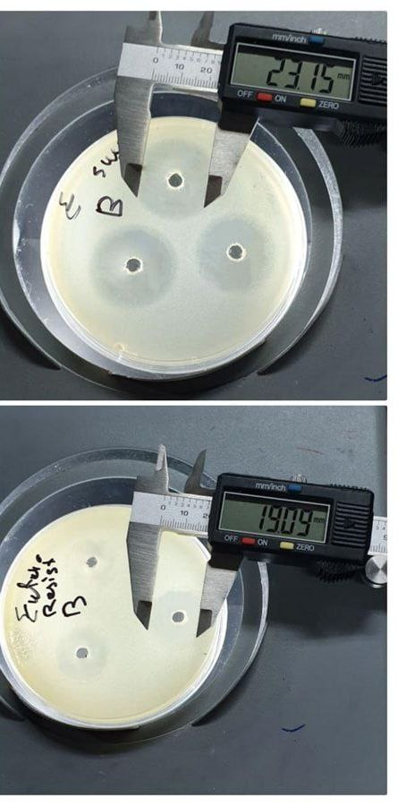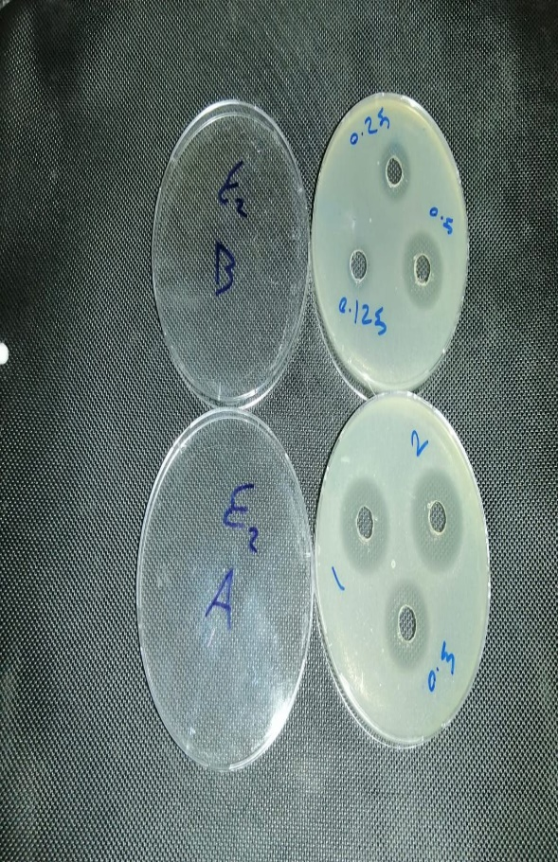

Fig.1: Ciprofloxacin concentrations varied, resulting in an inhibition zone against susceptible and resistant *Enterococcus faecalis* isolates.

**Increased resistance to ciprofloxacin in *Enterococcus faecalis***

In this test, sensitive *Enterococcus faecalis* isolates were continually treated to 50, 25, and 12.5% of the ciprofloxacin minimum inhibitory concentration (MIC) for 21 days. Following the exposure's conclusion (21 days later), ciprofloxacin MIC climbed to 4-fold the breakpoint value, becoming 1μg/ml and 1.8μg/ml against Enterococcus faecalis, respectively, according to the data. In comparison to the absorbance on day zero, the spectrophotometer's measurements of the bacterial density at various intervals spanning from 0 to 21 days revealed a significant gradual increase (P<0.05) in the absorbance, indicating an increase in the density, or more specifically, an increase in the number of these bacteria. and concentration and absorbance have an inverse relationship. The bacteria *Enterococcus faecalis* showed the highest absorbance least absorption at the higher concentration (0.5 MIC) and the lowest at the lower concentration (0.125 MIC). during all exposure times (7, 14, and 21 days).with substantial discrepancy in the absorbance of all concentrations, Table 3.

**Table 3: Absorbance Measurements at Various Sub-MIC Concentrations**

|  |  |  |  |  |  |  |
| --- | --- | --- | --- | --- | --- | --- |
| Drug | Concentration  (μg/ml) | Periods/Day | 0 (Control) | 7 Days | 14 Days | 21 Days |
| Cipro | 0.5 MIC | Absorbance | D0.08±0.00a | C0.08±0.001c | B0.39±0.001c | A1.20±0.001c |
| Cipro | 0.25 MIC | Absorbance | D0.08±0.00a | C0.15±0.001b | B0.80±0.002b | A1.85±0.001b |
| Cipro | 0.125 MIC | Absorbance | D0.08±0.00a | C0.56±0.001a | B1.48±0.001a | A3.11±0.002a |
| LSD | - | - | - | - | - | 0.0031 |

**Table 4: Absorbance Measurements at Various Drug Concentrations**

|  |  |  |  |  |  |
| --- | --- | --- | --- | --- | --- |
| Drug | Concentration (μg/ml) | 0 Days | 7 Days | 14 Days | 21 Days |
| Cipro | 0.5 MIC | D0.08±0.00a | C0.08±0.001c | B0.39±0.001c | A1.20±0.001c |
| Cipro | 0.25 MIC | D0.08±0.00a | C0.15±0.001b | B0.80±0.002b | A1.85±0.001b |
| Cipro | 0.125 MIC | D0.08±0.00a | C0.56±0.001a | B1.48±0.001a | A3.11±0.002a |
| LSD | - | - | - | 0.0031 |  |

**Table 5: Absorbance Measurements for *Enterococcus faecalis***

|  |  |  |
| --- | --- | --- |
| Concentration (μg/ml) | Time Period | Absorbance |
| 0.5 MIC | 0 Days | D0.08±0.00a |
| 0.5 MIC | 7 Days | C0.08±0.001c |
| 0.5 MIC | 14 Days | B0.39±0.001c |
| 0.5 MIC | 21 Days | A1.20±0.001c |
| 0.25 MIC | 0 Days | D0.08±0.00a |
| 0.25 MIC | 7 Days | C0.15±0.001b |
| 0.25 MIC | 14 Days | B0.80±0.002b |
| 0.25 MIC | 21 Days | A1.85±0.001b |
| 0.125 MIC | 0 Days | D0.08±0.00a |
| 0.125 MIC | 7 Days | C0.56±0.001a |
| 0.125 MIC | 14 Days | B1.48±0.001a |
| 0.125 MIC | 21 Days | A3.11±0.002a |
| LSD | - | 0.0031 |

**Discussion**

A dilution susceptibility test using broth or agar,the MIC is the minimal antibiotic concentration (amount of the drug needed to halt observable growth of a microbe). To determine antibiotic susceptibility interpretations and breakpoints, these MIC values must be used in conjunction with bacterial identification. In order to determine whether a particular species of bacteria is sensitive to the antibiotic or resistant to it, the antibiotic's chosen concentration is known as a "breakpoint." (MacGowan and Wise, 2001). Bacteria are classified as resistant or intermediately susceptible depending on whether For a pair of bacteria that are antibiotics, their MIC value is either more or less than the breakpoint. have established breakpoints for every antibiotic-bacteria combination.When deciding which targeted antibiotic should be delivered to a patient, doctors can use these figures as crucial information.

According to optical density (OD) spectroscopy, the increased absorbance of the two isolates' suspensions under study, Staphylococcus aureus and Escherichia coli, following 21 days of extended exposure to ciprofloxacin at sub-MIC may be the result of an increase in the populations of these bacteria. is a technique for measuring a single wavelength's loss of light due to absorption and scattering (Myers *et al.,* 2013). The amount of light that passes through a sample will decrease as the number of cells in the sample increases, as OD is directly correlated with cell count. (2016). Shao and others. At the end of the exposure (after 21 days), the ciprofloxacin MIC increased to four times the breakpoint values, according to the data. As a result, both a rise in the number of bacteria and a decrease in the antibacterial drugs' effectiveness at the MIC indicate that the bacteria have evolved a defence mechanism that prevents them from being impacted by these agents. developed resistance due to exposure to sub-inhibitory concentrations, which was in contrast to a study by Al-Samarraae that found ciprofloxacin to have the lowest resistance rate. (Al-Samarraae, 2019).

However, pathogens may come into contact with when undergoing using antibiotics or spending time in the outdoors for a variety of reasons, sub-inhibitory antibiotic concentrations (sub-MICs) may be present. (Yang *et al*., 2020). First, due to the pharmacokinetics of antibiotics, antibiotic concentrations gradually decline to below the minimum inhibitory concentrations (MICs) after injection. Secondly, drug-drug interactions in non-blood regions where pathogens come into direct touch with antibiotics are the cause tissues or the interior environment of bacterial biofilms that contain antibiotic sub-MICs.(Kümmerer, 2009). Third, waste emissions from healthcare facilities, other treatment centers, or pharmaceutical companies may result in the generation of antibiotic sub-MICs. Fourth, bacterial evolution and the emergence of drug-resistant organisms can lead to antibiotic sub-MICs. (Yang *et al*., 2020). Fifth, in the clinic as a result of poor adherence, incorrect therapy, and subpar drugs (Chatterjee *et al*., 2018; Fisher *et al*., 2018). Additionally, several nations still permit the use of antimicrobials in stock farming at sub-MIC levels to increase animal productivity or guard against bacterial illnesses. (Hao *et al*., 2014).

In the past ten years, there has been a lot of research done on the significant affect the morphology, development of biofilms, and expression of pathogenicity in both Gram-positive and Gram-negative bacteria. (Hodille *et al*., 2017). A range of bacterial characteristics, including pathogenicity, Expression of genes, gene transfer, quorum sensing, and biofilm development, can undergo similar changes when antibiotics of distinct classes and hence different mechanisms of action are used in sub-MIC concentrations (Andersson and Hughes, 2014). The minimal antibiotic concentration that promotes the sub-inhibitory concentration (concentrations below the MIC) is the concentration at which a resistant mutant is selected over wild-type bacteria cells, causing to continue to grow at a slower rate (MSC).

**Conclusion**

The results of the study demonstrate that Enterococcus faecalis growth is efficiently inhibited by ciprofloxacin, with notable variations between susceptible and resistant strains. Susceptible strains exhibit reduced MICs, and the MIC values are within CLSI guidelines. Smaller inhibition zones are seen in resistant strains, though. MIC values tripling in just 21 days, prolonged exposure to sub-MIC dosages may hasten the development of resistance.

**Ethical Approval:**

As per international standards or university standards written ethical approval has been collected and preserved by the author(s).

COMPETING INTERESTS

Authors have declared that they have no known competing financial interests OR non-financial interests OR personal relationships that could have appeared to influence the work reported in this paper.

Disclaimer (Artificial intelligence)

Option 1:

Author(s) hereby declare that NO generative AI technologies such as Large Language Models (ChatGPT, COPILOT, etc.) and text-to-image generators have been used during the writing or editing of this manuscript.

Option 2:

Author(s) hereby declare that generative AI technologies such as Large Language Models, etc. have been used during the writing or editing of manuscripts. This explanation will include the name, version, model, and source of the generative AI technology and as well as all input prompts provided to the generative AI technology

Details of the AI usage are given below:

1.

2.

3.

**References**

Al-Samarraae, I. A. (2019). Antibiotic Susceptibility and Molecular Detection of *Pseudomonas aeruginosa* Isolated from Bovine Mastitis. The Iraqi Journal of Veterinary Medicine. 43(2), 77-85.‏

Andersson, D. I., & Hughes, D. (2014). Microbiological effects of sublethal levels of antibiotics. *Nature Reviews Microbiology,* 12(7), 465-478.‏

Bank, W. (2017). Drug-Resistant Infections: A Threat to Our Economic Future. Washington, DC: World Bank.‏

Bengtsson-Palme, J., & Larsson, D. J. (2016). Concentrations of antibiotics predicted to select for resistant bacteria: proposed limits for environmental regulation. Environment international, 86, 140-149.‏

Blázquez, J., Couce, A., Rodríguez-Beltrán, J., & Rodríguez-Rojas, A. (2012). Antimicrobials as promoters of genetic variation. Current opinion in microbiology, 15(5), 561-569.‏

Cantón, R., & Morosini, M. I. (2011). Emergence and spread of antibiotic resistance following exposure to antibiotics. FEMS microbiology reviews, 35(5), 977-991.‏

Chatterjee, A., Modarai, M., Naylor, N. R., Boyd, S. E., Atun, R., Barlow, J., ... & Robotham, J. V. (2018). Quantifying drivers of antibiotic resistance in humans: a systematic review. The Lancet Infectious Diseases, 18(12), e368-e378.‏

Dal Sasso, M., Culici, M., Bovio, C., & Braga, P. C. (2003). Gemifloxacin: effects of sub-inhibitory concentrations on various factors affecting bacterial virulence. International journal of antimicrobial agents, 21(4), 325-333.‏

Davies, J. (2014). Antibiotic resistance and the golden age of microbiology. Upsala journal of medical sciences, 119(2), 65-67.‏

Dixit, A., Kumar, N., Kumar, S., & Trigun, V. (2019). Antimicrobial resistance: progress in the decade since emergence of New Delhi metallo-β-lactamase in India. Indian journal of community medicine: official publication of Indian Association of Preventive & Social Medicine, 44(1), 4.‏

Fisher, H., Oluboyede, Y., Chadwick, T., Abdel-Fattah, M., Brennand, C., Fader, M., ... & Pickard, R. (2018). Continuous low-dose antibiotic prophylaxis for adults with repeated urinary tract infections (AnTIC): a randomised, open-label trial. The Lancet infectious diseases, 18(9), 957-968.‏

Hao, H., Cheng, G., Iqbal, Z., Ai, X., Hussain, H. I., Huang, L., ... & Yuan, Z. (2014). Benefits and risks of antimicrobial use in food-producing animals. Frontiers in microbiology, 5, 288.‏

Hodille, E., Rose, W., Diep, B. A., Goutelle, S., Lina, G., & Dumitrescu, O. (2017). The role of antibiotics in modulating virulence in Staphylococcus aureus. Clinical microbiology reviews, 30(4), 887-917.‏

Kümmerer, K. (2009). Antibiotics in the aquatic environment–a review–part I. Chemosphere, 75(4), 417-434.‏

Laureti, L., Matic, I., & Gutierrez, A. (2013). Bacterial responses and genome instability induced by subinhibitory concentrations of antibiotics. Antibiotics, 2(1), 100-114.‏

MacGowan, A. P., & Wise, R. (2001). Establishing MIC breakpoints and the interpretation of in vitro susceptibility tests. Journal of Antimicrobial Chemotherapy, 48(suppl_1), 17-28.‏

Myers, J. A., Curtis, B. S., & Curtis, W. R. (2013). Improving accuracy of cell and chromophore concentration measurements using optical density. BMC biophysics, 6(1), 1-16

O’Neill, J. (2019). Antimicrobial resistance: tackling a crisis for the health and wealth of nations. Rev Antimicrob Resist. 2014.‏

Sabri, N. A., Schmitt, H., Van der Zaan, B., Gerritsen, H. W., Zuidema, T., Rijnaarts, H. H. M., & Langenhoff, A. A. M. (2020). Prevalence of antibiotics and antibiotic resistance genes in a wastewater effluent-receiving river in the Netherlands. Journal of Environmental Chemical Engineering, 8(1), 102245.‏

Shao, J., Xiang, J., Axner, O., & Ying, C. (2016). Wavelength-modulated tunable diode-laser absorption spectrometry for real-time monitoring of microbial growth. Applied optics, 55(9), 2339-2345.‏

Yang, H., Xu, S., Huang, K., Xu, X., Hu, F., He, C., ... & Liu, Q. (2020). Anti-staphylococcus Antibiotics Interfere With the Transcription of Leucocidin ED Gene in Staphylococcus aureus Strain Newman. Frontiers in microbiology, 11, 265.‏