***Case report***

**Diagnosis and Management of Spirocercosis in a Beagle Dog:A Case Report**

Abstract

A 2-year-old male Beagle was presented to the Referral Veterinary Polyclinic, Indian Veterinary Research Institute, Izatnagar with a history of anorexia, chronic vomiting, fever, continuous whining and unresponsive to regular anti-emetic and antacid treatment since 3 months. Clinical signs include intermittent vomiting, lethargy and severe weight loss. A complete blood count showed mild leucocytosis with insignificant changes in serum biochemistry profile. Diagnostic investigation with endoscope imaging revealed the presence of glistening space occupying nodule in the distal thoracic esophageal wall. Feacal examination confirmed the presence of *Spirocerca lupi* eggs. Based on these findings, the dog was diagnosed with spirocercosis. Dog was treated with subcutaneous injections of Doramectin administered q14d for 3 occasions along with other supportive includes Ceftriaxone-Tazobactam, Ondansetron, Pantoprazole, Phenobarbitone sodium and fluid for hydration. Management of spirocercosis is always challenging as nodules located mainly in the aorta. This case had the spirocerca nodules in the oesophageal area and hence showed uneventful recovery after the Doramectin injection.

Keywords: Spirocercosis, Dog, Chronic vomiting, Doramectin;

1. **Introduction:**

Spirocercosis is a disease caused by the parasitic roundworm *Spirocerca lupi,* which mainly infects dogs. The parasite spreads when dogs ingest infected dung beetles that have consumed dog faeces containing *S. lupi* eggs. While it is most prevalent in tropical and subtropical regions, sporadic cases can also occur in temperate climates (Giannelli *et al*., 2014 and Wright *et al*., 2016). Spread of disease is mainly influenced by high dog population densities and environmental factors like soil type, pH, temperature, rainfall, and sunlight exposure (Jyothi Sree and Hafeez, 2013). Spirocercosis leads to characteristic lesions with the migrating larvae (L3 and L4 stages) travel through the gasteroepiploic arteries, eventually forming nodules in the lower oesophagus and thoracic aorta (Dvir *et al.,* 2010; Joubert *et al.,* 2005). Dogs become infected with *S. lupi* by ingesting contaminated dung beetles. The larvae migrate from the stomach to the thoracic aorta within 10 days, then to the oesophagus within 3-4 months where they form nodules. This causes aortic scarring, aneurysms, and oesophageal nodules. Some larvae migrate abnormally to other organs like lungs or heart. Severe cases may lead to spinal inflammation, neurological issues, or sudden death from aortic rupture (Yildirim *et al.,* 2007; Mylonakis *et al*., 2008).

The hallmark symptoms of spirocercosis primarily involve oesophageal lesions with affected dogs showing persistent regurgitation, vomiting, and difficulty swallowing (dysphagia), often leading to significant weight loss together with non-specific signs like pyrexia (Dvir *et al*. 2001; Mazaki-Tovi *et al.* 2002). This study addresses the successful diagnosis and therapeutic management of spirocercosis in a Beagle dog.

1. **Case presentation** 
   1. **Clinical Presentation of animal**

A 2-year-old male Beagle was presented with a history of chronic vomiting, fever, continuous whining and unresponsive to regular anti-emetic and antacid treatment since 3 months to the Referral Veterinary Polyclinic, Indian Veterinary Research Institute, Izatnagar. On clinical examination the dog exhibited dullness with moist pink mucus membrane, lethargy, intermittent vomiting and severe weight loss. No abdominal pain on palpation. Slightly elevated rectal temperature with 103.2℉ while other vital parameters *viz.*, heart rate, respiration rate and lung sound were within reference panel.

* 1. **Laboratory examination**

A routine haematology revealed mild leucocytosis (24.72 x 103/cmm). Serum biochemistry with Kidney function and Liver function test were within the normal reference panel.

* 1. **Faecal examination**

**A faecal sample was examined using a sugar flotation method, as previously described by Markovics and Medinski (1996), which revealed the presence of embryonated**Spirocerca lupi**eggs (Fig.1)**



**Fig.1 Embryonated *Spirocerca lupi* egg**

(Floatation technique, 10x)

* 1. **Endoscopy**

Upper Gastro-intestinal (GI) endoscopy was performed as per routine procedure by pre-anesthetizing the animal with atropine (0.02 mg/kg SC), xylazine (1 mg/kg IM) and induced with ketamine (5 mg/kg IV). Endoscopic examination showed pale pink mucosa of oesophagus with a glistening space occupying nodule in the distal thoracic esophageal wall (Fig. 2 A and B).





**A**

**B**

**Fig. 2 A and B Esophageal nodule in the distal thoracic esophageal wall**

* 1. **Treatment**

The dog was treated with doramectin at the dose rate **200 µg/kg** of body weight, SC q14d, for 3 doses. The other supportive therapy includes Ceftriaxone-Tazobactam @25mg/kg bwt. IV BiD, [Ondansetron@0.5mg/kg bwt.IV](mailto:Ondansetron@0.5mg/kg%20bwt.IV) BiD, Pantoprazole@1mg/kg bwt. IV OD, Phenobarbitone sodium@2mg/kg bwt PO and fluid for hydration for 7 days.

1. **Result and discussion**

Most of the *Spirocerca lupi* infections are asymptomatic, affected dogs older than 6 months of age may develop clinical signs associated with oesophageal lesions such as vomition, regurgitation, pyrexia, weakness, anoxexia, weight loss, salivation and melena (Yogeshpriya *et al*., 2016). The clinical manifestations of spirocercosis vary depending on the anatomical location and extent of the lesions. Aortic involvement typically remains asymptomatic unless aneurysmal rupture occurs. Oesophageal lesions frequently result in dysphagia, manifested by repeated swallowing attempts (odynophagia) or regurgitation. A confirmatory diagnosis of *S. lupi* infection is achieved through faecal flotation technique. However, faecal flotation for *S. lupi* eggs has limited sensitivity due to intermittent egg shedding and the egg density, often requiring specialized solutions (e.g., sodium nitrate, zinc sulphate, or sugar solutions). Therefore, FLOTAC technique has improved detection sensitivity compared to conventional methods. Additionally, a PCR assay has been developed for more reliable faecal detection (Boulineau *et al.,* 2005; Lavy *et al.,* 2002). Oesophageal endoscopy has a greater diagnostic sensitivity than radiography for direct visualization of *S. lupi* nodules (van der Merwe *et al.,* 2008)

**Treatment with doramectin @200 µg/kg SC q14d for three doses has emerged as the most effective approach for achieving clinical remission (Fig.3 A and B) (Rojas *et al.,* 2017; Joubert *et al.,* 2005). Doramectin is safe and effective against**Spirocerca lupi**in naturally infected dogs (Berry, 2000). Due to its lipophilic nature, doramectin persists longer in the body than some other avermectins, providing at least 14 days of active protection in calves (Weatherley *et al.,* 1993). The drug is expected to kill larvae before they mature in the oesophagus besides delaying larval development by at least 40 days thus reducing egg production by adult worms. These effects lead to fewer worms, smaller and fewer oesophageal nodules, and prevention of fatal aortic ruptures (Lavy *et al.,* 2003). Supportive therapy includes antibiotics (to prevent secondary infections), antiemetics, antacids, and phenobarbitone sodium (2 mg/kg PO q12h) for mild sedation and pain-related whining.**



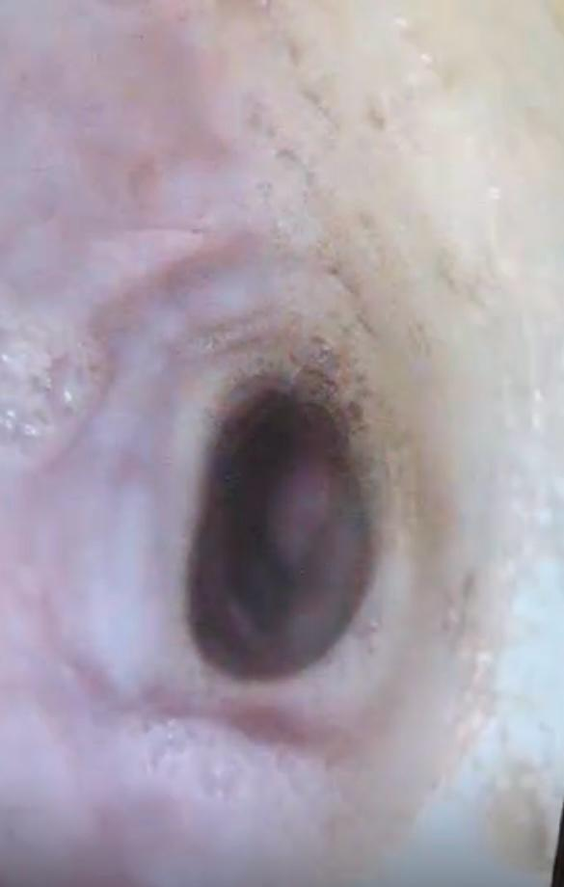

**B**

**A**

**Fig. 3 A and B Endoscopic examination after 3rd doses showed regression in the nodule size**

1. **Conclusion**

*Spirocerca lupi* is a nematode parasite of carnivores affecting mainly the canine oesophagus (Bailey 1972).  **Dogs with spirocercosis-associated oesophageal lesions, early diagnosis and treatment with doramectin along with supportive therapy resulted in marked clinical improvement.** Rerular faecal testing enhances diagnostic accuracy. **Managing spirocercosis is often challenging, as the nematodes typically form nodules in the aorta. However, in this case, the nodules were localized to the esophageal region, leading to an uneventful recovery following doramectin administration. Please write few line about the usefulness of gastro-endoscopy in diagnosis this consition.**

References follow journal criteria strictly

1. Bailey WS*. Spirocerca lupi:* a continuing inquiry. J Parasitol. 1972;58:3–22.
2. **Berry WL.** Spirocerca lupi esophageal granulomas in 7 dogs: resolution after treatment with doramectin. J Vet Intern Med. 2000;14(6):609-12.
3. Boulineau TM, Andrews-Jones L, Van Alstine W. Spontaneous aortic dissecting hematoma in two dogs. J Vet Diagn Invest. 2005;17(5):492–7.
4. Dvir E, Kirberger RM, Clift SJ, Van Der Merwe LL. Review: challenges in diagnosis and treatment of canine spirocercosis. Isr J Vet Med. 2010;65(1):5–10.
5. Dvir E, Kirberger RM, Malleczek D. Radiographic and computed tomographic changes and clinical presentation of spirocercosis in the dog. Veterinary Radiology & Ultrasound. 2001 Mar;42(2):119-29.
6. Giannelli A, Baldassarre V, Ramos RA, Lia RP, Furlanello T, Trotta M, et al. *Spirocerca lupi* infection in a dog from southern Italy: an “old fashioned” disease? Parasitol Res. 2014;113:2391–4.
7. Joubert KE, McReynolds MJ, Strydom F. Acute aortic rupture in a dog with spirocercosis following the administration of medetomidine. J S Afr Vet Assoc. 2005;76(3):159–62.
8. Jyothi Sree Ch, Hafeez Md. A study on prevalence of spirocercosis in dogs in certain parts of Andhra Pradesh, India. Int J Agric Sci Vet Med. 2013;1(3):59–66.
9. Lavy E, Aroch I, Bark H. Evaluation of doramectin for the treatment of experimental canine spirocercosis. Vet Parasitol. 2002;109(1–2):65–73.
10. Lavy E, Harrus S, Mazaki-Tovi M, Bark H, Markovics A, Hagag A, Aizenberg I, Aroch I. Spirocerca lupi in dogs: prophylactic effect of doramectin. Research in veterinary science. 2003 Dec 1;75(3):217-22.
11. **Markovics A, Medinski B.** Improved diagnosis of low-intensity Spirocerca lupi infection by the sugar flotation method. J Vet Diagn Invest. 1996;8(4):400-1.
12. Mazaki-Tovi M, Baneth G, Aroch I, Harrus S, Kass PH, Ben-Ari T, Zur G, Aizenberg I, Bark H, Lavy E. Canine spirocercosis: clinical, diagnostic, pathologic, and epidemiologic characteristics. Veterinary Parasitology. 2002 Aug 2;107(3):235-50.
13. Mylonakis ME, Rallis T, Koutinas AF. Canine spirocercosis. Compend Contin Educ Vet. 2008;30(2):111–6.
14. Rojas A, Segev G, Markovics A, Aroch I, Baneth G. Detection and quantification of *Spirocerca lupi* by HRM qPCR in fecal samples from dogs with spirocercosis. Parasit Vectors. 2017;10:1–8.
15. Van der Merwe LL, Kirberger RM, Clift S, Williams M, Keller N, Naidoo V. *Spirocerca lupi* infection in the dog: a review. Vet J. 2008;176(3):294–309.
16. **Weatherley AJ, Hong C, Harris TJ, Smith DJ, Hammet NC.** Persistent efficacy of doramectin against experimental nematode infections in calves. In: Vercuysse J, editor. Doramectin – a novel avermectin. Vet Parasitol. 1993;49(1):45-50.
17. Wright I, Stafford K, Coles G. The prevalence of intestinal nematodes in cats and dogs from Lancashire, north-west England. J Small Anim Pract. 2016;57(8):393–5.
18. Yıldırım MZ, Kutsal O, Avcıoğlu H. Spirocercosis in a dog. Ankara Üniversitesi Veteriner Fakültesi Dergisi. 2007 Mar 1;54(1):61-4.
19. Yogeshpriya S. A complete overview on spirocercosis in dogs. Int J Food Agric Vet Sci. 2016;6(3):16–20.