**AN ASSESSMENT ON SEASONAL PHYSICO-CHEMICAL VARIATIONS OF CHARIPUNIA BEEL OF MORIGAON DISTRICT, ASSAM, INDIA**

**ABSTRACT**

The present study was conducted to evaluate the seasonal physicochemical characteristics of Charipunia *beel*(7.0 ha) in the Morigaon district of Assam, for a period of one year from May 2022 to April 2023.The majority of physico-chemical parameters were found to be in a favorable range for aquatic species growth and reproduction.The water temperature of Charipunia*beel* ranged from 18.60o C to 29.30o C, water pH from 5.5 to 7.9, dissolved oxygen ranged from 4.5 mg/l to 7.6 mg/l, total alkalinity from 42.3 mg/l to 67.1 mg/l, total hardness from 51.3 mg/l to 70.2 mg/l, free carbon dioxide from 5.5 to 9.3 mg/l, turbidity from 3.1 NTU to 4.6 NTU, and ammonia nitrogen ranged from 0.14 mg/l to 0.32 mg/l.Although the beel conditions were found to be favorable for fish production, there is an urgent need for strict imposition and monitoring of fishery regulations during the banned season.In addition, the identification and protection of feeding and breeding grounds of indigenous fishes, as well as awareness among fishermen, are very much needed for sustainable use of the *beel*.

***Keywords****:* Physico-chemical, charipunia beel, seasonal variation, water quality

**INTRODUCTION**

*Beels* are natural or semi-natural water bodies commonly found in Assam, play a vital role in the region's aquatic ecosystem and support a wide range of biodiversity, including fish and other aquatic organisms. The physico-chemical parameters of water in these *beels* are essential for determining the ecological health and productivity of these water bodies.These parameters include factors such as temperature, pH, dissolved oxygen, turbidity, electrical conductivity, total dissolved solids (TDS), and nutrient levels (e.g., nitrates and phosphates).These factors are interrelated and influence the survival, growth, and reproduction of aquatic species. In Assam, the water quality of *beels* is closely linked to local environmental conditions, including seasonal variations, agricultural practices, and human activities, such as fishing, wastewater disposal, and the use of chemicals in nearby farmlands. Seasonal changes, such as the monsoon and post-monsoon periods, can lead to variations in these parameters due to runoff, flooding, and changes in water volume. Therefore, continuous monitoring of the physicochemical parameters is crucial for understanding the health of the beel ecosystem and implementing effective conservation and management practices. Furthermore, the physico-chemical characteristics of *beel* waters play a key role in the overall functioning of the aquatic food chain. For instance, the availability of dissolved oxygen supports fish and other aquatic life, while an imbalance in nutrient levels may lead to eutrophication, affecting biodiversity. Thus, it is necessary to regularly assess and monitor the physico-chemical parameters to ensure that the *beels* in Assam remain productive and sustainable for both ecological and economic purposes. The productivity of a water body is largely influenced by its physico-chemical and biological characteristics. Water quality is crucial in determining the biodiversity of aquatic ecosystems. In wetlands, water quality is influenced by factors such as river flow, soil composition, climate, landscape features, pollution, erosion, and river modification. The goal of this research was to assess the water quality of the beel, which is essential for understanding the ecological health and sustainability of aquatic ecosystems.These measurements help evaluate the suitability of water for supporting aquatic life and offer insights into the effects of both environmental and human factors on the ecosystem.

**METHODOLOGY AND STUDY AREA**

The Charipunia *beel* is a perennially close *beel* located in Charipunia village in the Morigaon district with latitude 26ᵒ15’10.0” N and longitude 92ᵒ21’22.8” E.The area of the *beel* is around 7 hectares (17.297 acres).The minimum depth of this beel is 5 feet and the maximum is 12 feet. Approximately 250 families depend on this *beel* for their livelihood.The beel is under the lease of Charipunia Goan Unnayan Samiti which was established in the year 1988-89.

Water samples were collected monthly from the surface layer at two locations (stations 1 and 2) for the research.Samples were collected early in the morning, between 4:30 and 6:00 AM, to maintain consistency in measurements.Samples from each station were stored in separate plastic bottles, clearly marked as Station 1 and Station 2. The study analyzed several parameters, including water temperature (°C), pH, dissolved oxygen (mg/l), total alkalinity, total hardness, free carbon dioxide, turbidity, and total ammonia-nitrogen (mg/l). These physico-chemical properties were measured according to the standard methods specified in the APHA (1986) and Michael (1986) guidelines, ensuring reliable and consistent results.

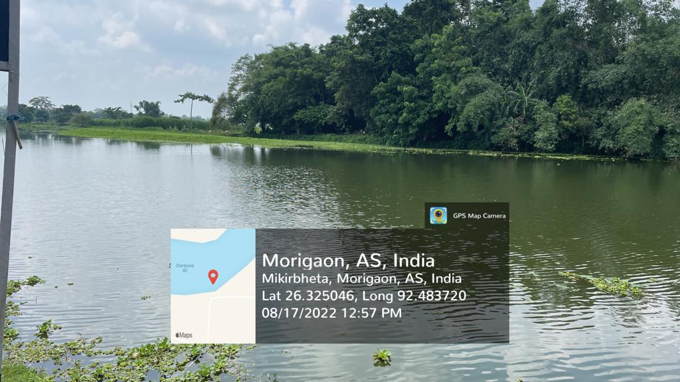 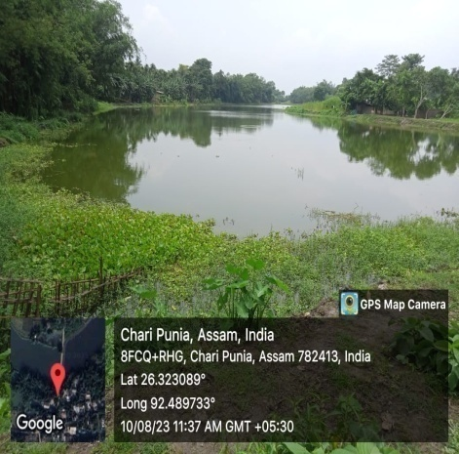

**Map 1**: GPS MAP LOCATIONS OF STUDY SITES OF CHARIPUNIA *BEEL*

**RESULTS AND DISCUSSION**

From May 2022 to April 2023, various water quality parameters of the Charipunia beel, including water temperature, pH, dissolved oxygen, total alkalinity, total hardness, turbidity, free carbon dioxide, and total ammonia-nitrogen, were measured ( Table 1).Water quality is defined as the overall relationship between the physical, chemical, and biological properties of a water body.Analyzing water quality is essential for conserving natural ecosystems (Patil et al., 2012).Additionally, water quality significantly affects fish growth, maturation, reproduction, and development (Nargis and Pramanik, 2008). Human activities such as agriculture, urban development, domestic sewage disposal, and other factors can alter the physico-chemical properties of water, thereby degrading water quality (Verma et al., 2011). The wetland holds great biological, environmental, and social significance, and any decline in water quality will negatively impact the entire wetland ecosystem (Sharma *et al .* 2024).

Table 1: Seasonal Changes in the Physico-Chemical Parameters of Charipunia

|  |  |  |  |  |  |  |
| --- | --- | --- | --- | --- | --- | --- |
| **Season /**  **Parameters** | **Pre- monsoon(February 2023, March 2023, April 2023, May 2022)** | | **Monsoon(June 2022, July 2022, August 2022, September 2022)** | | **Post- monsoon(October 2022, November 2022, December 2022, January 2023)** | |
| Station 1 | Station 2 | Station 1 | Station 2 | Station 1 | Station 2 |
| Water Temperature(ºC) | 24.70± 1.58 | 24.45± 1.65 | 26.75± 1.35 | 26.82± 1.49 | 19.30± 0.35 | 19.45± 0.17 |
| Water pH | 7.37± 0.21 | 7.55± 0.13 | 6.40± 0.33 | 6.27± 0.23 | 6.70±0.15 | 6.60± 0.26 |
| Dissolved oxygen (mg/l) | 5.90± 0.57 | 6.17±0.58 | 5.42± 0.29 | 5.12± 0.13 | 5.57±0.20 | 5.80±0.20 |
| Total alkalinity (mg/l) | 46.30± 1.17 | 44.32± 1.06 | 48.67± 2.49 | 46.45± 2.65 | 57.02± 1.63 | 59.40± 3.25 |
| Total hardness (mg/l) | 60.72± 3.43 | 61.30±3.43 | 56.02± 1.94 | 55.27± 2.01 | 65.55± 0.93 | 66.65± 0.91 |
| Free CO2 (mg/l) | 6.55± 0.34 | 6.67± 0.34 | 6.00± 0.15 | 5.80± 0.15 | 8.17± 0.40 | 8.25± 0.46 |
| Turbidity (NTU) | 3.62± 0.20 | 3.47± 0.14 | 4.42± 0.08 | 4.40± 0.10 | 3.52± 0.15 | 3.52± 0.04 |
| Total Ammonia- nitrogen (mg/l) | 0.22± 0.02 | 0.23± 0.03 | 0.18± 0.01 | 0.17± 0.01 | 0.15± 0.01 | 0.16± 0.01 |

*Data are mean± Standard Error of 3 determination

Fig. 1: Seasonal Fluctuations in Average Water Temperature (◦C) at Two Selected Stations (S1, S2)

Fig. 2: Seasonal Fluctuations in Water pH at Two Selected Stations (S1, S2)

FIG 3: SEASONAL VARIATION OF DO IN TWO SELECTED SAMPLING STATIONS (S1, S2)

FIG.4: SEASONAL VARIATION OF TOTAL ALKALINITY IN TWO SELECTED SAMPLING STATIONS

FIG 5: SEASONAL VARIATION OF HARDNESS IN TWO SELECTED SAMPLING STATIONS (S1, S2)

FIG 6: SEASONAL VARIATION OF TURBIDITY IN TWO SELECTED SAMPLING STATIONS (S1, S2)

FIG 7: SEASONAL VARIATION OF FREE CARBON DIOXIDE IN TWO SELECTED SAMPLING STATIONS (S1, S2)

FIG 8: SELECTED VARIATION OF TOTAL AMMONIA- NITROGEN AT TWO SELECTED SAMPLING STATIONS (S1, S2)

**CONCLUSION**

This study assessed the physicochemical characteristics of Charipunia beel in Morigaon district, Assam, India, from May 2022 to April 2023. The research was conducted at two stations across three seasons: pre-monsoon, monsoon, and post-monsoon seasonal variations of physicochemical parameters in Charipunia beel, which can inform future management and conservation. Water temperature ranged from 18.60°C (December) to 29.30°C (July). Turbidity varied between 3.10 NTU (January) and 4.60 NTU (September).Total ammonia-nitrogen concentrations were highest in May (0.32 mg/l) and lowest in December (0.14 mg/l). Free carbon dioxide levels peaked in November (9.30 mg/l) and were lowest in September (5.50 mg/l). Total hardness ranged from 51.30 mg/l (August) to 70.20 mg/l (February). Total alkalinity was highest in November (67.10 mg/l) and lowest in March (42.30 mg/l). Dissolved oxygen concentrations were highest in February (7.60 mg/l) and lowest in May (4.50 mg/l). Water pH varied from 5.50 (July) to 7.90 (March).The chemical composition of the wetland directly impacts the survival of its biodiversity. It is essential for individuals engaged in activities related to wetland resources to be aware of the consequences of overexploitation and the improper use of these resources for their livelihoods. The study concludes that the water quality of the beel remains generally healthy. However, if anthropogenic activities such as the excessive use of fertilizers near agricultural fields and the use of detergents for washing are not regulated, the water quality may deteriorate further, potentially affecting the composition of aquatic flora and fauna. This research could contribute to the optimal use and sustainable management of the beel.

**REFERENCES**

APHA (2010). Standard methods for the examination of water and wastewater, 21stEdn. Eaton, A.D., Clesceri, L.S., Rice, E.W. and Greenberg, A.E. (eds), American Public Health Association, Washington, D.C.

Baruah, D., and Baruah, P. P. (2024). Physico-chemical parameters and phytoplankton heterogeneity in different seasons of Sorbhog Beel, a pivotal floodplain wetland in the Himalayan Foothill. *Vegetos*, ***37***(1), 68-81.

Bora, S. and Biswas, S.P (2015). Water quality and ichthyofaunal diversity of an oxbow lake in upper Assam. *International Journal of Fisheries and Aquatic Studies***., 3**(1):15-18

Deka,U. and Sarma, S.K. (2018). An assessment of physico-chemical properties of water of two wetlands of Nalbari district of Assam, North-East India, *International Journal of Basic and Applied Research****.,*8**(12):361-371.

Doimari, R., Konwar, S., Dutta, A. J., Sinha, D., Daflari, K. D., & Das, M. J. (2024). Checklist of aquatic macrophytes and water quality assessment of Kakarikata Beel, Majuli District, Assam. Uttar Pradesh Journal of Zoology, **45**(19), 10-16.

Nargis, A., and Pramanik, S. H. (2008). Physico-chemical parameters in relation to meterological and climatic conditions in a fish pond. *Bangladesh Journal of Scientific and Industrial Research***, 43**(3): 405-410

Patil, P. N., Sawant, D. V., and Deshmukh, R. N. (2012). Physico-chemical parameters for testing of water- A review. *International Journal of Environmental Sciences***, 3**(3):1194-1207

Sharma, P., Sarkar, R., Deka, J. P., et al. (2024). Assessing water quality of Deepor Beel, Assam, NE India, using water quality index: A case of Ramsar wetland. Arabian Journal of Geosciences, 17(20).

Verma, P.U., Chandawat, D.K. and Solanki, H.A (2011). Seasonal variations in physico- chemical variations and phytoplankton analysis of Kankarai*Lake. Life Sciences Leaflets***, 19**:842-854