**Stock structure analysis of *Rita rita* (Hamilton, 1822), for conservation from the Brahmaputra River**

**ABSTRACT**

The population structure of *Rita rita* was delineated using conventional (body morphometrics and meristic) and image-based (truss network analysis) methods. The study was done with three stocks, Tezpur stocks from the Brahmaputra River, and Nagaon stocks from Kolong River and Jamuna stocks from the Jamuna River, the latter two rivers are tributaries of River Brahmaputra. A total of 30 truss measurements constructed by inter-connecting 14 landmarks based on 300 samples were used to delineate the population structure. The Factor Analysis (FA) and Principal Component Analysis (PCA) and Discriminant Function Analysis (DFA) were employed to determine the populations' variations. The factor analysis (FA) based on truss morphometry indicated body depth-related traits loading heavily on the first factor and shape-relatedcharacteristics belonging to the caudal portion on the second factor. Principal components explained 85.70% variation among morphometric characters, while the first two, the principal component 1 (PC1) and PC2 explained82.14% and 3.56% respectively. The discriminant function analysis (DFA) correctly classified74% of the original grouped classes of Tezpur, Nagaon and Jamuna Stocks.Bilinear data models based on PCA were generated using SPSS software (SPSS 22) for predicting each stock. Two clusters were identified, the Nagaon and Jamuna stocks were similar compared to Tezpur stocks. Geographic isolation, riverine ecology, temperature variation and biology can be attributed to the discrimination of the stock. The stock structure analysis of this species may help frame management and conservation measures incorporating marker-based studies.

The findings suggested the possible existence of two stocks of *Rita rita*, a single stock in the Brahmaputra River while Jamuna River and Kopili River contained the same stock**.**

**Keywords**:Stock structure, Truss morphometrics, Reproductive biology, *Rita rita*

**INTRODUCTION**

Inadequate fishery management practices can lead to unforeseen changes in fish phenotypes (Turan *et al*., 2006). Therefore, accurate stock identification is a cornerstone of contemporary fisheries management, enabling effective strategies for both sustainable fisheries and endangered species conservation. Many conventional stock assessment methods rely on the assumption of uniform life history traits within a closed population model. Critically, this approach can yield misleading results if the actual population being studied is either subdivided or represents a portion of a larger metapopulation (Cadrin & Friedland, 1999).

Morphological analysis, encompassing both meristic and morphometric characters, offers a valuable approach for stock identification in fishes due to its ability to capture phenotypic variations (Keivany & Mohsen, 2017). However, a recognized limitation of this technique lies in its time-consuming nature for differentiating and separating fish stocks (Cadrin, 2000). As defined by Booke (1981), a fish stock represents a self-sustaining population within a definable area.Stock identification studies play a crucial role in locating and protecting essential nursery and spawning grounds, promoting sustainable harvest practices and effective monitoring strategies (Kutkuhn, 1981; Smith *et al*., 1990; Begg *et al*., 1999). Climate change-derived weather pattern fluctuations can influence stock population dynamics within a given area, potentially reflecting factors such as reproductive isolation, distinct spawning components, sub-stocks, or even a metapopulation structure (Bailey, 1997).

The mighty Brahmaputra is one of the largest rivers which harbours 126 species of fish belonging to 26 families of which 41 species sustain fisheries of commercial importance (Bhattacharya *et al*.,2017). The river Kopili is one of the important major tributaries of the Brahmaputra on its left bank. The river flows for a total length of about 290 kilometers and has a catchment area of 16,420 square kilometers (6,340 sq. miles) (IWAI, 2015). A total of 54 piscine species comprising of 7 orders, 16 families and 35 genera are distributed across Kopili river among which majority of the species belongs to Cypriniformes (55%) (Das *et al*., 2012).The Jamuna River, the main tributary of the Kopili originates from the Khanbamun hills in Karbi Anglong District and flows from east to west for a length of 120 kilometers and falls in the Kopili near Jamunamukh.Altogether, 36 species belonging to 27 genera,16 families and 7 orders are widely distributed across Jamuna River (Das *et al*., 2012).

*Rita rita* exhibits a robust, compact body structure devoid of scales. The abdomen is notably broad and flat. The head is large, flattened both dorso-ventrally and laterally, and possesses a short, inconspicuous median longitudinal groove that does not extend to the base of the occipital process. The occipital process itself is elongated, surpassing its width by a factor of 1-2, exhibits a posterior notch, and reaches the basal bone of the dorsal fin. The mouth is positioned inferiorly and extends transversely, with a wide gape that is approximately half the length of the head. The dentition is heterodont, featuring villiform, conical teeth in an unbroken, slightly curved band on the upper jaw, and molariform and villiform teeth arranged in two distinct, elliptical patches on the palate, sometimes connected at their apex. Three pairs of barbels are present: the maxillary pair extends to the operculum, the nasal barbels are significantly shorter, and the mandibular pair reaches the pre-operculum. The first dorsal fin is exceptionally large, supported by a robust, hollow spine with serrated posterior edge. The second dorsal fin is adipose, well-developed, and has a broad base. The pectoral fin spine is shorter than the dorsal spine and is serrated on both edges. The pelvic fin lacks a spine. The caudal fin is deeply forked, with lobes of equal size. The fish's coloration is greenish-gray on the dorsal surface and flanks, transitioning to a dull white on the abdomen (Talwar and Jhingran, 1991; Jayaram, 2010). *Rita rita*, a freshwater catfish commonly referred to as "Rita" along the Brahmaputra River. Prized for its high nutritional value, *R. rita* is a commercially important food~~.~~The IUCN has classified this species as "Lower Risk near Threatened" in India. This designation is attributed to a confluence of factors, including excessive exploitation, environmental pollution, the introduction of invasive species, the construction of dams, and inadequate river flow. (Gupta, 2015). While recognized by various local names across India and neighboring countries, existing knowledge of its feeding habits, diet, and reproductive biology remains limited. Truss network analysis was used to delineate a few stocks in India. Thegrowing demand for wild seeds and high market price caused increased pressure on wild population.To ensure the long-term sustainability of this valuable species, scientific studies focusing on stock identification, reproductive biology, and the development of an artificial breeding protocol are urgently needed.

**MATERIALS AND METHODS**

**Sampling**

A total of 300 samples of *Rita rita* were collected from three important rivers namely Brahmaputra (from Tezpur) and Kopili (Nagaon District) and Jamuna (Hojai district) from August, 2022 to July, 2023 as detailed in the table 1. The fish samples were collected directly from the local fish market and samples were pooled to eliminate any discrimination. The samples consisted of both males and females at the ratio of 1:1. Fishes were anesthetized using clove oil at the rate of 50-100 mg/l and then brought to the laboratory of Department of Fisheries Resource Management, Faculty of Fishery Sciences, AAU, Raha for further analysis. The fish samples were handled following the Institutional Animal Ethics Committee (IAEC) guidelines.

**Table .1 Details of Sampling**

|  |  |  |  |
| --- | --- | --- | --- |
| **Collection Site** | **Brahmaputra River** | **Jamuna River** | **Kopili River** |
| **Location** | 26.6528° N,  92.7926° E (Tezpur) | 26.1070° N,  92.7456° E (Jamunamukh) | 26.1903° N,  92.3740°E (Dharamtul) |
| **Date of Sampling** | 26th Oct, 2022 | 18th Nov, 2022 | 23rd December, 2022 |
| **Sample Size (n)** | 100 | 100 | 100 |
| **Total (N)** | 300 | | |

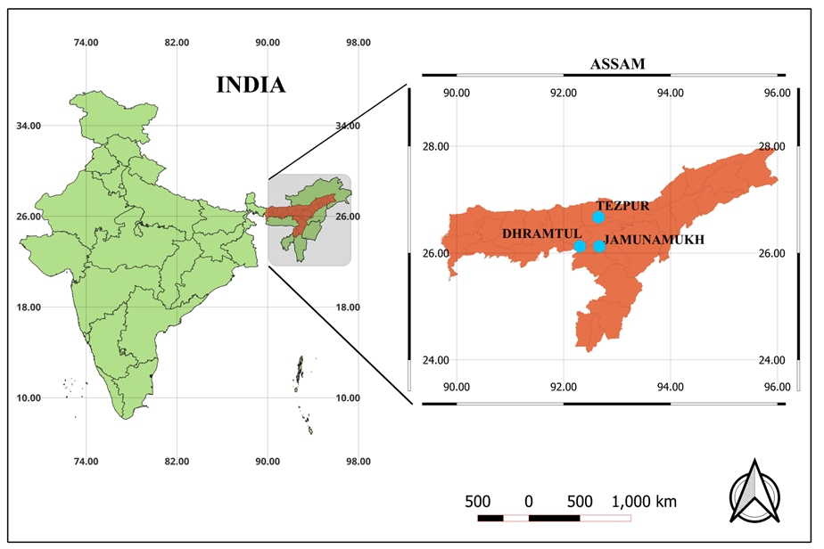

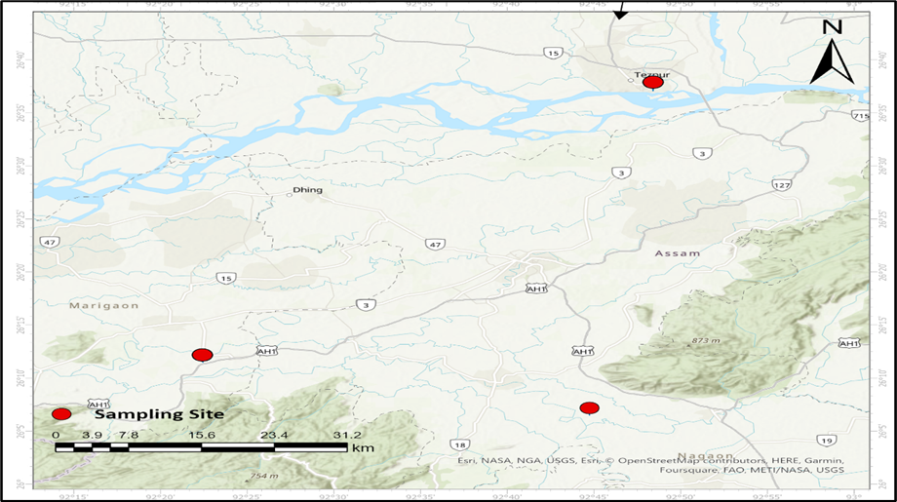

**Dharamtul**

**Jamunamukh**

**Tezpur**

**PLATE 1:(A) MAP OF INDIA ,(B) MAP OF ASSAM AND (C) LOCATION SELECTED FOR STOCK SAMPLING OF *Rita rita***

**Digitization of Samples**

The digital images of 300 fish samples were taken using a Canon SX50 digital camera, samples were then washed under running water, laid out on a flat plane with a grid of known distances (laminated graph paper sheet) ~~was~~ stored on top of a level surface, and the fins were raised using pins for standard view. An expanded polystyrene sheet (2cm) was placed beneath the laminated graph sheet to facilitate pinning. The distances between the vertical and horizontal grids in the plane laminated graph sheet were fixed. Each point was labeled with a specific code to identify it in the image. The camera is mounted on a leveling tripod to achieve the desired inclination.

**Morphometric measurements of truss distances**

A linear combination of the two software, tpsDig2 V2.1(Rohlf, 2006) and Paleontological Statistics (PAST) (Hammer *et al*., 2001) was used to extract morphometric data from the images of each specimen. The distances that connect 14 landmarks (Table 2) formed a series of quadrilaterals each having internal diagonals to form 30 morphometric measurements extracted from 300 specimens.



**Fig.1: Truss measurements from the body of *Rita rita* (Hamilton,1822)**

**Table .2 Landmarks used for extracting truss measurements from the body of *Rita rita***

|  |  |
| --- | --- |
| **Landmarks number** | **Landmarks position** |
| 01 | Anterior tip of the snout on the upper jaw |
| 02 | Origin of the occipital process |
| 03 | Origin of the dorsal fin |
| 04 | The insertion point of the dorsal fin |
| 05 | Origin of the adipose fin |
| 06 | The insertion point of the adipose fin |
| 07 | Dorsal origin of caudal fin |
| 08 | Ventral origin of the caudal fin |
| 09 | The insertion point of anal fin |
| 10 | Origin of anal fin |
| 11 | The insertion point of pelvic fin |
| 12 | Origin of pelvic fin |
| 13 | The insertion point of pectoral fin |
| 14 | Origin of the pectoral fin |

**Analysis of truss morphometric data**

Morphometric distances present meaningful correlation as they are continuous variables and appropriate for conventional multivariate analysis. The landmark and truss network distances are subjected to descriptive statistical analysis, for outlier detection and to inspect the linearity of correlations. All the morphometric measurements were log-transformed and the same data were tested for normality by MS Excel 2019 and PAST software. Size-dependent variables were removed using an allometric approach (Elliot *et al*., 1995). Data were transformed using the formula.

Madj= M (SLmean/SL)b

where Madj is the transformed morphometric measurement, M is the original morphometric measurement, SL is the standard length of fish, SL mean is the mean standard length for fish species and b:the within-group slope of the mean regression of log M against log SL. The results derived from the allometric method were established by testing the significance of the correlation between the transformed variables. In the present study, Principal Component Analysis (PCA) and Discriminant Function Analysis (DFA) were employed to differentiate the variation between the stock population.

**RESULT**

**TRUSS MORPHOMETRICS**

After the transformation of truss measurements, none of the standardized truss measurements showed a significant correlation with standard length, which indicates that the effect of body length had been successfully removed with the allometric transformation. In the principal component analysis, the first two components together i.e., PC1 and PC2 explained 85.70 % of the total variation. The eigen value for the first component was 13.81 and it was 0.59 for the second component (Table 3). The characters pertinent to the depth of the body and belly region were loaded highly on principal component 1 (PC 1), whereas measurements associated with the caudal portion were loaded on principal component 2 (PC 2).

The component loadings of the 30 truss distances (variables) are listed in Table 4 and it shows the variance explained by the variable on that particular component. In interpreting the component, an item is said to load on a given component if the component loading was 0.7 or greater for that component and was less than 0.7 for the others (Hatcher, 2003). The highlighted variables are variables with meaningful loading as per Hatcher's (2003) criteria. The truss distances with meaningful loading on PC1 were 3-14, 4-12, 4-13,59,5-10,9-10, 11-12,12-13 and 13-14. All nine distances characterize the anterior half of the fish body with depth measurement and horizontal abdominal position. PC 2 explained 3.56 % of total variation with five variables loaded significantly on it and they were distances 5-11, 6-9,7-9,8-9 and 10-11 respectively. It indicates that a significant amount of variation among the groups explained by PC2 can be accounted for solely by differences in the shape of the caudal peduncle portion. The bivariate plot of the PC1 against PC2 revealed two stocks, i.e., a single stock at river Brahmaputra and another stock in rivers Jamuna and Kopili.

**Table :3 Eigen values and proportion of variance contribution to the total variance of truss distance**

|  |  |  |  |  |
| --- | --- | --- | --- | --- |
| **Component** | **Eigen value** | **% Total Variance** | **Cumulative Eigen value** | **Cumulative Percentage (%)** |
| PC1 | 13.81 | 82.14 | 13.81 | 82.14 |
| PC2 | 0.59 | 3.56 | 14.4 | 85.70 |

**Table 4 : Variable loadings in principal component analysis of truss distance (Marked loadings are >.700000)**

|  |  |  |
| --- | --- | --- |
| **Truss Distances** | **PC1** | **PC2** |
| t3-t14 | **0.79737\*** | 0.54742 |
| t4-t5 | 0.42905 | 0.62404 |
| t4-t11 | 0.68455 | 0.62185 |
| t4-t12 | **0.72032\*** | 0.64088 |
| t4-t13 | **0.75527\*** | 0.54694 |
| t5-t6 | 0.60598 | 0.42504 |
| t5-t9 | **0.76579\*** | 0.51287 |
| t5-t10 | **0.70177\*** | 0.64725 |
| t5-t11 | 0.48375 | **0.82405\*** |
| t6-t7 | 0.44061 | 0.59541 |
| t6-t8 | 0.55545 | 0.64534 |
| t6-t9 | 0.44733 | **0.79207\*** |
| t6-t10 | 0.66398 | 0.62225 |
| t7-t8 | 0.58398 | 0.55344 |
| t7-t9 | 0.39954 | **0.84284\*** |
| t8-t9 | 0.27147 | **0.80837\*** |
| t9-t10 | **0.81593\*** | 0.25151 |
| t10-t11 | 0.10182 | **0.83273\*** |
| t11-t12 | **0.88779\*** | -0.01984 |
| t12-t13 | **0.75181\*** | 0.50462 |
| t13-t14 | **0.80815\*** | 0.25187 |

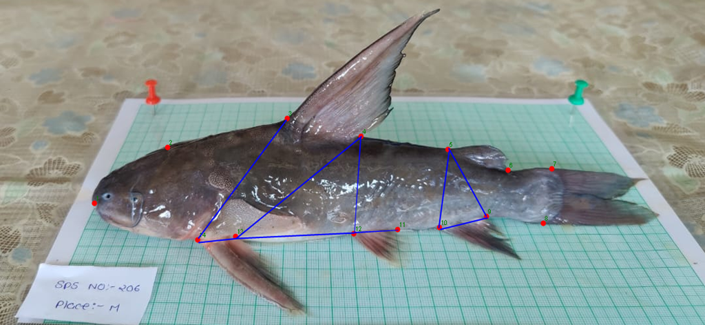



FIG. 2: Distances with meaningful loading on first two components in truss network analysis of *Rita rita*

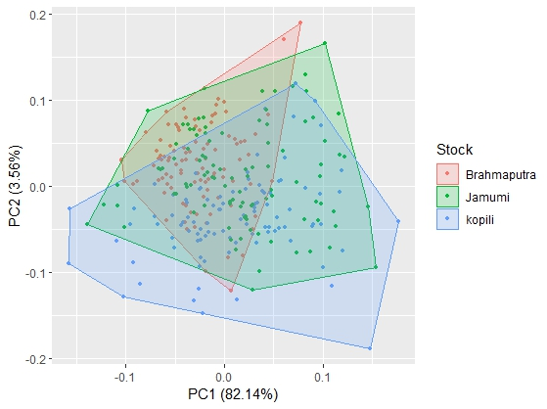

FIG.3: PC A biplot between stocks based on truss distance. Differentsitesarecodedbydifferentcolours. Stocks: Brahamaputra, Jamuna and Kopili

Two factors were extracted by factor analysis, and it showed 79.12% of variations with eigenvalue more than one, factor1explained 73.68%,andfactor2explained5.43%ofthevariations among different stocks.The truss distance with high loading on the first factor are 2-3, 2-13, 2-14,3-13, 3-13, 3-14, 4-13, 4-14, 5-10 and 5-11 which showed 13.04 % of variations. Factor 2 explained the truss distances such as 6-7, 6-8, 6-9, 7-8 and 8-9 explaining 8.24 % variations. Factor 1 highlighted the most variations inbodyshapeandfactor2 relatedto caudal peduncle shape.

The percentage of fish from the four locations classified using discriminant function analysis is given in Table 5.The cross-validation of the analysis resulted in 80%,84% and 58% of individuals correctly classified in Brahmaputra River, Jamuna River and Kopili River populations respectively. In this analysis, a high percentage of the individuals (74%) was well classified.

**Table 5: Percentage of fish in each location (in lines) classified in each location (in columns) in the cross-validation of the discriminant analysis**

|  |  |  |  |
| --- | --- | --- | --- |
| **LOCATION** | **BRAHMAPUTRA RIVER** | **JAMUNA RIVER** | **KOPILI RIVER** |
| **BRAHMAPUTRA RIVER** | 80 | 7 | 13 |
| **JAMUNA RIVER** | 2 | 84 | 14 |
| **KOPILI RIVER** | 27 | 15 | 58 |
| **Total Rate of Classification (%)** | 74% | | |
| **Total Rate of Misclassification (%)** | 26% | | |

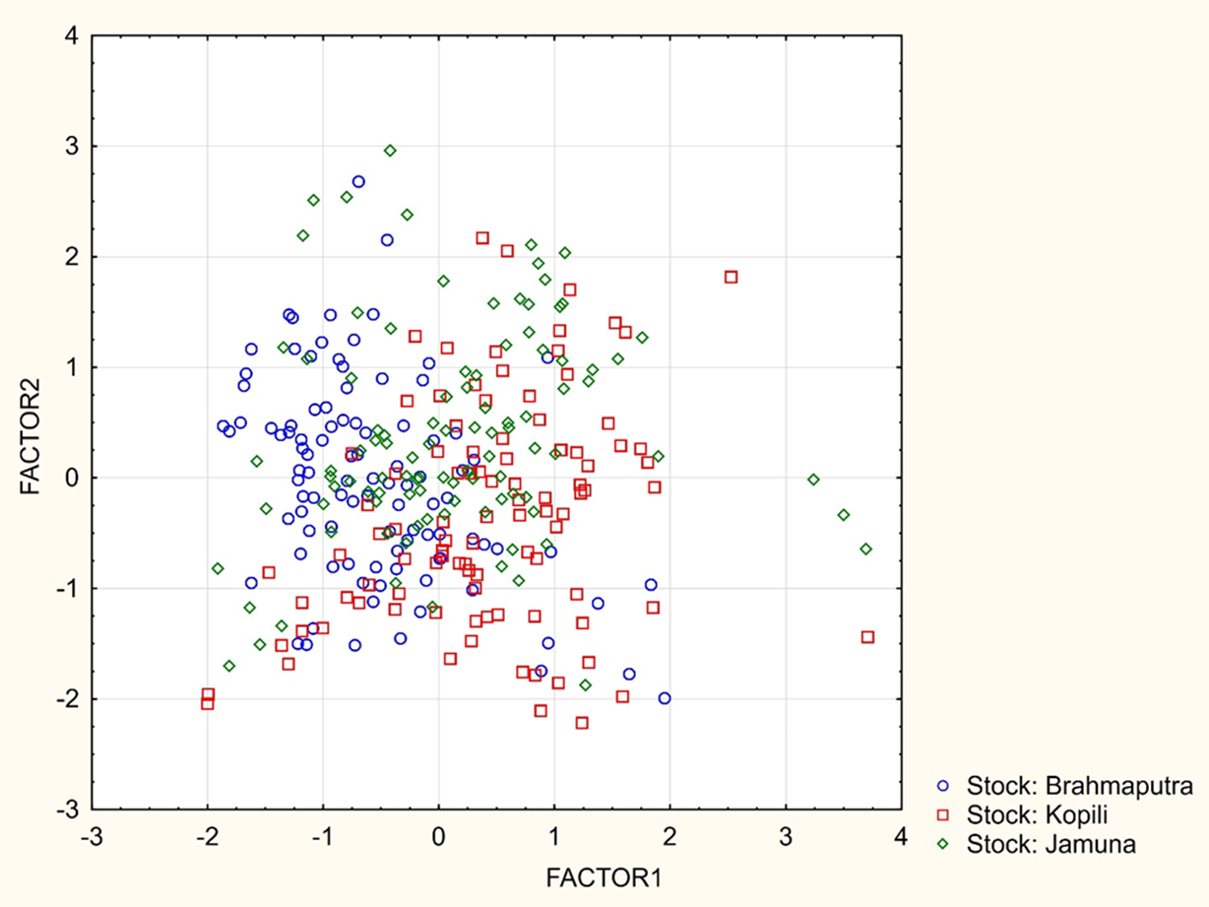

DF 1

DF 2

FIG. 4: Discriminant function analysis of biplot between stocks based on truss distance. Different sites are coded by different colours.

**DISCUSSION**

Stock structure studies provide valuable insights into the abundance of fish species, which can inform the development of effective management strategies. By examining various characteristics, including morphological traits, advanced morphometrics, biochemical signals, and the structure of fish populations, researchers can differentiate between different fish stocks.(Marcil *et al*., 2006) This information is crucial for predicting how these stocks will respond to various management interventions. Recent advancements in software technology have revitalized the utility of these methods by incorporating image analysis. This approach offers a promising solution, as it leverages the power of computational tools to enhance the accuracy and efficiency of fish identification and stock discrimination studies. Within a single species, individuals inhabiting diverse habitats often exhibit clear morphological differentiation. This suggests that fish can adapt their physical characteristics to the specific requirements of their environment. Phenotypic plasticity, a well-documented phenomenon in fish, demonstrates that genetically similar individuals can develop distinct traits when reared in different environments. (Ehlinger and Wilson 1988; Imre *et al*. 2002). Phenotypic plasticity, the study of the observable traits of an organism, is increasingly used in conjunction with genomics to investigate population structure**.** This combined approach has been widely adopted in agricultural sciences, where phenomic software is employed to collect phenotypic data for mutagenesis studies. By sampling individuals from various ecological niches, researchers can gain valuable insights into population structure and genetic variation. (Ramya *et al*. 2021)

Traditionally, stock identification has relied on the characterization of distinct morphological features. Truss morphometrics offers a significant advantage in this field by capturing the entirety of an organism's shape, regardless of the direction or location of shape variation (Cavalcanti *et al.*, 1999). In this study, principal component analysis (PCA) was used to identify biologically relevant groupings within a specific anatomical region by retaining the key components of shape variation.

This study's truss network analysis revealed two key Principal Components (PCs). The first PC (PC1) appears to primarily represent the body depth aspect, particularly the anterior half, as evidenced by the positive loadings of all six significant distances on this component. These distances encompass both straight and oblique depth measurements. This strong correlation between PC1 and body depth suggests a size effect influencing the morphometric characteristics of the analyzed populations.

The size-dependent variable was removed from the truss variable by using a modified formula originally given by Elliot *et al*. (1995). Since standard length was taken as the index of size for depth-related size effect which could have loaded in the first principal component. Similar variable loadings on the first component were reported earlier by Sajina *et al*. (2011) on *Megalapsis cordyla* and Sen *et al*. (2011) on *Decapterus russelli* from the Arabian Sea and Bay of Bengal. All the traits on PC 2 belonged to the caudal region of the fish body. A study by Muchlisin (2013) on the Rasbora group has similar morphometric approaches that show the head and caudal region as the major characters for distinguishing the groups. Saini *et al*. (2008) reported a higher maximum body width, longer adipose, anal, and caudal fin, and an elongated caudal peduncle for *Mystus seenghala* population in the Sutlej River. Imre *et al*. (2002) reported morphological variation in the caudal region of brook charr (*Salvelinus fontinalis*) from microhabitats differing in water velocity and the fishes from turbulent waters with a deeper caudal peduncle.

Factor analysis based on truss morphometric showed that factor 1 is related to body shape and factor 2 is related to caudal peduncle shape.Variations in the caudal region and body shape may be attributed to differences in hydrobiological conditions. The findings of Sajina *et al*. (2011) on *M. cordyla* further support this, indicating that body shape, head shape, and caudal region are all associated with factors 1 to 3. Moreover, variations in these traits can be explained by the hydrological conditions of the stocks. Similar findings was reported by Ramya *et al*. (2021) whose factor analysis based on truss morphometryshowedthatfactoroneisrelatedtobodyshapeandfactortwoisrelatedtoheadshape.

The truss morphometric analysis identified two distinct stocks: one solely inhabiting the Brahmaputra River and another encompassing fish from the Jamuna and Kopili Rivers. Discriminant factor analysis (DFA) served as a cross-validation technique, with 74% of individuals correctly classified to their respective stocks. This indicates some level of intermingling between the Jamuna and Kopili populations, potentially due to their close geographic proximity, similar environmental conditions, and the confluence of these rivers at Jamunamukh. Conversely, the Brahmaputra stock exhibited minimal overlap with the Jamuna-Kopili group, likely reflecting distinct environmental conditions in the Brahmaputra River.

The DFA analysis further revealed that within the total sample of 100 Brahmaputra stock specimens, 80 individuals were captured in the Brahmaputra River itself, while 13 and 7 were found in the Kopili and Jamuna Rivers, respectively. This finding aligns with previous research by Mir *et al*. (2013) who identified two stocks of *Schizothorax richardsonii* based on geographic isolation between the Eastern and Western Himalayas. In the present study, the caudal region emerged as a key differentiating factor between the Brahmaputra and Jamuna-Kopili stocks, potentially reflecting phenotypic plasticity in response to differing hydrological conditions.

These results are consistent with other studies that employed morphometrics for stock identification. Khan *et al*. (2012) distinguished three distinct stocks of *Heteropneustes fossilis* in the Ganga, Yamuna, and Gomti rivers, attributing the differentiation to environmental parameters that likely restricted intermingling between populations. Similarly, Iqbal *et al*. (2013) identified six distinct stocks of *Labeo rohita* from various sites along the Ganga River using truss morphometrics, suggesting phenotypic plasticity as a major contributor to stock variation.

The morphological characteristics of fish are shaped by a complex interplay between genetics and environment, with their interaction playing a crucial role (Poulet *et al*., 2004). Environmental factors, particularly during early developmental stages when phenotypes are more susceptible to external influences, hold particular significance (Pinheiro *et al*., 2018). It's important to note that the phenotypic variability observed may not always correspond to population differentiation at the molecular level (Ihssen *et al*., 1981). In the context of this study, geographical isolation emerges as a potential driver of phenotypic divergence between populations or stocks. This divergence can stem from genetic variations arising from migration patterns, natural selection pressures, mutations, and environmental factors acting on isolated populations (Poulet *et al*., 2004).

**CONCLUSION**

The observed morphological variations in *Rita rita* populations likely reflect adaptations to their specific environmental conditions. Future studies employing molecular and biochemical methods could provide further confirmation of this hypothesis. Techniques like microsatellite and mtDNA analysis, used in conjunction with morphometric data, would effectively elucidate the genetic basis of phenotypic differences across geographic regions. In simpler terms, integrating genetic characterization with truss network analysis could enhance the accuracy of species delineation and support the development of targeted management strategies for individual stocks. Furthermore, this study suggests a recruitment period for *R. rita* from May to June. This information would be valuable for fisheries biologists in formulating appropriate regulations for the sustainable conservation of this commercially important food fish across the three rivers investigated.

**Compliance With Ethical Standards**

**Ethical Approval**

This study was duly compiled with all sorts of regional, institutional and national animals

ethics clearance.

**REFERENCES**

Bailey, K. M. (1997). Structural dynamics and ecology of flatfish populations. *Journal of Sea Research*, **37(3-4)**: 269-280.

Begg, G. A., and Waldman, J. R. (1999). A holistic approach to fish stock identification. *Fisheries Research*, **43(1-3)**: 35-44

Cadrin, S. X. and Friedland, K. D. (1999). The utility of image processing techniques for morphometric analysis and stock identification. *Fisheries Research*, **43(1-3)**:129-139

Cadrin, S. X. (2000). Advances in morphometric identification of fishery stocks. *Reviews in Fish Biology and Fisheries*, **10(1)**: 91-112

Cavalcanti, M. J., Monteiro, L. R. and Lopes, P. R. (1999). Landmark-based morphometric analysis in selected species of serranid fishes (Perciformes: Teleostei). *Zoological Studies-Taipei-*, **38(3)**: 287-294

Elliot, J. A., Philbrick, D. R. and Wiedman, C. I. (1995). Evidence from archival data on the relation between security analysts' forecast errors and prior forecast revisions. *Contemporary Accounting Research*, **11(2):**919-938

Ehlinger, T.J., and Wilson, D.S. (1988). Complex foraging polymorphism in bluegill sunfish. Proc. Natl. Acad. Sci. U.S.A. 85: 1878–1882.

Gupta, S. (2015). *Rita rita* (Hamilton, 1822), a threatened fish of Indian subcontinent. *International Research Journal of Biological Sciences*, **4(11)**: 70-73.

Hammer, O., Harper, D. A., and Ryan, P. D. (2001). PAST: Paleontological statistics software package for education and data analysis. *Palaeontologia electronica*, **4(1)**: 9

Hatcher, L., O'Rourke, N. and Psych, R. (2013). *A step-by-step approach to using SAS for factor analysis and structural equation modeling*. Sas Institute.

Ihssen, P. E., Booke, H. E., Casselman, J. M., McGlade, J. M., Payne, N. R., and Utter, F. M. (1981). Stock identification: materials and methods. *Canadian journal of fisheries and aquatic sciences*, **38(12)**: 1838-1855.

Imre, I., McLaughlin, R. L. and Noakes, D. L. G. (2002). Phenotypic plasticity in brook charr: changes in caudal fin induced by water flow. *J. Fish Biol*., **61(5)**: 1171-1181

Iqbal M. J., Kumar, S. U., Prakash, G. O., Kumar D. A., and Jena, J. (2013). Age and growth in the Indian major carp *Labeo rohita* Cypriniformes: Cyprinidae from tropical rivers of Ganga basin, India. *Revista de Biologia Tropical*, **61(4)**: 1955-1966

Jayaram, K.C. (2010). The freshwater fishes of the Indian Region. Narendra Publishing House, New Delhi, India

Keivany, Y. and Mohsen, A.R.A.B. (2017). Geometric morphometric comparison of trout barb, *Capoeta trutta* (Teleostei: Cyprinidae) in the Tigris River basin. *Iran. J. Ichthyol*., **4(3)**: 220-230

Khan, M. A., Khan, S., and Miyan, K. (2012). Length–weight relationship of giant snakehead, *Channa marulius* and stinging catfish, *Heteropneustes fossilis* from the River Ganga, India. *Journal of Applied Ichthyology*, **28**(1): 154-155

Kutkuhn, J. H. (1981). Stock definition as a necessary basis for cooperative management of Great Lakes fish resources. *Canadian Journal of Fisheries and Aquatic Sciences*, **38(12)**: 1476-1478

Marcil, J., Swain, D.P. and Hutchings, J.A. (2006). Counter gradient variation in body shape between two populations of Atlantic cod (*Gadus morhua*). Proceedings of the Royal Society. *J. Biol. Sci*., **273(1583)**: 217-223.

Mir, F. A., Mir, J. I., & Chandra, S. (2013). Phenotypic variation in the Snowtrout *Schizothorax richardsonii* (Gray, 1832) (Actinopterygii: Cypriniformes: Cyprinidae) from the Indian Himalayas. *Contributions to Zoology*, ***82*(3)**: 115-122

Muchlisin, Z. A. (2013). Morphometric variations of rasbora group (pisces: cyprinidae) in Lake Laut Tawar, Aceh Province, Indonesia, based on truss character analysis. *Hayati Journal of Biosciences*, **20(3)**: 138-143

Pinheiro, R. E. E., Rodrigues, A. M. D., Santos, J. T. D. O., Costa, J. D. A., Pereyra, C. M., Torres, A. M. and Muratori, M. C. S. (2018). Occurrence and diversity of yeast species isolated from fish feed and tambatinga gut. *Latin american journal of aquatic research*, **46(4)**: 837-842.

Poulet, N., Berrebi, P., Crivelli, A. J., Lek, S. and Argillier, C. (2004). Genetic and morphometric variations in the pike perch of a fragmented delta. *Archiv für Hydrobiologie*, **159(4)**:531-554

Ramya, V. L., Behera, B. K., Das, B. K., Krishna, G., Pavankumar, A., & Pathan, M. K. (2021). Stock structure analysis of the endemic fish, Barbodes carnaticus (Jerdon 1849), for conservation in a biodiversity hotspot. *Environmental Science and Pollution Research*, *28*, 55277-55289.

Rohlf, F. J. (2006). tpsDig 2.10. Stony Brook, NY: Department of Ecology and Evolution, State University of New York

Saini, A., Dua, A. and Mohindra, V. (2008). Comparative morphometrics of two populations of giant river catfish (*Mystus seenghala*) from the Indus River system. *Integr. Zool*., **3**: 219–226

Sajina, A. M., Chakraborty, S. K., Jaiswar, A. K., Pazhayamadam, D. G. and Sudheesan, D. (2011). Stock structure analysis of *Megalaspis cordyla* (Linnaeus, 1758) along the Indian coast based on truss network analysis. *Fisheries Research*, **108(1)**: 100-105

Sen, S., Jahageerdar, S., Jaiswar, A. K., Chakraborty, S. K., Sajina, A. M. and Dash, G. R. (2011). Stock structure analysis of *Decapterus russelli* (Ruppell, 1830) from east and west coast of India using truss network analysis. *Fisheries Research*, **112**(1-2):38-43

Smith, P. J., Jamieson, A., and Birley, A. J. (1990). Electrophoretic studies and the stock concept in marine teleosts. *ICES Journal of Marine Science*, **47(2)**: 231-245.

Talwar P.K. and Jhingran A.G.(1991). Inland fishes of India and adjacent countries. Vol-1 and Vol-2. Oxford and IBH Publishing Co. Pvt. Ltd. New Delhi, Bombay and Calcutta, 1063

Turan, C. (2006). The use of otolith shape and chemistry to determine stock structure of Mediterranean horse mackerel *Trachurus mediterraneus* (Steindachner). *Journal of Fish Biology*, **69**:165-180