A Study of Fresh water Ichthyofaunal Diversity of Lakshmipuram Lake, Anakapalli Dist., Andhra Pradesh, India

# Abstract

The present study investigates the ichthyofaunal diversity of Lakshmipuram Lake from January 2024 to December 2024, a vital freshwater body supporting ecological balance and local livelihoods. A total of 47 fish species were identified at different sites. Freshly collected fishes were carefully cleansed and photographed and they were fixed in jar and preserved in 9-10% formalin solution. Fish species were identified using classical taxonomical observations. Among the identified 12 orders, the order Cypriniformes was dominant with 18 species which contributed to 37% followed by Siluriformes 10 (21%), Perciformes 3 (4%), Channiformes, Cichliformes, and Anguilliformes each 3 (6%), Beloiniformes and Synbranchiformes each 2 (4%), Cyprinodontiformes, Gobiiformies, Osteoglossiformes, and Anabantiformes each 1 (2%). The population status is of 11 species were abundant which contributed to 23% whereas 25 species were common contributing to 53%, 4 species were moderate by contributing to 8%, and the least percent of species i.e., 7 were represented as rare which contributed to only 14%. According to IUCN 2024, 36 species contributed to 77% are least concern (LC), 8 species contributed to 16% are near threatened (NT), 2 species contributed to 4% are not evaluated (NE), and 1 species of 2% are data deficient (DD). Thus, the Lake was good potential for fish fauna.

# Keywords

Freshwater fish, Lakshmipuram lake, Ichthyofaunal diversity, IUCN

# Introduction

India is one of the world's most biodiverse countries, with an extensive network of freshwater ecosystems, including rivers, lakes, ponds, reservoirs, and wetlands. It is renowned for its quantity and richness of biodiversity in the variety of fishes found in both fresh and marine waters. There are over 20,000 fish species worldwide, with 2179 species found in India, in freshwater sources such lakes, dams, and tanks (Telkhade and Jambhule, 2017). The main intention of fish is to supplement the human diet with proteins, lipids, and vitamins A and D (Sanapala et al., 2022).

Lake supports a wide variety of fish species that supports for commercial fishes. Fish biodiversity of lake essentially represents the fish faunal diversity and their abundance. Freshwater fish diversity is a vital component of aquatic ecosystems, playing a crucial role in maintaining ecological balance, nutrient cycling, and water quality. Freshwater fishes are one of the most threatened taxonomic groups that are due to degradation and defragmentation of habitats water abstraction, industries and private use, introduction of exotic species, pollution, and global climate change impact (Sekhara, Raju and G. Simhachalam, 2014). Lack of knowledge about fish fauna is a major barrier to the popularization of lesser-known fish species in each environment (Sanapala et al., 2022). Therefore, knowledge of the fish fauna in freshwater environments is necessary in order to plan scientific approaches for their efficient utilization for fish production (Ramulu and Benarjee, 2013).

Various workers have studied fishes of India like Day (1875), Price (1978), Khanna (1992), Jayaram (1994), Suresh (2003), and Telkhade 2017.

The present study on freshwater fish diversity and its ecological significance aims to achieve the diversity and distribution of freshwater fish species in Lakshmipuram Lake, Anakapalli Dist., Andhra Pradesh, India. Also, to analyze the conservation status of fish species and to recommend conservation and management strategies for sustaining freshwater fish diversity and promoting sustainable fishery practices.

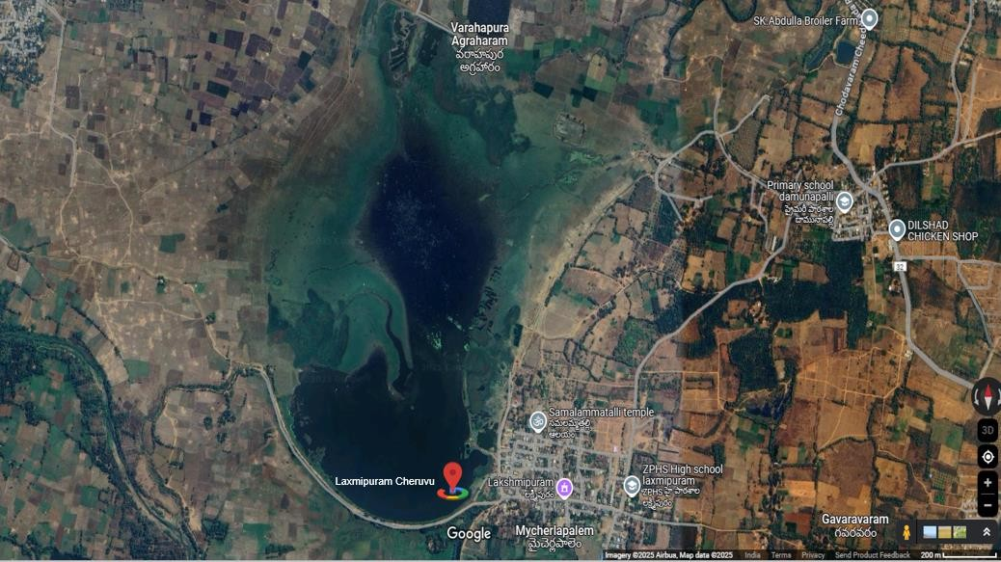

**Image 1: Satellite image of Lakshmipuram lake, Lakshmipuram village Chodavaram Mandal, Andhra Pradesh, India. Image credits to Google Maps**

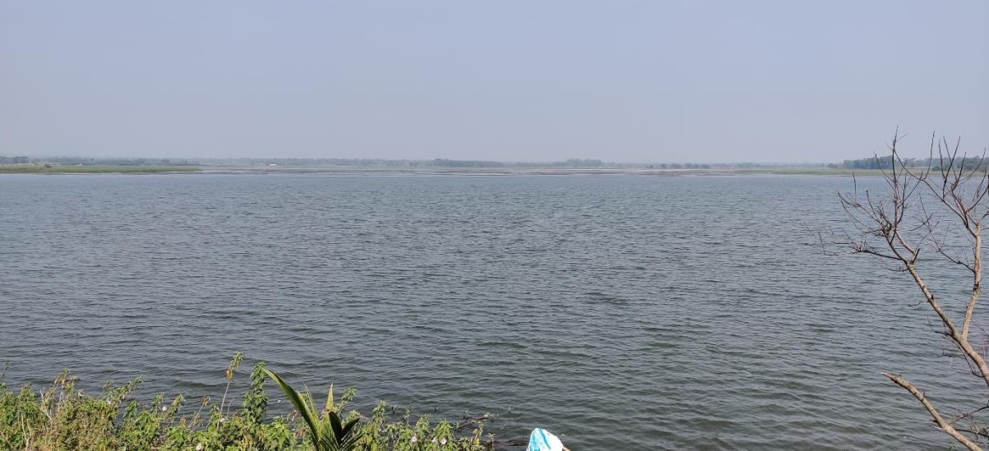

**Image 2: Lakshmipuram lake, Lakshmipuram village Chodavaram Mandal, Andhra Pradesh, India.**

# Materials and Methods

* 1. **Study Area**

Lakshmipuram Lake is situated in the the village of Lakshmipuram in Chodavaram Mandal, Anakapalli district, Andhra Pradesh, India. Its 650 acres of land are highly helpful to all the farmers in the nearby areas. Every year, about 1500 acres are successfully farmed beneath this lake. It is close to National Highway 16 and has a road transit facility. Its average elevation is 30 meters above sea level, and its coordinates are 22.090N 82.150E. The region has a tropical climate, with reported average temperatures and humidity ranging from 24.2°C to 30°C and 61%, respectively (Gudabandi Vijaya Pratap et.al., 2025).

# Sampling and Collection of Fishes

The fish samples were collected from January 2024 to December 2024 from different sites in Lakshmipuram lake with the assistance of local fishermen using various types of gear (drag nets, push nets, cast nets, stationary gill nets) and bamboo baskets (Traps) (Rama Rao, 2014). Fishes were also collected from local fish markets and fish sellers. Freshly collected fish were carefully cleansed and photographed. These fish were taken to the lab and fixed in glass jars before being preserved in a 9-10% formalin solution (Jayaram, 1999). Identification of the species was done mainly on the morphometric and meristic characters were done by Day, F. (1875), Talwar, P.K. (1991), Jayaram (2010), Menon (1988), and Munro (2000). The IUCN (2024) conservation status of the fish species has been listed (2024). The lake is nutrient-rich and identified of better quality for fish farming (Gudabandi Vijaya Pratap et.al., 2025).

# Results and Discussion

The current study analyzed the fish species taxa and diversity in Andhra Pradesh's Lakshmipuram Lake between January 2024 to December 2024. The study reveals the presence of fouty seven (47) species of fishes belonging to twelve (12) orders and nineteen

(19) families and thirty-five (35) genera. List of fish including common names, population status and their conservational status were given in table 1.

The list of fish species are *Anguilla bengalensis, Anguilla bicolor, Moringua raitaborua, Xenentodon cancila, Hyporhamphus limbatus, Cirrhinus mrigala, Ctenopharyngodon Idella*, Cyprinus carpio*, Hypopthalmicthys molitrix*, Labeo catla, Labeo calbasu, Labeo rohita, Osteobrama cotio, Puntius chola, Puntius ticto, Puntius sophore, Systomus sarana, Garra gotyla, Amblypharyngodon microlepis, Amblypharyngodon mola, Salmostoma bacaila, Rasbora daniconius, Danio devario, Aplocheilus panchax, Channa orienalis, Channa punctata, Channa striatus, Glossogobius giuris, Notopterus notopterus, Mystus cavasius, Mystus gulio,, Mystus tengara, Mystus vittatus, Clarias batrachus, Clarias magur, Heteropneustes fossilis, Ompok bimaculatus, Wallago attu, Eutropiichthys vacha, Anabas testudineus, Oreochromis niloticus*, Pseudetroplus maculates, Etroplus suratensis, Macrognathus pancalus, Mastacembelus armatus, Chanda nama, Parambassis ranga.*

Out of 47 species recorded from Lakshmipuram lake Four (4) are exotic fishes (* indicates exotic fishes) available in lakshmipuram lake. Earlier studies reported by Chinnababu Sanapala et., al. fish genetic resources found here in the Madduvalasa Reservior of Srikakulam district reveals that there are 31 species of fishes belonging to 5 orders, 21 genera of 13 families (Sanapala et al., 2022); A total of 55 species of fishes were identified belonging to 9 orders at Meghadrigedda (Sharmila, et al., 2016); Total of 25 fishes are belonging to 7 orders, 11 families and 18 genera reported in Kamalapur lake in Telangana by M. Thirupathaiah (M. Thirupathaiah, et al., 2014); presence of 49 fish species from 12 orders, 19 families, and 33 genera in Gotta barrage at Hiramandalam by Rama Rao (Rama Rao, 2023); presence of 92 species of fish belonging to 13 orders, 34 families and 57 genera in Kolleru lake by G. Simhachalam (G. Simhachalam et al., 2014); a total of 47 fish species across 11 orders and 19 families were observed in Gosthani River by Rama Rao (Rama Rao, et al., 2024).

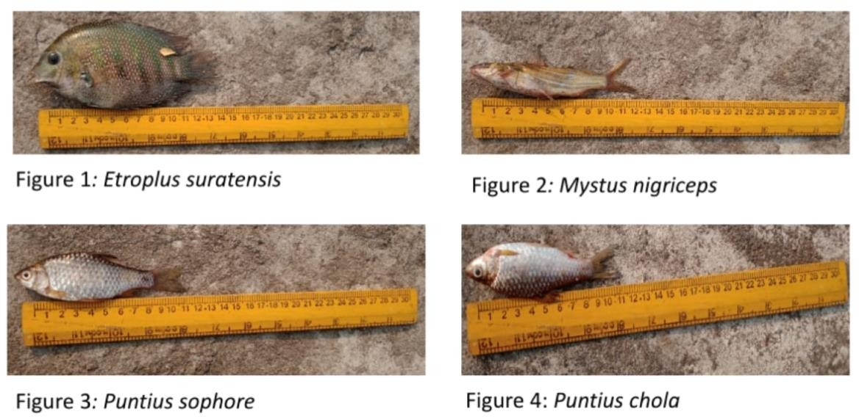

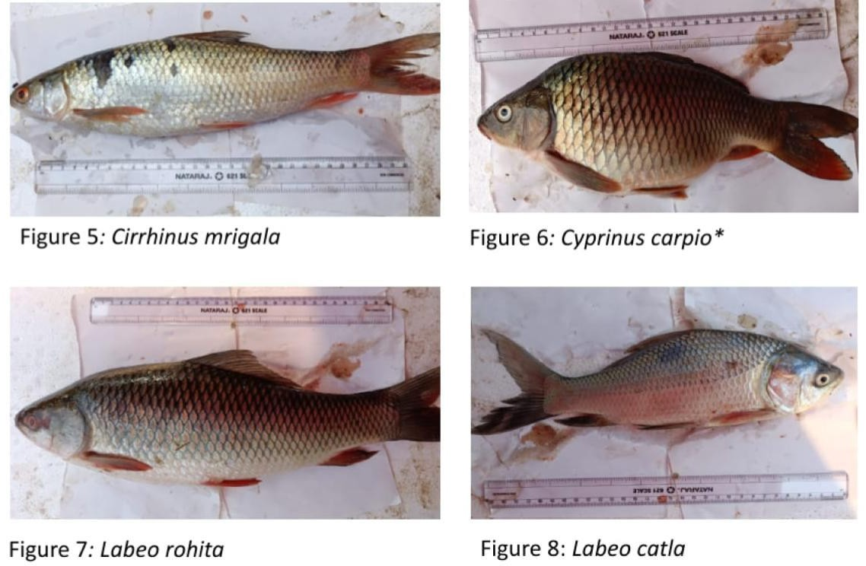

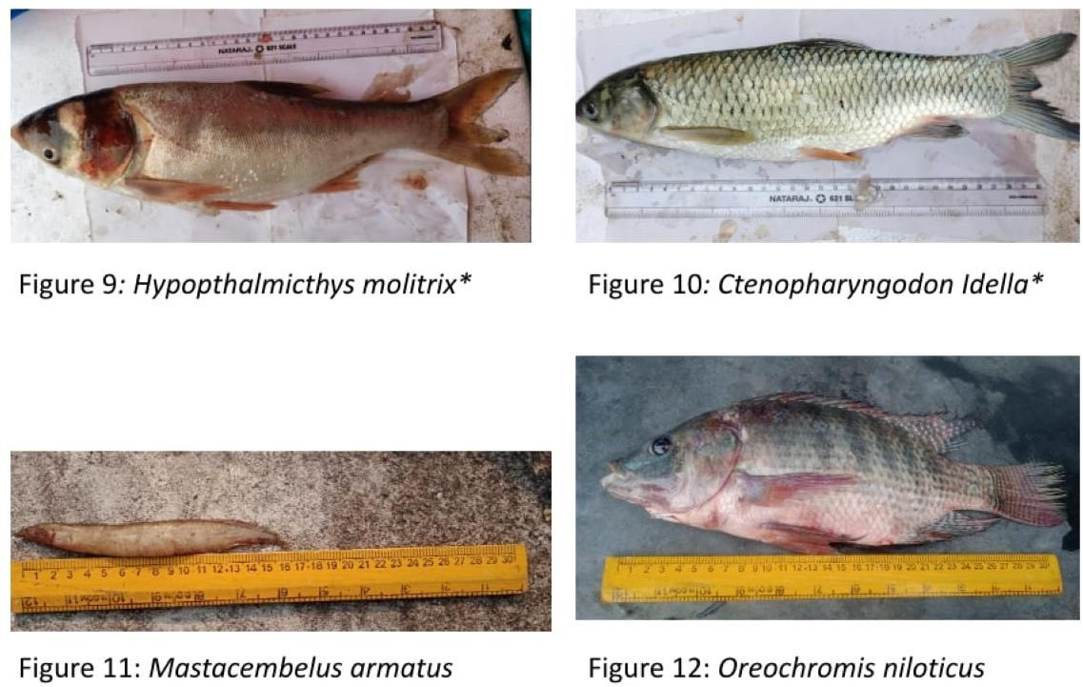

**Table 1: List of fishes and their order, family, genus, species, common name, population status, IUCN status in Lakshmipuram Lake.**

|  |  |  |  |  |  |  |
| --- | --- | --- | --- | --- | --- | --- |
| **Sl.N**  **o** | **Order** | **Family** | **Species Name** | **Common Name** | **Populatio n status** | **Conservation**  **status (IUCN, 2022)** |
| 1 | Anguilliformes | Anguillidae | *Anguilla bengalensis* | Indian mottled eel | R | NT |
| 2 | *Anguilla bicolor* | Shortfin eel | R | NT |
| 3 | Moringuidae | *Moringua raitaborua* | Purple spaghetti-  eel | M | NE |
| 4 | Beloiniformes | Belonidae | *Xenentodon cancila* | Freshwater garfish | R | DD |
| 5 | Hemiramphidae | *Hyporhamphus*  *limbatus* | Congaturi halfbeak | R | LC |
| 6 | Cypriniformes | Cyprinidae | *Cirrhinus mrigala* | Mrigal carp | A | LC |
| 7* | *Ctenopharyngodon*  *idella* | Grass carp | M | LC |
| 8* | *Cyprinus carpio* | common carp | A | LC |
| 9* | *Hypopthalmicthys*  *molitrix* | silver carp | R | NT |
| 10 | *Labeo catla* | Catla | A | LC |
| 11 | *Labeo calbasu* | Black Rohu | C | LC |
| 12 | *Labeo rohita* | Rohu | A | LC |
| 13 | *Osteobrama cotio* | Cotio | C | LC |
| 14 | *Puntius chola* | Swamp barb | A | LC |
| 15 | *Puntius ticto* | Two-spot barb | A | LC |
| 16 | *Puntius sophore* | Spotfin swamp barb | A | LC |
| 17 | *Systomus sarana* | Olive barb | C | LC |
| 18 | *Garra gotyla* | Sucker head | R | LC |
| 19 | Danionidae | *Amblypharyngodon*  *microlepis* | Indian carplet | A | LC |
| 20 | *Amblypharyngodon*  *mola* | Mola carplet | A | LC |
| 21 | *Salmostoma bacaila* | Large razorbelly  minnow | C | LC |
| 22 | *Rasbora daniconius* | Slender rasbora | C | LC |
| 23 | *Danio devario* | Sind danio | C | LC |
| 24 | Cyprinodontiforme | Aplocheiidae | *Aplocheilus panchax* | Blue Panchax | C | LC |
| 25 | Channiformes | Channidae | *Channa orienalis* | Asiatic snakehead | C | NE |
| 26 | *Channa punctata* | Spotted snakehead | A | LC |
| 27 | *Channa striatus* | Striped Snakehead | C | LC |
| 28 | Gobiiformies | Gobiidae | *Glossogobius giuris* | Tank Goby | C | LC |
| 29 | Osteoglossiformes | Notopteridae | *Notopterus notopterus* | Bronze Featherback | C | LC |
| 30 | Siluriformes | Bagridae | *Mystus cavasius* | Striped dwarf  catfish | C | LC |
| 31 | *Mystus gulio* | Long-whiskered  catfish | R | LC |
| 32 | *Mystus nigriceps* | Two-spot catfish | A | LC |
| 33 | *Mystus vittatus* | Striped dwarf  catfish | A | LC |
| 34 | Claridae | *Clarias batrachus* | Walking catfish | C | LC |
| 35 | *Clarias magur* | Walking Catfish | C | LC |
| 36 | Heteropneustida | *Heteropneustes fossilis* | Indian Stinging  Catfish | C | LC |
| 37 | Siluridae | *Ompok bimaculatus* | Butter catfish | C | NT |
| 38 | *Wallago attu* | Wallago catfish | C | NT |
| 39 | Schibeidae | *Eutropiichthys vacha* | Batchwa vacha | C | LC |
| 40 | Anabantiformes | Anabantidae | *Anabas testudineus* | Climbing perch | M | LC |
| 41* | Cichliformes | Cichlidae | *Oreochromis niloticus* | Nile tilapia | M | NT |
| 42 | *Pseudetroplus*  *maculates* | Orange Chromide | C | LC |
| 43 | *Etroplus suratensis* | Green Chromide | C | LC |
| 44 | Synbranchiformes | Mastacembelida | *Macrognathus pancalus* | Barred spiny eel | C | LC |
| 45 | *Mastacembelus*  *armatus* | Zig-zag eel | C | LC |
| 46 | Perciformes | Ambassidae | *Chanda nama* | Elongate glassy  perchlet | C | LC |
| 47 | *Parambassis ranga* | Indian X-ray fish | C | LC |

A= Abundant (76-100%); C = Common (51-75%); M = Moderate (26-50%); R = Rare (1-25%) of the total catch. EN- Endangered; VU- Vulnerable: LC- Least concern; DD- Data deficient; NE- Not evaluated, NT: Near threaten.

*Exotic fishes No’s: 7, 8, 9 and 41

**Table 2: Percent composition of families, genera, and species of fishes under various orders**

|  |  |  |  |  |
| --- | --- | --- | --- | --- |
| **Sl.No.** | **Order** | **Families %** | **Genera %** | **Species %** |
| 1 | Anguilliformes | 10 | 8 | 6 |
| 2 | Beloiniformes | 10 | 5 | 4 |
| 3 | Cypriniformes | 10 | 35 | 37 |
| 4 | Cyprinodontiformes | 5 | 3 | 2 |
| 5 | Channiformes | 5 | 3 | 6 |
| 6 | Gobiiformies | 5 | 3 | 2 |
| 7 | Osteoglossiformes | 5 | 3 | 2 |
| 8 | Siluriformes | 25 | 16 | 21 |
| 9 | Anabantiformes | 5 | 3 | 2 |
| 10 | Cichliformes | 5 | 8 | 6 |
| 11 | Synbranchiformes | 5 | 5 | 4 |
| 12 | Perciformes | 5 | 6 | 8 |

**Table 3: Taxa composition of population status and IUCN**

|  |  |  |  |  |
| --- | --- | --- | --- | --- |
| **Population**  **Status** | **Abudant** | **Rare** | **Moderate** | **Common** |
| No. of Species  and % | 11 | 7 | 4 | 25 |
| 23% | 14% | 8% | 53% |
| **IUCN** | **Least concern** | **Data deficient** | **Not evaluted** | **Near threatren** |
| **No. of Species**  **and %** | 36 | 1 | 2 | 8 |
| 77% | 2% | 4% | 16% |

In this present study, the percent composition of families, genera and species under different orders are shown in Table 2 and Figure 1-12. Among the 12 orders, the order Cypriniformes was dominant with 18 species which contributed to 38% followed by Siluriformes 10 (21%), Perciformes 2 (4%), Channiformes, Cichliformes, and Anguilliformes each 3 (7%), Beloiniformes and Synbranchiformes each 2 (4%), Cyprinodontiformes, Gobiiformies, Osteoglossiformes, and Anabantiformes each 1 (2%). Recorded genera out of 35 Cypriniformes was dominated by 13 (36%) followed by Siluriformes 6 (16%), Anguilliformes,

Cichliformes, and Perciformes each 3 (8%), Beloiniformes and Synbranchiformes each 2 (5%), Cyprinodontiformes, Channiformes, Gobiiformies, Osteoglossiformes, and Osteoglossiformes each 1 (3%). Among 20 different familes, Siluriformes was dominated with 5 families contributed to 25% followed by Anguilliformes, Beloiniformes, Cypriniformes and Perciformes each 2 (10%); Cyprinodontiformes, Channiformes, Gobiiformies, Osteoglossiformes, Anabantiformes and Cichliformes each 1 family (5%). The generic composition of fishes

belonging to different families shows that, 13 genera included in Cyprinidae followed by 5 genera under Danionidae; 4 genera under Bagridae; 3 genera under each in Channidae and Cichlidae; 2 genera each under Anguillidae, Claridae, Siluridae, Mastacembelidae, Ambassidae and Channidae; 1 genus each under Moringuidae, Belonidae, Hemiramphidae, Aplocheiidae, Gobiidae, Notopteridae, Heteropneustidae, Schibeidae and Anabantidae.

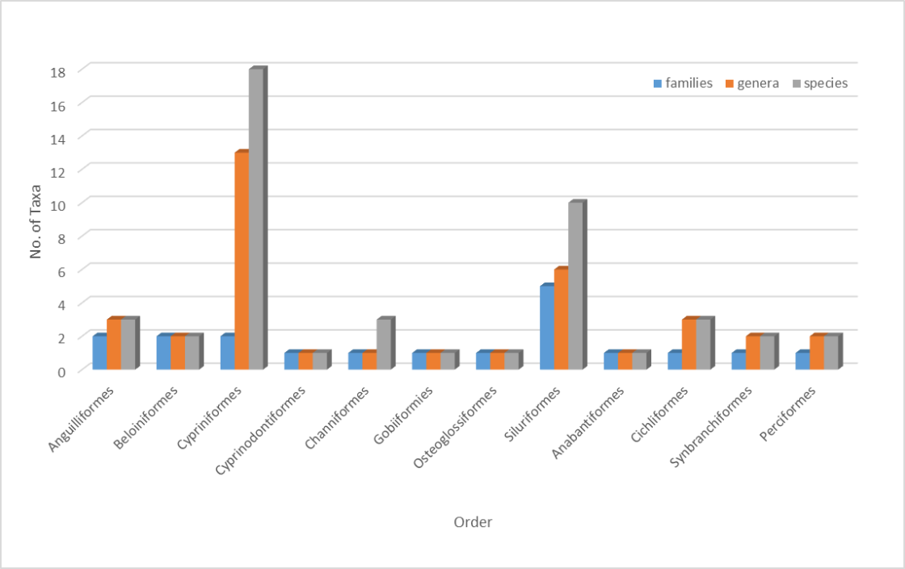

**Figure13: Graphical representation of percentage of taxa reported in Lakshmipuram lake.**

The number and percent composition of population status is as follows; 11 species were abundant which contributed to 23% whereas 27 species were common contributing to 55%, 4 species were moderate contributing to 8%, and the least percent of species i.e., 7 were represented as rare which contributed to only 14% in the total catch (Table. 3 and Figure 14). According to IUCN 2024, 38 species contributed to 78% are least concern (LC), eight species contributed to 16% are near threatened (NT), two species contributed to 4% are not evaluated (NE), and one species of 2% are data deficient (DD) (Table 3 and Figure 15).

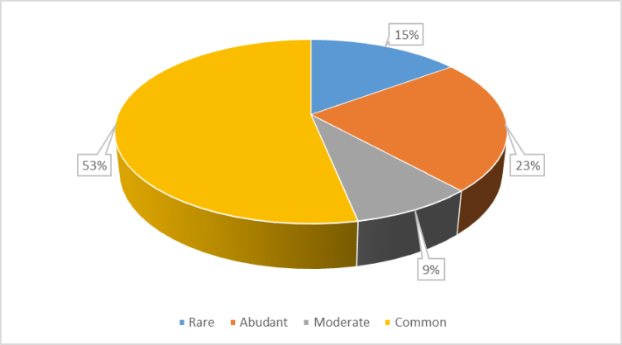

**Figure 14: Pie chart showing the percentage of population status**

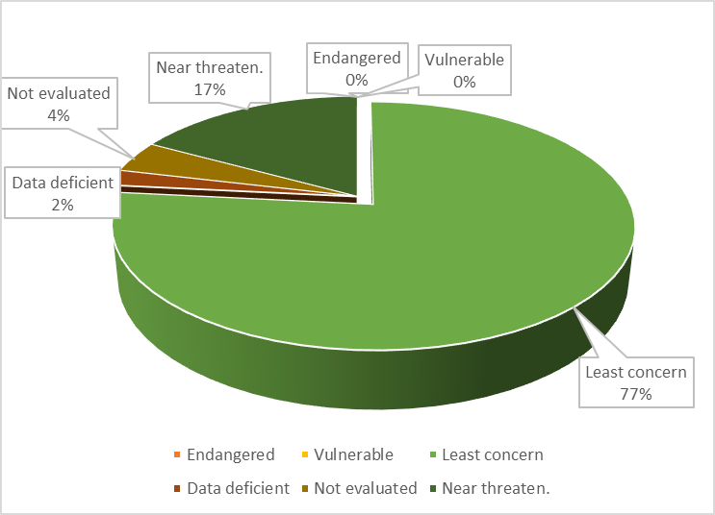

**Figure 15: Image showing the percentage of IUCN status 2024**

# Conclusion

This is the first documentation of fish fauna in Lakshmipuram Lake. A comprehensive study of the fish diversity in Lakshmipuram Lake revealed a diverse and abundant collection of species that span several taxonomic groupings and ecological niches. The lake's contribution to local fisheries and livelihood opportunities for nearby residents is highlighted by the presence of commercially valuable species like *Labeo rohita*, *Catla catla*, and *Cirrhinus mrigala*. Furthermore, the presence of species like *Heteropneustes fossilis*, *Channa striatus*, and *Clarias batrachus* suggests that the lake can support a variety of aquatic life in spite of environmental changes. Interestingly, the discovery of species that can withstand pollution, like *Oreochromis mossambicus*, points to the possible effects of environmental stressors and highlights the necessity of preventative conservation efforts.

In conclusion, the diverse fish fauna of Lakshmipuram Lake reflects the region's rich aquatic biodiversity and emphasizes the lake's ecological significance. By promoting conservation initiatives and sustainable fisheries management, we can ensure the long-term stability of this invaluable aquatic ecosystem.

# References

Alo Saha et., al. (2024). A Study on the Fresh Water Fish Diversity of Mora Dhansiri River, Assam, India. Uttar Pradesh Journal of Zoology. 45 (6), 164-171.

Day, F. (1875). The fishes of India, being a natural history of the fishes known to inhabit the seas and freshwaters of India, Burma and Ceylon., *Biodiversity Heritage Library.*

G. Simhachalam et., al, (2014). Biodiversity and Conservation Status of Fishes of River Sarada, Visakhapatnam District, Andhra Pradesh, India. Research Journal of Animal, Veterinary and Fishery Sciences; 2(2), 1-8.

G. Simhachalam et., al, (2014). Biodiversity and Conservation status of Ichthyofauna of Lake Kolleru, Andhra Pradesh, India. IJSR - INTERNATIONAL JOURNAL OF SCIENTIFIC RESEARCH. 3 (5).

Gudabandi Vijaya Pratap, Tulasi Bhushan Rao, Bellala Krishna, Palaka Lakshman, and Bora Keerthana. 2025. “Assessment of Physico-Chemical Characteristics of Lakshmipuram Lake, Anakapalli Dist., Andhra Pradesh, India”. *Uttar Pradesh Journal of Zoology* 46 (5):9-25.

IUCN Red List of threatened species, version; 2024.

Jayaram, K.C. (1994). The freshwater fishes of India, A handbook, *Zoological survey of India*, Calcutta. Fish as Indicator of water quality. Paper presented at the international symposium on biological indicators of water quality in new castle. Proc. Indian Acad. Sci. (63): Pp. 57 – 66

Jayaram, K.C. (2010). The Freshwater Fishes of the Indian Region. Second Edition. Narendra Publishing House, Delhi,A

Khanna, D. R. (1993). Ecology and Pollution of Ganga River., *Ashish Publishing House*, Delhi. 1- 241.

Menon, A.G.K. (1988): Checklist of freshwater fishes of India. Zoological Survey of India; (ZSI) Kolkata. pp. 65-66.

M. Thirupathaiah et., al, (2014). Diversity and Conservation Status of Fish Fauna in Freshwater Lake of Kamalapur, Karimnagar District, Telangana, India. IOSR Journal of Environmental Science, Toxicology and Food Technology (IOSR-JESTFT); 8 (5), 19-24.

Munro ISR. The Marine and Freshwater Fishes of Ceylon. Biotech Books, Delhi; 2000.

Rama Rao K. Ichthyo faunal bio diversity in the lower Manair Dam at Karimnagar district; Telangana State: India Pelagia Research Library. Advances in Applied Science Research,2014a:5(5):237-248.

Rama Rao K. (2023). Ichthyofaunal diversity of Gotta barrage at Hiramandalam, Vamsadhara River, Srikakulam Dt. Andhra Pradesh, India. International Journal of Zoology Studies. 8 (2), 23-28.

Rama Rao K. et., al, (2024). Taxonomic Check List of Ichthyofaunal Diversity in Gosthani River at Tagarapuvalasa, Visakhapatnam, Andhra Pradesh, India. Uttar Pradesh Journal of Zoology. 45 (10), 57-64.

Ravindar. B. (2010): “Studies on the ecology and fish fauna of fresh water bodies in Warangal District” Ph.D., Thesis, Kakatiya University, Warangal, Andhra Pradesh.

Sanapala et., al. (2022). The study on fish diversity of Madduvalasa reservoir Srikakulam district, Andhra Pradesh, India. International Journal of Fisheries and Aquatic Studies 2022; 10(2): 122-124

Sharma, S.V. and Nayak D.Y. (2001): Checklist of fishes inhabiting in water bodies in Nallamala hill range in Andhra Pradesh. J. Aqua. Biol. 16(1): 35-36.

Sharmila Sree. J and U. Shameem (2016). Ichthyo Faunal Bio Diversity in the Meghadrigedda Reservoir at Visakhapatnam, Andhra Pradesh: India; International Journal of Innovative Research in Science, Engineering and Technology; 5(3); 4065-4078.

Talwar, P.K. and Jhingran, A.G., 1991. Inland fishes of India and adjacent countries (Vol. 2). CRC press

**DISCLAIMER (ARTIFICIAL INTELLIGENCE)**

Author(s) hereby declares that NO generated AI technologies such as Large Language Models (ChatGPT, COPILOT, etc.,) and text-to-image generators have been used during writing or editing of this manuscript.