The distribution pattern of Poecilotheria spiders (Mygalomorphae : Theraphosidae) along the foothills of the Western Ghats of Tamil Nadu, India with a note on the Local Ecological Knowledge (LEK) on large-bodied spiders.

ABSTRACT
This study investigates the distribution pattern of Poecilotheria spiders along the foothills of the Western Ghats of Tamil Nadu, focusing on habitat preference, altitudinal variations, and the merit of Local Ecological Knowledge (LEK) in identifying species presence. Data collection involved exclusive field visits and questionnaire surveys with 749 respondents, revealing a significant gap in Poecilotheria distribution studies. The questionnaire survey revealed a widespread distribution of Poecilotheria spiders across the study area. The spiders were found to inhabit a diverse range of host trees and habitats, from low-lying areas to higher altitudes suggesting their adaptability to different habitats. Statistical analysis demonstrated significant correlations between species sightings and demographic variables, such as age, gender, and occupation. The study underscores the importance of local people's knowledge in identifying the species distribution. Also, the study highlights the urgent need for species conservation from various threats to the species and habitat.

Keywords: Poecilotheria, distribution, Host plants, Local Ecological Knowledge (LEK)
1. INTRODUCTION

The order Araneae is divided into three suborders: Mesothelae, Mygalomorphae, and Araneomorphae. Mygalomorph spiders, categorized under Orthognatha due to the parallel alignment of their chelicerae, make up only about 7% of all spider species and have been relatively understudied compared to other spider groups. The genus Poecilotheria originated with Latreille, who described mygale fasciata based on a depiction of Aranea maxima ceilonica in Seba's Thesaurus. Native to Ceylon, it was later named Scurria by C. Koch in 1850. Since the name was already used for a mollusk, Simon renamed it Poecilotheria in 1885 (1899a). The genus Poecilotheria is a poorly studied group within the family Theraphosidae (Das et al., 2012). The genus Poecilotheria Simon, 1885, in the family Theraphosidae (Mygalomorphae), currently comprises 15 species worldwide. Of these, seven are endemic to India (Poecilotheria formosa, P. metallica, P. miranda, P. regalis, P. rufilata, P. striata, and P. tigrinawesseli) of which six of these were described in the late 19th century (Smith, 2006). Six are endemic to Sri Lanka (P. fasciata, P. ornata, P. rajaei, P. smithi, P. subfusca, and P. srilankensis), and two (P. hanumavilasumica and P. vitata) are found in both India and Sri Lanka (World Spider Catalogue, 2024).
The Poecilotheria spiders display a varied distribution across India. Over 80% of the mygalomorph spider species found in India were found in union territories and coastal states (Singh, 2020). The genus is predominantly distributed across the forested hills and plains of Central and Peninsular India (Smith, 2006). In the southern regions, particularly within the Western Ghats and coastal regions of Kerala and Tamil Nadu, P. formosa, P. hanumavilasumica, P. regalis, and P. striata are distributed favouring the dense, biodiverse forests these areas provide (Joesph and Jose, 2022; Molur et al., 2008; Pocock, 1899b, 1900; Smith 2004). Karnataka, another Western Ghats state, is home to P. regalis, P. rufilata, and P. striata, while Andhra Pradesh and Tamil Nadu, with its distinct dry forest zones hosts P. metallica, P. regalis, P. formosa and P. tigrinawesseli (Molur et al., 2004; Pocock, 1900; Ramana, 2022; Siliwal et al., 2011a). Further north, P. miranda is found in Maharashtra, Bihar and Jharkhand, and extends into West Bengal and Odisha in eastern India (Choudhury et al., ; Gravely, 1915; Molur et al., 2008). Chhattisgarh and Maharashtra in central India support species such as P. tigrinawesseli and P. miranda, showing this genus ecological adaptability (Mirza et al., 2014; Smith, 2006;). Overall, while the Southern and Western Ghats offer the highest diversity of Poecilotheria species, select species extend into central, northern, and eastern regions of India, each adapting to the unique ecological zones of their habitats (Siliwal et al., 2011b).
Poecilotheria spiders are nocturnal and arboreal inhabitants, they live under tree barks and tree holes (Ashik and Ezhilarasi, 2023; Gravely, 1915) these spiders are considered one of the world's largest and most fascinating spider groups (Nanayakkara et al., 2015), adult leg spans reach 15-20 cm length and boasting variegated prominent colouration. These spiders are difficult to detect due to their camouflage colouration, secretive behaviour and sensitivity to vibration and movement.
One of the most traded invertebrate groups is tarantulas (Caldas et al., 2018), including several species of Poecilotheria, which are frequently traded both legally and illegally in the pet market (Fukushima et al., 2019) because of the diverse colouring (Sunil, 2011). This species was added to Schedule II, Part G of the Wildlife (Protection) Act of 1972 in 2022 (Ministry of Law and Justice, 2022). Although 13 species of the Poecilotheria genus were listed by CITES in Appendix I, P. hanumavilasumica was not listed until 2000 due to a lack of species data. All of the genus' species are now included in Appendix II of CITES (CITES, 2024).
Previous studies highlight the need to investigate species distribution, as current sightings are confined to limited locations but may span the Western and Eastern Ghats. Research is crucial to confirm their range and distribution continuity in Tamil Nadu. With limited information on Poecilotheria species, this study aims to explore new distributional ranges along the foothills of the Western Ghats in Tamil Nadu.

2. STUDY AREA

The study was carried out in 14 districts falling under the foothills of the Western Ghats of Tamil Nadu (Map.1), namely Krishnagiri, Dharmapuri, Erode, Salem, Nilgiri, Coimbatore, Tirupur, Dindigul, Theni, Madurai, Virudhunagar, Tirunelveli, Tenkasi, and Kanyakumari. The total area covered by the Western Ghats districts in Tamil Nadu is approximately 52,052 sq.km, of which around 10,428 sq.km is designated as forest land. The study was conducted outside the protected areas with the focus . The study area covers a stretch of about 908 km, starting from Jawalagiri (12.5532, 77.6094) in Krishnagiri district in the north and ending with Pechiparai (8.4487, 77.3090) in Kanyakumari district in the south. We covered over 1180 km during fieldwork, to encompass the entire study area. The study area has diverse landscapes and ecological richness. The altitudinal range of the study area extends form 168 meters above mean sea level (MSL) to 2,637 meters above MSL. In Western Ghats of Tamil Nadu, the average minimum temperature is between 17° - 20°C, while the highest temperature can be between 28° - 35°C during the warmer months.

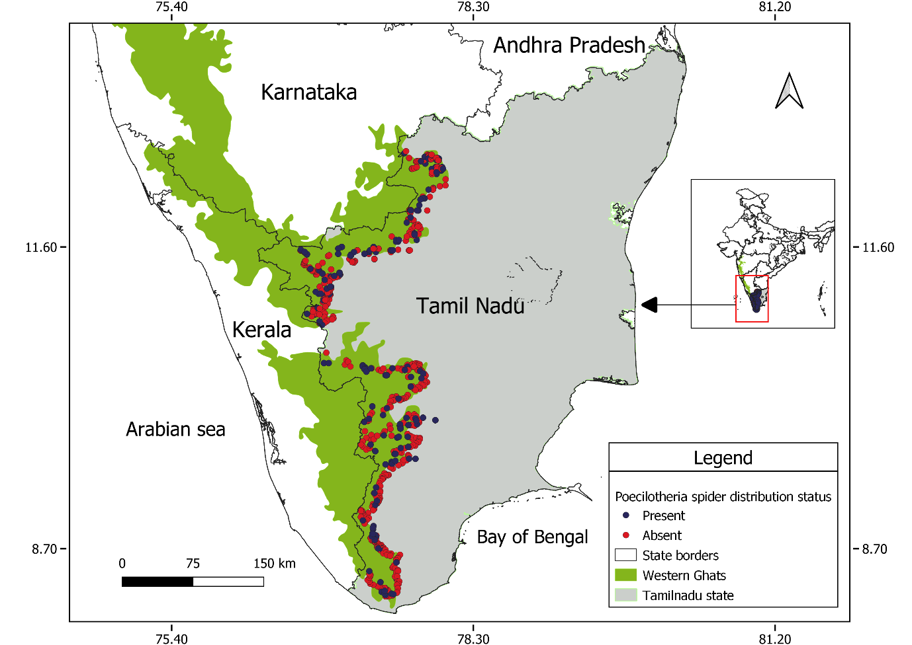
Map 1. Survey locations indicating presence and absence of the species
3. METHODOLOGY

The study was conducted from January 2020 to March 2022. Questionnaire surveys were conducted between 9:30 am and 4:00 pm IST to interact with local villagers. To obtain information on geographic distribution, species presence and absence, a comprehensive questionnaire was created. Given the morphological distinctiveness of Poecilotheria spiders, respondents were asked specific questions on habitat, size, colours, and web style to decrease the possibility of misidentification. Negative responses were defined as those that did not fit the established traits of Poecilotheria (e.g., improper type of the web or body morphology). We offered images of different Poecilotheria spp. to responders who accurately described them to verify their identity. This procedure minimized the chance of inaccurate identification and guaranteed the accuracy of the sightings that were recorded.
In addition to the questionnaire survey, we conducted focused field surveys, utilizing scan sampling method in potential habitats (Nanayakkara et al., 2015) and in the locations where respondents had specified based on validated responses in favuour of presence of these spiders. There was no biological specimen collected for our study. Field visits for random species surveys were conducted between 18:00 hrs and 21:00 hrs. We aimed to confirm the presence of Poecilotheria spp. across new distributional ranges throughout the study area using methodical searches in micro niches that are known to harbour Poecilotheria Verifying the species existence and obtaining further information about their range and preferred habitats were the goals of the field surveys. We made sure that the data collection process was consistent and repeatable throughout the entire investigation. To obtain a thorough distribution of the genus Poecilotheria from the study area, data gathered from field and questionnaire surveys were methodically documented and analysed. Spider identification was accomplished by following the keys of Pocock (1900) and Smith (2002).
Survey locations and species sighting locations were mapped using QGIS software. We performed statistical analysis using SPSS software and conducted chi-square tests to evaluate the credibility of respondents in providing reliable and insightful information for species identification.
4. RESULTS
In our study, we employed two primary methods of analysis to examine the distribution and documentation of Poecilotheria spiders. Initially, we conducted a questionnaire survey across the research area to capture presence-absence data, leveraging local knowledge to identify potential Poecilotheria habitats. Based on these survey responses, we undertook field searches to confirm species presence, providing a more accurate understanding of distribution patterns and habitat preferences including host trees.
The second phase of analysis evaluated the credibility and reliability of each respondent’s insights, focusing on variables such as age, gender, and occupation to identify which demographic groups were most likely to contribute valuable information regarding species sightings. This evaluation highlighted the critical role of local knowledge, as the community members often hold a nuanced understanding of their environment. By integrating this knowledge with field observations, we were able to significantly enhance species identification and refine our mapping of Poecilotheria distribution within the study area.

A total of 749 (265 females and 484 males) residents in the study area participated in the questionnaire survey. Of these, 510 a significant majority (68.1%) indicated the absence of the spiders in their area, while 239 (31.9%) respondents reported sightings of Poecilotheria spiders. Map 3. highlights direct sighting locations, plotted alongside areas where the species was reported to be present according to the questionnaire survey responses. Survey data indicate nine previously unreported, additional distribution sites for Poecilotheria species within Tamil Nadu's Western Ghats foothills (Table 1; Map 3). Photographs taken during the direct sighting were given in the Figure. 1. The surveyed locations across the study area were mapped (Map 1) based on data gathered through a questionnaire survey. Map 2. illustrates the presence-absence distribution, overlaid on a land use and land cover (LULC) map, to provide insights into habitat-specific dispersal of the species throughout the study area.

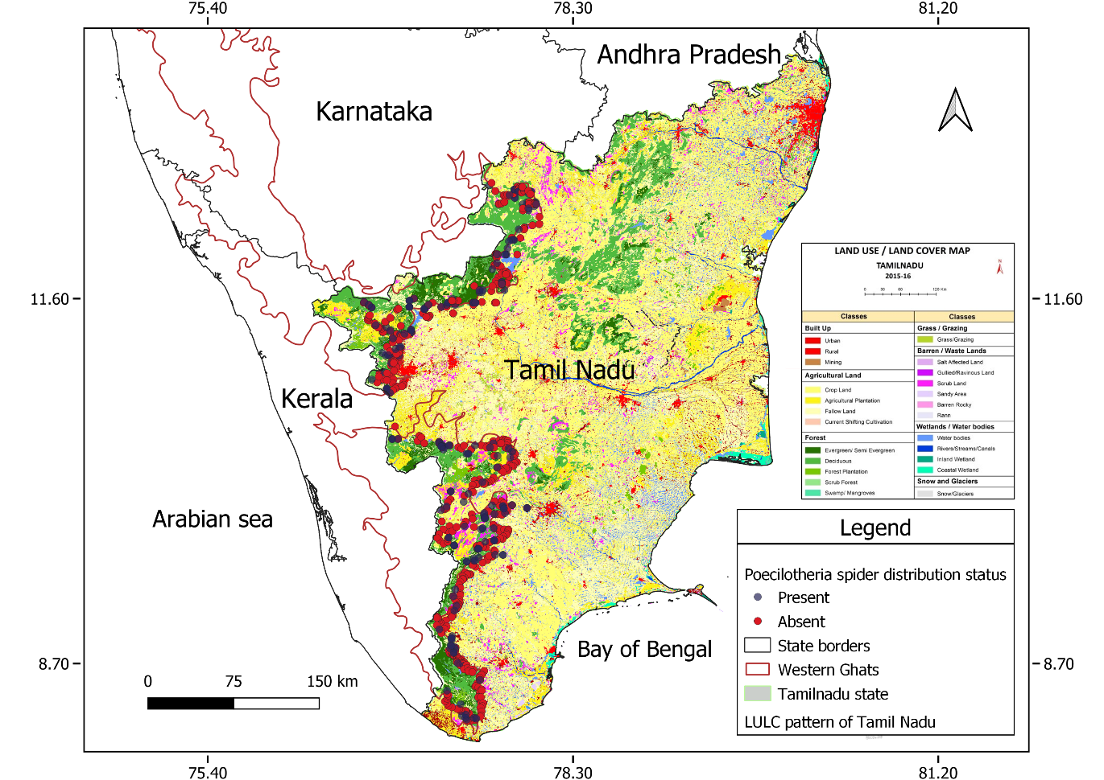
Map 2. Illustrates the presence-absence distribution, overlaid on a land use and land cover (LULC) map
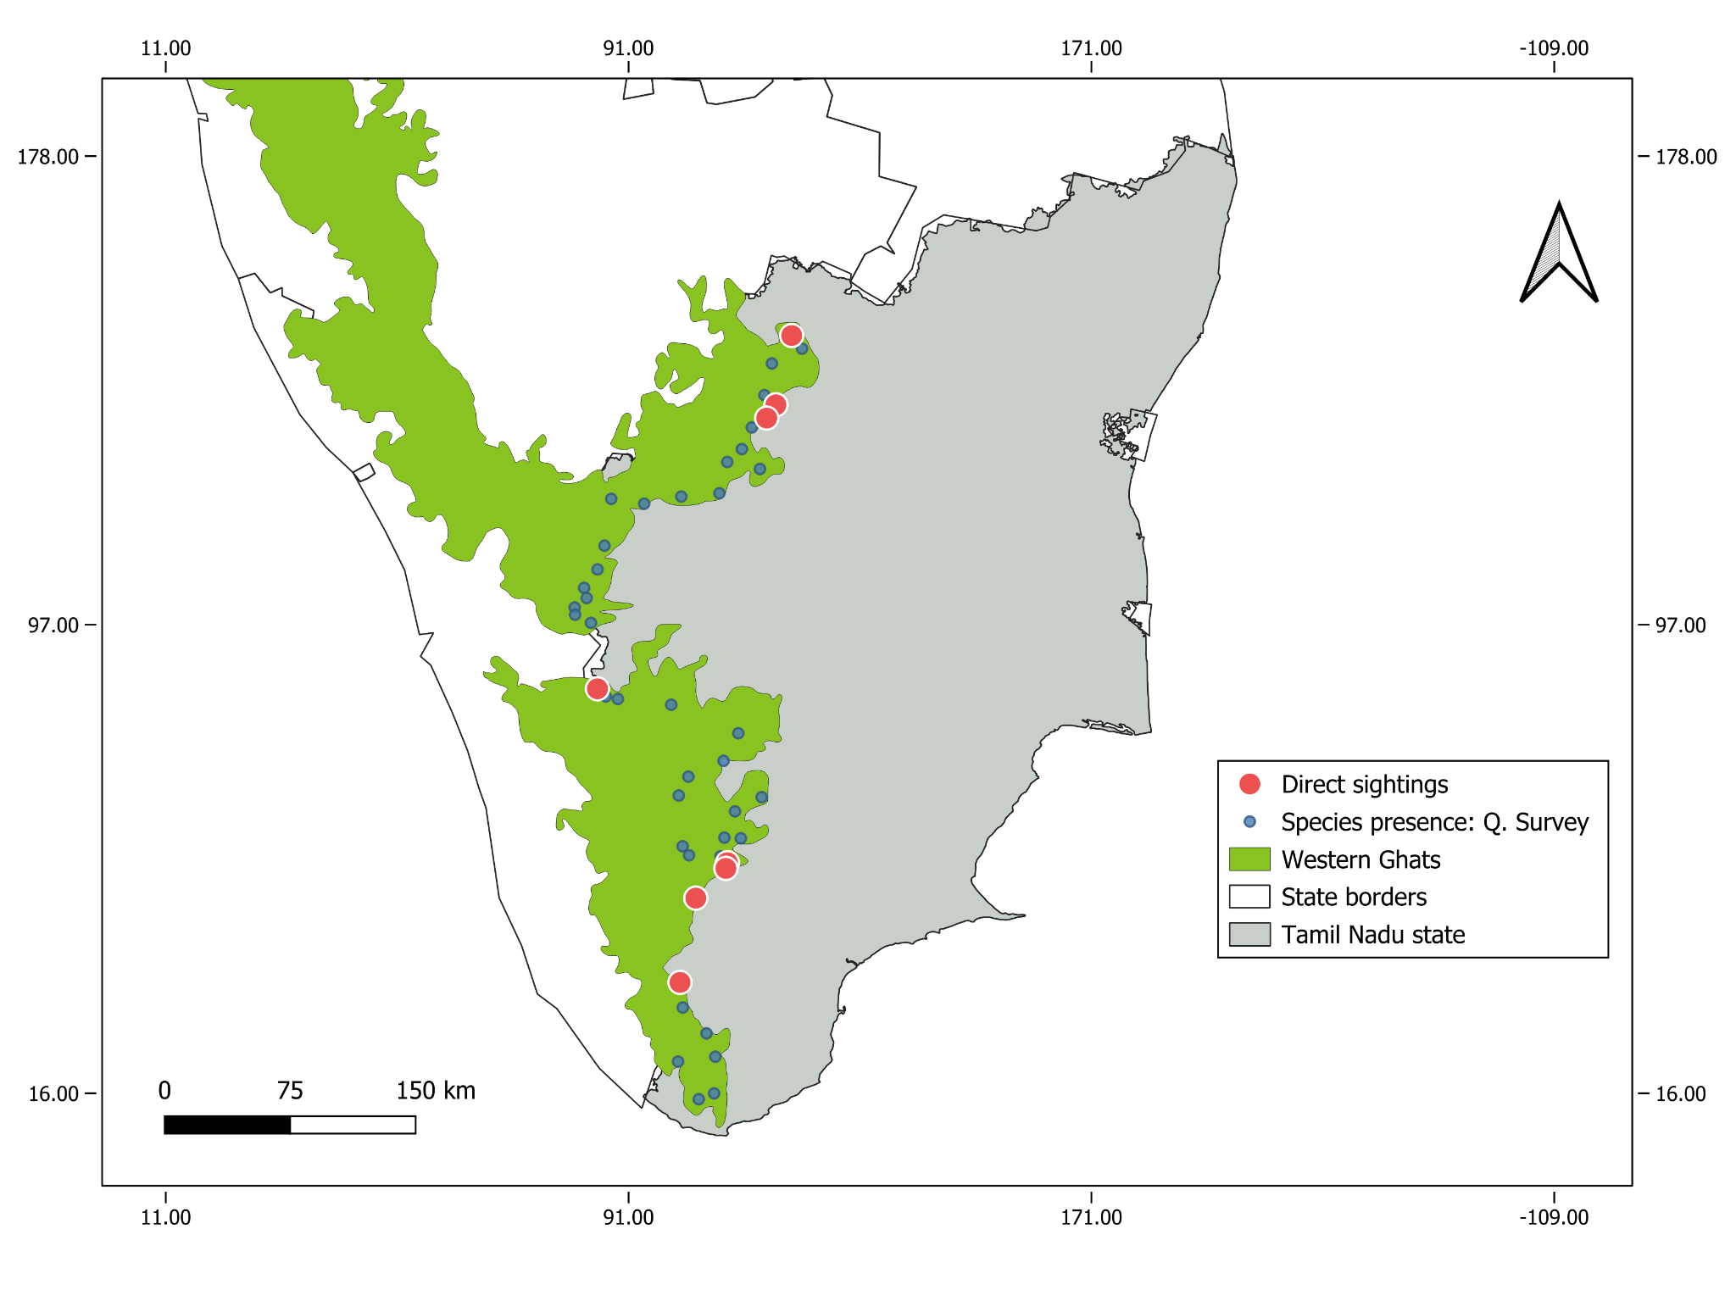
Map 3. Direct sightings and reported spider presence from the questionnaire.

Table 1. Direct sightings of Poecilotheria spider locations in the Study Area
S. No | District | Location | Habitat/Tree | Elevation (m)
 | Tenkasi | Courtallam | Ficus religiosa | 168
 | Virudhunagar | Senbagathoppu | Human habitation | 170
 | Virudhunagar | Senbagathoppu | Tamarindus indica | 170
 | Virudhunagar | Rajapalayam | Cocos nucifera | 187
 | Tenkasi | Sivagiri | Abandon building | 222
 | Dharmapuri | Santhaipettai | Albizia amara | 500
 | Dharmapuri | Moolabellur | Albizia amara | 510
 | Krishnagiri | Gudiyur | Bamboo hut | 879
 | Coimbatore | Valparai | Human habitation | 1000

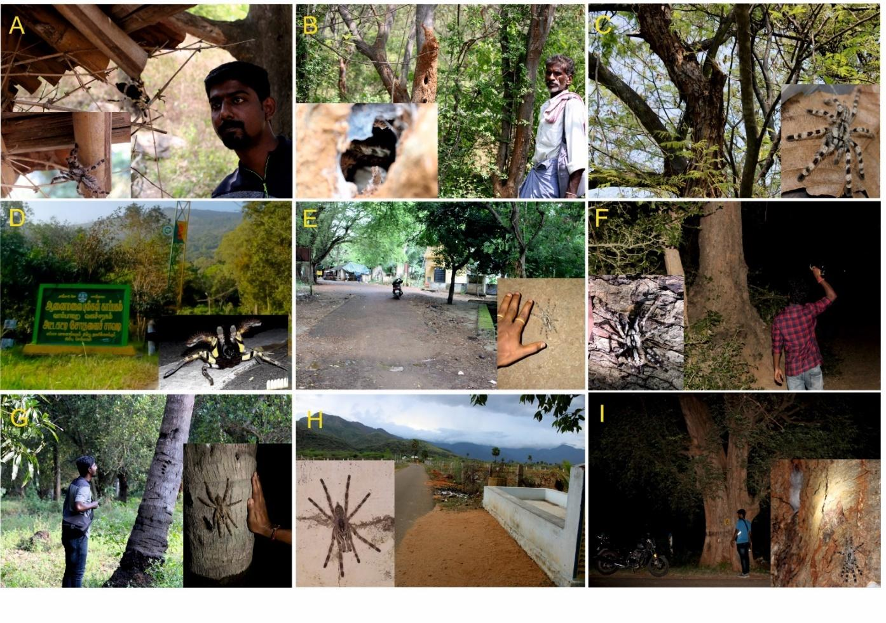
Figure. 1. Species sightings across the foothills of the Western Ghats, Tamil Nadu: A. Found inside bamboo in the roof of a cattle shed at Gudiyur. B. Located inside a tree hole about 3 meters from the roadside at Santhaipettai. C. A spider was observed inside a tree adjacent to a forest area, high up in a tree at Moolabellur. D. This spider was spotted at night near the Attakatty forest check post in Valparai. E. Sighted near tribal settlement at Shenbagathoppu, Srivilliputhur. F. Observation by our team occurred along the Shenbagathoppu road near to the tamarind trees in Srivilliputhur. G. Seen in a coconut tree on a farm at Rajapalayam. H. Observed a spider during nighttime in a concrete structure, as seen in the accompanying picture. I. Sighted in a tamarind tree along the old Courtallam road. Background images for D, E, G, and H were taken by the first author during daytime field visits to verify the sightings. The spider images were provided by our community survey respondents. No specimens were collected during the study; if spiders are found, they are photographed, examined, and released back into their natural habitat without causing them any harm.

According to the distribution data we came to know that this genus has been found in and around a variety of habitation viz., human habitations, plantations and different habitats of forest like dry deciduous, moist deciduous and semi-evergreen. Host trees of the species were documented during the field work (Table.2). This adaptation demonstrates the capacity of the animal to flourish in environments with both human influence and diverse habitats. The elevation range of Poecilotheria species in the Western Ghats spans from approximately 168 meters in Courtallam, located in the Tenkasi district, to around 1,000 meters in the highland areas of Valparai taluk, Coimbatore district. This broad altitudinal gradient highlights the species' adaptability to diverse ecological zones. Lowland areas, characterized by relatively warmer climates and distinct vegetation types such as dry deciduous forests, offer habitats with specific prey availability and microclimatic conditions. In contrast, the highlands, with cooler climates and evergreen or semi-evergreen forests, provide different ecological niches, possibly offering refuge from higher temperatures and enhanced prey diversity. This adaptability underscores their ecological plasticity and resilience across varying elevations.
Table 2. Habitat and nesting preference of Poecilotheria spp. in the Study Area
Tree names (Local/Scientific) | Location (Districts)
Bambusa bambos (Bamboo) | Krishnagiri (Denkanikottai), Erode (Sathyamangalam),  Coimbatore.
Tamarindus indica (Tamarind) | Krishnagiri (Denkanikottai), Erode (Sathyamangalam), Coimbatore, Theni, Virudhunagar, Tenkasi.
Cocos nucifera (Coconunt) | Dharmapuri (Palacode), Coimbatore, Virudhunagar, Tenkasi (Courtallam)
Albizia amara (Oil cake tree) | Dharmapuri (Hogenakkal), Coimbatore (Pollachi), Madurai
Commiphora Caudata (Hill Mango) | Erode (Sathyamangalam), Coimbatore (Pollachi)
Tectona grandis (Teak) | Coimbatore (Pollachi, Siruvani), Kanyakumari (Pechiparai)
Prossofis juliflora (Mesquite) | Dharmapuri (Hokenakkal), Coimbatore (Pollachi)
Musa spp. (Banana) | Erode (Sathyamangalam)
Borassus flabellifer (Palmyra palm) | Tirunelveli (Rajapudur)
Theobroma cacao L. (cocoa) | Coimbatore (Pollachi), Virudhunagar (Krishan Kovil)
Artocarpus heterophyllus (Jack fruit) | Virudhunagar (Atthi kovil)
Mangifera indica (Mango) | Virudhunagar (Krishnan Kovil)
Ficus benghalensis (Banyan) | Tenkasi (Courtallam)
Ficus elastica (rubber) | Kanyakumari (Pechiparai)
Casuarina equisetifolia (Casuarina) | Kanyakumari (Pechiparai)

In evaluating the credibility of respondents in providing reliable and insightful information for species identification, this analysis considers key variables such as age, gender, and occupation. The relationship between the respondents' responses and their demographic information (age, gender and occupation) was assessed using the chi-square test. Finding out if these variables affected the probability of reporting Poecilotheria spp. presence was the goal of the statistical analysis.
Of the 265 female respondents, 22.3% (59) reported having seen the spider, while the remaining 77.7% (206) had not. Among the 484 male respondents, 37.2% (180) reported spider sightings, 62.8% (304) had not seen any Poecilotheria species. Overall, 31.9% of respondents across genders reported seeing the spider (Figure. 2). The statistical analysis in the study revealed significant associations between various demographic factors and Poecilotheria spp. sightings. A Chi-Square Test indicated a significant association between gender and spider sightings, with a Pearson Chi-Square value of 18.196 (df = 2, p < 0.001). This result led to the acceptance of the alternative hypothesis, suggesting that gender influences spider sightings.

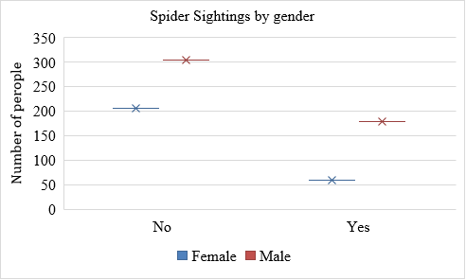
Figure. 2. Represent significant association between gender and spider sightings
Among the surveyed age groups, the older group (51–90 years) reported the highest number of spider sightings, with 135 individuals confirming encounters. The middle-aged group (21–50 years), with over 250 respondents, recorded 98 sightings, making them the second-highest contributors. In contrast, the youngest group (below 20 years), comprising only 5 respondents, reported a few sightings (Figure. 3). This trend highlights the older group's significant contribution, likely due to their greater engagement in outdoor or rural activities, followed by the middle-aged group, who also play a substantial role in providing observational data.
Similarly, the relationship between age and spider sightings was significant, as demonstrated by another Chi-Square Test with the same Pearson Chi-Square value of 18.196 (df = 2, p < 0.05). The alternative hypothesis was accepted here as well, indicating that age plays a crucial role in spider sightings.
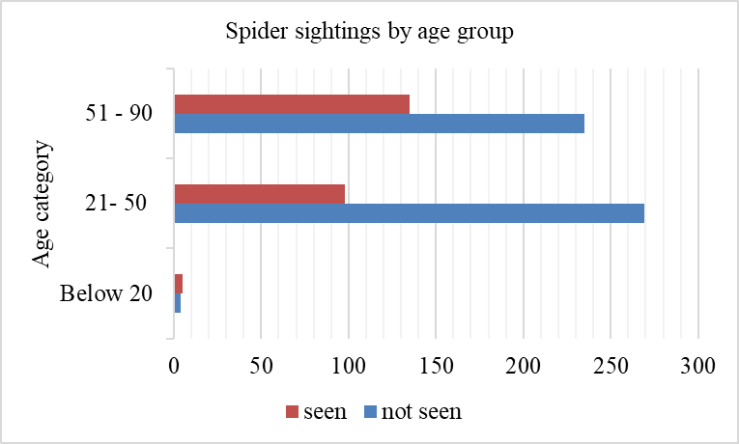
Figure. 3. Represents relationship between age and spider sightings

The study looked at spider sightings in a variety of occupational categories (Figure. 4). Of the people who were not working, 20% had seen the spider and 80% had not. Of the daily labourers, 28.5% had seen the spider and 71.5% had not. Only 20% of farmers reported not seeing the spider, while 80% reported seeing it. This was a remarkably high sighting rate. Of the shepherds, 55.9% saw the spider and 44.1% did not. Half of the students did not see the spider, whereas the other half did. Those who spend a lot of time in their natural habitats, such as farmers and shepherds, reported seeing spiders more frequently. A notable number of sightings were reported by daily labourers, who also worked outdoors. As a result of their reduced exposure to the spider's natural environment, workers in more sedentary occupations, such as those in the workforce, reported fewer sightings.
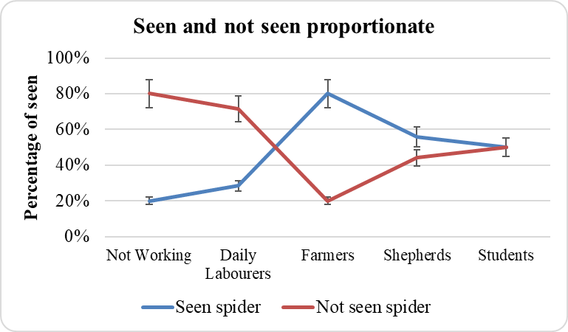
Figure. 4. Represent influence of occupation on spider sightings

The analysis also examined the influence of occupation on spider sightings. A Chi-Square Test showed a significant association, again with a Pearson Chi-Square value of 18.196 (df = 2, p < 0.05). This statistical result supported the alternative hypothesis, confirming that occupation affects the likelihood of encountering spiders.
There is currently no consolidated information available on the host plants of Poecilotheria species in Tamil Nadu. In this study, we provide a comprehensive checklist of the host plants preferred by Poecilotheria species. The data were systematically collated through a combination of questionnaire surveys conducted with local communities and direct field surveys.
The identification of species distribution benefited greatly from Local Ecological Knowledge, particularly in light of the difficulties in accurately detecting nocturnal species in the field. Nine direct sightings were documented in this investigation, all of which occurred at sites where the local population responded favourably. In certain instances, the species was spotted with the direct help of local guides who offered advice on the spot.

4. DISCUSSION

Comprehensive surveys on the geographic distribution patterns of the genus Poecilotheria are lacking, and further studies are needed to determine their range and the continuity of their distribution (Molur et al., 2004). Therefore, the present study has gathered new species distribution and given additional new distribution ranges and in the study area. Also, our findings from the Southern Western Ghats of Tamil Nadu (from Madurai to Tirunelveli) present a different scenario with several locations harbouring substantial populations as indicated by frequent sightings reported by both local residents and direct observation.
Evidence suggests that habitat loss, primarily due to development activities like road expansion and tree felling, is a major threat to the Poecilotheria populations. The intentional killing of spiders is becoming increasingly common. In Dharmapuri, road construction and habitat fragmentation paved way for more intentional killing, adversely affecting species populations. Similarly, tree felling along roadsides in Courtallam has directly resulted in the loss of critical microhabitats.
Information of the host plants of Poecilotheria species, filling a critical gap in the existing ecological knowledge, it is vital for the development of habitat-specific conservation strategies, as it highlights the intricate relationships between these arboreal spiders and their host plants
Local Ecological Knowledge (LEK) played a pivotal role in our research, particularly given the challenges of locating nocturnal species like Poecilotheria. This invaluable input from local communities not only facilitated the identification of species distribution during our study but also ensures that future research can easily locate these species. By engaging with local people who can provide accurate information about the species, researchers can significantly enhance the efficiency and precision of their fieldwork.

The findings of this study reveal a significantly additional distribution ranges of Poecilotheria species across the foothills of Tamil Nadu's Western Ghats than previously documented. Also, a broader issue is the negative perception of the species among local communities. Many respondents expressed fear or aversion toward Poecilotheria, often perceiving them as dangerous. This fear-driven behaviour can lead to the intentional killing of these spiders, exacerbating their risk of population decline. Education and outreach are essential for altering public attitudes towards Poecilotheria, with future conservation efforts likely to benefit from community-based initiatives that aim to reduce negative interactions.

DISCLAIMER (ARTIFICIAL INTELLIGENCE)

Author(s) hereby declare that NO generative AI technologies such as Large Language Models (ChatGPT, COPILOT, etc) and text-to-image generators have been used during writing or editing of this manuscript.

REFERENCE
Ashik, M. M., & Ezhilarasi, N. (2023). New distributional range record of the Red slate ornamental spider Poecilotheria rufilata (Theraphosidae) in Anaimalai Tiger Reserve, Western Ghats of Tamil Nadu. World Journal of Advanced Research and Reviews, 18(2), 017–020.
Caldas, A. T. M., Dias, M. A., & Peres, M. (2018). Invertebrate (Araenae: Mygamolomorphae) illegal trade: An ignored side of wildlife trafficking. American Journal of Zoology, 7, 20–23.
Choudhury, S. R., Siliwal, M., & Das, S. K. (2019). Spiders of Odisha: A preliminary checklist. Journal of Threatened Taxa, 11(9), 14144–14157.
CITES. (2024). Convention on International Trade in Endangered Species of Wild Fauna and Flora. Accessed 09.11.2024. Available at: https://cites.org/eng/app/appendices.php
Das, K. S. A., Sreekala, L. K., & Abdurahiman, O. (2012). Predation on the Kelaart's Pipistrelle Bat, Pipistrellus ceylonicus Kelaart (Chiroptera: Vespertilionidae), by the Reddish Parachute Tarantula, Poecilotheria rufilata Pocock (Araneae: Theraphosidae), in Chinnar Wildlife Sanctuary, Kerala, India. Tropical Natural History, 12(2), 257–260.
Fukushima, C., Mendoza, J. I., West, R. C., Longhorn, S. J., Rivera, E., Cooper, E. W. T., Hénaut, Y., Henriques, S., & Cardoso, P. (2019). Species conservation profiles of tarantula spiders (Araneae, Theraphosidae) listed on CITES. Biodiversity Data Journal, 7, e39342.
Gravely, F. H. (1915). Notes on Indian mygalomorph spiders. Records of the Indian Museum, 11, 257–287.
Joseph, L., & Jose, K. S. (2022). Checklist of spiders from Vallakadavu range of Western Ghats, Kerala, India. ENTOMON, 47(3), 341–344.
Ministry of Law and Justice. (2022). The Gazette of India, Part II, Section 1: Notification No. 27, December 20, 2022. New Delhi: Government of India.
Mirza, Z. A., Sanap, R. V., & Bhosale, H. (2014). New distribution records for Poecilotheria species in central India. Journal of Arachnology, 42(3), 323–329.
Molur, S., Daniel, B. A., & Siliwal, M. (2004). Distribution of the regal parachute spider Poecilotheria regalis Pocock, 1899. ZOOS'PRINT JOURNAL, 19(10), 1665–1667.
Molur, S., Siliwal, M., & Daniel, B. A. (2008). At last! Indian tarantulas on IUCN Red List. Zoos' Print, 23(12), 1–3.
Nanayakkara, R. P., Ganehiarachchi, G. M., Vishvanath, N., & Kusuminda, T. G. T. (2015). Discovery of the Critically Endangered tarantula species of the genus Poecilotheria (Araneae: Theraphosidae), Poecilotheria hanumavilasumica, from Sri Lanka. Journal of Asia-Pacific Biodiversity, 8(1), 1–6.
Pocock, R. I. (1899a). The genus Poecilotheria: Its habits, history, and species. Journal of Natural History, 3(13), 82–96.
Pocock, R. I. (1899b). Descriptions of some new Oriental spiders of the family Lycosidae. Annals and Magazine of Natural History, 4(2), 197–222.
Pocock, R. I. (1900). The fauna of British India, including Ceylon and Burma: Arachnida. Taylor and Francis, London, 279 pp.
Ramana, S. P. V., & Harinth, P. (2022). Rediscovery of the endangered spider tarantula from Sri Lankamalleswara reserve forest-Southern Andhra Pradesh-India. Journal of Applied Entomologist, 2(3), 33–36.
Siliwal, M., Molur, S., & Daniel, B. A. (2011a). Revision of Indian Poecilotheria. Journal of Threatened Taxa, 3(9), 2016–2040.
Siliwal, M., Molur, S., & Daniel, B. A. (2011b). Distribution notes on Poecilotheria species. Zoo Outreach Organisation, 27, 22–27.
Singh , R. (2020). Diversity of mygalomorph spiders (Araneae: Opisthothelae) in India. International Journal of Biological Innovations, 2(2), 178–201.
Smith, A. M. (2002). A field guide on the Theraphosid spiders of India and Sri Lanka, particularly the genus Poecilotheria. Fitzgerald Publishers, 1–35.
Smith, A. M. (2004). A new species of the arboreal Theraphosid, genus Poecilotheria, from Southern India (Araneae, Mygalomorphae, Theraphosidae) with notes on its conservation status. Journal of the British Tarantula Society, 19, 48–61.
Smith, A. M. (2006). A new species of Poecilotheria from northern peninsular India (Araneae, Mygalomorphae, Theraphosidae) with notes on its distribution and conservation status. Journal of the British Tarantula Society, 21, 83–94.
Sunil, J. K. (2011). Redescription of Poecilotheria striata Pocock with notes on the distribution of other Poecilotheria from Kerala, India (Araneae: Theraphosidae). Research Lines, IV(I-B), 46–52.
USFWS OLE. (2018). Internal report on U.S. trade in species of Poecilotheria species 2006–2017. Data taken from Law Enforcement Management Information System (LEMIS) database. Report compiled on October 18, 2018.
World Spider Catalog. (2024). World Spider Catalog. Version 2.5. Natural History Museum Bern. Available online at http://wsc.nmbe.ch, accessed on 08-09-2024. doi: 10.24436/2.

