**Study the effect of Cerium Oxide Nanoparticles on the Corneal injury healing in Rabbits**

**Abstract**

**Background:** injury in the cornea in animals tend to heal delay due to a vascular structure. Therefore, treatments that accelerate the healing of cornea needs to investigated. **Object:** To enhancing and evaluation of the healing process of cornea injury through clinically and fluorescent dye examination. **Materials & methods:** Thirty-six rabbits were used in this study. Under general anesthesia, done induce cornea injury by NaOH 0.4%. the animals were divided in to three groups: group one (Control group 12 rabbits), group two (treated group 12 rabbits) and group three (treated group 12 rabbits). The animals were examined clinical during the studied period and fluorescence dye evaluation was performed at 1st, 3th, and 4th week post operation. **Results:** in control group, after 28 days of inducing a corneal injury, showed a fibrous tissue layer remained on the corneal surface, and corneal opacity remained. However, corneal opacity exhibited greater transparency. While, in treated group will observe the complete healing of the eye, with the restoration of blood and nutrient supply to cornea, resulting in the total resolution of all corneal damage **Conclusion:**  results of this study, demonstrated the Nano cerium oxide acceleration and enhanced healing of cornea.

**Keywords: Nanoparticles, Cerium Oxide, Cornea anatomy.**

**Introduction**

Corneal injuries can occur from foreign objects, improperly fitted contact lenses, bacterial or viral infections, bleach, acid or alkaline chemicals, and exposure to UV rays, tanning beds, or UV reflections, causing temporary or permanent damage and vision loss. Ulcer may be located centrally, Para centrally, or peripherally and can be superficial or deep (Gurnani *et al.,* 2023). The main factors influencing corneal epithelium repair post-injury include the corneal stem cell pool, vascular supply and early inflammation, corneal nerve endings, as well as electrochemical gradients, extracellular matrix, and cellular communication. The treatment of corneal ulcers requires a multifaceted approach due to the avascular nature of the normal cornea. Medications are utilised to avert the bacterial infections (the ophthalmic antibiotic drops or ointment) and to alleviate spasms and the pain (ophthalmic atropine drops or ointment) (Mohan et al., 2023; Jasim et al.,2025). Certain situations may necessitate surgical intervention, particularly in instances of imminent corneal perforation or when medicinal treatment is ineffective (Deshmukh *et al.,* 2020).

Surgical intervention may be required about 30 to 40% of the corneal ulcers, that depending upon severity of infection at presentation. Criteria for surgical intervention in the infectious keratitis encompass non-healing or unresponsive ulcers, the ulcers that deteriorate despite medicinal treatment, progressive corneal thinning, descemetocele formation, and eventual corneal perforation. In critical instances, a corneal ulcer can lead to the corneal transplant. A corneal transplant entails the surgical excision of corneal tissue, succeeded by the implantation of donor tissue. (Tuli *et al.,* 2016). Cerium oxide nanoparticles demonstrate various biological characteristics, facilitating their widespread application in biomedical fields (Yaser *et al*., 2025). CeO2 nanoparticles have demonstrated the ability to enhance wound healing by reducing inflammation, a decreasing oxidative stress responses, reducing the infection risks, and promoting the angiogenesis during healing process. These characteristics make CeO2 nanoparticles an attractive contender for wound healing applications (Walkey *et al.,* 2015; Yasser *et al.,* 2025). CeO2 nanoparticles can both facilitate and inhibit angiogenesis (Cheng *et al.,* 2021).

**Materials and Methods:**

**Animals**

Thirty-six adult rabbits which are year old and weighing about (1.5±0.5 Kg) were purchased. All animals were had free access to the diet and drinking water and maintained at temperature of the room (Hashim & Nazht, 2021). All of experimental procedures were performed in accordance with Basrah University, Veterinary Medicine College guidelines for welfare of experimental animals. The animal experimentation ethics approval.

**Experimental design**

Thirty-six adult rabbits were used in this study. All the rabbits are divided into three groups, each group containing (12) rabbits randomly; Group one (Control group) (n=12), the animals received distal water topical drops after one-day post-injury daily and persist for seven days. The group two (treated group) (n=12), were the animals treated by Cerium oxide is locally applied at the injury site of cornea daily with the concentration of (5µg/ml) for one week. The group three (treated group) (n=12), were the animals treated by Cerium oxide is locally applied at the injury site of cornea daily with the concentration of (10µg/ml) for one week.

**preparation of cerium oxide nanoparticle**

Nanoparticle cerium oxide were prepared and diluted as following according to (Malyla, 2023):

To prepare cerium oxide nanoparticle at concentration (5μg/ml) Take 0.5mg of cerium oxide nanoparticle were diluted with 100 ml of distal water then mixed well in flask, and then became each (1) ml contain on (5μg/ml) of cerium oxide nanoparticle.

And prepare cerium oxide nanoparticle at concentration (10μg/ml) take (1mg) of cerium oxide nanoparticle were diluted with 100 ml of distal water, and then became each (1) ml contain on (10μg/ml) of cerium oxide nanoparticle, this material was prepared at the Research Center in the College of Veterinary Medicine.

**preparation of NaOH**

NaOH prepare according the following formula according to (Mane,2011):

100×volume of the solution in (ml) /W/V% = weight of the solute in (g)

Dissolved (4g) of NaOH in 100 ml of distal water at the research center in College of Veterinary Medicine and close the container tightly.

**Method of inducing of Corneal Injuries**

Rabbits were anesthetized by intramuscular the injection of (10 mg/kg) xylazine and injection of (25 mg/kg) ketamine HCl (Hashim, 2014, Hashim *et al.,* 2021 and Akter *et al*., 2023). The experiment was carried out on the right eye of each the animal. The body temperature was maintained at temperature between 37-37.5°C. Corneal wound was performed by alkaline burn as described by (Gronkiewicz *et al.,* 2016). A round (10 mm) diameter circular of filter paper disk soaked in 4% sodium hydroxide (NAOH;4 µl,1mol/l) and applied to the cornea of right eye for 20 seconds then disc was removed and cornea rinsed with sterile distal water for 1minute seconds figure (1).

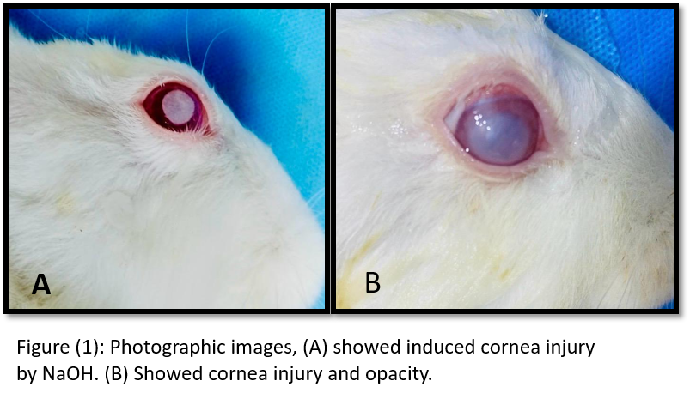

**Parameters of study**

**1.Evaluation in the clinic**

Complete external and complete ophthalmic examinations of both eyes have been conducted. The eyes have been examined for corneal ulcers, eyelid adhesion, lacrimation, infection, or purulence. The healing process of the ocular surface for each treated the eyes were assessed and evaluated at 1, 2, 3, and 4 weeks' post-treatment.

**2.Floursence dye examination**

Piece of blotting paper infused with fluorescent dye will be applied to surface of the rabbit's eye. The rabbit will blink. Blinking disperses the dye, enveloping the "tear film" that covers corneal surface. A blue light is subsequently aimed at rabbit's eye using an ophthalmoscope. The experimental corneal ulcer will be dyed and have a green hue under blue light.

**Statistical analysis**

Standard errors were incorporated into the results. A statistical software tool (SPSS for Windows version 22, USA) was utilised to conduct One-Way ANOVA with multiple comparison tests on data. The significance threshold for the differences was established at (P ≤ 0.05) (Abdulrazak *et al*., 2018).

**Results**

**1-Clinic evaluation**

The results of the clinical findings, after the induction of corneal injury in all groups, the freshly burned corneal tissue becomes hazy immediately after the burn and subsequently turns opaque within 24 hours. That appears to be a sharp damage in stromal layer of cornea. appear the animal a clinical signs opacity, lacrimation, itching, and discharge Figure (2, A).

**In the first 3days** Rabbits exhibited blepharospasm as a result of pain associated with ulcer formation, leading to semi-closed eyes. At the first week Corneal edema was most prominent signs after induce corneal injury in all groups and noticed conjunctival edema and swelling the eyelid and appear the animal a clinical signs photophobia, eyelids adhesion, signs of conjunctivitis, Purulent exudates and obvious corneal ulcer. On the seventh day of the treatment group, we observe a decrease in the severity of the inflammatory signs, but the swelling and corneal opacity remain figure (2, B).

**At second week after** induce corneal injury in the control group exhibited persistent eye swelling, discharge, eyelid swelling, cornea opacity, Purulent exudates and inflammatory signs Figure (3, A).

**whereas in the treatment group** (5μg/ml cerium oxide nanoparticle) showed resolution of inflammatory signs, although corneal opacity persisted, tear production diminished, and the capillaries are very small blood vessels is growing and minimal swelling remained with the cessation of eye discharge Figure (3, B).

**In the treated group** (10μg/ml of cerium oxide nanoparticle) all inflammatory signs will resolve, the corneal opacity will decrease, the blood vessels will grow more clearly visible near the cornea, and the edema will disappear Figure (3, C).

**At third weeks after** induce corneal injury in control group all signs of inflammation disappeared, and leaving only corneal opacity. a little redness remained, reduction of purulent secretions and the eye ulcer become small in shape and size Figure (4, A).

**However, in the treated group** (5μg/ml of cerium oxide nanoparticle) the corneal ulcer was transparent and smaller in size and New blood vessels develop at the location of the corneal injury and are clearly visible Figure (4, B).

**In the treated group** (cerium oxide nanoparticle) the size of the corneal ulcer is small, and there are numerous blood vessels around the ulcer. Additionally, we only observe a small scar in the center of the cornea figure (4,C).

**At fourth week** after inducing a corneal injury in the control group a fibrous tissue layer persisted on the corneal surface, and the corneal opacity persisted, However, the eye opacity is more transparent than that of the control group during the initial phases of the study and small in size and shape Figure (5, A).

**whereas in treated group** (5μg/ml of cerium oxide nanoparticle) all inflammatory signs disappeared the swelling and redness, and the eye returned to its normal state. (graph 1)

**At treated group** (10μg/ml of cerium oxide nanoparticle) Full restoration of the cornea, the eye returning to its normal state, and the resolution of all ocular issues. The rabbits in this group exhibit normal vision Figure (5, B).

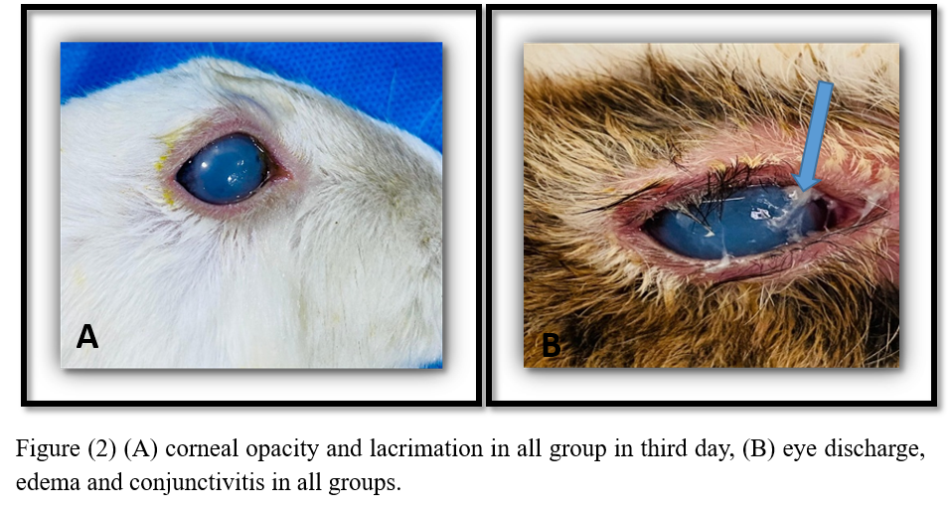

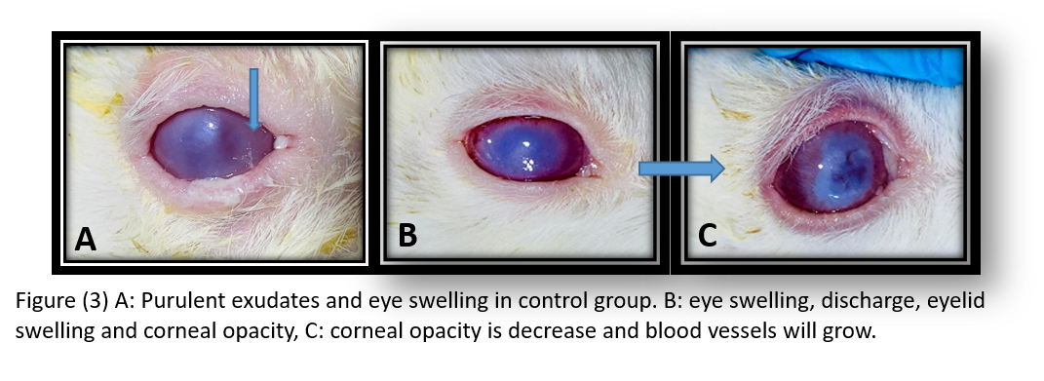

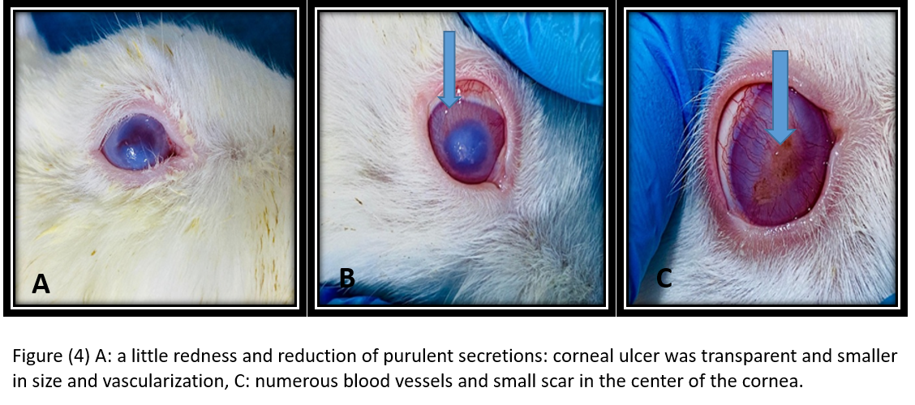

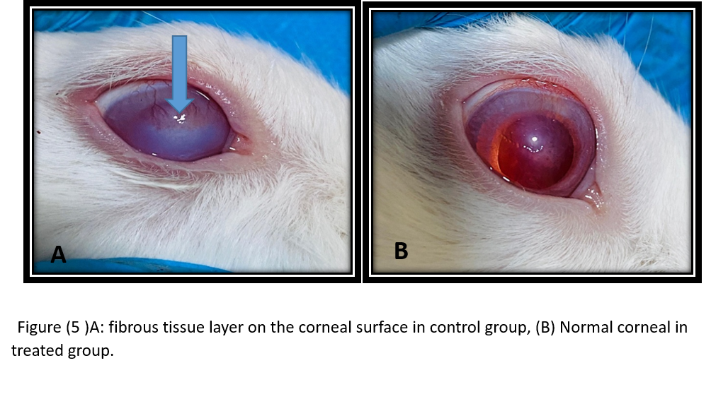

Graph (1) shows the comparison of corneal opacity in all group among the periods of study.

**2-Fluorescent staining**

A healthy cell exhibits minimal permeability to fluorescein, whereas a compromised epithelium fails to obstruct fluorescein from infiltrating the damaged tissue and diffusing through the par acellular space into the underlying epithelial layers. Consequently, fluorescein does not dissipate with blinking and tear flow as readily as the healthy, smooth, and taut areas of the neighboring cornea (Figure 6, A).   
 A corneal ulcer is an open sore in the cornea of a rabbit. The corneal ulcer usually appears as white or dull greyish lesion on eye cornea. Occasionally, the ulcers form throughout entire cornea and may be extend deeper. The pus may accumulate behind cornea, occasionally resulting in white film at the bottom of cornea. conjunctiva is usually bloodshot Figure (6, B).

Immediately in all group after induce the alkaline burn and using the fluorescein staining of eye cornea, corneal ulcer will appear a yellow-green area of uptake using blue light on the ophthalmoscope device Figure (6, C).

Following 21 days of inducing a corneal injury, in control group a little redness remained, reduction of purulent secretions and the eye ulcer become small in shape and size figure (7 A). In treated group a reduction in the ulcer's size and a decrease in the opacity of the eye will be observed and observe the development of new blood vessels Figure (7 B).

Following 28 days of inducing a corneal injury in the control group, a fibrous tissue layer remained on the corneal surface, and corneal opacity remained. However, corneal opacity exhibited greater transparency figure (8 A). In treated group will observe the complete healing of the eye, with the restoration of blood and nutrient supply to the cornea, resulting in the total resolution of all corneal damage Figure (8 B). 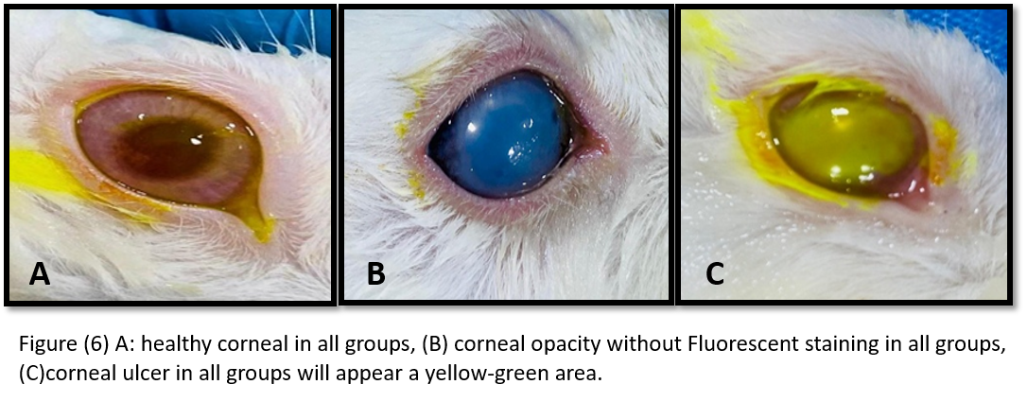

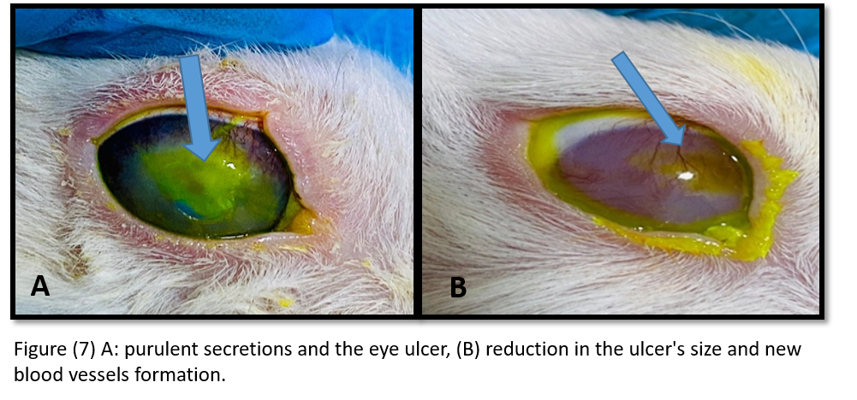

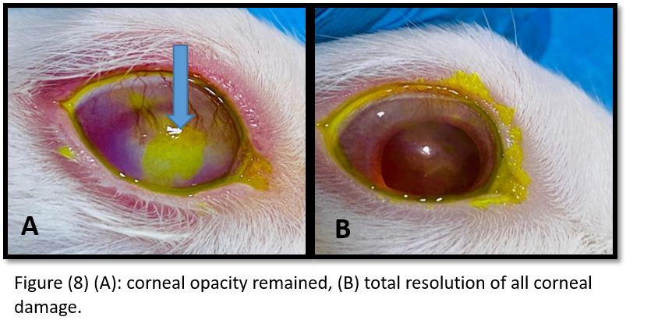

**Discussions**

In this study indicated that cerium oxide nanoparticles enhanced corneal wound healing, restored functional corneal nerves, and protected corneal cells from oxidative stress. Treatment with cerium oxide nanoparticles promotes re-innervation of the damaged cornea in rabbit eyes. The study of cerium oxide nanoparticle (CeO2) on healing of the corneal wounds in rabbits explores potential therapeutic benefits of this nanomaterial for ocular injuries.

Previous studies the Nano-cerium oxide has shown promise in the medical applications because its antioxidant, anti-inflammatory, and the regenerative properties, making it candidate for promoting tissue healing (Sadidi *et al*.,2020). The cerium oxide exhibits strong redox activity, mimicking enzymes like superoxide dismutase (SOD) and a catalase, which help neutralize the reactive oxygen species (ROS). ROS accumulation is a common issue in tissue damage, including corneal wounds, where oxidative stress can delay healing. By reducing oxidative stress in damaged corneal tissues, nano-CeO2 can accelerate healing by maintaining a balanced cellular environment. In the present study the rabbits have shown that applying CeO2 nanoparticles to corneal wounds can reduce inflammation, leading to less scarring and better tissue regeneration compared to untreated wounds (Lord *et al*.,2021). Previous studies have shown the importance of cerium oxide nanoparticles in preserving ocular surface homeostasis, indicating potential protective benefits against injury (Yu *et al*.,2019). Cerium oxide nanoparticle are a crucial for several corneal activities, aiding in the maintenance of corneal integrity and a sustaining epithelial barrier and cellular viability The anti-inflammatory, antibacterial, and The antioxidant properties of cerium oxide nanoparticles have been established (Cui *et al*.,2022).

Also the other results of this study, we used fluorescein dye to assess the ulcer's size and boundaries after the injury. We observed that the cornea absorbed the dye and changed its colour to yellow, indicating corneal injury and the formation of an opacity. In the third week, after examining the eye with fluorescein dye, we notice a slight reduction in the size of the ulcer in control group. However, we observe a smaller and less opaque ulcer in treatment group compared to control group, and the eye absorbs less fluorescein dye in this group. But in the fourth week (at the end of the experiment), the ulcer disappears, the eye returns to normal, and the lack of dye absorption after the examination indicates complete healing. In the treatment group, after administering the dye, we notice the presence of small scars and a little opacity, and these scars will be stained with fluorescein after administration.

Prior research has demonstrated that the cornea is examined for epithelial abnormalities and subsequently assessed using fluorescein dye. Corneal epithelial defects exhibit a green hue when illuminated with cobalt blue light on the ophthalmoscope or slit lamp. The morphology and position of the epithelium defect may provide insights into the diagnosis (Kim, Jeehee. 2000). Traumatic defects may first have irregular edges, which subsequently repair from the periphery, resulting in a stellate healing pattern. Previous research has demonstrated that to visualise an ulcer distinctly, it is necessary to administer eye drops containing a yellow-green dye known as fluorescein. The fluorescein temporarily stains damaged regions of the cornea, enabling the visualisation of areas that are normally imperceptible (Carr, N. J. 2022).  
  
**Conclusions**

The study showed that cerium oxide nanoparticle can help repair cornea in the rabbits with cornea injury by stimulating keratocytes activity. The high antioxidant capacity of cerium oxide nanoparticle contributes to faster healing in rabbit's cornea injury. There for, our results suggest the potential pharmaceutical use of cerium oxide nanoparticle for heling of the cornea injury.

**Ethical Approval**

According to the approval, (**61/37/2025**) through local committee of animal care and use at college of veterinary medicine, the university of basrah, Iraq.

**DISCLAIMER (ARTIFICIAL INTELLIGENCE)**

Authors hereby declares that NO generative AL technologies such as Large Language Models (ChatGPT, COPILT, ect.) and text-to-image generators have been used during the writing or editing of this manuscript.

**COMPETING INTERESTS**

Authors have declared that no competing interests exist.

**References**

1- Gurnani B, Kaur K. Predicting Prognosis Based on Regional Prevalence, Ulcer Morphology and Treatment Strategy in Vision-Threatening Pythium insidiosum Keratitis. Clin Ophthalmol. 2023; 17:1307-1314.

2- Mohan, Madhuvanthi; Natarajan, Radhika; Kaur, Kirandeep1; Gurnani, Bharat2. Treatment Approach to Corneal Ulcer. TNOA Journal of Ophthalmic Science and Research 61(4):p 396-407, Oct–Dec 2023.

2- Jasim MM, Naeem RM, Abduljaleel MR, Sanad NH, Ibrahim AA (2025). Efficacy of autogenic, allogenic and heterogenic platelet rich plasma (PRP) on Avulsion skin wounds in rabbit model. Adv. Life Sci. 12(1): 91-97.

3- Deshmukh, R., Stevenson, L. J., & Vajpayee, R. (2020). Management of corneal perforations: An update. *Indian Journal of Ophthalmology*, *68*(1), 7-14.‏

4- Tuli S, Gray M. Surgical management of corneal infections. Curr Opin Ophthalmol. 2016 Jul;27(4):340-7.

5-Yaser, D. A., & Hashim, A. M. Randomized Clinical Study of Nano-Cerium Oxide and its Efficacy in Sciatic Nerve Regeneration: A Histopathological Evaluation .‏

6-Walkey, C., Das, S., Seal, S., Erlichman, J., Heckman, K., Ghibelli, L., Traversa**,** E ., McGinnis, J F.,  and  Self W T., (2015). Catalytic properties and biomedical applications of cerium oxide nanoparticles. Environ. Sci. Nano 2 (1), 33–53.

7-Yasser, D. A., Hashim, A. M., & Naeem, R. M. (2025). Effects of nano-cerium oxide and alpha lipoic acid on sciatic nerve regeneration in rats. Adv. Anim. Vet. Sci, 13(4), 743-751.‏

8- Cheng, H., Shi, Z., Yue, K., Huang, X., Xu, Y., Gao, C., et al. (2021a). Sprayable hydrogel dressing accelerates wound healing with combined reactive oxygen species-scavenging and antibacterial abilitiesActa. Biomater 124, 219–232.

9- Malyla, V. (2023). *Understanding the Pathogenesis and Developing Novel Treatments for Lung Cancer*. University of Technology Sydney (Australia).

10- Mane, V. S., & Babu, P. V. (2011). Studies on the adsorption of Brilliant Green dye from aqueous solution onto low-cost NaOH treated saw dust. *Desalination*, *273*(2-3), 321-329.

11- Hashim, A. M., & Nazht, H. H. (2021). RADIOLOGICAL EVALUATION OF THE XENO-BOVINE BONY IMPLANTATION TREATED BY LOW LEVEL LEASER THERAPY IN THE INDUCED EMPTY FEMORAL SPACE IN RABBITS-I. Biochemical & Cellular Archives, 21(1).

11-Hashim, A. M., Abd, H. H., & Hellal, M. M. (2021). Histopathology Study of the Platelet Rich Plasma on the Wound Healing in Rabbits. Medico-legal Update, 21(2).‏

11- Akter, M. A., Yesmin, N., Talukder, M. B. A., & Alam, M. M. (2023). Evaluation of anaesthesia with xylazine-ketamine and xylazine-fentanyl-ketamine in rabbits: A comparative study. *Journal of Advances in VetBio Science and Techniques*, *8*(1), 38-46.

12- Gronkiewicz, K. M., Giuliano, E. A., Kuroki, K., Bunyak, F., Sharma, A., Teixeira, L. B. C. and Mohan, R. R. (2016). Development of a novel in vivo corneal fibrosis model in the dog. *Experimental eye research*, *143*, 75-88.

13- Abdulrazak, A. W., Afshar, F. S., and Masoudifard, M. (2018). Effects the Pulsed Electromagnetic Field on the Superficial Digital Flexor Tendonitis in Donkey: Sonographic Study. Basrah Journal of Veterinary Research, 17(3): 472–490. College of Veterinary Medicine, University of Basrah.

14- Sadidi, H., Hooshmand, S., Ahmadabadi, A., Javad Hoseini, S., Baino, F., Vatanpour, M., & Kargozar, S. (2020). Cerium oxide nanoparticles (Nanoceria): Hopes in soft tissue engineering. *Molecules*, *25*(19), 4559.‏

15- Lord, M. S., Berret, J. F., Singh, S., Vinu, A., & Karakoti, A. S. (2021). Redox active cerium oxide nanoparticles: current status and burning issues. *Small*, *17*(51), 2102342.‏

16- Yu, F., Zheng, M., Zhang, A. Y., & Han, Z. (2019). A cerium oxide loaded glycol chitosan nano-system for the treatment of dry eye disease. *Journal of Controlled Release*, *315*, 40-54.‏

17- Cui, W., Wang, Y., Luo, C., Xu, J., Wang, K., Han, H., & Yao, K. (2022). Nanoceria for ocular diseases: recent advances and future prospects. *Materials Today Nano*, *18*, 100218. ‏

18- Kim, Jeehee. (2000). The use of vital dyes in corneal disease. Current opinion in ophthalmology. 11. 241-7. 10.1097/00055735-200008000-00005.

19-Carr, N. J. (2022). The pathology of healing and repair. *Surgery (Oxford)*, *40*(1), 13-19.‏