**Sustainable Aqua-Agriculture Production Using a Novel Integrated Recirculating Marine Aquaponics System**

**ABSTRACT**

Aquaponics stands as an advancing closed-loop food production method, integrating recirculating aquaculture with hydroponics. This cutting-edge system integrates hydroponics with recirculating aquaculture to develop a sustainable method for food production. The present research is geared towards specific objectives that are pivotal in establishing an integrated technology for aquaculture wastewater treatment and fostering a sustainable hydroponic system. These objectives encompass designing and constructing a small-scale aquaponics system, analyzing the water quality, and evaluating the growth, survival rate, and biochemical composition of both white-legged shrimp *Litopenaeus vannamei* and *Amaranthus viridis* plants. The study results emphatically underline the growing importance of aquaponics, indicating a promising trend for the future. Among the diverse aquaponic systems investigated, the Nutrient Film Technique emerges as the most effective and cost-efficient integrated system for horticulture. These findings provide valuable insights for beginners and farmers aspiring to implement this aquaponic system, specifically in cultivating white-legged shrimp along with greens. The research not only offers direction but also emphasizes the adaptability of this system based on different species combinations. Furthermore, this study serves as a keystone for those venturing into aquaponics, highlighting the potential of this method to revolutionize local food production. Promoting the exploration and adoption of alternative food systems helps lessen dependence on the industrial global food market and fosters sustainable, community-focused agricultural practices.

**Keywords: *A****quaponics; NFT; Litopenaeus vannamei;* *Amaranthus viridis;*

1. **INTRODUCTION**

The global population is projected to reach 9 billion by 2050 and hence a need for substantial advancements in the agricultural sector to meet the rising demands for food, protein, and other resources. Natural disasters and crises disproportionately affect the millions of people who heavily depend on vital sectors, including agriculture, for their livelihoods. To alleviate poverty and achieve food security, the agricultural industry must expand significantly, as the Food and Agriculture Organization (FAO) emphasized in 2018. This population surge intensifies the urgency to explore innovative and sustainable agricultural practices (Rakocy et al., 2015).

In this context, aquaponics provides a sustainable farming method that combines hydroponic plant cultivation with recirculating aquaculture, thus creating a self-contained ecosystem where plants and fish coexist. In this system, fish waste, particularly ammonia, is converted into nutrients that nourish plants, allowing for efficient soil-free cultivation of fish and vegetables. This system offers a promising solution for sustainable food production (DeLong et al., 2009). The plants then remove the required nitrates from the water by acting as organic filters. Subsequently, the cleansed water is cycled back into the fish enclosure, and the procedure is repeated.

Aquaponics offers a primary benefit over traditional irrigation methods with its remarkable water-saving capabilities by continuously circulating water between fish habitats and plant beds. Additionally, it employs dissolved fish waste as an organic fertilizer for plants, hence offering a natural fertilization method. This integrated approach has several advantages over standalone hydroponic or aquaculture systems. This efficient use of resources not only lowers the costs but also conserves water, contributing to a more sustainable food production system. However, despite its potential, the development of aquaponics faces substantial challenges, particularly related to energy consumption, infrastructure, and water management. Addressing these key issues is crucial for ensuring the environmental and economic viability of aquaponic systems. Efforts to mitigate these challenges are crucial for harnessing the full potential of aquaponics as a transformative solution in the realm of sustainable agriculture, offering a path toward a more food-secure and environmentally conscious future.

In line with this view, the present study focuses on key objectives aimed at developing integrated technology for aquaculture wastewater treatment while promoting a sustainable hydroponic system. These objectives include designing and constructing a small-scale aquaponics system, analyzing water quality, and evaluating the growth, survival rate, and biochemical composition of both white-legged shrimp *L. vannamei* and *A. viridis* plants.

1. **MATERIALS AND METHODS**

## 2.1. Description of Aquaponics system

## Two setups were established including the Nutrient Film Technique (NFT) and control system (Fig. 1a, b). Aquaponics system comprised interconnected tanks 50 L fish tank, a filter, and a plant tank. Maintaining a consistent 40 L water volume in all tanks was crucial for system operation throughout the study period of 20 days. Three different treatments were used in the experiment: a control group in which the hydroponic sub-system was left empty; an arrow-shaped PVC conduit containing plants with their roots partially submerged in water; and the Nutrient Film Technique (NFT) treatment. Using a randomized block experimental design, every treatment was carefully planned out. Within the fish tanks of the NFT aquaponics systems, a submersible water pump with a 15W power rating was installed. This pump could lift water vertically up to 1m. Connected to the pump was a PVC pipe measuring 6.5 cm in diameter and 61 cm in length. This pipe facilitated the smooth flow of water into the filter tank. Biological filters within the system utilized gravel as a substrate. These filters played a vital role as they hosted nitrifying bacteria, which adhered to the gravel surface, transforming toxic nitrogenous wastes, particularly ammonia, into nitrite and further into nitrate, rendering them harmless and maintaining the water quality at safe levels.

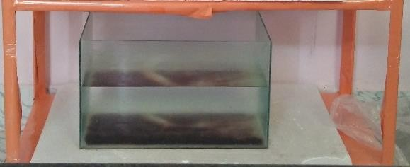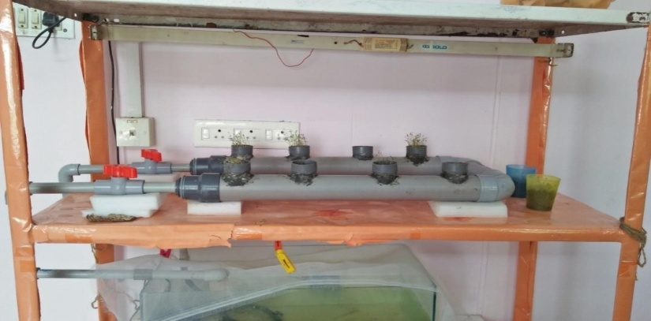 (a) Control(b) Experiment

**Fig. 1. Aquaponics System's Nutrient Film Technique (a. Control; b. Experiment)**

**2.2. Physico-chemical characteristics of shrimp culture water**

Water quality parameters, such as temperature, dissolved oxygen, pH, alkalinity, calcium, magnesium, ammonia (NH3-N), nitrite (NO2-N), nitrate (NO3-N), and phosphate (PO43) were analyzed by adopting standard procedures of (APHA (2012)., Jenkins and Medsker (1964) and Strickland and Parsons (1972)).

## 2.3. Optimization of Plant Growth

## Presently, four different plant species viz Spinach (*Amaranthus viridis*), Chili (*Capsicum annuum*), Tomato (*Solanum lycopersicum*), and Cabbage (*Brassica oleracea*) were cultivated in pots using soil as the growth medium. Various salinity concentrations of 1, 2, 3, and 5 PSU were applied to determine which plant species could best adapt to saline conditions.

**2.4. Rearing of *L. vannamei* and feeding mechanism**

Disease-free, uniformly proportionate, healthy whiteleg shrimp (*L. vannamei*) were introduced to the system. Every day, they were fed SAGA Green-1, a commercial sinking pellet aqua feed which contain 38% crude protein, 7% crude fat, and 4% crude fiber. Feeding started at a rate of 2.5% of the shrimp body weight and continued twice a day, at 8:00 AM and 4:00 PM. The amount of feed was changed following the shrimp observed voracity during daily feedings, and the results were documented. Using the techniques described by Azaza et al. (2009), shrimp were weighed to assess growth performance and counted to estimate the survival rate (%) at harvest. Furthermore, two shrimp samples were taken at random from each aquaponics system every five days. Measurements included body weight increase (g), feed conversion ratio, specific growth rate (SGR), dry feed intake (g), shrimp survival rate (%), and proximate composition were all recorded, and the protocol was followed according to the method of (Tamin et al., (2015), Endut et al., (2009) and Sumbing et al., (2016)). These measurements were made using the following formulas.

Feed conversion ratio = Total dry feed intake/Wet weight gain specific

Growth rate (%/day) = 100 (final weight- initial weight) / no. of days

Survival rate (%) = 100 (initial number of shrimp-final number of shrimp)

## Biochemical Composition

## Estimation of protein

## The Folin-Ciocalteau phenol technique was utilized to evaluate the protein content of shrimp by adopting the Lowry et al. (1951) method. When the aromatic amino acids phenylalanine, tryptophan, and tyrosine are present in proteins, they decrease phosphomolybdate and the tungstate of folin-phenol reagent, which results in the formation of a complex between the protein and copper ions in an alkaline media and the production of a dark blue colour. Using the following formula, the percentage (%) of protein contained in the sample was determined:

$$Protein\%=\frac{Standard value × O.D of the sample}{Weight of sample taken}×100$$

## Estimation of Lipid

## The chloroform-methanol technique was used to determine the lipid content (Folch et al., 1957). A test tube containing 10 mg of shrimp was filled with a 5 ml solution of a 2:1 chloroform to methanol combination. After sealing the tube with aluminium foil, it was allowed to incubate for a full day at room temperature. The mixture was filtered using filter paper after it had been incubated. After gathering the filter residue in a 10 ml beaker that had been previously weighed, it was heated on a hot plate. After the methanol and chloroform combination evaporated, lipid residue was left in the beaker. The sample fat content was measured by computing the weight difference and the following formula was utilized to determine the percentage (%) of lipids contained in the sample:

$$Lipid\%=\frac{Amount of lipid in the sample}{Weight of sample taken}×100$$

## Estimation of Carbohydrate

## After homogenizing a 5 mg sample with double-distilled water, it was centrifuged for 10 minutes at 3000 rpm. One ml of 5% phenol solution and five millilitres of Con.H2SO4 were added to the supernatant. After 30 minutes of standing, the optical density (OD) was measured at 490 nm. The reference glucose was D-glucose. The following formula was used to determine how much carbs were in the sample: $$Carbohydrate \% =\frac{Standard Value × O.D of the sample}{Weight of sample taken}=× 100$$

## Estimation of moisture

## The sample was dried in an oven at 105°C using the AOAC (1995) technique to determine the moisture content. The metal dish was initially washed, and dried, and its consistent weight was noted. Once the sample was on the plate, the weight of it was determined. The sample weight was found by dividing the two weights by their difference. The dish containing the sample was then put in a controlled oven and dried at 105°C until the weight remained consistent. The following formula was used to determine the dried shrimp sample moisture content.

$$Moisture \% =\frac{Weight of the sample ×Weight of the dried sample}{Weight of sample taken}=× 100$$

1. **RESULTS**

In this study, the plant species *A. viridis*, *C. annuum*, *S. lycopersicum*, and *B. oleracea* were cultivated in pots using soil as the growth medium and exposed to salinity concentrations of 1, 2, 3, and 5 PSU to assess their adaptability to saline conditions. Initially, saline water at 35 PSU was tested, but no growth was observed in any of the plants. Subsequently, lower salinity concentrations (1, 2, 3, and 5 PSU) were applied. Among the four species, spinach (*A. viridis*) exhibited the highest growth at 2 PSU, outperforming the other species at all concentrations. It was therefore selected for further studies.

* 1. **Physico-chemical parameters of shrimp culture water**

The health and productivity of shrimp largely depend on maintaining water quality. Optimal conditions for shrimp in a recirculating tank require a consistent supply of high-quality water. Standard methods should be followed during routine water quality examinations including temperature, alkalinity, pH, dissolved oxygen, calcium (Ca+), magnesium (Mg-), ammonia, nitrate, nitrite, and phosphate. Table 1 presents the water quality analysis conducted on the 20th day of the experiment. In all aquaponics systems, the average temperature in the shrimp tanks ranged from 28 to 31°C during the trial, staying within the normal range. The pH of the shrimp cultivation water varied between 7.7 and 8.6. On the 15th day of the experiment, the control system recorded the highest pH value of 8.6, while all treatment systems reported the lowest pH value of 7.7 at the start of the trial.

One of the most important and limiting factors for shrimp survival is dissolved oxygen (DO). Insufficient DO levels can negatively impact shrimp as well as the microorganisms that oxidize organic materials, upsetting the ecosystem around shrimp cultivation as a whole. Because nitrifying bacteria are aerobic, they need oxygen to create NO3-N. The DO range in the current investigation was determined to be 5.47 to 10.45 mg L-1, which is marginally beyond the allowable limits of the water quality standards set out by the US Environmental Protection Agency (USEPA). The highest DO (10.45 mg L-1) was measured in the NFT system after the trial. In every treatment system, a minimum DO of 5.47 mg L-1 was noted at the beginning of the trial. One of the most reliable markers of pH is alkalinity. According to USEPA standards, the alkalinity in both systems was found to be within the allowable range. On the 15th day of the experiment, the control system recorded the highest alkalinity value of 26 mg L⁻¹, while all treatment systems reported the lowest value of 22 mg L⁻¹ at the start of the trial.

Calcium is crucial for the development of eggs, shells, and tissues, especially during shrimp spawning and fry rearing. For effective spawning and growth, *L. vannamei* may require very soft water with low hardness. Therefore, understanding the specific requirements of any species intended for spawning or cultivation is essential. In the NFT system, the highest levels of calcium (Ca⁺) and magnesium (Mg⁻) recorded during the study were 760 mg L⁻¹ and 201 mg L⁻¹, respectively. In contrast, the control group showed lower levels, with Ca⁺ at 320 mg L⁻¹ and Mg⁻ at 89 mg L⁻¹. The aquaponics system maintained consistent Ca⁺ and Mg⁻ levels throughout the experiment.

**Table 1.** **Water Quality Parameter of Aquaponics System on the 20th day of the experiment**

**Parameters Control NFT**

Temperature (°C) 29.83±0.92 29.50±0.84

pH 8.30±0.29 8.15±0.28

Alkalinity (mg L-1) 24.13±1.59 23.60±1.50

Calcium (mg L-1) 595±192.52 592.33±137.81

Magnesium (mg L-1) 138±71.90 170.53±54.47

Ammonia (mg L-1) 0.64±0.31 0.26±0.05

Nitrite (mg L-1) 4.17±2.37 3.63±2.05

Nitrate (mg L-1) 0.33±0.20 0.14±0.09

Phosphate (mg L-1) 3.45±0.34 2.39±0.97

Dissolved (mg L-1) 8.37±1.79 8.13±1.86

Note: Control and NFT – Nutrient Film Technique. All the values are mean values of triplicate samples ± SD.

During the experiment, the dissolved nutrients analyzed (Table 1) included nitrogen compounds (ammonia, nitrite, and nitrate) and phosphorus (orthophosphate). From day 0 to day 5, the accumulation of uneaten feed and shrimp waste caused NH3-N levels to rise across all treatments, ranging from 0.27 to 1.01 mg L⁻¹. However, NH3-N levels in the NFT system dropped to 0.34 mg L⁻¹ after the fifth day, unlike in the control system. Nitrite (NO2-N), a reactive compound, is quickly converted to nitrate (NO3-N) by nitrifying bacteria in the presence of sufficient oxygen. Nitrate levels showed an increasing trend during the experiment, varying from 0.011 to 4.20 mg L⁻¹, particularly in the NFT and control systems. Despite this increase, NO2-N levels remained safe for *L. vannamei*. It is worth noting that NO2-N levels are typically higher than those of NH3-N and NO3-N. High nitrite levels can be harmful to shrimp, as plants do not utilize nitrite as a nutrient. Nitrate (NO3-N), a non-toxic compound for shrimp, also serves as a nutrient source for plants alongside ammonium (NH4-N). Throughout the experiment, nitrate levels remained suitable for *L. vannamei* survival, though they fluctuated daily. The lowest nitrate concentration (0.021 mg L⁻¹) was recorded on the first day, while the highest (0.52 mg L⁻¹) was observed on the 20th day in the control system. In contrast, nitrate levels in the NFT system declined from 0.021 mg L⁻¹ on the first day to 0.1 mg L⁻¹ by the end of the study.

## Analysis of Shrimp Growth Rate

## The maximum length (11±0.21 cm) was observed on the 20th day (in animals reared in NFT) whereas the control system (10.1±0.13 cm) showed minimum length measurements throughout the study period. The weight of white-leg shrimp increased from time to time for all treatments. The maximum weight of *L. vannamei* was reached at NFT (6.27±0.42 g) on the 20th day followed by the control system showed a minimum weight (4.61±0.12 g) throughout the study period which is shown in (Fig 2).



## Fig. 2. Total Length & Weight of white-leg shrimp (*L. vannamei*) during the experimental period; All values are mean values of triplicate samples ± SD.

## Analysis of Shrimp Survival Rate

## The survival rate of *L. vannamei* on the final day of the experiment showed a high rate in the NFT aquaponics system (60±0.34%) whereas in the control system (53±0.21%) it was recorded as slightly low (Fig 3). The figure-3 depicts the survival rate of shrimp under treatment and control conditions. The observed survival was higher in treatment (96.18±0.19%) than in control (90.57±0.47%) at the end of the experiment (30th day). Before the experiment 100% survival was observed with control and treatment on the 1st day; on the 15th day decreased survival between 100% to 85.9±0.79% in control than treatment varied between 100% to 90.47±0.25%.

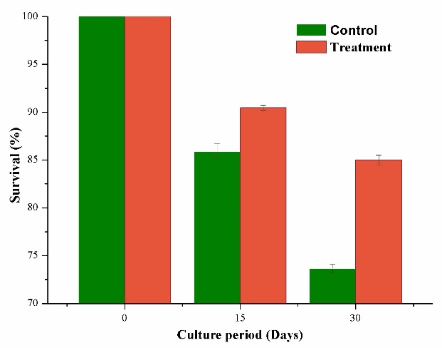

**Fig. 3. Survival rate of *L. vannamei* during the experimental period. Control and treatment experiments were carried out in a normal tank and nutrient film technique set up respectively. All values are mean values of triplicate samples ± SD.**

## Biochemical composition of *L. vannamei*

## The proximate composition such as Protein, Carbohydrate, Lipid, and Moisture was found to be higher in shrimp grown in the NFT aquaponics system with the concentration of 36.31±0.24%, 7.23±0.34%, 1.05±0.12% and 3.74±0.15% respectively when compared to control shrimp which showed less biochemical composition (Fig. 4).

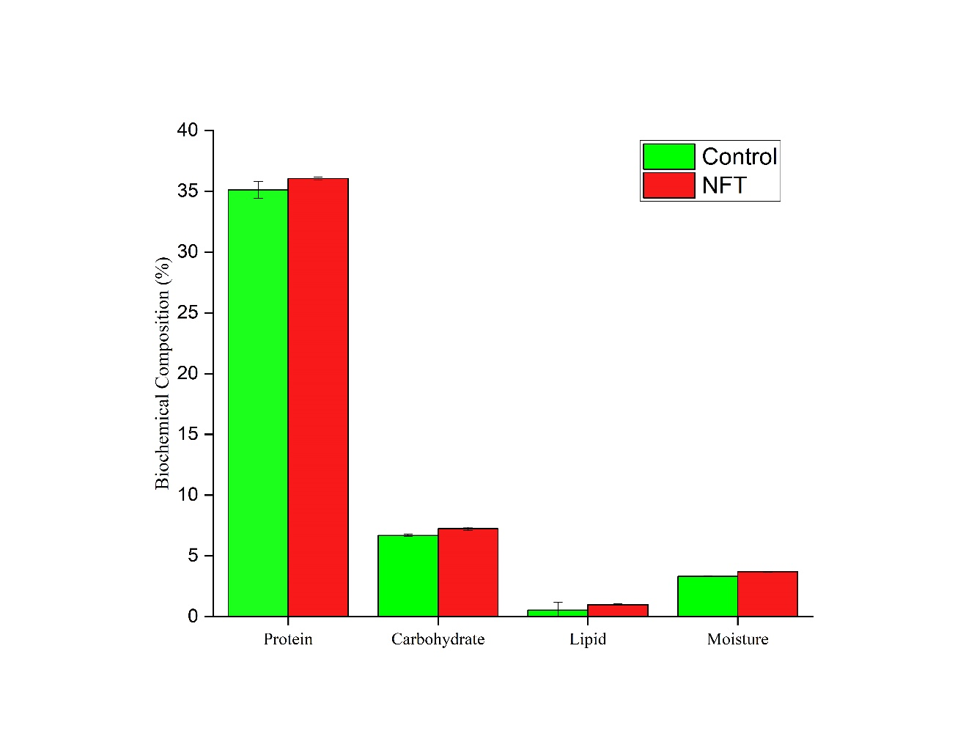

**Fig. 4. Biochemical Composition of *L. vannamei* during the experimental period. Control and treatment experiments were carried out in the normal tank and nutrient film technique setup respectively. All the values are mean values of triplicate samples ± SD.**

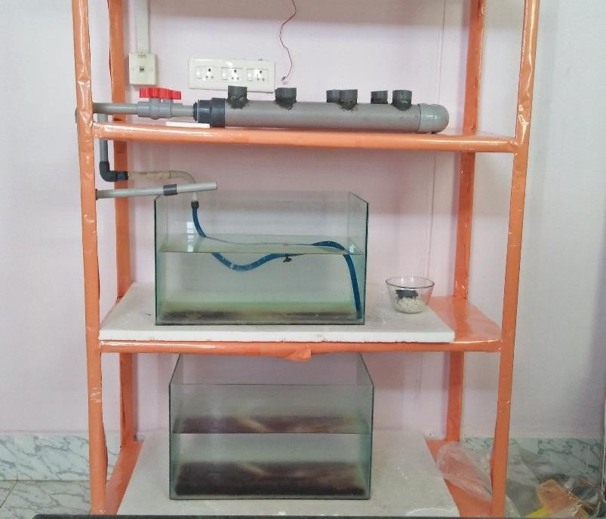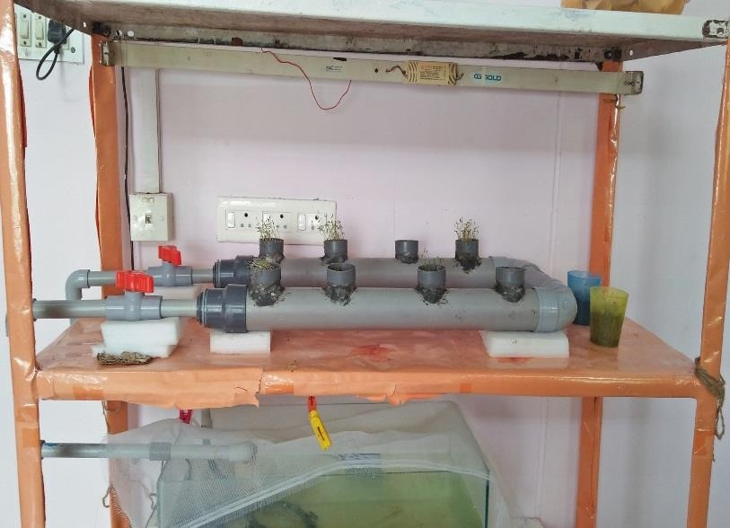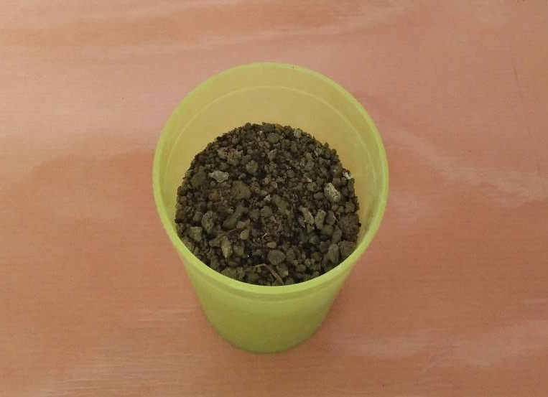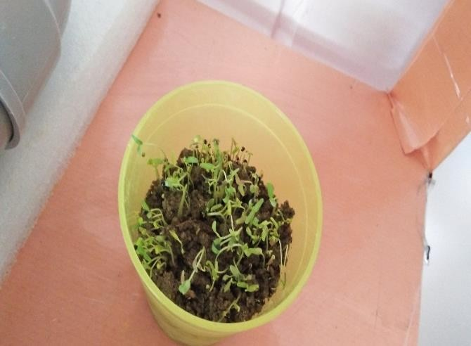

(C) Initial day

(D) Final day

(B) Experiment

(A) Control

**Fig. 5. Plant growth in NFT and control aquaponics system**

Figure 5 illustrates the plant growth observed in both the NFT aquaponics system and the control. The seed length for Dhanta sag varied between 0.1 and 0.2 cm. Signs of stem growth were first noted in the control on Day 5, with lengths ranging from 2 to 2.7 cm. In contrast, the initial stem growth in the NFT aquaponics system on Day 5 ranged between 3 and 4 cm. On the same day, Dhanta sag grown in the control system had an average stem length of 1.15 cm, with a range of 3 to 4.15 cm, while in the NFT system, stem lengths ranged from 4.55 to 6.93 cm. By Day 10, the stem length of sprouts grown in the control system varied from 6 to 7.5 cm, whereas in the NFT system, stem lengths ranged from 8 to 9 cm. The first signs of leaf formation were observed on Day 6 in the control system, while in the NFT system, leaf formation was noted on Day 5. The control system produced leaves with lengths ranging from 0.3 to 0.5 cm, while the NFT system produced leaves with lengths from 0.4 to 0.6 cm. By the end of the experiment (Day 20), the maximum plant growth observed in the control system ranged from 9.4 to 10.7 cm, while in the NFT system, plant growth ranged from 11.4 to 12.3 cm, as shown in Figures 6, 7, and 8.



**Fig. 6. Length of *A. viridis* during experimental period. Control and treatment experiment were carried out in normal tank and nutrient film technique setup respectively. All values are mean values of triplicate samples ± SD.**



**Fig. 7. Weight gain of *A. viridis* during the experimental period. Control and treatment experiments were carried out in the normal tank and nutrient film technique setup respectively. All values are mean values of triplicate samples ± SD.**

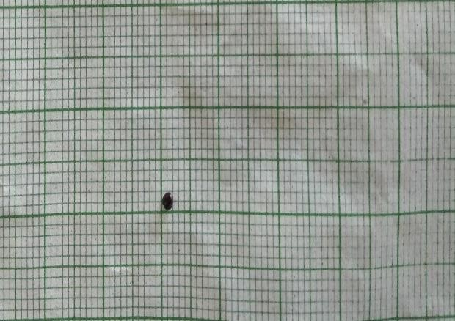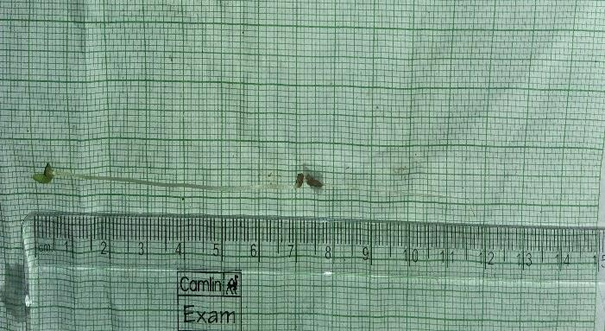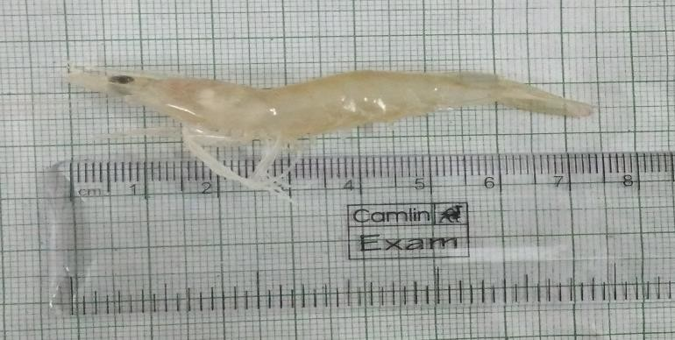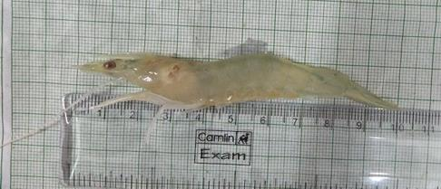**1a. Initial 1b.Final**

## 

## 

## 2a. Initial 2b.Final

**Fig. 8. Initial and Final growth rate of whiteleg shrimp *L. vannamei* (1a & 1b) and Dhanta sag *A. viridis* (2a & 2b).**

The recorded plant growth parameters from seed to mature plant of control and NFT aquaponics system are shown in Table 2. The seed length was increased gradually from Day 1 in the control system (0.10 cm) to the end of the experiment achieving an adult plant length of 10.47 cm. Contrasted with the NFT System, seed germination (0.10 cm) was started then root length (5.07 cm) was increased and finally achieved adult plant length was 12.13 cm at the end of the experiment. The present study results concluded that the growth characteristics of plants from seed to mature stage have been noticed higher in the NFT system than control.

**Table 2. Growth measurements from seed to matured plant of *A. viridis***

|  |  |  |  |  |  |  |  |  |  |
| --- | --- | --- | --- | --- | --- | --- | --- | --- | --- |
| **Treatment** | **Seed Length (cm)** | **Seed**  **Width**  **(cm)** | **Rood**  **Length**  **(cm)** | **Rood Width**  **(cm)** | **Stem**  **Length**  **(cm)** | **Stem**  **Width**  **(cm)** | **Leaf**  **Length**  **(cm)** | **Leaf**  **Width**  **(cm)** | **Matured**  **Plant**  **Length (cm)** |
| Control | 0.10±  0.02 | 019±0.02 | 4.4±0.2 | 0.6±0.1 | 6.3±  0.26 | 0.12±0.02 | 0.55±  0.05 | 0.35±  0.05 | 10.47±  0.25 |
| NFT | 0.10±  0.02 | 0.19±0.01 | 5.07±  0.31 | 0.5±0.1 | 6.5±0.2 | 0.45±0.63 | 0.6±  0.02 | 0.6±0.1 | 12.13±  0.15 |

1. **DISCUSSION**
   1. **Physico-chemical characteristics of the aquaponics system**

In the present study, the water temperature was initially averaged around 31ºC, gradually dropping to a range of 29 to 29.5ºC at the end of the study. The average temperature of 29.3ºC remained within the acceptable range for white shrimp, as reported by Wyban et al., (1995), which is between 29 and 32ºC. On the other hand, the aquaponics system pH was lower than the control, and this may be due to the CO₂ produced by the respiration of shrimp and the metabolic processes of bacteria. The carbonate equilibrium is changed by the emission of CO₂, which leads to the creation of H⁺ ions and the observed pH drop. This drop in pH levels is further made worse by bacterial oxidation activities. According to Princic et al. (1998), ammonia oxidation, which produces CO₂, frequently causes pH decreases in situations with high ammonia levels, such as aquaculture effluent. Moreover, alkalinity and hardness (Ca2+ and Mg2+) are closely related to pH, and there are possible hazards associated with specific pH values. Marques et al. (2017) illuminated the complex relationship between pH and ammonia concentration, highlighting that pH fluctuations in aquaponics systems can significantly influence system performance and efficiency. In addition, the toxicity of substances such as ammonia, cyanides, hydrogen sulfide, and heavy metals is closely linked to pH levels in aquatic systems (Klontz, 1993).

The natural food sources and water that white shrimp consume usually provide them with adequate calcium. Many metabolic processes, including as blood coagulation, muscular contraction, nerve impulse transmission, enzyme activation, osmoregulation, and skeletal development, depend on calcium. Calcium deficiencies, whether dietary or water-based, can interfere with metabolic gradients and weaken shells, however they are uncommon in species such as salmonids, carp, and catfish (Lovell, 1998).

Osmoregulation, the formation of hard tissue, the activation of enzymes involved in protein synthesis and glucose metabolism, and the preservation of shrimp muscle integrity all depend on magnesium, another critical mineral. including calcium shortage, magnesium deficiency can cause symptoms including weak muscles, poor development, and low survival rates (Lovell, 1998). According to recent research by Aljehani et al. (2023), shrimp growth, resistance, and reproductive success are all greatly impacted by the calcium and magnesium levels in aquaponics systems.

Dissolved oxygen (DO) levels began above 5.47 mg L⁻¹ in all treatments and increased to between 8.36 and 10.45 mg L⁻¹ by the end of the experiment. DO is a vital parameter because it is necessary for the oxidation of ammonia and is a key limiting factor for shrimp survival. Optimal DO levels for shrimp growth should be maintained between 3 to 5 mg L⁻¹, with levels below 2 mg L⁻¹ being detrimental (Masser et al., 1999; Colt, 2006). When DO levels fall below this range, the efficiency of ammonia and nitrite oxidation by nitrifying bacteria decreases (Masser et al., 1999; Hargreaves, 2006). A recent review by Han et al. (2024) emphasized that maintaining optimal DO levels not only supports shrimp health but also optimizes nutrient cycling in recirculating aquaculture systems, reinforcing the importance of oxygen in maintaining system balance.

Ammonia (NH₃-N) levels rose on day 10 but decreased by day 20, with concentrations of 0.29 mg L⁻¹ in the NFT system and 0.34 mg L⁻¹ in the control system at the experiment's conclusion. These levels were below the tolerance threshold of 1.0 mg L⁻¹ for shrimp (DeLong et al., 2009). The NFT system demonstrated more effective ammonia removal, especially by day 20, likely due to the nitrifying bacteria's activity in converting ammonia to nitrite. High ammonia levels are typically associated with a decrease in DO, as oxygen is required to convert ammonia to nitrite, resulting in lower DO levels in the water. Recent studies, such as those by Costa et al. (2023), underscore the effectiveness of biofiltration in aquaponics systems, further validating the beneficial impact of nitrifying bacteria on water quality.

Although NO₂-N levels increased during the experiment, they remained within safe limits for *L. vannamei* due to the adequate oxygen supply required for the oxidation process. In recirculating systems, NO₂-N concentrations should not exceed 10 mg L⁻¹ for extended periods, with optimal levels generally remaining below 1 mg L⁻¹ (Losordo et al., 1998). Similarly, NO₃-N levels increased over the course of the study, reaching higher concentrations by the end compared to the start. NO₃-N, along with NH₄, serves as a nitrogen source for plants, although A. viridis prefers NO₂-N over NO₃-N. While NH₃-N can be directly utilized by plants, NO₃-N must be converted into a more accessible form. Xu et al., (1992) observed that NH₄ accumulates more readily in plant tissue, particularly under high nitrogen conditions, due to its faster and more metabolically efficient assimilation compared to NO₃-N. Recent studies, such as those by Zhang et al., (2023) have further demonstrated that nitrate utilization in aquaponics systems varies depending on the plant species and their specific nitrogen metabolism pathways, highlighting the necessity for customized nutrient management strategies.

Although orthophosphate (PO₄³⁻) had no detrimental effects on shrimp development, elevated levels can cause eutrophication and algal blooms, which over time may be harmful to shrimp health. Orthophosphate levels rose from day 0 to day 10 of the culture period, fell on day 15, and then increased once again on day 20.The control system had lower amounts of orthophosphate than the NFT system. Since orthophosphate is dissolved, it is easily taken by plants, which require phosphorus as a nutrient. According to the experiment, Dhanta sag grew more when the phosphorus levels were lower than the nitrogen levels. This conclusion is consistent with recent research by Sari et al. (2023), which found that in integrated aquaponics, phosphorus level regulation is essential for preventing eutrophication and preserving system stability.

* 1. **Growth Characteristics of *L. vannamei***

The growth performance of *L. vannamei* (whiteleg shrimp) in the aquaponics system highlights the effectiveness of utilising shrimp excretions as a nutrient source within the integrated system. During the study, shrimp cultivated in the Nutrient Film Technique (NFT) system showed significantly better growth metrics than those in the control group. The final average weight of shrimp in the NFT system was 6.27 g, outperforming the control group, which reached only 4.61 g. Similarly, the shrimp in the NFT system attained a greater total length of 11 cm, compared to 10.1 cm in the control system.

Survival rates further emphasised the benefits of the NFT system, with a survival rate of 60%, in contrast to 53% observed in the control group. This aligns with the findings by Argue et al. (2002), who noted the challenges of cultivating *L. vannamei* due to its relatively slow growth. Despite these challenges, its high market demand drives research toward optimizing its cultivation. Recent studies, such as Aljehani et al. (2023), have emphasized the importance of efficient waste management and water quality control in improving growth and survival rates for aquaculture species.

The improved performance in the NFT system can be attributed to its superior water quality management. By incorporating biofiltration, the NFT system effectively removed harmful nitrogen compounds, such as ammonia and nitrite, while maintaining adequate levels of dissolved oxygen. These conditions support optimal metabolic and physiological functioning in shrimp, as previously reported by Hargreaves (2006). Additionally, the higher survival and growth rates observed in the NFT system underscore the importance of an integrated approach that balances nutrient recycling and water quality for shrimp cultivation.

Furthermore, the NFT system significantly enhanced the growth of *A. viridis* (Dhanta sag), which serves as a complementary component of the aquaponics system. This finding aligns with studies by Lennard and Leonard (2006), who highlighted the potential of aquaponics systems to improve nutrient uptake efficiency in plants. Recent research by Zhang et al. (2023) also supports these results, demonstrating that aquaponics systems provide a more efficient platform for plant nutrient absorption compared to traditional hydroponic systems.

* 1. **Growth Characteristics of *A. viridis***

*Dhanta sag* (*A. viridis*) demonstrated exceptional growth in the aquaponics system, thriving without the addition of external nutrients and solely utilizing the wastewater generated from whiteleg shrimp (*L. vannamei*) cultivation. Throughout the study, *A. viridis* exhibited rapid development, characterized by vibrant green leaves and a lack of visible nutrient deficiencies, indicating sufficient nutrient absorption from the shrimp culture. The root system flourished in the Nutrient Film Technique (NFT) system, achieving greater length and density compared to the control group. This enhanced root development enabled improved nutrient uptake and offered a larger surface area for microbial communities to colonize, facilitating nutrient cycling and water quality improvement.

The adaptability of *A. viridis* to nutrient-rich aquaculture wastewater makes it a suitable candidate for integrated aquaponics systems. The elongated roots, a hallmark of its growth, not only absorb nutrients efficiently but also provide a habitat for nitrifying bacteria. These bacteria oxidize ammonia into nitrate, creating a sustainable environment for both plant and shrimp cultivation (Endut et al., 2010, 2011; Hu et al., 2015).

During the experimental period, the height of *A. viridis* steadily increased, starting at 0.2 cm and reaching 12.3 cm by the end of the study. The final biomass of the plant was 0.047 g in the NFT system and 0.041 g in the control, showcasing better performance in the NFT setup. The rapid growth observed aligns with studies by Buzby and Lin (2014), which emphasized that higher nutrient availability drives increased plant growth and nutrient uptake. Similarly, Lennard and Leonard (2006) reported effective nutrient removal when *A. viridis* was grown in gravel-based hydroponic systems, further validating its phytoremediation potential.

In addition to its role in nutrient cycling, *A. viridis* is a valuable crop due to its nutritional composition. Commonly consumed as a leafy vegetable, *A. viridis* is rich in essential vitamins, minerals, and phytochemicals, making it a complementary dietary component alongside fruits and other vegetables. Its dual role as a nutrient remover and edible crop underscores its potential in aquaponics systems to enhance sustainability and profitability.

This study highlights the promising future of aquaponics systems, emphasizing their ability to integrate sustainable waste management with food production. However, economic challenges remain a critical barrier to the widespread adoption of aquaponics. Research into cost-effective technologies, innovative designs, and global awareness campaigns especially targeting developing regions will be essential for unlocking the full potential of aquaponics. Recent advancements in system automation and resource efficiency (Zhang et al., 2023; Costa et al., 2023) further highlight the need for collaborative research efforts to address these challenges and promote sustainable agricultural practices globally.

1. **CONCLUSION**

The study highlights aquaponics major environmental benefits over conventional farming methods. By combining crop and protein production into a single, resource-efficient system, aquaponics holds promise for improving the sustainability of global food systems when used on a broader scale. This creative farming method has great potential for global development as it provides a workable way to supply wholesome food at a reasonable price, particularly in areas with limited resources. This study demonstrates the successful co-cultivation of Dhanta sag (*A. viridis*) and premium whiteleg shrimp (*L. vannamei*), highlighting aquaponics as an economical and sustainable substitute for hydroponics, aquaculture, and traditional agriculture. The system is a useful model for farmers and novices interested in farming because of its adaptability to different species combinations. Further investigation into species selection, nutrient recycling, and system design optimization will increase its uptake and scalability. Aquaponics can help create a more resilient and sustainable food future for people throughout the world by encouraging alternate food production methods.

**Data availability**

Data available on request from the corresponding author

**Declarations**

The authors declare that they have no known competing financial interests or personal relationships that could have appeared to influence the work reported in this paper.

**Ethics approval**

The fishes are used for rearing in an aquaponics system. Experimental fishes were anaesthetized using MS-222 before for analysis purposes. The fishes handling and all maintenance were made as per the guidelines of the Animal’s Ethical Committee.

**Code availability**

Not applicable

**References**

Aljehani, F., N'Doye, I., & Laleg-Kirati, T. M. (2023). Feeding control and water quality monitoring in aquaculture systems: Opportunities and challenges. *arXiv preprint arXiv:2306.09920*.

AOAC., 1995. Official methods of analysis (16th ed) Washington, DC, USA: Anal Chem

APHA, A., 2012. WEF Standard methods for the examination of water and wastewater. 22 edn: American Public Health Association (APHA) J Am WATER Work Assoc (AWWA) & Water Environ Res (WEF). <https://doi.org/10.12691/rse-5-1-5>

Argue, B. J., Arce, S. M., Lotz, J. M., & Moss, S. M. (2002). Selective breeding of Pacific white shrimp (Litopenaeus vannamei) for growth and resistance to Taura Syndrome Virus. *Aquaculture*, *204*(3-4), 447-460. https://doi.org/10.1016/S0044-8486(01)00830-4

Azaza, M. S., Wassim, K., Mensi, F., Abdelmouleh, A., Brini, B., & Kraϊem, M. M. (2009). Evaluation of faba beans (Vicia faba L. var. minuta) as a replacement for soybean meal in practical diets of juvenile Nile tilapia Oreochromis niloticus. *Aquaculture*, *287*(1-2), 174-179. https://doi.org/10.1016/j.aquaculture.2008.10.007

Buzby, K. M., & Lin, L. S. (2014). Scaling aquaponic systems: Balancing plant uptake with fish output. *Aquacultural Engineering*, *63*, 39-44. https://doi.org/[10.1016/j.aquaeng.2014.09.002](https://doi.org/10.1016/j.aquaeng.2014.09.002)

Colt, J. (2006). Water quality requirements for reuse systems. *Aquacultural Engineering*, *34*(3), 143-156. <https://doi.org/10.1016/j.aquaeng.2005.08.011>

Costa, F., Frecassetti, S., Rossini, M., & Portioli-Staudacher, A. (2023). Industry 4.0 digital technologies enhancing sustainability: Applications and barriers from the agricultural industry in an emerging economy. *Journal of Cleaner Production*, *408*, 137208.

Davis, S. J. (2016). *An index of global economic policy uncertainty* (No. w22740). National Bureau of Economic Research. https://doi.org/10.3386/w22740

DeLong, D. P., Losordo, T., & Rakocy, J. (2009). *Tank culture of tilapia* (Vol. 282, pp. 1-8). Stoneville, MS, USA: Southern Regional Aquaculture Center. https://hdl.handle.net/11244/319789

Endut, A., Jusoh, A., Ali, N., Nik, W. W., & Hassan, A. (2010). A study on the optimal hydraulic loading rate and plant ratios in recirculation aquaponic system. *Bioresource technology*, *101*(5), 1511-1517. <https://doi.org/10.1016/j.biortech.2009.09.040>

Endut, A., Jusoh, A., Ali, N., Wan Nik, W. N. S., & Hassan, A. (2009). Effect of flow rate on water quality parameters and plant growth of water spinach (Ipomoea aquatica) in an aquaponic recirculating system. *Desalination and water treatment*, *5*(1-3), 19-28. <https://doi.org/10.5004/dwt.2009.559>

Folch, J., Lees, M., & Stanley, G. S. (1957). A simple method for the isolation and purification of total lipides from animal tissues. *Journal of biological chemistry*, *226*(1), 497-509. https://doi.org/[10.1016/S0021-9258(18)64849-5](https://doi.org/10.1016/S0021-9258(18)64849-5)

Han, T., Zhang, M., Feng, W., Li, T., Liu, X., & Wang, J. (2024). Effects of Aeration Intensity on Water Quality, Nutrient Cycling, and Microbial Community Structure in the Biofloc System of Pacific White Shrimp Litopenaeus vannamei Culture. *Water*, *17*(1), 41.

Hargreaves, J. A. (2006). Photosynthetic suspended-growth systems in aquaculture. *Aquacultural engineering*, *34*(3), 344-363. https://doi.org/10.1016/j.aquaeng.2005.08.009

Hu, Z., Lee, J. W., Chandran, K., Kim, S., Brotto, A. C., & Khanal, S. K. (2015). Effect of plant species on nitrogen recovery in aquaponics. *Bioresource technology*, *188*, 92-98. https://doi.org/[10.1016/j.biortech.2015.01.013](https://doi.org/10.1016/j.biortech.2015.01.013)

Jenkins, D., & Medsker, L. L. (1964). Brucine Method for the Determination of Nitrate in Ocean, Estuarine, and Fresh Waters. *Analytical Chemistry*, *36*(3), 610-612. https://doi.org/[10.1021/ac60209a016](https://doi.org/10.1021/ac60209a016)

Klontz, G. W. (1993). Environmental requirements and environmental diseases of salmonids. *Fish medicine*, 333-342.

Lennard, W. A., & Leonard, B. V. (2006). A comparison of three different hydroponic sub-systems (gravel bed, floating and nutrient film technique) in an aquaponic test system. *Aquaculture International*, *14*, 539-550. <https://doi.org/10.1007/s10499-006-9053-2>

Losordo, T. M., Masser, M. P., & Rakocy, J. (2000). *Recirculating aquaculture tank production systems*. Southern Regional Aquaculture Center.

Lovell, T. (1989). *Nutrition and feeding of fish* (Vol. 260). New York: Van Nostrand Reinhold.

Lowry, O. H., Rosebrough, N. J., Farr, A. L., & Randall, R. J. (1951). Protein measurement with the Folin phenol reagent. <https://doi.org/10.1016/S0021-9258(19)52451-6>

Marques, J. A., de Barros Marangoni, L. F., & Bianchini, A. (2017). Combined effects of sea water acidification and copper exposure on the symbiont-bearing foraminifer Amphistegina gibbosa. *Coral Reefs*, *36*, 489-501.

Masser, M. P., Rakocy, J., & Losordo, T. M. (2000). *Recirculating aquaculture tank production systems*. Southern regional aquaculture center. <https://hdl.handle.net/11244/319795>

Princic, A., Mahne, I., Megušar, F., Paul, E. A., & Tiedje, J. M. (1998). Effects of pH and oxygen and ammonium concentrations on the community structure of nitrifying bacteria from wastewater. *Applied and environmental microbiology*, *64*(10), 3584-3590. https://doi.org/[10.1128/aem.64.10.3584-3590.1998](https://doi.org/10.1128%2Faem.64.10.3584-3590.1998)

Þórarinsdóttir, R. I., Kledal, P. R., Skar, S. L. G., Sustaeta, F., Ragnarsdóttir, K. V., Mankasingh, U., ... & Shultz, C. (2015). *Aquaponics guidelines*.

Strickland, J. D. H., & Parsons, T. R. (1972). A practical handbook of seawater analysis. https://doi.org/[10.1002/iroh.19700550118](https://doi.org/10.1002/iroh.19700550118)

Sumbing, M. V., Al-Azad, S., Estim, A., & Mustafa, S. (2016). Growth performance of spiny lobster Panulirus ornatus in land-based Integrated Multi-Trophic Aquaculture (IMTA) system. *Transactions on Science and Technology*, *3*(1-2), 143-149. https://doi.org/10.7719/pjae.vlil.483

Tamin, M., Harun, A., Estim, A., Saufie, S., & Obong, S. (2015). Consumer acceptance towards aquaponic products. *J. Bus. Manag*, *17*, 49-64. https://doi.org/10.1002/agr.21562

Wyban, J., Walsh, W. A., & Godin, D. M. (1995). Temperature effects on growth, feeding rate and feed conversion of the Pacific white shrimp (Penaeus vannamei). *Aquaculture*, *138*(1-4), 267-279. https://doi.org/10.1016/0044-8486(95)00032-1

Xu, Q. F., Tsai, C. L., & Tsai, C. Y. (1992). Interaction of potassium with the form and amount of nitrogen nutrition on growth and nitrogen uptake of maize. *Journal of Plant Nutrition*, *15*(1), 23-33. <https://doi.org/10.1080/01904169209364299>

Zhang, Y., Zhang, Y. K., & Li, Z. (2022). A new and improved aquaponics system model for food production patterns for urban architecture. *Journal of Cleaner Production*, *342*, 130867.