**Demonstration of Supplementary Feeding Practices in Composite Carp Culture: A Case Study from Warangal, Telangana**

**ABSTRACT:**

Fish farming plays a crucial role in ensuring income generation, employment opportunities and nutritional security in rural India. This study, conducted by Krishi Vigyan Kendra (KVK), Mamnoor, Warangal aimed to evaluate the performance of supplementary feeding in carp culture through Front Line Demonstrations (FLD). The trials were carried out using three different treatment options each with a minimum of three replications under field conditions for a period of eight months. Data were systematically collected to assess specific growth rate, fish production, disease incidence and economic returns. The findings were utilized to compute gross returns, net returns and the benefit-cost (B:C) ratio. The results indicated that regular application of supplementary feed led to improved fish production and sustainable economic benefits. Therefore, the adoption of composite fish culture along with scientific pond management and regular supplementary feeding practices is recommended to enhance profitability for fish farmers.

**Key Words:** Fish farming, supplementary feeding, composite fish culture, Front Line Demonstration, carp growth, economic returns, rural aquaculture, pond management.

**INTRODUCTION:**

The fisheries sector plays a pivotal role in the Indian economy by contributing to food and nutritional security, employment generation, export earnings and overall economic development. Often referred to as a "Sunrise Sector," fisheries support the livelihoods of over 30 million individuals, particularly those from marginalized and vulnerable communities (DAHDF, 2024). According to the FAO's 2024 report The State of World Fisheries and Aquaculture (SOFIA), India ranks among the top global fish producers, contributing around 8% of the world’s total fish production with a record output of 174.45 lakh metric tonnes during 2023-2024. The country also leads in inland fisheries production, with an annual yield of 1.9 million metric tonnes.

In the context of aquaculture, India produced 13.13 million metric tonnes of inland fish during 2022-2023. Andhra Pradesh topped the chart with 4.5 million metric tonnes, followed by West Bengal at 2 million metric tonnes. Telangana, although a relatively new state, ranks third in terms of fishery resources and sixth in production. The state reported a fish output of 175.45 lakh metric tonnes in 2022-2023, contributing significantly to its economy with a Gross Value Added (GVA) of ₹2,17,983 crores, reflecting a compound annual growth rate (CAGR) of 14.1% surpassing the national average of 10.1% (Ganesh et al., 2024).

In Telangana, approximately 45.8% of the working population is engaged in fisheries and aquaculture, making this sector a vital driver of rural livelihood and development (Socio-Economic Outlook, Government of Telangana, 2023). To further support the sector, the government is implementing various schemes aimed at improving productivity, minimizing post-harvest losses, and enhancing the welfare of fishers (Ganesh et al., 2024).

Freshwater aquaculture in India primarily relies on composite fish culture, involving Indian major carps such as Rohu (Labeo rohita), Catla (Catla catla), and Mrigal (Cirrhinus mrigala), along with Chinese carps like Common carp (Cyprinus carpio), Grass carp (Ctenopharyngodon idella), and Silver carp (Hypophthalmichthys molitrix). This polyculture system not only maintains water quality but also enhances production compared to monoculture systems (Chakrabarti, 1998; Azim et al., 2001; Dhawan and Kaur, 2002).

Composite fish culture is a widely accepted and profitable practice; however, its success heavily depends on the adoption of scientific pond management, including both pre-stocking and post-stocking practices. Despite its benefits, many farmers overlook essential practices such as pond cleaning, liming, fertilization, eradication of predatory & weed fishes and water quality management (Ramakrishna et al., 2013). Additionally, irregular feeding practices often limited to mustard oil cakes are common. This study seeks to compare fish yield and economic outcomes between traditional farmer practices and scientifically guided supplementary feeding methods. By promoting awareness of regular feeding, balanced diets and proper pond maintenance, the study aims to encourage widespread adoption of improved practices in composite fish culture (Islam et al., 2008; Sampa, 2024).

Krishi Vigyan Kendra (KVK), Mamnoor, operating under P.V. Narsimha Rao Telangana Veterinary University, Hyderabad, plays a key role in disseminating new technologies through training and demonstration programs. KVK focuses on skill development among farmers, rural youth and extension workers while conducting short-term, on-farm trials to validate promising technologies in the Warangal district.

**Materials and Methods**

The present study was conducted by Krishi Vigyan Kendra (KVK), Mamnoor, Warangal under the aegis of P.V. Narsimha Rao Telangana Veterinary University, Hyderabad. The study was implemented through Front Line Demonstrations (FLD) titled "Demonstration on Supplementary Feed Performance in Carp Culture," and was carried out over a period of eight months under field conditions. Three treatment options were evaluated with a minimum of three replications per treatment.

Treatment (T1) represented the traditional farmer practice, which involved occasional pond cleaning and feeding with de-oiled rice bran (DOB) and groundnut oil cake (GNOC) without adhering to a specific feeding rate. Treatment (T2)involved proper pond cleaning and feeding with pelleted feed at 5% of the fish's body weight during the fingerling stage, 3% during the grow-out stage (150-250 g) and 2% during the adult stage. Additionally, probiotics and growth promoters were applied at a rate of 1 liter per acre. Treatment (T3) was similar to T2 but emphasized strict adherence to both pre-stocking and post-stocking management practices, including pond preparation, liming, fertilization, weed and predator control, water quality monitoring, and health management. For T2 and T3, pelleted feed was administered at 5% of fish body weight during the fingerling stage, 3% during the intermediate stage (250–500 g), and 2% for mature fish. Probiotics and growth promoters were applied weekly at 1 litre/acre. Initial fish weights averaged 200–220 grams. Stocking density was 6,500 fish/ha. Parameters such as specific growth rate (SGR), percentage weight gain, yield (q/ha), gross and net returns, and B:C ratio were recorded and analyzed.

**Specific Growth Rate (SGR)** (%): where and represent initial and final weights, and represent the respective time points in days.

**Net Return**: Gross Return - Cost of Production

**Benefit-Cost Ratio (B:C)**: Gross Return /Cost of Production

The details of the FLD components, including input distribution, management protocols and performance indicators, were systematically recorded and evaluated.

**Table 1: Overview of the Front Line Demonstration (FLD) on Carp Culture**

|  |  |  |
| --- | --- | --- |
| **1** | **Title of Front Line Demonstration** | Demonstration on Supplementary Feed Performance on Carps |
| **2** | **Problem diagnosed** | Low fish productivity due to traditional feeding methods and inadequate health management practices |
| **3** | **Technologies Assessed:** | **Farmers Practice (T1)** Occasional pond cleaning and feeding with de-oiled rice bran (DOB) and groundnut oil cake (GNOC) without maintaining an appropriate feeding rate. **T2:** Proper pond cleaning and feeding with pelleted feed at 5% of body weight during the fingerling stage, 3% for fish weighing 100–120 g, and 2% for adult fish. Also includes the use of probiotics and growth promoters at 1 liter per acre. **T3:** Strict adherence to all pre- and post-stocking management practices, including prophylactic treatment, feeding as per T2, and application of health supplements. |
| **4** | **Production System and Thematic Area:** | Composite fish culture involving Indian Major Carps with focus on fish disease management. |
| **5** | **Performance Indicators:** | The improved technologies demonstrated better growth performance, disease resistance, and economic returns compared to traditional practices. |
| **6** | **Recommendation for Micro-Level Adoption:** | The best results were achieved under T3, yielding 16.5 quintals/ha. Regular feeding with pelleted feed or mixed mustard oil cake, fortified with vitamins and minerals, along with appropriate medication is recommended for broader adoption. |
| **7** | **Farmer Participation and Response:** | Farmers actively participated through training programs and demonstrations. They expressed satisfaction with the improved fish yield and profitability resulting from the adoption of scientific fish farming practices. |

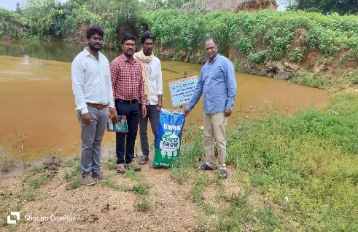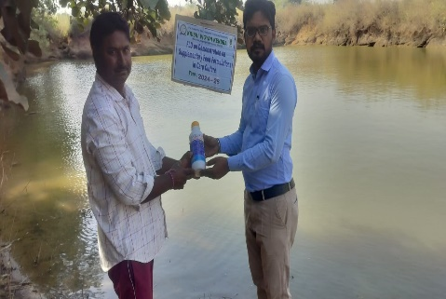

**Fig.No.1.** Critical Input Distribution Under Front Line Demonstrations

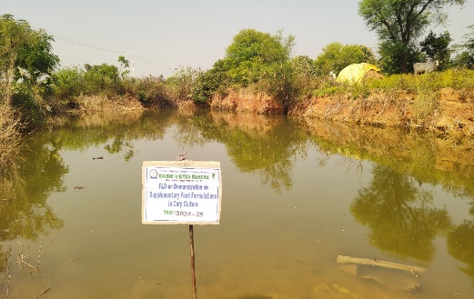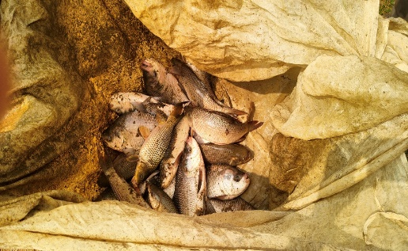

**Fig.No.2.** Grow out Fish Ponds

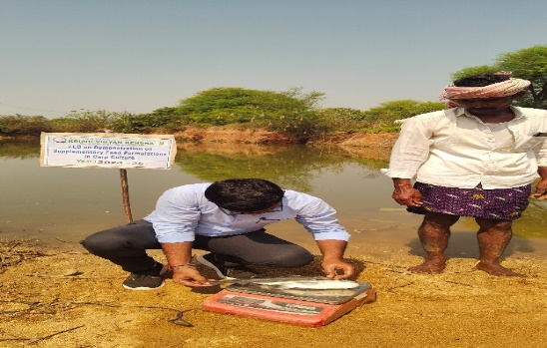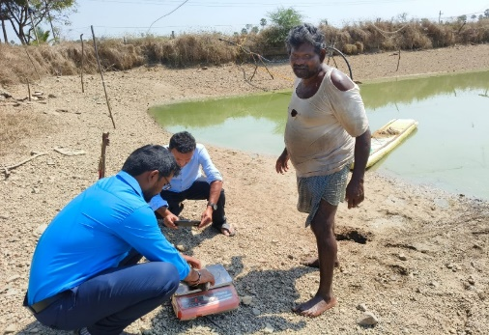

**Fig.No.3.** Recording Growth Data (Weight, Length)

**Results and Discussion**

The findings of the Front Line Demonstrations (FLD) conducted by KVK, Warangal, clearly demonstrated that structured supplementary feeding practices significantly influence fish yield and economic performance in carp culture. Among the three treatment options tested, Treatment 3 (T3), which involved proper pond cleaning and feeding with pelleted feed at 2% of body weight along with the application of growth promoters at 1 litre per acre, produced the highest yield of 17.2 quintals per hectare. This outcome was followed by Treatment 2 (T2), which included stage-wise feeding with pelleted feed and probiotics, resulting in a yield of 14.8 quintals per hectare. The lowest yield, 12.1 quintals per hectare, was recorded under farmers' practice (T1), which lacked structured feeding and pond management protocols. These results are consistent with the findings of Gupta et al. (2025) and Hasan & New (2013), who emphasized the importance of balanced feeding schedules for maximizing growth and production.

A detailed analysis of average weight gains across species further substantiated the positive impact of the improved practices. In T1, the final weights of Catla, Rohu, and Mrigal were 180 g, 200 g, and 125 g, respectively. Under T2, the average weights increased to 350g (Catla), 225 g (Rohu), and 150 g (Mrigal). The highest growth rates were observed in T3, where the final weights were 400 g (Catla), 250 g (Rohu), and 175 g (Mrigal). These improvements can be attributed to consistent feeding, better water quality, and enhanced nutrient availability, aligning with the observations made by Adewumi (2018) and Azim et al. (2002).

Although the cost of cultivation was slightly higher in T2 and T3 compared to T1, the corresponding net returns were significantly greater. This is primarily due to the market demand for larger and healthier fish, which were sold at Rs. 150 per kg in local markets. The calculated market value was Rs. 1.87 lakhs, Rs. 1.585 lakhs, and Rs. 1.255 lakhs per hectare for T3, T2, and T1 respectively during a two-month culture period. As Eriegha and Ekokotu (2017) noted, extended culture duration further amplifies profitability. By the end of the eight-month culture period, the average fish weight was projected to reach 800 g, potentially yielding around 48 quintals per hectare in T3. These findings suggest that with scientific management and regular feeding, fish farmers can achieve net returns up to Rs. 4.0 lakhs per hectare, confirming the conclusions drawn by Chandra & Bharti (2018) and Iqbal et al. (2015).

Furthermore, the outcomes of this study align with previous research (Moore, 1985; Nandeesha et al., 2001; Yamamoto et al., 2007), which highlight that regular feeding and proper manuring significantly enhance aquaculture productivity. Azim et al. (2002) also reported superior growth rates in carp species under combined feeding regimes compared to fertilization-only approaches. These findings reinforce the critical role of feed quality, frequency, and water management in achieving optimal aquaculture outcomes.

**Table 2: Effect of Feed Supplement on Growth Performance of Carps**

|  |  |  |  |  |
| --- | --- | --- | --- | --- |
| **Treatment** | **Initial Wt (g)** | **Final Wt (g)** | **% Wg** | **SGR** |
| T1: Traditional feeding (DOB + GNOC) | 220 ± 5 | 510 ± 12 | 131.8 | 0.89 |
| T2: Pelleted feed with probiotics | 220 ± 5 | 710 ± 15 | 222.7 | 1.22 |
| T3: High-quality feed + All Other Feed supplements | 220 ± 5 | 825 ± 18 | 275.0 | 1.35 |

DOB- Di Oiled Rice Bran, GNOC: Ground nut Oil Cake, Wt- Weight: % Wg- Percentage weight gain; SGR- Specific growth rate. Data expressed as mean.

**Table 3: Effect of Feed Supplement on Economic Performance of Carps**

|  |  |  |  |  |  |
| --- | --- | --- | --- | --- | --- |
| **Treatment** | **Yield** | **% Increase** | **Gross cost** | **Gross return** | **B:C** |
| T1: Traditional feeding (DOB + GNOC) | 12.5 | – | 46,500 | 1,56,250 | 3.36 |
| T2: Pelleted feed with probiotics | 16.8 | 34.4% | 56,000 | 2,10,000 | 3.75 |
| T3: High quality feed + All Other Feed supplements | 20.4 | 63.2% | 64,500 | 2,55,000 | 3.95 |

**Conclusion**

This study underscores the importance of adopting scientifically validated practices in composite fish culture. Proper pond cleaning, fertilization, pest control, and regular feeding with formulated feed significantly improve growth performance and yield. The economic analysis confirmed that despite higher input costs, farmers using high-quality feed and supplements achieved greater profitability. It is recommended that such practices be widely promoted among fish farmers for sustainable aquaculture development.

**References**

Adewumi A A (2018) The impact of nutrition on fish development, growth and health. *Int. J. Scienti. Res. Public.* **8**(6), 147-153

Azim M E, Verdegem M C J, Rahman M M, Wahab M A, van Dam A A and Beveridge M C M (2002) Evaluation of polyculture of Indian major carps in periphyton-based ponds. *Aquaculture* **213**, 131-149.

Azim M E, Wahab M A, Van Dam A A, Beveridge M C, Milstein M A and Verdegem M C J (2001) Optimization of fertilization rate for maximizing periphyton production on artificial substrates and their implications for periphyton- based aquaculture, *Aquaculture Research* **32**, 749-760.

Chakrabarti N M (1998) Biology, Culture and Production of Indian Major Carps. Fisheries Scientist in Indian Council of Agricultural Research, 175pp.

Chandra, G., & Bharti, B. K. (2018). Assessment the effect of supplementary feeding on fish production in rural fish farming practices. *Journal of Experimental Zoology India*, *21*(2).

Department of Animal & Fish Resources (Fisheries) (2011) A presentation of 11th five year plan by fisheries directorate. http://ahd.bih.nic.in/ (accessed July 18, 2016).

Dhawan A and Kaur S (2002) Effect of pig dung on water quality and polyculture of carp species during winter and summer. *Aquaculture International* **10**, 297-307.

Eriegha, O. J., & Ekokotu, P. A. (2017). Factors affecting feed intake in cultured fish species: A review. *Animal Research International*, *14*(2), 2697-2709.

Ganesh G, Rajanna N, Sai Kiran J, Shashank j, Raju A, Soumya CH and Arunjyoti R.(2024). Socio-economic profile of fish farmers of Warangal district, Telangana. International Journal of Advanced Biochemistry Research; SP-8(9): 557-567. DOI: <https://doi.org/10.33545/26174693.2024.v8.i9Sg.2174>.

Gupta, G., Srivastava, D. K., Pandey, H. P., Singh, R. L., Vats, A. S., & Verma, S. K. (2025). Effect of Feed Supplement on Growth And Economic Performance of Indian Major Carp In Composite Fish Culture System. *Journal of Experimental Zoology India*, *28*(1).

Hasan, M. R., & New, M. B. (2013). On-farm feeding and feed management in aquaculture. *FAO fisheries and aquaculture technical paper*, (583).

Iqbal K J, Ashraf M, Qureshi N A, Javid A, Abbas F, Hafeez-ur- Rehman M, Rasool F, Khan N and Abbas S (2015) Optimizing growth potential of *Labeo rohita* fingerlings fed on different plant origin feeds. *Pak. J. Zool.* **47**(1), 31-36

Islam M S, Huq K A and Rahman M A (2008) Polyculture of Thai pangus (*Pangasius hypophthalmus,* Sauvage 1878) with carp and prawn: a new approach in polyculture technology regarding growth performance and economic returns. *Aquaculture Research* **39**,1620-1627.<https://doi.org/10.1111/j.1365-2109.2008.02035.x>

Moore L B (1985) The role of feeds and feeding in aquatic animals production. *Geo Journal* **10**, 245-251.

Nandeesha M C, De Silva S S and Murthy D K (2001) Use of mixed feeding schedules in fish culture: performance of common carp, *Cyprinus carpio* L., on plant and animal protein based diets. *Aquaculture Research* **26**(3), 161-166.

Pailan, G.H., Biswas, G. (2022). Feed and Feeding Strategies in Freshwater Aquaculture. In: Lama, T., Burman, D., Mandal, U.K., Sarangi, S.K., Sen, H. (eds) Transforming Coastal Zone for Sustainable Food and Income Security. Springer, Cham.<https://doi.org/10.1007/978-3-030-95618-9_35>.

Ramakrishna R, Shipton T A and Hasan R M (2013) Feeding and feed management of Indian major carps in Andhra Pradesh, India. FAO Technical Bulletin 578. *Food and Agriculture Organisation of the United Nations, Rome, Italy,* 90 pp.

Sampa, A. Y. (2024). *Determinants and Outcomes of Formulated Pelleted Feed Use Across Diverse Aquatic Farming System in Bangladesh* (Master's thesis, Michigan State University).

Yamamoto T, Shima T, Furuita H, Sugita T and Suzuki N (2007) Effects of feeding time, water temperature, feeding frequency and dietary com- position on apparent nutrient digestibility in rainbow trout *Oncorhynchus mykiss* and common carp *Cyprinus carpio*. *Fisheries Science* **73**, 161-170.