**SCORPIONS OF INDAPUR TEHSIL, PUNE DISTRICT, M/S, INDIA.**

**Abstract:**

A thorough survey of scorpions was conducted in the Indapur Tehsil area of Pune district, M/S, India, to document the diversity of scorpion species in the area. The survey revealed the presence of seven distinct species belonging to two families (Buthidae and Scorpionidae) and four genera. The species recorded during the survey included *Hottentotta tamulus, Hottentotta rugiscutis, Hottentotta pachyurus, Orthochirus bicolor, Orthochirus bastawadei, Deccanometrus xanthopus,* and *Deccanometrus phipsoni*. The study found that species distribution varied across microhabitats, with *Hottentotta tamulus* being the most prevalent and widely distributed species, while *Deccanometrus phipsoni* was the rarest. The survey highlights the importance of protecting scrublands with stones, vegetated areas, and older trees with exfoliating bark for scorpion conservation. These habitats provide shelter, food, and breeding grounds for scorpions, and their destruction can lead to population decline and even extinction. Future research should focus on scorpion ecology, population estimates, distribution patterns, and biogeographical dynamics to inform targeted conservation strategies. Additionally, studies on the impact of habitat destruction, climate change, and human activities on scorpion populations are necessary to develop effective conservation plans.

**Keywords:** Scorpion diversity, Microhabitats, Conservation, Indapur Tehsil

**Introduction:**

Scorpions are ubiquitous arthropods that inhabit all continents except Antarctica, with the highest abundance and diversity observed in tropical and subtropical regions(Bastawade, 1984; Chandra et al., 2021). Some species have adapted to human-modified environments, making them increasingly encountered in urban and rural areas (Lira et al., 2023). Historically, the detection of scorpions was challenging due to their nocturnal and elusive nature. However, the advent of ultraviolet (UV) light technology has significantly enhanced the detection and study of these arachnids (Gaffin & Curry, 2020; Ortega-Escobar et al., 2023; Vergara-Asenjo et al., 2023). Consequently, scorpion research has experienced a profound increase since the mid-20th century. Presently, the global scorpion fauna comprises approximately 23 families and 2772 species (Rein, 2023). India, situated within the neotropical region, exhibits a diverse geography that encompasses the Himalayan mountain ranges, floodplains, evergreen forests, and arid regions. This varied landscape supports a wide distribution of scorpions, ranging from the Himalayan mountains to the intertidal zones of islands (Chandra et al., 2021).

The scorpion fauna of India was first explored by (Pocock & Blanford, 1900). India, being a vast nation with diverse natural habitats, harbors a rich scorpion fauna. This taxon is represented by 18 genera across six families, namely Buthidae, Chaerilidae, Euscorpiidae, Scorpionidae, Hormuridae, and Vaejovidae (Suranse, 2017; Suranse et al., 2017; Tikader & Bastawade, 1983). In 2024, Mohapatra updated the checklist, documenting 153 species belonging to 30 genera and six families: Buthidae, Chaerilidae, Hormuridae, Scorpiopidae, Scorpionidae, and Rugodentidae. This update reflects the addition of 40 species since earlier studies, underscoring the significance of continued taxonomic research and biodiversity assessments in India (Mohapatra, 2024).

Scorpions are found throughout India but are not explored (or are not reported) in a few north-eastern states like Manipur and Nagaland and union territories like Chandigarh, Dadra Nagar Haveli, Daman and Diu. The highest number of species are recorded from Maharashtra, Tamil Nadu, Karnataka and Kerala, which fall on the Western Ghats biodiversity hotspot (Mohapatra, 2024). Previous studies in India have primarily focused on taxonomy, neglecting evolutionary relationships, behavioural biology, and reproductive biology. Phylogenetic investigations on Indian scorpions are scarce, likely due to challenges in collection and the venomous nature of these nocturnal creatures. The lack of comprehensive research underscores the need for an exhaustive study encompassing taxonomy, evolution, ecology, and behaviour.

The actual diversity of scorpions in India remains to be fully explored, as evidenced by the increasing rate of species descriptions in recent years. In light of this, the present study aims to document the scorpion diversity in the Indapur Tehsil region of Pune district, Maharashtra, India, particularly in the context of proposed habitat modifications

Quantitative documentation of biodiversity is crucial, particularly for invertebrate groups like arachnids, which are often overlooked. By providing baseline biological data, this research emphasizes the importance of impact assessments before developmental projects, highlighting the vulnerability of scorpions to habitat modification.

**Material and method:**

The study was conducted in Indapur Tehsil, Pune District, Maharashtra, India. A randomized quadrat method was employed to assess scorpion distribution patterns and species richness. Five 100m x 100m quadrats were randomly selected across four seasons (July 2023 - June 2024). The study encompassed five distinct scorpion microhabitats: scrubland with stones, arid with stones, grassy hilltops with stones, burrows, and hillslopes with boulders (Fig.1).

Field surveys were conducted during both day and night. Ultraviolet light (Amici Vision 4w 21 LED UV Torch) was used for nocturnal surveys. Geographical coordinates and elevation were recorded using a Global Positioning System (GPS: Garmin Oregon 550), and specimens were photographed with a Canon EOS 1200D camera. Species identification relied on established keys and online database.

Species-specific methodologies were employed. *Deccanometrus xanthopus* was identified by semi-circular burrow openings, and population estimates were derived from burrow counts without excavation. Lapidicolous species (*Hottentotta tamulus, Orthochirus bicolor, Deccanometrus phipsoni*) were found under stones, while non-burrowing species (*Isometrus rigidulus, Hottentotta pachyurus*) were directly recorded. Surveys were conducted by four experienced observers, following specific protocols for each species.

**Results:**

A comprehensive survey of scorpions in the Indapur Tehsil region of Pune district, Maharashtra, revealed seven distinct species belonging to two families (Buthidae and Scorpionidae) and four genera. The species composition included Buthidae (*Orthochirus bicolor, Hottentotta tamulus, H. rugiscutis, H. pachyurus,* and *Orthochirus bastawadei*) and Scorpionidae (*Deccanometrus xanthopus* and *D. phipsoni*).

**Habit and Habitat**

The study revealed significant variation in the habits and habitats of the species observed. Scorpions were predominantly found in microhabitats such as, Rocky terrains, Scrublands and Human settlements. Species like *Hottentotta tamulus* and *Deccanometrus xanthopus* were frequently encountered under rocks or within crevices, leveraging the moisture retention and shade offered by these microhabitats. *Orthochirus bicolor* and *Hottentotta pachyurus* showed a preference for loose soil in scrub habitats, often burrowing to avoid predators and desiccation. Furthermore, *Hottentotta tamulus* was frequently found near human habitation, adapting to diverse conditions, often hiding under debris or logs.

**Species Richness and Distribution Pattern**

The survey recorded seven species, with the family Buthidae being more diverse (five species) compared to Scorpionidae (two species) (S. V. Giramkar, 2008). *Hottentotta tamulus* emerged as the most prevalent and widely distributed species, observed in nearly all surveyed habitats. Its adaptability to varied environments contributed to its dominance. *Deccanometrus phipsoni* was the least common species, found exclusively in dense, undisturbed forest patches. Species distribution was influenced by microhabitat specificity. For example, *Hottentotta rugiscutis* was primarily found in dry, rocky areas, while *Orthochirus bastawadei* showed a preference for sandy soils(S. Giramkar et al., 2024).

**Ecological Observations**

All species were predominantly nocturnal, emerging at night to hunt and display territorial behavior.Species like *Deccanometrus xanthopus* and *Orthochirus bicolor* exhibited burrowing tendencies, creating shelters that provided protection against harsh climatic conditions.In areas of overlap, interspecific interactions were noted, with dominant species often outcompeting others for resources.

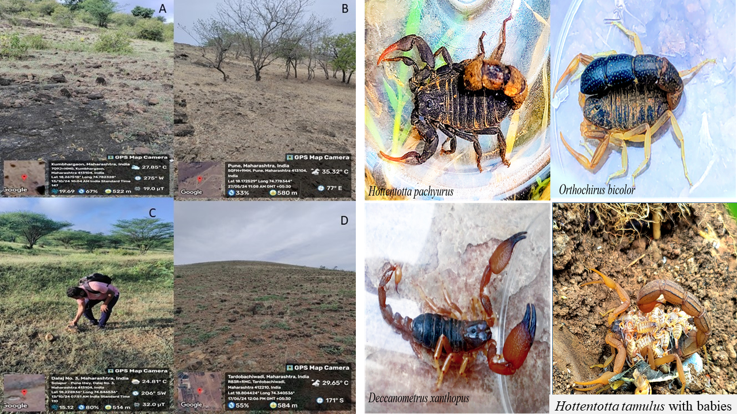

**Fig. 1:** Scorpion collection sites **Fig. 2:** Representative Photographs of specimens observed in study area

**Table 1:** Family wise distribution of Scorpions from Indapur tehsil.

|  |  |  |
| --- | --- | --- |
| **Family** | **Genus** | **species** |
| Buthidae | *Orthochirus* | *bicolor* |
| *bastawadei* |
| *Hottentotta* | *tamulus* |
| *rugiscutis* |
| *pachyurus* |
| Scorpionidae | *Deccanometrus* | *xanthopus* |
| *phipsoni* |

**Discussion**:

The scorpion fauna of the Indapur Tehsil region is characterized by a relatively low species diversity, with seven species recorded from two families and four genera. This is likely due to the limited mobility of scorpions, their habitat specificity, and unique ecological traits. The species distribution and abundance patterns revealed microhabitat (Lira et al., 2018, 2023), with *Hottentotta tamulus* dominating and *Deccanometrus phipsoni* being rare (Pande et al., 2012; Suranse et al., 2017).

The apparent abundance of *Deccanometrus xanthopus* may be underestimated due to its fossorial behavior, which makes it difficult to detect. The conservation priorities should focus on protecting scrublands with stones, vegetated areas, and older trees with exfoliating bark. Unaltered stone rubble habitats also require preservation for *Isometrus rigidulus* (Starr, 2013). Our findings emphasize the importance of environmental impact assessments before developmental projects in perceived 'wasteland' areas. Future research should investigate scorpion ecology, population estimates, distribution patterns, and biogeographical dynamics to inform targeted conservation strategies. This study underscores the need for comprehensive biodiversity assessments in India's diverse landscapes.

**Conservation Implications:**

The scorpion fauna of the Indapur Tehsil region is vulnerable to habitat destruction, fragmentation, and degradation due to human activities such as agriculture, urbanization, and infrastructure development. The conservation of scorpion habitats requires a multi-faceted approach that involves protecting and restoring natural habitats, promoting sustainable land-use practices, and raising awareness about the importance of scorpion conservation.

**Consent for publication:**

Not applicable

**Availability of data and materials:**

Data is available with the corresponding author and will be made available on request.

**References:**

Bastawade, D. B. 1984. Scorpions (Arachnida). *Records of the Zoological Survey of India*, 259–262.

Chandra, K., Kosygin, L., Raghunathan, C., & Gupta, D. 2021. Faunal Diversity of North-East Biogeographic Zone of India: An Overview. *Faunal Diversity of Biogeographic Zones of India: North-East*, 1–39.

Gaffin, D. D., & Curry, C. M. 2020. Arachnid navigation–a review of classic and emerging models. *The Journal of Arachnology*, *48*(1), 1–25.

Giramkar, S., Mundhe, A., & Joshi, M. 2024. *Fauna of Annasaheb Magar Mahavidyalaya Hadapsar Campus Pune, M/S, India.* *11*(3).

Giramkar, S. V. 2008. *The comparative account of anatomy and histology of nervous, reproductive systems and venom gland of Heterometrus xanthopus (Pocock)(Scorpionidae) and Orthochirus bicolor (Pocock)(Buthidae) from Pune and surrounding region*.

Lira, A. F. A., Andrade, A. R. S., & Foerster, S. I. A. 2023. Latitudinal Trends in Scorpion Assemblages of Brazilian Atlantic Forest: Do the Rapoport’s and Bergmann’s Rules Apply? In R. W. Myster (Ed.), *Neotropical Gradients and Their Analysis* (pp. 179–203). Springer International Publishing.

Lira, A. F. A., DeSouza, A. M., & Albuquerque, C. M. R. 2018. Environmental variation and seasonal changes as determinants of the spatial distribution of scorpions (Arachnida: Scorpiones) in Neotropical forests. *Canadian Journal of Zoology*, *96*(9), 963–972.

Mohapatra, P. P. 2024. *Checklist of Fauna of India: Arthropoda: Arachnida: Scorpiones*.

Ortega-Escobar, J., Hebets, E. A., Bingman, V. P., Wiegmann, D. D., & Gaffin, D. D. 2023. Comparative biology of spatial navigation in three arachnid orders (Amblypygi, Araneae, and Scorpiones). *Journal of Comparative Physiology A*, *209*(4), 747–779.

Pande, S., Bastawade, D., Padhye, A., & Pawashe, A. 2012. Diversity of scorpion fauna of Saswad-Jejuri, Pune District, Maharashtra, western India. *Journal of Threatened Taxa*, 2381–2389.

Pocock, R. I., & Blanford, W. T. 1900. *The fauna of British India, including Ceylon and Burma. Arachnida*.

Rein, J. O. (2023). *The Scorpion Files. Trondheim: Norwegian University of Science and Technology. 2012*.

Starr, C. (2013). *Woodland management: A practical guide*. Crowood.

Suranse, V. (2017). *Molecular phylogeny and venom characterization of Indian Scorpions* [PhD Thesis].

Suranse, V., Sawant, N. S., Paripatyadar, S. V., Krutha, K., Paingankar, M. S., Padhye, A. D., Bastawade, D. B., & Dahanukar, N. 2017. First molecular phylogeny of scorpions of the family Buthidae from India. *Mitochondrial DNA Part A*, *28*(4), 606–611.

Tikader, B. K., & Bastawade, D. B. 1983. *Scorpions: Scorpionida Arachnida* (Vol. 3). Zoological Survey of India.

Vergara-Asenjo, G., Alfaro, F. M., & Pizarro-Araya, J. 2023. Linnean and Wallacean shortfalls in the knowledge of arthropod species in Chile: Challenges and implications for regional conservation. *Biological Conservation*, *281*, 110027.