**Green Synthesis of Copper oxide Nanoparticles Using Aquatic Plant Extracts: Evaluation of Antimicrobial and Antioxidant Properties Against Human and Aquatic Pathogens**

**Abstract:**

In this work copper oxide nanoparticles (CuONPs) were synthesised using aquatic plants (Nelumbo nucifera, Nymphaea rubra and Eichhornia crassipes) and measured its antioxidant and antibacterial activities against the five human pathogens viz., *Escherichia coli, Pseudomonas aeruginosa, Klebsilla pneumonia, Acinetobacter baumannii* and *Staphylococcus aureus*) and four aquatic pathogens (*Aeromonas hydrophila, Vibrio cholerae Edwardseilla tarda,* and *Aeromonas caviae*). The CuONPs were characterized using FTIR spectroscopy, UV-Visible spectroscopy, XRD, HR-TEM and EDS. The FTIR showed the different phytochemicals of the aqueous extract involved in the formation of nanoparticles. The XRD studies showed that the CuONPs were crystalline in nature. Antibacterial assay was performed by Kirby-Bauer well diffusion assay. Of the assayed CuONPs, synthesized using *Nelumbo nucifera*, *Nymphaea rubra* and *Eichhornia crassipes* showed highest zone of inhibition and exhibited the maximum antibacterial efficacy against *Klebsiella* *pneumoniae* (25 mm), *Edwardsiella* *tarda* (28 mm) and *Staphylococcus* *aureus* (30 mm) respectively. Moreover, antioxidant studies were performed using DPPH scavenging, ABTS•+ decolourization assay, and H2O2 scavenging assays in which the Nymphaea rubra mediated CuONPs showed maximum DPPH scavenging activity (73%), ABTS•+ decolourisation activity (81.2%) and hydrogen oxide scavenging activity (82.1%). The results of our study indicate the scope of high medicinal value on application of CuONPs synthesized using aquatic plants. In addition, aquatic weeds may be applied clinically towards various diseases with reported antioxidant and antibacterial properties.

**Keywords:** Copper oxide nanoparticles, Aquatic plants, Anti-bacterial, Anti-oxidant, Human pathogens, Aquatic pathogens.

1. **Introduction:**

The field of nanotechnology is a multidisciplinary field, where physics, chemistry, engineering, and material science are integrated as well. New progresses in this area led to the concept of using metal oxide nanoparticle like the silver oxide, gold oxide, copper oxide nanoparticles etc., for various biological applications in terms of their specific properties (Alshammari et al., 2023; Santhosh et al., 2022; Teklu et al., 2023). Nanoparticles are very minute particles which measures about 1 to 100nm in size (Gu et al., 2023). Nowadays, metal oxide nanoparticles produced using silver, titanium, nickel, gold, zinc, nickel, barium, etc., have reported bactericidal, anti-proliferative, catalytic properties and hence, they were widely used in pharmaceutical and medical industries due to their budget friendly nature (Kirubakaran et al., 2023; Naz et al., 2023; Xu et al., 2022). In ancient times, copper was believed to possess medicinal properties, and it was used in various forms for various purposes like wound healing, disinfecting agents, and the treatment of diseases (Grace et al., 2009; Iliger et al., 2021; Subhankari & Nayak, 2013). This tradition is now being carried on by the use of copper-based nanoparticles in contemporary pharmaceutical and medical applications, which opened up new possibilities for illness prevention and therapy.

Nanoparticles are being synthesized through various physical and chemical methods. Which include spray pyrolysis, molecular and atomic condensation, sol-gel processes, vapour deposition, ball milling, sputtering, etching, etc. (Abuzeid et al., 2023; Ivanova et al., 2024). However, these methods have various limitations like low-productivity, high production costs, requirement of expensive instruments, high input of energy eco-toxicity due to production of toxic by-products, etc. (Antonio-Pérez et al., 2023; Chakraborty et al., 2022; Osman et al., 2024). The green synthesis technique is advantageous over these methods due to their low cost, easily available, and eco-friendly in nature, using natural available resources by avoiding toxic chemicals and reagents (Das et al., 2020; Iliger et al., 2021; Santhosh et al., 2022; Wu et al., 2020). Further it also overcomes the limitations of physical and chemical synthesis including the need of threshold pressure and temperature conditions, long reaction reflux durations, formation of toxic by-products (Singh et al., 2023). The generation of nanoparticles using plant parts is simple because the functional groups present in the plant phytochemicals has the ability to reduce metal ions thereby facilitating the formation of nanoparticles (Teklu et al., 2023).

Aquatic plants have wide variety of phytochemicals like flavonoids, saponins, polysaccharides, terpenoids, tannins, phenolic compounds having oxidation-reduction capacities and convert metal ions into stable metal nanoparticles (Kirubakaran et al., 2024; Vijayaram et al., 2024). Its vast range of medicinal properties might also control the weed up to some extent and play significant role in discovering new chemotherapeutic agents. Attention toward these issues might useful in a badly needed new age for the chemotherapeutic treatment of infection by the employment of plant and plant-derived products. The following Aquatic plants were used in this study *Nelumbo nucifera, Eichhornia crassipes*, and *Nymphaea rubra*, among these, *N. nucifera*, commonly called Lotus, has been greatly known for its therapeutic properties since ancient times. Various parts of the plant possess distinct medicinal properties (Ono et al., 2006; Sharma et al., 2017). The aquatic plant *E. crassipes is* commonly called water hyacinth. *N. rubra* grows on the shores of fresh water bodies and is commonly known as a water lily. These aquatic plants contain various secondary metabolites, such as phenols, flavonoids, sterols, and terpenoids, and possess various medicinal properties like antidiuretic, hepatoprotective, and even anthelmintic properties (Jagathesan & Rajiv, 2018; Kumar & Pareek, 2016; Tyagi Tulika, 2015). Previously few researches have shown the synthesis of silver and gold nanoparticles from different parts of these aquatic plants, like the leaf, root, flower, and seed, having antimicrobial activity (C.G. Kiruba Daniel et al., 2012; Hublikar et al., 2021; Martínez‐espinosa et al., 2022; Prabakaran, 2018; Premanand et al., 2016).

Therefore, the goal of the present study was to synthesis copper oxide nanoparticles using aqueous leaf extracts from N. rubra, E. crassipes, and N. nucifera and to them by Fourier-transform infrared spectroscopy (FTIR), X-ray diffraction, UV-vis spectroscopy, and Scanning Electron Microscopy (SEM), and to examine their antibacterial efficacy using agar well diffusion assay against various human and fish pathogens, and to explore their antioxidant activity.

**2. Materials and Methods**

Copper(II) sulfate pentahydrate (CuSO4.5H2O) was acquired from Sigma-Aldrich. Nutrient Agar was purchased from HiMedia. Milli-Q deionized water was used in all experiments.

**2.1 Preparation of Aqueous Extracts**

Fresh leaves of lotus, water lily and water hyacinth leaves were collected from Kandiyaperi Lake, Tirunelveli. The leaves of respective plants were gently washed in distilled water for the removal of dust particles and dried on dry absorbent paper, and then chopped into small pieces. 25g of dried leaves from each plant were soaked in 250 mL of distilled water separately and heated at 80 ℃ for 30 minutes. The leaf extracts were filtered using Whatman No. 1 filter paper. The leaf extracts were then used for the preparation of copper oxide nanoparticles.

* 1. **Synthesis of copper oxide nanoparticles**

A modified method of Maulana et al. (2023) was followed for the synthesis of copper oxide nanoparticles. To 25 mL of water lily, water hyacinth, or lotus leaf extracts, about 100 mL of 1 mM copper sulphate pentahydrate solution was added in 250 mL conical flasks. The mixture was allowed to be stirred for 24 h at room temperature. The mixture was then centrifuged for 15 min at 12,000 rpm. The copper oxide nanoparticles were collected by washing the pellet generated with distilled water. The copper oxide nanoparticles thus obtained were dried at 80 °C in a hot air oven. The copper oxide nanoparticles were further washed with ethanol and deionized water to remove any other contaminants.

**2.3 Characterization of Nanoparticles:**

The synthesized copper oxide nanoparticles were characterized by absorbance within the range of 200 nm to 800 nm using a 3000+ LABINDIA dual beam Ultraviolet-Visible (UV-Vis) spectrophotometer (Chandraker et al., 2020). The crystalline nature, chemical state and the elemental composition of the nanoparticles was assessed using XRD diffractometer at λ=0.154nm (Rajesh et al., 2018). Morphology and particle size of nanocomposites were observed using HR-TEM with the help of FEI Tecnai G2 20 S-TWIN Transmission Electron Microscope.

Elemental composition of prepared sample was calculated using EDS analyser coupled with the TESCAN VEGA3 SBH Scanning Electron Microscope (Shanmugapriya et al., 2022). The biomolecules of the plant extracts involved in the formation of copper oxide nanoparticles were confirmed by FTIR (Fourier Transform Infrared Spectroscopy) using Shimadzu FTIR-8400S spectrophotometer.

**2.4 Anti-Bacterial activity:**

Antibacterial activity of the synthesized copper oxide nanoparticles was evaluated by using the Kirby-Bauer well diffusion assay (Biemer, 1973) with some modifications against five human pathogens, viz., *Escherichia coli, Pseudomonas aeruginosa, Klebsiella pneumonia, Acinetobacter baumannii, Staphylococcus aureus*, and four fish pathogens, viz., *Aeromonas hydrophilia, Vibrio cholerae, Edwardsiella tarda,* and *Aeromonas caviae*. The bacteria cultured in the nutrient broth were spread by a sterile swab on Mueller-Hinton agar. Sterile cork borer was used to cut wells on the agar. The wells were 5 cm apart. The wells of all agar plates were loaded with CuO NPs at various concentrations; 100 µg/mL, 200 µg/mL, 300 µg/mL, 400 µg/mL, and 500 µg/mL along with 100 µL of DMSO (dimethyl sulfoxide) as a negative control. The plates were incubated at 37 °C for 24 h. The zone of inhibition was measured, and the results were compared with a standard drug, streptomycin (positive control at 50 µL/L concentration).

**2.5 Antioxidant assay**

**2.5.1 DPPH radical scavenging activity:**

A modified method of the Pandit et al., (Pandit et al., 2017) technique was used to assess the ability of the synthesized CuONPs to scavenge 1,1-diphenyl-2-picryl-hydrazyl (DPPH). Briefly, 3 mL of nanoparticle solution in water was mixed with 1 mL of 0.1 mM DPPH in a solution of methanol at several doses (10, 20, 30, 40, and 50 μg/mL).The mixture was shaken vigorously and incubated in dark for 30 minutes at room temperature. The radical scavenging activity of the samples was determined by measuring the absorbance at 517 nm using a UV-Vis spectrophotometer (Jasco V-770). DPPH• scavenging activity was calculated using the formula:

DPPH• scavenging effect (%) = [(A0 − A1)/A0] × 100

Where A0 is the absorbance of the blank solution, A1 is the absorbance of the nanoparticles.

**2.5.2 ABTS Decolorization Assay:**

The antioxidant activity of the plant extracts was evaluated using an ABTS decolorization assay following the method of Sanna et al. (2014) with slight modifications. ABTS was prepared as follows: To 9.5 mL of 7 mM ABTS, 245 μL of 100 mM potassium persulfate was added and mixed thoroughly. The solution was then raised to 10 mL using distilled water. The resulting solution was incubated in dark condition for 18 h to allow the ABTS radical to react with the plant extracts. before being diluted to an absorbance of 0.70 using 0.1 M potassium phosphate buffer is used with a pH of 7.4. at 734 nm (±0.02). Samples of 10, 20, 30, 40 and 50 μg/mL dilute solutions have been created in methanol. A specimen tube containing 10 μL of the material was filled with 2.99 mL of the ABTS radical solution and properly mixed. At a wavelength of 734 nm, the absorbance of the clear mixture was measured. A sample's percentage of antioxidant capacity was calculated using equation (1).

Percentage Capability of antioxidants = [(AcAs)/Ac] x 100

AC is the absorbance of the blank solution, As is the absorbance of the nanoparticles.

whereby the matching absorbance values of the control specimen and experiment are symbolized by Ac and As.

**2.5.3 Hydrogen peroxide radical scavenging assay:**

The synthesized nanoparticles were tested for their ability to scavenge hydrogen peroxide radicals using a modified method of Elmastaş et al., (Elmastaş et al., 2006). A hydrogen peroxide (20 mM) solution was prepared in phosphate buffered saline (pH 7.4). 1 mL of each CuO NPs at various concentrations (10, 20, 30, 40 and 50 μg/mL) in methanol was added to 2 ml of H2O2 solution. After a period of 10 minutes, the absorbance at 230 nm was compared to a blank solution containing phosphate buffer without hydrogen peroxide. The proportion of methanol extract and standard 765-compound α-tocopherol that scavenges H2O2 was computed. The percentage scavenged was calculated using the following equation (2):

Percentage scavenged (H2O2) = [(*A*0 − *A*1)*/A*0] × 100

Where A0 is the absorbance of the blank solution, A1 is the absorbance of the nanoparticles.

**3. Results and Discussion:**

**3.1. Characterization:**

**3.1.1. Size and Morphology of Copper Oxide Nanoparticles**

Morphology of the synthesized nanoparticles can be examined by the transmission electron microscope. Figures 1(a), 1(c), and 1(e) show the TEM images of CuONPs synthesized using *Nelumbo nucifera, Eichhornia crassipes,* and *Nymphaea rubra* respectively. The nanoparticles exhibit structures that resemble clusters and rocks. The synthesized nanoparticles varied in size ranging from 5 to 30 nm. One essential tool for quantitatively assessing element composition and identifying any given nanomaterial chemically is energy dispersive spectroscopy (EDS). The EDS spectra of CuONPs are shown in Figure 1(b), 1(d), and 1(f). The images that were obtained make it abundantly clear that the nanocomposites were present without any peaks of impurities. The EDS spectrum indicated the presence of copper (Cu), oxygen (O), and carbon (C) and confirmed the formation of CuONPs. The atomic percentage compositions of the nanocomposites are shown in an inset pie chart.

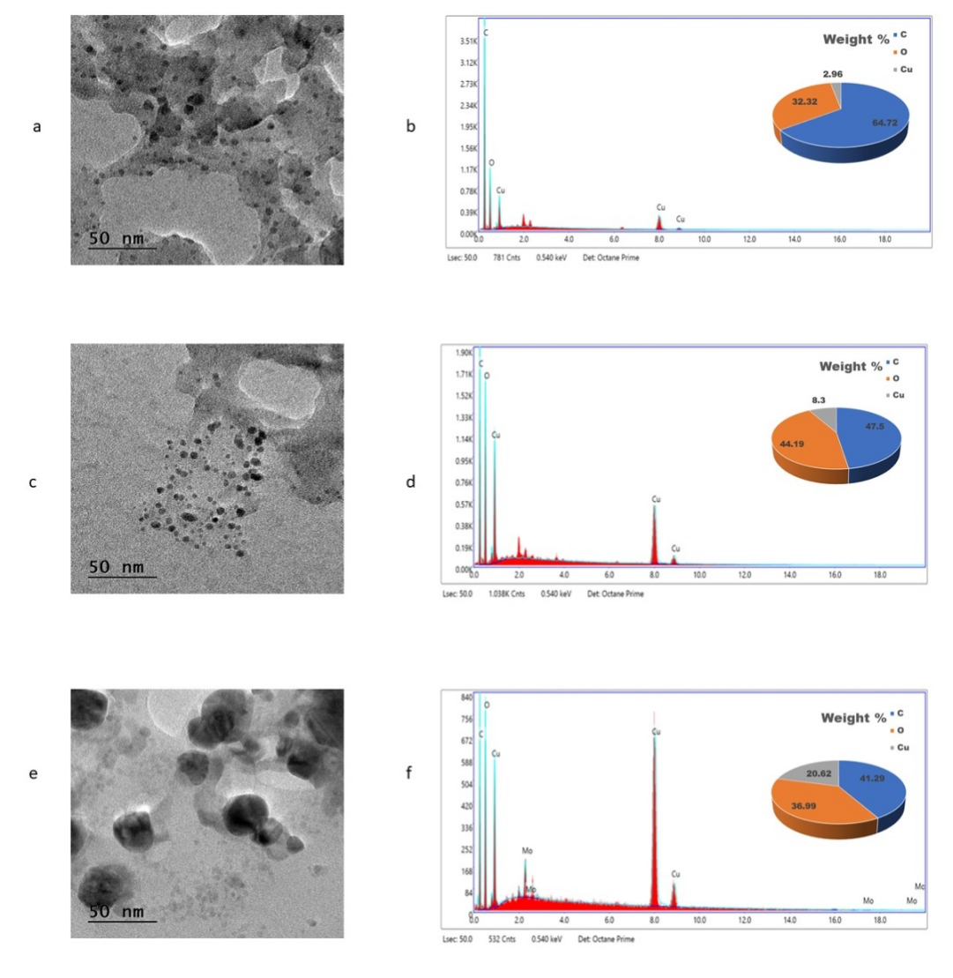

**Figure 1.** (a), (c), (e) TEM images, (b), (d), (f) EDS spectra of the copper oxide nanoparticles prepared using *Nelumbo nucifera, Eichhornia crassipes,* and *Nymphaea rubra* extracts.

The crystallinity of the nanoparticles was confirmed through XRD analysis and the images are shown in Figure 2. The lattice planes (111), (202), and (020) are observed at 23°, 38.1°, and 29.8° for the *Nelumbo nucifera*-mediated copper oxide nanoparticles. For the *Eichhornia crassipes*-mediated nanoparticles, the planes (-111), (111), and (-202) are observed at 35°, 38.3°, and 48.4°. The planes (110), (111), and (20-2) correspond to the angles 35.2°, 38.4°, and 48.5° for the *Nymphaea rubra*-mediated nanoparticles. Similar results were observed copper oxide nanoparticles were synthesized using Efedra-aladaplant extract (Atri et al., 2023). These peaks in the XRD spectrum show that the synthesized CuONPs are crystalline in nature. (Shende et al., 2015), (Rajesh et al., 2018), (Chandraker et al., 2020), (Sarwar et al., 2021) synthesized crystalline copper oxide nanoparticles using *Citrus medica* Juice, *Syzygium aromaticum* bud extract, *Ageratum houstonianum Mill.* leaf extract, cinnamon bark extract respectively. The crystallinity of the CuONPs was calculated using the Scherer’s formula d=Kλ/βcosθ. According to the formula, the average crystalline size of the *Nelumbo nucifera, Eichhornia crassipes* and *Nymphaea rubra*-mediated copper oxide nanoparticles was, 9.23±03 nm, 11±17 nm, and 12±03 nm respectively.

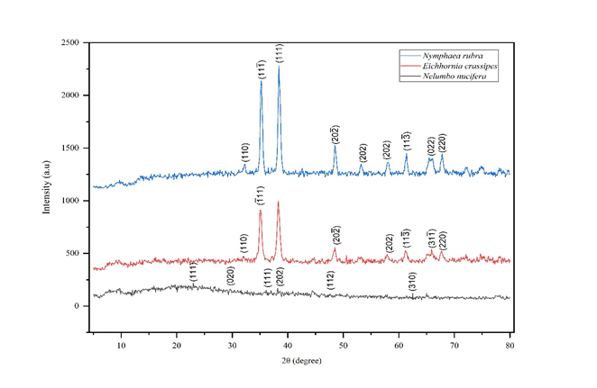

**Figure 2.** XRD spectroscopic data of the copper oxide nanoparticles.

**3.1.2. Fourier-Transform Infrared (FTIR) Spectroscopy of Copper Oxide Nanoparticles**

Vibration spectroscopy through FTIR helps to determine the functional groups of the biomolecules in the aqueous weed extracts that were involved in the formation and stabilisation of the copper oxide nanoparticles (Das et al., 2020). Figure 3 shows the FTIR spectroscopy of the synthesized nanoparticles. A significant number of peaks were observed for each of the synthesized nanoparticles. The peak at 1727 cm-1 is assigned to the C-O vibration of the plant, indicating the presence of esters in the plant extracts. The peaks at 3428 cm-1, 3370 cm-1, and 3448 cm-1 indicate the O-H stretching vibration. Similarly, a previous finding showed the presence of O-H group in the 3371-3212 cm-1 region of the spectrum (Nzilu et al., 2023). The peaks at 1618 cm-1, 1622 cm-1 and 1625 cm-1 correspond to the bending vibration of O-H groups in the plant. The bands at 2915 cm-1, 2890 cm-1 of the spectrum indicated the presence of C-H stretching frequencies in the plant. The peaks at 1448 cm-1, 1435 cm-1, and 1442 cm-1 of the spectrum are assigned to the lactone functional group in the plant while the peaks at 1068 cm-1, 1096 cm-1, and 1040 cm-1 correspond to the amino groups present in the plant extracts. The peaks at 1286 cm-1, 1225 cm-1, and 1337 cm-1 indicate the C-C stretching vibration. The peaks observed in 2386 cm-1, 2383 cm-1 and 2381 cm-1 indicated the presence of SH group in the plant. The peaks at 1448 cm-1, 1435 cm1, and 1442 cm-1 are assigned to the lactone functional group in the plant. Peaks observed in 620 cm-1 and 618 cm-1 and 617 cm-1 related to the stretching vibration of CuONPs.

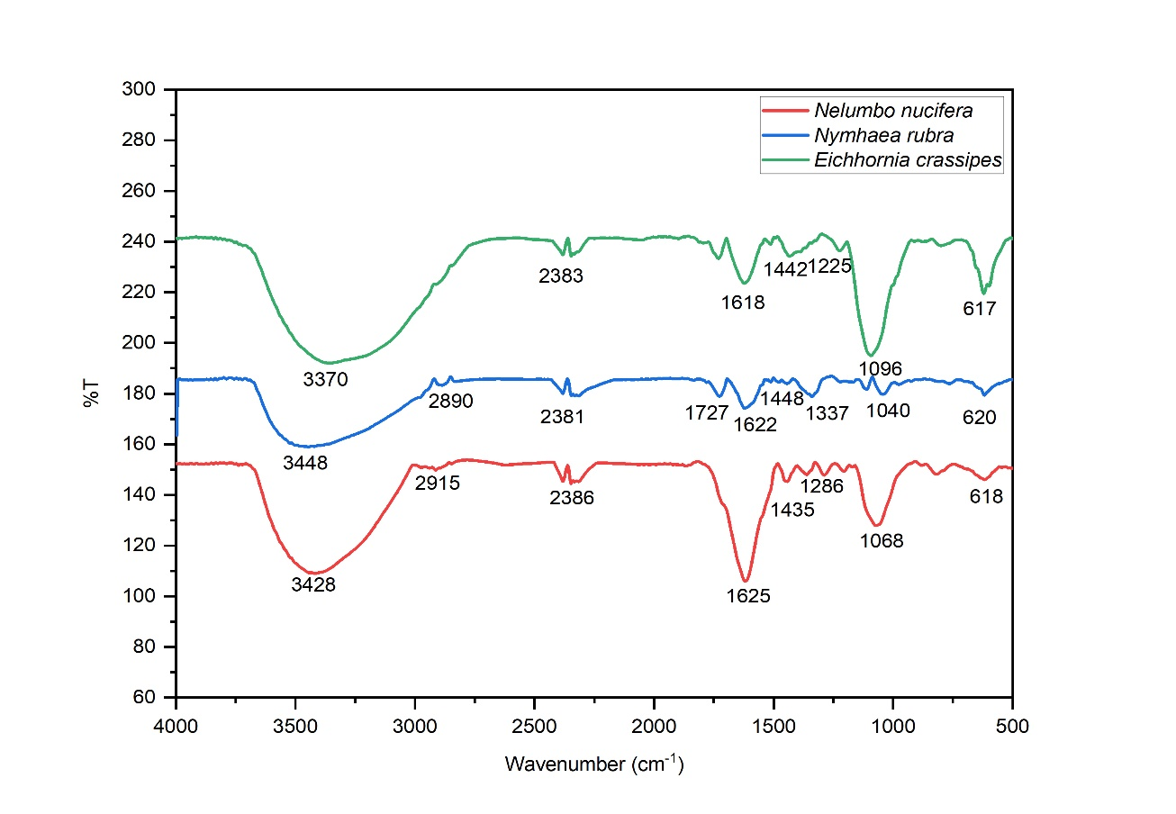

**Figure 3.** FTIR spectra of the copper oxide nanoparticles.

Overall, the results show that the phenol, lactone, thiol, ester, and alcohol groups in the plant extracts are involved in the copper oxide nanoparticles formation. Moudgil et al. (Moudgil et al., 2022) synthesized CuONPs using *Eichhornia crassipes* leaf extract. The FTIR results revealed the involvement of phenols, alkaloids, tannins and flavonoids in the formation of copper oxide nanoparticles. The copper oxide nanoparticles are stabilized by the biomolecules found in the plant extracts, which act as a capping agent (Alshammari et al., 2023; Das et al., 2020).

**3.1.3. UV-Vis Spectral Studies of Copper Oxide Nanoparticles**

The UV-Vis absorption spectra of the synthesized copper oxide nanoparticles are shown in the (figure 4) given below. Usually, the copper oxide nanoparticles show a wavelength ranging from 280 nm to 360 nm. In this case, the bands observed around 300 nm are assigned as σ-π*, and the absorption bands detected around 350 nm are assigned to π-π* transition indicating the CuONPs formation from the plant extracts. Nanoparticles are actually formed by the reduction of copper sulphate by the ions present in plant extracts to form copper hydroxide. Further decomposition by calcination reaction produces copper oxide nanoparticles (Karuppannan et al., 2021). Different plant extracts produce nanoparticles each having different absorption spectra. Nasrollahzadeh & Mohammad Sajadi, (2015) synthesized CuONPs using *Ginkgo biloba* leaf extract having an absorption peak at 269 nm. While using *Eclipta prostrata* leaf extracts, Chung et al., (Chung et al., 2017) synthesized copper oxide nanoparticles with an absorption peak at 565 nm. Fatma et al., (Fatma et al., 2017) obtained CuONPs using *Passiflora foetida* leaf extract, which absorbed the maximum at 350 nm of the spectrum, a similar result was observed in our study.

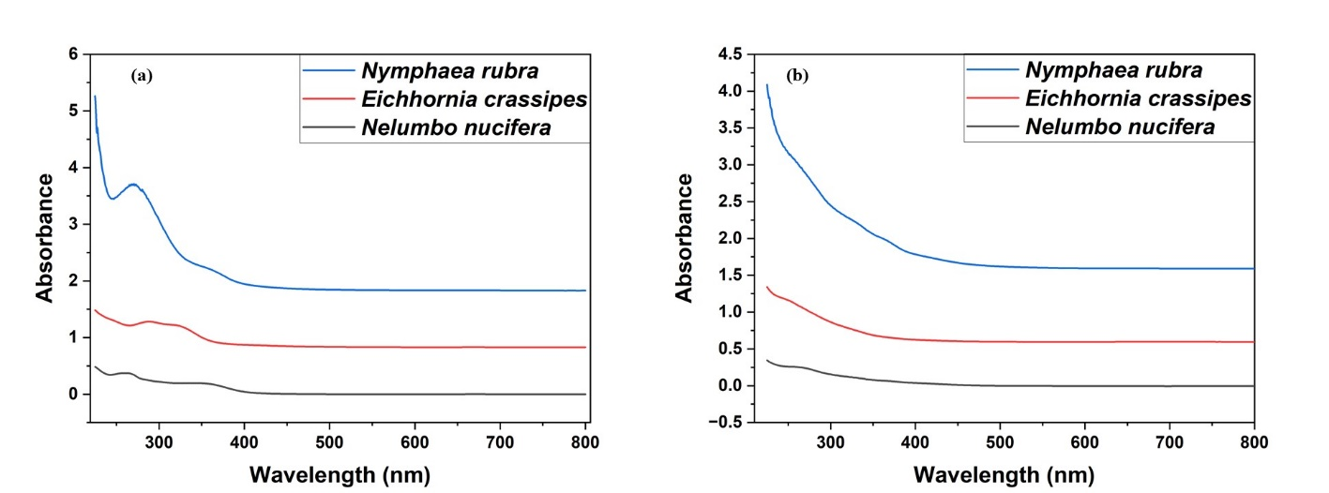

**Figure No.4**  UV-Vis spectra of the (a) Plant extracts (b) Copper oxide nanoparticles.

**3.2. Antioxidant Activity of Copper Oxide Nanoparticles:**

**3.2.1 DPPH Assay:**

DPPH is one of the synthetic stable free radicals that can be easily scavenged by antioxidants and the extent to which it is scavenged is assessed to check the antioxidant capacity of desired molecules (Dangana et al., 2023). The percentage of radical scavanging activity exhibited by the synthesized copper oxide nanoparticles was assessed against standard ascorbic acid and is shown in Table 1. In all the tested nanoparticles, *Nymphaea rubra-mediated* copper oxide nanoparticles exhibited higher antioxidant activity (73.7%), while those synthesized using *Eichhornia crassipes* exhibited the least antioxidant activity (65.2%). The antioxidant activity exhibited by standard ascorbic acid was higher in all concentrations as it is a strong antioxidant. Previously, Das et al., (2020) synthesized CuONPs using *Moringa oleifera* leaves. In this study, the nanoparticles synthesized showed lower antioxidant activity (29.3) than the leaves extract (65.5%). In another study it was found nanoparticles synthesized using *Withania somnifera* showed 62% of antioxidant activity (Shanmugapriya et al., 2022).

**Table 1.** DPPH scavenging activity of the synthesized copper oxide nanoparticles against ascorbic acid.

|  |  |  |  |  |  |
| --- | --- | --- | --- | --- | --- |
| **Samples** | **Percentage of radicals scavenged at different concentrations (µg/ml)** | | | | |
| **10** | **20** | **30** | **40** | **50** |
| Ascorbic Acid | 65.2 | 74.6 | 86.9 | 91.4 | 96.2 |
| *Nelumbo nucifera*-mediated CuO nanoparticles | 14.9 | 26.8 | 38.4 | 57.6 | 69.3 |
| *Nymphaea rubra*-mediated CuO nanoparticles | 18.9 | 30.3 | 44.8 | 60.1 | 73.7 |
| *Eichhornia crassipes-*mediated CuO nanoparticles | 14.0 | 28.5 | 39.8 | 52.6 | 65.2 |

**3.2.2 ABTS**•+ **Decolourisation Assay**

ABTS•+ was used as another assay to determine the antioxidant capacity of the synthesized CuONPs and the result of which is given in Table 2. The principle behind the assay is based on the interaction between the antioxidants and the ABTS•+ [2,2’-Azino-bis (3-ethylbenzothiazoline-6-sulfonic acid) diammonium salt] free radical cation. These interactions will produce a decolorization reaction, and the extent of decolorization is proportional to the inhibition percentage of the antioxidant (Dong et al., 2015; Ilyasov et al., 2020). In this study, the copper oxide nanoparticles showed the decolourisation potential in a dose dependent manner i.e., increased antioxidant property with increase in concentration. Similar trend was observed in the standard ascorbic acid. *Nymphaea rubra-mediated* copper oxide nanoparticles showed the highest ABTS•+ scavenging activity (81.2%) at 50 µg/ml followed by *Nelumbo nucifera* (75.7%) and *Eichhornia crassipes* (70.8%). The lowest activity was observed in *Eichhornia crassipes-*mediated CuO nanoparticles (10.3%) at its lowest concentration. The reason beyond the concentration dependent antioxidant activity is the minute size and a higher concentration of the nanoparticles provide more surface area, which results in more free radicals to bind to their surface, increasing ABTS scavenging potential (Aien et al., 2023).

**Table 2.** ABTS•+ decolourisation assayof the synthesized copper oxide nanoparticles.

|  |  |  |  |  |  |
| --- | --- | --- | --- | --- | --- |
| **Samples** | **Percentage of radicals scavenged at different concentrations (****µg/ml)** | | | | |
| **10** | **20** | **30** | **40** | **50** |
| Ascorbic Acid | 61.6 | 73.9 | 86.1 | 93.3 | 97.8 |
| *Nelumbo nucifera*-mediated CuO nanoparticles | 11.5 | 24.1 | 37.4 | 58.2 | 75.7 |
| *Nymphaea rubra*-mediated CuO nanoparticles | 14.8 | 29.0 | 44.3 | 63.7 | 81.2 |
| *Eichhornia crassipes-*mediated CuO nanoparticles | 10.3 | 22.3 | 33.8 | 52.4 | 70.8 |

**3.2.3 Hydrogen peroxide radical scavenging assay:**

Table 3 shows the hydrogen peroxide radical-scavenging activity of the synthesized copper oxide nanoparticles. Hydrogen peroxide is among one of the toxic free radicals, which can induce cell death by impacting many cellular energetic systems through the deactivation of glycolytic enzymes as evidenced by invitro studies (Rehana et al., 2017). Scavenging the hydrogen peroxide will prevents the cells from apoptosis to a great extent. The synthesized copper oxide nanoparticles exhibit significant antioxidant activities in dose dependent manner. On all the concentrations tested, *Nymphaea rubra*-mediated copper oxide nanoparticles exhibited the highest scavenging activity (77.2%) at 50 µg/ml, *Eichhornia crassipes* exhibited the least antioxidant activity (69.5%), and *Nelumbo nucifera* exhibited moderate antioxidant activity (77.2%).

**Table 3.** Hydrogen peroxide radical scavenging activity of synthesized CuONPs against standard ascorbic acid.

|  |  |  |  |  |  |
| --- | --- | --- | --- | --- | --- |
| **Samples** | **Percentage of radicals scavenged at different concentrations (****µg/ml)** | | | | |
| **10** | **20** | **30** | **40** | **50** |
| Ascorbic Acid | 68.4 | 78.9 | 88.2 | 95.1 | 97.9 |
| *Nelumbo nucifera*-mediated copper oxide nanoparticle | 11.0 | 26.2 | 41.4 | 60.6 | 77.2 |
| *Nymphaea rubra*-mediated copper oxide nanoparticle | 13 | 28.7 | 44.4 | 63.7 | 82.1 |
| *Eichhornia crassipes-*mediated copper oxide nanoparticle | 9.8 | 23.5 | 37.1 | 54.4 | 69.5 |

**3.3. Anti-Bacterial Activity of the Copper Oxide Nanoparticles:**

Using an agar-well diffusion method, the antibacterial activity of the copper oxide nanoparticles was evaluated against six human pathogens and four fish pathogens. All nanoparticles exhibited increased antibacterial activity at increased concentrations. Table 4 shows the antibacterial activity of CuONPs against human pathogens. In all tested concentrations, *N. nucifera-mediated* copper oxide nanoparticles didn’t show any antibacterial activity against *E. coli* which shows its resistant towards the nanoparticles*;* however, they showed high antibacterial activity (25 mm) against *Klebsilla pneumonia* at high concentrations 500 µg/ml. Water-hyacinth-mediated CuONPs showed no antibacterial efficacy against *Pseudomonas aeruginosa* at any of the tested concentration*.* Like *N. nucifera-mediated* CuO NPs, the *E. crassipes* showed high antibacterial activity against *K. pneumonia*. *N. rubra* showed its highest antibacterial activity against *S. aureus,* in which the zone of inhibition was higher (30 mm) than that of the Streptomycin (positive control - 25 mm).

Table 5 shows the antibacterial activity of synthesized CuONPs against fish pathogens. All the synthesized CuONPs showed high antibacterial activity against *E. tarda* particularly the *E. crassipes* and *N. rubra* mediated showed their highest activity (25 mm) at their highest concentrations 500 µg/ml. Both *N. nucifera* and *E. crassipes* showed the least antibacterial activity against *A. hydrophilia,* while *N. rubra* showed the least antibacterial activity against both *A. hydrophilia* and *V. cholerae*. The above results show that *E. coli* and *P. aeruginosa* are resistant to *N. nucifera* and *E. crassipes-mediated* nanoparticles, respectively, while *S. aureus* is highly sensitive to *N. rubra-mediated* copper oxide nanoparticles. The results were better than the CuONPs mediated by *Cedrus deodara* aqueous extract (Ramzan et al., 2019). Nzilu et al., 2023 synthesized CuONPs from plant extracts, which showed a maximum zone of inbition of 20.4 mm which was higher than those synthesized chemically (16mm). In this study, the *N.* rubra showed an inhibition zone of 30 mm. The clear zone formed may be due to the lysis of the bacterial cells by the copper oxide nanoparticles. Nanoparticles trigger bacterial cell death by binding to the cell membrane, alteration of membrane composition and activation of cell death pathway (Karuppannan et al., 2021). Oxidative stress, nucleic acid damage, lipid peroxidation, or disruption of membrane potential cause cell death (Rajeshkumar et al., 2019; Tiwari et al., 2016). The higher antibacterial activity of the synthesized nanoparticles shows them as a potent antibacterial alternative to conventional antibiotics.

**Table 4.** Results of antibacterial activity of synthesized copper oxide nanoparticles against human pathogens.

|  |  |  |  |  |  |  |
| --- | --- | --- | --- | --- | --- | --- |
| **Concentration**  **(µg/ml)** | | **Zone of Inhibition (mm)** | | | | |
| ***Escherichia coli*** | ***Klebsilla pneumonia*** | ***Pseudomonas aeruginosa*** | ***Acinetobacter baumannii*** | ***Staphylococcus aureus*** |
| Lotus mediated copper oxide nanoparticles | 100 | - | 11 | 9 | - | 10 |
| 200 | - | 12 | 12 | - | 15 |
| 300 | - | 14 | 15 | 6 | 17 |
| 400 | - | 20 | 17 | 8 | 18 |
| 500 | - | 25 | 18 | 10 | 19 |
| Water lily-mediated copper oxide nanoparticle | 100 | - | 10 | - | 6 | - |
| 200 | - | 15 | - | 6 | - |
| 300 | - | 16 | - | 7 | 12 |
| 400 | - | 18 | - | 9 | 12 |
| 500 | 10 | 20 | - | 14 | 15 |
| Water hyacinth mediated copper oxide nanoparticle | 100 | 8 | 12 | - | 10 | 15 |
| 200 | 13 | 16 | 10 | 14 | 20 |
| 300 | 15 | 17 | 15 | 15 | 23 |
| 400 | 16 | 18 | 18 | 16 | 26 |
| 500 | 19 | 22 | 20 | 19 | 30 |
| PP |  | - | - | - | - | - |
| DMSO |  | - | - | - | - | - |
| Streptomycin |  | 25 | 30 | 28 | 27 | 25 |

**PP**: Aqueous extract, **DMSO**: Negative control, **Streptomycin**: Positive control

**Table 5.** Results of antibacterial activity of synthesized copper oxide nanoparticles against fish pathogens.

|  |  |  |  |  |  |
| --- | --- | --- | --- | --- | --- |
| **Concentration**  **(µg/ml)** | | **Zone of Inhibition (mm)** | | | |
| ***Aeromonas hydrophila*** | ***Vibrio cholerae*** | ***Edwardseilla tarda*** | ***Aeromonas caviae*** |
| Lotus mediated copper oxide nanoparticles | 100 | - | 8 | 8 | - |
| 200 | - | 9 | 10 | - |
| 300 | 6 | 10 | 13 | 8 |
| 400 | 7 | 13 | 15 | 9 |
| 500 | 8 | 15 | 17 | 11 |
| Water lily-mediated copper oxide nanoparticle | 100 | 7 | 7 | 12 | 11 |
| 200 | 7 | 10 | 18 | 18 |
| 300 | 10 | 15 | 20 | 22 |
| 400 | 15 | 20 | 23 | 23 |
| 500 | 20 | 22 | 28 | 26 |
| Water hyacinth mediated copper oxide nanoparticle | 100 | 12 | 12 | 12 | 11 |
| 200 | 15 | 20 | 18 | 18 |
| 300 | 20 | 22 | 20 | 22 |
| 400 | 22 | 22 | 23 | 23 |
| 500 | 25 | 25 | 28 | 26 |
| PP |  | - | - | - | - |
| DMSO |  | - | - | - | - |
| Streptomycin |  | 30 | 25 | 28 | 32 |

**4. Conclusion:**

Copper oxide nanoparticles were synthesized using three plants: *Nelumbo nucifera, Nymphaea rubra,* and *Eichhornia crassipes*. The nanoparticles formation was confirmed by the UV-Vis spectroscopic method. The functional groups of the plant biomolecules that are actively involved in the formation of CuONPs were investigated through FTIR spectroscopy. The morphology and particle size distribution of the copper oxide nanoparticles synthesized was measured by High-Resolution Transmission Electron Microscopy (HR-TEM) and their elemental analysis was performed with EDS. The crystallinity of nanoparticles was further confirmed by XRD pattern analysis. The synthesized copper oxide nanoparticles showed significant antioxidant properties. The nanoparticles showed scavenging activity against the DPPH, ABTS, and hydrogen peroxide radicles. The nanoparticles were also used to investigate their antibacterialactivity against five human pathogens, viz., *Escherichia coli, Pseudomonas aeruginosa, Klebsiella pneumonia, Acinetobacter baumannii, Staphylococcus aureus,* and four fish pathogens, viz., *Aeromonas hydrophilia, Vibrio cholerae, Edwardsiella tarda, and Aeromonas caviae*. They showed promising results with the formation of inhibition zones. These results show the possibility of obtaining nanoparticles biologically using locally available plants in a cost-effective manner and their utilization for antioxidant and antibacterial properties. The nanoparticles are not only beneficial for human health but also aid in fish health through their use in treatment and prevention of fish diseases, thereby enhancing the sustainability and profitability of aquaculture.

**Competing Interests:**

The authors declare that they have no relevant financial or non-financial interests to disclose.

**Disclaimer (Artificial Intelligence):**

The authors hereby declare that no generative AI tools, including text-to-image generators and large language models (ChatGPT, COPILOT, etc.), were utilized in the creation or editing of manuscripts.

**Data availability:**

The authors declare that the datasets generated during and/or analysed during the current study are available from the corresponding author on reasonable request.

**References:**

1. Abuzeid, H. M., Julien, C. M., Zhu, L., & Hashem, A. M. (2023). Green synthesis of nanoparticles and their energy storage, environmental, and biomedical applications. Crystals, 13(11). https://doi.org/10.3390/cryst13111576
2. Aien, J., Khan, A. A., Haq, S., Khan, A. R., Elmnasri, K., Ben Ali, M., et al. (2023). Antibacterial, antioxidant, and physicochemical properties of Pipper nigram-aided copper oxide nanoparticles. Crystals, 13(2). https://doi.org/10.3390/cryst13020330
3. Alshammari, S. O., Mahmoud, S. Y., & Farrag, E. S. (2023). Synthesis of green copper nanoparticles using medicinal plant Krameria sp. root extract and its applications. Molecules, 28(12). https://doi.org/10.3390/molecules28124629
4. Antonio-Pérez, A., Durán-Armenta, L. F., Pérez-Loredo, M. G., & Torres-Huerta, A. L. (2023). Biosynthesis of copper nanoparticles with medicinal plants extracts: From extraction methods to applications. Micromachines, 14(10). https://doi.org/10.3390/mi14101882
5. Atri, A., Echabaane, M., Bouzidi, A., Harabi, I., Soucase, B. M., & Ben Chaâbane, R. (2023). Green synthesis of copper oxide nanoparticles using Ephedra alata plant extract and a study of their antifungal, antibacterial activity, and photocatalytic performance under sunlight. Heliyon, 9(2). https://doi.org/10.1016/j.heliyon.2023.e13484
6. Biemer, J. J. (1973). Antimicrobial susceptibility testing by the Kirby-Bauer disc diffusion method. Annals of Clinical Laboratory Science, 3(2).
7. C.G. Kiruba Daniel, S., Nehru, K., & Sivakumar, M. (2012). Rapid biosynthesis of silver nanoparticles using Eichornia crassipes and its antibacterial activity. Current Nanoscience, 8(1). https://doi.org/10.2174/1573413711208010125
8. Chakraborty, N., Banerjee, J., Chakraborty, P., Banerjee, A., Chanda, S., Ray, K., et al. (2022). Green synthesis of copper/copper oxide nanoparticles and their applications: A review. Green Chemistry Letters and Reviews, 15(1). https://doi.org/10.1080/17518253.2022.2025916
9. Chandraker, S. K., Lal, M., Ghosh, M. K., Tiwari, V., Ghorai, T. K., & Shukla, R. (2020). Green synthesis of copper nanoparticles using leaf extract of Ageratum houstonianum Mill. and study of their photocatalytic and antibacterial activities. Nano Express, 1(1). https://doi.org/10.1088/2632-959X/ab8e99
10. Chung, I., Rahuman, A. A., Marimuthu, S., Kirthi, A. V., Anbarasan, K., Padmini, P., & Rajakumar, G. (2017). Green synthesis of copper nanoparticles using Eclipta prostrata leaves extract and their antioxidant and cytotoxic activities. Experimental and Therapeutic Medicine, 14(1). https://doi.org/10.3892/etm.2017.4466
11. Dangana, R. S., George, R. C., & Agboola, F. K. (2023). The biosynthesis of zinc oxide nanoparticles using aqueous leaf extracts of Cnidoscolus aconitifolius and their biological activities. Green Chemistry Letters and Reviews, 16(1). https://doi.org/10.1080/17518253.2023.2169591
12. Das, P. E., Abu‐Yousef, I. A., Majdalawieh, A. F., Narasimhan, S., & Poltronieri, P. (2020). Green synthesis of encapsulated copper nanoparticles using a hydroalcoholic extract of Moringa oleifera leaves and assessment of their antioxidant and antimicrobial activities. Molecules, 25(3). https://doi.org/10.3390/molecules25030555
13. Dong, J. W., Cai, L., Xing, Y., Yu, J., & Ding, Z. T. (2015). Re-evaluation of ABTS·G+ assay for total antioxidant capacity of natural products. Natural Product Communications, 10(12). https://doi.org/10.1177/1934578x1501001239
14. Elmastaş, M., Gülçin, I., Işildak, Ö., Küfrevioǧlu, Ö. I., Ibaoǧlu, K., & Aboul-Enein, H. Y. (2006). Radical scavenging activity and antioxidant capacity of bay leaf extracts. Journal of the Iranian Chemical Society, 3(3). https://doi.org/10.1007/BF03247217
15. Fatma, S., Kalainila, P., Ernest Ravindran, R. S., & Renganathan, S. (2017). Green synthesis of copper nanoparticles from Passiflora foetida leaf extract and its antibacterial activity. Asian Journal of Pharmaceutical and Clinical Research, 10(4). https://doi.org/10.22159/ajpcr.2017.v10i4.15744
16. Grace, M., Chand, N., & Bajpai, S. K. (2009). Copper alginate-cotton cellulose (CACC) fibers with excellent antibacterial properties. Journal of Engineered Fibers and Fabrics, 4(3). https://doi.org/10.1177/155892500900400303
17. Gu, J., Chen, F., Zheng, Z., Bi, L., Morovvati, H., & Goorani, S. (2023). Novel green formulation of copper nanoparticles by Foeniculum vulgare: Chemical characterization and determination of cytotoxicity, anti-human lung cancer, and antioxidant effects. Inorganic Chemistry Communications, 150, 110442. https://doi.org/10.1016/J.INOCHE.2023.110442.
18. Hublikar, L. V., Ganachari, S. V., Raghavendra, N., Patil, V. B., & Banapurmath, N. R. (2021). Green synthesis silver nanoparticles via Eichhornia crassipes leaves extract and their applications. Current Research in Green and Sustainable Chemistry, 4, 100212. https://doi.org/10.1016/j.crgsc.2021.100212
19. Iliger, K. S., Sofi, T. A., Bhat, N. A., Ahanger, F. A., Sekhar, J. C., Elhendi, A. Z., Al-Huqail, A. A., & Khan, F. (2021). Copper nanoparticles: Green synthesis and managing fruit rot disease of chilli caused by Colletotrichum capsici. Saudi Journal of Biological Sciences, 28(2), 1003–1011. https://doi.org/10.1016/j.sjbs.2020.12.003
20. Ilyasov, I. R., Beloborodov, V. L., Selivanova, I. A., & Terekhov, R. P. (2020). ABTS/PP decolorization assay of antioxidant capacity reaction pathways. International Journal of Molecular Sciences, 21(3), 1131. https://doi.org/10.3390/ijms21031131
21. Ivanova, I. A., Daskalova, D. S., Yordanova, L. P., & Pavlova, E. L. (2024). Copper and copper nanoparticles applications and their role against infections: A minireview. Processes, 12(2), 352. https://doi.org/10.3390/pr12020352
22. Jagathesan, G., & Rajiv, P. (2018). Biosynthesis and characterization of iron oxide nanoparticles using Eichhornia crassipes leaf extract and assessing their antibacterial activity. Biocatalysis and Agricultural Biotechnology, 13, 384–390. https://doi.org/10.1016/j.bcab.2017.11.014
23. Karuppannan, S. K., Ramalingam, R., Mohamed Khalith, S. B., Dowlath, M. J. H., Darul Raiyaan, G. I., & Arunachalam, K. D. (2021). Characterization, antibacterial and photocatalytic evaluation of green synthesized copper oxide nanoparticles. Biocatalysis and Agricultural Biotechnology, 31, 101904. https://doi.org/10.1016/j.bcab.2020.101904
24. Kirubakaran, D., Selvam, K., Dhaneeshram, M., Shivakumar, M. S., Rajkumar, M., & Shanmugarathinam, A. (2024). Biogenic synthesis of copper nanoparticle using Impatiens chinensis L: Insights into antimicrobial, antioxidant and anticancer activity. Journal of Molecular Structure, 1317, 138991. https://doi.org/10.1016/J.MOLSTRUC.2024.138991
25. Kirubakaran, D., Selvam, K., Prakash, P., Shivakumar, M. S., & Rajkumar, M. (2023). In-vitro antioxidant, antidiabetic, anticholinergic activity of iron/copper nanoparticles synthesized using Strobilanthes cordifolia leaf extract. OpenNano, 14, 100188. https://doi.org/10.1016/j.onano.2023.100188
26. Kumar, A., & Pareek, A. (2016). Pharmacognostic studies on Nymphaea spp. World Journal of Pharmaceutical Research, 5(6), 1273–1290. https://doi.org/10.20959/wjpr20166-6285
27. Martínez-Espinosa, J. C., Ramírez-Morales, M. A., & Carrera-Cerritos, R. (2022). Silver nanoparticles synthesized using Eichhornia crassipes extract from Yuriria Lagoon, and the perspective for application as antimicrobial agent. Crystals, 12(6), 814. https://doi.org/10.3390/cryst12060814
28. Maulana, I., Ginting, B., & Azizah, K. (2023). Green synthesis of copper nanoparticles employing Annona squamosa L extract as antimicrobial and anticancer agents. South African Journal of Chemical Engineering, 46, 100643. https://doi.org/10.1016/j.sajce.2023.07.010
29. Moudgil, A., Varma, S., Shinde, M. D., Vamkudoth, K. R., Sarkar, D. M., Shende, R. A., Amalnerkar, D., & Chaudhari, B. P. (2022). One-pot concurrent biosynthesis of biphasic CuxO (cuprous and cupric oxide) nanoparticles using leaf extract of Eichhornia crassipes and investigation of their potent healthcare applications. Emergent Materials, 5(2), 327–340. https://doi.org/10.1007/s42247-022-00347-1
30. Nasrollahzadeh, M., & Mohammad Sajadi, S. (2015). Green synthesis of copper nanoparticles using Ginkgo biloba L. leaf extract and their catalytic activity for the Huisgen [3+2] cycloaddition of azides and alkynes at room temperature. Journal of Colloid and Interface Science, 457, 141–147. https://doi.org/10.1016/j.jcis.2015.07.004
31. Naz, S., Gul, A., Zia, M., & Javed, R. (2023). Synthesis, biomedical applications, and toxicity of CuO nanoparticles. Applied Microbiology and Biotechnology, 107(4), 1181–1197. https://doi.org/10.1007/s00253-023-12364-z
32. Nzilu, D. M., Madivoli, E. S., Makhanu, D. S., Wanakai, S. I., Kiprono, G. K., & Kareru, P. G. (2023). Green synthesis of copper oxide nanoparticles and its efficiency in degradation of rifampicin antibiotic. Scientific Reports, 13(1), 12988. https://doi.org/10.1038/s41598-023-41119-z
33. Ono, Y., Hattori, E., Fukaya, Y., Imai, S., & Ohizumi, Y. (2006). Anti-obesity effect of Nelumbo nucifera leaves extract in mice and rats. Journal of Ethnopharmacology, 106(2), 238–244. https://doi.org/10.1016/j.jep.2005.12.036
34. Osman, A. I., Zhang, Y., Farghali, M., Rashwan, A. K., Eltaweil, A. S., Abd El-Monaem, E. M., Mohamed, I. M. A., Badr, M. M., Ihara, I., Rooney, D. W., & Yap, P. S. (2024). Synthesis of green nanoparticles for energy, biomedical, environmental, agricultural, and food applications: A review. Environmental Chemistry Letters, 22(2), 1309–1348. https://doi.org/10.1007/s10311-023-01682-3
35. Pandit, R., Gaikwad, S., & Rai, M. (2017). Biogenic fabrication of CuNPs, Cu bioconjugates and in vitro assessment of antimicrobial and antioxidant activity. IET Nanobiotechnology, 11(5), 624–630. https://doi.org/10.1049/iet-nbt.2016.0165
36. Prabakaran, N. (2018). Evaluation of antimicrobial activity of silver nanoparticle using Eichhornia crassipes leaves extract. Journal of Pharmacognosy and Phytochemistry, 7(5), 1308–1311.
37. Premanand, G., Shanmugam, N., Kannadasan, N., Sathishkumar, K., & Viruthagiri, G. (2016). Nelumbo nucifera leaf extract mediated synthesis of silver nanoparticles and their antimicrobial properties against some human pathogens. Applied Nanoscience, 6(3), 361–370. https://doi.org/10.1007/s13204-015-0442-6
38. Rajesh, K. M., Ajitha, B., Reddy, Y. A. K., Suneetha, Y., & Reddy, P. S. (2018). Assisted green synthesis of copper nanoparticles using Syzygium aromaticum bud extract: Physical, optical and antimicrobial properties. Optik, 154, 766–773. https://doi.org/10.1016/j.ijleo.2017.10.074
39. Rajeshkumar, S., Menon, S., Venkat Kumar, S., Tambuwala, M. M., Bakshi, H. A., Mehta, M., Satija, S., Gupta, G., Chellappan, D. K., Thangavelu, L., & Dua, K. (2019). Antibacterial and antioxidant potential of biosynthesized copper nanoparticles mediated through Cissus arnotiana plant extract. Journal of Photochemistry and Photobiology B: Biology, 197, 111531. https://doi.org/10.1016/j.jphotobiol.2019.111531
40. Ramzan, M., Obodo, R. M., Mukhtar, S., Ilyas, S. Z., Aziz, F., & Thovhogi, N. (2019). Green synthesis of copper oxide nanoparticles using Cedrus deodara aqueous extract for antibacterial activity. Materials Today: Proceedings, 36, 121–127. https://doi.org/10.1016/j.matpr.2020.05.472
41. Rehana, D., Mahendiran, D., Kumar, R. S., & Rahiman, A. K. (2017). Evaluation of antioxidant and anticancer activity of copper oxide nanoparticles synthesized using medicinally important plant extracts. Biomedicine and Pharmacotherapy, 89, 1067–1077. https://doi.org/10.1016/j.biopha.2017.02.101
42. Sanna, V., Pala, N., DessÌ, G., Manconi, P., Mariani, A., Dedola, S., Rassu, M., Crosio, C., Iaccarino, C., & Sechi, M. (2014). Single-step green synthesis and characterization of gold-conjugated polyphenol nanoparticles with antioxidant and biological activities. International Journal of Nanomedicine, 9(1). https://doi.org/10.2147/IJN.S70648
43. Santhosh, P. B., Genova, J., & Chamati, H. (2022). Green synthesis of gold nanoparticles: An eco-friendly approach. Chemistry (Switzerland, 4)(2). https://doi.org/10.3390/chemistry4020026
44. Sarwar, N., Humayoun, U. Bin, Kumar, M., Zaidi, S. F. A., Yoo, J. H., Ali, N., Jeong, D. I., Lee, J. H., & Yoon, D. H. (2021). Citric acid mediated green synthesis of copper nanoparticles using cinnamon bark extract and its multifaceted applications. Journal of Cleaner Production, 292, 125974. https://doi.org/10.1016/j.jclepro.2021.125974
45. Shanmugapriya, J., Reshma, C. A., Srinidhi, V., Harithpriya, K., Ramkumar, K. M., Umpathy, D., Gunasekaran, K., & Subashini, R. (2022). Green synthesis of copper nanoparticles using Withania somnifera and its antioxidant and antibacterial activity. Journal of Nanomaterials, 2022. https://doi.org/10.1155/2022/7967294
46. Sharma, B. R., Gautam, L. N. S., Adhikari, D., & Karki, R. (2017). A comprehensive review on chemical profiling of Nelumbo nucifera: Potential for drug development. Phytotherapy Research, 31(1). https://doi.org/10.1002/ptr.5732
47. Shende, S., Ingle, A. P., Gade, A., & Rai, M. (2015). Green synthesis of copper nanoparticles by Citrus medica Linn. (Idilimbu) juice and its antimicrobial activity. World Journal of Microbiology and Biotechnology, 31(6). https://doi.org/10.1007/s11274-015-1840-3
48. Singh, D., Jain, D., Rajpurohit, D., Jat, G., Kushwaha, H. S., Singh, A., Mohanty, S. R., Al-Sadoon, M. K., Zaman, W., & Upadhyay, S. K. (2023). Bacteria-assisted green synthesis of copper oxide nanoparticles and their potential applications as antimicrobial agents and plant growth stimulants. Frontiers in Chemistry, 11. https://doi.org/10.3389/fchem.2023.1154128
49. Subhankari, I., & Nayak, P. L. (2013). Antimicrobial activity of copper nanoparticles synthesized by ginger (Zingiber officinale) extract. World Journal of Nano Science & Technology, 2(1).
50. Teklu, B., Kadiri, S. K., & Vidavalur, S. (2023). Green synthesis of copper oxide nanoparticles using Balanites aegyptiaca stem bark extract and investigation of antibacterial activity. Results in Chemistry, 6. https://doi.org/10.1016/j.rechem.2023.101152
51. Tiwari, M., Jain, P., Chandrashekhar Hariharapura, R., Narayanan, K., Bhat, K. U., Udupa, N., & Rao, J. V. (2016). Biosynthesis of copper nanoparticles using copper-resistant Bacillus cereus, a soil isolate. Process Biochemistry, 51(10). https://doi.org/10.1016/j.procbio.2016.08.008
52. Tyagi, T. A. M. (2015). Pharmaceutical potential of aquatic plant Pistia stratiotes (L.) and Eichhornia crassipes. Journal of Plant Sciences, 3(1).
53. Vijayaram, S., Razafindralambo, H., Sun, Y. Z., Vasantharaj, S., Ghafarifarsani, H., Hoseinifar, S. H., & Raeeszadeh, M. (2024). Applications of green synthesized metal nanoparticles — A review. Biological Trace Element Research, 202(1). https://doi.org/10.1007/s12011-023-03645-9
54. Wu, S., Rajeshkumar, S., Madasamy, M., & Mahendran, V. (2020). Green synthesis of copper nanoparticles using Cissus vitiginea and its antioxidant and antibacterial activity against urinary tract infection pathogens. Artificial Cells, Nanomedicine and Biotechnology, 48(1). https://doi.org/10.1080/21691401.2020.1817053
55. Xu, J. J., Zhang, W. C., Guo, Y. W., Chen, X. Y., & Zhang, Y. N. (2022). Metal nanoparticles as a promising technology in targeted cancer treatment. Drug Delivery, 29(1). https://doi.org/10.1080/10717544.2022.2039804