**SEASONAL INCIDENCE OF INSECT PESTS OF STEM BORER OF MAIZE *(CHILO PARTELLUS L.)***

**ABSTRACT:** The Field experiment was carried out at the Entomological experimental field, Diksha Bhawan, Institute of Agriculture and Natural Science, Deen Dayal Upadhyaya Gorakhpur University, Gorakhpur (Uttar Pradesh) during the *Kharif* season 2023 to study on “Seasonal incidence of insect-pests of stem Borer of Maize *(Chilo Partellus L.).* The pest activity was initially observed in the 32nd SMW and continued till the crop harvesting stage 43rd SMW. The recorded percentage of dead heart ranged from 0.33 to 3.27 per cent during the year, 2023. The percentage of dead heart formation was low from the First week of August to the end of August and varied from 0.33 to 1.67 per cent. The dead heart formation increased from the first week of September and reached its peak *i.e.* 3.27 per cent during the 39th standard week. It is evident from the correlation of per cent dead heart of stem borer, *C*. *partellus*was found positive with maximum (r= 0.371) and minimum (r= 0.34) temperature during*,* 2023. The correlation between dead heart with morning and evening relative humidity was found positive r= 0.07 and 0.221, respectively. While rainfall negative correlation r= -0.359 dead heart of *C*. *partellus*, respectively during the year 2023. The correlation coefficient between the larval population of *C. partellus*and weather parameters presented in the data revealed that the correlation of the larval population of *C. partellus*was found positive with maximum (r= 0.334) and minimum (r= 0.362) temperature during the year*,* 2023. The correlation between larval population with morning and evening relative humidity was found negative r= -0.092 and r= -0.304, respectively. While rainfall had negative correlation (r= -0.313) larval population.

**KEYWORD:** *C. partellus,*Seasonal incidence, Correlation coefficient.

**INTRODUCTION**

Maize (*Zea mays* L.) belongs to the family Poaceae is a cereal grain, also known as the Queen of cereals‖ due to its diverse usages. In India, maize is the third most important staple food crop after rice and wheat. Depending on the regions and socio-economic conditions of the population, maize is used for various purposes including food, feed, fodder, sweet corn, baby corn, popcorn, starch and several industrial products. (Reddy *et al*., 2020). Maize is a traditional crop that is generally cultivated as a source of food, feed and fodder. Demand for maize crops is increasing in higher amount every year due to the higher nutritional benefits. Nutritionally, maize grains have 10% protein, 4% oil, 70% carbohydrate, and 2-3% crude fibres, besides having Vitamin A and E, nicotinic acid and riboflavin but its protein Zein is deficient in tryptophan and lysine among essential acids and is deficient in calcium. One of the major reasons for the decline in maize productivity is due to the insect pest infestation. It is attacked by about 140 species of insect pests causing varying degrees of damage throughout the crop period. (MB and Patel *et al*., 2020) The generation of new agricultural technology has led to 12 times increase in maize production i.e. from 1.73 tonnes in 1950-51 to 21.60 million tonnes at present in India. However, the average productivity of maize crop in India i.e. 29.67 quintals per hectare and Uttar Pradesh i.e. 17.78 quintals per hectare, is very low as compared to that of the world i.e. 51.85 quintals per hectare in 2011 (FAO 2016) (Reddy *et al*, .2021).

The larvae cut the growing point resulting in the drying up of the central shoot and subsequent formation of dead heart which on pulling comes out easily. Larvae feed on the tissues (pith) inside the stem and tunnels are formed due to which not only plant vigour is lost but also a reduction in grain yield. With slight wind, the plant collapses and dries. Losses in yield vary from 26.7 to 80.4 per cent and are attributed to early infestation (10-20 days old plants) on the growing plant. Caterpillars also damaged by boring into immature cobs and tassels. Keeping in view of the importance of the maize crop, and the economic losses caused by the spotted stem borer during *Kharif* season. (Reddy, *et al*., 2018).

**MATERIAL AND METHODS**

The Field experiment was carried out at the Entomological experimental field, Diksha Bhawan, Institute of Agriculture and Natural Science, Deen Dayal Upadhyaya Gorakhpur University Gorakhpur (Uttar Pradesh) The experiment site is located at about 100 km away from the Nepal border and Eastern part of Uttar Pradesh. Gorakhpur is situated in the Eastern part of Uttar Pradesh and is situated within latitude 26*7479’N and Longitude 83.3812 with an altitude of 75 meters above the mean sea level (MSL). The soil of the experimental field was uniform with sandy loam garden soil having medium fertility and fairly good drainage. Soil is medium in organic carbon and nitrogen. The Kohinoor (desi) variety of maize was sown at a rate of 20–25 kg/ha using the dibbling method, with a 60 cm gap between rows and a 60 cm gap between plants. 2 to 3 seeds were planted per hill at a depth of 4-5 cm. Apply Super phosphate@75-150 kg, 75- 110 kg of Urea and 15-20 kg of Potash per acre maize crop. Apply a whole amount of SSP and MOP and one-third of Urea at the time of sowing. The occurrence of maize stem borer, *Chilo partellus* (Swinhoe), was observed by 5 randomly selected plants at ten different locations in each location of the plot. Then the stems were counted for the number of larvae of *Chilo partellus* Swinhoe at seven days intervals starting from seven days after germination till harvest of the crop. The total number of dead hearts due to stem borer was recorded from five randomly selected plants from the net plot and the mean per cent dead hearts was worked out by using the following formula:

Per cent dead heart = Total number of plants X 100

Number of dead hearts

The observation was recorded at weekly intervals throughout the cropping season. To assess the incidence of stem borer at weekly intervals the total number of plants and number of infested plants (number of dead hearts and pin holes present on the leaves) was counted from each plot.

The percentage infestation of the maize stem borer was calculated according to the following equation:



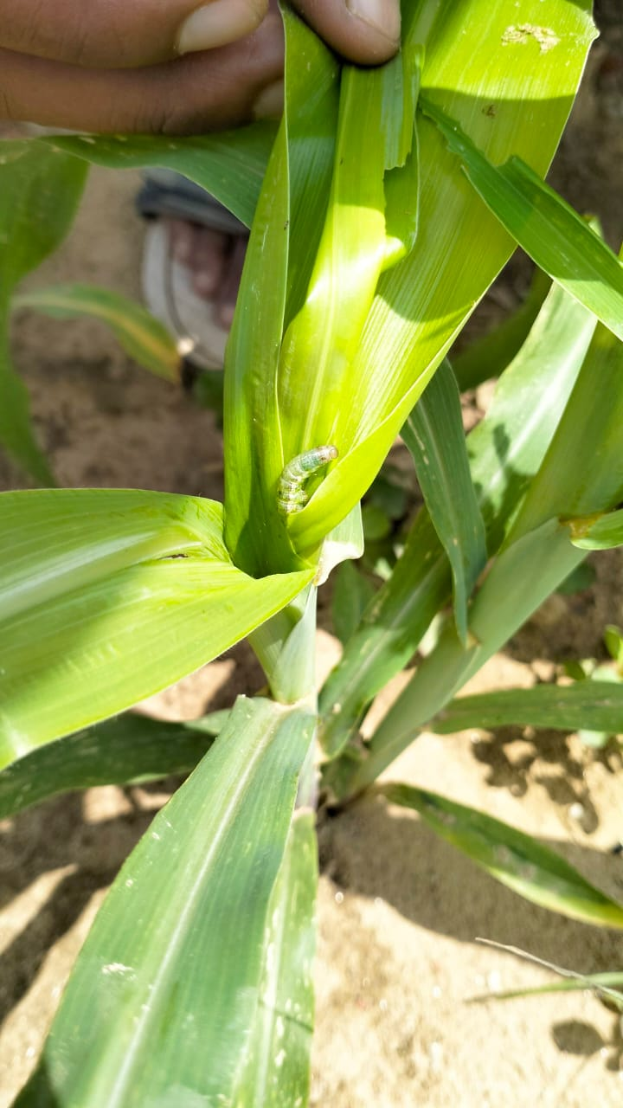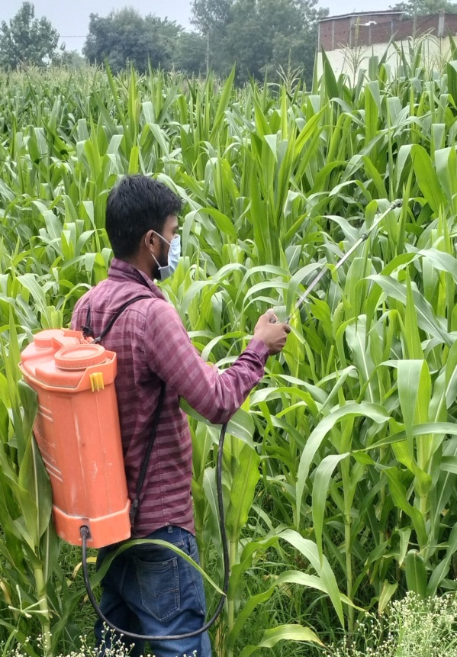

**Fig. 1 Infestation of *Chilo partellus* and spraying of pesticides.**

**RESULT AND DISCUSSION**

###### Seasonal incidence of maize stem borer, *Chilo partellus* (Swinhoe) on maize

The data about the mean number of maize stem borer larvae per plant have been summarized in Table 1 and illustrated in Fig. 1. The data presented in the table revealed that the pest activity was initially observed in the 32nd standard week (1st week of August 2023) and continued till the crop harvesting stage (43rd standard week of October 2023). It was further inferred that the pest population in the beginning was low (0.47 larvae/plant) which increased continuously and reached its peak (5.13 larvae/plant) in the 39th standard week (4th week of September, 2023). After that, its population started declining slowly (3.67,1.73 and 0.67 larva/plant) from the 40th standard week (1st week of October) to the 42nd standard week (3rd week of October, 2023). It might be due to prevailing high temperature, unexpected rainfall and fluctuating sunshine duration (max. 35.27 ºC, 0.31mm) noticed during these standard weeks continuously.

So far as the effect of weather parameters is concerned, the maximum number of maize stem borer population (5.13 larvae/plant) was recorded during the 39th standard week (4th week of September 2023) when corresponding weather parameters *viz*., maximum, minimum temperature (ºC), relative humidity (per cent), rainfall (mm) were 33.36, 25.41, 77.67, 71.71, and 0.69, respectively. On the other hand, the minimum population of maize stem borer (0.47 larvae/plant) was recorded at maximum and minimum temperatures (30.84 ºC and 25.73 ºC), relative humidity (86.14 % and 79.29 %) rainfall (39.96 mm). The present findings are near the findings of Patel *et al*. (2016) who observed that the incidence of stem borer larvae commenced in the 29th standard week (3rd week of July) and reached a peak in the 34th standard week (3rd week of August).

The present finding broadly collaborates with the studies of Trehan and Butani (1949) who observed higher infestation of C. partellus during *Kharif* (July - August sown crop) than in September-October sown crop. The maximum incidence of the pest during the September and October months, as revealed in the present studies is in line with the reports of Siddig (1972) from Sudan who also observed the peak incidence of C. partellus on maize during November. Similar results were also reported by Firke and Kadam (1978) and Panwar and Sarup (1980) on maize.

**Correlation of larval population of stem borer, *C. partellus* during, 2023**

The result of the simple correlation coefficient between the larval population of *C. partellus*and weather parameters presented in the data revealed that the correlation of the larval population of *C. partellus*was found positive with maximum (r= 0.334) and minimum (r= 0.362) temperature during the year*,* 2023. The correlation between larval population with morning and evening relative humidity was found negative r= -0.092 and r= -0.304, respectively. While rainfall had a negative correlation (r= -0.313) larval population during the year, 2023.

The present investigation are in accordance with the findings of Jalali and Singh (2003) who stated that maximum and minimum temperatures showed a significant negative correlation with Chilo partellus infestation while relative humidity had a significant positive correlation with infestation during *Kharif.*

###### Seasonal incidence and correlation of infestation of *C. partellus* during the year, 2023

The observations on per cent infestation of *C. partellus* on maize were recorded from August (33rd standard week) till the harvest of the crop. The recorded per cent infestation varied from 4.7 to 34.3 per cent during the year, 2023.

The per cent infestation was low from the second week of August to the end of October and varied from 4.7 to 6.0 per cent. The infestation increased from the second week of August and reached its peak *i.e.* 34.3 percent during the 38th standard week. During this period mean temperature, mean relative humidity, and rainfall ranged from 29.52, 72.64%, and 0.33 respectively. The infestation of *C. partellus* declined thereafter and it varied from 4.7 to 34.3 per cent when mean temperature, mean relative humidity, and rainfall ranged from 29.35 to 29.52˚C, 77.64% to 72.64 %, 4.54 to 0.33 mm respectively. The percent infestation decreased subsequently in June *i.e.* 39th to 43rd standard week of the respective year.

The present findings are in close proximity with the findings of Patel *et al.,* (2016), who observed that the incidence of stem borer larvae commenced in 29th standard week (3rd week of July) and reached to a peak in the 34th standard week (3rd week of August). The present experimental findings, it is quite clear that the maize stem borer per cent infestation was high (32.0 per cent) in the 38th standard week (3rd week of September 2016) and then infestation decreased continuously may be due to unexpected rainfall and also due to maturity stage of the crop when the larva was under preparation of diapause. Zulfikar *et al.,* (2010).

**Correlation of infestation of stem borer, *C. partellus* during, 2023**

The result of the simple correlation coefficient between the infestation of *C. partellus* during the year, 2023 and weather parameters are presented in the data revealed that the correlation of per cent infestation of *C. partellus*was found positive with maximum (r= 0.403) and positive with minimum (r= 0.172) temperature during the year*,* 2023. The correlation between the percent infestation of *C. partellus* with morning and evening relative humidity was found negative correlation r= -0.065 and r= 0.098, respectively. While rainfall negative correlation r= -0.465 per cent infestation of *C. partellus*, respectively during the year, 2023.

The present investigation are in accordance with the findings of Jalali and Singh (2003) who stated that maximum and minimum temperatures showed a significant negative correlation with Chilo partellus infestation while relative humidity had a significant positive correlation with infestation during *Kharif*.

###### Seasonal incidence of percent dead heart of *C. partellus* during, 2023

The dead heart formation of *C. partellus* in maize was recorded from August (32nd standard week) to mid-October (39th standard week). The recorded percentage of dead heart ranged from 0.33 to 3.27 per cent during the year, 2023. The percentage of dead heart formation was low from the First week of August to the end of August and varied from 0.33 to 1.67 per cent. The dead heart formation increased from the first week of September and reached its peak *i.e.* 3.27 per cent during the 39th standard week. During this period mean temperature, mean relative humidity, rainfall varied from 28.280c, 74.48%, and 0.69 mm respectively. The formation of dead heart declined thereafter and it varied from 0 to 2.53 per cent when mean temperature, mean relative humidity, and rainfall ranged from 28.13˚C, 76.07%, and 1.73 mm, respectively. The dead heart formation decreased subsequently in October *i.e.* 42th and 43th standard week of respective year.

These findings are supported more or less by Ahad et al. (2008) who reported that the maximum infestation of Chilo partellus who found infestation rose in the summer months and declined more till the beginning of the winter season. The experimental results were similar to the findings of Kandalkar *et al*. (1996) who reported that the peak infestation of *C. partellus* was noticed between 31-68 days after sowing. The infestation of *Chilo partelous* was found highest at the temperature of 32.5 °C relative humidity at 68% (Zulfiqar *et al.,* 2010).

**Correlation of dead heart of stem borer, *C*. *partellus* during, 2023**

It is evident from the correlation of the per cent dead heart of stem borer, *C*. *partellus*was found positive with maximum (r= 0.371) and minimum (r= 0.34) temperature during*,* 2023. The correlation between dead heart with morning and evening relative humidity was found positive r= 0.07 and 0.221, respectively. While rainfall negative correlation r= -0.359 dead heart of *C*. *partellus*, respectively during the year, 2023. Dead heart (r = -0.606*) while minimum relative humidity was a negative and non-significant correlation with r = -0.141 and r = - 0.218 respectively. The weather variables rainfall (mm) and sunshine (hrs.) were also recorded as non-significant and negative correlations. These records were also revealed by Jeengar (2005) with reported temperature and relative humidity significant with the stem borer infestation.

**Table 1. Seasonal incidence and correlation of larval population of *C. partellus* during the year, 2023**

|  |  |  |  |  |  |  |  |
| --- | --- | --- | --- | --- | --- | --- | --- |
| **SMW** | **Date of observation** | **Larvae/plant** | **Temperature** | | **Relative humidity** | | **Rainfall mm** |
|  |  |  | **max** | **min** | **Morn.** | **Even** |  |
| 31st | 30/07/2023 | 0.00(1.00) | 34.2 | 27.00 | 78.71 | 70.71 | 4.91 |
| 32nd | 6/8/2023 | 0.47(1.21) | 30.84 | 25.73 | 86.14 | 79.29 | 39.96 |
| 33rd | 13/082023 | 0.93(1.39) | 32.24 | 26.46 | 82.57 | 72.71 | 4.54 |
| 34th | 20/08/2023 | 1.67(1.63) | 31.73 | 25.66 | 62.57 | 76.57 | 23.56 |
| 35th | 27/08/2023 | 2.07(1.75) | 31.82 | 27.23 | 71.43 | 62 | 0.31 |
| 36th | 3/9/2023 | 2.53(1.87) | 35.1 | 26.13 | 77.43 | 75.14 | 9.77 |
| 37th | 10/9/2023 | 3.40(2.09) | 35.27 | 26.89 | 75.29 | 69.29 | 1.19 |
| 38th | 17/09/2023 | 4.07(2.25) | 33.14 | 25.91 | 73.57 | 71.71 | 0.33 |
| 39th | 24/09/2023 | 5.13(2.47) | 33.36 | 25.41 | 77.67 | 71.29 | 0.69 |
| 40th | 1/10/2023 | 3.67(2.16) | 31.9 | 24.37 | 78.71 | 73.43 | 1.73 |
| 41th | 8/10/2023 | 1.73(1.65) | 34.43 | 23.44 | 71.86 | 55 | 0 |
| 42th | 15/10/2023 | 0.67(1.29) | 31.6 | 19.74 | 70.14 | 53.29 | 0.46 |
| 43th | 22/10/2023 | 0.00(1.00) | 31.9 | 17.66 | 65 | 52.71 | 0 |
| **Mean** |  | 2.03 | 32.89 | 24.74 | 74.70 | 67.93 | 6.73 |
| **CD@5%** |  | **0.068** |  |  |  |  |  |
| **S.Em±** |  | **0.023** |  |  |  |  |  |
| **S.E(d)** |  | **0.033** |  |  |  |  |  |
| **CV(%)** |  | **2.38** |  |  |  |  |  |

|  |  |  |  |  |  |  |  |
| --- | --- | --- | --- | --- | --- | --- | --- |
| **SW** | **Date of observation** | **%**  **Infestation** | **Temperature** | | **Relative humidity** | | **Rainfall mm** |
|  |  |  | **max** | **min** | **Morn.** | **Even.** |  |
| 31st | 30/07/2023 | 0.0(0.00) | 34.2 | 27.00 | 78.71 | 70.71 | 4.91 |
| 32nd | 6/8/2023 | 0.0(0.00) | 30.84 | 25.73 | 86.14 | 79.29 | 39.96 |
| 33rd | 13/082023 | 4.7(12.27) | 32.24 | 26.46 | 82.57 | 72.71 | 4.54 |
| 34 th | 20/08/2023 | 10.0(18.83) | 31.73 | 25.66 | 62.57 | 76.57 | 23.56 |
| 35 th | 27/08/2023 | 12.7(20.80) | 31.82 | 27.23 | 71.43 | 62 | 0.31 |
| 36th | 3/9/2023 | 18.7(25.57) | 35.1 | 26.13 | 77.43 | 75.14 | 9.77 |
| 37th | 10/9/2023 | 26.0(30.60) | 35.27 | 26.89 | 75.29 | 69.29 | 1.19 |
| 38th | 17/09/2023 | 34.3(35.83) | 33.14 | 25.91 | 73.57 | 71.71 | 0.33 |
| 39th | 24/09/2023 | 29.0(32.55) | 33.36 | 25.41 | 77.67 | 71.29 | 0.69 |
| 40th | 1/10/2023 | 26.0(30.64) | 31.9 | 24.37 | 78.71 | 73.43 | 1.73 |
| 41th | 8/10/2023 | 17.0(24.31) | 34.43 | 23.44 | 71.86 | 55 | 0 |
| 42th | 15/10/2023 | 9.7(18.00) | 31.6 | 19.74 | 70.14 | 53.29 | 0.46 |
| 43 th | 22/10/2023 | 6.0(14.04) | 31.9 | 17.66 | 65 | 52.71 | 0 |
| **Mean** |  | **14.9** | **32.89** | **24.74** | **74.70** | **67.93** | **6.73** |
| **CD@ 5%** |  | **3.07** |  |  |  |  |  |
| **S.Em±** |  | **1.04** |  |  |  |  |  |
| **S.E(d)** |  | **1.48** |  |  |  |  |  |
| **CV(%)** |  | **8.97** |  |  |  |  |  |

**Table-2. Seasonal incidence and correlation of percentage infestation of *C. partellus* during the year, 2023**

**Table- 3. Seasonal incidence and correlation of dead heart of *C. partellus* during the year, 2023.**

|  |  |  |  |  |  |  |  |
| --- | --- | --- | --- | --- | --- | --- | --- |
| **SW** | **Date of observation** | **Dead heart**  **(%)** | **Temperature** | | **Relative humidity** | | **Rainfall mm** |
|  |  |  | max | min | Morn. | Even. |  |
| 31st | 30/07/2023 | 0.00(0.00) | 34.2 | 27 | 78.71 | 70.71 | 4.91 |
| 32nd | 6/8/2023 | 0.33(3.27) | 30.84 | 25.73 | 86.14 | 79.29 | 39.96 |
| 33rd | 13/082023 | 0.67(4.69) | 32.24 | 26.46 | 82.57 | 72.71 | 4.54 |
| 34th | 20/08/2023 | 1.07(5.88) | 31.73 | 25.66 | 62.57 | 76.57 | 23.56 |
| 35th | 27/08/2023 | 1.67(7.40) | 31.82 | 27.23 | 71.43 | 62 | 0.31 |
| 36th | 3/9/2023 | 1.93(7.97) | 35.1 | 26.13 | 77.43 | 75.14 | 9.77 |
| 37th | 10/9/2023 | 2.27(8.64) | 35.27 | 26.89 | 75.29 | 69.29 | 1.19 |
| 38th | 17/09/2023 | 2.53(9.14) | 33.14 | 25.91 | 73.57 | 71.71 | 0.33 |
| 39th | 24/09/2023 | 3.27(10.40) | 33.36 | 25.41 | 77.67 | 71.29 | 0.69 |
| 40th | 1/10/2023 | 2.53(9.14) | 31.9 | 24.37 | 78.71 | 73.43 | 1.73 |
| 41th | 8/10/2023 | 1.679(7.41) | 34.43 | 23.44 | 71.86 | 55 | 0 |
| 42th | 15/10/2023 | 0.73(4.90) | 31.6 | 19.74 | 70.14 | 53.29 | 0.46 |
| 43th | 22/10/2023 | 0.00(0.00) | 31.9 | 17.66 | 65 | 52.71 | 0 |
| **Mean** |  | **1.44** | **32.89** | **24.74** | **74.70** | **67.93** | **6.73** |
| **CD@ 5%** |  | **0.79** |  |  |  |  |  |
| **S.Em±** |  | **0.27** |  |  |  |  |  |
| **S.E(d)** |  | **0.38** |  |  |  |  |  |
| **CV(%)** |  | **7.72** |  |  |  |  |  |

**Table 4. Correlation of Larval population with weather parameters**

|  |  |  |  |  |
| --- | --- | --- | --- | --- |
| Sr. No | Weathers Parameters | Larvae Population/Plant |  |  |
|  | % Dead heart infestation | % infestation in plant |
| 1. | Maximum Temp (Tmax) | 0.334 | 0.371 | 0.403 |
| 2. | Minimum Temp (Tmin) | 0.362 | 0.341 | 0.172 |
| 3 | Morning RH (RHmor) | 0.092 | 0.074 | -0.065 |
| 4. | Evening RH (RHeve) | 0.308 | 0.221 | 0.098 |
| 5. | Rainfall (mm) | -0.313 | -0.359 | -0.465 |

**Figure -2 Seasonal incidence and correlation of larval population of *C. partellus* during the year, 2023**

0

10

20

30

40

50

60

70

80

90

100

31

32

33

34

35

36

37

38

39

40

41

42

43

Larval/Plant

max.temp

min.temp

max.RH

min.RH

Rainfall

**Figure-3. Seasonal incidence and correlation of percenatage infestation of *C. partellus* during the year, 2023**

**Fig-4. Seasonal incidence of percent dead heart of *C. partellus* during, 2023**

**References**

Firke, P.V. and Kadam, M.V. 1978. Studies on the seasonal incidence of jowar stem borer, *Chilo zonellus* (Swinhoe). Journal of Maharashtra Agriculture University. 3: 41- 142.

Jalali S K and Singh S P. 2003. Bio-ecology of *Chilo partellus* (Swinhoe) (Lepidotera : Crambidae) and evaluation of its natural enemies-a review. *Agriculture Review 24*(2), 79-100.

Jeengar KL. 2005. Studies on the seasonal incidence of maize pest complex and development of location-specific IPM modules against the stem borer, Chilo partellus (Swinhoe). Ph. D. Thesis, Department of Zoology & Entomology, Maharana Pratap University of Agriculture and Technology, Udaipur.

Kandalkar HG, Men UB, Wanjari SS, Dhope AM, Narkhade SS, Shekhar VB. 1996. Effect of weather factors on population of shoot fly and stem borer. *P K V Research Journal,20*(1):94-95.

Panwar, V.P.S and Sarup, P. 1980. Differential development of *Chilo partellus* (Swinhoe) in various maize varieties. *Journal of Entomological Research. 4*: 28-33.

Patel, J. R., Varma, H. S. and Shinde, Y. A. 2016. Population dynamics of maize stem borer, *Chilo partellus* and its natural enemies. *Indian J. Ent. 78*(2), 126-128.

Reddy, D. C., Singh, D. V., Singh, G., Singh, H., Mishra, P. and Shahi, U. P. (2020). Influence of stem morphological traits on the incidence of spotted stem borer, *Chilo partellus* in different maize genotypes. *Ent*, *33*(2), 88-91.

Reddy, Gadepally Vinay, and Ashwani Kumar. "Efficacy of various insecticides against maize stem borer *Chilo partellus* (Swinhoe) and their cost-benefit analysis at Prayagraj." *Journal of Entomology and Zoology Studies* 9.6 (2021): 130-134.

Reddy, M. L., Soujanya, P. L., Sekhar, J. C., Sreelatha, D., & Reddy, V. N. (2018). Efficacy of new insecticide molecules against spotted stem borer Chilo partellus (Swinhoe) in maize. *International Journal of Plant Protection*, *11*(1), 70-72.

S Reddy, M. L., Soujanya, P. L., Sekhar, J. C., Sreelatha, D., & Reddy, V. N. (2018). Bio-efficacy of various insecticides against maize stem borer *Chilo partellus* (Swinhoe) Crambidae: Lepidoptera in Junagadh conditions.

Siddig, S.A. (1972). Graminaceous stem borers in the Northern Province of the Sudan. I. Ecological studies. *Zeitschrifer Angewandte Entomologie. 71*: 376-381.

Yadav, M. K., Rai, A. K., Kumar, M., Singh, M. K., & Kumar, N. Effect of infestation of maize sotted stem borer, *Chilo partellus* (Swinhoe) on height of different genotypes in normal and artificially infested lines.

Zala, M. B., & Patel, B. N. (2020). Evaluation of different insecticidal application strategies against stem borer, *Chilo partellus* swinhoe infesting maize. *Journal of Entomology and Zoology Studies*, *8*(4), 1982- 1988.

Zulfiqar M A, Sabri M A, Raza M A, Hamza A, Hayat A and Khan A (2010) Effect of temperature and relative humidity on the population dynamics of some insect pests of maize. *Pakistan J. Life Sci. 8*(1), 16-18.