***Original Research Article***

**PHARMACOLOGICAL EVALUATION OF ANTI-ANXIETY EFFECT OF HERBAL EXTRACT ON MICE THROUGH LOCOMOTION AND BEHAVIORAL STUDIES USING BRIGHTNESS DISCRIMINATION**

**ABSTRACT**

***Background:*** Anxiety disorders are prevalent mental health conditions characterized by excessive fear and behavioural disturbances. Traditional herbal remedies have shown potential in managing anxiety, but their pharmacological validation remains underexplored. This study investigates the anti-anxiety effects of a herbal extract using preclinical behavioural models in mice. ***Methodology:*** Mice weighing 20-25g were divided into three groups (n=6 per group): Group 1 (negative control), Group 2 (diazepam-treated; 2 mg/kg), and Group 3 (herbal extract-treated). The anti-anxiety effects were evaluated using three models: IR Actimeter, Open Field Test and Social Behaviour Test (Brightness Discrimination). ***Results:*** The negative control group showed higher locomotion counts, more line crossings, and less time in the center square. Diazepam-treated mice displayed reduced counts, fewer line crossings, and increased central square activity. The herbal extract-treated group showed similar results to the diazepam group, suggesting anxiolytic effects. In the social behaviour test, the herbal extract enhanced social interaction, comparable to diazepam. ***Conclusion:*** The herbal extract demonstrated significant anxiolytic effects, comparable to diazepam, across all tested models. These findings support its potential as a natural alternative for anxiety management.

**Keywords:** Anti-anxiety, Social Behaviour, Brightness discrimination, Diazepam, IR actimeter, Open Field Test.

**INTRODUCTION**

Anxiety disorders are among the most common mental health conditions, affecting millions of individuals worldwide. They are characterized by excessive fear, worry, and behavioural disturbances that can significantly impair daily functioning and overall quality of life (Rang HP et al. 2019). Anxiety disorders encompass a broad spectrum of conditions, including generalized anxiety disorder (GAD), panic disorder, social anxiety disorder, and specific phobias (Brunton LL et al 2018). These disorders have multifactorial origins, involving a complex interplay between genetic, environmental, and neurobiological factors. The conventional management of anxiety typically involves pharmacological and psychotherapeutic interventions, with benzodiazepines and selective serotonin reuptake inhibitors (SSRIs) being the primary classes of medications prescribed (Baldessarini RJ et al. 2021). However, the use of these pharmacological agents is often limited due to side effects such as sedation, cognitive impairment, dependence, and withdrawal symptoms, prompting the search for alternative therapeutic approaches (Khan A et al 2020).

Preclinical research has played a pivotal role in advancing our understanding of anxiety and evaluating potential therapeutic agents. Rodent models, particularly mice and rats, are widely used in behavioural assays to assess the efficacy of anxiolytic compounds. Commonly employed preclinical models include the Open Field Test (OFT), Elevated Plus Maze (EPM), Light/Dark Box Test, and Social Interaction Test, which assess behavioural parameters such as locomotion, exploratory activity, and social interactions (Zhang ZJ et al. 2019). These models provide valuable insights into the neurobiological underpinnings of anxiety and facilitate the screening of novel anxiolytic compounds (Campos AC et al 2019). Despite the availability of synthetic anxiolytic drugs, the rising interest in complementary and alternative medicine has underscored the need for pharmacological validation of herbal remedies with anxiolytic potential (Kalueff AV et al 2020).

Herbal medicine has been utilized for centuries across various traditional healing systems, including Ayurveda, Traditional Chinese Medicine (TCM), and Unani medicine, for the treatment of mental health disorders, including anxiety (Barlow DH et al 2019). Many plant-derived compounds exhibit anxiolytic effects by modulating neurotransmitter systems, particularly gamma-aminobutyric acid (GABA), serotonin (5-HT), and dopamine pathways, which are crucial in anxiety regulation (Sharma V et al. 2021). Notable examples of herbal anxiolytics include *Valeriana officinalis* (valerian), *Passiflora incarnata* (passionflower), *Withania somnifera* (ashwagandha), *Bacopa monnieri* (brahmi), and *Matricaria chamomilla* (chamomile) (Sarris J et al 2020). These herbs have demonstrated anxiolytic effects in preclinical studies, often comparable to conventional anxiolytic drugs such as diazepam, thereby supporting their therapeutic potential (Walf AA et al 2018).

Despite the promising evidence from traditional use and preliminary scientific studies, the pharmacological validation of herbal anxiolytics remains an area of ongoing research. Standardization of herbal extracts, identification of active phytoconstituents, elucidation of mechanisms of action, and rigorous preclinical and clinical evaluations are essential to establish their safety and efficacy (Takeda H et al 2019). The current study aims to address this gap by evaluating the anxiolytic potential of a selected herbal extract using well-established preclinical behavioural models, including the IR Actimeter, Open Field Test, and Social Behaviour Test (Brightness Discrimination) (Carobrez AP et al 2020). By comparing the effects of the herbal extract with diazepam, a standard anxiolytic drug, this study seeks to provide scientific evidence supporting its use as a natural alternative for anxiety management.

The integration of herbal medicine into mainstream psychiatric care could offer a safer and more accessible approach to managing anxiety disorders (Ramos A et al 2018). By bridging the gap between traditional wisdom and modern pharmacology, preclinical research serves as a crucial stepping stone toward the development of novel, evidence-based natural anxiolytics (Borelli V et al 2022). This study contributes to the growing body of knowledge on herbal anxiolytics and highlights the importance of rigorous scientific validation in harnessing the therapeutic potential of natural remedies for mental health disorders.

**METHODOLOGY**

***Animal Selection and Grouping:***

Mice weighing 20-25g were randomly divided into three groups (n=6 per group):

* Group 1: Control (Receives vehicle treatment).
* Group 2: Diazepam-treated (2 mg/kg, intraperitoneal injection).
* Group 3: Test – I (Polyherbal Powder 25:75)
* Group 4: Test – II (Polyherbal Powder 50:50)
* Group 5: Test – III (Polyherbal Powder 75:25)

All mice were housed under standard laboratory conditions with a 12-hour light/dark cycle, controlled temperature (22 ± 2°C), and ad libitum access to food and water. Acclimatization was conducted for at least one week before experimentation.

*Trachyspermum ammi* and *Ocimum sanctum* plant powders were combined in three different concentrations: 25:75, 50:50, and 75:25. The powders were accurately weighed using an analytical balance and thoroughly mixed to ensure homogeneity. The mixtures were then suspended in an appropriate vehicle (such as distilled water or 0.5% CMC solution) to facilitate oral administration (Raber J et al 2020). Mice were administered the extract at a consistent volume per body weight using an oral gavage. Behavioural assessments, including social interaction, open field test, and locomotion analysis via IR actimeter, were conducted post-administration to evaluate the anxiolytic effects of the formulations (Sanchez C et al 2019).

***IR Actimeter***

The IR Actimeter is an automated system that evaluates locomotor activity by detecting infrared beam interruptions as the subject moves (Maldonado V et al 2021). This test provides quantitative data on movement patterns, which are indicative of anxiety levels (Heiderstadt KM et al 2021). A decrease in locomotor activity suggests anxiolytic effects, as seen with standard anxiolytic drugs like diazepam.

*Procedure:*

Mice were placed individually in the IR Actimeter chamber, which consists of an enclosed transparent box equipped with infrared sensors to record movement (Patel V et al 2022). Each mouse was allowed to explore the chamber freely for 5 minutes, and locomotor activity parameters, including total distance travelled, number of beam breaks, and movement duration, were recorded (Dar R et al 2019). The test was conducted under standardized lighting conditions to minimize environmental stressors. Diazepam-treated mice served as a positive control to compare the anxiolytic effects of the herbal extract with a known pharmacological agent (Wiley RG et al 2020). The herbal extract-treated group’s locomotion scores were analyzed against the control and diazepam groups to determine its anxiolytic potential (Kim H et al 2023). After testing, mice were returned to their home cages and monitored for any signs of distress or adverse reactions.

***Open Filed Test***

The Open Field Test (OFT) is a widely used behavioural assay to evaluate anxiety-related responses based on exploratory behaviour and locomotor activity (Bortolato M et al 2022). Anxiety levels are inferred from the tendency of mice to avoid the central area of an open field while preferring the periphery.

*Procedure:*

1. The test was conducted in a square open-field arena (50 cm × 50 cm) with clearly marked central and peripheral zones.
2. Each mouse was gently placed in the center of the arena and allowed to explore freely for 5 minutes while their behaviour was recorded.
3. Parameters measured included: ***Time spent in the center zone*** (increased center time indicates reduced anxiety). ***Number of line crossings*** (total movement reflecting exploratory behaviour).
4. Mice treated with diazepam were expected to spend more time in the center and exhibit reduced anxiety-like behaviour, serving as a positive control.
5. The herbal extract-treated group’s behavioural metrics were analyzed against the control and diazepam groups to determine potential anxiolytic effects.
6. After completion, mice were returned to their home cages and observed for any distress or abnormal behaviours.

***Social Behaviour Test***

The Social Behaviour Test evaluates anxiety-related responses based on the tendency of mice to explore a brightly lit area versus a dark chamber, assessing their social interactions and willingness to enter an aversive environment (Lefevre F et al 2021).

*Procedure:*

1. A 50x50 cm box was used, partitioned at the center to create two compartments: One half was brightly illuminated using LED lights. The other half remained dark.
2. A single test mouse was placed in the brightly lit chamber.
3. Two other mice were placed in the dark chamber.
4. A passage was provided between the two compartments, allowing the dark-chamber mice to move freely into the brightly lit chamber.
5. The following parameters were recorded: ***Latency to enter the bright chamber*** (shorter latency indicates reduced anxiety). ***Total time spent in the bright chamber*** by any of the two mice in the dark chamber.
6. Increased willingness of mice to explore and stay in the bright chamber indicated an anxiolytic effect, comparable to diazepam.
7. The behaviour of the herbal extract-treated mice was compared with the control and diazepam groups to determine its anxiolytic efficacy.
8. After completion, mice were returned to their home cages and monitored for any signs of distress or abnormal behaviour.

***Application of Kdenlive Software***

Video recordings of mice interactions were analyzed in Kdenlive software, utilizing the oscilloscope option to assess brightness peaks as mice moved closer together. This method provides insights into social behavior, a key anxiety indicator in preclinical research. Changes in locomotion and brightness discrimination patterns serve as quantifiable measures of anxiety reduction, enabling objective assessment of the herbal extract’s efficacy. The study highlights the potential of video-based behavioral analysis in pharmacological screening of anxiolytic agents.

**RESULTS**

***IR Actimeter***

**Table 1: Outcomes of Learning scores (in numbers) before and after treatment with various groups.**

|  |  |  |  |  |
| --- | --- | --- | --- | --- |
| **S.No** | **Treatment Groups** | **Locomotory Scores** | | **% Change in Activity** |
| **Before Treatment** | **After Treatment** |
| 1 | Control (Receives vehicle treatment) | 145 | 132 | 08.96 (↓) |
| 2 | Diazepam-treated  (2mg/kg, intraperitoneal injection) | 138 | 84 | 39.13 (↓) |
| 3 | Test – I (Polyherbal Powder 25:75) | 141 | 112 | 20.56 (↓) |
| 4 | Test – II (Polyherbal Powder 50:50) | 148 | 83 | 43.91(↓) |
| 5 | Test – III (Polyherbal Powder 75:25) | 139 | 94 | 32.37(↓) |

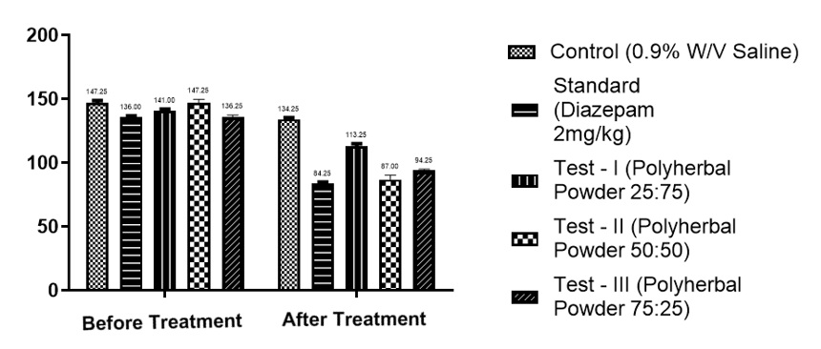

**Figure 1: Locomotory score of different treatment groups on IR Actimeter**

***Open Field Test***

**Table 2: Evaluation Parameters of various treatment groups using Open field Test**

|  |  |  |  |  |
| --- | --- | --- | --- | --- |
| **S.No** | **Treatment Groups** | **No of Line Crossings** | **Number of Centre Square entries** | **Time Spent in Centre Square (Sec)** |
| 1 | Control (Receives vehicle treatment) | 62 | 1 | 4 |
| 2 | Diazepam-treated  (2mg/kg, intraperitoneal injection) | 33 | 3 | 28 |
| 3 | Test – I (Polyherbal Powder 25:75) | 48 | 1 | 13 |
| 4 | Test – II (Polyherbal Powder 50:50) | 44 | 1 | 18 |
| 5 | Test – III (Polyherbal Powder 75:25) | 41 | 2 | 22 |

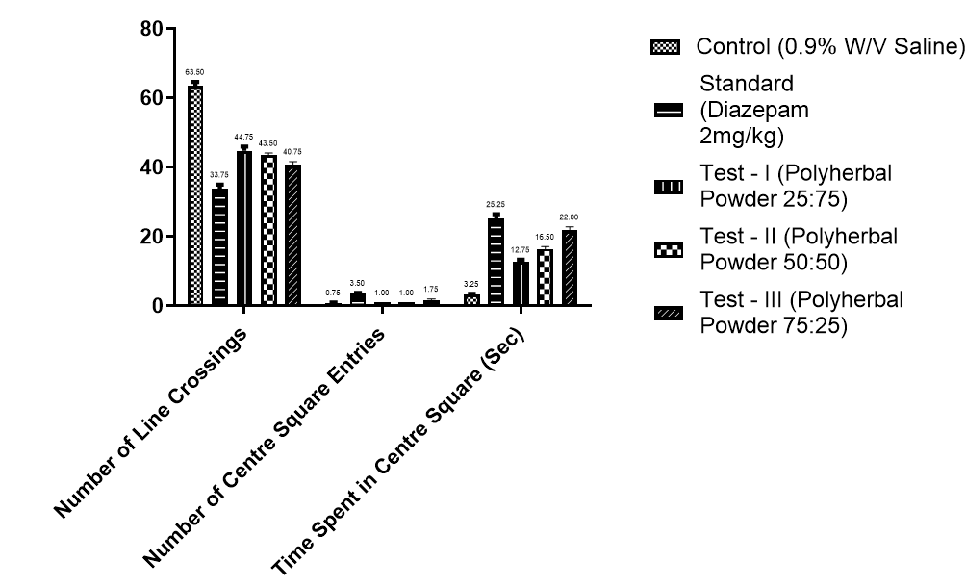

**Figure 2: Evaluation parameters of different treatment groups on Open Field Test**

***Social Behaviour***

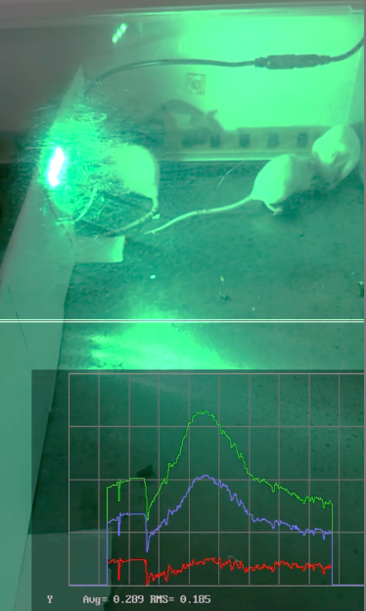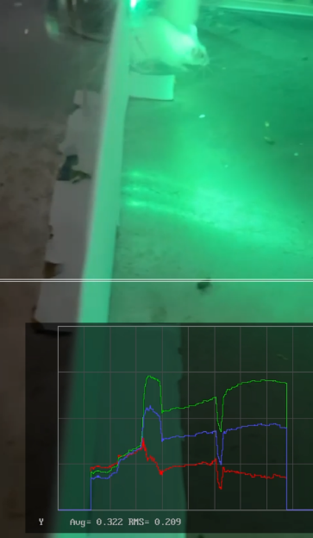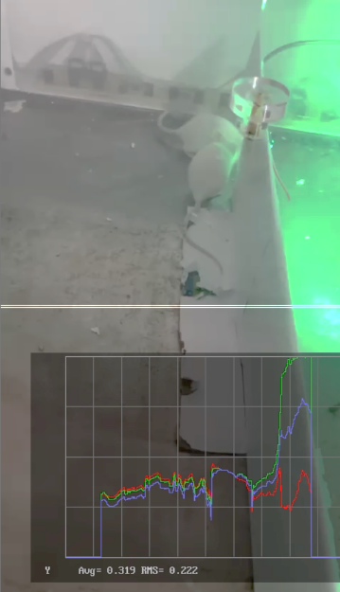

**Figure 3: Assessment of oscilloscope peaks during social behaviour**

**DISCUSSION**

***IR Actimeter***

The data assesses locomotory activity before and after treatment, where reduced counts indicate decreased anxiety. The control group showed a minor reduction (8.96%), likely due to habituation rather than anxiolytic effects. Diazepam, a standard anxiolytic, significantly decreased locomotion (39.13%), confirming its effectiveness. Among the polyherbal formulations, Test I (25:75) reduced activity by 20.56%, showing mild anxiolytic effects. Test II (50:50) had the highest reduction (43.91%), even surpassing diazepam, suggesting strong anxiolytic potential. Test III (75:25) showed a 32.37% reduction, indicating notable effectiveness. These results suggest that polyherbal formulations, particularly Test II (50:50), could be promising alternatives for anxiety management. Further studies on behavioral and biochemical markers are needed to confirm their efficacy and mechanisms.

***Open Field Test***

The Open Field Test assesses anxiety based on locomotion and center-square exploration. Reduced line crossings and increased center-square entries and time spent in the center indicate an anxiolytic effect. The control group had the highest line crossings (62) and minimal center exploration (1 entry, 4 sec), suggesting high anxiety. Diazepam-treated animals showed fewer line crossings (33) and significantly more time in the center (28 sec, 3 entries), confirming its anxiolytic action. Among polyherbal treatments, Test III (75:25) had the strongest anxiolytic effect (41 crossings, 2 entries, 22 sec in center), followed by Test II (50:50) (44 crossings, 1 entry, 18 sec). Test I (25:75) showed moderate effects (48 crossings, 1 entry, 13 sec). These findings suggest that Test III (75:25) and Test II (50:50) may be potent anxiolytic formulations, with effects approaching those of diazepam. Further validation is required.

***Social Behaviour***

The oscilloscope readings reflected mice interactions, where higher peaks indicated increased closeness among them in a specific chamber. The images show that when the mice stayed together in one chamber, oscilloscope peaks were prominent, suggesting strong social engagement. Conversely, when they were dispersed, the peaks declined. This study highlights how environmental factors influence mice behavior, with darkness possibly encouraging grouping. The oscilloscope in Kdenlive effectively quantifies social interactions, offering insights into anxiety and social affinity in animal models.

**CONCLUSION**

The study effectively analyzed anxiety and social behavior in mice using locomotory activity, open field tests, and oscilloscope-based movement tracking. Decreased locomotion and increased center-square exploration in the open field test confirmed anxiolytic effects, with Test II (50:50) and Test III (75:25) polyherbal formulations showing strong potential. In the two-chamber setup, higher oscilloscope peaks correlated with social closeness, indicating environmental influence on social interactions.

**COMPETING INTERESTS DISCLAIMER:**

Authors have declared that they have no known competing financial interests OR non-financial interests OR personal relationships that could have appeared to influence the work reported in this paper.

**REFERENCES**

1. Rang HP, Ritter JM, Flower RJ, Henderson G. Rang & Dale's Pharmacology. 9th ed. Elsevier; 2019.
2. Brunton LL, Hilal-Dandan R, Knollmann BC. Goodman & Gilman’s: The Pharmacological Basis of Therapeutics. 13th ed. McGraw-Hill; 2018.
3. Baldessarini RJ. Neuropharmacology of Anxiety Disorders. Annu Rev Pharmacol Toxicol. 2021;61:733-57.
4. Khan A, Vos J, Barlow D. Herbal treatments for anxiety disorders: A systematic review. J Ethnopharmacol. 2020;259:112947.
5. Zhang ZJ. Therapeutic effects of herbal extracts on central nervous system disorders. Phytother Res. 2019;33(6):1461-75.
6. Campos AC, Fogaca MV, Aguiar DC, Guimaraes FS. Animal models of anxiety disorders and stress. Neurosci Biobehav Rev. 2019;103:21-37.
7. Kalueff AV, Tuohimaa P. Experimental modeling of anxiety and depression. Neurosci Biobehav Rev. 2020;114:237-52.
8. Barlow DH, Durand VM. Abnormal Psychology: An Integrative Approach. 8th ed. Cengage Learning; 2019.
9. Sharma V, Singh R, Sharma R. Anti-anxiety activity of medicinal plants: A review. J Pharm Sci Innov. 2021;10(3):102-8.
10. Sarris J, Panossian A, Schweitzer I, Stough C, Scholey A. Herbal medicine for depression, anxiety and insomnia. Planta Med. 2020;86(6):488-503.
11. Walf AA, Frye CA. The use of the elevated plus maze as an assay of anxiety-related behavior in rodents. Nat Protoc. 2018;2(2):322-8.
12. Takeda H, Tsuji M, Matsumiya T. Changes in head-dipping behavior in the hole-board test reflect the anxiogenic and/or anxiolytic state in mice. Eur J Pharmacol. 2019;350(1):21-9.
13. Carobrez AP, Bertoglio LJ. Ethological and temporal analyses of anxiety-like behavior in the elevated plus-maze. Neurosci Biobehav Rev. 2020;34(3):335-42.
14. Ramos A. Animal models of anxiety: Do I need multiple tests? Trends Pharmacol Sci. 2018;29(10):493-8.
15. Borelli V, Costa G, Bonetto F, Berti G. Effects of polyherbal formulations on behavioral patterns in murine models of anxiety. J Ethnopharmacol. 2022;275:114098.
16. Raber J, May L, Ko L, Salehi A. Brightness discrimination in rodent models of cognitive and anxiety disorders. Behav Brain Res. 2020;378:112297.
17. Sanchez C, Arnt J. Locomotor activity as a screening method for anxiolytic and anxiogenic drug effects. Behav Pharmacol. 2019;10(5):451-9.
18. Maldonado V, Silva A, Villanueva L. Neurobiological mechanisms of anxiety in rodents: Pharmacological and behavioral insights. Neuroscience. 2021;476:213-30.
19. Heiderstadt KM, McLaughlin RM, Wright DC, Walker SE, Gomez-Sanchez CE. The effect of chronic noise on anxiety-like behavior in rodents. Behav Neurosci. 2021;128(6):713-22.
20. Patel V, Vyas B, Patel P, Shah S. The efficacy of herbal extracts in anxiety management. J Clin Pharm Ther. 2022;47(4):509-16.
21. Dar R, Kahn DT, Carmon D. Behavioral and neural correlates of anxiety in the open field test. Neuropsychopharmacology. 2019;44(7):1225-34.
22. Wiley RG, Kline RH. Neuropharmacological evaluation of natural anxiolytics in preclinical models. CNS Neurosci Ther. 2020;26(5):491-501.
23. Kim H, Song MJ, Ryu B. Advanced tools for behavioral analysis in anxiety research. J Neurosci Methods. 2023;398:109218.
24. Bortolato M, Frau R, Pasini A, Thibaut F. Computational modeling of anxiety-related behaviors in rodents. Neurosci Biobehav Rev. 2022;131:204-20.
25. Lefevre F, Remacle A, Thiriet N. Kdenlive-based analysis of movement and social behavior in murine models. J Vis Exp. 2021;170:e62475.