HELMINTH GLYCAN: IMPORTANCE IN HOST IMMUNE MODULATION

Abstract
Helminth, a multicellular parasite, comprises a major class of human pathogens and causes large amount pathogenicity. They have the potential to survive within their hosts for long time periods through suppression of the host's immune system. Helminth’s cuticle possesses varieties of complex glycol conjugates that cross-reacts with both the innate and adaptive immune system in definitive and intermediate hosts. Mostly antigenic glycans, polyfucose, tyvelose, terminal GalNAc, phosphorylcholine, methyl groups, and sugars are expressed by different stages of parasitic helminths. These glycans share structural features with those in their intermediate and vertebrate hosts including Le^{X}, LDNF, LDN , and Tn antigens by the process of molecular mimicry alternatively known as “glycan gimmickry” either derived from the pathogen or acquired from the host to hide from recognition by the host immune system. This is the active strategy of helminth parasites to use their glycans to target glycan-binding proteins (C-type lectins, galectins) within the host to promote their survival. These molecules represent a major untapped reservoir of immunomodulatory compounds, which have the ability to treat autoimmune and inflammatory disorders, and antigenic glycans, which could be exploited as vaccines and diagnostics. This review will be based on different sets of interactions between helminth glycans and host immune system and some advancing therapeutics with vaccine development.
Keywords: Glycol conjugates, GalNAc, Le^{X}, LDNF, glycan gimmickry, galectins, immunomodulatory,

1. Introduction
Helminths are multicellular parasitic worms that comprise a major class of human pathogens. They rely on a host species to complete a portion of their life cycle, which results in morbidity for human and animal hosts. The three classes of helminths – nematodes, trematodes, and cestodes – account for half of the WHO-designated “Neglected Tropical Diseases,” and infect 1–2 billion of the world’s poor people with soil-transmitted helminths (gastrointestinal nematodes including Ascaris sp, Trichuris sp, Necator sp.) and blood-dwelling trematodes being the most common.
Each human helminth has a multi-stage lifecycle, which depends on particular intermediate and definitive hosts environment and ecological niche. For example, Schistosoma mansoni, the most common cause of schistosomiasis, lives only in fresh water inhabited by the mollusc host Biomphalaria glabrata. Its eggs hatch into miracidia which penetrate susceptible snails. The miracidia circulate in the snail haemolymph and change into sporocysts, which over the course of about a month generate free-swimming cercariae that exit the snail. Cercariae perforate the skin of a human host or other mammals exposed to water harbouring infected snails. They are changed into schistosomula larvae, which, after a few days in the dermis, make their way into the venous circulation. Within 1–3weeks they traverse the narrow pulmonary capillary beds and migrate to the portal vessels, feeding on blood, and growing in size as they move. Male and female worm mate and migrate up to the mesenteric vein, where they commence egg laying, about 5–6weeks after initial infection. Eggs excreted into the faeces continue the schistosome life cycle if they are deposited back into fresh water, while others become trapped in the intestinal walls and liver.
A significant hallmark of parasitic worms is their ability to survive within their hosts for long time periods through suppression of the host’s immune system. In their vertebrate hosts, helminths develop from larvae to adult worms, often via different larval stages, thereby releasing a huge number of antigens in their environment, such as disposed surface layers and gut contents. In contrast to microbial antigens, adult worms are relatively larger animals that cannot simply be removed via phagocytosis by the much smaller immune cells. During their development, helminths migrate to different tissues in the body to reach their final destination, and thus challenge the immune system to deal with a large variety of continuously changing antigens [Cummings and Turco, 2009].

A sign of parasitic worms is their ability to survive within their hosts for a long time through suppression of the host’s immune system. Even though the infected hosts initially mount an inflammatory immune reaction to the invading pathogens, most helminths have the capacity to polarize the immune response towards a strong CD4+ T-helper 2 cell response and establish a chronic infection. More recently it has been shown that regulatory T cells (Tregs) play an important role [Van Riet et al.2007; Hewitson et al., 2009]. Tregs suppress inflammatory Th1/Th17 responses and pathology, while permitting a contained Th2 response. Interestingly, such responses are beneficial for both the host and the parasite; host pathology is reduced, and the parasites have a better chance to survive in such a “modified Th2” environment [McKee and Pearce, 2004; Taylor et al., 2006].

2. Glycans expressed by parasitic helminths
Parasitic helminths are characterized by their production of different varieties of glycoproteins, containing complex N- and O-glycans, and glycolipids; all of these glycans are unusual and structurally distinct from host glycans. Helminth glycans commonly terminate with β-linked GalNAc-, often in the sequence GalNAcb1-4GlcNAc- (termed the LacdiNAc motif, LDN), which is not present in vertebrate glycans. In addition, many helminths use unusual sugars, such as tyvelose, found in N-glycans of Trichinella Spiralis which may be useful in both resistance to several infection and diagnostics. Several helminths also generate unusual modifications of sugars, such as the phosphorylcholine (PC) modification of glycans of Echinococcus granulosus, and 2-O-methylation of fucose and 4-O-methylation of galactose in highly antigenic glycan of Toxocara canis [Prasanphanich et al., 2013]. Many of the known helminth glycans contain highly antigenic moieties that comprise either foreign monosaccharides or unusual linkages of common monosaccharides. In some cases, the immunogenic glycans appear to be restricted to one or a few species, such as the tyvelose-containing glycan antigens found within Trichinella spiralis. Other immunogenic glycan modifications are shared by several helminths, and sometimes core α1-3-fucose moiety in N-glycans of different helminths, snails, and plants, causing cross-reactivity in serum diagnostics. Such immunogenic glycan antigens on helminths or secreted products induce the generation of anti-glycan antibody modulations, which are dominant within many helminth-infected host [Die and Cummings, 2009].

Table 1. A list of major glycans secreted by different parasitic helminths is given below [Tundup et al., 2012]
Receptors/immune cells Involved
Glycans | Helminth Species | Human | Mouse | Biological functions
Lewis X | Schistosomes | DC-SIGN | SIGNR-1 | Th2 immune modulation
LDN | Schistosomes | MGL | MGL-2 | B cell response
LDNF | Schistosomes | MGL | MGL | Humoral immune response (IgG, IgM)
α1,3 core fucose | Haemonchus sp. | - | - | Humoral immune response (IgE);Th2
Core β 2-xylose | Schistosomes | DC-SIGN | - | Th2
High Mannose  N-glycans | Schistosomes | DC-SIGN | SIGNR-1/3 | Humoral immune response/ Immune suppression
Tn antigen | Schistosomes | MGL | MGL2 | B cell response; Th2; Immune suppression
Chitin | Tapeworms | Galectins | - | Macrophage polarization
3. Host-like glycan determinants expressed by parasitic helminths
In addition to immunogenic non-host glycan antigens, many helminths express host-like glycan determinants [Cummings, 2009]; these can also induce the secretion of anti-glycan responses. The induction of antibodies that cross reacts with host determinants may result from the “foreign” presentation of the host-like parasite glycan antigens, in that the antigens are often presented in highly multivalent forms, which may also be visualized by their linkage to immunogenic helminth proteins. Different classes of host-like glycans by parasitic helminths are widespread, and different host-like glycans are found in a broad range of parasites.

3.1 Le^{X} antigens are expressed within a few parasitic helminths

Species of the human trematode Schistosoma sp. express Le^{X} antigens in all life stages [Nyame et al., 1998]. These Le^{X} antigens are found on both glycoproteins and glycolipids, either on the body surface of the helminth stages, or within secreted products such as the soluble egg antigens (SEA). Interestingly, the expression of Le^{X} moieties is weak in the molluscan stages of schistosomes [Nyame et al., 2002], and in cercariae (the infectious stage for humans which is released by the snails) Le^{X} expression is highly restricted to the oral sucker [Van Remoortere et al., 2000]. After transformation of the cercariae to schistosomula shortly after entering the mammalian host, Le^{X} is found on the whole surface area of the larvae [Nyame et al., 2003]. These data shows that the synthesis of Le^{X} moieties in the parasites appears to be strongly upregulated during infection of the mammalian host, suggesting a biological relevance for the expression of this structure for the helminth. However, whether Le^{X} is upregulated as a result of this infection or occurs independently of infection is not known.

3.2 LDN and its fucosylated derivative, LDNF of parasitic helminths

Mammalian glycoproteins typically have glycan structures based on the LacNAc (Galβ1-4GlcNAc-) core structure, which can be converted to Le^{X} by α1-3-fucosylation of the GlcNAc residue. Many invertebrates including helminths express the modified core structure LDN, which can be transformed to a fucosylated derivative, LDNF [Van Den Eijnden et al.,1998]. In schistosomes, LDN and LDNF moieties are observed within several stages, along with the expression of Le^{X} antigens [Cummings and Nyame, 1999; Hokke et al., 2007]. In contrast to Le^{X}, LDN and LDNF are also found within different molluscan schistosomal stages [Lehr et al., 2007; Peterson et al., 2009]. In schistosomes, LDN and LDNF moieties are used as a backbone for further modifications, among others leading to several multi-fucosylated structures that are found in egg and cercarial glycoproteins and glycolipids such as LDNDF (GalNAcβ1-4[Fucα1-2Fucα1-3] GlcNAc-), or F-LDNF-DF (Fucα1-3GalNAcβ1-4[Fucα1-2Fucα1-3] GlcNAc-) [Khoo et al.,1995; Wuhrer et al.,2002; Jang-Lee et al.,2007] or repeats of LDN and LDNF as found on N-glycans of schistosomes [Wuhrer et al.,2006 ].

4. Interactions between helminth glycans and host immune system

4.1 Innate immune responses of the Host to the Helminth-derived glycans
The response of an infected host to a parasitic helminth is multilateral and involves both innate and adaptive immune responses, and a host of cellular modulations. Mammalian immune responses to helminths are incredibly complex. The innate response can both limit the pathology of the infection and directly contribute to destruction and expulsion of worms. However, the parasites have evolved glycan gimmickry approaches to overcome the host responses. Thus, the balance arrived at in a chronic infection may result in asymptomatic symptoms even though humans rarely clear all of the infecting organisms without treatment.

Antigen presenting cells (APCs) including dendritic cells (DCs) and macrophages initially encounter invading pathogens and are essential for regulation of the type of adaptive immune response (Fig 1). Helminths induce effector cell generation consisting of Th2, T regulatory cells (Tregs) (Fig 2), and alternatively activated, which may contribute to the potency of helminths to reduce inflammation associated with auto-immune disease. Recognition of pathogen glycans is known to be umpire by no less than two classes of specialized pattern-recognition receptors (PRRs) on APC, the Toll-like receptors (TLRs) and C-type lectin receptors (CLRs), which are contributory in regulation of adaptive immunity. There are over a dozen different C-type lectins expressed in DC and Langerhans cells, and many other glycan-binding proteins, such as selectins, and galectins expressed by lymphocytes, all of which have competent to interact with parasite-derived glycans. TLRs function as PRRs that can recognize a wide variety of foreign molecular patterns (pathogen-associated molecular patterns or PAMPs), as seen, for example, where they identify the many variants of LPS. While CLRs can also function as PRRs, their specificity is often much more restricted, as seen with lectin-1, which is a receptor for β-glucan. The stability between CLR-and TLR- mediated signals appears crucial to determine the balance between tolerance and immunity. Human galectins-1 and-3 have been shown to identify the galactosylated-fucose epitope that is expressed in nematodes and the LDN-motifs that are natural in Schistosomes, respectively, implying a role for galectins in pattern recognition of parasitic helminths [Die and Cummings,2009].

5. Glycan gimmickry

The Procedure by which parasite glycans are involved in modulating immune responses through specific recognition by cellular receptors are largely unclear. Since the primary receptors for helminth glycans are glycan-binding proteins, such as the CLRs expressed by DCs, it is usual that they play a role in immune modifications (Fig 2). DC-SIGN (Dendritic Cell-Speciﬁc Intercellular adhesion molecule-3-GrabbingNon-integrin) finds a wide variety of pathogens, and may be a key player in the interaction of different helminths with DCs. Within schistosomes, Le^{X} antigens are copiously expressed and are reported to contribute to the immunomodulating properties of schistosomes [Srivatsan et al., 1992; Van Remoortere et al., 2000; Okano et al., 2001; Thomas and Harn ,2004]. DC-SIGN recognizes Le^{X,} but also LDNF and pseudo-Le^{Y}, a glycan antigen that has thus been found only on schistosomal cercariae [Wuhrer et al., 2002, Meyer et al., 2005].

Human DCs attach to and internalize S. mansoni soluble egg antigens (SEA) via interaction with the MGL (Human Mφ galactose-type lectin), the MR (mannose receptor), and DC-SIGN, thereby producing a DC phenotype capable of skewing toward Th2 responses [Van Liempt et al., 2007]. The individual roles of these CLRs in schistosome Th2- skewing have not been demonstrated. Mice express seven paralogs of human DC-SIGN, and one of these termed SIGNR, also attached Lewis-related antigens, such as Le^{X} and Le^{Y} [Galustian et al.,2004; Koppel et al., 2005]. Although SIGNR has not been reported to be shown by DCs, it is expressed by macrophages of the spleen, lymph nodes, and peritoneum. Interestingly, SIGNR1-deficient mice have normal responses to infection with S. mansoni, including granuloma formation and immune responses to egg antigens [Saunders et al.,2009]. Such results implies that SIGNR receptor function may be redundant or that it is not important for immune responses to schistosome antigens (Fig 3). An immunomodulatory role for DC-SIGN has been demonstrated for Helicobacter pylori, a bacterial human pathogen that results in chronic infection. In elegant studies using H. pylori phase variants, which differ in their expression of Lewis glycan antigens, it was shown that H. pylori variants, which bind DC-SIGN, stops biasing of naive CD4+ T cells toward Th1 cells, whereas non-DC-SIGN-binding H. pylori variants promote development into Th1 cells [Bergman et al.,2004].The interaction of DC-SIGN via mannose-based structures can also lead to repress of DC-mediated immune responses, as is illustrated by M. tuberculosis, which binds DC-SIGN via mannose-capped lipoarabinomannan (LAM) [Geijtenbeek et al.,2003]. Remarkably, the immunodeficiency virus HIV1 targets DC-SIGN to be engulfed in DC and transported to T cell-rich places, to efficiently infect T cells [Geijtenbeek et al., 2003]. It has been stated that the carbohydrate domain of DC-SIGN is flexible and allows binding of either mannose-containing structures, Le^{X}, LDNF or pseudo-Le^{Y} via different attachment modes [Guo et al., 2004; Meyer et al.,2005]. It is conceivable that DC-SIGN induces different signaling pathways as a consequence of these different binding modes. Furthermore, data thus far suggest that signaling via DC-SIGN is dependent on TLR activation, and the type of TLR and possibly other receptors may determine the exact function of DC-SIGN [Geijtenbeek and Gringhuis, 2009].

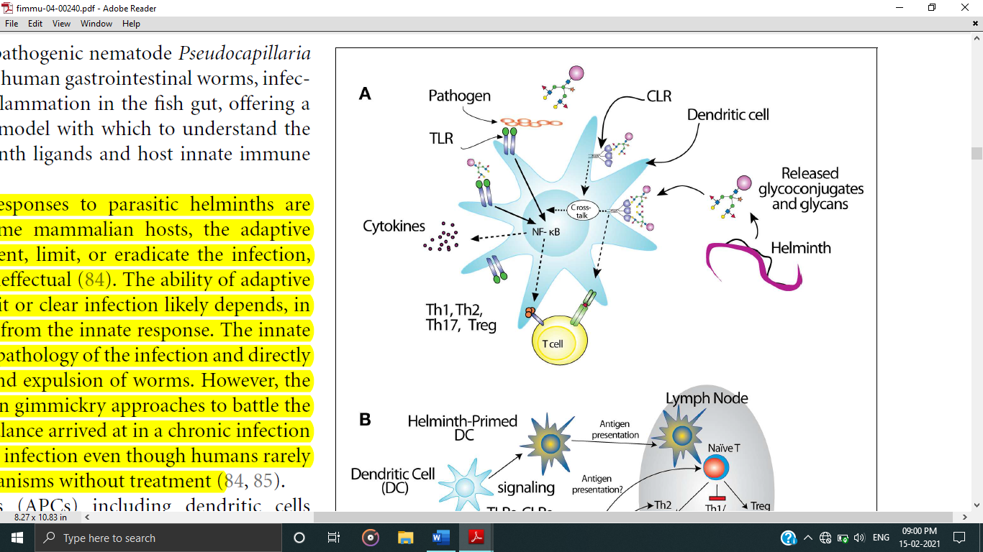
Fig 1. Interactions of glycans with immune cells and regulatory pathways. Glycan-binding proteins such as the C-type lectin receptor (CLR) and DC-SIGN (Dendritic Cell-Speciﬁc Intercellular adhesion molecule-3-GrabbingNon-integrin) in co-operation with Toll-like receptors (TLR), such as TLR4, regulate dendritic cell responses to parasite glycans [Die and Cummings,2009].

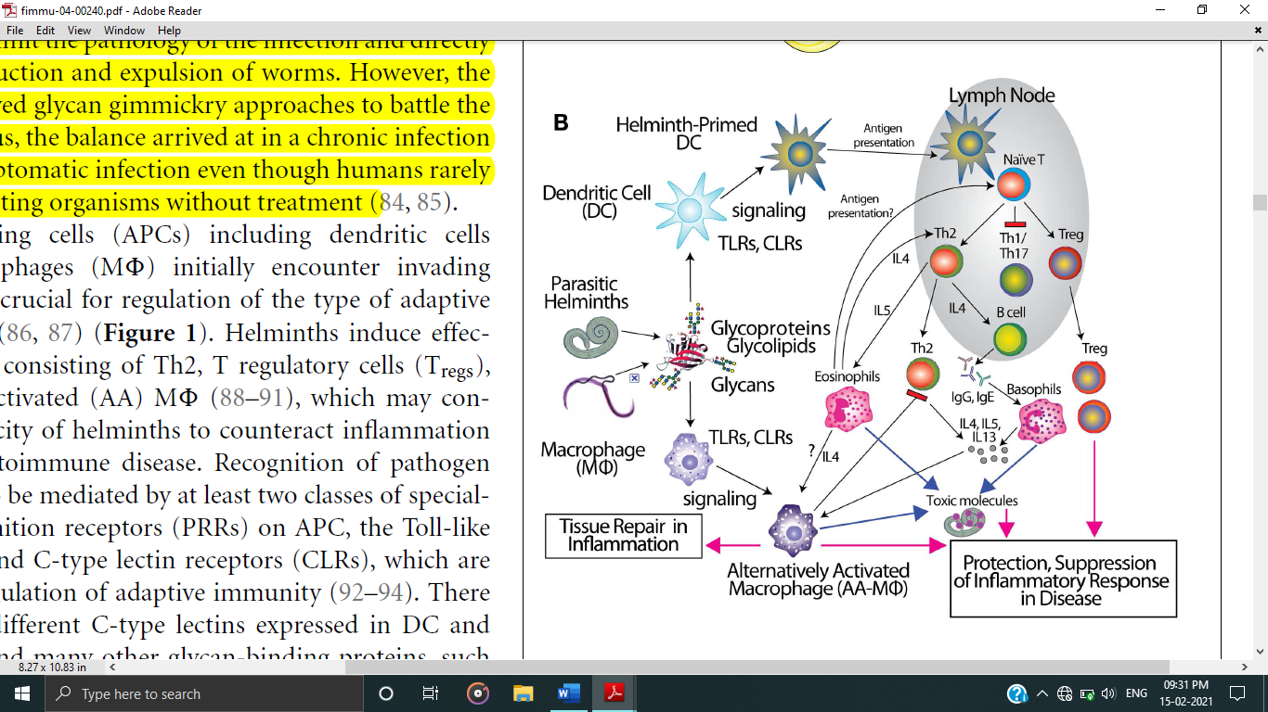

Fig 2. Schematic representation of the role of dendritic cells (DC) and macrophages in inducing an anti-inflammatory adaptive immune response upon contact with helminth glycans [Die and Cummings,2009].
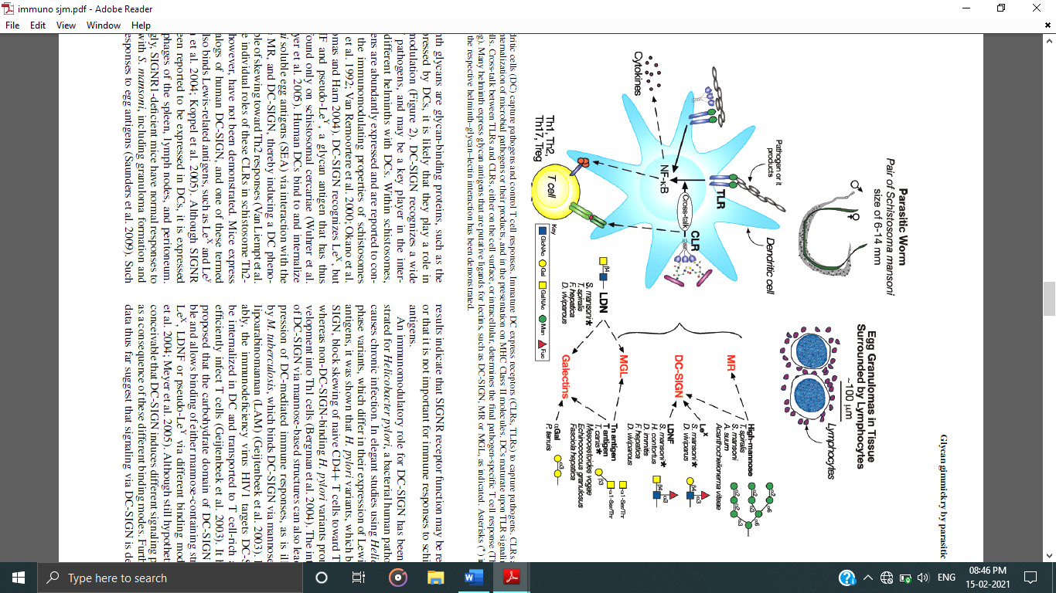

Fig 3. Dendritic cells (DC) capture pathogens and control T cell responses. Immature DC express receptors (CLRs, TLRs) to capture pathogens. CLRs are efficient in internalization of microbial pathogens or their products, and in the presentation on MHC Class II molecules. Cross-talk between TLRs and CLRs, either on the cell surface, or intracellular, determines the final pathogen-specific T cell responses (Th1, Th2, Th17, or Treg). Many helminths express glycan antigens that are putative ligands for lectins, such as DC-SIGN, MR or MGL, as indicated. (∗) indicate cases where the respective helminth–glycan–lectin interaction has been demonstrated [Die and Cummings,2009].

6. Adaptive responses of the host to the helminth-derived glycans
Helminth infections present a two-way trouble to immunologists: firstly, they have an insufficient understanding of the immune effector mechanisms that combat worms. Secondly, the study of adaptive immunity to eukaryotic pathogens has traditionally focused on protein, rather than glycan antigens. A large part of the surface-exposed and secreted antigens of helminths consists of glycoconjugates. Due to the immune-modulatory effects of several glycoconjugates mentioned above, helminths usually show a Th2 response. Non-endemic naive individuals to S. mansoni can suffer from a more Th1-type acute disease known as Katayama fever, in which elevated levels of TNFα, IL-1 and IL- 6, accompany eosinophilia, but people in endemic regions rarely suffer acute symptoms. Instead, they seem to be predisposed to developing a chronic, Th2-type response, the onset of which concur with egg laying. This may branch from sensitization in vitro or very early in life. The immune response to chronic helminth infection is overruled by a self-reinforcing Th2 feedback loop between cytokines IL-4, IL-5, IL-13 and prominent expansion of eosinophils and mast cells. Initiation of this Th2 feedback loop has been a topic of research in the last few years, implicating mast cells, basophils, eosinophils, alternatively activated macrophages, and epithelial cells, just to name a few, as being required to initiate production of Th2 cytokines. Most recently, novel innate immune cell types have surfaced as the most likely Th2-initiating cells. Whatever the Th2 cell type it is likely that they receive important signals from helminth glycoconjugates. These glycoconjugates modulates on the adaptive and effector immune responses which are controlled by helper T cell responses (Th1, Th2, or Th17) and B cell antibody responses [Maizels et al., 2018]

During the chronic Th2 response, abundant antibodies of all classes are produced, especially IgE, IgG1, and IgG4. In schistosomiasis, chronic pathology is primarily due to eosinophilic granulomas, containing of macrophages, CD4+ T-cells, eosinophils, and collagen that surround eggs trapped in liver, intestinal, or bladder tissue, which are eventually transformed to fibrotic scars. Many other nematodes and cestodes also cause eosinophilic granulomas. The regulatory response is crucial in control of chronic helminth diseases, for the well-being of both host and parasite. Schistosomes, hookworms, and filarial nematodes result in the development of Tregs, and the secretion of regulatory cytokines like IL-10 and TGF-β from multiple cell types, and IgG4, a non-complement fixing isotype. This type of response, collectively termed “modified Th2,” serves to limit the immune-pathology that would result from an uncontrolled Th2 amplification loop, and allows the host to remain healthy for the long period of helminth infection. In concordance with this idea, schistosomiasis patients with chronic liver and spleen inflammation lack the IL-10 response to worm antigens, which is observed in chronic patients with low-level symptoms. Alternative actuation of macrophages is induced by Th2 cytokines like IL-4 and IL-13 as well as directly by the products of several helminths, including S. mansoni, F.hepatica, filarial nematodes, and tapeworms. Though we have defined these incidents of helminth glycol-conjugate interactions with innate immune receptors, described above, it seems likely that this class of molecules plays a large role in dictating the character of the immune response to infection [Prasanphanich et al.,2013].

7. Helminth host-like glycans interact with soluble galectins to modulate immune functions

CLRs on antigen-presenting cells and helminth host-like glycans can react with extracellular soluble lectins that play a role in immune regulation. An example is seen in the β-galactoside-recognizing family of lectins known as galectins. Many helminth glycans display terminal galactose, such as Galα1-3Galβ1-4GlcNAc-R (Parelaphostrongylus tenuis) [Duffy et al.,2006], Galα1-3GalNAc-R (Haemonchus contortus) [Van Stijn et al.,2010] which may interfere with host galectins. Helminth LDN glycans have been described to interact with galectin-3 [Van Den Berg et al.,2004]. In a murine model, LDN antigens showed the ability to induce the Th2-associated formation of liver granulomas [Van de Vijver et al.,2006], possibly via cross reaction with the soluble lectin galectin-3 which appeared to be highly upregulated in granulomas. The recent observation that galectin-3 knock-out mice showed a decreased granuloma formation [Breuilh et al.,2007, Oliveira et al.,2007]. While the growing evidence is compelling, much more research needs to be done in animal systems to better understand the specific functions of galectins and other glycan-binding proteins in immune modulation by parasites.

8. Role of helminth glycans to other inflammatory responses

The immunomodulatory properties of helminth glycans are significant not only to the results of helminth infections, but also similarly applicable to the outcomes of vaccinations, co-infections, and inflammatory disorders. Helminth infections and their products have the ability to ameliorate responses to a variety of inflammatory disorders. For example, in clinical studies of patients suffering from inflammatory bowel disease, treatment with the pig nematode Trichuris suis caused remission of Crohn’s disease for more than half of the patients and improved the symptoms of Ulcerative Colitis for many patients. Recently, two small clinical trials of multiple sclerosis (MS) patients – one comparing un-infected to those with naturally acquired Trichuris suis infection, and the other using T. suis ova as treatment–suggested that T. suis may minimize unsuitable MRI changes, reduce exacerbations, and affects favourable immunological parameters such as elevated IL-4 and IL- 10 [Rosche et al.,2013]. Other helminth glycans, such as schistosome N-glycans containing α3-fucose and core β2-xylose epitopes (egg-derived glycoproteins) [Fig. 5], have also been associated with the induction of Th2- biased cytokines affecting dendritic cell-mediated immune responses by enhancing the Ag presentation processes and by transducing signals into DC in case of allergic manifestation [Faveeuw et al.,2003].

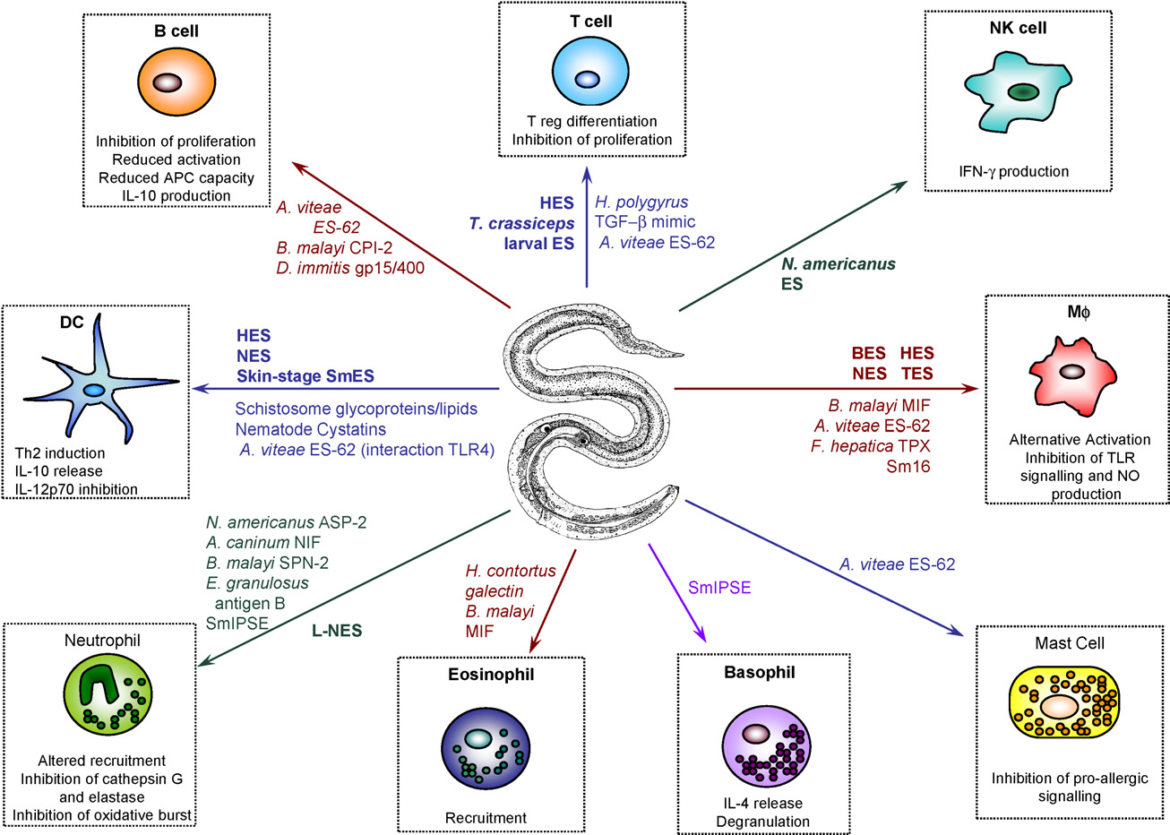

Fig 5: Mechanisms of immune modulation by helminth ES products: APC, antigen presenting cell; ASP, Ancylostoma sp. secreted protein; BES, B. malayi ES; CPI, cysteine proteinase inhibitor (cystatin); HES, H. polygyrus ES; IPSE, IL-4-inducing principle of schistosome eggs; L-NES, larval N. brasiliensis ES; MIF, macrophage migration inhibitory factor; NES, adult N. brasiliensis ES; NIF, neutrophil inhibitory factor; Sm, Schistosoma mansoni; SPN, serine proteinase inhibitor (serpin); TLR, toll-like receptor; TGF, transforming growth factor; TES, T. canis ES [Hewitson et al.,2009]

9. Applications of helminth-derived glycans in diagnosis of parasitic infections

Treatment of helminth infections currently relies on chemotherapeutics such as albendazole and praziquantel. Chemotherapy significantly decreases worm burden and morbidity but is not always curative, and its effectiveness varies. However, the effectiveness of MDA (Mass Drug Administration) in controlling transmission and reducing morbidity is difficult to determine, because traditional diagnostic methods are laborious and insufficient to detect low-level infection or track variations in worm burden. The “gold standard” for diagnosis of helminth infection continues to be microscopic examination of stool or urine samples for eggs. However, eggs are not consistently shed into faeces and urine. Despite improvements in the sensitivity and ease-of-use of these tests, stool samples are still difficult to obtain in the field, often yield false negatives due to temporal variation in egg-laying, and differentiation of the type of helminth eggs in stool requires skilled laboratory technicians.

Commercial ELISA-based detection kits are available for diagnosis of some parasites including malaria (Plasmodium sp.), cryptosporidiosis, and giardia in stool, urine, or serum samples. For helminths causing schistosomiasis, filariasis and trichinellosis, antibody-based tests are available from commercial sources or by special request from the CDC but are not widely used in endemic areas. Antibody tests are generally sensitive, but they suffer several drawbacks, such as inability to differentiate between active (acute or chronic) and past infections, cross-reactivity among multiple helminth species and difficulty of performance in the field [Prasanphanich et al.,2013].

10. Prospects of new diagnostic tests on the basis of helminth-derived glycan detection

Recent studies have disclosed a new set of potential diagnostic antigens, found in serum and urine for schistosomiasis and other helminths. Carbohydrate-based antigens and αGAbs are efficient techniques given that they are chemically stable, specific to certain helminth species, vary with stage of infection, and are represented both on worm surfaces and in secreted products. Several glycan-based detection methods are now in the line for schistosomiasis. Additionally, a test for the other well-studied circulating schistosome glycan antigen, circulating anodic antigen (CAA), which is excreted by adult worms into urine and serum, has recently been adapted for field use with effective outcomes. The test is highly sensitive and can identify just a few worm pairs. These and other novel diagnostic tests are ready for comparison in the field and are likely to change the face of schistosomiasis diagnostics in future.

Modern glycan microarray technology is also being used to find new glycan candidates for diagnosis of helminths. Studies have shown that LDNF, which is more easily produced in the lab than tyvelose, is also a sensitive indicator of T. spiralis infection. Similarly, results from glycan microarray analyses have shown that the sheep nematode H. contortus possesses Gala1- 3GalNAc, which is antigenic and uncommon among nematodes and trematodes [Prasanphanich et al., 2013]. These new microarray technologies have promising ability to screen a single sample for antibodies to multiple glycans from different helminth species, many of which are co-endemic, in a micro scale assay. Thus, glycan arrays have enormous potential to define the diagnostic antigens of the future.

11. Prospect of vaccines:

Development of resistance to anthelmintics, especially in the face of MDA, has long been of concern. Reduced susceptibility to praziquantel has been recorded in some human schistosomiasis- endemic areas, and it is possible to generate resistant schistosomes in the lab. Clearly, vaccines that elicit the development of immunity are a great intervention in control of helminths. Modern vaccine development for parasitic helminths has focused on recombinant proteins but not on glycoproteins, which targets the major antigens of infection.

In the mid-1990s, six S. mansoni glycoproteins, studied in various labs, were chosen by the WHO to undergo independent laboratory testing. None of these reached the required 40% effectiveness required to move past animal testing. Two candidates have reached the clinical phase. Bilhvax (Sh28-GST) has progressed through phase I, II and III trials, however, there has been a more than 10-year delay in publishing the results. Another candidate schistosomiasis vaccine, Sm14, may enter clinical trials this year, and at least two more candidates are going through the preclinical pipeline. The N. americanus protein ASP2 was clinically tested for hookworm, but recipients of the vaccine developed hives [Prasanphanich et al., 2013]. Currently two more hookworm candidates, GST1 and APR1, are being developed and clinical testing for GST1 will be started. These studies highlight the difficulty of identifying effective targets and inducing the proper character of immune response for helminth vaccines. Modern methods of producing recombinant glycoproteins may allow prospective targeting of specific glycoprotein antigens for vaccine studies.

12. Conclusion:

Glycan gimmickry expression allows the parasites to target Toll-like receptors (TLRs) and C-type lectin receptors (CLRs) on host cells or react with immunomodulating soluble lectins such as galectins. This may contribute to the DC trafficking, T-cell interactions and signalling through a myriad of cytoplasmic motif to shift the host immune response from an inflammatory towards a more anti-inflammatory type of response. Thus, parasitic helminths can guide the immune system to produce a better environment for them by limiting immune attack. Molecular insights into the innate and adaptive immune responses to glycoconjugates of parasitic helminths are providing new discoveries for developing diagnostics, therapeutics, and potential vaccine towards these organisms. While glycans are targets in common infections, much remains to be discovered about the expression and functions of parasite-derived glycans, and their potential role in between immune activation and immune evasion mechanism by parasitic helminths. While some glycans are useful in diagnostics and monitoring, none of the specific glycans of these parasites has yet been translated into molecular targets for vaccines.

REFERENCES

Bergman MP, Engering A, Smits HH, van Vliet SJ, van Bodegraven AA,Wirth HP, Kapsenberg ML,Vandenbroucke-Grauls CM, van Kooyk Y, Appelmelk BJ. Helicobacter pylori modulates the T helper cell 1/T helper cell 2 balance through phase-variable interaction between lipopolysaccharide and DC-SIGN. Journal of Experimental Medicine. 2004; 200:979–990.

Breuilh L, Vanhoutte F, Fontaine J, van Stijn CM, Tillie-Leblond I, Capron M,Faveeuw C, Jouault T, Die IV, Gosset P, et al. Galectin-3 modulates immune and inflammatory responses during helminthic infection: Impact Of galectin-3 deficiency on the functions of dendritic cells. Infection and Immunity. 2007; 75:5148–5157.

Cummings RD, Nyame AK. Schistosome glycoconjugates. Biochimica et Biophysica Acta. 1999; 1455:363–374.

Cummings RD, Turco S. Parasitic infections. In: Varki A, Cummings RD, Esko JD, Freeze HH, Stanley P, Bertozzi CR, Hart GW, Etzler ME, editors. Parasitic Infections. 2009. Woodbury (NY): Cold Spring Harbor Laboratory Press, pp. 553–566.

Cummings RD. The repertoire of glycan determinants in the human glycome. Molecular Biosystems. 2009; 5:1087–1104.

Die IV, Cummings RD. Glycan gimmickry by parasitic helminths: A strategy for modulating the host immune response? Glycobiology.2009;20(1): 2-12.doi:10.1093/glycob/cwp140.

Duffy MS, Morris HR, Dell A, Appleton JA, Haslam SM. Protein glycosylation in Parelaphostrongylus tenuis—First description of the Galα1–3Gal sequence in a nematode. Glycobiology. 2006; 16:854–862.

Faveeuw C, Mallevaey T, Paschinger K,Wilson IB, Fontaine J, Mollicone R, Oriol R, Altmann F, Lerouge P, Capron M, Trottein F. Schistosome N-glycans containing core α3-fucose and core β2-xylose epitopes are strong inducers of Th2 responses in mice. European journal of Immunology. 2003; 33: 1271– 1281.

Galustian C, Park CG, Chai W, Kiso M, Bruening SA, Kang YS, Steinman RM, Feizi T.. High and low affinity carbohydrate ligands revealed for murine SIGN-R1 by carbohydrate array and cell binding approaches, and differing specificities for SIGN-R3 and Langerin. International Immunology. 2004; 16:853–866.

Geijtenbeek TB, Gringhuis SI. Signalling through C-type lectin receptors: Shaping immune responses. Nature Reviews Immunology. 2009; 9:465–479.

Geijtenbeek TB, Van Vliet SJ, Koppel EA, Sanchez-Hernandez M, Vandenbroucke-Grauls CM, Appelmelk B,Van Kooyk Y. Mycobacteria target DC-SIGN to suppress dendritic cell function. Journal of Experimental Medicine. 2003; 197:7–17.

Guo Y, Feinberg H, Conroy E, Mitchell DA, Alvarez R, Blixt O, Taylor ME, Weis WI, Drickamer K. Structural basis for distinct ligand-binding and targeting properties of the receptors DC-SIGN and DC-SIGNR. Nature Structural and Molecular Biology. 2004; 11:591–598.

Hewitson JP, Grainger JR, Maizels RM. Helminth immunoregulation: The role of parasite secreted proteins in modulating host immunity. Mol Biochem Parasitol. 2009; 167:1–11.

Hokke CH, Deelder AM, Hoffmann KF, Wuhrer M. Glycomics-driven discoveries in schistosome research. Experimental Parasitology. 2007; 117:275–83.

Jang-Lee J, Curwen RS, Ashton PD, Tissot B, Mathieson W, Panico M, Dell A, Wilson RA, Haslam SM. 2007. Glycomics analysis of Schistosoma mansoni egg and cercarial secretions. Mol Cell Proteomics. 6:1485–1499.

Khoo KH, Sarda S, Xu X, Caulfield JP, McNeil MR, Homans SW, Morris HR, Dell A. Aunique multifucosylated -3GalNAcβ1-4GlcNAcβ1-3Galα1-motif constitutes the repeating unit of the complex O-glycans derived from the cercarial glycocalyx of Schistosoma mansoni. Journal of Biological Chemistry. 1995; 270:17114–17123.

Koppel EA, Wieland CW, Van Den Berg VC, Litjens M, Florquin S, van Kooyk Y, Van Der Poll T, Geijtenbeek TB. Specific ICAM-3 grabbing non integrin-related 1 (SIGNR1) expressed by marginal zone macrophages is essential for defense against pulmonary Streptococcus pneumoniae infec tion.European Journal of Immunology. 2005; 35:2962–2969.

Lehr T, Geyer H, Maass K, Doenhoff MJ, Geyer R.. Structural characterization of N-glycans from the freshwater snail Biomphalaria glabrata cross-reacting with Schistosoma mansoni glycoconjugates. Glycobiology. 2007; 17:82–103.

Maizels RM, Smits HH, McSorley HJ. Modulation of Host Immunity by Helminths:The Expanding Repertoire of Parasite Effector Molecules. Immunity. 2018; 49(5):801-818. https://doi.org/10.1016/j.immuni.2018.10.016.

McKee AS, Pearce EJ. CD25+CD4+ cells contribute to Th2 polarization during helminth infection by suppressing Th1 response development. Journal of Immunology. 2004; 173:1224–1231.

Meyer S, Van Liempt E, Imberty A, Van Kooyk Y, Geyer H, Geyer R, Van Die I. DC-SIGN mediates binding of dendritic cells to authentic Pseudo-Lewis Y glycolipids of Schistosoma mansoni cercariae, the first parasite-specific ligand of DC-SIGN. Journal of Biological Chemistry. 2005; 280:37349–37359.

Nyame AK, Debose-Boyd R, Long TD, Tsang VC, Cummings RD.. Expression of Le X antigen in Schistosoma japonicum and S. haematobium and immune responses to Le X in infected animals: Lack of Le X expression in other trematodes and nematodes. Glycobiology. 1998; 8:615–624.

Nyame AK, Lewis FA, Doughty BL, Correa-Oliveira R, Cummings RD. Immunity to schistosomiasis: Glycans are potential antigenic targets for immune intervention. Experimental Parasitology.2003; 104:1–13.

Nyame AK, Yoshino TP, Cummings RD. Differential expression of Lac- DiNAc, fucosylated LacDiNAc, and Lewis X glycan antigens in intra molluscan stages of Schistosoma mansoni. Journal of Parasitology. 2002; 88:890–897.

Okano M, Satoskar AR, Nishizaki K, Harn DA Jr. Lacto-N-fucopentaose III found on Schistosoma mansoni egg antigens functions as an adjuvant for proteins by inducing Th2-type response. Journal of Immunology. 2001; 167:442–450.

Oliveira FL, Frazao P, Chammas R, Hsu DK, Liu FT, Borojevic R, Takiya CM, El-Cheikh MC. Kinetics of mobilization and differentiation of lymphohematopoietic cells during experimental murine schistosomiasis in galectin-3−/− mice. Journal of Leukocyte Biology. 2007; 82:300–310.

Peterson NA, Hokke CH, Deelder AM, Yoshino TP.. Glycotope analysis in miracidia and primary sporocysts of Schistosoma mansoni: Differential expression during the miracidium-to-sporocyst transformation. International Journal of Parasitology. 2009; 39:1331–1344.

Prasanphanich NS, Mickum ML, Heimburg-Molinaro J, Cummings RD. Glycoconjugates in host-helminth interactions. Frontiers in Immunology. 2013; 4.doi: 10.3389/fimmu.2013.00240.

Rosche B, Wernecke KD, Ohlraun S, Dörr JM, Paul F. Trichuris suis ova in relapsing-remitting multiple sclerosis and clinically isolated syndrome (TRIOMS): study protocol for a randomized controlled trial. Trials. 2013;14:112. doi: 10.1186/1745-6215-14-112.

Saunders SP, Walsh CM, Barlow JL, Mangan NE, Taylor PR, McKenzie AND, Smith P, Fallon PG..The C-type lectin SIGNR1 binds Schistosoma mansoni antigens in vitro, but SIGNR1-deficient mice have normal responses during schistosome infection. Infection and Immunity. 2009;77: 399–404.

Srivatsan J, Smith DF, Cummings RD. The human blood fluke Schistosoma mansoni synthesizes glycoproteins containing the Lewis x antigen. Journal of Biology Chemistry. 1992; 267:20196–20203.

Taylor JJ, Mohrs M, Pearce EJ. Regulatory T cell responses develop in parallel to the responses and control the magnitude and phenotype of the Th effector population. Journal of Immunology 2006; 176:5839–5847.

Thomas PG, Harn DA Jr. Immune biasing by helminth glycans. Cell Microbiology. 2004; 6:13–22.

Tundup S, Srivastava L, and Harn DA Jr. Polarization of host immune responses by helminth-expressed glycans. Annals of the New York Academy of Sciences. 2012;1253(1):E1-E13. doi: 10.1111/j.1749-6632.2012.06618.x

Van de Vijver KK, Deelder AM, Jacobs W, Van Marck EA, Hokke CH. LacDiNAc- and LacNAc-containing glycans induce granulomas in an invivo model for schistosome egg-induced hepatic granuloma formation. Glycobiology. 2006; 16:237–243.
Van Den Berg TK, Honing H, Franke N, van Remoortere A, Schiphorst WE, Liu FT, Deelder AM, Cummings RD, Hokke CH, Die IV. LacDiNA glycans constitute a parasite pattern for galectin-3-mediated immune recognition. Journal of Immunology. 2004; 173:1902–1907.

Van Den Eijnden DH, Neeleman AP, Bakker H,Van Die I. Novel pathways in complex-type oligosaccharide synthesis. New vistas opened by studies in invertebrates. Advances in Experimental Medicine and Biology. 1998; 435:3–7.

Van Liempt E, Van Vliet SJ, Engering A, Garcia Vallejo JJ, Bank CM, Sanchez- Hernandez M, van Kooyk Y, Van Die I. Schistosoma mansoni soluble egg antigens are internalized by human dendritic cells through multiple C-type lectins and suppress TLR-induced dendritic cell activation. Molecular Immunology. 2007; 44:2605–2615.

Van Remoortere A, Hokke CH, Van Dam GJ, Van Die I, Deelder AM, Van Den Eijnden DH. Various stages of schistosoma express Lewis(x), Lac-DiNAc, GalNAcβ1-4 (Fucα1-3) GlcNAc and GalNAcβ1-4(Fucα1-2Fucα1-3)GlcNAc carbohydrate epitopes: Detection with monoclonal antibodies that are characterized by enzymatically synthesized neoglycoproteins. Glycobiology. 2000; 10:601–609.

Van Riet E, Hartgers FC, Yazdanbakhsh M. Chronic helminth infections induce immunomodulation: Consequences and mechanisms. Immunobiology. 2007; 212:475–490.

Van Stijn CM, Van Den Broek M, Vervelde L, Alvarez RA, Cummings RD, Tefsen B, Die IV. Vaccination-induced IgG response to Galα1- 3GalNAc glycan epitopes in lambs protected against Haemonchus contortus challenge infection. International Journal of Parasitology. 2010; 40(2): 215-22. doi: 10.1016/j.ijpara.2009.07.009.

Wuhrer M, Kantelhardt SR, Dennis RD, Doenhoff MJ, Lochnit G, Geyer R.. Characterization of glycosphingolipids from Schistosoma mansoni eggs carrying Fuc(α1-3) GalNAc-, GalNAc(β1-4) [Fuc(α1-3)] GlcNAcand Gal(β1-4) [Fuc(α1-3)] GlcNAc- (Lewis X) terminal structures. European Journal of Biochemistry. 2002; 269:481–493.

Wuhrer M, Koeleman CA, Deelder AM, Hokke CH. Repeats of LacDiNAc and fucosylated LacDiNAc on N-glycans of the human parasite Schistosoma mansoni. FEBS Journal. 2006; 273:347–361.

