**Checklist of insects belonging to the order Diptera present in different local fish markets at Vadasery, Kanyakumari District, Tamilnadu.**

**ABSTRACT:**

Insects are pervasive in the environment and play important roles in maintaining the stability of ecosystem by being a part of the food chain, mediating decomposing process and through various ecological interactions such as pollination, predation and herbivory.

The study focused on documenting the diversity of diptera species found in the two local fish markets located in vadasery. This study was conducted from 6th July 2023 to 29th July 223, spanning a duration of four weeks. The study area was divided into two zones and a systemic record of the presence and absence of Diptera individuals was maintained for various fish species. A total of 8422 Diptera individuals were collected comprising predominantly Muscidae, Calliphoridae and Sacrophagidae families. Zone A yielded 785 Muscidae, 698 Calliphoridae and 62 Sacrophagidae individuals, whereas Zone B recorded 4,463 Muscidae, 2303 Calliphoridae and 149 Sacrophagidae individuals. This study was investigated the presence of Diptera species in vadasey fish markets, revealing that both zones were frequented by calyptrate families. The findings highlight the market’s potential as breeding grounds for disease carrying flies, emphasizing their significance as a public concern.

*Keywords: Diptera, Calyptrate families, Fish markets, public health, Sanitation.*

**1. INTRODUCTION:**

Insects are highly adaptable creature and can be found in nearly every conceivable habitat and situation. Insects are a major food source for many species of fish, amphibians, reptiles, birds and mammals.

The order Diptera, commonly called true files or two winged flies are a familiar group of insects like gnats, black flies, mosquitoes, fruit flies and horse flies. Diptera are among the most diverse orders with a current world tally close to 160,000 extant species (Pape *et al*., 2011).

The Diptera are diverse not only in species richness, but also in their structure, habitat exploitation, life habits and interactions with humankind (Henning 1973, McAlphine *et al*., 1981, 1987, Papp and Darvas 2000, Brown 2001, Skevington and Dang 2002, Marshall 2012). The Diptera have fully colonized all continents including Antarctica and particularly every habitat except the open sea and inside glaciers.

Dipteran species are the major forensically important insect because it is typically the first forms to colonize animal remains. The most used in the forensic cases is the dipteran life cycle (Smith 1986, Frost *et al*., 2010). Most observed insects near dead bodies are dipteran species of Calliphoridae and Sacrophagidae as the first colonizer flies, followed by coleopteran species. In the natural environment, insects start colonizing the corpse according to the specific sequence called as ‘faunal succession’. Adult of Calliphoridae and Sacrophagidae are the major species attracted in the initial stage of decomposition.

Fish is a vital component of coast bound, especially in developing countries of the world. As the world population grows, the need for more food and more fish has correspondingly increased. India is the third largest fish producing country and the second largest aquaculture fish producer in the world. It contributes about 7% to the global fish production. The country is home to more than 10% of the global fish biodiversity and is one of the 17 mega biodiversity rich countries. Around 14 million people engaged in fisheries and its allied activities.

Dipteran flies are mostly found on cured fish that has been preserved through fermentation, picking, smoking or a combination of these. Adult female flies lay their eggs (or, in some species, small larvae), usually in batches, on the flesh of fish. Flies in the family Calliphoridae – blow flies, Ephydridae – shore flies and Muscidae – house flies only infest moist fish in the early stages of the curing process; those in the families Milichidae - freeloader flies, Phoridae -scuttle flies, humpbacked flies or coffin flies and Piophillidae – skipper flies can infest partially and fully cured fish. The larvae (usually known as maggots) feed on the surface of the flesh and may also burrow deeply into it.

Dried fishery products frequently suffer and severe losses due to infestation by flesh flies (Sacrophagidae), beetles (Dermates, Cornestes and *Necrobia* spp) and mites *(Lardoglyphus* and *Lyrophagous* spp). (Venugopal and Doke 1999, Gopakumar and Devadasan 1982, Esser *et al*., 1990, Wood 1982). A large quantity of dried fish is lost in India due to infestation by earwing, hide beetles and copra beetles. Infestation of sun-dried fish by the blowfly and beetle larvae caused upto 30% loss of the products. (Bala and Mondol 2001, Nowsad 2005). The losses have been to net reductions in the amount of nutrients available to consume (nutritive quality) and market prices (economic losses) or both quantitative and qualitative losses. (Odeyemi *et al*., 2000, Atijegbe 2004).

The present study aims to prepare a checklist of insects belonging to the order Diptera present in different two local fish markets at vadasery, Kanyakumari District, Tamilnadu.

**2. MATERIALS AND METHODS:**

**Study area:**

The proposed fieldwork was conducted in the different fish markets at Vadasery, Kanyakumari district, Tamil Nādu, India.

The Study area was divided into 2 major zones namely A and B to make collection procedure easier,

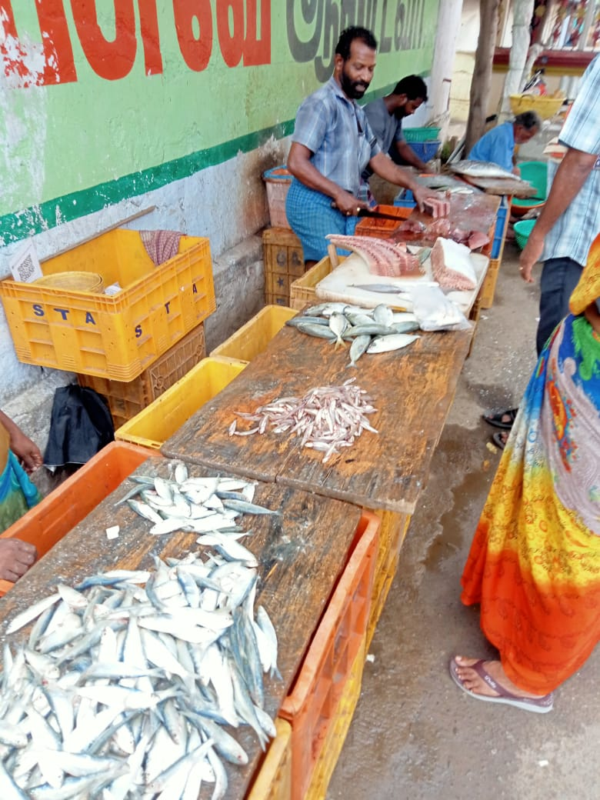

Picture 2 : Zone A includes Kalungadi Fish market, Vadasery.

Picture 1 : Zone B includes Vathiyarvillai Fish market, Vadasery.

**Diptera sampling method:**

The dipteran species were collected from two local fish markets Vadasery from 06-07-2023 to 29-07-2023 for a period of 20 days.

A total of 8422 species belonging to three families from two markets of Vadasery. House fly (Family- Muscidae) shared maximum number of species followed by blow flies (Family- Calliphoridae) shared minimum number of species and Flesh flies (Family- Sarcophagidae) with some species.

The blow fly, house fly and flesh fly were caught by forceps, hands and by the ordinary aerial insect net.

**Preservation:**

The collected specimens were then preserved in vials containing 75% ethyl alcohol and then labelled. They were brought to the research laboratory of the Department of Zoology, Scott Christian College for further identification.

**Relative Abundance:**

The difference between the total number of individuals of all species, the total number of individuals of the species and relative abundance of insect was calculated using the formula, (Pennington,1986).

Total no. of individuals of the species

Relative abundance = ___________________________________ x100

Total no. of individuals of all species

**RESULT AND DISCUSSION**

**Table 1: Brief description of the study site**

|  |  |
| --- | --- |
| Site | Locality (Vadasery) |
| Zone A | Kalungadi Fish market |
| Zone B | Vathiyarvillai Fish market |

**Table 2: Diptera species records from two selected zones of Vadasery fish markets.**

|  |  |  |  |  |  |  |  |
| --- | --- | --- | --- | --- | --- | --- | --- |
| **Fish Scientific Name** | **Common Name** | **Family** | | | **Family** | | |
| **Zone A** | | | **Zone B** | | |
| **Calliphoridae** | **Sarcophagidae** | **Muscidae** | **Calliphoridae** | **Sarcophagidae** | **Muscidae** |
| Euthynnus affinis | Eastern little tuna | + | + | + | + | + | + |
| Clupea brachisoma | Sardine | + | + | + | + | + | + |
| Caranx kurra | Horse mackeral | + | + | + | + | + | + |
| Engraulis indicus | Anchovi | + | + | + | + | + | + |
| Trygon zugei | Sting ray | + | + | + | + | + | + |
| Sphyraena jello | Pick handle barracuda | + | + | + | + | + | + |
| Dussumieria acuta | Rainbow sardine | + | + | + | + | + | + |
| Leiognathus equulus | Common pony fish | - | - | - | + | + | + |
| Caranx Sexfasciatus | Horse mackeral | + | + | + | + | + | + |
| Penaeus indicus | Indian prawn | - | - | - | + | + | + |
| Uroteuthi duvauceli | Indian squid | + | - | + | + | + | + |
| Balistis maculatus | Trigger fish | - | - | - | + | + | + |
| Sarda orientalis | Oriental bonito | + | + | + | + | - | + |
| Epinephilus megachir | Honeycomb perch | - | - | - | + | + | + |
| Scomber microlepidotus | Indian mackeral | + | + | + | + | + | + |
| Trichiurus muticus | Ribbon fish | - | - | - | + | + | + |
| Belone cancila | Needle fish | - | - | - | + | + | + |
| Thynnus macropterus | Tunny | - | - | - | + | + | + |
| Lutjanus erythropterus | Snapper | + | + | + | + | + | + |
| Etroplus suratensis | Pearl spot | + | - | + | + | + | + |
| Sciaena miles | Jew fish | - | - | - | + | + | + |
| Sciaena aneus | Jew fish | - | - | - | + | - | + |
| Clupea kanagurta | Sardine | + | - | + | + | + | + |
| Upeneus sulphurius | Yellow goat fish | - | - | - | + | - | + |
| Selar crumenophthalmus | Big eye scad | + | - | + | + | + | + |
| Engraulis mystax | Anchovi | + | + | + | + | + | + |
| Pellona indica | Herring | - | - | - | + | + | + |
| Lutjanus quinquelineatus | Lined snapper | - | - | - | + | + | + |

|  |  |  |  |  |  |  |  |  |  |
| --- | --- | --- | --- | --- | --- | --- | --- | --- | --- |
| **Table 3: List of dipteran species and their occurance in the two selected zones of the study site.** | | | | | | | | | |
| **Fish Scientific Name** | **Common Name** | **No. of days present** | **Family** | | | **No. of days present** | **Family** | | |
| **Zone A** | | | **Zone B** | | |
| **Calliphoridae** | **Sarcophagidae** | **Muscidae** | **Calliphoridae** | **Sarcophagidae** | **Muscidae** |
| Euthynnus affinis | Eastern little tuna | 8 | 97 | 11 | 73 | 20 | 298 | 20 | 469 |
| Clupea brachisoma | Sardine | 5 | 56 | 2 | 65 | 16 | 296 | 15 | 458 |
| Caranx kurra | Horse mackeral | 5 | 43 | 1 | 60 | 8 | 95 | 9 | 118 |
| Engraulis indicus | Anchovi | 12 | 137 | 10 | 161 | 16 | 346 | 14 | 437 |
| Trygon zugei | Sting ray | 1 | 9 | 1 | 6 | 7 | 29 | 3 | 183 |
| Sphyraena jello | Pick handle barracuda | 5 | 36 | 6 | 54 | 12 | 167 | 10 | 340 |
| Dussumieria acuta | Rainbow sardine | 4 | 24 | 8 | 55 | 13 | 142 | 18 | 277 |
| Leiognathus equulus | Common pony fish | - | - | - | - | 10 | 85 | 3 | 248 |
| Caranx Sexfasciatus | Horse mackeral | 11 | 126 | 6 | 85 | 20 | 247 | 16 | 530 |
| Penaeus indicus | Indian prawn | - | - | - | - | 4 | 17 | 1 | 94 |
| Uroteuthi duvauceli | Indian squid | 2 | 3 | - | 13 | 3 | 6 | 2 | 40 |
| Balistis maculatus | Trigger fish | - | - | - | - | 2 | 2 | 2 | 39 |
| Sarda orientalis | Oriental bonito | 4 | 55 | 5 | 61 | 5 | 75 | - | 101 |
| Epinephilus megachir | Honeycomb perch | - | - | - | - | 3 | 6 | 3 | 44 |
| Scomber microlepidotus | Indian mackeral | 3 | 36 | 3 | 76 | 15 | 160 | 10 | 270 |
| Trichiurus muticus | Ribbon fish | - | - | - | - | 5 | 46 | 3 | 159 |
| Belone cancila | Needle fish | - | - | - | - | 2 | 10 | 1 | 32 |
| Thynnus macropterus | Tunny | - | - | - | - | 2 | 5 | 1 | 30 |
| Lutjanus erythropterus | Snapper | 1 | 10 | 1 | 6 | 7 | 40 | 3 | 104 |
| Etroplus suratensis | Pearl spot | 3 | 18 | - | 15 | 3 | 31 | 2 | 14 |
| Sciaena miles | Jew fish | - | - | - | - | 3 | 10 | 2 | 55 |
| Sciaena aneus | Jew fish | - | - | - | - | 2 | 13 | - | 48 |
| Clupea kanagurta | Sardine | 1 | 19 | - | 6 | 3 | 55 | 3 | 146 |
| Upeneus sulphurius | Yellow goat fish | - | - | - | - | 2 | 14 | - | 14 |
| Selar crumenophthalmus | Big eye scad | 1 | 4 | - | 19 | 2 | 42 | 5 | 104 |
| Engraulis mystax | Anchovi | 2 | 25 | 8 | 30 | 2 | 45 | 1 | 77 |
| Pellona indica | Herring | - | - | - | - | 1 | 8 | 1 | 11 |
| Lutjanus quinquelineatus | Lined snapper | - | - | - | - | 2 | 13 | 1 | 21 |
| **Total no. of Species** | |  | **698** | **62** | **785** |  | **2303** | **149** | **4463** |

The result of the present study is given in tables 1 and 2 and figures 1 and 2.

The locality of Vadasery with two selected Zones denoted as Zone A and Zone B was selected for the study of the dipteran species and records maintained. Zone A is the Kalungadi fish market and Zone B is Vathiyarvilai fish market (Table 1).

The records of dipteran species in the two zones is given in Tabler 2. Muscidae were recorded from all the two zones. Calliphoridae were present in maximum numbers and Sacrophagidae were present in limited numbers.

Table 3 gives a distribution of Diptera in the two zones. Totally 8422 species were collected. In Zone A, Muscidae 785 individuals were recorded, Calliphoridae 698 individuals were recorded and Sacrophagidae only 62 individuals recorded. In Zone B, Muscidae had 4463 individuals, Calliphoridae had 2303 individuals and Sacrophagidae had 149 individuals.

The percentage of individuals collected per family in Zone A are represented in the form of graph (Figure 1). The Muscidae was the dominant family occupying 50.80% of the total, followed by Calliphoridae occupying 45.17% and the least represented family was Sacrophagidae 4.01% of the total species.

The percentage of individuals occurrence per family in Zone B are represented in the form of graph (figure 2). The Muscidae was the dominant family occupying 64.54% of total, followed by Calliphoridae occupying 33.30% and least represented family Sacrophagidae 0.70% of the total species.

The Diptera are an excellent model for studying synanthorphy, the ecological importance and their medical – veterinary characteristics as vectors for etilogical agents such as amoeba cysts, helminth’s eggs, pathogenic enterobacteria, viruses and fungi (D’ Alm eida, 1992, Nunes *et al*., 2012). The diverse order of Diptera comprises the most important group of medical, veterinary insects, mosquitoes and related families and several calyptrate families – Calliphoridae, Sacrophagidae and Muscidae.

According to data collected both zones were visited by calyptrate families. Therefore, the occurrence distribution and prevalence of these Dipteran families in the fish markets of Vadasery are factors of great public health importance.

Zone A is small compared to Zone B as only 4 or 5 fishermen sell their fishes which get sold within two hours, due to high demand. Hence less number of calyptrate were recorded.

Moreover, Dipteran species cannot count accurately visiting the fish, because it is not known whether the same individuals are visiting the same fish again and again.

The dense bones of trigger fish and snapper fishes make it more challenging for Diptera larvae to thrive (Mello *et al.,* 2015, Ferraz *et al.,* 2017); this could be a reason for some species for avoidance.

By using preservatives, fisherman can help minimized the presence of Diptera species on fish, which can improve the quality and appearance of the fish (Adams *et al.,* 2017); this could be also contribute to the frequency of visitations by calyptrate family.

**CONCLUSION:**

This study provides valuable insights into the diversity and abundance of Diptera species in vadasery fish market were frequented by calyptrate families, comprising Muscidae, Calliphoridae and Sacrophagidae species. The predominance of these species underscores the market’s potential as bredding grounds for disease – carrying flies, emphasizing their significance as a public health concern.

The result of this study highlights the need for regular monitoring, improved sanitation, and effective pest management strategies to mitigate the spreads of disease and protect public health. This finding emphasizes the importance of educating market vendors, consumers and relevant stakeholder about the risks associated with Diptera infestations and the benefits of maintaining good hygiene practices.

**References:**

Adams, C.J., Hall, M.J.R and Cook, D.F. The use of ice and salt as preservatives to reduce Diptera infestation of fish. Journal of food protection, 2011, 74(10), 1711-1716.

Atijegbe, S.R. Infestation of smoked fish in Ghana. M.Phil. Thesis in Entomology University Ghana, Legon, Ghana. 2004, 103.

Bala, B.K., Mondol, M.R.A. Experimental Investigation of Solar Drying of Fish using Tunnel Dyer, Drying Technology. 2001; 19(2): 1-10.

Brown, B.V. Flies, Gnats and Mosquitoes. *In* S.A Levin(ed). *Encyclopedia Of Biodiversity*. Academic Press. London. 2001, Pp. 815-826

D’ Almeida, J.M. Calyptrate Diptera (Muscidae and Anthomyiidae) of the state of Rio de Janeiro – 1. Synanthro py. Memorias do Institute Oswaldo curz, 1992, 87:381-386.

Esser, J.R., Sunarya, Wiryante, J. Assessment and reduction of insect infestation and losses of cured fish in Indonesia. Post-Harvest Technology Preservation and Quality of Fish in Southeast Asia. International Foundation for Science, Sweden, 1990, 149.

Ferraz, A.C.P., de Carvalho, C.J.B and de Mello-patiu, C.A. Relationship between fish bone density and the presence of Diptera larvae on fish carcasses. Forensic science international, 2017, 275, 253-258.

Frost, C.L., Braig, H.R., Amendt, J. and Perotti, M.A. Indoor arthropods of forensic importance: insects associated with indoor decomposition and mites as indoor markets: In: Amendt, J., Campobasso, C.P., Grass Berger, M. and Goff, M.L. (eds), *Current concepts in forensic entomology. Springer, New York, USA*, 2010, P.93-108.

Gopakumar, K., Devadasan K. The fish curing industry in India. Production and Storage of Dried Fish. FAO Fisheries Report No. 279 Supplement, Food and Agriculture Organization of the United Nations, Rome, 1982, 63.

Hennig, W. Diptera (Zweiflugler). 1973. *Handbook der zoologie(Berlin).* 1973,4: 1-200.

Marshall, S.A. Flies: the natural History and Diversity of flies (Diptera). *Biodiversity*. 2012, 3: 3-27.

Mc Alpine, J.F., B.V. Peterson, G.E. Shawal H.J. Teskey, J.R. Vockeroth and D.M. Wood (coordinators). *Manual of Nearctic Diptera*. 3. Research Branch, *Agricultural Canada Monograph* 32. 1981.

Mc Alphine, J.F., B.V. Peterson, G.E. Shawal, H.J. Teskey, J.R. Vockeroth and D.M. Wood (coordinators). *Manual of Nearctic Diptera*. 2. Research Brach, Agricultural Canada Monograph 28. 1987, Pp. 675-1332.

Mello, R.P., de Carvalho, C.J.B and de Mello- patio. Effects of fish bone density on the development of blowfly larvae (chrysops spp.). Journal of insect science, 2015, 15(4), 731-738.

Nowsad, A.K. Low cost processing of fish in coastal Bangladesh. BGD/97/017 Field Doc: 5/2005. Food and Agriculture Organization of the United Nations. Dhaka. 2005, 73.

Nunes, A.M., Muller, F.A., Gonacalves, R.S., Garcia, M.S., Costal, V.A and Nava, D.E. Moscas Frugivoras e seus parasiloids nos Municipios de pelotas e capao do Leao, Rio Grande do sul, Brasil, Ciencia Rural, 2012, 42, 1-8.

Odeyemi, O.O., Owode, R.A, Akinkuolere O. Toxicity and population Suppression effects of Parkia clappatoniana on dried fish pests (*Dermestes maculatus* and *Necrobia rufipes).* Global Journal of Pure and Applied Sciences. 2000; 6:191-195.

Pape, T.V., Blagoderov and M.B. Monto ski. Order Diptera Linnaeus, 1758. Pp.222-229. *In Z*, -Q, Zhang (ed). Animal Biodiversity an outline of higher-level classification and survey of taxonomic richness. *Zoo taxa*. 2011, 3148:1-237.

Papp, L. and B. Darvas (eds). Contributions to a manual of Palearctic Diptera. General and Applied Dipterology. *Science Herald, Budapest, Hungary*. 2000, Volume 1.

Skevington, J.H and P.T. Dang(eds). Exploring the Diversity of flies (Diptera). *Biodiversity*. 2002, 3: 3-27.

Smith, K.G. A manual of Forensic entomology. Oxford: British museum of natural history, *Cornell University press, University printing House,* 1986, Pp 205.

Venugopal, V., Doke, S.N., Thomas P. Radiation processing to improve the quality of fishery products. Critical Reviews in Food Science and Nutrition. 1999; 39(5): 391-440.

Wood, C.D. Loss of traditionally cured fish: a case study. The production and Storage of Dried Fish. FAQ Fisheries Report No. Supplement, Food and Agriculture Organization of the United Nations, Rome, Italy, 1982; 279:172.