**Observations on Sun Basking, Dust Bath behavior of Golden**

**Jackal (Canis aureus) and other Canidae species.**

**ABSTRACT;** The Canidae family is represented in the Indian subcontinent by the Golden Jackal, Indian Wolf, Indian Fox, and Asiatic Wild dog. Amongst them probably the Jackal is most common, and inhabits different types of habitats.It feeds on variety of food like smaller animals and certain crops. This study was undertaken with the object to determine its sunbath, and dust bath behavior. Jackals occasionally resort to sun bath and dust bath, the purpose is to get rid of ectoparasites, control body temperature, control immunity to muscle performance .During this study we observed jackals, wild dogs, hyena and fox using this remedy.

**KEYWORDS;** Golden Jackal, Indian Fox, Hyena, Wild dog, Sunbath, Dustbath

**INTRODUCTION**

The Golden Jackal (*Canis aureus*), Indian Wolf (*Canis lupus pallipes*), Indian Fox (*Vulpes bengalensis*) and Asiatic Wild dog (*Cuon alpinus*) belong to family Canidae, and Stripped Hyena (*Hyaena hyaena*) to Hyaenidae The canids have adapted to life under contrasting conditions heat and cold, of dryness and humidity. In this, the jackal has been perhaps the most successful.It has spread over the whole of India**,** has colonized forested regions, plains, desert, close to human settlements and high through mountainous country Whereas the wild dogs and wolves keep to forests and grasslands Jackals hunt mostly at night, yet in cold weather or on a cloudy day frequently come out to hunt by day (Moulten & Hulsey 1999;Simchareon1998;Johnsingh and Manjrekar 2013**;**AbdRabou et al. 2021).

Jackals are highly adaptable omnivores with a diverse diet that varies with their environment. In areas near human settlements, their food sources are more accessible compared to the challenges they face in forests (Prater 1971; Johnsingh and Manjrekar 2013). Their diet consists of scavenged remains, sickly or injured livestock such as lambs, goats, and sheep, birds of all sizes, crabs, insects, and even wounded deer or antelope hunted in small packs. By scavenging and clearing carcasses, jackals play a vital ecological role, though they can also cause significant crop damage.

However, their proximity to human settlements can lead to the spread of diseases like rabies, with feral dogs being a more significant contributor (Johnsingh and Manjrekar 2013; Aiyadurai and Jhala 2006; Abd Rabou et al. 2021). At Kanha Tiger Reserve, we observed and documented a pack of three jackals preying on a young female cheetal (Bharos and Bharos 2023). Jackals also share a fascinating relationship with larger carnivores. They emit a distinct warning cry, different from their usual howling, upon sensing the presence of big predators like tigers and leopards. Known locally by names like *Kol-Bhalu*, *Pheal*, or “lion provider,” these jackals often follow or lead larger predators to scavenge scraps left behind (Bharos and Bharos 2017; Dunbar Brander 1991; Linkie and Ridout 2011).

The eerie, drawn-out howls of jackals at dusk or before dawn are a familiar sound to many. Historically, their calls were even considered a good omen by the infamous *Thugs* of the 19th and early 20th centuries, who viewed them as a sign to proceed with their criminal activities (Meadows Taylor 1922).

From a conservation perspective, the jackal is listed in Appendix I of CITES and is protected under Schedule III of the Indian Wildlife (Protection) Act, 1972. Their role as scavengers, coupled with their interactions with humans and other wildlife, highlights their ecological and cultural significance.

**PHENOMENA OF SUNBASKING OR SUNBATH -- PURPOSE AND BEHAVIOUR**

Wolves, jackals, and foxes are generally well-adapted to tolerate the sun's heat, but their behaviour is still influenced by temperature conditions (Dunbar Brander, 1991). The woebegone (sad-looking) jackal, for example, often basks in the morning sunlight to shake off the winter gloom (Charaspet et al., 2019). Geiser et al. (2002) suggest that sunbathing is a comforting behavior for many species, including humans, animals, birds, reptiles, and insects.

As noted on the National Geographic website by Jani Hall (2022), creatures of all sizes—from reptiles like lizards to frogs, monarch butterflies, and even hippos—rely on sunbathing to meet biological needs. Reptiles, in particular, are well-known for basking, using the sun to conserve energy and ward off diseases. Birds also enjoy sun sessions, with species from at least 50 avian families periodically stretching their wings and basking to regulate their body temperature, a process called thermoregulation.

Hall explains that for ectotherms (cold-blooded animals), environmental temperatures directly affect their body temperature. When the temperature drops, their bodily chemical reactions, such as those controlling immune functions and muscle performance, slow down. To counteract this, ectotherms actively seek heat sources, such as warm rocks, heated water, or direct sunlight, depending on their needs, body size, and how well their surface colour absorbs sunlight. As temperatures rise, these processes accelerate, making sunbathing critical for survival.

Certain animals, like ring-tailed lemurs, roadrunners, and Alpine ibexes, use the sun to conserve energy during cold mornings or when food is scarce. For instance, ibexes bask in the winter sun on frigid mountain slopes, where limited grass leaves them with little fuel. Some species even enter temporary states of low metabolism and body temperature to conserve energy. A study on dunnarts, a marsupial species, revealed that by soaking up sunlight, they could survive on only a quarter of their usual food and water intake, as sunlight helps reduce the metabolic work required to maintain their body temperature.

While sunbathing in birds may aid in killing pests, bacteria, or managing moisture, the full range of benefits it offers to animals with fur remains largely unexplored. Similarly, Vadim Khomyakov (2024) noted an observation of a pack of golden jackals basking in the sun in their zoo enclosure in Istanbul, Turkey (Fig. 2). These sun-seeking behaviors underscore the importance of sunlight for thermoregulation and energy conservation in a variety of species.

.A black-backed jackal was photographed curled up in the sun on a cold morning in Kalahari,Palestine, (Fig-1 - credit Jami Tarris, Getty image)

The motives of freshwater turtles have been of particular interest, given that nocturnal ones assume basking-like positions at night and [a study](https://www.jstor.org/stable/1447562) found that some of them do not raise their body temperature while sunning, ruling out thermoregulation as a rationale. [Vadim Khomyakov](https://www.dreamstime.com/photobeginner_info)(2024), says that leech removal is also a likely possibility.Image from above link by Jami Tarris(Fig -2)

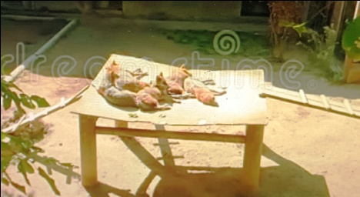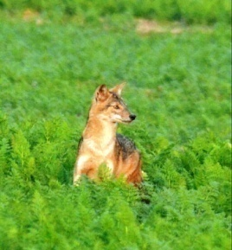

Fig-1, Getty Image, Fig – 2,

Credit-Jami Tarris Credit-[Vadim Khomyakov](https://www.dreamstime.com/photobeginner_info) (2024)

**Sunbathing and Dust Bathing Behavior in Wild Canines**

Sunbathing and dust bathing are notable behaviors among many wild animals, characterized by rolling or resting in dust, dry earth, or sand. These activities serve several purposes, including parasite removal and thermoregulation. Carnivores in the wild often harbor parasites, and dust bathing helps maintain healthy fur, feathers, or skin. Additionally, in some mammals, this behavior may be a way of marking territory by transferring chemical signals to the ground. Dust bathing is commonly observed in tigers, horses, elephants, and donkeys (Johnsingh and Manjrekar 2013; Poche et al., 2000).

**Observations of Jackals**

Jackals typically rest in burrows, small caves, hollow logs, or grasslands during the day (Prater1971; Johnsingh and Manjrekar 2013). Studies estimate that jackals spend 71% of their time resting, 24% moving, and only 5% feeding. They are most often found in medium to dense thickets of *Prosopis*, with occasional sightings in open fields and sparse thickets (Aiyadurai and Jhala 2006).

During a visit to Pench Tiger Reserve in Madhya Pradesh on November 1, 2024, we observed jackals displaying sunbathing behavior. At around 8:30 a.m., on a sunny and dusty forest road, we encountered three Indian golden jackals leisurely sitting in the sunlight. On our approach, one walked away, while the other two continued basking until we were about 15 meters away. They eventually moved into the forest. The observation lasted about ten minutes and was unique, as jackals in other parts of the park remained in forested areas.(Fig, 3,4,5)

This behavior aligns with findings from previous studies and observations. For example, in the winter of 2021 at Kanha Tiger Reserve (KTR), a pack of seven jackals was observed basking on a dusty road, with two lying down and simultaneously indulging in dust bathing to alleviate itching and remove ticks.

Similar observations were made at Guru Ghasidas-Tamor Pingla Tiger Reserve (GGTPTR), Chhattisgarh, on December 2, 2024, where a jackal was seen sitting on dry grass in the sunlight. At another location in the same park, two jackals were feeding on the carcass of an Indian gaur killed by a tiger. In Sanjay Dubri National Park on January 28, 2024, a pair of jackals was spotted sunbathing in filtered sunlight (Danesh Sinha *Pers. Comm.*). They initially moved away upon noticing a vehicle but later resumed their basking once the disturbance subsided.

Dharmendra Pare (*Pers. Comm)* reported a pack of five or six jackals basking in an open grassy patch near a road in KTR during winter at around 8:30 a.m. This behavior appears common during colder months when jackals seek warmth from the sun.

**Indian Fox Behavior**

Indian foxes, like jackals, exhibit sunbathing and dust-bathing behavior. They are often seen lying on rocks or in open grasslands during the early morning or late afternoon. For example, in January 2024, a solitary Indian fox was observed basking in a grassland area in Rajnandgaon district, Chhattisgarh. The fox seemed uncomfortable upon noticing the observer, moved slightly away, and resumed sunbathing in a nearby spot. The observation lasted about 30 minutes in clear, bright sunlight ( Fig, 6,7,8).

In another instance, a fox was observed near Bharritola village, sitting on the ground and sunning itself. These behaviors align with observations of foxes maintaining body temperature and relieving discomfort from parasites or itching through dust bathing.

**Asiatic Wild Dogs**

Asiatic wild dogs, or dholes, listed as "Vulnerable" by the IUCN and protected under Schedule II of the Indian Wildlife (Protection) Act, 1972, are another species that frequently indulge in sunbathing and dust bathing. These forest-dwelling animals are often seen resting on forest roads, dry stream beds, or open grassy patches.

In Kanha Tiger Reserve, dholes were observed either sunbathing or pursuing prey, such as cheetal herds. In one remarkable instance, a pack attempted to catch a cheetal fawn that had sought refuge in a tank. After several attempts, the dholes succeeded in dragging the fawn to shore and consuming it. These behaviors highlight their adaptability and determination.

**Hyenas**

Hyenas also exhibit sunbathing and dust-bathing habits. In GGTPTR, Chhattisgarh, a hyena was spotted on November 25, 2024, lying on a dusty forest road with its legs in the air, a posture often seen in tigers. The hyena appeared to be both sunbathing and dust bathing in the early morning hours when the temperature was around 8-9°C. Upon the approach of a vehicle, the hyena stood up and retreated into the forest. The dust conditions at the site suggested recent dust-bathing activity.

**Conclusion**

Our observations, combined with literature and reports, confirm that sunbathing and dust bathing are common behaviors among various wild canines, including jackals, foxes, wild dogs, and hyenas. These behaviors serve multiple purposes, such as thermoregulation, parasite removal, and energy conservation. While these habits are well-documented, additional studies could further explore their ecological significance and variation across different species.

**References**

**Abd Rabou, A. , Elkahlout, K. , Almabhouh, F. , Mohamed, W. , Khalaf, N. , Al-Sadek, M. , Alfarra, R. , Al-Moqayed, L. , Shafei, A. , Fayyad, N. , Adeem, B. , Dardona, A. , Awad, A. , Al-Agha, M. and Abd Rabou, M. (2021)** Occurrence and Some Ecological Aspects of the Golden Jackal (*Canis aureus* Linnaeus, 1758) in the Gaza Strip, Palestine. *Open Journal of Ecology*, **11**, 105-125. doi: [10.4236/oje.2021.112010](https://doi.org/10.4236/oje.2021.112010)

**Ambika Aiyadurai and Yadvenradev, V.Jhala(2006).** FORAGING AND HABITAT USE BY GOLDEN JACKALS (CANIS AUREUS)IN THE BHAL REGION, GUJARAT, INDIA1.*Journal of the Bombay Natural History Society, 103 (1), Jan-Apr 2006 5-12,*

**Bharos, A. Bharos A M K (2023)**. Photographic Evidence of Predation by Golden Jackal (*Canis aureus*) on Young Cheetal ( Axis axis), *Cheetal, Journal of the Wildlife Preservation Society Dehradun.* Vol.60 , No 1. P- 37-40.

**Bharos, A..M.K. and Bharos, Akhilesh (2017)**. Our Experience with“ Pheall”. *Cheetal, Journal of the Wildlife Preservation Society Dehradun.* Vol.54 ,No 3&4, P- 31-32..

**Geiser, Fritz; Goodship, Nicola;Pavey, Chris (2002).** *"Was basking important in the evolution of mammalian endothermy?".*Naturwissenschaften.**89**(9):412–414. (doi:10.1007/s00114-002-0349-4 )

**Indian Wildlife (Protection) Act 1972**.(Amended upto 1991) Natraj Publishers, Dehradun P-154

**Jami Tarris,** Getty Images, [*https://uk.pinterest.com/pin/blackbacked-jackal-basking-in-morning-sun-282671314099264829*](https://uk.pinterest.com/pin/blackbacked-jackal-basking-in-morning-sun-282671314099264829)). Fig-2

**Linkie M, Ridout MS. (2011)**. Assessing tiger-prey interactions in Sumatran rainforests. *Journal Zoology* 284: 224-229.

**Moulten, C. & Hulsey, E. (1999).** Kanha Tiger Reserve, Portrait of Indian National Park. Vakils and Feffer and Simons Ltd, Mumbaip220

**Meadows Taylor (1922).***The Confession of a Thug*. Longmans, Green and Co .Bombay. P-238

**Poche. Richard.,** [**S. J. Evans**](https://www.researchgate.net/scientific-contributions/S-J-EVANS-2022558981?_sg%5B0%5D=Vf-PJSB5oRn-36MNi6p19Hfqx2ylhIYo8p20o5-G3XTOTIPrnVbbaVZ0ZlGZMiH0QD_iTjw.udw7rhh5WbvNYXLFQqO2uIlQ9ntZhrPgwF5zNnuq1P5HoKxOs35OpTKrAYvYNptMsO6gUPoTAa1jfU20liURQg&_sg%5B1%5D=Wd5mqbXoOnWUEfl44MB-rPjQyX1jmzIl-JtGk83BtAQOEqmNyGaw_BledLdtrGj6M0kPPYw.2yVSPzZb0C7pLccTSO6iWK8ZCPXyNju8bkaYk3IpYd6uRZZZxbELIwxndhxKVN-kTQAVofc0lGTuU1jhQgUzVA&_tp=eyJjb250ZXh0Ijp7ImZpcnN0UGFnZSI6InB1YmxpY2F0aW9uIiwicGFnZSI6InB1YmxpY2F0aW9uIiwicG9zaXRpb24iOiJwYWdlSGVhZGVyIn19) **,** [**M. A. Siddique**](https://www.researchgate.net/scientific-contributions/M-A-SIDDIQUE-2022436998?_sg%5B0%5D=Vf-PJSB5oRn-36MNi6p19Hfqx2ylhIYo8p20o5-G3XTOTIPrnVbbaVZ0ZlGZMiH0QD_iTjw.udw7rhh5WbvNYXLFQqO2uIlQ9ntZhrPgwF5zNnuq1P5HoKxOs35OpTKrAYvYNptMsO6gUPoTAa1jfU20liURQg&_sg%5B1%5D=Wd5mqbXoOnWUEfl44MB-rPjQyX1jmzIl-JtGk83BtAQOEqmNyGaw_BledLdtrGj6M0kPPYw.2yVSPzZb0C7pLccTSO6iWK8ZCPXyNju8bkaYk3IpYd6uRZZZxbELIwxndhxKVN-kTQAVofc0lGTuU1jhQgUzVA&_tp=eyJjb250ZXh0Ijp7ImZpcnN0UGFnZSI6InB1YmxpY2F0aW9uIiwicGFnZSI6InB1YmxpY2F0aW9uIiwicG9zaXRpb24iOiJwYWdlSGVhZGVyIn19)**, ,** [**Perveen Sultana**](https://www.researchgate.net/profile/Perveen_Sultana?_tp=eyJjb250ZXh0Ijp7ImZpcnN0UGFnZSI6InB1YmxpY2F0aW9uIiwicGFnZSI6InB1YmxpY2F0aW9uIiwicHJldmlvdXNQYWdlIjoic2NpZW50aWZpY0NvbnRyaWJ1dGlvbnMifX0) **,** [**M. E. Hague**](https://www.researchgate.net/scientific-contributions/M-E-HAGUE-2022422144?_tp=eyJjb250ZXh0Ijp7ImZpcnN0UGFnZSI6InB1YmxpY2F0aW9uIiwicGFnZSI6InB1YmxpY2F0aW9uIiwicHJldmlvdXNQYWdlIjoic2NpZW50aWZpY0NvbnRyaWJ1dGlvbnMifX0)  **(2000)**. Notes on the golden jackal (Canis aureus) in Bangladesh. *MAMMALIA* 51(2):259-270. DOI: [10.1515/mamm.1987.51.2.259](http://dx.doi.org/10.1515/mamm.1987.51.2.259)

**Prater, S.H. (1971, 2005).***The Book of Indian Animals. 12th Ed.*Bombay Natural History Society, Bombay, pp.162 (126-27).

**Simchareon S. (1998).** Home range of and habitat use by male Asiatic jackal (*Canis aureus*) at Khao Nang Rum Wildlife Research Center, Thailand. *Nat Hist Bull Siam Soc* 46: 3-15.

**WEBSITE**

https://uk.pinterest.com/pin/blackbacked-jackal-basking-in-morning-sun--282671314099264829/.**A black-backed jackal curled up in the sun on a cold Kalahari**

[*https://uk.pinterest.com/pin/blackbacked-jackal-basking-in-morning-sun-282671314099264829*](https://uk.pinterest.com/pin/blackbacked-jackal-basking-in-morning-sun-282671314099264829)

National Geography: <https://www.nationalgeographic.com/animals/article/why-animals-love-to-bask-in-the-sun>

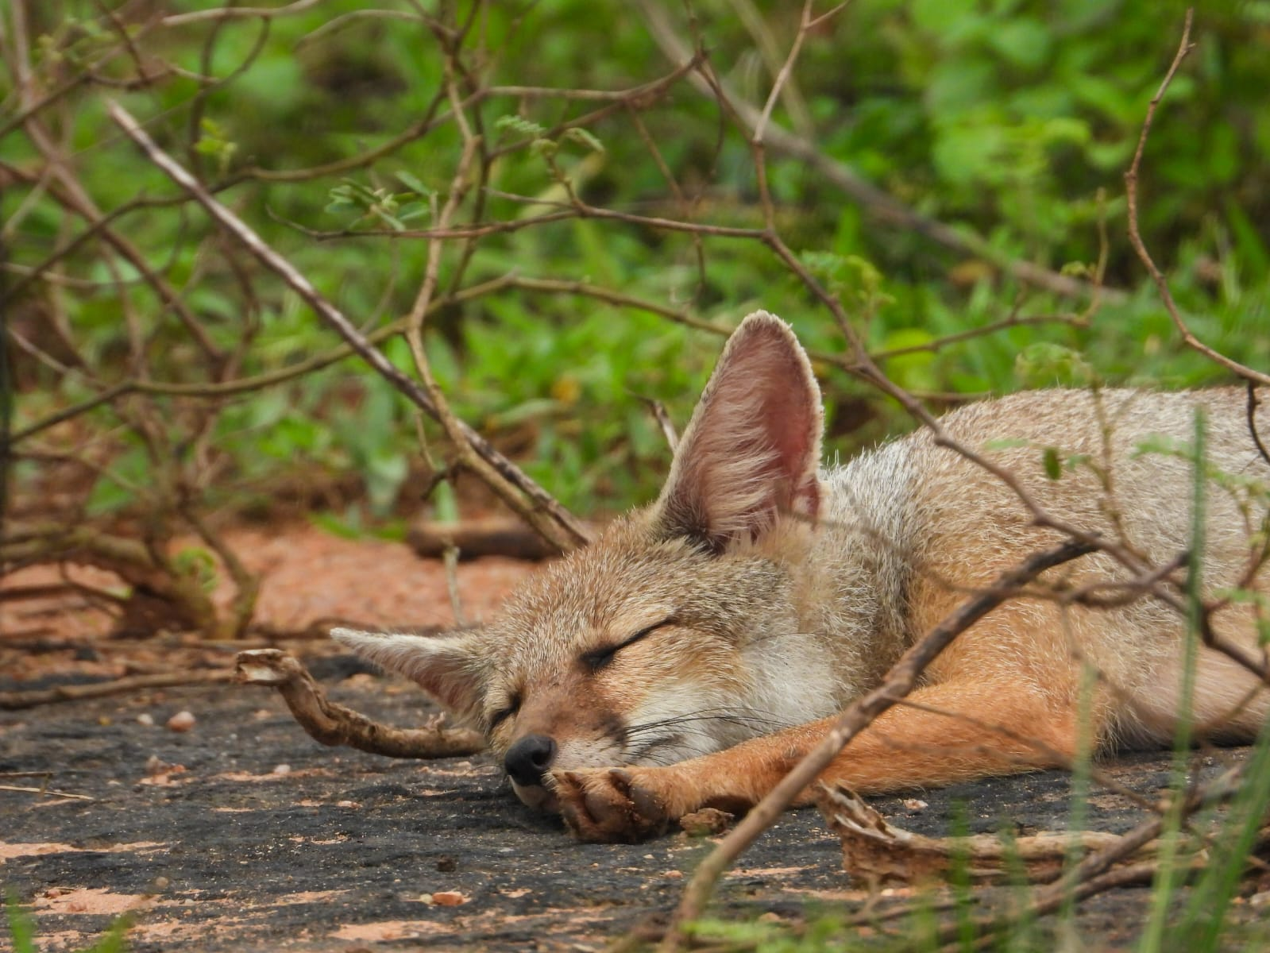

Fig 3 : Observation of Jackal’s behaviour

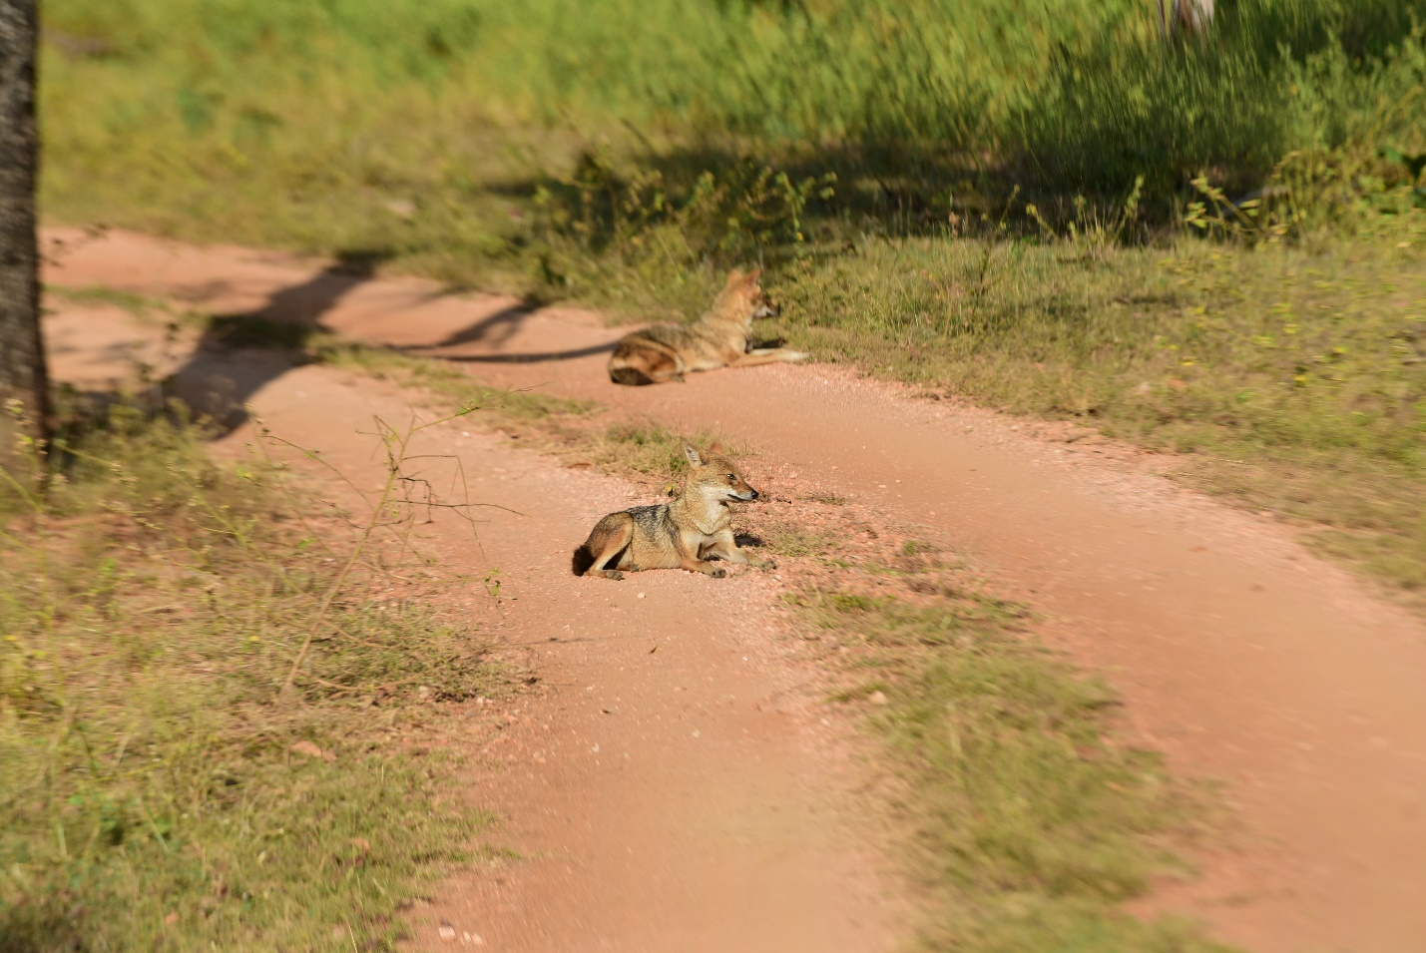

Fig4 : Observation of Jackals’ behaviour

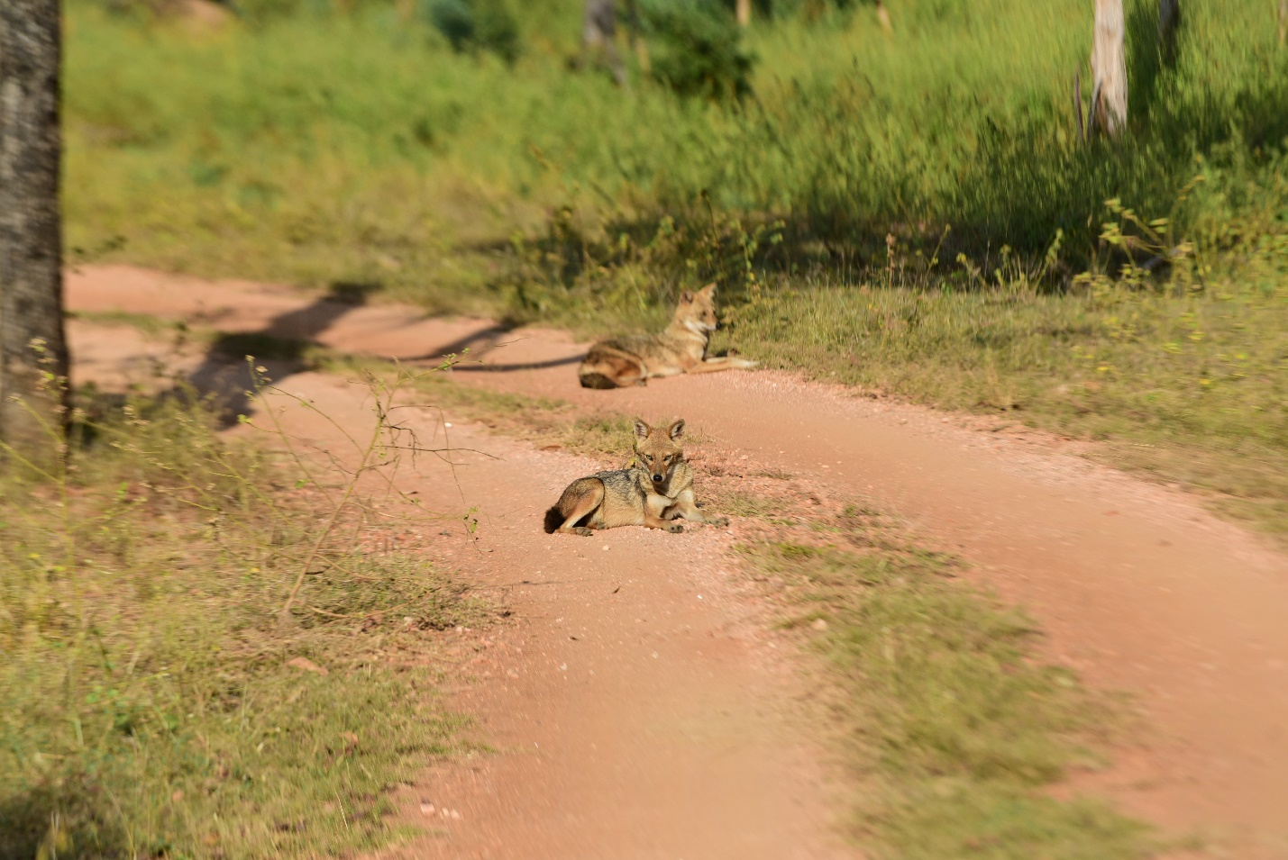

Fig 5 : Observation of Jackals’ behaviour

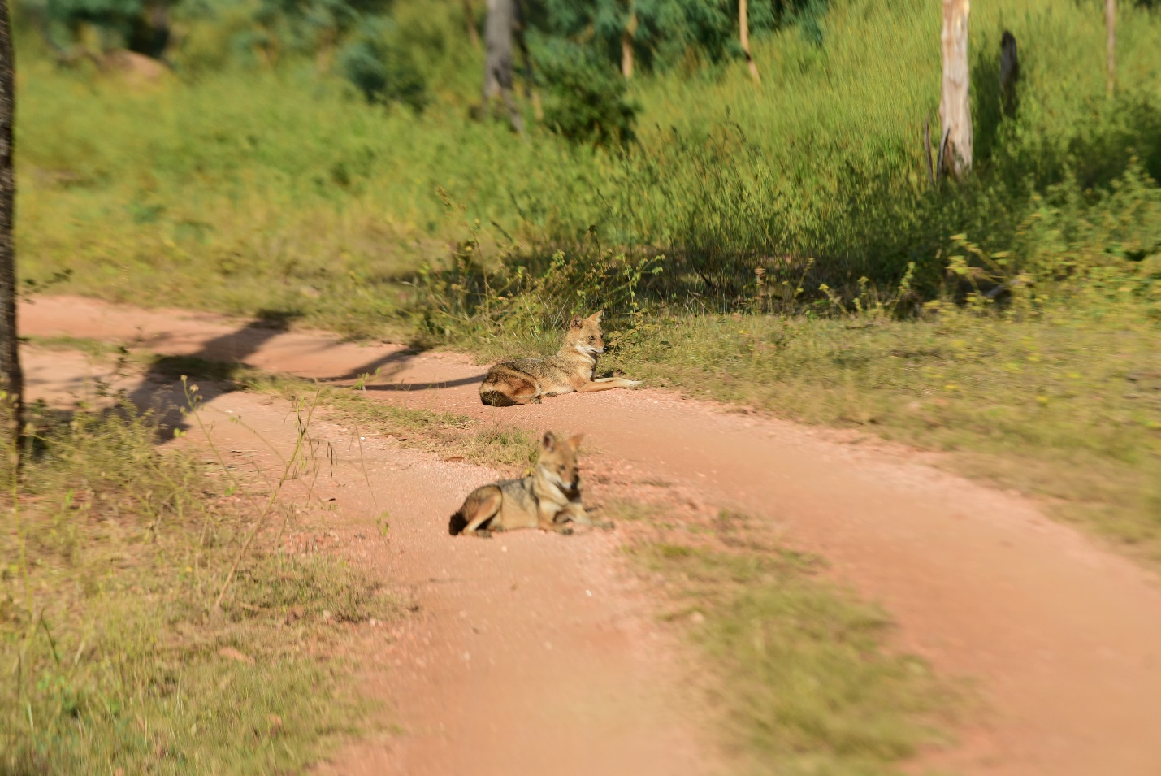

Fig 6 : **Observation of Indian Fox Behavior**

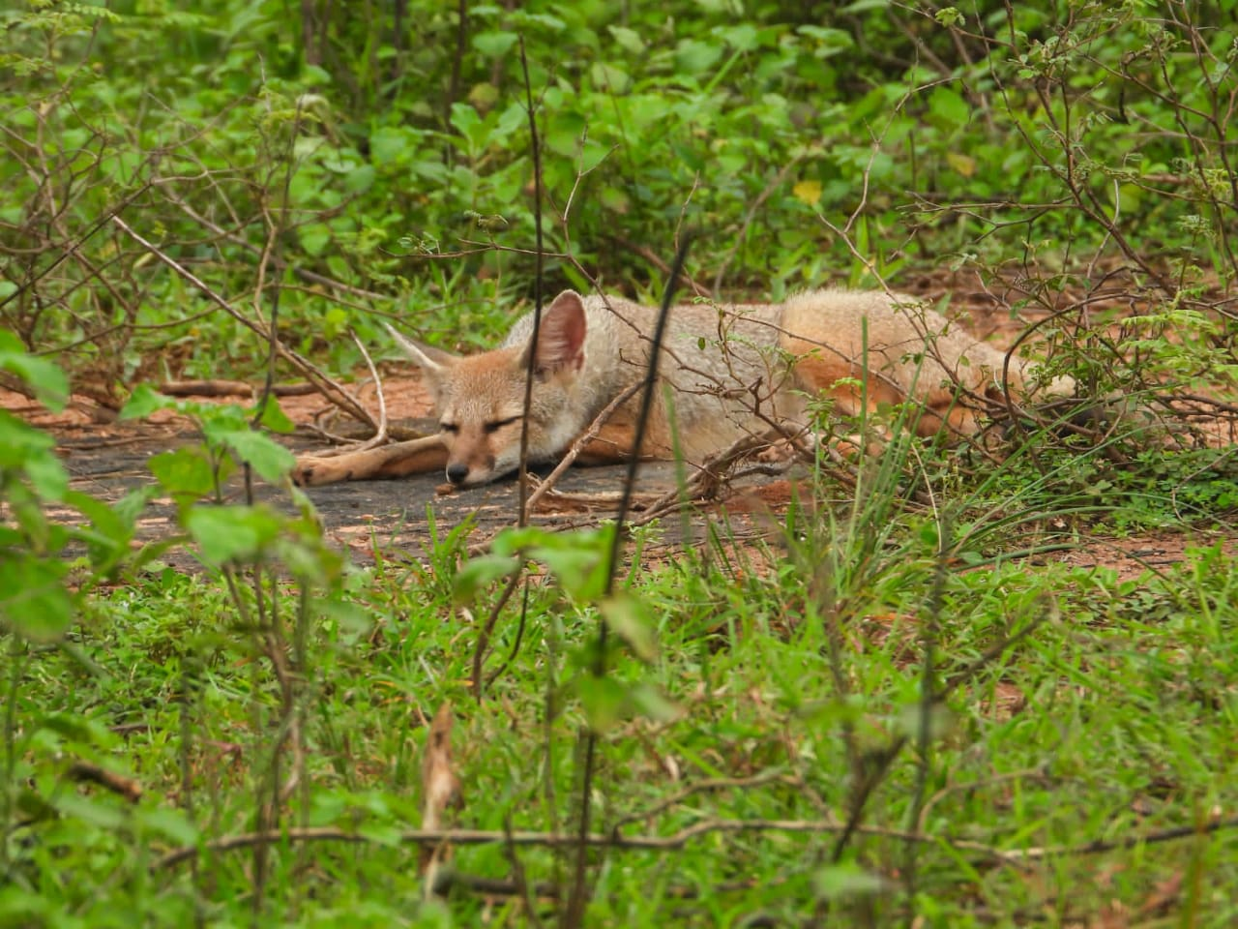

Fig 7 : **Observation of Indian Fox Behavior**

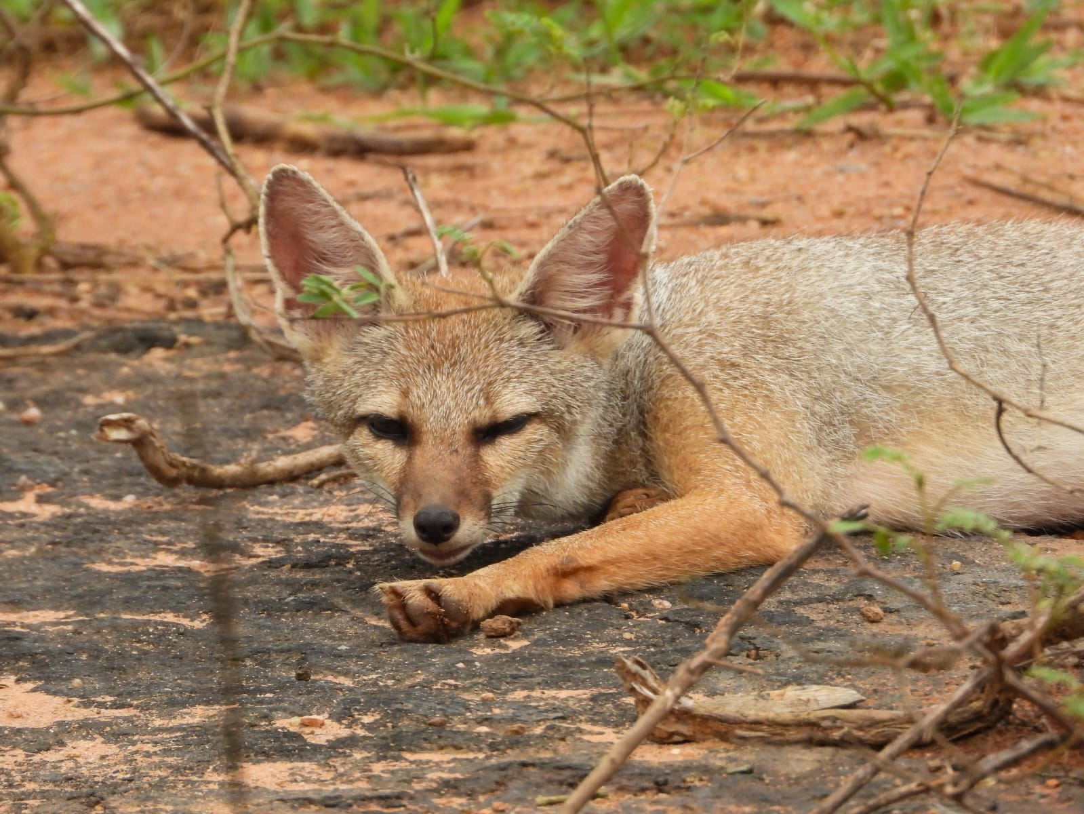

Fig 8 : **Observation of Indian Fox Behavior**