**Dynamics of Mosquito Populations in Natural and Artificial Phytotelmata from Southern West Bengal, India**

**Abstract**

The phytotelma is a small, isolated, collected water body in a living or dead plant part of a terrestrial ecosystem. The ecosystem in phytotelmata supports the nourishment and development of various organisms and acts as an important breeding ground for disease-spreading vector mosquitoes. The present study deals with the occurrence of mosquito species in various phytotelmata of southern West Bengal in India. The natural phytotelmata are decreased day-by-day from human habitation, and some artificial phytotelmata are mimicking the natural phytotelmata. The results of the study state that the artificial telmata are more available and accessible in the post-monsoon period (months of September to November) for developing the bamboo super-structure or pandals in various festivals. These artificial phytotelmata effectively promote the development of the different life stages of different mosquitoes (e.g., *Anopheles* sp., *Aedes* sp., etc.) for which the vector-borne diseases (e.g., dengue, malaria) become endemic in North 24 Parganas and its adjacent areas during the post-monsoon period of festivals. The study demonstrates that the mosquito surveillance data in natural and artificial phytotelmata can be used to predict seasonal mosquito abundance, and it may provide guidance for the public health authorities for vector control measures to reduce the risk of mosquito-borne diseases in study areas.

**Keywords:** Artificial phytotelmata, Diversity of phytotelmata, Gangetic plains, Mosquito diversity, Vectoring mosquito.

1. **Introduction**

The phytotelmata is a crucial but unfamiliar ecosystem that is a major natural mosquito breeding site for various species [1]. The phytotelmata generally include tree holes, bamboo stumps, leaf axils, fallen leaves, and fruit husks [2,3]. The water source of the phytotelmata is usually rainwater and plant sap. The aquatic microfauna present in phytotelmata is composed of a mixture of species that inhabit soil and freshwater [4]. These are lentic habitats, unique for their small size, discreteness, and ephemerality [5], and are known to accommodate aquatic invertebrates [3,6], most dominated by insect larvae at high densities [7]. Detritus aquatic insects use phytotelmata as their primary habitat, and some reside permanently [2,3,8]. Phytotelmata have been studied to determine various factors that influence the structure of insect communities [9,3,10,11]. Water-filled tree holes are the most tractable small aquatic system, partly because they are relatively persistent and can be mimicked with plastic cups, bamboo sections, or other inexpensive materials [12].

Emerging zoonotic diseases pose a risk to both humans and animals, comprising those transmitted by animals as well as mosquitoes [13]. Japanese encephalitis virus is one of the genus Culex mosquito-borne zoonotic viruses that have been reported in West Bengal and have become endemic in new areas. These viruses can infect both humans and animals [14]. Mosquitoes have varying preferences for different types of phytotelmata depending on conditions such as appropriate microhabitat, food availability, breeding opportunities, and predator escape. It serves as an excellent indicator of the condition of insects and vectors in a specific area. To complete their early life cycle phases, mosquitoes that transmit various diseases, including dengue, filariasis, malaria, and others, seek phytotelmata (i.e., egg, larva, pupa) [15]. Mosquitoes reproduce in various habitats such as paddy fields, stagnant water, pools, tree holes, and both natural and artificial containers [16].

There are several studies on the phytotelmata with different aspects of medically important insect biology and their vector incidents in human society nationally and internationally [11,17,18], but it is yet to be studied in West Bengal in detail. Our study aims to quantify different invertebrate species inhabiting three types of phytotelmata, such as the extracted bamboo stump (used as pandals and construction materials) and the leaf axil of Colocasia sp. and Musa sp. The diversity, density, relative abundance, and seasonal dynamics of those organisms, especially available mosquitoes in the phytotelmata, have been examined. Effects of the natural and artificially occurring phytotelmata and the density and relative abundance of the mosquitoes are also determined here.

1. **Materials and methods**

## **2.1 Study Site**

The study was carried out in the two urban areas (Naihati municipality, 22°54’N, 88°24E’), and Bhatpara municipality, 22°85’N, 88°39E) in North 24 Parganas district, West Bengal, India.

## **2.2 Study Period**

The study was done in two timelines, in the first, the study samples were collected only in the rainy season (June 2017 to September 2017). Secondly, samples were collected 5 days a week for every month of the year, taking three consecutive years, *viz.,* 2017, 2018, and 2019. The samples were collected randomly from the leaf-axil of *Colocasia* sp., *Musa* sp., and bamboo stump phytotelmata (n=750). Two hundred fifty samples of each type of phytotelmata.

## **2.3 Sampling and physicochemical parameter analysis of the phytotelmata**

The natural phytotelmata are the different parts of the trees/plants that can hold rainwater for some days during rain and may be dried after some time. The artificial phytotelmata are those that are made by human activities, like bamboo stumps, plastic, or unused containers. For sampling, we selected leaf-axils of two plants (banana plants, (*Musa* sp.), and elephant ear plants, *Colocasia* sp.), which were considered as natural-telmata, and the man-made extracted bamboo stumps, which were considered as artificial-telmata. The impound water sample and the different biological specimens were collected in glass beakers with the help of glass pipettes (10 ml and 25 ml in volume). The collected specimens were transferred to glass vials containing 70% alcohol for preservation and further investigations.

The physico-chemical parameters include the height of the phytotelmata from the ground, the amount of water, the temperature, and the pH of the water in the phytotelmata. These were noted following a standard protocol [19]. The temperature of the water samples was recorded with the help of a Comet Borosilicate glass mercury thermometer. The pH of the samples was recorded with pH paper (Amici kart 5-meter pH test strips, acid test paper, water litmus testing kit). The heights of the phytotelmata from the respective ground level were measured with a scale calibrated in inches.

## **2.4 Specimen identification**

The collected mosquito samples were identified up to the genus following dichotomous keys [20,21]. However, other organisms were recorded with their common English names.

## **2.5 Data analysis**

The Shannon-Weiner Index (H') of species diversity is calculated using the formula H' = - ∑ pi * ln (pi), where “pi” is the proportion of individual belong to the species “i”, “ln” is the natural logarithm and ∑ represents the summation of the of the product of “pi” and ln (pi) for all species in the community. The species richness is calculated by counting the total number of species within a specific habitat (natural and artificial telmata).

The species evenness is calculated as the Shannon-Weiner Index (H') divided by the logarithm of the species richness. The relative abundance was calculated by dividing the total number of species in a specific habitat by the total sum of all species in a particular habitat (like bamboo stumps, leaf axils of *Musa* sp., *Colocasia* sp). The seasonal dynamics of the mosquitoes were determined in the study using standard software and protocol.

1. **Results**

Approximately, nine groups of organisms such as mosquitoes (*Anopheles* sp., *Culex* sp., *Aedes sp*., and Toxorhynchitis), ants, snails, aphids, leeches, tubifex, dipteran maggots, banana beetles, and earthworms were found around 750 phytotelmata in three study sites of the lower Gangetic plains of West Bengal (Table 1). The phytotelmata comprise various life stages of the mosquitoes (i.e., the eggs, larva, pupa, and adult).

To understand the diversity, the Shannon diversity index was performed in different types of phytotelmata showed that, surprisingly, in all types of phytotelmata Shannon index diversity is very low (Table 2). The value is less than the typical value (between 1.5 and 3.5) of most of the ideal community. So, both the richness and evenness of mosquito species are very less in both types of phytotelmata. It is also found that mosquitoes are more abundant in all types of phytotelmata (Table 1). It signifies that disease spreading vectors like mosquitoes are more available than other types of less harmful organisms like ants, snails, aphids, etc.

The species richness is relatively greater in natural phytotelmata (leaf axil of *Musa* sp. and *Colocasia* sp.) than in artificial telmata. It is also observed that the species richness is higher in the *Musa* sp. than in the *Colocasia* sp. (Table 2). The species richness is directly proportional to the water volume in the telmata; i.e., more water supports to occurrence of more species diversity (Table 1). The organisms of different species in telmata mostly prefer neutral or slightly acidic water (Table 1). The height of the phytotelmata has no impact on the mosquito species diversity in the habitat (Table 1). The species diversity mainly depends on the nature and availability of phytotelmata.

**Table 1.** Different organisms in the phytotelmata of lower Gangetic plains of West Bengal.

|  |  |  |  |  |  |  |  |  |  |  |  |  |  |  |  |  |  |  |  |  |  |  |
| --- | --- | --- | --- | --- | --- | --- | --- | --- | --- | --- | --- | --- | --- | --- | --- | --- | --- | --- | --- | --- | --- | --- |
| Sl.no | Nature of phytotelmata |  | no. of phytotelmata study | Infected no. of phytotelmata | Total no. of individuals | Mosquito no. | | | |  |  | Ant | snail | aphid | Leech | Tubifex | Dipteran maggot | Banana beetle | Earth worm | P  H | Vol. of water | Height  of phyto  telmata |
|  |  |  |  |  |  | *Ano*  *pheles* | *Cu*  *lex* | *Aedes* | *Toxorhynchites* | Total |  |  |  |  |  |  |  |  |  |  |  |  |
| 1 | Leaf axil of  *Musa* sp. |  | 250 | 195 | 440 | 62 | 98 | 29 | 5 | 194 |  | 75 | 16 | 36 | 7 | 42 | 22 | 15 | 33 | 7 | 4.9 | 74 |
| 2 | Leaf axil of  *Banana* sp. |  | 250 | 220 | 480 | 75 | 104 | 15 | 4 | 198 |  | 112 | 59 | 39 | 16 | 24 | 12 | 0 | 20 | 7 | 4.5 | 6.5 |
| 3 | Bamboo stump |  | 250 | 87 | 256 | 79 | 55 | 70 | 12 | 216 |  | 27 | 3 | 0 | 4 | 0 | 0 | 0 | 6 | 7 | 3.7 | 58 |

**Table 2:**

It is found that the diversity of all mosquito species is very low in all telmata (Table 3). It is observed that the species diversity is very low in all telmata. The species richness, evenness,

**Table 2.** Species richness, evenness, and H’ index of mosquitoes in the different types of phytotelmata in West Bengal.

|  |  |  |  |
| --- | --- | --- | --- |
|  | **Phytotelmata** | | |
| ***Musa* sp.** | ***Colocasia* sp.** | **Bamboo stump** |
| **H'-index** | 1.087920461 | 0.980215553 | 1.241930018 |
| **Evenness** | 0.271980115 | 0.245053888 | 0.310482504 |
| **Species**  **Richness** | 4 | 4 | 4 |

**Table 3.** Species richness, evenness, and H’ index of different organisms present in the various types of phytotelmata in West Bengal.

|  |  |  |  |
| --- | --- | --- | --- |
|  | ***Musa* sp.** | ***Colocasia* sp.** | **Bamboo stump** |
| **H'-index** | 1.73732899 | 1.654264029 | 0.585648919 |
| **Evenness** | 0.790692498 | 0.795532837 | 0.363884133 |
| **Species Richness** | 9 | 8 | 5 |

and the H’-index of different groups of organisms is almost similar in the telmata but greater in natural telmata (leaf axil) than those in artificial telmata (bamboo stump) (Figure 1). The H’-index and evenness of different types of mosquitoes are slightly greater in the artificial telmata (Extracted bamboo stump) than in other natural telmata (Figure 2).

The abundance of mosquitoes is relatively smaller in the natural telmata than in the artificial telmata. The *Culex* sp. is more abundant, followed by *Anopheles* sp, *Aedes* sp, and *Toxorhynchites* sp. in the telmata of leaf axils. In contrast, *Anopheles* sp. is greater in the artificial telmata and followed by *Aedes* sp., *Culex* sp., and *Toxorhynchites* sp. (Figure 3). It is also found that the smaller water volume in the artificial telmata supports more mosquito species than that in the natural telmata. The low pH of the artificial telmata supports more mosquitoes than the natural telmata. The abundance of the *Aedes* sp. and *Toxorhynchites* sp. is directly correlated to the height of the telmata from ground level (Figure 4). In natural telmata, all types of mosquitoes are comparatively greater from June to August. The humidity and temperature of the telmata are directly proportional to the abundance of mosquitoes. The *Culex* sp. is dominant over other mosquitoes throughout the study period (Figure 5 and 6).

The mosquito abundance is greater in the artificial telmata in Sept- Nov., however, *Aedes* sp. is more dominant in those months than other mosquitoes (Figure 7 and 8). The availability of artificial telmata (e.g., extracted bamboo stump) is relatively greater in the post-monsoon (Sept-Nov) season than in the monsoon (Jun-Aug) and pre-monsoon (Mar-May) season. In the artificial telmata, we observed that there are some black-colored dormant mosquito eggs attached to the extracted bamboo stem’s inner side. These are mainly eggs of *Aedes* sp. As a result, the two most occurring diseases, such as dengue and malaria, are spread out due to the availability of their insect vectors, *viz. Aedes* sp. and *Anopheles* sp.

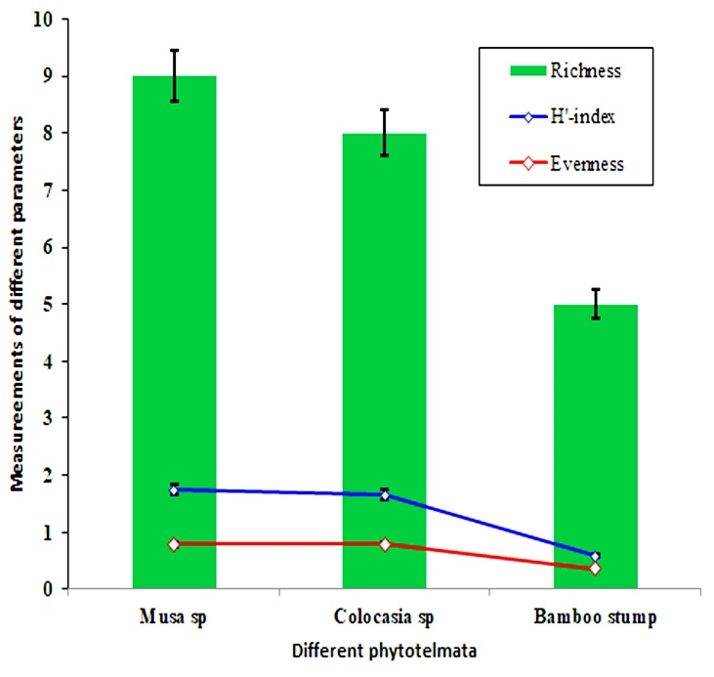

**Figure 1** The graphical representation of the species occurrence in three phytotelmata, showing the species richness, Shannon-Weiner (H') index, and evenness of different types of organisms.

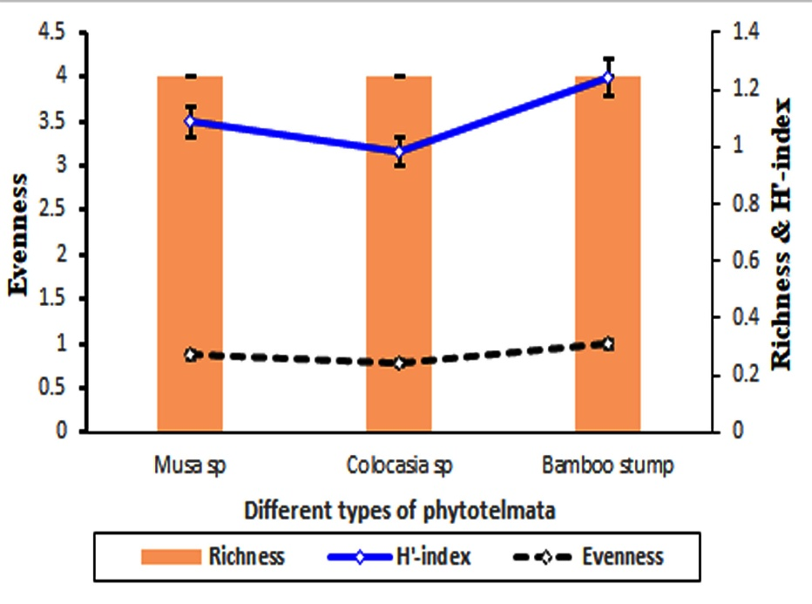

**Figure 2** The graphical representation of the species occurrence in three phytotelmata, showing the species richness, H'-index (Right side), and evenness (Left side) of the mosquitoes.

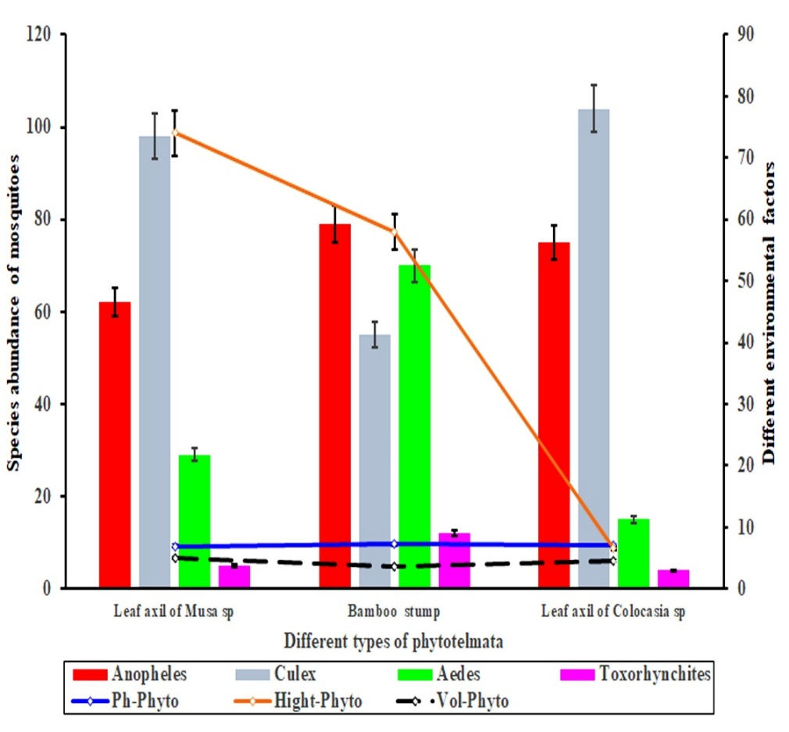

**Figure 3** Different types of mosquito species in phytotelmata. Species abundance of mosquito species is plotted on the left axis and different environmental factors are plotted on the right axis of the plot of different types of phytotelmata. Error bars are standard errors (*p = .05*).

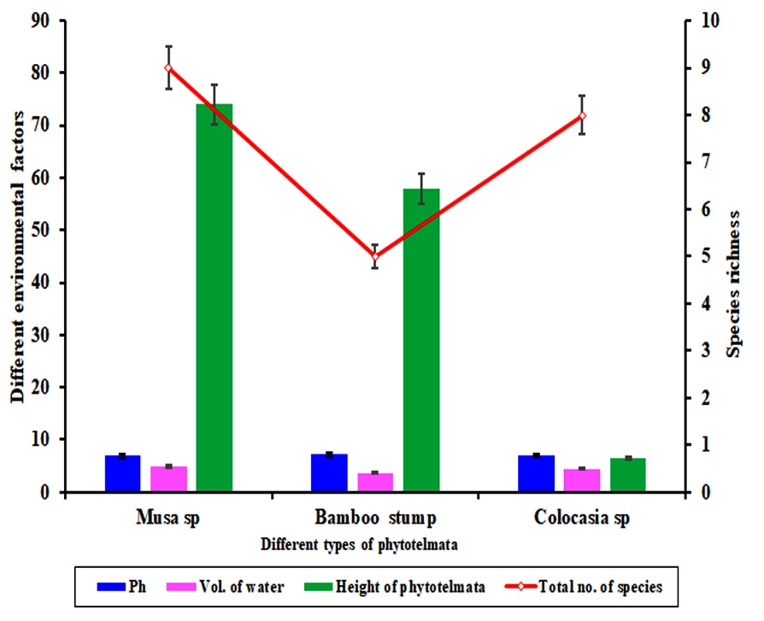

**Figure 4** Different types of phytotelmata. Effects of different environmental factors (bar graph and the left axis), Species richness (line graph and the right axis) of different types of phytotelmata. Error bars are standard errors (*p = .05*).

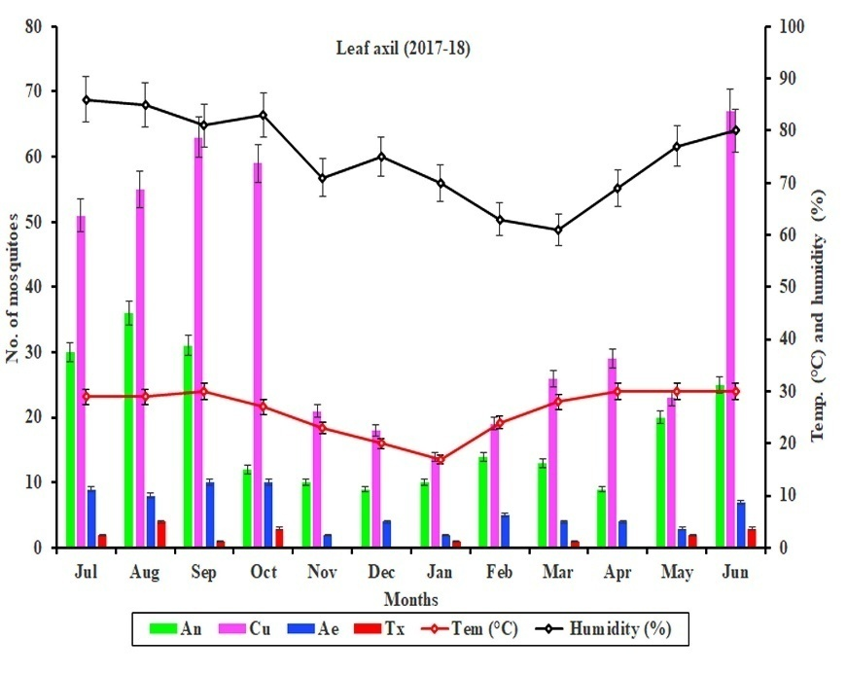

**Figure 5** Number of mosquitoes and environmental effects on Leaf axil (LA) in the year 2017-2018. The number of mosquitoes is plotted on the left axis (July to June), and different environmental factors (temperature and humidity) are plotted on the right axis of the plot. Error bars are standard errors (*p = .05*).

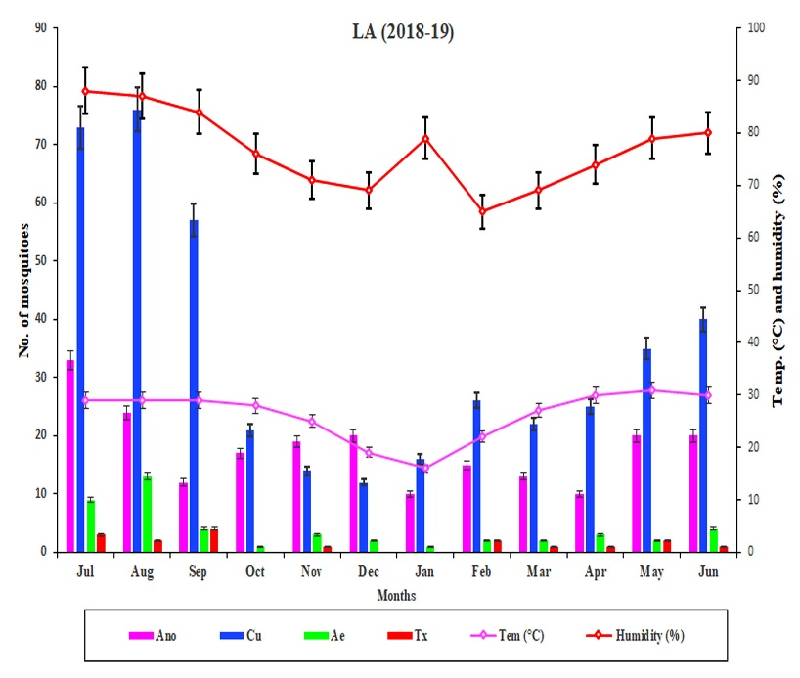

**Figure 6** Number of mosquitoes and environmental effects on Leaf axil (LA) in the year 2018-2019. The number of mosquitoes is plotted on the left axis (July to June) and different environmental factors (temperature and humidity) are plotted on the right axis of the plot. Error bars are standard errors (*p = .05*).

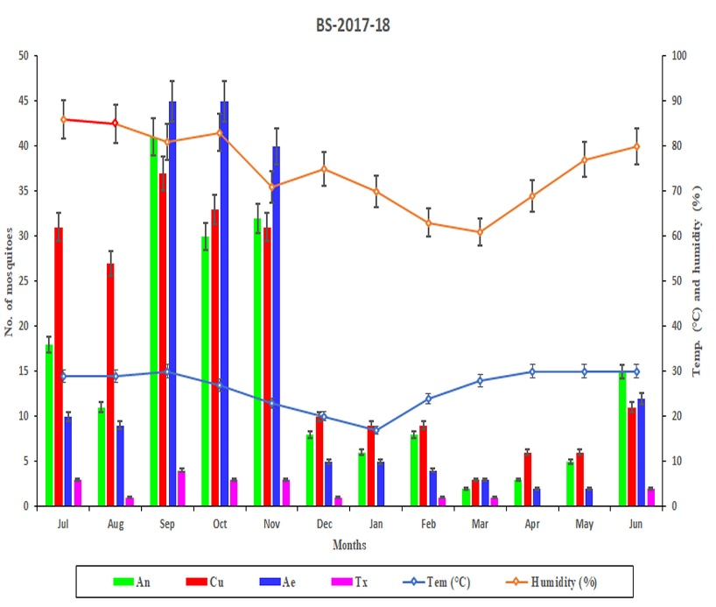

**Figure 7** Number of mosquitoes and environmental effects on Bamboo Stump (BS) in the year 2017-2018. The number of mosquitoes is plotted on the left axis (July to June) and different environmental factors (temperature and humidity) are plotted on the right axis of the plot. Error bars are standard errors (*p = .05*).

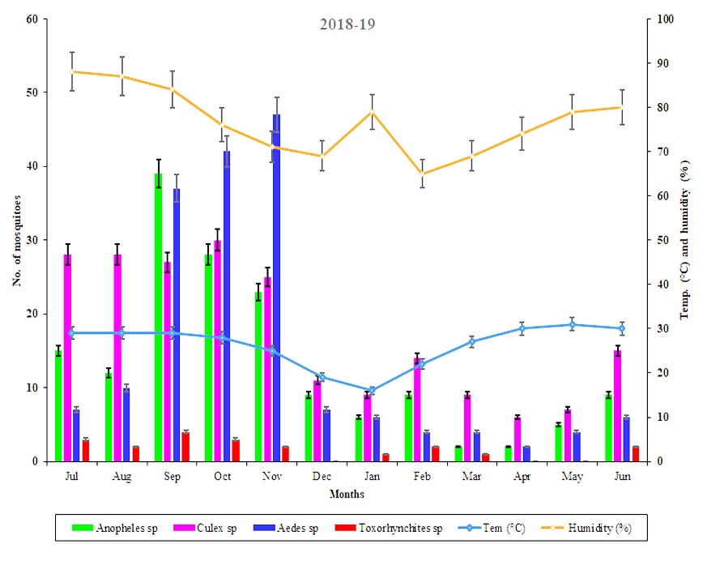

**Figure 8** Number of mosquitoes and environmental effects on Bamboo Stump (BS) in the year 2018-2019. The number of mosquitoes is plotted on the left axis (July to June), and different environmental factors (temperature and humidity) are plotted on the right axis of the plot. Error bars are standard errors (*p = .05*).

1. **Discussion**

The organisms that are found in different types of phytotelmata are mainly invertebrates. The species richness of different groups is greater in natural telmata than in artificial telmata. The species richness correlated with the amount of water and the stability of water in phytotelmata. It is assumed that the ability of water holding and stability in natural telmata is greater than in artificial telmata and is corroborated by some other research [22], but no such correlation is found with the height of phytotelmata from the ground. It is the opposite of the work by Majumder *et al.,* 2011 [17]. Different types of diseases spreading to mosquitoes are more abundant than other groups of organisms in all phytotelmata. Even mosquito is the only group where all the stages of the life cycle are available in phytotelmata [23]. The different life stages of mosquitoes are more available in artificial phytotelmata than natural phytotelmata, mosquitoes prefer to breed and nourish artificial telmata rather than natural telmata. This study is corroborated by the study conducted in the Western Ghats region [24]. The telmata in the bamboo stump are basic because of the low species richness in the artificial telmata, and they release less CO2 [25]. Rainfall can both positively influence mosquito abundance by the creation of standing water for vector breeding and negatively impact abundance during the monsoon by the destruction of breeding sites [26].

The area of North 24-Parganas is more prone to malaria and dengue due to the availability of the artificial breeding grounds of the respective mosquito vectors [26]. The results of the present study stated that the artificial telmata are relatively preferred by the *Aedes* and *Anopheles* mosquitoes. Thus, the natural phytotelmata are preferred mostly by Culex sp. Rather than *Anopheles* sp., *Aedes* sp. was used in the study of phytotelmata in the Western Ghat, India [24]. It is found that most of the mosquito species are adapted to breed in less amount of water in artificial telmata. It is assumed that water stability is less in these types of telmata. The *Aedes* sp. and *Toxorhynchites* sp. are preferred higher heights than the other two mosquitoes as breeding grounds above ground level. The eggs of *Aedes* sp. mosquitoes, which are already present in the artificial telmata, remain alive and start their lifecycle again from the dormant stage in the presence of even a small quantity of water. So, the number of more harmful and disease-spreading vectors *Aedes* sp*.* is comparatively higher at these times. Mosquitoes within the genus *Culex* sp. and *Aedes* sp. have been implicated as the principal vectors of many arboviruses and have been reported in several mosquito species. *Anopheles* sp., *Aedes* sp., and *Culex* sp. are a major threat to public health, considering the values of larval abundance found in this study associated with artificial phytotelmata [27].

Different types of mosquitoes are greater in number month of June to August. It is assumed that rainfall and humidity enhance mosquito flight activity. Rainfall also provides breeding sites for mosquito to lay their eggs. Mosquitoes have high peaks at 84 % to 88% relative humidity. It is corroborated by the study of Selvan *et al*., 2016 [18]. The mosquito abundance in artificial telmata (extracted bamboo stump) is greater in the monsoon period. During this period, more harmful diseases spreading mosquitoes *Aedes* and *Anopheles* were greater than other types of less harmful mosquitoes. Species diversity is very low in the overall studied telmata. The natural telmata are more diverse than artificial telmata due to the presence of different types of predatory organisms. These predatory organisms predate the egg, larva, and pupa of different types of mosquitoes and biologically control the mosquito vector. Since there are no specific treatments or vaccines available for many viral infections in humans, prevention of this mosquito-borne disease relies on controlling the mosquito population by decreasing mosquito breeding sites and implementing effective control strategies with the involvement of the local community [28].

1. **Conclusion**

The phytotelmata in the present study areas enhance the development and survivability of different types of organisms, especially disease-borne vector mosquitoes, *viz., Aedes, Anopheles,* and*Culex*. The natural telmata (leaf-axil of *Colocasia* sp*.* and *Musa* sp.) are very much restricted in some areas of the urban society, but artificially extracted bamboo stumps are frequently everywhere in the urban area as festive and construction structures. The eggs of the *Aedes* mosquitoes are adapted to live in the artificial telmata even in dry conditions. As a result, the populations of the *Aedes* mosquitoes are significantly increased throughout the festive periods. It is also evident that the population of the *Aedes* sp and *Anopheles* sp. is enormously greater in the post-monsoon period in the study areas, probably due to the development of bamboo structures for festivals and building purposes. A program for monitoring these primary mosquito breeding habitats with the involvement of local authorities and the community-engaged intervention to control mosquito-borne disease may be given importance at the local level, especially during post post-monsoon season.

The present work mainly focuses on the abandoned portions of neighbouring ecosystem of human settlements, which are used as a very important mosquito breeding niches, and definitely promote the disease transmission to the adjacent area of the study sites. Different types of phytotelmata, both artificial and natural, may be useful for future works including the altered breeding habitats and population ecology of the different mosquitoes.

**Disclaimer (Artificial intelligence)**

Author(s) hereby declared that NO generative AI technologies such as Large Language Models (ChatGPT, COPILOT, etc.) and text-to-image generators have been used during the writing or editing, figures, quotation citation and references of this manuscript.

**Reference**

1. Brown, R. and D. Fish. 1983. The psychological causality implicit in language. Cognition. 14: 237-273.
2. Greeney, H.F. 2001. The insects of plant-held waters: a review and bibliography. J. Trop. Ecol.17: 241-260.
3. Kitching, R.L. 2001. Food webs in phytotelmata:“bottom-up” and “top-down” explanations for community structure. Annu. Rev. Entomol. 46: 729-760.
4. Richardson, B.A. 1999. The bromeliad microcosm and the assessment of faunal diversity in a Neotropical forest 1. Biotropica31: 321-336.
5. Yule, C.M. and Y.H. Sen. 2004. Freshwater invertebrates of the Malaysian region. Academy of Sciences Malaysia.
6. Williams, D.D. 2006. The biology of temporary waters. Oxford University Press, USA.
7. Frank, J.H. and L.P. Lounibos. 1987. Phytotelmata: swamps or islands? Fla. Entomol. 14-20.
8. Yanovlak, S.P. 2001. The Macrofauna of Water‐filled Tree Holes on Barro Colorado Island, Panama 1. Biotropica33: 110-120.
9. Barrera, R. 1996. Species concurrence and the structure of a community of aquatic insects in tree holes. J. Vector Ecol. 21: 66-80.
10. Sota, T., M. Mogi, and E.Hayamizu. 1994. Habitat stability and the larval mosquito community in tree holes and other containers on a temperate island. Researches on population ecology36: 93-104.
11. Yanoviak, S.P. 1999. Community structure in water-filled tree holes of Panama: effects of hole height and size. Selbyana 106-115.
12. Das, K.A. and K.A. Nishadh, 2013. Tree hole aquatic habitat: a model for ecological experiments. Conserv. Sci. 1: 36-38.
13. Gokhale M, Sudeep AB, Mathapati B, Balasubramanian R, Ullas PT, Mohandas S, Patil DR, Shete AM, Gopale S, Sawant P, Jain R, Holeppana var M, Suryawanshi AT, Chopade G, Dhaigude S, Patil DY, Mourya DT, Yadav PD. 2022. Serosurvey for Nipah virus in bat population of southern part of India. Comp Immunol Microbiol Infect Dis 85:101800. https://doi.org/10.1016/j.cimid.2022.101800.
14. Ballav, Sudeep; Biswas, Asit Kumar; Saha, Pabitra; Guha, Ushnish; Pramanik, Tulsi; Maji, Ardhendu Kumar; Guha, Subhasish Kamal 2023. Japanese Encephalitis Virus Infection among Wild Caught Vectors Mosquitoes and Domestic Pigs in Northern West Bengal, India. Indian Journal of Public Health 67(4):p 646-653, DOI: 10.4103/ijph.ijph_1734_22.
15. Yee, D.A., D. Allgood, J.M. Kneitel, and K.A. Kuehn. 2012. Constitutive differences between natural and artificial container mosquito habitats: vector communities, resources, microorganisms, and habitat parameters. J. Med. Entomol.49: 482-491.
16. Balasubramanian, R., Nikhil, T.L., 2015. Effects of rainfall and salinity increase on prevalence of vector mosquitoes in coastal areas of Alappuzha district, Kerala. J. Environ. Biol. 36 (6), 1325.
17. Munirathinam, A., R. Krishnamoorthi, G. Baskaran, R. Govindarajan, A.Veerapathiran, A. Venkatesh, and B.K. Tyagi. 2015. Mosquito diversity in Keeriparai and Mundanthurai hill ranges of the Western Ghats, southern India. J. Threat. Taxa.7:7552-7556.
18. Selvan, P.S., A. Jebanesan, andD.Reetha. 2016. Entomofaunal diversity of tree hole mosquitoes in Western and Eastern Ghats hill ranges of Tamilnadu, India. Acta trop.159: 69-82.
19. Majumder, J.,Goswami, R and Agarwala, B. 2011. A preliminary study on the insect community of Phytotelmata: an ephemeral ecosystem in Tripura, Northeast India. NeBIO Vol. 2, No. 3, September 2011, 27 - 31
20. Bram, R.A. 1967. Classification of Culex subgenus Culex in the new world (Diptera: Culicidae). Proceedings of the United States National Museum.
21. Darsie, R.J., 1985. Mosquitoes of Argentina. Part I. Keys for identification of adult females and fourth stage larvae in English and Spanish (Diptera, Culicidae).
22. Albicócco, A.P., A.E. Carbajo, and D. Vezzani, 2011. Mosquito community structure in phytotelmata from a South American temperate wetland. J. Vector Ecol.36: 437-446.
23. Rossi, G. C., &amp; Harbach, R.E, 2008. Phytotelmat0myia, a new neotropical subgenus of Culex (Diptera: Culicidae). Zootaxa, 1879(1), 1-17.
24. Munirathinam, A., R. Krishnamoorthi, G. Baskaran, R. Govindarajan, A.Veerapathiran, A. Venkatesh, and B.K. Tyagi. 2014. Mosquito species biodiversity in phytotelmata from Western Ghats, southern India. HALTERES, volume 5, 56-63.
25. Bauer, U. and W. Federle, 2009. The insect-trapping rim of Nepenthes pitchers: surface structure and function. Plant signaling & behavior. 4:1019-1023.
26. Campos, R.E. and T.J. Zavortink. 2010. Description of the larva and pupa and redescription of the adults of Isostomyiaparanensis (Brèthes)(Diptera: Culicidae). Zootaxa.2689: 27-36.
27. Balasubramanian, R.; Anukumar, B.; Nikhil, T.L. 2015. Stegomyia indices of *Aedes* mosquito infestation and container productivity in Alappuzha district Kerala. *Int. J. Mosq. Res.* **2015**, *2*, 148.
28. Gopalan RB, Babu BV, Sugunan AP, Murali A, Ma MS, Balasubramanian R, Philip S. 2021. Community engagement to control dengue and other vector-borne diseases in Alappuzha municipality, Kerala, India. Pathog Glob Health. 115(4):258-266. doi: 10.1080/20477724.