*Original Research Article*

**DEVELOPMENT AND EFFICACY ASSESSMENT OF A NATURAL ANTI-INFLAMMATORY CREAM: AN IN VIVO STUDY ON CARRAGEENAN-INDUCED PAW EDEMA IN RATS**

**ABSTRACT**

**Introduction:** Inflammation is a physiological response that, when chronic, contributes to various disorders. The demand for herbal remedies is growing due to their fewer side effects compared to synthetic drugs. This study aimed to formulate and evaluate an herbal anti-inflammatory cream using natural ingredients with known anti-inflammatory properties. The cream was formulated using quercetin (a flavonoid), Vitamin E oil, calendula extract, beeswax, eucalyptus oil, almond oil, and aloe vera gel, chosen for their potential anti-inflammatory and skin-soothing properties. The formulation’s effectiveness was compared with a standard anti-inflammatory drug, indomethacin. **Methodology:** The cream underwent comprehensive physicochemical evaluations including pH measurement, viscosity analysis, dye test, homogeneity, appearance assessment, irritation testing, accelerated stability studies, and thin-layer chromatography (TLC) to assess its stability and formulation quality. In vivo studies were conducted using 24 rats divided into four groups (n=6 per group, 250g each). Group 1 served as the control, Group 2 as the paw edema induction group, Group 3 received standard treatment with indomethacin (10 mg/kg), and Group 4 was treated with the herbal anti-inflammatory cream. The carrageenan-induced paw edema method was employed to evaluate anti-inflammatory activity, with paw volumes measured using a digital plethysmometer. **Results:** The herbal anti-inflammatory cream exhibited desirable physical and chemical properties, with no signs of irritation or instability. In vivo studies demonstrated that the herbal cream significantly reduced paw edema in treated rats, showing comparable efficacy to the standard drug indomethacin. **Conclusion:** The results indicate that the formulated herbal anti-inflammatory cream is effective in reducing inflammation, showing potential as a natural alternative to synthetic anti-inflammatory medications. **Keywords:** Anti-Inflammatory Cream, Quercetin, Eucalyptus oil, Plethysmometer, Vitamin E oil, Carrageenan.

**INTRODUCTON**

Inflammation is a complex biological response of the body to harmful stimuli such as pathogens, damaged cells, or irritants. It serves as a protective mechanism to eliminate the initial cause of cell injury, clear out necrotic cells and tissues, and initiate tissue repair (Behera A et al. 2021). The inflammatory response involves a cascade of molecular and cellular events, primarily mediated by the activation of immune cells, release of cytokines, and production of inflammatory mediators such as prostaglandins, histamines, and leukotrienes (Chandrashekar R et al. 2013). Acute inflammation is characterized by redness, swelling, heat, pain, and loss of function, whereas chronic inflammation can lead to several diseases, including arthritis, cardiovascular disorders, and neurodegenerative conditions (Rao MSD et al. 2021). One of the widely used experimental models to assess inflammation in vivo is the carrageenan-induced paw edema model in rats, which mimics the acute inflammatory response seen in human conditions (Fathima H et al. 2021). This model allows for the evaluation of anti-inflammatory agents, including natural formulations.

In recent years, herbal remedies have gained significant attention as alternatives to synthetic drugs for managing inflammation due to their efficacy, safety, and minimal side effects (Winter CA et al. 1962). The increasing prevalence of chronic inflammatory diseases and the adverse effects associated with long-term use of non-steroidal anti-inflammatory drugs (NSAIDs) have fueled interest in natural anti-inflammatory agents (Vinegar R et al. 1969). Medicinal plants and their bioactive compounds exhibit potent anti-inflammatory properties by targeting key inflammatory pathways, including the inhibition of cyclooxygenase (COX) and lipoxygenase (LOX) enzymes, suppression of pro-inflammatory cytokines, and modulation of oxidative stress (Dil Rosa M et al. 1971). The development of herbal formulations, such as anti-inflammatory creams, offers a topical approach for localized inflammation management, reducing systemic exposure and potential toxicity (Posadas I et al. 2004). These creams leverage the synergistic effects of multiple bioactive constituents to provide relief from inflammation, pain, and swelling (Morris CJ et al. 2003).

Several phytochemicals and plant-derived oils have been incorporated into natural anti-inflammatory creams to enhance their therapeutic efficacy (Panthong A et al. 2004). Quercetin, a flavonoid found in many fruits and vegetables, exerts potent anti-inflammatory and antioxidant properties by inhibiting COX and LOX enzymes, reducing the production of pro-inflammatory cytokines such as TNF-α and IL-6, and stabilizing mast cells (Rao YK et al 2005). Aloe vera, widely recognized for its medicinal benefits, contains polysaccharides, glycoproteins, and anthraquinones that suppress inflammatory responses, accelerate wound healing, and provide a soothing effect on the skin (Silva GN et al. 2005). Almond oil, rich in monounsaturated fatty acids and vitamin E, exhibits anti-inflammatory and emollient properties that help in reducing skin irritation and enhancing skin barrier function (Sulaiman MR et al. 2008). Vitamin E oil acts as a powerful antioxidant that scavenges free radicals, thereby preventing oxidative stress-induced inflammation and supporting skin repair (Perianayagam JB et al. 2006). Eucalyptus oil, containing eucalyptol (1,8-cineole), has been demonstrated to exert anti-inflammatory and analgesic effects by inhibiting inflammatory mediators and improving blood circulation in the affected area (Sawadogo WR et al. 2006).

Given the therapeutic potential of these natural ingredients, the development of an anti-inflammatory cream incorporating quercetin, Aloe vera, almond oil, vitamin E oil, and eucalyptus oil presents a promising approach for the management of acute inflammation (Kumar S et al. 2010). The present study aims to assess the efficacy of this herbal formulation using the carrageenan-induced paw edema model in rats (Sulaiman MR et al. 2008). By evaluating the extent of inflammation reduction and comparing its effectiveness with standard anti-inflammatory treatments, this research contributes to the growing field of natural therapeutics, offering an alternative to synthetic drugs with fewer side effects and enhanced biocompatibility (Zakaria ZA et al. 2007). The findings may provide valuable insights into the formulation of herbal-based topical treatments for inflammatory conditions and pave the way for further clinical applications (Zakaria ZA et al. 2010).

Natural anti-inflammatory creams offer several advantages, including the use of plant-based ingredients that are generally well-tolerated and less likely to cause irritation or adverse reactions compared to synthetic alternatives (Fowler JF et al. 2010). They often contain soothing agents like aloe vera, turmeric, or chamomile, which provide gentle relief for inflammation and minor skin conditions (Pazyar N et al. 2014). Additionally, they are free from harsh chemicals, making them a preferred choice for individuals with sensitive skin. However, these creams may have some disadvantages, such as slower onset of action compared to pharmaceutical anti-inflammatory creams (Bedi MK et al. 2002). Their effectiveness can also vary based on formulation, and they may require frequent application to maintain results.

**Therapeutic Applications of Key Ingredients**

***Quercetin****:* Quercetin is a naturally occurring flavonoid found in many fruits, vegetables, and grains. It possesses strong anti-inflammatory and antioxidant properties by inhibiting inflammatory mediators such as prostaglandins and leukotrienes. The topical application of quercetin in creams has been effective in treating skin conditions like eczema, arthritis, and muscle aches due to its ability to reduce inflammation and oxidative stress.

***Vitamin E Oil****:* Vitamin E oil is a potent antioxidant that nourishes and protects the skin. It plays a crucial role in reducing redness, boosting the skin’s healing process, and improving overall skin health. Its emollient properties make it an excellent soothing agent for irritated or inflamed skin, enhancing its application in anti-inflammatory formulations.

***Calendula Extract****:* Calendula extract is widely used in formulations to treat minor irritations, wounds, and inflammation. It contains triterpenoids, known for their strong anti-inflammatory properties, which help reduce swelling and promote tissue healing. Calendula is particularly effective in managing skin conditions associated with inflammation and irritation.

***Beeswax****:* Beeswax is a natural wax obtained from honeybees, commonly used as a thickening agent in creams. It provides a protective layer on the skin, helping retain moisture while also exhibiting mild anti-inflammatory properties. Its ability to soothe and soften the skin makes it beneficial in treating inflammatory skin conditions.

***Eucalyptus Oil****:* Eucalyptus oil is well known for its anti-inflammatory, analgesic, and antimicrobial properties. It effectively reduces pain and swelling in sore muscles and aching joints. The presence of eucalyptus oil in anti-inflammatory creams provides a cooling effect that helps alleviate discomfort caused by inflammation.

***Almond Oil****:* Almond oil is rich in vitamins and fatty acids, offering calming and nourishing effects for the skin. Its anti-inflammatory properties make it a gentle yet effective ingredient for soothing irritated skin, reducing redness, and providing hydration, making it a valuable addition to natural anti-inflammatory formulations.

***Aloe Vera Gel****:* Aloe vera gel is widely recognized for its soothing and anti-inflammatory properties. It is frequently used to treat wounds, burns, and other skin irritations. Aloe vera contains enzymes and polysaccharides that facilitate the healing process, relieve pain, and reduce inflammation, making it a crucial component in anti-inflammatory creams.

Table1. Formulation of Natural Anti-Inflammatory Cream

|  |  |  |
| --- | --- | --- |
| **INGREDIENTS** | **QUANTITY** | **PURPOSE** |
| Quercetin | 1% | Anti-inflammatory agent |
| Aloe Vera Gel | 30% | Skin hydration and anti-inflammatory |
| Calendula Extract | 10% | Anti-inflammatory |
| Beeswax | 10% | Emollient and stabilizer |
| Almond oil | 20% | Cooling effect and pain relief |
| Vitamin E Oil | 1-2 drops | Antioxidant and preservative |
| Eucalyptus oil | 2-3 drops | Pain-relieving and anti-inflammatory |

**METHOD OF PREPARATION**

The preparation of the natural anti-inflammatory cream begins with melting beeswax and almond oil using a double boiler until fully mixed. In a separate beaker, the aqueous ingredients, including aloe vera gel and calendula extract, are heated using the double boiler method. To ensure proper emulsification, both the oil and aqueous phases are maintained at the same temperature before being combined (Zakaria ZA et al. 2011). The aqueous phase is slowly added to the oil phase while triturating thoroughly to form a homogeneous mixture. Quercetin powder is gradually incorporated into the formulation while continuous mixing is maintained (Saeidnia S et al. 2011). After the mixture cools to a suitable temperature, vitamin E oil and menthol crystals are added, ensuring they are fully dissolved and well incorporated (Zakaria ZA et al. 2011). The final formulation is mixed thoroughly to achieve an even distribution of all ingredients, resulting in a smooth and effective anti-inflammatory cream (Basche et al. 2004).

***Anti-inflammatory Activity Using Plethysmometer***

The anti-inflammatory activity of the natural cream was evaluated using the carrageenan-induced paw edema model in rats (Kalita S et al. 2018). Male Wistar rats were divided into three groups: control (treated with placebo cream), test (treated with the natural anti-inflammatory cream), and standard (treated with indomethacin cream). Edema was induced by injecting 0.1 mL of 1% carrageenan solution into the right hind paw of each rat (Gaur K et al. 2009). The test and standard creams were applied topically 30 minutes before carrageenan injection (Mujumdar AM et al. 2004). Paw volume was measured at 0, 5, 15, 30, and 60 minutes post-injection using a digital plethysmometer. The percentage inhibition of edema was calculated to assess the efficacy of the test cream in comparison to the standard drug. The results indicated a significant reduction in paw edema in the test group, demonstrating the anti-inflammatory potential of the natural cream (Anil Kumar D et al. 2010). The effect was comparable to that of indomethacin, suggesting that the formulation effectively inhibited the inflammatory response. The presence of bioactive compounds such as quercetin, eucalyptus oil, and aloe vera contributed to the observed anti-inflammatory effects, validating the use of this herbal formulation as a promising alternative to synthetic anti-inflammatory agents. The animal experiments performed as per the guidelines of CCSEA approved by IAEC of Chalapathi Institute of Pharmaceutical Sciences (A), Guntur, A.P ***(IAEC No: 18/IAEC/CLPT/2022-23)***

**EVALUATION PARAMETERS**

1. **pH**: The pH of the cream was found to be in the range of 4.6 which is good for skin pH

2. **Viscosity:** The viscosity of cream was in the range of cP 73.7 at 50 RPM which indicates that the cream is easily spreadable by small amount of shear.

3. **Dye Test:** This dye test confirms that the formulation was o/w type emulsion cream.

4. **Homogeneity:** The formulation produces a uniform distribution of extracts in cream and this was confirmed visual appearance and by touch.

5. **Appearance:** When formulation was kept for a long time, it was found that there was no change in color of cream.

6. **After Application:** Emollience, slipperiness and amount of residue left after the application of the fixed amount of cream is identified.

7. **Irritancy:** The formulation showed no redness, edema, inflammation, & irritation during irritancy studies. This formulation is safe to use for skin.

8. **Accelerated Stability Studies:** This formulation remained stable even after 3 months of storage and showed more acceptability and high stability

9. **Thin Layer Chromatography (TLC):** The mobile phase used in estimation of quercetin in the prepared cream is n-butanol: glacial acetic acid: water:0.1% formic acid in the ratio of 7:1:1:0.25v/v/v/v. and the Rf value was found to be 0.9.

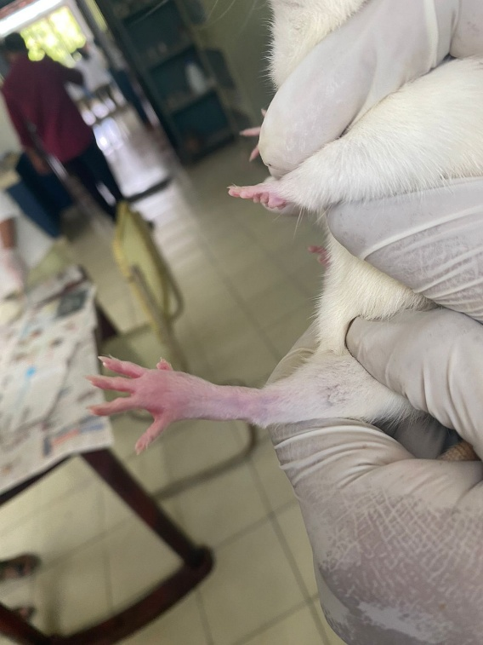

Figure 01: Onset of inflammation to rat paw by inducing carrageenan

**RESULTS AND DISCUSSION**

***Anti Inflammatory Activity***

Table 02: Evaluation of Paw edema in ml for all treatment groups.

|  |  |  |  |  |  |  |  |  |  |  |  |  |
| --- | --- | --- | --- | --- | --- | --- | --- | --- | --- | --- | --- | --- |
| **S.No** | **Treatment** | **Evaluation of Paw edema after the administration of egg albumin (ml)** | | | | | | | | | | **Mean Values in paw edema** |
| **0min** | | **5min** | | **15min** | | **30min** | | **60min** | |
| 1 | Control | L | R | L | R | L | R | L | R | L | R |
| 3.15 | 3.14 | 3.17 | 3.15 | 3.15 | 3.12 | 3.16 | 3.15 | 3.16 | 3.14 | 3.14 ± 0.10 |
| Difference | | 0.1 | | 0.2 | | 0.3 | | 0.1 | | 0.2 | | 0.18 |
| 2 | Negative Control | 3.18 | 3.13 | 3.21 | 3.14 | 3.35 | 3.16 | 3.91 | 3.14 | 4.15 | 3.15 | 3.56 ± 0.05 |
| Difference | | 0.05 | | 0.07 | | 0.19 | | 0.77 | | 1.0 | | 0.41 ± 0.08 |
| 3 | Standard - Indomethacin  (15mg/kg) | 3.14 | 3.14 | 3.16 | 3.14 | 3.22 | 3.16 | 3.25 | 3.15 | 3.24 | 3.16 | 3.20 ± 0.10 |
| Difference | | 0 | | 0.02 | | 0.06 | | 0.10 | | 0.08 | | 0.06 ± 0.03 |
| 4 | Test Product  (Anti Inflammatory Cream) | 3.16 | 3.16 | 3.20 | 3.15 | 3.23 | 3.14 | 3.27 | 3.15 | 3.31 | 3.16 | 3.23 ± 0.10 |
| Difference | | 0 | | 0.05 | | 0.09 | | 0.12 | | 0.15 | | 0.10 ± 0.02 |

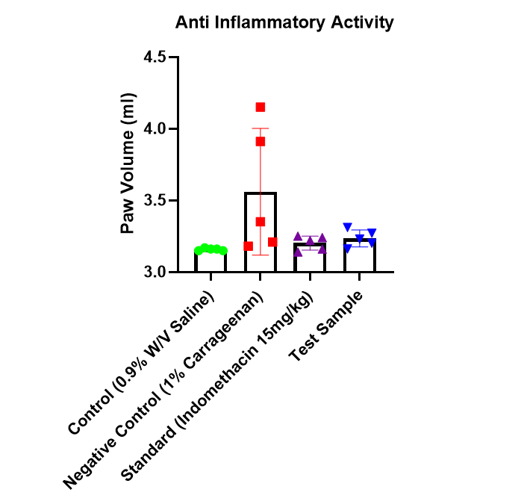

Figure 02: Evaluation of Paw edema for all treatment groups

**STATISTICAL ANALYSIS**

The data analysis was conducted using GraphPad Prism software, with statistical evaluation performed through a two-way ANOVA to assess the significance of the results related to anti-inflammatory activity. This approach allowed for the comparison of multiple variables and interactions, ensuring a comprehensive assessment of the data. The P value is significant for all the data (P<0.0001)

**DISCUSSION**

The graph illustrates the anti-inflammatory activity of different treatments on carrageenan-induced paw edema in rats. The negative control group (1% carrageenan) exhibited the highest paw volume, confirming successful inflammation induction. In contrast, the standard drug (indomethacin, 15 mg/kg) significantly reduced paw edema, validating its known anti-inflammatory effects. The test sample, representing the herbal anti-inflammatory cream, demonstrated a comparable reduction in paw volume to indomethacin, indicating its efficacy. This aligns with the study's findings that the formulation, containing quercetin, Vitamin E, calendula extract, and other natural anti-inflammatory agents, effectively mitigates inflammation. The minimal variability in the treated groups suggests consistent efficacy, whereas the negative control showed notable variability, emphasizing inflammation progression. These results support the claim that the herbal cream serves as a viable natural alternative to synthetic anti-inflammatory drugs. Further research is warranted to establish its long-term safety, stability, and therapeutic potential in clinical applications. The negative control group (1% carrageenan) showed the highest paw volume (~3.8–4.2 ml), confirming inflammation induction. The standard group (indomethacin, 15 mg/kg) exhibited a significant reduction (~3.3–3.5 ml), demonstrating its efficacy. The test sample (herbal anti-inflammatory cream) showed a similar decrease (~3.3–3.5 ml), suggesting strong anti-inflammatory activity. The control group (0.9% saline) maintained the lowest paw volume (~3.0–3.2 ml), indicating no inflammation. The comparable effects of the test sample and indomethacin suggest the herbal cream as a promising natural anti-inflammatory alternative.

**CONCLUSION**

The study demonstrates that the formulated herbal anti-inflammatory cream effectively reduces carrageenan-induced paw edema in rats, showing comparable efficacy to the standard drug, indomethacin. The natural ingredients, including quercetin, Vitamin E, calendula extract, and aloe vera, contribute to its anti-inflammatory properties. The reduction in paw volume in the test sample group supports the potential of herbal formulations as alternatives to synthetic drugs. With favorable physicochemical properties and no signs of irritation, the cream presents a promising natural remedy for inflammation. Further studies are necessary to validate its long-term efficacy, safety, and potential applications in clinical settings.

**Ethical Approval**

Animal Ethic committee approval has been collected and preserved by the author(s)

**Disclaimer (Artificial intelligence)**

Author(s) hereby declare that NO generative AI technologies such as Large Language Models (ChatGPT, COPILOT, etc.) and text-to-image generators have been used during the writing or editing of this manuscript.

**REFERENCES**

1. Anilkumar D, Rohini RM, Sukumaran S, Jeevani I, Ruckmani A. Anti-inflammatory and analgesic activities of *Clitoria ternatea* Linn. extracts. Anc Sci Life. 2010;30(1): 2-7.
2. Basch E, Ulbricht C, Hammerness P, Bevins A, Sollars D. Aloe vera (Aloe barbadensis): a review of the literature. J Herb Pharmacother. 2004;4(1):71-90.
3. Bedi MK, Shenefelt PD. Herbal therapy in dermatology. Arch Dermatol. 2002 Feb;138(2):232-42.
4. Behera A, Samal HB, Sharma DK, Kanhar S, Kadam A, Khamkar P, et al. Anti-inflammatory activity of herbal tablet of Phyllanthus emblica on carrageenan-induced paw edema in Wistar rats. J Pharm Res Int. 2021;33(54B):155-67.
5. Chandrashekar R, Rao SN. Acute anti-inflammatory activity of ethanolic extract of leaves of Leucas indica by carrageenan induced paw oedema in Wistar albino rats. Int J Basic Clin Pharmacol. 2013;2(3):302-5.
6. Di Rosa M, Giroud JP, Willoughby DA. Studies of the acute inflammatory response induced in rats in different sites by carrageenan and turpentine. J Pathol. 1971;104(1):15-29.
7. Fatima H, Shahid M, Jamil A, Naveed M. Therapeutic potential of selected medicinal plants against carrageenan-induced inflammation in rats. Dose Response. 2021;19(4):1-12.
8. Fowler JF Jr, Woolery-Lloyd H, Waldorf H, Saini R. Innovations in natural ingredients and their use in skin care. J Drugs Dermatol. 2010 Jun;9(6 Suppl):S72-81; quiz s82-3.
9. Gaur K, Kori ML, Tyagi LK, Nema RK, Sharma CS, Singh V. Anti-inflammatory activity of *Tephrosia purpurea* in rat. J Nat Rem. 2009;9(1):64-9.
10. Kalita S, Kumar G, Karmakar D, Kalita J, Tripathy S, Pal R, et al. Evaluation of anti-inflammatory activity of *Moringa oleifera* leaf extract in experimental models. Biomed Pharmacother. 2018;108:838-46.
11. Kumar S, Malhotra R, Kumar D. Euphorbia hirta: Its chemistry, traditional and medicinal uses, and pharmacological activities. Pharmacogn Rev. 2010;4(7):58-61.
12. Morris CJ. Carrageenan-induced paw edema in the rat and mouse. Methods Mol Biol. 2003;225:115-21.
13. Mujumdar AM, Upadhye AS, Misar AV. Studies on anti-inflammatory activity of *Mimosa pudica* in rats. J Herb Pharmacother. 2004;4(2):47-55.
14. Panthong A, Kanjanapothi D, Niwatananun V, Tuntiwachwuttikul P, Reutrakul V. Anti-inflammatory activity of methanolic extracts from Ventilago harmandiana Pierre. J Ethnopharmacol. 2004;91(2-3):237-42.
15. Pazyar N, Yaghoobi R, Rafiee E, Mehrabian A, Feily A. Skin wound healing and phytomedicine: a review. Skin Pharmacol Physiol. 2014;27(6):303-10.
16. Perianayagam JB, Sharma SK, Pillai KK. Antiinflammatory activity of Trichodesma indicum root extract in experimental animals. J Ethnopharmacol. 2006;104(3):410-4.
17. Posadas I, Bucci M, Roviezzo F, Rossi A, Parente L, Sautebin L, et al. Carrageenan-induced mouse paw edema is biphasic, age-dependent and displays differential nitric oxide cyclooxygenase-2 expression. Br J Pharmacol. 2004;142(2):331-8.
18. Rao MSD, Kumar SP, Rao VK. Anti-inflammatory activity of ten indigenous plants in carrageenan induced paw oedema in albino rats. Biomedicine. 2021;41(3):649-53.
19. Rao YK, Fang SH, Tzeng YM. Anti-inflammatory activities of Flueggea virosa extracts on acute and chronic inflammatory models in mice. J Ethnopharmacol. 2005;102(3):385-90.
20. Saeidnia S, Gohari AR, Mokhber-Dezfuli N, Kiuchi F. A review on phytochemistry and medicinal properties of the genus Achillea. Daru. 2011;19(3):173-86.
21. Sawadogo WR, Boly R, Lompo M, Some N, Lamien CE, Guissou IP, et al. Anti-inflammatory, analgesic and antipyretic activities of Dicliptera verticillata. Int J Pharmacol. 2006;2(4):435-8.
22. Silva GN, Martins FR, Matheus ME, Leitão SG, Fernandes PD. Investigation of anti-inflammatory and antinociceptive activities of Lantana trifolia. J Ethnopharmacol. 2005;100(3):254-9.
23. Sulaiman MR, Hussain MK, Zakaria ZA, Somchit MN, Moin S, Mohamad AS, et al. Evaluation of the antinociceptive activity of Ficus deltoidea aqueous extract. Fitoterapia. 2008;79(7-8):557-61.
24. Sulaiman MR, Zakaria ZA, Lihan R, Israf DA, Sahdan R, Somchit MN, et al. Antinociceptive and anti-inflammatory activities of Orthosiphon stamineus Benth. methanol extract in animal models. Acta Pharm. 2008;58(1):105-14.
25. Vinegar R, Schreiber W, Hugo R. Biphasic development of carrageenin edema in rats. J Pharmacol Exp Ther. 1969;166(1):96-103.
26. Winter CA, Risley EA, Nuss GW. Carrageenin-induced edema in hind paw of the rat as an assay for anti-inflammatory drugs. Proc Soc Exp Biol Med. 1962;111:544-7.
27. Zakaria ZA, Abdul Hisam EE, Rofiee MS, Norhafizah M, Somchit MN, Teh LK, et al. In vivo anti-nociceptive and anti-inflammatory activities of dried and fermented processed virgin coconut oil. Med Princ Pract. 2011;20(3):231-6.
28. Zakaria ZA, Mohamad AS, Chear CT, Wong YY, Israf DA, Sulaiman MR, et al. Antiinflammatory and antinociceptive activities of Zerumbone from Zingiber zerumbet Smith. Int Immunopharmacol. 2010;10(8):900-9.
29. Zakaria ZA, Rofiee MS, Somchit MN, Zuraini A, Sulaiman MR, The LK, Salleh MZ. Anti-inflammatory and antinociceptive activities of *Curcuma domestica* extracts in animal models. Int J Pharmacol. 2011;7(4):403-9.
30. Zakaria ZA, Sulaiman MR, Mat Jais AM, Somchit MN, Farhan AA, Zuraini A. The in vitro antibacterial activity of Parkia speciosa (stink bean) pod extracts. Int J Pharmacol. 2007;3(4):409-14.