Shortcommunication

# First sight record of Black Crested Bulbul (*Rubigula flaviventris* Tickell, 1833*)* in the temperate forest of Darjeeling Himalaya, India.

**Abstract:**

The Black crested bulbul *Rubigula flaviventris* is a frugivorous species of songbird in the bulbul family, Pycnonotidae. It is found in Southeast Asia, ranging from India to Vietnam and south China. The bird’s natural habitat is subtropical or tropical moist lowland forest. This paper reports the first photographic and sight evidence of *Rubigula flaviventris* in the upper region of the temperate forest of the Darjeeling Himalaya, India. This sighting, recorded at an elevation of 2500m in Tiger Hill Forest on 14th October, 2023, supported by photographic evidence, highlights the species’ adaptability to diverse habitats. Given its solitary occurrence at this elevation, further studies are recommended to assess its habitat preferences, population status and conservation needs. This report contributes to the growing understanding of avian biodiversity in the Darjeeling Himalaya and underscores the importance of continued ornithological monitoring of the region.

**Keywords:** Frugivorous, Bulbul, High Altitude, Biodiversity, Passerine Birds.

# Introduction

Bulbuls are among the ecologically important group of frugivorous, seed-dispersing birds within the family Pycnonotidae (order Passeriformes) occupying ecologically diverse and a wide range of habitats (Ponpituk et al. 2020). Black Crested Bulbul was formerly included in the genus *Pycnonotus* and most of the species to this genus has been described as common but gradually declining owing to ongoing trapping pressure (del Hoyo et al. 2005

BirdLife International 2023)*.* Higher molecular phylogenetic level studies revealed that the family Pycnonotidae supports the concepts of monophyly and it comprises an exclusively African and a predominantly Asian clade (Shakya & Sheldon 2017). However, it is also important to note that the several genera of the family Pycnonotidae were found not to be monophyletic and further taxonomic changes was found to be desirable to provide a more accurate classification based on phylogeny (Shakya & Sheldon 2017). At present, the genus *Pycnonotus* is found to be polyphyletic based on super matrix approach. In accordance with the most recent system of classification using molecular phylogenetic analyses which have resolved the taxonomic anomalies to draw conclusion for family Pycnonotidae to ensure accurate taxonomic identification with comparable results across different morphotypes and genotypes. Many species which were previously placed in the genus *Pycnonotus* have now been transferred to more appropriate genera *Rubigula* (Frank et al. 2021). *Rubigula* is a [genus](https://en.wikipedia.org/wiki/Genus) of Asian [passerine](https://en.wikipedia.org/wiki/Passerine) birds in the bulbul family, [Pycnonotidae](https://en.wikipedia.org/wiki/Pycnonotidae) (Indian Birds2023).

The species is evaluated as Least Concern in 2016 assessed mostly on its broad geographical range which includes Bangladesh; Bhutan; Cambodia; China; India; Lao People's Democratic Republic; Malaysia; Myanmar; Nepal; Thailand; Vietnam that are home to many of the documented native species (BirdLife International 2016). They are mostly generalists, feeding primarily on various types of fruits and arthropods, and they play a major ecological role as seed dispersers, especially in habitats that are degraded (Corlett, 1998; Sankamethawee et al. 2011; Corlett 2017; Shakya &Sheldon 2017). As per the literature review, 30 genera and 130 species of bulbuls are recognized globally. (Dickinson & Christidis 2014). A diagnostic characteristic of this family is a thin sheet of bone in the operculate nostrils (Fishpool &Tobias 2005). Most species also have drab or dark- coloured fluffy plumage, with characteristically colourful patches of feathers, especially on the throat and abdomen.

Flock calls recorded using a unidirectional stereo microphone by van Helvoort and Soetawijaya (1987) describes the sound as 'tee-tee-wheet-wheet", 'whit-wheet-wit' and various combinations of these elements. However, they did not mention the distinguishable call note for both sexes and thus the calls are indistinguishable from either of the sexes. Black Crested Bulbuls have been recorded from north east regions of India (Pratihar, et. al 2017).There is also a record of Black Crested Bulbuls in the riverine and Hill forest of Buxa Tiger Reserve (60-1750 m a.s.l) (Sivakumar et al 2006). This paper reports the first photographic and sight evidence of a single Black Crested Bulbul (*Rubigula flaviventris* Tickell,1833*)* in Tiger Hill Forest at an elevation of 2500m and suggests that further study of its range, status and biology is urgently needed. Their presence in these temperate regions also provide an inventory for Wildlife researchers.

# Location

The Darjeeling Himalaya as a part of ‘IUCN-Himalaya Hotspot for Conservation’ is a natural greenhouse widely known as the botanical paradise which harbors one of the richest biodiversity in the world. The sighting was done in the upper part of Tiger Hill Forest (hereinafter, THF) of Darjeeling Himalaya (2250–2590 m a.s.l.). THF is mostly dominated by the matrices of Natural Forests, Plantation Forest, Grasslands and a Catchment area for water supply system of Darjeeling Municipality. The vegetation in this area includes mostly *Alnus nepalensis, Quercus lamellose, Q. lineata, Lithocarpus pachyphylla, Castanopsis hystrix, Castanopsis acuminatissima, Oxyspora paniculata, Rhododendron arboreum, R. grande* and shrubs such as *Rubus lineatus, R. ellipticus,*

*R. niveus, R. paniculatus R. calycinus* etc., with *Cryptomeria japonica* mostly found in the plantation forest. Many parts of the forest area were found to be mostly covered by an invasive bamboo species *Yushania maling.* Despite the several birding activities in THF over the years, there has been no previous documentation of occurrence of Black Crested Bulbul (*Rubigula flaviventris* Tickell,1833*)* at an altitudinal elevation of 2500m.

# Methods and observation

During a regular birding expedition in mid-October 2023 in the THF, Ganesh Pradhan and Shuvam Sharma from a clear vantage point encountered Black Crested Bulbul. The bird was sitting singly on the branch of *Rubus lineatus* in an open area of THF. Although the bird immediately became aware of the presence of the observer, it made an effort to flee immediately. This permitted him to take only a single photograph with NIKON Z50 gear from a single angle, within a distance of less than five meters.

# Description

An examination of single zoom in photograph confirms its identity and status as a mature male Black Crested Bulbul (Plate 1). The following descriptions were made of the distinguishing features noted from the photographed bird: a crested bulbul; head black with an erect blackish crest; chin and upper throat black; pale yellow iris; thin sheet of bone in the operculate nostrils; primary coverts and greater coverts mostly olive green with few greyish plumages in between; breast yellowish in colouration; blackish leg. The remiges and rectrices appeared well developed and complete, indicating that the bird was fully fledged and that was evident from its immediate trot off into bamboo forest.

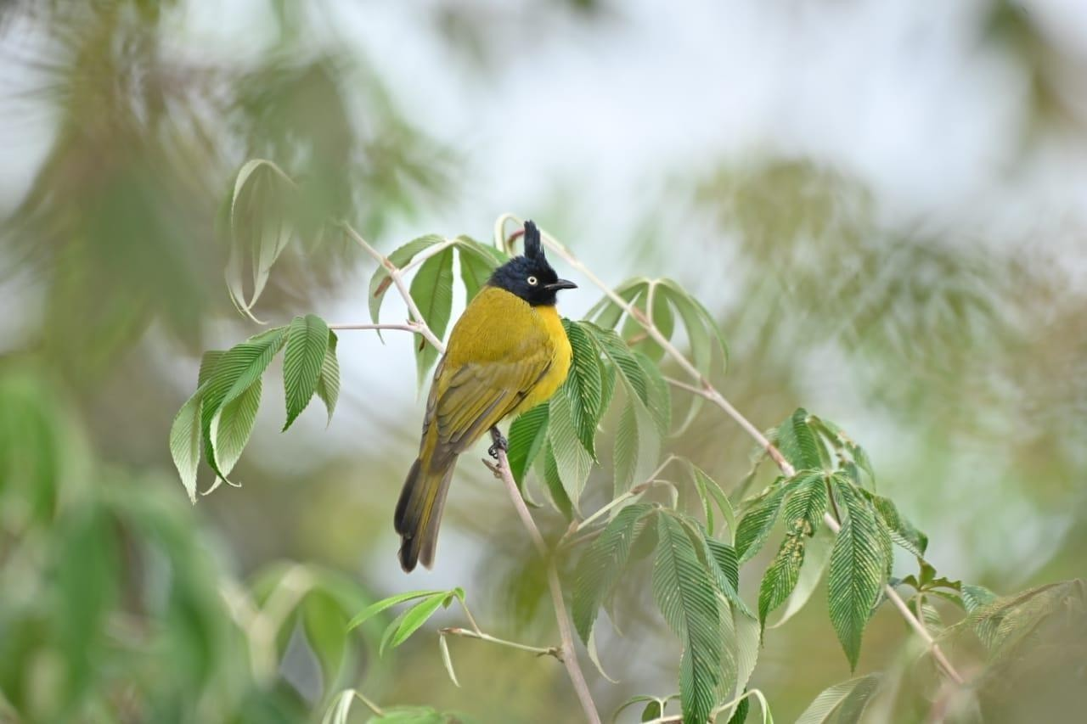**Plate1.Black Crested Bulbul (*Rubigula flaviventris* Tickell,1833*)* from Tiger Hill Forest.**

# Conclusion

In conclusion, this is the first record for the sighting of Black Crested Bulbul from THF at an elevation of 2500m. This not only extends its known global distribution but is interesting in that it is the first record of this passerine species occurring in the temperate forest of Darjeeling Himalaya. In view of its solitary occurrence, it mandates a separate systematic study on essential habitat requirements, abundance, distribution patterns, and conservation threats for initiating and adopting long-term conservation of this species in a high elevation temperate forest.

Disclaimer (Artificial intelligence)

Option 1:

Author(s) hereby declare that NO generative AI technologies such as Large Language Models (ChatGPT, COPILOT, etc.) and text-to-image generators have been used during the writing or editing of this manuscript.

Option 2:

Author(s) hereby declare that generative AI technologies such as Large Language Models, etc. have been used during the writing or editing of manuscripts. This explanation will include the name, version, model, and source of the generative AI technology and as well as all input prompts provided to the generative AI technology

Details of the AI usage are given below:

1.

2.

3.

# References

BirdLife International (2023) Species factsheet: *Rubigula flaviventris*. Downloaded from[http://datazone.birdlife.org/species/factsheet/black-crested-bulbul-rubigula-](http://datazone.birdlife.org/species/factsheet/black-crested-bulbul-rubigula-flaviventris on%2026/12/2023) [flaviventris on 26/12/2023](http://datazone.birdlife.org/species/factsheet/black-crested-bulbul-rubigula-flaviventris on%2026/12/2023).

Checklist of birds of India v7.3.2023.WebsiteURL:https:/[/www.indianbirds.in/india/](http://www.indianbirds.in/india/)[Uploaded on 20 December 2023.]

Corlett, R.T.1998.Frugivory and seed dispersal by vertebrates in the Oriental (Indomalayan) region. *Biol. Rev.* 73: 413–448.

Corlett, R.2017.Frugivory and seed dispersal by vertebrates in tropical and subtropical Asia: An update. *Global Ecology and Conservation* 11: 1-22. https://doi.org/10.1016/ j. gecco.2017.04.007

Dickinson, E.C.,&Christidis, L. 2014.TheHowardandMooreCompleteChecklist oftheBirdsof the World, 4th edn, Vol. 2. Passerines. Eastbourne, UK:Aves Press.

delHoyo, J., Elliott,A., & Christie, D. 2005. Handbookofthe Birds ofthe World, vol. 10: Cuckoo-shrikestoThrushes.Lynx Edicions ,Barcelona, Spain. IUCN.2016.The IUCN Red List of Threatened Species. Version 2016-3.Available at: [www.iucnredlist.org.](http://www.iucnredlist.org/) (Accessed: 07 December 2016).

Fishpool,L.D.C.,&Tobias,J.A.2005.Family Pycnonotidae (Vol.10:124–251).In:Handbook of the Birds of the World. del Hoyo, J., Elliott,A. &Sargatal, J.Barcelona: Lynx Edicions/Birdlife International

Ponpituk.Y.,Siri.S.,Safoowong.M.,Suksavate.W.,Marod.D.,Duengkae.P.2020.Temporal variation in the population of bulbuls (Family Pycnonotidae) in lower montane forest, NorthernThailand. *BiodiversitasJournalofBiologicalDiversity* 21(8).https://doi.org/ 10.13057/biodiv/d210829

Pratihar, S., & Clark Jr, H. O. 2017. Defaunation and Conservation).

Sankamethawee,W.,Pierce,A.,Gale,G.,Hardesty,B.D.2011.Plant-frugivore interactions in an intact tropical forest in north-east Thailand. *Integrative Zoology* 6 (3): 195-212. <https://doi.org/10.1111/j.1749-4877.2011.00244.x>

Shakya, S., &Sheldon, F. 2017. The phylogeny of the world's bulbuls (Pycnonotidae) inferred using a supermatrix approach. *International Journal of Avian Sciences*159(3):498-509. [https://doi.org/10.1111/ibi. 12464](https://doi.org/10.1111/ibi.%2012464)

Sivakumar, S., Varghese, J. E. E. J. O., & Prakash, V. I. B. H. U. 2006. Abundance of birds in different habitats in Buxa Tiger Reserve, West Bengal, India. Forktail, 22, 128

Van Helvoort, B.E.,& Soetawijaya,M.N. 1987.First sight record of Black-crested Bulbul

*Pycnonotus melanicterus* on Bali.*KUKILA*,3(1-2),53-54.