Studies on the diversity and species composition of odonata (Arthropoda: Insecta) from Chandgad taluk of Kolhapur district, Maharashtra, India

# ABSTRACT

In present study, a total of 66 odonate species belonging to 41 genera representing 10 families were recorded from Chandgad taluka of Kolhapur district in Northern Western Ghats. Dragonflies (Anisoptera) with 38 species (58%) were dominating the study area followed by 28 species (42%) of Damselflies (Zygoptera). Among the genera, *Orthertum* were in maximum number (6) of species followed by *Pseudagrin* were of 5 species. Libellulidae family members are recorded in the highest number (30) followed by Coenagrionidae (15). Among the study sites highest numbers of odonates were recorded from slow running stream Kitwade with 33 species and weedy pond Tawarewadi with 32 species. The fast-running stream Tilari represents the least number (3) of species. The slow running stream and weedy pond habitat support the odonate diversity compared to fast running stream, semi forest and lake side habitat.

*Keywords:* Odonate, Dragonflies, Damselflies, Habitat association, Similarity in species composition, Jaccard index

# INTRODUCTION

Odonates encompassing the dragonflies (Anisoptera) and damselflies (Zygoptera) distributed in a wide range of aquatic habitats. These are sensitive to habitat alterations induced by human activities like industrialization and urbanization (Subramanian *et al.*, 2005; Kulkarni and Subramanian, 2013; Emiliyamma, 2014). Dragonflies have been recognized as ecological indicators to assess the ecosystem health of freshwater wetlands (Suhling *et al*., 2006; Gómez- Tolosa, *et al*., 2021). Most of the odonates are highly specific in habitat selection, some of them use natural lentic or lotic water bodies and, some species adapted to manmade water bodies. Habitat selection plays an important role in distribution and ecology of odonates (Andrew *et al*., 2008). The dragonflies tend to be much more sensitive to pollution than damselflies. The complex habitat and microhabitats offer a large number of odonate species (Subramanian, 2005; Ameilia, *et al*., 2006; Koli, *et al*., 2014; Koneri, *et al*., 2020). The ecological factors like pH, amount and type of aquatic vegetation, temperature and, nature of water bodies (lotic/lentic) affects the distribution pattern of nymphs as well as adult odonate flies. Some generalist species can tolerate a wide range of conditions while some specialist species are very sensitive to their environment (Chovanec and Waringer, 2001; Schindler *et al*., 2003; Chovanec *et al*., 2004; Ameilia *et al*., 2006; Smith and Pontius, 2006; Subramanian *et al*., 2011). The life history of odonates is closely associated with water bodies and uses a wide range of habitats for their breeding. Globally around 6313 odonate species representing 693 genera (Paulson and Schorr, 2020). Indian subcontinent comprises 488 odonate species and 27 subspecies belong to 154 genera spread across 18 families (Subramanian and Babu, 2017). Subramanian and Babu (2020) documented 196 odonate species from Western Ghats of India. However, so far in Maharashtra 134 odonate species documented by Tiple and Koparde (2015). Recently, it is updated to 144 species by Sawant *et al*., (2022). Chandgad taluka in Kolhapur district of southern Maharashtra is a part of Northern Western Ghats and consists of a wide range of diversified temporary and permanent water bodies which are well suited for odonate breeding activity. Aiwale (2016) made a preliminary observation on

diversity and morphometry of some odonates in Dharwad (Karnataka) and Tilari of Chandgad taluka and, documented 24 odonate species. Since, there are no published report on diversity of odonates from Chandgad, we made an attempt to assess the diversity, distribution pattern, habitat association and similarity in species composition of odonates in different habitats of Chandgad taluka.

# MATERIAL AND METHODS

## Study area:

Chandgad being a part of the Northern [Western Ghats](https://en.wikipedia.org/wiki/Western_Ghat) is rich in biodiversity. It receives 3000mm to 5000mm of annual rainfall from the [South-West monsoon](https://en.wikipedia.org/wiki/Southwest_monsoon) and temperatures ranging from 290C to 360C during summer and 140C to 210C during winter. It consists of several water bodies and irrigation canals. It is also traversed by [Ghataprabha](https://en.wikipedia.org/wiki/Ghataprabha_River), Hiranyakeshi and Tamraparni Rivers connected by several streams and, consists reservoirs like Tilari dam, Ghataprabha dam, Jangamhatti dam, Ambewadi dam etc. The forest area is of moist mixed deciduous and semi-evergreen mixed with acacia plantation, bamboo forest and some cymbopogon type of grasslands.

## Diversity and Habitat Association:

We selected ten study sites *i.e.* Kitwade, Jangmahatti, Nittur, Tilari, Kodali, Tawarewadi, Kamewadi, Ambewadi, Chinchane and Yashwantrao Chavan College (YCC) Campus Halkarni with different habitats viz. Slow Running Stream (SRS), Fast Running Stream (FRS), Lake Side (LS), Weedy Pond (WP), River Side (RS), Marsh Land (ML), Semi Forest (SF) and Semi-Urban (SU) (Table - 1). Photo plate 1 (Images 1 to 10) shows the habitat structure of study sites selected. Study sites were visited once in a month from June 2018 to July 2022 for the documentation of odonates and to study their diversity, habitat association, species richness. Odonate species were collected using insect net and tried to identify in the

field itself using handbooks by Emiliyamma *et al*., (2005), Subramanian (2005) and Andrew *et al*., (2008). Later, the specimens were released in to their natural habitat. Some of the specimens were brought to the laboratory to confirm their identity with the help of literature and biodiversity portals like Odonate of India (Joshi *et al*., 2020), Bug guide (2020), Encyclopedia Britannica (2020). Nikon D5300, D7200 camera and mobiles are used to capture the images of odonates.

## Species Richness and Similarity:

Sampling was done by the Visual Encounter Survey (VES) method. VES is used to determine the species richness of an area, to compile a species list (species composition of study site) and to estimate relative abundances of species within an assemblage (Heyer *et al*., 1994). To examine the similarity in species composition between study-sites, an agglomerative hierarchical cluster analysis were performed using the Unweighted pair-group average (UPGMA) applied to a matrix of Jaccard similarity coefficients between all sites. UPGMA is a cophenetic correlation which showing very less alteration between input and output. It is more efficient than any other method and also more distinct clustering tool (Hale and Dougherty, 1988). Clusters are joined based on the average distance between all members of the group. The algorithm begins the clustering by assigning each observation to a cluster which merges until one large cluster is formed (Struyf *et al*., 1997). Jaccard similarity coefficient was calculated by Past software Version 3.25 (Hammer, 2019).

# RESULTS

## Diversity, Habitat association and Species richness:

A total of 66 odonate species belonging to 41 genera representing 10 families were recorded from the study sites (Table - 2). Photo plate 2 (Images 1 to 20) shows some of the odonate species recorded in different habitats of study area. The dragonflies dominated the study area with 38 (58%) species belonging to 4 families whereas, the damselflies comprised 28 (42%) species belonging to 6 families of odonates recorded (Table - 2, Fig. 1) in study area. Out of ten study-sites Kitwade and Tawarewadi represented more number (18% - each of

the study sites) of odonate species whereas, Tilari contributed hardly 2% of odonate species (Fig. 2 and 3) recorded. Among the genera *Orthertum* represent maximum number (6) of species followed by *Pseudagrin* representing 5 species (Table - 3). Members of Libellulidae are most common representative of Anisoptera with 30 (45%) species followed by Coenagrionidae representing Zygoptera with 15 (23%) species (Fig. 4). In Gomphdae family we identified one odonate upto genus *Bumagomphaus* (Table - 2). Platycnemididae and Aeshnidae represent 5 and 4 species respectively; Gomphidae contribute 3 species; Calopterygidae, Chlorocyphidae, Euphaeidae and Lestidae represents 2 species each; Synthemistidae represent single species (Table - 2, Fig. 4). The slow running stream - Kitwade and weedy pond - Tawarewadi recorded highest number (33 and 32 respectively) of species followed by River side - Kamewadi (21) and Marsh land - Ambewadi (20). Slow running stream – Nittur, Jangamhatti and Semi-urban - Yashawantrao Chavan College Campus study- sites represent almost equal number of species (17, 18 and 19 respectively); Lakeside - Kodali and Semi forest area - Chinchane represent 9 and 6 species respectively. The fast- running stream – Tilari recorded the least number (3) of odonate species (Table - 1). Dragonflies are dominating almost all the study sites (Fig. 2).

Among the recorded species *Neurothemis fulvia, Neurothemis tullia, Orthetrum internum, Urothemis signata, Ischnura rubilio, Ischnura nursei* and *Agriocnemis pieris* are the most dominant species in Marshland (Ambewadi) and Weedy pond (Tawarewadi) characterized by stagnant water covered with heterogeneous vegetation. Some of the species like *Brachythemis contaminata, Bradinopyga geminata, Diplacodes trivialis, Orthetrum sabina, Pantala flavescens* and *Potamarcha congener* preferred open habitat. The other species like *Acisoma panorpoides, Trithemis aurora, Crocothemis servilia, Neurobasis chinensis, Vestalis apicalis, Pseudagrion decorum*, *Euphaea fraseri and Euphaea thosegharensis* were associated with rocky slow running stream shaded with heterogeneous vegetation and dense

forest canopy habitat. These species also prefer paddy field. *Pseudagrion rubriceps, Paracercion malayanum* found very close to water bodies.

## Similarity in species composition:

The dendrogram (Fig. 5) illustrates more or less similar influence on species composition. Overall pattern shows two are larger groups which contain Tawarewadi, Kamewadi, Ambewadi, Jangmahatti and Kitwade as a first group and Nittur, Chinchane and

Y.C.C as a second group. Kodali and Tilari study sites not showing much similarity with other study sites so they form different clades as third and fourth groups. Kamewadi and Ambewadi share highest similarity (60%) among them.

# DISCUSSION

Chandgad taluka is rich in odonate diversity representing 14% of odonate species recorded in Indian subcontinent, 34% of species documented in the Western Ghats and 46% of species reported from Maharashtra. The weedy pond and rocky slow running streams shaded with riparian vegetation and dense forest canopy habitat supporting more number of odonate species than fast running stream, semi forest and open lake side (without vegetation cover) habitat. The variety of wetland biomass present on the water body supports the life cycle and breeding activity of odonates. Our findings also corroborates the results of Kulkarni & Subramanian (2013) that, the species composition depends upon landscape structure and vegetation cover. We noticed that, among the array of species in all the habitats, in specific habitats - specific dragonflies/damselflies show their abundance. It also depends upon the season and type of riparian vegetation present. Specific season and riparian vegetation play an important role in species diversity and abundance.

There is a seasonal pattern of odonate distribution. Some species are dominating in the rainy season (June to September) and some species are dominating in summer (December to April). Gomphidae and Coenogrionidae species predominantly found in June to August. Whereas, Aeshnidae species found in summer season. Likewise*, Brachydiplax sobrina, Ictinogomphus rapax, Neurothemis fulvia, Neurothemis tullia, Orthetrum internum,*

*Rhyothemis variegata, Urothemis signata, Vestalis apicalis,* and *Euphaea fraseri* species abundantly found only in June to September. *Acisoma panorpoides, Crocothemis servilia, Pseudagrion rubriceps* and *Trithemis* species recorded in present study are (Table - 2) abundantly found during October to April. Some more studies are needed in this direction to analyze the seasonal distribution of odonates.

The dendrogram illustrate two large groups Tawarewadi, Kamewadi, Ambewadi, Jangmhatti Kitwade and Nittur, Chinchane, Y.C.C shows more or less similar type of species composition and vegetation cover (Fig. 5). The dragonflies were abundantly present in almost all the study sites (Fig. 2). The study sites characterized with rocky habitat with riparian vegetation contribute more number of odonate species. The study sites Chinchane and Y.C.C had open habitat with a canopy cover of the deciduous forest without natural water reservoir. The odonate species of these sites are adapted for man-made water resources such as cement cisterns, small pits and mining ditches. The common thing in these habitats is anthropogenic activity like industrialization, mining and urbanization. Therefore very few generalist species were recorded from these habitats. Tilari study site is of fast running stream habitat lacks vegetation cover and not supporting wetland vegetation. On the other hand Kodali study site is also lacks vegetation cover and pH ranges from 6.2 to 6.7. Hence, in these habitats very few odonate species were recorded (Fig. 2) and formed different clade in dendrogram (Fig. 5).

Odonates are highly responsive to environmental changes including anthropogenic activity (Emiliyamma *et al*., 2005). We noticed that, there is a decrease in number of odonate species and their abundance after reopening of Daulat Sugar Factory in Halkarni nearer to YCC campus. After reopening of the said factory due to heavy dumping of factory waste, ash dusting on all over the plantation there is a tremendous change in habitat structure. This type of

anthropogenic activity causes loss of habitat quality and local extinctions of dragonflies, especially the habitat of specialists (Harabis and Dolny, 2011).

The dragonflies are considered as more sensitive to habitat disturbance and their presence in any water body confirms its synthetic pollution-free status (Zia *et al*., 2009; Zia, 2010). The agricultural habitat supports the effective number of odonate species. Many odonate species complete their life cycle in paddy or sugarcane field ([Seidu](https://www.tandfonline.com/author/Seidu%2C%2BIssah) *et al*., 2017). Tawarewadi weedy pond appear to be good habitat for odonate diversity situated in densely populated area along the roadside surrounded by sugar cane and paddy field. Several larval and adult odonates feed on many insects such as mosquitoes (Culicide), deer flies (Tabanidae), blackflies (Simuliidae) and other dipterans that are pest of humans and domestic animals. *Crocothemis servilia* species effectively used to control the *Aedes aegypti* mosquito as well as it predates on paddy *jassid Nilaparvata sp.,* paddy borer *Chilo suppersalis* (Walker) and jowar stem borer *Chilo partellus* (Bhusnar and Sathe, 2017). Therefore, we need to conserve natural habitats and consider odonates as biocontrol agent as well as ecological indicators. Among the present study sites, Chinchane and YCC campus are under threat due to intensive anthropogenic activities like mining and industrialization. Some conservation measures are needed to be taken up to conserve these habitats to protect odonates and other insects which maintain ecological health in nature.

1. **CONCLUSION**

Chandgad taluk of Kolhapur district in Maharashtra is very rich in odonate diversity. Dragonfly species were recorded in maximum number compared to damselfly species. Libellulidae family members were dominating and are most common species recorded. Odonates prefer the slow running stream habitats and stagnant water bodies rather than fast moving stream habitats. It is also observed that, odonates show seasonal distribution.

Disclaimer (Artificial intelligence)

Option 1:

Author(s) hereby declare that NO generative AI technologies such as Large Language Models (ChatGPT, COPILOT, etc.) and text-to-image generators have been used during the writing or editing of this manuscript.

Option 2:

Author(s) hereby declare that generative AI technologies such as Large Language Models, etc. have been used during the writing or editing of manuscripts. This explanation will include the name, version, model, and source of the generative AI technology and as well as all input prompts provided to the generative AI technology

Details of the AI usage are given below:

1.

2.

3.

# REFERENCES

1. Aiwale, J. M. (2016). Species composition and biodiversity of odonates fauna in selected areas of Western Ghats region- A morphometric analysis. *M. Sc. Project report* submitted to Karnatak University Dharwad, 49pp.
2. Ameilia, Z. S., Che Salmah, M. R. & Hassan, A. A. (2006). Diversity and distribution of dragonfly (Odonata: Insecta) in the Kerian River Basin, Kedah-Perak, Malaysia. *USU Repository*, 1-15
3. Andrew, R. J., Subramaniam, K. A. & Tiple, A. D. (2008). *A handbook on common odonates of Central India*, 65pp
4. Bhusnar, A. R. & Sathe, T. V. (2017). Biology of A Dragaonfly Crocothemis Servilia Servilia Drury (Odonata: Libellulidae), A Predator of Paddy Pests in Kolhapur. IOSR *Int. J. Pharm. Biol. Sci*., 12(03), 18-20.
5. BugGuide (2020). Hosted by Iowa State University, Department of Entomology.[https://bugguide.net/index.php?q=searchandkeys=ODONATAandsearch](https://bugguide.net/index.php?q=search&keys=ODONATA&search=Search)

[=Search.](https://bugguide.net/index.php?q=search&keys=ODONATA&search=Search)

1. Chovanec, A. & Waringer, J. (2001). Ecological integrity of river–floodplain systems- assessment by dragonfly surveys (Insecta: Odonata). *Regulated Rivers: Research and Management:* An International Journal Devoted to River Research and Management, 17(4‐5), 493-507.
2. Chovanec, A., Waringer, J., Raab, R. & Laister, G. (2004). Lateral connectivity of a fragmented large river system: assessment on a macroscale by dragonfly surveys (Insecta: Odonata). *Aquatic Conservation: Marine and Freshwater Ecosystems*, 14(2), 163-178.
3. Emiliyamma, K. G. (2014). Systematic studies on Odonata (Insecta) of southern Western Ghats. *Records of the Zoological Survey of India*, 114(1), 57-87.
4. Emiliyamma, K. G., Radhakrishnan, C. & Palot, M. J. (2005). *Pictorial handbook on common dragonflies and damselflies of Kerala*. *Zoological Survey of India*.
5. Encyclopedia Britannica. (2020). <https://www.britannica.com/animal/Odonata>
6. Gómez-Tolosa, M., Rivera-Velázquez, G., Rioja-Paradela, TM., Mendoza-Cuenca, LF., Tejeda-Cruz, C. & López, S. (2021). The use of Odonata species for environmental assessment: a meta-analysis for the Neotropical region. *Environmental Science and Pollution Research*. 28, 1381-96.
7. Hammer, Q. (2019). Past**,** Paleontological Statistics. Version 3.25 Reference manual, 275pp
8. Harabis, F. & Dolny, A. (2011). Human altered ecosystem: Suitable habitats as well as ecological traps for dragonflies (Odonata): the matter of scale. *J. Insect Conserv*. 1-10.
9. Hale, R. B. & Dougherty, D. (1988). Differences between ward’s and UPGMA methods of cluster analysis: Implications for School Psychology. *Journal of School Psychology*. 26, 121-131
10. Heyer, W. R., Donnelly, M. A., McDiarmid, R. W., Hayek, L. C. & Foster, M. S. (1994). *Measuring and monitoring biological diversity: Standard methods for amphibians.* Smithsonian Institution Press, Washington.
11. Joshi, S., Dawn, P. Roy & Kunte, K. (eds.). (2020). *Odonata of India, v. 1.48*. Indian Foundation for Butterflies. <https://www.indianodonata.org/>
12. Koli, V., Bhatnagar, C. & Shekhawat, D. (2014). Diversity and Species Composition of Odonates in Southern Rajasthan, India. *Proc Zool Soc.* DOI 10.1007/s12595-014-0103-x
13. Koneri, R., Nangoy, M. & Maabuat, P. V. (2020). Composition and Diversity of Dragonflies (Insecta: Odonata) in Tunan Waterfall Area, North Minahasa, North Sulawesi, Indonesia. *Pakistan J. Zool*., 52(6), 2091-2100.
14. Kulkarni, A. S., & Subramanian, K. A. (2013). Habitat and seasonal distribution of Odonata (Insecta) of Mula and Mutha river basins, Maharashtra, India. *Journal of*

*Threatened Taxa*, 5(7), 4084-4095.

1. Paulson, D. & Schorr, M. (2020).World Odonata List. [https://www.pugetsound.edu/academics/academic-resources/slater-](https://www.pugetsound.edu/academics/academic-resources/slater-museum/biodiversity-resources/dragonflies/world-odonata-list2/)

[museum/biodiversity-resources/dragonflies/world-odonata-list2/](https://www.pugetsound.edu/academics/academic-resources/slater-museum/biodiversity-resources/dragonflies/world-odonata-list2/) accessed on

24.08.2020.

1. Sawant, D., Ogale, H. & Deulkar, R. M. (2022). An annotated checklist of odonates of Amboli-Chaukul-Parpoli region showing new records for the Maharashtra State, India with updated state checklist. *Journal of Threatened Taxa*, 14(11), 22164-22178.
2. Schindler, M., Fesl, C. & Chovanec, A. (2003). Dragonfly associations (Insecta: Odonata) in relation to habitat variables: a multivariate approach. *Hydrobiologia*, *497*, 169-180.
3. Seidu, I., Danquah, E., Ayine Nsor, C., Amaning Kwarteng, D. & Lancaster, L. T. (2017). Odonata community structure and patterns of land use in the Atewa Range Forest Reserve, Eastern Region (Ghana). *International Journal of Odonatology*, 20(3- 4), 173-189.
4. Smith, C. D. & Pontius, J. S. (2006). Jackknife estimator of species richness with S- PLUS. *Journal of Statistical Software*, 15, 1-12.
5. Struyf, A., Hubert, M. & Rousseeuw, P. J. (1997). Integrating robust clustering techniques in S-PLUS. *Computational Statistics and Data Analysis*, 26(1), 17-37.
6. Subramanian, K. A. (2005). *Dragonflies and Damselflies of Peninsular India-A Field Guide.* E- Book of Project Lifescape. Centre for Ecological Sciences, Indian Institute of Science and Indian Academy of Sciences, Bangalore, India. 118pp.
7. Subramanian, K. A. & Babu, R. (2017). Checklist of Odonata (Insecta) of India.

Version 3.0.

1. Subramanian, K. A. & Babu, R. (2020). Dragonflies and Damselflies (Insecta: Odonata) of India, pp 29-45. In: Ramani, S. Mohanraj, P. and Yeshwanth, H. M. (eds). *Indian Insects: Diversity and Science.* CRC Press, Taylor and Francis group, London, 450pp.
2. Subramanian, K. A., Sivaramakrishnan, K. G. & Gadgil, M. (2005). Impact of riparian

land use on stream insects of Kudremukh National Park, Karnataka state, India. *Journal of insect science*, 5(1).

1. Suhling, F., Sahlén, G., Martens, A., Marais, E. & Schütte, C. (2006). Dragonfly assemblages in arid tropical environments: a case study from western Namibia. *Biodiversity and Conservation*, 15, 311-332.
2. Tiple, A. D. & Koparde, P. (2015). Odonata of Maharashtra, India with notes on species distribution. *Journal of Insect Science*, 15(1): 1-10 DOI: 10.1093/jisesa/iev028.
3. Zia, A. (2010). *Biosystematics of damselflies (Zygoptera: Odonata) of Pakistan* (Doctoral dissertation, Arid Agriculture University Rawalpindi–Pakistan).
4. Zia, A., Rafi, M. A., Hussain, Z. & Naeem, M. (2009). Occurrence of Odonata in northern area of Pakistan with seven new records. *Halteres,* 1(1), 48-56.

UNDER PEER REVIEW

**Table 1.** the study sites, habitat and number of odonate species recorded

|  |  |  |  |  |  |
| --- | --- | --- | --- | --- | --- |
| Sl.  No. | Study site | Latitude | Longitude | Habitat | Number of odonate species recorded |
| 1 | Kitwade | 16.9101°N | 73.946266°E | SRS | 33 |
| 2 | Jangamhatti | 17.2142° N | 74.55525° E | SRS | 18 |
| 3 | Nittur | 15.9873908°N | 74.363146° E | SRS | 17 |
| 4 | Tilari Nagar | 15.7987° N | 74.3433°E | FRS | 3 |
| 5 | Kodali | 16.8751807°N | 74.1902069° E | LS | 9 |
| 6 | Tawarewadi | 15.9200367°N | 73.3206208°E | WP | 32 |
| 7 | Kamewadi | 16.7101043° N | 74.250945799°E | RS | 21 |
| 8 | Ambewadi | 16.7158234° N | 74.2047176°E | ML | 20 |
| 9 | Chinchane | 16.0224N° | 74.2525°E | SF | 6 |
| 10 | YCC campus | 16.44098°N | 73.84388 °E | SU | 19 |

**Abbreviations used:** SRS - Slow Running Stream, FRS - Fast Running Stream, LS - Lake Side, WP - Weedy Pound, RS - River Side, ML - Marsh Land, SF - Semi Forest, SU - Semi Urban YCC – Yashwantrao Chavan College

1

|  |  |  |  |  |  |  |  |  |  |  |  |  |  |
| --- | --- | --- | --- | --- | --- | --- | --- | --- | --- | --- | --- | --- | --- |
| **Table 2.** Odonate species Recorded in Different Study Sites in Chandgad Taluka of Kolhapur district, Maharashtra | | | | | | | | | | | | | |
| Sl.  No. | Species Name | Name of the Study Site and their Habitat | | | | | | | | | | | Fre que ncy |
| Kitawade (A) | | Jangmhatti (B) | Nittur  (C) | Tilari  (D) | Kodali  (E) | Tawarewadi  (F) | Kamewadi  (G) | Ambewadi  (H) | Chinchane  (I) | Y.C.C  (J) |
|  | Habitat | SRS | | SRS | SRS | FRS | LS | WP | RS | ML | SF | SU |
| I. Suborder : Anisoptera  A. Superfamily : Aeshnoidea  1. Family : Aeshnidae | | | | | | | | | | | | | |
| 1 | *Anax guttatus*  (Burmeister, 1839) | | − | − | − | − | − | * | − | − | − | − | 1 |
| 2 | *Anax immaculifrons*  (Rambur, 1842) | | − | − | − | − | − | − | − | − | − | * | 1 |
| 3 | *Anax indicus*  (Lieftinck, 1942) | | − | − | − | − | * | − | − | − | − | − | 1 |
| 4 | *Gynacantha dravida*  (Lieftinck, 1960) | | − | − | − | − | − | − | − | − | − | * | 1 |
| B. Superfamily: Gomphoidea  2. Family : Gomphidae | | | | | | | | | | | | | |
| 5 | *Burmagomphus* | | * | − | − | − | − | − | − | − | − | − | 1 |
| 6 | *Ictinogomphus rapax*  (Rambur, 1842) | | * | − | − | − | * | * | − | − | − | − | 3 |
| 7 | *Merogomphus longistigma* (Fraser, 1922) | | * | − | − | − | − | − | − | − | − | * | 2 |
| C. Superfamily : Libelluloide  3. Family : Synthemistidae | | | | | | | | | | | | | |
| 8 | *Macromidia donaldi*  (Fraser, 1924) | | * | − | − | − | − | − | − | − | − | − | 1 |
| 4. Family : Libellulidae | | | | | | | | | | | | | |
| 9 | *Acisoma panorpoides*  (Rambur, 1842 ) | | * | * | * | − | − | * | * | * | − | − | 6 |

2

|  |  |  |  |  |  |  |  |  |  |  |  |  |
| --- | --- | --- | --- | --- | --- | --- | --- | --- | --- | --- | --- | --- |
| 10 | *Brachythemis contaminata*  (Fabricius, 1793 ) | * | − | * | − | * | − | − | − | − | * | 4 |
| 11 | *Bradinopyga geminata*  (Rambur, 1842) | − | − | − | − | − | − | − | − | * | * | 2 |
| 12 | *Brachydiplax sobrina (Rambur, 1842)* | − | * | − | − | − | − | − | − | − | − | 1 |
| 13 | *Crocothemis servilia*  (Drury, 1770) | * | * | − | − | − | * | − | * | − | − | 4 |
| 14 | *Diplacodes lefebvrii*  (Rambur, 1842) | − | − | − | * | − | * | − | − | − | − | 2 |
| 15 | *Diplacodes trivialis*  (Rambur, 1842) | * | − | − | − | − | * | * | − | * | * | 5 |
| 16 | *Hylaeothemis apicalis*  (Fraser, 1924) | * | * | − | − | − | − | − | − | − | − | 2 |
| 17 | *Indothemis carnatica*  (Fabricius, 1798) | − | * | − | − | − | − | − | − | − | − | 1 |
| 18 | *Indothemis limbata*  (Selys, 1891) | * | * | − | − | − | * | − | − | − | − | 3 |
| 19 | *Neurothemis fulvia*  (Drury, 1773 ) | − | − | − | − | * | * | − | * | − | * | 4 |
| 20 | *Neurothemis intermedia*  (Rambur, 1842) | − | − | − | − | − | * | * | * | − | − | 3 |
| 21 | *Neurothemis tullia*  (Drury, 1773) | − | − | − | − | − | * | * | * | − | − | 3 |
| 22 | *Orthetrum chrysis*  (Selys, 1891) | − | * | − | − | − | − | − | * | − | − | 2 |
| 23 | *Orthetrum glaucum*  (Brauer, 1865 ) | * | * | − | − | * | * | − | − | − | − | 4 |
| 24 | *Orthetrum luzonicum*  (Brauer, 1868) | * | − | − | − | − | − | * | * | − | − | 3 |
| 25 | *Orthetrum pruinosum*  (Burmeister, 1839) | * | * | * | − | − | * | * | * | * | * | 8 |

3

|  |  |  |  |  |  |  |  |  |  |  |  |  |
| --- | --- | --- | --- | --- | --- | --- | --- | --- | --- | --- | --- | --- |
| 26 | *Orthetrum sabina*  (Drury, 1770) | * | − | * | − | * | * | * | * | * | * | 8 |
| 27 | *Orthetrum taeniolatum*  (Schneider, 1845) | * | * | − | − | − | − | * | * | − | − | 4 |
| 28 | *Palpopleura sexmaculata*  (Fabricius, 1787) | * | − | − | − | − | * | − | − | − | * | 3 |
| 29 | *Pantala flavescens*  (Fabricius, 1798) | * | * | * | − | − | * | * | * | * | * | 8 |
| 30 | *Potamarcha congener*  (Rambur, 1842) | − | − | − | − | − | − | − | − | * | − | 1 |
| 31 | *Rhyothemis variegata*  (Linnaeus, 1763) | − | − | * | − | − | * | * | * | − | − | 4 |
| 32 | *Tholymis tillarga*  (Fabricius, 1798) | * | − | − | − | − | − | − | − | − | * | 2 |
| 33 | *Tramea limbata*  (Desjardins, 1832) | * | − | − | − | − | * | − | − | − | * | 3 |
| 34 | *Trithemis aurora*  (Burmeister, 1839) | * | * | * | − | − | * | * | − | − | − | 5 |
| 35 | *Trithemis festiva*  (Rambur, 1842 ) | * | * | * | − | − | * | * | − | − | * | 6 |
| 36 | *Trithemis kirbyi*  (Selys, 1891) | − | − | − | − | − | * | * | − | − | − | 2 |
| 37 | *Urothemis signata*  (Rambur, 1842) | − | − | − | − | − | * | − | * | − | − | 2 |
| 38 | *Zygonyx iris*  (Selys, 1869) | − | − | − | * | − | − | − | − | − | − | 1 |
| II. Suborder : Zygoptera  D. Superfamily: Calopterygoidea  5. Family : Calopterygidae | | | | | | | | | | | | |
| 39 | *Neurobasis chinensis*  (Linnaeus, 1758 ) | * | − | − | − | − | − | − | − | − | − | 1 |

4

|  |  |  |  |  |  |  |  |  |  |  |  |  |
| --- | --- | --- | --- | --- | --- | --- | --- | --- | --- | --- | --- | --- |
| 40 | *Vestalis apicalis*  (Selys, 1873) | * | − | * | − | − | − | − | − | − | * | 3 |
| 6. Family : Chlorocyphidae | | | | | | | | | | | | |
| 41 | *Heliocypha bisignata*  (Hagen in Selys,1853) | * | − | − | * | − | − | _ | _ | _ | _ | 2 |
| 42 | *Libellago indica*  (Fraser, 1928) | * | − | − | − | − | − | * | − | − | − | 2 |
| 7. Family : Euphaeidae | | | | | | | | | | | | |
| 43 | *Euphaea fraseri*  (Laidlaw, 1920) | * | * | − | − | − | − | − | − | − | − | 2 |
| 44 | *Euphaea thosegharensis*  *(* Sadasivan & Bhakare,  2021) | * | − | − | − | − | − | − | − | − | − | 1 |
| E. Superfamily : Coenagrionoidea  8. Family : Coenagrionidae | | | | | | | | | | | | |
| 45 | *Aciagrion approximans*  (Selys, 1876) | * | − | − | − | − | − | * | * | − | − | 3 |
| 46 | *Agriocnemis pieris*  (Laidlaw, 1919) | − | − | − | − | − | − | − | * | − | − | 1 |
| 47 | *Agriocnemis pygmaea*  (Rambur, 1842) | − | − | − | − | − | * | − | − | − | * | 2 |
| 48 | *Agriocnemis splendidissima*  (Laidlaw, 1919) | * | * | − | − | − | * | − | * | − | − | 4 |
| 49 | *Ceriagrion coromandelianum*  (Fabricius, 1798) | − | − | * | − | − | * | − | * | − | * | 4 |
| 50 | *Ceriagrion olivaceum*  (Laidlaw, 1914) | − | − | − | − | * | * | − | − | − | − | 2 |
| 51 | *Ceriagrion rubiae (Laidlaw, 1916)* | − | − | * | − | * | * | − | − | − | * | 4 |
| 52 | *Ischnura rubilio* | − | * | * | − | − | * | * | * | − | * | 6 |

5

|  |  |  |  |  |  |  |  |  |  |  |  |  |
| --- | --- | --- | --- | --- | --- | --- | --- | --- | --- | --- | --- | --- |
|  | (Selys, 1876) |  |  |  |  |  |  |  |  |  |  |  |
| 53 | *Ischnura nursei*  (Morton, 1907) | − | − | − | − | − | − | − | * | − | − | 1 |
| 54 | *Paracercion malayanum*  (Selys, 1876 ) | − | − | − | − | − | * | − | − | − | − | 1 |
| 55 | *Pseudagrion indicum*  (Fraser, 1924) | − | − | − | − | − | − | − | * | − | − | 1 |
| 56 | *Pseudagrion malabaricum*  (Fraser, 1924) | * | − | − | − | − | * | − | − | − | − | 2 |
| 57 | *Pseudagrion*  *microcephalum (Rambur, 1842 )* | * | − | − | − | * | * | − | − | − | − | 3 |
| 58 | *Pseudagrion rubriceps (Selys, 1876)* | − | * | − | − | − | * | * | − | − | − | 3 |
| 59 | *Pseudagrion decorum (Rambur, 1842)* | * | − | − | − | − | − | * | − | − | − | 2 |
| 9. Family : Platycnemididae | | | | | | | | | | | | |
| 60 | *Caconeura ramburi*  (Fraser, 1922) | * | − | − | − | − | − | − | − | − | − | 1 |
| 61 | *Copera vittata*  (Selys, 1863) | − | − | * | − | − | − | * | − | − | − | 2 |
| 62 | *Copera marginipes*  (Rambur, 1842) | − | − | * | − | − | − | − | − | − | − | 1 |
| 63 | *Disparoneura quadrimaculata*  (Rambur, 1842) | − | − | * | − | − | − | − | − | − | − | 1 |
| 64 | *Prodasineura verticalis (Selys, 1860)* | − | − | − | − | − | * | − | − | − | − | 1 |
| Superfamily : Lestoidea  10. Family : Lestidae | | | | | | | | | | | | |

6

|  |  |  |  |  |  |  |  |  |  |  |  |  |
| --- | --- | --- | --- | --- | --- | --- | --- | --- | --- | --- | --- | --- |
| 65 | *Lestes elatus*  *(Hagen in Selys, 1862)* | − | * | * | − | − | − | * | − | − | − | 3 |
| 66 | *Lestes viridulus*  (Rambur, 1842) | − | − | * | − | − | − | * | − | − | − | 2 |

**Note:** (*) - indicate species recorded, (−) - indicate species not recorded

UNDER PEER REVIEW

**Table 3.** genera wise number of odonate species recorded in study area

|  |  |  |  |  |  |
| --- | --- | --- | --- | --- | --- |
| Sl.  No. | Name of the Genera | Number of species  recorded | Sl.  No. | Name of the Genera | Number of species  recorded |
| 1 | *Gynacantha* | 1 | 22 | *Libellago* | 1 |
| 2 | *Burmagomphus* | 1 | 23 | *Heliocypha* | 1 |
| 3 | *Ictinogomphus* | 1 | 24 | *Aciagrio* | 1 |
| 4 | *Merogomphus* | 1 | 25 | *Paracercion* | 1 |
| 5 | *Macromidia* | 1 | 26 | *Caconeura* | 1 |
| 6 | *Acisoma* | 1 | 27 | *Disparoneura* | 1 |
| 7 | *Brachythemis* | 1 | 28 | *Prodasineura* | 1 |
| 8 | *Bradinopyga* | 1 | 29 | *Diplacodes* | 2 |
| 9 | *Brachydiplax* | 1 | 30 | *Indothemis* | 2 |
| 10 | *Crocothemis* | 1 | 31 | *Euphaea* | 2 |
| 11 | *Hylaeothemis* | 1 | 32 | *Ischnura* | 2 |
| 12 | *Palpopleura* | 1 | 33 | *Copera* | 2 |
| 13 | *Pantala* | 1 | 34 | *Lestes* | 2 |
| 14 | *Potamarcha* | 1 | 35 | *Anax* | 3 |
| 15 | *Rhyothemis* | 1 | 36 | *Neurothemis* | 3 |
| 16 | *Tholymis* | 1 | 37 | *Trithemis* | 3 |
| 17 | *Tramea* | 1 | 38 | *Agriocnemis* | 3 |
| 18 | *Urothemis* | 1 | 39 | *Ceriagrion* | 3 |
| 19 | *Zygonyx* | 1 | 40 | *Pseudagrion* | 5 |
| 20 | *Neurobasis* | 1 | 41 | *Orthetrum* | 6 |
| 21 | *Vestalis* | 1 | **Total** | | **66** |

Photo plate 1. habitats of study sites in Chandgad taluka of Kolhapur

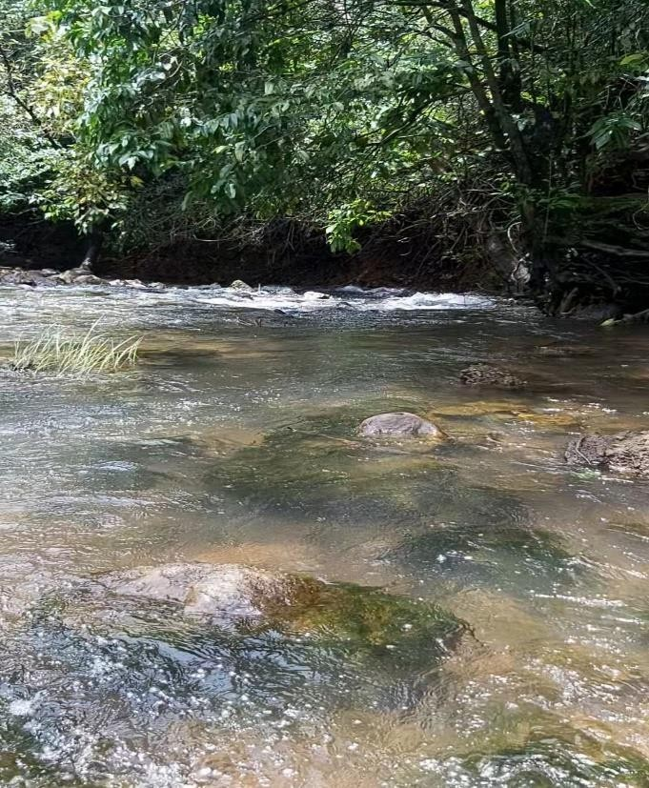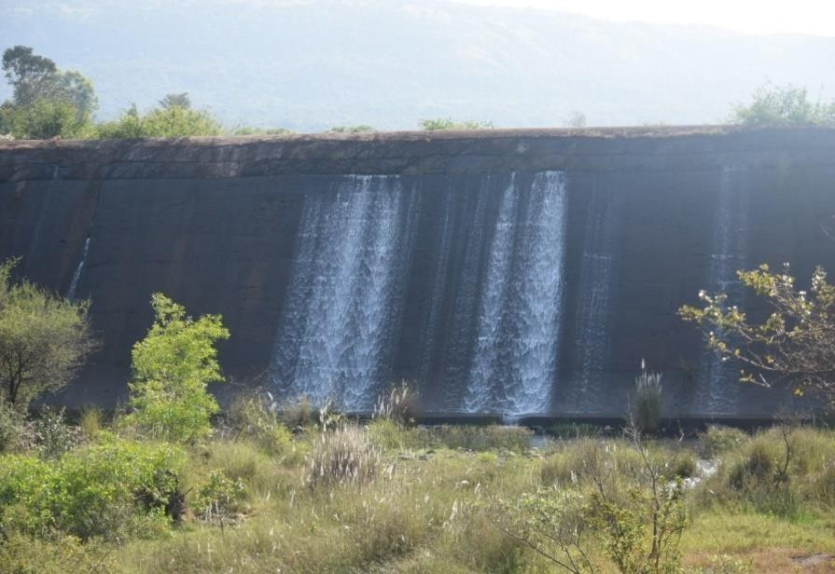

1. Kitwade (SRS) 2. Jangamhatti (SRS)

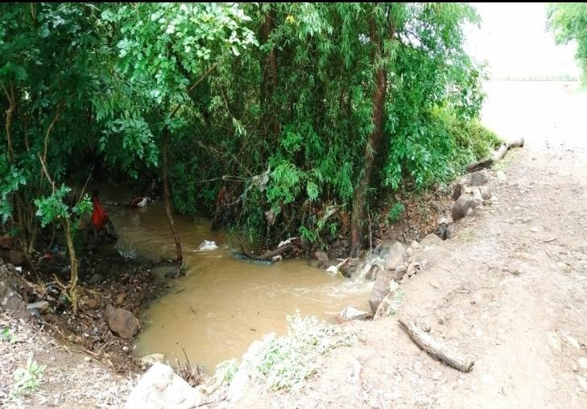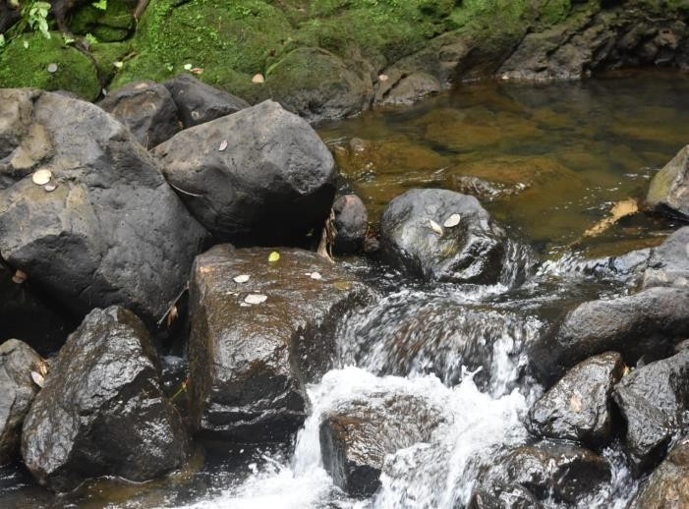

3. Nittur (SRS) 4. Tilari Nagar (FRS)

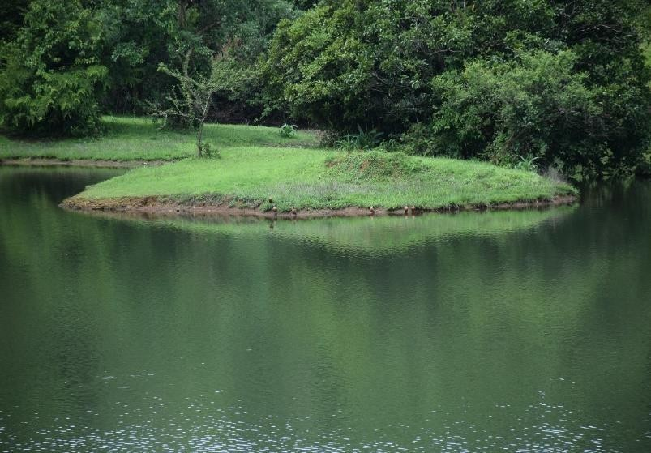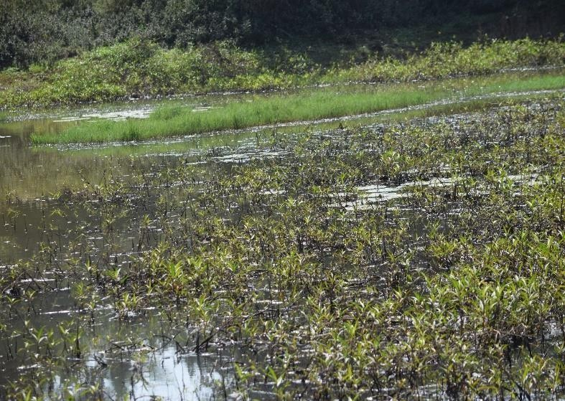

5. Kodali (LS) 6. Tawarewadi (WP)

Photo plate 1 continued

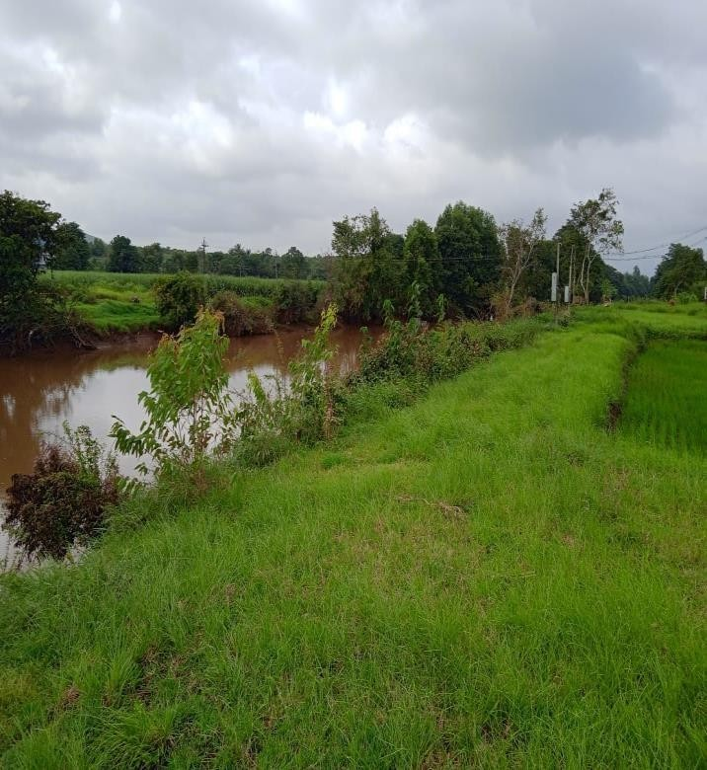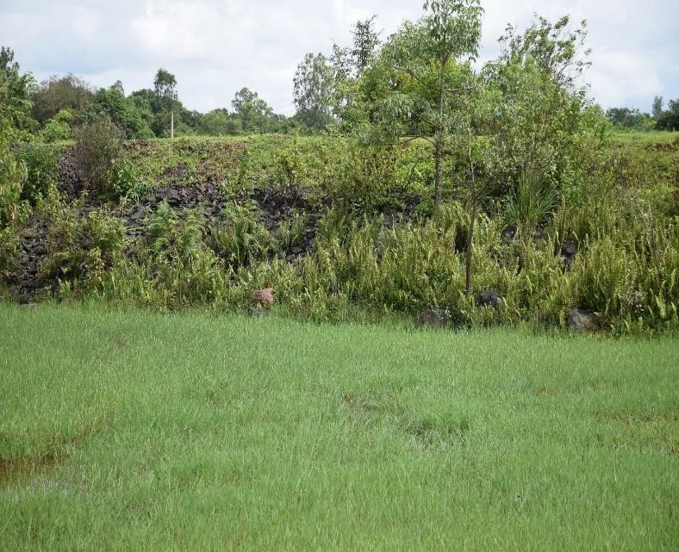

7. Kamewadi (RS) 8. Ambewadi (ML)

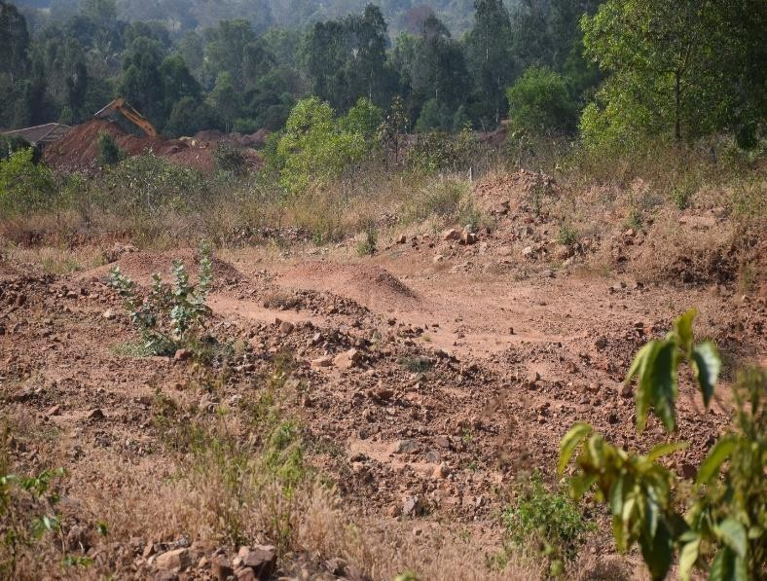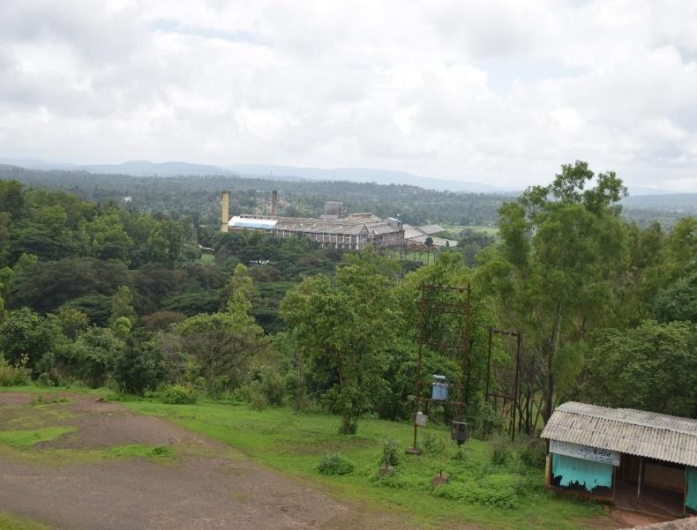

9. Chinchane (SF) 10. YCC Campus (SU)

Photo plate 2. some of the Odonate species recorded in the study area Chandgad taluka of Kolhapur, Maharashtra

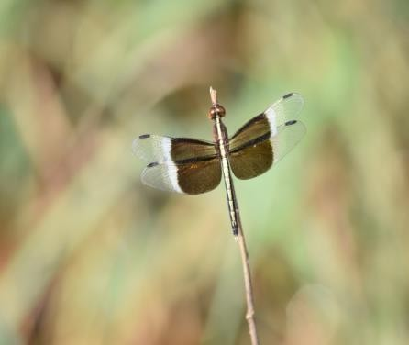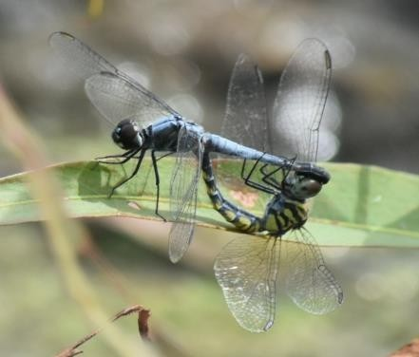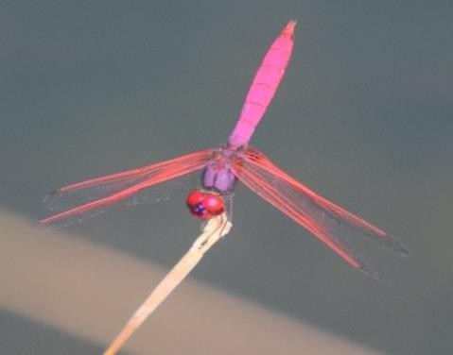

1. *Neurothemis tullia* (Male) 2. *Brachydiplax sobrina* 3. *Trithemis aurora* (Male)

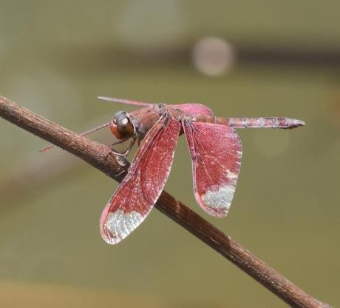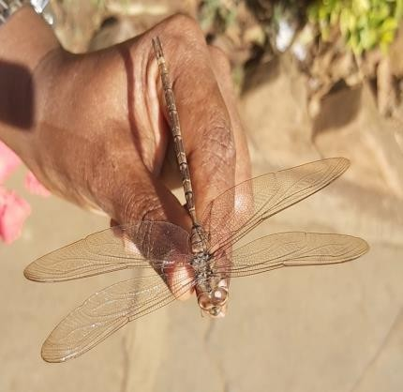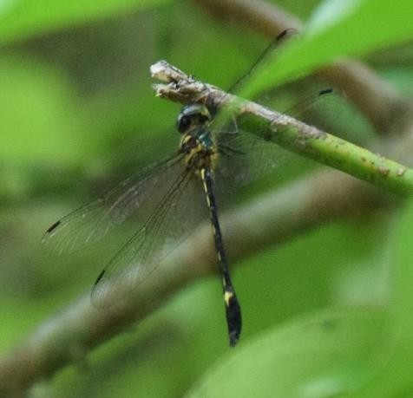

4. *Neurothemis fulvia* (Male) 5*. Gynacantha dravida* 6. *Macromidia donaldi*

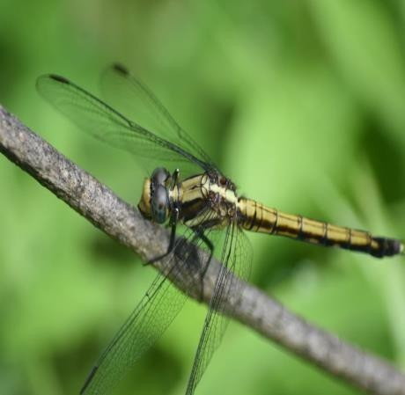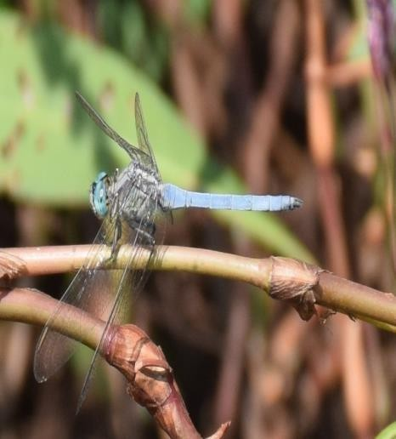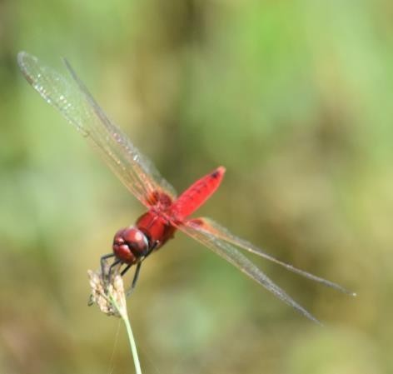

7. *Orthetrum luzonicum* (Female) 8. *Orthetrum luzonicum* (Male) 9. *Urothemis signata*

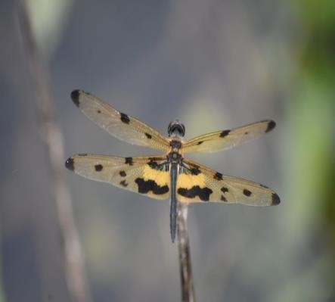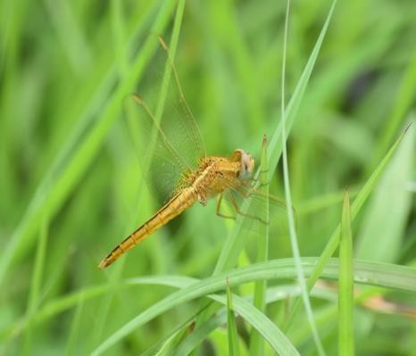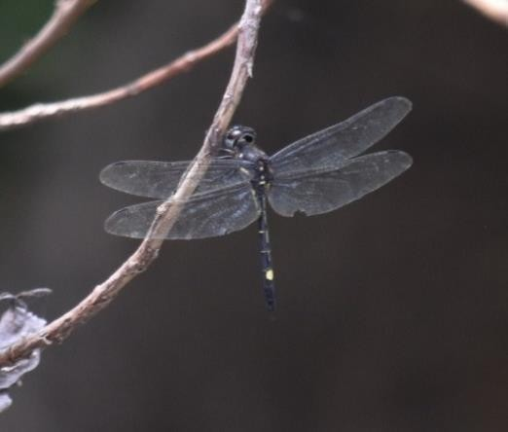

10. *Rhyothemis variegata* 11. *Orthetrum pruinosum* (Female) 12. *Zygonyx iris*

Photo plate 2 continued

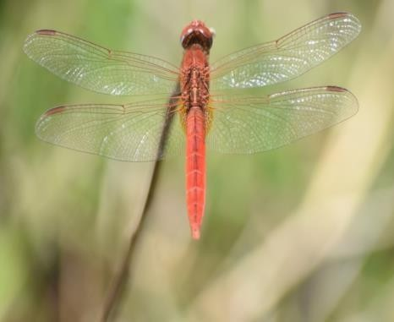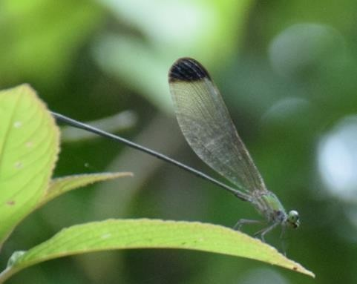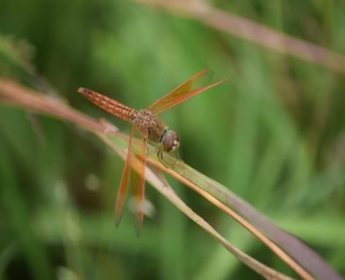

13. *Crocothemis servilia* 14. *Vestalis apicalis* 15. *Brachythemis contaminata*

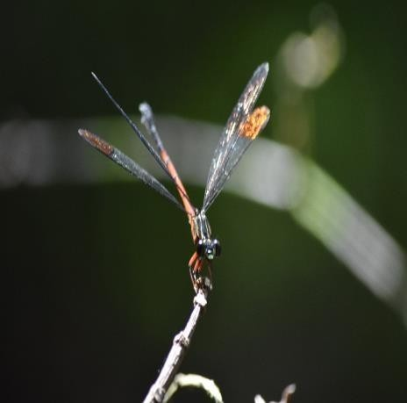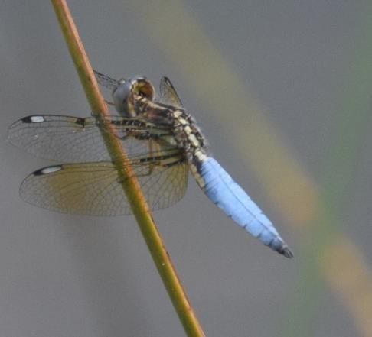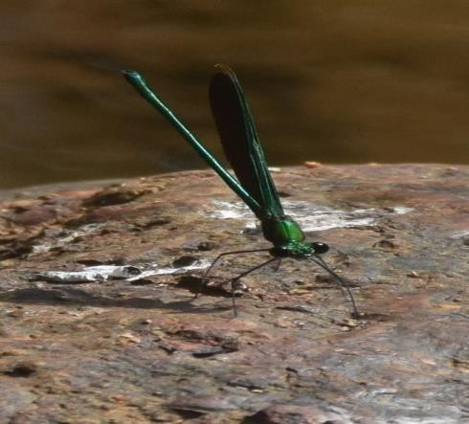

16. *Euphaea fraseri* 17. *Palpopleura sexmaculata* 18. *Neurobasis chinensis*

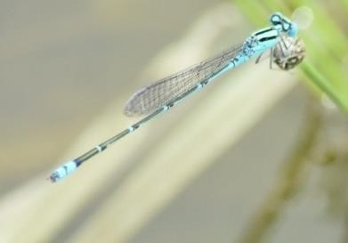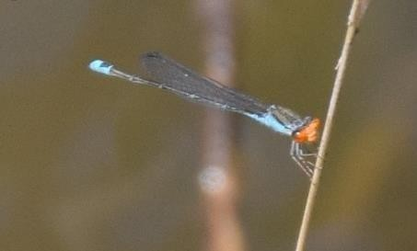

19. *Pseudagrion malabaricum* 20. *Pseudagrion rubriceps*



40

**Figure 1. Shows total number of Dragonfly and**

**Damselfly species recorded in study area**

**38**

35

30

**28**

25

20

15

10

5

DRAGONFLIES

DAMSELFLIES

0

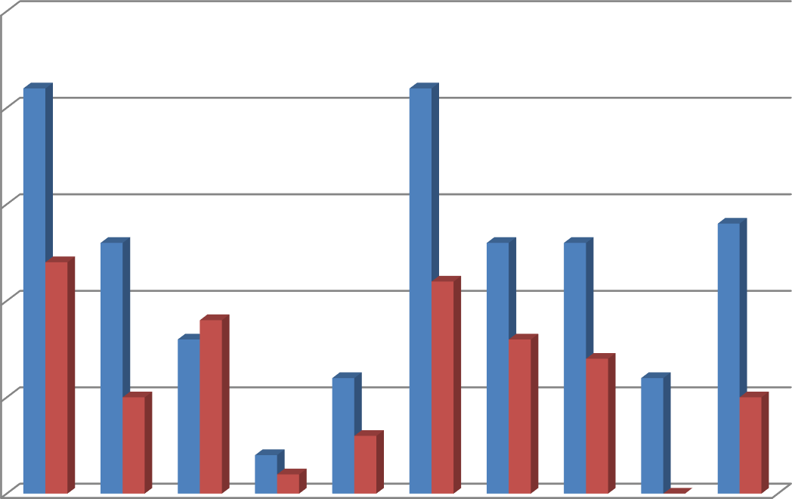

**Figure 2. Shows number of dragonfly and damselfly**

**species recorded in different study sites**

25

20

15

10

5

|  |  |  |  |  |  |  |  |  |  |  |
| --- | --- | --- | --- | --- | --- | --- | --- | --- | --- | --- |
| 0 | Kitwad e | Jangmh atti | Nittur | Tilari | Kodali | Taware wadi | Kamew adi | Ambew adi | Chinch ane | Y.C.C |
| Dragonfly | 21 | 13 | 8 | 2 | 6 | 21 | 13 | 13 | 6 | 14 |
| Damselfly | 12 | 5 | 9 | 1 | 3 | 11 | 8 | 7 | 0 | 5 |

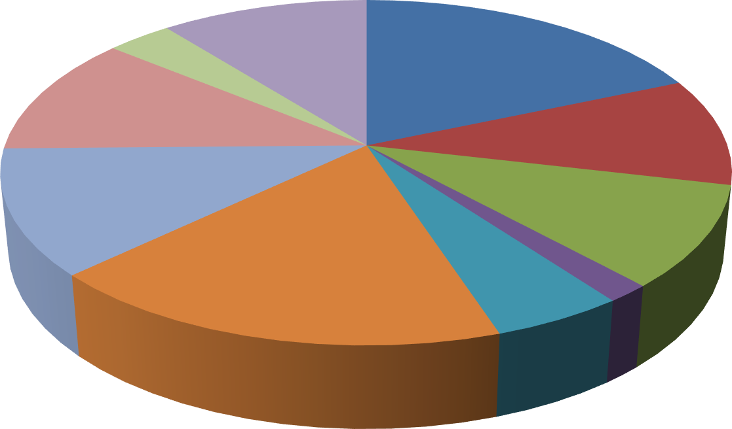

**Figure 3. Shows the number and percentage of donates**

**species recorded in different study sites**

Chinchane, 6, 3%

Y.C.C, 19, 11%

Kitwade, 33, 18%

Ambewadi, 20,

11%

Jangmhatti, 18,

10%

Kamewadi, 21,

12% Nittur, 17, 10%

Tawarewadi, 32,

18%

Kodali, 9, 5%

Tilari, 3, 2%

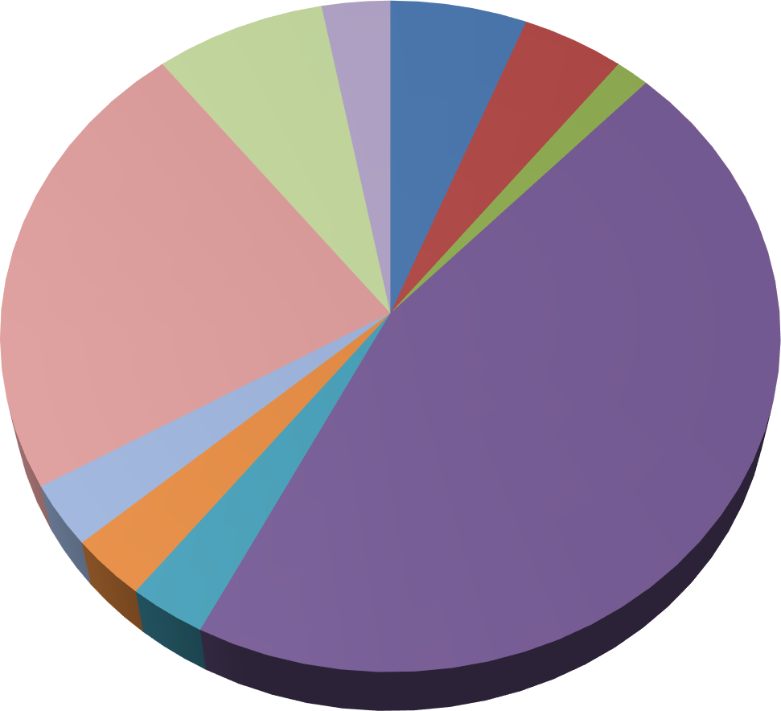

**Figure 4. Shows family wise percentage of odonate**

**species recorded in study area**

Lestidae

3%

Gomphidae

5%

Aeshnidae

6%

Platycnemididae

8%

Synthemistidae

1%

Coenogrionidae

23%

Libellulidae

45%

Euphaeidae

3%

Chlorocyphidae

3%

Calopterygidae

3%

**Figure 5.** A dendrogram show the similarity in species composition between different habitat types

