Review on Fish as Bio-Indicators: Assessing The Health of River Ecosystems
ABSTRACT
Fish are crucial for maintaining the ecological balance of river ecosystems, serving important functions in nutrient cycling, energy transfer, and habitat formation. As key components of intricate food webs, fish help control prey populations and uphold ecosystem stability. Their movements facilitate the distribution of nutrients throughout river systems, which supports primary productivity and enhances the connections between freshwater, estuarine, and marine environments. Moreover, fish serve as bio-indicators, signaling changes in water quality and habitat health due to pollution and environmental stress. This chapter explores the various roles fish play in preserving river biodiversity and ecological stability, with a focus on the impacts of human-induced challenges like overfishing, habitat destruction, and pollution. It emphasizes the critical need for effective conservation and management strategies to safeguard fish populations and their habitats, ultimately supporting the resilience and functionality of river systems.
KEYWORDS: Fish, Trophic interaction, Indicator species, Pollution, Overfishing
Introduction
River ecosystems play a crucial role in maintaining biodiversity and ecological balance. They serve as hotspots for a diverse range of aquatic and terrestrial species, providing essential habitats. Additionally, rivers are important for hydrological processes as they facilitate water movement, recharge groundwater, and regulate surface water levels (Allan & Castillo, 2007). Nutrient cycling in rivers plays a crucial role in enhancing floodplains and boosting soil fertility, which in turn supports the growth of natural vegetation and agricultural activities (Odum & Barrett, 2005). Additionally, rivers provide vital resources for human livelihoods, including irrigation, drinking water, fishing, and hydropower for generating electricity. India has a vast network of inland open water resources, known for their rich fish diversity and considerable production potential. The river systems of the country extend over approximately 29,000 kilometers, comprising 14 major rivers, each with a catchment area exceeding 20,000 square kilometers. Additionally, there are 44 medium-sized rivers with catchment areas ranging between 2,000 and 20,000 square kilometers, along with numerous smaller rivers characterized by catchment areas of less than 2,000 square kilometers (Das et al., 2012). In India, river systems are broadly classified into five major categories: The Ganga, Brahmaputra, and Indus river systems, which dominate the northern region, and the east and west coastal river systems that characterize Peninsular India. Riverine environments are crucial globally due to their rich fish diversity. They support a wide range of species adapted to flowing water ecosystems. The fish populations in these areas play a vital role in food web dynamics, nutrient cycling, and maintaining ecological balance. India's rivers, known for their exceptional biodiversity, are particularly abundant in fish species. Out of 2,801 recognized species, approximately 999 freshwater fish species have been identified in Indian waters, highlighting their important role in global aquatic biodiversity (Froese & Pauly, 2021). These river systems not only enhance ecological health but also provide food and economic support for millions, especially in rural communities (Vass et al., 2011). However, challenges such as climate change, pollution, overfishing, and habitat degradation threaten these vital ecosystems. Fish play crucial roles in energy transfer, nutrient cycling, and maintaining the balance of the food web, making them vital ecological contributors in aquatic ecosystems. They help regulate algal growth and support biodiversity by dispersing nutrients and promoting habitat diversity (Holmlund & Hammer, 1999; Flecker et al., 2010). Studying fish is key to understanding the ecological services they offer, such as food security and water purification, and is essential for developing effective conservation strategies to address issues like overfishing and habitat destruction.
Fish play a crucial role as bio-indicators in assessing the health of river ecosystems, as they are highly responsive to environmental disturbances, pollution levels, and habitat degradation (Hussain et al., 2021). This review comprehensively explores the significance of various fish species in biomonitoring, highlighting their effectiveness in detecting water quality changes resulting from human activities. Since fish exhibit physiological, biochemical, and behavioral responses to toxicants, they serve as valuable tools in ecotoxicological evaluations (Adams, 2002).
Furthermore, fish communities provide essential insights into the sustainability and ecological integrity of freshwater systems, making them indispensable for conservation efforts and water resource management (Simon, 1999). The ability of fish to reflect ecosystem health also aids policymakers in formulating evidence-based environmental regulations aimed at controlling aquatic pollution (U.S. EPA, 2020). By synthesizing existing literature and identifying gaps in knowledge, this manuscript establishes a foundation for advancing research in fish-based biomonitoring. Given the challenges posed by industrialization, climate change, and the growing demand for sustainable freshwater ecosystem management, the findings of this review are highly relevant to global conservation and fisheries management strategies (Besse et al., 2012).
The Ecological Roles of Fish
Fish are vital to both freshwater and marine ecosystems, significantly shaping their structure and function. They serve as crucial components in food webs, functioning as predators, prey, and competitors, which helps regulate the populations of other aquatic organisms and supports biodiversity (Pauly et al., 1998). Additionally, fish play a role in nutrient cycling and maintaining water quality by feeding on algae and detritus (Flecker et al., 2010). Migratory species, such as salmon, enhance both aquatic and terrestrial ecosystems by transporting nutrients to riparian zones, which in turn supports a variety of plant and animal life (Naiman et al., 2002). Their activities, including nesting and sediment movement, also help to create habitat diversity and resilience.
Trophic Interactions
Fish play a vital role in the interactions within aquatic ecosystems, functioning at various levels of the food web. They can act as primary consumers by feeding on algae and plankton, or as secondary and tertiary consumers by preying on smaller fish and invertebrates (Hutchinson, 1957). Through these feeding habits, fish help regulates the populations of different species, which promotes balance in the ecosystem and prevents overpopulation (Pauly et al., 1998). Additionally, fish aid in nutrient cycling by excreting waste and breaking down organic material, enriching the water and supporting primary producers (Flecker et al., 2010). Their predatory and grazing activities also shape community composition and influence the flow of energy within ecosystems.

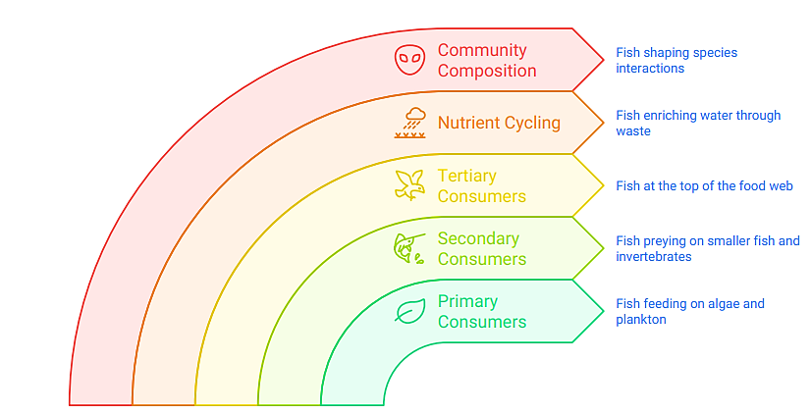
Fig. 1 Role of Fish in trophic interaction

Nutrient Cycling
Fish serve a vital function in the biogeochemical cycling of nutrients within aquatic ecosystems by facilitating the transport, redistribution, and release of essential nutrients, thereby influencing ecosystem productivity and stability. Migratory species, for instance, move nutrients such as nitrogen and phosphorus between different habitats, transferring them from oceans to rivers and enhancing ecosystems that may lack these vital resources. This influx of nutrients boosts productivity in those areas. Furthermore, fish enhance nutrient availability through their excretion and the decomposition of their bodies after they die, which directly enriches the surrounding water. These mechanisms contribute to the sustenance and proliferation of primary producers, including algae and aquatic plants, thereby playing a fundamental role in preserving ecosystem health and enhancing overall productivity (Taylor et al., 2012; McIntyre et al., 2008).

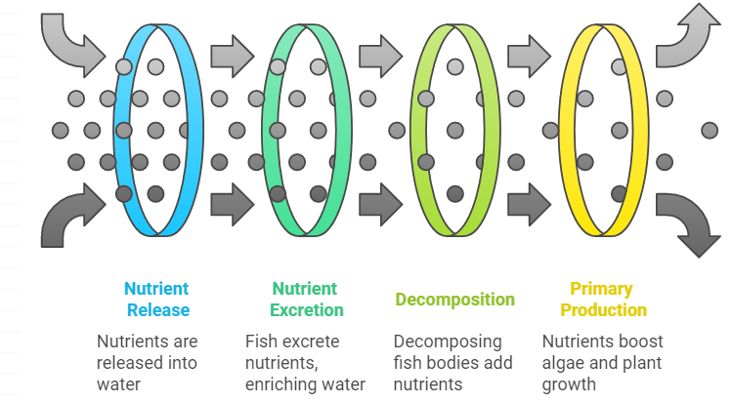
Fig. 2 Fish-Driven Nutrient Enrichment

Habitat Modification by Fish
- Physical Alteration: Fish play a significant role in modifying their habitats through behaviors such as burrowing, spawning, and feeding. These activities disrupt sediment layers, alter the composition of substrates, and create essential habitats like shelters and spawning areas. Such changes increase the complexity and diversity of the habitat, which in turn benefits a wide range of aquatic organisms (Caux et al., 1997).
- Sediment Transport: Fish activity plays a significant role in sediment dynamics by disturbing sediment during their spawning or feeding activities. These actions affect the patterns of erosion and deposition, which are crucial for maintaining vibrant aquatic ecosystems. The interactions that depend on sediment are vital for supporting habitat functionality and biodiversity (Flecker, 1996; MDPI, 2021).

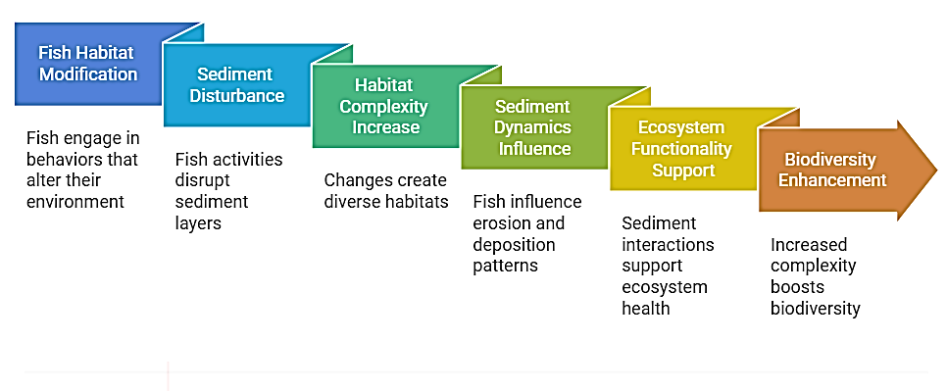
Fig. 3 Fish induced habitat dynamics

Biodiversity Maintenance
- Predator-Prey Interactions
Fish are essential for maintaining biodiversity by controlling prey populations. Predatory fish, including pike (Esox lucius) and largemouth bass (Micropterus salmoides), help regulate the numbers of smaller fish and invertebrates, preventing overpopulation and ensuring a balanced food web. This top-down regulation fosters coexistence among species and boosts the ecosystem’s resilience and stability (McIntyre & Flecker, 2010; Power et al., 1996). Moreover, the predatory behavior of species like Atlantic cod (Gadus morhua) influences the distribution and size of prey populations, adding to the complexity and structure of the community (Worm et al., 2009).

- Habitat Creation and Modification
Fish contribute significantly to habitat formation and modification through various behaviors, including burrowing, nesting, and foraging, which influence substrate composition and ecosystem structure. For example, salmon (Oncorhynchus spp.) are vital for nutrient cycling in freshwater ecosystems due to their migration and spawning activities. Their presence enhances riparian zones and fosters fertile conditions that support a variety of species (Naiman et al., 2002). Moreover, catfish (Siluriformes) contribute to habitat modification by burrowing and forming shelters in the substrate, which provides safe spaces for different aquatic organisms (Crawford & Smock, 1995).
Indicator species
Fish serve as essential bio indicators for assessing water quality and monitoring the overall health of aquatic ecosystems, as their presence, abundance, and physiological responses reflect environmental conditions and ecosystem integrity.
- Monitoring Water Quality
Fish are highly effective bio indicators of water quality due to their sensitivity to environmental perturbations, including pollution and habitat alterations, making them valuable for assessing ecosystem health and detecting ecological disturbances. For instance, trout (Salmonidae) are particularly vulnerable to pollutants such as heavy metals and chemicals, and finding them in a water body usually indicates good water quality. Conversely, a decline or absence of these fish can signal water pollution or damage to their habitat. Likewise, minnows (Cyprinidae) can reflect changes in water quality, as fluctuations in their populations often point to nutrient enrichment or changes in water flow (Karr, 1981).
- Assessing Ecosystem Health
Fish serve as important indicators of the health of river ecosystems, with their variety and numbers reflecting the stability and resilience of these environments. The presence of species like salmon (Oncorhynchus spp.), which thrive in clean, oxygen-rich waters and need suitable spawning areas, is a sign of a healthy ecosystem. On the other hand, their absence can indicate serious ecological disruptions or habitat degradation (Worm et al., 2009). Additionally, species such as catfish (Siluriformes) and bass (Micropterus spp.) offer insights into the balance of food webs and how factors like overfishing or habitat changes affect biodiversity (Power et al., 1996).
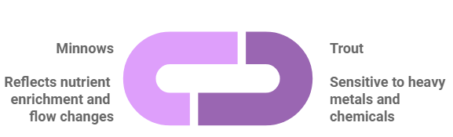 | 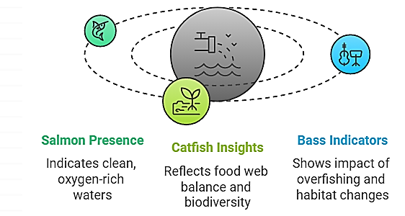
Fig. 4 Fish as indicator of water quality and river ecosystem health

Threats to Fish and River Ecosystems
Habitat Loss and Degradation
Habitat loss and degradation pose serious threats to fish and river ecosystems around the world. Activities like dam construction, river channelization, and pollution have significantly affected river habitats, resulting in a decline in biodiversity and disrupting crucial ecosystem functions. These alterations diminish the capacity of ecosystems to deliver essential services and sustain aquatic life.
- Dam Construction: Dams are constructed to provide advantages such as hydroelectric power, water supply, and flood management, but they can also significantly impact river ecosystems. By obstructing fish migration, dams alter the natural flow of water and the movement of sediment, which can change habitats. Fish species like salmon and trout, which rely on migrating upstream and downstream for reproduction, are particularly affected (Baxter, 1977). Moreover, the alterations in water temperature and oxygen levels caused by dam operations can be detrimental to aquatic life, leading to decreased fish populations and changes in community structure (Poff et al., 1997).
- River Channelization: Channelization refers to the alteration of river channels to manage their course, improve navigation, or lessen the risk of flooding. This often involves straightening, widening, or deepening the channels. While these changes can help reduce flood damage and facilitate human activities, they also disrupt natural habitats and impact water flow, making it more difficult for fish to access vital spawning and feeding areas (Berman & Pess, 2008). Such alterations decrease habitat complexity, which limits the availability of suitable environments for fish survival and reproduction. Such environmental disturbances can have profound adverse impacts on fish populations, potentially disrupting their distribution, abundance, and physiological functions, thereby compromising the overall health and stability of riverine ecosystems.
- Pollution: Pollution from agricultural runoff, industrial waste, and effluents from wastewater treatment facilities poses a serious threat to aquatic habitats. High levels of nutrients, especially nitrogen and phosphorus, lead to algal blooms that reduce oxygen levels, creating hypoxic zones or "dead zones" where aquatic life cannot thrive (Diaz & Rosenberg, 2008). Additionally, pollutants like heavy metals, pesticides, and pharmaceuticals present toxic risks to fish and other aquatic species (Vörösmarty et al., 2010). These contaminants not only compromise water quality but also result in bioaccumulation and biomagnification, endangering the health and stability of entire ecosystems.

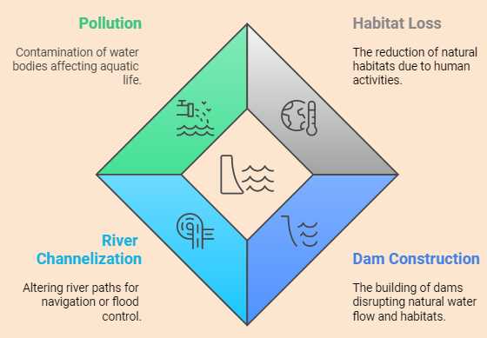
Fig.5 River ecosystem health

Overfishing
Overfishing poses a significant threat to fish populations and the integrity of aquatic ecosystems. It occurs when the rate of fish extraction surpasses their natural reproductive potential, leading to a decline in stock abundance. This unsustainable practice disrupts ecological equilibrium, reduces species diversity, and triggers cascading effects throughout trophic networks, ultimately endangering the stability and resilience of both marine and freshwater ecosystems.
- Depletion of Fish Populations: The overexploitation of fish resources has led to a dramatic decline in fish populations worldwide, exemplified by the collapse of Atlantic cod stocks in the 1990s and the decreasing abundance of large pelagic species such as tuna and swordfish. These declines are largely attributed to technological advancements in fishing, rising market demand, and inadequate regulatory enforcement (Pauly et al., 2002). Beyond depleting fish stocks, overfishing also reduces genetic diversity and weakens the ability of fish populations to adapt to environmental changes, thereby threatening their long-term sustainability. Furthermore, it threatens the livelihoods of communities that depend on fisheries, putting both ecological and economic stability at risk.
- Disruption of Food Webs: Overfishing has a profound impact on both marine and freshwater food webs, disrupting their structure and functionality. The depletion of apex predators, including sharks and large predatory fish, triggers trophic cascades that induce profound alterations in ecosystem structure and function, affecting species interactions and overall ecological stability. For example, when herbivorous fish are overfished in coral reef systems, it often results in unchecked algae growth, which can harm reef habitats (Jackson et al., 2001). Likewise, the overharvesting of forage fish like anchovies and sardines affects the food supply for higher trophic-level species, including seabirds and marine mammals, thereby disrupting the balance and biodiversity of the ecosystem (Pikitch et al., 2014).
Climate Change
Climate change poses significant challenges to aquatic ecosystems by affecting water temperature, flow patterns, and oxygen levels. As global temperatures rise, rivers, lakes, and oceans are warming, prompting many species to migrate toward cooler areas, such as higher latitudes or altitudes, to remain within their thermal limits (Comte & Olden, 2017). This shift in species distribution disrupts established food webs and community interactions. Variations in precipitation patterns, coupled with the rising frequency of extreme weather events, disrupt natural hydrological regimes, thereby affecting critical ecological processes that sustain aquatic ecosystems. These changes can obstruct fish migration, reduce spawning success, and disrupt nutrient cycling, ultimately threatening ecosystem productivity and stability (Poff et al., 2010). For instance, modified river flows can limit access to spawning areas for migratory species like salmon. Additionally, rising water temperatures worsen oxygen depletion, especially in stagnant and nutrient-rich waters, where hypoxic conditions are becoming more common. This issue is particularly severe in eutrophic lakes and coastal regions, leading to fish kills and declines in biodiversity (Diaz & Breitburg, 2009). The ripple effects of these changes jeopardize not only the ecological health of aquatic systems but also the livelihoods of communities that rely on fisheries and water resources. Moreover, climate change intensifies the effects of other stressors, such as pollution and overfishing, creating a compounded burden on aquatic ecosystems. Tackling these challenges necessitates global efforts to combat climate change, alongside local conservation initiatives aimed at boosting ecosystem resilience and safeguarding biodiversity.
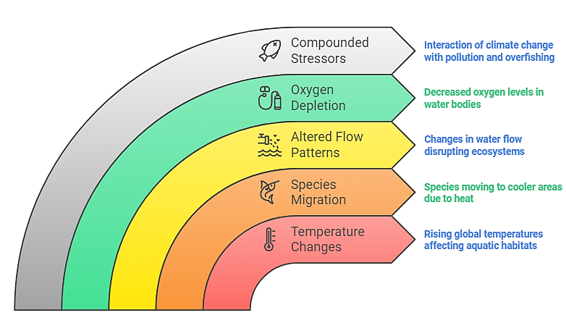
Fig. 6 Impact of climate change on aquatic ecosystem
Invasive Species: Competition with Native Species and Predation on Native Prey
Invasive species represent a major threat to aquatic ecosystems, often outcompeting native species and disrupting local food webs and habitats. These non-native species can establish and thrive in new environments because they lack natural predators or diseases that would usually keep their populations in check. This advantage can result in rapid population growth and dominance within the ecosystem. A notable example of an invasive species is the zebra mussel (Dreissena polymorpha), which was introduced into North America's Great Lakes through ballast water discharged by ships. Upon establishment, zebra mussels outcompete native mussel species for resources such as food and habitat, leading to substantial disruptions in the lakes' ecological equilibrium (Strayer, 2009). Their proliferation also affects aquatic food web dynamics by extensively filtering plankton, thereby reducing the availability of this crucial food source for fish populations that rely on it for sustenance. Another significant example of species introduction with profound ecological consequences is the introduction of the Nile perch (Lates niloticus) into Lake Victoria. This highly predatory species has been a major driver of biodiversity loss, contributing to the near extinction of numerous endemic cichlid species through intense predation pressure (Kishe-Machumu et al., 2015). The resulting ecological shift has had long-term implications for the lake’s structural and functional integrity, altering species composition, disrupting nutrient cycling, and reducing habitat complexity. The invasion of such species can trigger cascading changes throughout the ecosystem, disrupting nutrient dynamics, altering habitat structure, and diminishing overall biodiversity. These disruptions weaken the resilience of the ecosystem, making it less capable of withstanding other environmental stressors and reducing its ability to provide essential services and support local communities.
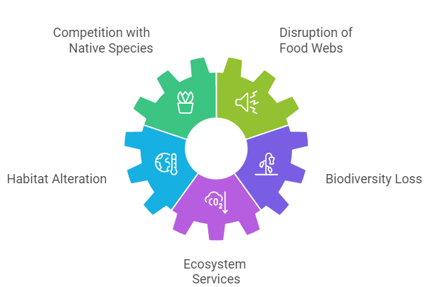
Fig. 7 Impact of invasive species on aquatic ecosystem

Conservation and Management Strategies
Protected Areas: Establishing and Managing Protected Areas for Critical Fish Habitats
Creating and managing protected areas is a crucial strategy for protecting vital fish habitats and promoting biodiversity. These designated zones serve as safe havens, providing fish species relief from human-related threats like overfishing, habitat loss, and pollution. Research on marine protected areas (MPAs) demonstrates their success in increasing fish populations, enhancing biodiversity, and strengthening ecosystems against environmental challenges (Gell & Roberts, 2003). A prominent example of successful conservation initiatives is the Great Barrier Reef Marine Park in Australia, where targeted management strategies have contributed to the recovery of fish populations and the restoration of coral reef health (Hughes et al., 2017). Freshwater protected areas are equally important for conservation. For example, regions along the Amazon River basin are crucial for safeguarding the habitats of native fish species such as the arapaima (Arapaima gigas), which is vital for local communities and the ecological balance of the area (Farias et al., 2016). To ensure these areas thrive, effective management strategies must be implemented, including regulating fishing practices, controlling pollution sources, and enforcing no-take zones. These strategies strengthen conservation efforts by enhancing protective measures, ensuring the sustained viability of fish populations and the preservation of their ecosystems.
Habitat Restoration
Habitat restoration plays a crucial role in rehabilitating degraded ecosystems and enhancing fish populations. Riparian zones and wetlands are essential for maintaining water quality, regulating streamflow, and providing vital habitats for fish and other aquatic organisms. Activities like replanting native vegetation and managing invasive species can improve water retention, reduce erosion, and increase habitat complexity. For example, restoring riparian buffers along Chesapeake Bay has been effective in improving water quality and creating better habitats for fish species such as brook trout (Salvelinus fontinalis) (Wenger et al., 2009). Similarly, wetland restoration projects in the Florida Everglades have enhanced habitat connectivity and sup

orted native fish and bird populations by restoring natural hydrological patterns (Davis et al., 2016). These restoration efforts lead to greater biodiversity, enhanced ecosystem services, and the development of more resilient aquatic systems that can support a variety of wildlife.

Sustainable Fisheries Management
The implementation of sustainable fisheries management practices is essential for preserving the long-term stability of fish populations and maintaining ecological equilibrium. Key management strategies encompass the establishment of catch quotas, the enforcement of size-based harvest restrictions, and the adoption of seasonal fishing closures. These measures are designed to mitigate overexploitation, promote stock replenishment, and ensure the resilience of aquatic ecosystems. For instance, total allowable catch (TAC) quotas have proven effective in curbing overfishing and supporting the recovery of fish populations (Hilborn & Walters, 1992). Size limits that protect young fish ensure they have the opportunity to mature and reproduce, which is essential for maintaining population stability (McClanahan et al., 2015). Additionally, creating no-take zones within marine protected areas is a successful strategy that can enhance fish biomass and biodiversity (Edgar et al., 2014). The combination of these methods, along with robust monitoring and enforcement, is vital for achieving a balance between ecological health and the livelihoods of those who rely on fishing.
Climate Change Mitigation and Adaptation
Mitigating the effects of climate change on fish populations and riverine ecosystems necessitates an integrated approach combining both mitigation and adaptation strategies. Mitigation efforts primarily aim to curb greenhouse gas emissions, thereby minimizing future temperature rise and mitigating habitat degradation. Key strategies include the adoption of renewable energy sources, improvements in energy efficiency, and the application of carbon sequestration technologies (IPCC, 2021). Conversely, adaptation measures focus on strengthening the resilience of both ecosystems and human communities to withstand the adverse impacts of climate change. This can be accomplished by restoring wetlands and riparian buffers to enhance water retention and temperature regulation, as well as creating fish corridors that allow for migration in response to shifting water flow patterns (Poff et al., 2017). Adaptive management practices, which include modifying fishing regulations and safeguarding critical habitats, are crucial for supporting fish populations as environmental conditions evolve (Glick et al., 2011). Effective climate change strategies must integrate both mitigation and adaptation efforts to safeguard biodiversity and the essential services provided by ecosystems.

Public Awareness and Education
Raising public awareness and educating individuals about the importance of fish and river ecosystems is essential for promoting responsible stewardship and sustainable practices. By teaching communities about the ecological value of these systems, the challenges they encounter, and the benefits they offer-such as clean water, food sources, and recreational activities-we can inspire collective conservation efforts. Environmental education programs that engage local communities in initiatives like habitat restoration and water quality monitoring have proven effective in cultivating a sense of responsibility and a deeper understanding (Bennet et al., 2017). Public awareness campaigns, backed by governments and non-governmental organizations, can highlight the threats posed by overfishing, pollution, and habitat destruction, encouraging people to adopt more environmentally friendly habits, such as minimizing plastic waste and opting for sustainable fisheries (Lück et al., 2018). Public education serves as a crucial tool in the conservation and sustainable management of fish and river ecosystems by fostering informed decision-making and encouraging active community participation. By raising awareness and promoting engagement, these initiatives contribute to the long-term preservation and ecological integrity of aquatic environments.
Conclusion
Fish are integral to the health of river ecosystems, playing key roles in nutrient cycling, supporting food webs, and contributing to biodiversity that benefits both aquatic and terrestrial systems. To safeguard the resilience of these ecosystems, it is vital to employ integrated management strategies that take into account the complex relationships among fish populations, water quality, habitat conditions, and human influences. Effective conservation requires a combination of habitat restoration, sustainable fishing practices, and the creation of protected areas. Ongoing research is also crucial for a deeper understanding of fish ecology and to guide adaptive management practices. By focusing on research and fostering collaborative conservation efforts, we can improve our capacity to protect fish populations and maintain the ecosystems that sustain them for future generations.
Disclaimer (Artificial intelligence)
Option 1:
Author(s) hereby declare that NO generative AI technologies such as Large Language Models (ChatGPT, COPILOT, etc.) and text-to-image generators have been used during the writing or editing of this manuscript.
Option 2:
Author(s) hereby declare that generative AI technologies such as Large Language Models, etc. have been used during the writing or editing of manuscripts. This explanation will include the name, version, model, and source of the generative AI technology and as well as all input prompts provided to the generative AI technology
Details of the AI usage are given below:
1.
2.
3.

Reference
- Adams, S. M. (2002). Biological indicators of aquatic ecosystem stress. American Fisheries Society.
- Allan, J. D., & Castillo, M. M. (2007). Stream ecology: Structure and function of running waters (2nd ed.). Springer.
- Baxter, R. M. (1977). Environmental effects of dams and impoundments. Annual Review of Ecology and Systematics, 8(1), 255–283. https://doi.org/10.1146/annurev.es.08.110177.001351
- Berman, C. H., & Pess, G. R. (2008). Assessing the impacts of river channelization on fish populations and river ecosystems. River Research and Applications, 24(9), 1321–1337. https://doi.org/10.1002/rra.1158
- Besse, J. P., Latour, J. F., & Garric, J. (2012). Antidepressants in surface waters: Occurrence and ecological effects. Environmental Toxicology and Chemistry, 31(3), 620-631. https://doi.org/10.1002/etc.1830.
- Caux, P. Y., Moore, D. R. J., & MacDonald, D. D. (1997). Ambient water quality guidelines (criteria) for turbidity, suspended and benthic sediments: Overview report. Environmental Protection Division, British Columbia Ministry of Environment.
- Comte, L., & Olden, J. D. (2017). Climate change reshuffles aquatic species distribution and community assembly. Nature Climate Change, 7(2), 103–107. https://doi.org/10.1038/nclimate3163
- Crawford, C. S., & Smock, L. A. (1995). The role of fish in nutrient cycling and habitat structure. Journal of the North American Benthological Society, 14(4), 590–600. https://doi.org/10.2307/1467472
- Das, M. K., Naskar, M., Mondal, M. L., Srivastava, P. K., Dey, S., & Rej, A. (2012). Influence of ecological factors on the patterns of fish species richness in tropical India. [Journal Name if available], [Volume and Page numbers if available].
- Davis, S. M., Gunderson, L., & Park, S. (2016). Restoration of wetland ecosystems in the Florida Everglades: Successes and challenges. Ecological Applications, 26(8), 2278–2293. https://doi.org/10.1890/15-1638.1
- Diaz, R. J., & Breitburg, D. L. (2009). The hypoxic environment. In J. G. Richards, A. P. Farrell, & C. J. Brauner (Eds.), Fish physiology: Hypoxia (Vol. 27, pp. 1–23). Elsevier. https://doi.org/10.1016/S1546-5098(08)00001-0
- Diaz, R. J., & Rosenberg, R. (2008). Spreading dead zones and consequences for marine ecosystems. Science, 321(5891), 926–929. https://doi.org/10.1126/science.1156401
- Edgar, G. J., Stuart-Smith, R. D., Willis, T. J., Kininmonth, S., Baker, S. C., & Houghton, R. A. (2014). Global conservation outcomes depend on marine protected areas with five key features. Nature, 506(7487), 216–220. https://doi.org/10.1038/nature13022
- Farias, I. P., Nogueira, A. M., & Torrente-Vilara, G. (2016). Protected areas in the Amazon basin and their role in fish conservation. Aquatic Conservation: Marine and Freshwater Ecosystems, 26(2), 422–438. https://doi.org/10.1002/aqc.2741
- Flecker, A. S. (1996). Ecosystem engineering by a dominant detritivore in a diverse tropical stream. Ecology, 77(6), 1845–1854. https://doi.org/10.2307/2265788
- Flecker, A. S., McIntyre, P. B., Moore, J. W., Anderson, J. T., Taylor, B. W., & Hall, R. O. (2010). Migratory fishes as material and process subsidies in riverine ecosystems. American Fisheries Society Symposium, 73, 559–592.
- Froese, R., & Pauly, D. (Eds.). (2021). FishBase. World Wide Web electronic publication. http://www.fishbase.org, version (06/2021).
- Gell, F. R., & Roberts, C. M. (2003). Benefits beyond boundaries: The fishery effects of marine reserves. Trends in Ecology & Evolution, 18(9), 448–455. https://doi.org/10.1016/j.tree.2003.08.007
- Hilborn, R., & Walters, C. J. (1992). Quantitative fisheries stock assessment: Choice, dynamics and uncertainty. Chapman & Hall. https://doi.org/10.1007/978-1-4612-0912-4
- Holmlund, C. M., & Hammer, M. (1999). Ecosystem services generated by fish populations. Ecological Economics, 29(2), 253–268. https://doi.org/10.1016/S0921-8009(99)00015-4
- Hussain, M., Ahmed, M. S., & Azmat, R. (2021). Fish as bioindicators of aquatic pollution: A review. Environmental Monitoring and Assessment, 193, 45. https://doi.org/10.1007/s10661-021-08775-0.
- Hutchinson, G. E. (1957). A treatise on limnology. Vol 1: Geography, physics and chemistry. John Wiley & Sons.
- IPCC. (2021). Climate change 2021: The physical science basis. Contribution of Working Group I to the Sixth Assessment Report of the Intergovernmental Panel on Climate Change. Cambridge University Press. https://doi.org/10.1017/9781009157896
- Jackson, J. B. C., Kirby, M. X., Berger, W. H., Bjorndal, K. A., Botsford, L. W., Bourque, B. J., & Warner, R. R. (2001). Historical overfishing and the recent collapse of coastal ecosystems. Science, 293(5530), 629–637. https://doi.org/10.1126/science.1059199
- Kishe-Machumu, M. A., Witte, F., & Wanink, J. H. (2015). Diet and growth of Nile perch (Lates niloticus) in the Mwanza Gulf of Lake Victoria. Hydrobiologia, 755(1), 267–278. https://doi.org/10.1007/s10750-015-2234-3
- Kotta, J., Nõomaa, K., & Herkül, K. (2022). Novel fish predator causes sustained changes in prey populations. Frontiers in Marine Science, 9, 849878. https://doi.org/10.3389/fmars.2022.849878
- Li, T., Huang, X., Jiang, X., & Wang, X. (2018). Assessment of ecosystem health of the Yellow River with fish index of biotic integrity. Hydrobiologia, 814, 31-43.
- Lück, M., Bagnall, A. M., & McCauley, D. J. (2018). Public awareness and conservation of freshwater ecosystems: A review of best practices and challenges. Aquatic Conservation: Marine and Freshwater Ecosystems, 28(7), 1729–1744. https://doi.org/10.1002/aqc.3007
- McClanahan, T. R., Muthiga, N., & Ateweberhan, M. (2015). Marine protected areas and their impact on fisheries management. Fisheries Research, 168, 57–65. https://doi.org/10.1016/j.fishres.2015.03.006
- McIntyre, P. B., & Flecker, A. S. (2010). Ecological roles of fish in ecosystems. Annual Review of Ecology, Evolution, and Systematics, 41(1), 637–659. https://doi.org/10.1146/annurev-ecolsys-102209-144720
- McIntyre, P. B., Jones, L. E., Flecker, A. S., & Vanni, M. J. (2008). Fish extinctions alter nutrient recycling in tropical freshwaters. Proceedings of the National Academy of Sciences, 105(47), 19734–19739. https://doi.org/10.1073/pnas.0804409105
- MDPI. (2021). Integration of constructed floodplain ponds into nature-like fish passes supports fish diversity in a heavily modified water body. Water, 13(8), 1018. https://doi.org/10.3390/w13081018
- Millennium Ecosystem Assessment. (2005). Ecosystems and human well-being: Wetlands and water synthesis. World Resources Institute.
- Naiman, R. J., Bilby, R. E., & Bisson, P. A. (2002). Riparian ecology and management in the Pacific coastal rain forest. BioScience, 52(8), 779–791
- Odum, E. P., & Barrett, G. W. (2005). Fundamentals of ecology (5th ed.). Brooks/Cole.
- Pauly, D., Christensen, V., & Guénette, S. (1998). A statistical ecosystem model of the North Atlantic: A preliminary analysis. Canadian Journal of Fisheries and Aquatic Sciences, 55(5), 1085–1095. https://doi.org/10.1139/f98-014
- Pikitch, E. K., Boersma, P. D., Boyd, I. L., Conover, D. O., Cury, P., Essington, T. E., ... & Worm, B. (2014). Little fish, big impact: Managing a crucial link in ocean food webs. Science, 343(6171), 1084–1087. https://doi.org/10.1126/science.1249327
- Poff, N. L., Allan, J. D., Bain, M. B., Karr, J. R., Prestegaard, K. L., Richter, B. D., ... & Stromberg, J. C. (1997). The natural flow regime: A paradigm for river conservation and restoration. BioScience, 47(11), 769–784. https://doi.org/10.2307/1313099
- Power, M. E., Tilman, D., Estes, J. A., Menge, B. A., Bond, W. J., Mills, L. S., ... & Paine, R. T. (1996). The role of top-down and bottom-up forces in the regulation of fish communities. Ecological Monographs, 66(4), 435–456. https://doi.org/10.2307/2963476
- Ripple, W. J., Estes, J. A., Beschta, R. L., Wilmers, C. C., Ritchie, E. G., Hebblewhite, M., & Schmitz, O. J. (2014). Status and ecological effects of the world's largest carnivores. Science, 343(6167), 1241484. https://doi.org/10.1126/science.1241484
- Simon, T. P. (1999). Assessing the sustainability and biological integrity of water resources using fish communities. CRC Press.
- Strayer, D. L. (2009). Twenty years of zebra mussels: Lessons from the mollusk that made headlines. Frontiers in Ecology and the Environment, 7(3), 135–141. https://doi.org/10.1890/080020
- Taylor, J. M., Back, J. A., Valenti, T. W., & King, R. S. (2012). Fish-mediated nutrient cycling and benthic microbial processes: Can consumers influence stream nutrient cycling at multiple spatial scales? Freshwater Science, 31(3), 928–944. https://doi.org/10.1899/11-113.1
- U.S. Environmental Protection Agency (EPA). (2020). Biomonitoring: Evaluating the health of aquatic systems using fish indicators. Retrieved from https://www.epa.gov/aquatic-life-use-support/biomonitoring
- Vannote, R. L., Minshall, G. W., Cummins, K. W., Sedell, J. R., & Cushing, C. E. (1980). The river continuum concept. Canadian Journal of Fisheries and Aquatic Sciences, 37(1), 130–137. https://doi.org/10.1139/f80-017
- Vass, K. K., Das, M. K., Tyagi, R. K., Katiha, P. K., Samanta, S., Srivastava, N. P., Bhattacharjya, B. K., Suresh, V. R., Pathak, V., Chandra, G., Debnath, D., & Gopal, B. (2011). Strategies for sustainable fisheries in the Indian part of the Ganga Brahmaputra river basins. International Journal of Ecology and Environmental Sciences, 37(4), 157–218.
- Vörösmarty, C. J., McIntyre, P. B., Gessner, M. O., Dudgeon, D., Prusevich, A., Green, P., ... & Davies, P. M. (2010). Global threats to human water security and river biodiversity. Nature, 467(7315), 555–561. https://doi.org/10.1038/nature09440
- Worm, B., Hilborn, R., Baum, J. K., Branch, T. A., Collie, J. S., Costello, C., ... & Zeller, D. (2009). Rebuilding global fisheries. Science, 325(5940), 578–585. https://doi.org/10.1126/scien

