Occurrence of Intestinal Nematode Parasites in Cockroach,

***Periplaneta americana* (L.)**

**Abstract:**

The present study investigates the occurrence of intestinal nematode parasites in the American cockroach, Periplanata americana (Linnaeus).Thousands of species of insect parasitic nematodes not only attack the general insect form, belonging to different orders but also the insect pests of agricultural, veterinary, medical and forestry importance. Classic identification of nematodes is based on morphological and anatomical differences using microscopic image analysis. Morphological identification is among the cheaper identification methods and helps relate morphology with possible function. A total of 200 cockroaches were collected from various locations in Aurangabad city and transported to the Department of Zoology, Dr. Babasaheb Ambedkar Marathwada University, Aurangabad, India for this study. The present communication deals with the taxonomic study of intestinal parasite infection in cockroaches, redescribed of two nematode parasites of *P. americana* were *Hammerschmidtiella diesingi* (Hammerschmidt, 1838) Chitwood, 1932 and *Thelastoma periplaneticola* Leibersperger, 1960 from Aurangabad, (M.S), India. The redescriptions presented in this study enhance our understanding of the morphology and diversity of these parasites, underscoring the necessity for continued research on the intestinal parasite fauna of cockroaches in India.

**Keywords:** *Periplaneta americana, Hammerschmidtiella, Thelastoma,* intestinal nematode

# Introduction:

“Cockroaches are one of the oldest insect orders with a fossil history extending back more than 300 million years. There are 3500-4000 known species worldwide of which only a few are troublesome to people” (Robertson, 2004). “The American cockroach, *Periplaneta americana* L. is the largest of the common domestic cockroaches measuring on average 4 cm in length. The American cockroach is second after the German cockroach in abundance. The cockroach is found in caves, mines, privies, latrines, cesspools, sewers, sewerage treatment plants, and dumps” (Bell and Adiyodi, 1981; Burmeister, 1838). Cockroaches are recognized to be mechanical vectors of disease-causing agents (Sia et al. 2016). Their presence in these habitats is of epidemiological significance, at least 22 species of pathogenic human bacteria, viruses, fungi and protozoan as well as five species of helminths worms have been isolated from collected American cockroaches (Rust *et al.,* 1991). Children under five years old of age among the group are exceptionally associated with intestinal parasitic infections (Fauziah, 2022).

“Nematodes, a diverse group of roundworms, exhibit a wide range of dietary habits, including parasitism of animals and plants. These parasites cause substantial economic losses in agriculture and pose significant health challenges to humans and animals” (Lin and Siddique, 2024). “Insect parasitic nematodes have been known since the 17th century and perhaps the earliest. Extensive studies on IPNs were carried out in the 19th and 20th centuries. During the last one-decade, remarkable progress has been made in the taxonomy of IPN. Studies on the economic importance and life histories of two mermithid parasites of grasshoppers”,

(Nguyen and Smart, 2004).

*Agamermis decaudata* Cobb *et al.,* 1923 and *Mermis subnigrescens* Cobb, 1926 were excellent contributions and stand as classics in insect nematology (Christie, 1936; Basir (1956) has done an excellent work on oxyuroid parasites of Arthropods. Poinar (1977) gave a generic key of entomophilic nematodes. Remarkable studies on parasitic nematodes of insects were made by Hammerschmidt (1938, 1947), Leidy (1849, 1851), Cobb (1910, 1930), Travassos (1920, 1958),

Steiner (1920, 1930), Artigas (1926, 1929), Chitwood and Chitwood (1930, 1950), Nickle (1963, 1984), and many others.

In India, work on nematode parasites of insects was started by Basir in 1940 and he did a lot during 1940-1970, which was followed by Siddiqi (1960), Farooqui (1967), Duggal and Aulakh (1988, 1989), Singh and Kaur (1988), Singh and Singh (1989), Rizvi and Jairajpuri (1995), Ganguly (2000), Ali (2000) and few others, mainly in North India. In South India, significant contributions and a series of reports were made by Rao (1958, 1965), followed by Kumari (1967), Devi *et al.,* (1991), Reddy and Rao (1987), Hussaini (2003) and others. Very recently Gantait and Chatterjee (2007) reported “30 species of parasitic nematodes of Arthropoda from Andhra Pradesh including two new subgenera and one new species”.

“Thousands of species of insect parasitic nematodes not only attack the general insect form, belonging to different orders but also the insect pests of agricultural, veterinary, medical and forestry importance. The potential for the use of entomophilic nematodes as self-perpetuating biological control agents lies in areas where chemical pesticides are too expensive, not practical or most noxious to humans and the environment” (Chitwood *et al.,* 1933). The progress of research in nematode systematics has been particularly impressive in the area of soil nematodes, plant parasitic nematodes and parasitic nematodes of vertebrates. However, studies on insect parasitic nematodes and their systematics have largely been neglected, though they have enough potential to be used as biological agents to control various insect pests without causing any damage to the ecology (Barron, 1981; Swarup and Gokte, 1986). Thus, with a view to enriching our knowledge on insect parasitic nematodes of Aurangabad, Maharashtra state the present work was proposed.

# Materials and Methods:

1. **Collection of the insects:** Two hundred cockroaches were collected from different parts of Aurangabad city province at night time or in the morning. Each cockroach was collected and put in a sterile test tube and then transported to the laboratory of the Department of Zoology, Dr. Babasaheb Ambedkar Marathwada University, Aurangabad, (M.S), India.
2. **Isolation parasites from internal surfaces:** After external washing. Cockroaches were placed in flask rinsed with 70% alcohol for 5 min to decontaminate external surfaces then the cockroaches were fixed on dissecting Petri dish and dissected. Collect the nematodes with the fine brush or needles into a small vial of a few of millilitres of ethyl alcohol 70%. Set apart the specimens in a well-stopped vial to examine them later and all separated parasites are stored to be examined later (Walter and Cancun, 2005).
3. **Killing, Fixing, Processing, Entomogenous Nematodes to Glycerin:** There are several standard methods for killing and processing nematodes to glycerin and depending on the type of nematodes good results can be obtained for each. Because of the diversity of insect nematodes, a single simple method cannot be used for all groups.

The method tends to clear the nematode but the definition gradually returns. Nematodes present a special problem during the dehydration process since the body wall is thin and often collapses by fixing TAF made with Ringers indeed of water and using a modification of the glycerin-ethanol method of processing to glycerin good results can often be achieved this method consists of transferring the nematodes from the fixative to a small cavity block contain 5 ml of 20 parts of ethanol (95%), one part glycerin and 79 parts distilled water. This dish is then placed in a closed vessel containing 96% ethanol for 12 hours at 35-400c. At this time, the dish is filled with a solution consisting of 5 parts glycerin and 95 parts glycerol (96%) and left partially opened Petri dish for 3 hours at 400c. The nematode then should be in pure glycerin. This method works well for insect nematodes in general, but requires and often the large drenched parasites often collapse (Courtney *et al.,* 1955).

1. **Preparation of permanent slides for taxonomic study:** For permanent mounts, nematodes were first fixed with TAF (2% Triethanolamine and 7.5 % Formaldehyde), dehydrated with a slow evaporation method and mounted on a slide (Morffe and Garcia 2010). Then the nematodes were properly arranged and a cover slip of 20 mm diameter was mounted carefully. Finally, the coverslip was sealed by its edges on the slide by using good quality nail polish as a sealing material. Finally, the slides were properly labeled with the collection data (Chitwood, 1932).
2. **Identification, drawing and microphotographs of specimens:** The identification of Insect parasitic nematodes belonging to various orders up to the species level by observing

The specimens under a compound microscope. The photomicrographs of all specimens were taken by a digital camera attached to the same microscope using low and high-power objectives. (Gantait and Venkataraman 2013).

1. **Use of classification scheme to arrange the available species:** In the present study, classification was proposed by Gantait and Sanyal (2007) and Manjur Shah *et al.,* (2012).

# Results and Discussion:

1. **Taxonomy of insect parasitic nematodes in cockroaches (*Periplaneta americana* L.)**
2. ***Hammerschmidtiella diesingi* (Hammerschmidt,1838) Chitwood, 1932 (Figure No.1 and 2)**

**Host :** *Periplaneta americana* Linn.

**Habitat:** Intestine

**Locality :** Aurangabad, (M.S), India

**Description: Females “**(n = 5): L = 2.068 - 3.164 mm; a = 11-12.3 (11.7 ± 0.48); b = 6.4-10.4 (8.7

± 1.47); c = 2.9-3.2 (2.9 ± 0.13); V = 21.3-25.6 (22.48 ± 1.79) %. Body spindle-shaped. Narrow

lateral alae present. Oesophagus consists of a cylindrical procorpus, a large ovoid metacarpus (pseudobulb), distinct isthmus which passes into the valvate bulb. The lumen of the procorpus and the first third of the metacarpus are strong sclerotized. The nerve ring is situated on the posterior end of the procorpus. Excretory pore located at 434-485 μm from the anterior end. Vulva is a transverse slit in the anterior third of the body, posterior to the base of the oesophagus. A long vagina and common uterus posteriorly directed. Gonads didelphic, prodelphic. Eggs elongated, ellipsoidal. One pair of lateral pores at a distance of 20-50 μm after the anal opening. Tail long and filiform”. (Nedelchev et al.2013)

**Remarks**: “Studies of the Bulgarian specimens are consistent with the description and scope of the measurements given by earlier workers who presented their areas of distribution. A cap-like characteristic structure of the tail tip of the female Indian population in our specimens was not observed”. (Shah 2007). Basir (1956) redescribed “*Hammerschmidtiella diesingi* from Aligarh, Uttar Pradesh”. Soota and Chaturvedi (1971) reported “it from the Howrah district of West Bengal; collecting from the rectum and junction of intestine and rectum of Periplaneta americana” (thirty Females; Z.S.I. Reg. Nos. W7069 - 73/1; collector- Y. Chaturvedi, 19- 22. 7. 1967). Gupta and Kaur (1978) reported the species from *P. americana* at Chandigarh, Punjab. Rizvi (2006) redescribed the species from Dehra Dun, Uttarakhand, collected from the posterior gut of *P. americana*. Gantait and

Chatterjee (2007) recorded “it from Anantapur, Andhra Pradesh; collected from the rectum of the cockroach host, *Blatta orientalis”.*

**Distribution**: North and South America, North India, China, Russia, Europe (Germany, Nördlingen) (Leibersperger 1960), Poland, North-East India (Shah 2007).

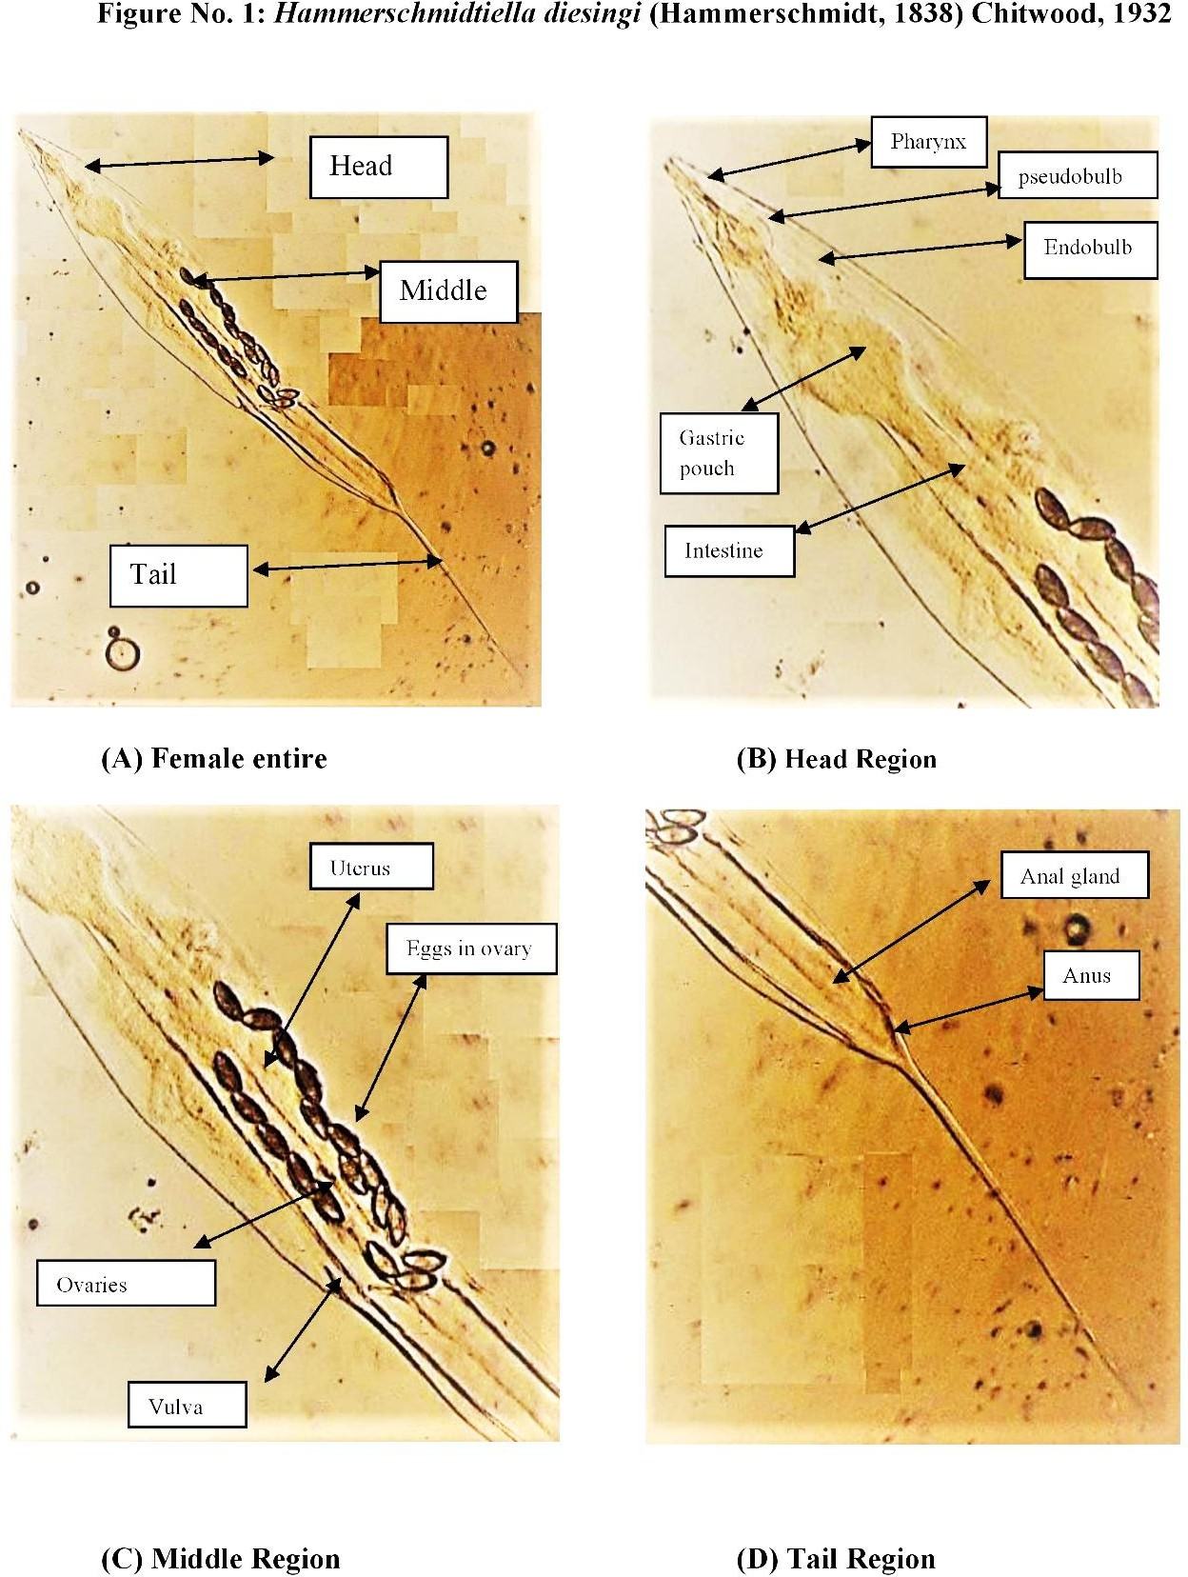

|  |  |  |
| --- | --- | --- |
| **(A)** | 50 µm | **(E)**  100 µm |
| **(B)** | 50 µm |
| **(C)** | 50 µm |
| **(D)** | 50 µm | **FigureNo.2*.* Camera lucida drawing of *Hammerschmidtiella diesingi* (Hammerschmidt, 1838) Chitwood, 1932**   1. Female Anterior end 2. Female oesophageal region 3. Female vulval region showing eggs 4. Female posterior end (lateral view) 5. Female entire |

**Figure No. 3 *Thelastoma periplaneticola* Leibersperger, 1960**

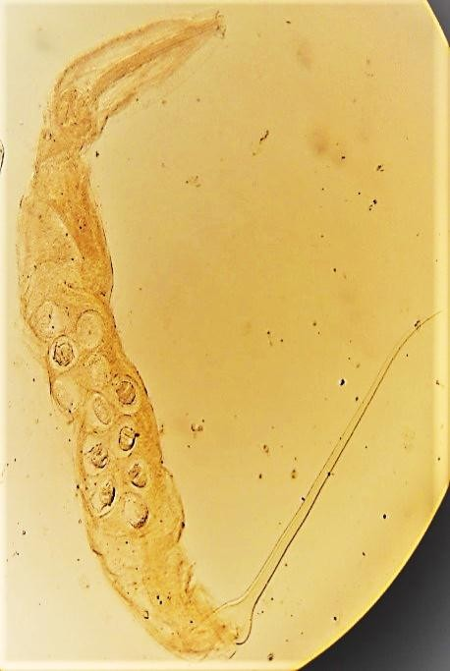

Tail

Middle

Head

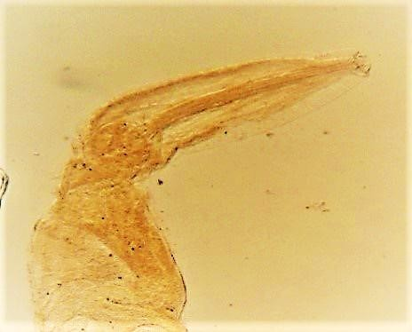

End bulb

Gastric pouch

Isthmus

Pharynx

Excretory pore

# (A) Female entire (B) Head Region

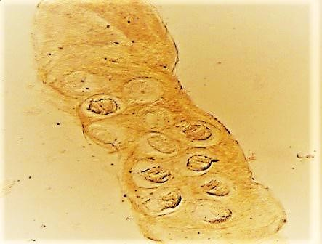

Uterus

Egg

Ovary

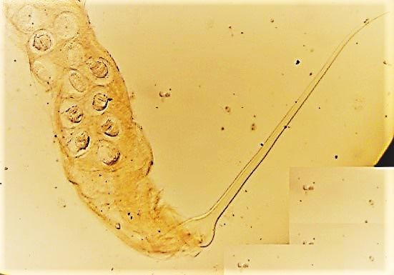

Anal gland

(**C) Middle Region (D) Tail Region**

1. ***Thelastoma periplaneticola* Leibersperger, 1960 (Figure No. 4)**

100 µm

|  |  |  |  |
| --- | --- | --- | --- |
|  | **(A)** | 50 µm | **(E)** |
| **(B)** | 50 µm | | 100 µm |
| **(C)** | 50 µm | |
| **(D)** | 50 µm | | **FigureNo.4*.* Camera lucida drawing of *Thelastoma periplaneticola* Leibersperger, 1960**   1. Female Anterior end 2. Female oesophageal region 3. Female vulval region showing eggs 4. Female posterior end (lateral view) 5. Female entire |

**Host :** *Periplaneta americana* Linn.

**Habitat :** Gut

**Locality :** Aurangabad, (M.S), India

**Genus:** *Thelastoma* Leidy, 1849

**Description: “**Females (n = 20): a = 11.05-17.17 (13.206 ± 1.478), b = 5.05-7.20 (5.924 ± 0.686),

c = 2.82-3.537 (3.166 ± 0.198), L = 2.138-3.474 (2.655 ± 0.364) mm, W = 0.142-0.284 (0.204 ±

0.0416) mm, oesophagus = 0.402-0.506 (0.447 ± 0.029) mm, excretory pore = 0.343-0.510 (0.417

± 0.034) mm; nerve ring = 0.170-0.218 (0.194 ± 0.012) mm, buccal cavity = 12.15-14.58 × 12.15-

14.48 (12.636 ± 0.997 × 13.30 ± 0.619), eggs = 70.47-85.05 × 46.17-60.75 (77.94 ± 4.322 × 55.89

± 3.612), tail = 0.657-1.021 (0.838 ± 0.118) mm, vulva = 1.09-1.717 (1.241 ± 0.168) mm. Body

small, cylindrical and tapering towards the anterior end and into a filiform tail posteriorly”. (Manjur, 2007).The buccal cavity was distinct. The oesophagus long with a cylindrical corpus, a short isthmus and an end bulb. Excretory pore a little above the base of the oesophagus in females. The vulva a little anterior to mid-body, and vulval lip is well developed. Ovaries amphidelphic, vagina directed anteriorly. The tail is filiform forming one-third of the total body length (Figure No. 3D). Eggs are oval in shape (Figure No. 3C). **Discussion:** The genus *Thelastoma* was erected by Leidy (1849) to accommodate “*T. attenuatum* as its type species. So far, the genus contains 54 (approx.) species described from the world over out of which 19 species are reported from India alone”. Thelastoma periplaneticola was first described by Leibersperger (1960) from Germany.

**Generic diagnosis: “**Female has Cephalic extremity formed by circumoral annule and enlarged second annule. Mouth surrounded by eight labial papillae. Amphids present. Lateral alae present or absent. Buccal cavity simple. The oesophagus consists of an anterior cylindrical corpus, an isthmus and a posterior valvular bulb. Excretory pore pre- or post-oesophageal bulb or at the level of the base of the bulb. Tail long filiform about one-third to one-fourth of the total body length. The vagina is short, muscular and anteriorly directed with a well-developed vulval lip. Vulva at or posterior to mid-body. Eggs are broadly oval”. (Manjur, 2007).

**Remarks:** All measurements are in conformity with the range given by Leibersperger (1960) except in having somewhat smaller eggs (72-102 × 58-97) and slightly shorter female tails (tail = 0.55-0.94 mm).

According to Shah (2007), the caudal filament tip of female *H. diesingi* from Manipur, India, has a terminal cap-like shape. Later, a number of investigations (Lee 1958; Leibersperger 1960; *Kloss* 1966; Gupta 1997; Blanco et al. 2012) contradicted these findings. This structure (Fig. 1 and 2), where females have a fine tail tip, was not visible to us in our studies. Spindle-shaped body. There are narrow lateral alae. The oesophagus is made up of a wide, oval metacarpus (also known as a pseudobulb), a distinct isthmus that connects to the valvate bulb, and a cylindrical. According to Khairul and Paran (1977), *T. bulhoesi* has a notably shorter tail than *T. bulhoesi* (c = 11.7–23.3 μm), while in the present study, *Thelastoma periplaneticola* has a longer tail which is closed to *T. dollfusi. T. malaysiense.*

***Conclusion***

In conclusion, the present taxonomic study confirms the presence of two nematode parasites, *Hammerschmidtiella diesingi* and *Thelastoma periplaneticola*, infecting the intestines of *Periplaneta americana* from Aurangabad, Maharashtra, India. The redescriptions provided in this study contribute to a better understanding of the morphology and diversity of these parasites, highlighting the need for further research on the intestinal parasite fauna of cockroaches in India.

Disclaimer (Artificial intelligence)

Option 1:

Author(s) hereby declare that NO generative AI technologies such as Large Language Models (ChatGPT, COPILOT, etc.) and text-to-image generators have been used during the writing or editing of this manuscript.

Option 2:

Author(s) hereby declare that generative AI technologies such as Large Language Models, etc. have been used during the writing or editing of manuscripts. This explanation will include the name, version, model, and source of the generative AI technology and as well as all input prompts provided to the generative AI technology

Details of the AI usage are given below:

1.

2.

3.

# References:

Ali, S. S., Ahmad, R., Hussain, M. A. and Pervez, R. (2000). Pest management *in pulses through entomopathogenic nematodes.* Indian Institute of Pulse Research, Kanpur, pp. 58.

Artigas, P. (1926). Nematoides de Invertebrados. Boletim Biologico, São Paulo, 1: 1-13. Artigas, P. (1929). Systematica dos nematoideos dos orthropodes. These de dottoromento,

Fac.Med., São Paulo, pp. 114.

Barron, G.L. (1981). Predators and parasites of microscopic animals. In Biology of conidial Fungi, Volume 2(Edited by Cole, G.T. Rendrick, B) Academic Press, 167-200.

Basir M.A. (1956). Oxyuroid parasites of Arthropoda. A monographic study. 1. Thelastomatidae

2. Oxyuridae. Zoologica (Stuttgart), 106, 1-79.

Basir, (1956). Rivista di Parassitologia, XXVIII (4): 279-282.

Bell, W J and K G Adiyodi (1981). The American cockroach. Chapman and Hall, London.

Blanco M.V., Lax P., Dueñas J.C.R., Gardenal C.N., Doucet M.E. 2012. Morphological and molecular characterization of the entomoparasitic nematode Hammerschmidtiella diesingi (Nematoda, Oxyurida, Thelastomatidae). Acta Parasitologica, 57, 302–310.

Burmeister, H. (1838). Kakerlaken, Schaben. Blattina. Handbuch der Entomologie, 2(2), 469– 517.

Chitwood BG and Chitwood MB (1933). Nematodes parasitic in Philippine cockroaches.

Philippine J Sci 52: 381-393.

Chitwood, B. G. (1932). A synopsis of the nematodes parasitic in insects of the family Blattidae.

Z. Parasitenkde, 5: 14 -50.

Chitwood, B. G. and Chitwood, M. B. (1937). A revised classification of the Nematoda. In: Helminthology, 30 Year Jubileum (Ed. K. I. Skrjabin). Izedatel’tsvo vsesoyuznoi Academia Naukovi Lenin., Moscow. 19

Chitwood, B. G. and Chitwood, M. B. (1950). An Introduction to Nematology, revised edition.

Monumental Printing, Baltimore, MD.

Christie, J. R. (1936). Life history of Agamermis decaudata, a nematode parasite of grasshoppers and other insects. Journal of Agricultural research, 52: 161-178.

Cobb, N. A. (1910). New nematode genera found inhabiting fresh water and non brakish soils.

Journal of the Washington Academy of Sciences, 3: 432- 444.

Cobb, N. A. (1923). One hundred new nemas (Type species of 100 new genera). Contributionsto a Science of Nematology, 9: 217-343.

Cobb, N. A. (1930). The chromatropism of Mermis subnigrescens, a nemic parasite of grasshoppers. Journal of the Washington Academy of Sciences, 19: 159-166.

Courtney, W.D., Polley, D. and Miller, V.L. (1955) TAF, an improved fixative in nematode technique. Plant Disease Reporter, 39, 570– 571.

Devi, T. R., Rao, P. N. and Reddy, Y. N. (1991). A new nematode parasite Howardula mutilates

n. sp. of the maize kernel pest Carpophilous mutilatus. Current Nematology, 2 (1): 23-26.

Duggal, C. L. and Au lakh, A. (1989). Thelastoma kherai sp. nov. and T. guptai sp. nov. (Nematoda: Thelastomatidae) from Periplaneta americana (Linnaeus) in Delhi, India. Research Bulletin (Science) of the Panjab University, 40, Parts I-II: 95-98.20

Duggal, C. L. and Aulakh, A. (1988); on some nematode parasites infecting household insectsin North-West India. Research Bulletin (Science) of the Panjab University, 39, Parts I-II: 21-25.

Farooqui, N. (1967). On a known and some new species of insect nematodes. Zool. Anz., 178:276-296.

Ganguly, S. (2000). Taxonomy of entomopathogenic nematodes. In: Abstract: National congress on centenary of nematology in India, appraisal and future plans. Division of Nematology, IARI, New Delhi, pp. 20-21.

Gantait V. V and Sanyal A. K. (2007). Check List of Insect Parasitic Nematodes of India **(**Nemathelminthes Section, Zoological Survey of India, M-Block, New Alipur, Kolkata- 700053, West Bengal, India.**)**

Gantait, V.V. and Chatterjee, A. (2007). Fauna of Andhra Pradesh, State Fauna Series, Zoological Survey of India, 5(part- 4): 81-123.

Gantait, V.V. and K. Venkataraman (2013). Catalogue of Arthropod Parasitic Nematodes of India. Zoological Survey of India. (Pp: 1-83).

Gupta N.K., Kaur J. (1978). On some nematodes from invertebrates in Northern India, Part-I. Revista IbÈrica de Parassitologia, 38, 301-324.

Gupta R. (1997). Description of the two species of nematodes of cockroach (Periplaneta americana) reported from Nepal. Tribhuvan University Journal, 20, 25–30.

Hammerschmidt, K. E. (1838). Helminthologische Beiträge. Isis (Oken), Leipzig, 5: 351-358. Hammerschmidt, K. E. (1847). Beschreibung einiger Oxyuris-Arten. Naturwiss. Abh. Wien,

1:279-288.

Hussaini, S. S. (2003). Progress of research work on entomopathogenic nematodes in India. In: Current status of research on entomopathogenic nematodes in India Project Directorate of Biological Control, Bangalore, India, pp. 27-68.

Kloss G.R. (1966). Revisão dos nematóides de Blattaria do Brasil. Papéis Avulsos do Departamento de Zoologia, 18, 147–188.

Kumari, M. M. (1967). A description of a new species of the nematode genus Johnstonia

Lee D.L. (1958). On the morphology of the male, female and fourth-stage larva (female) of *Hammerschmidtiella diesingi* (Hammerschmidt), a nematode parasitic in cockroaches. Parasitology, 48, 433–436.

Leibersperger E. (1960). Die Oxyuroidea de europaischen Arthropoden. Parasitologische Schriftenreihe, 11, 1-150.

Leibersperger E. (1960). Die Oxyuroidea der europäischen Arthropoden. Parasitologische Schriftenreihe, 2, 1–150.

Leidy J. (1849). New genera and species of Entozoa. Proceedings of the National Academy of Sciences of the United States of America, 4, 225-233.

Leidy, J. (1851). Contribution to helminthology. Proceedings of the National Academy of Sciences, Philadelphia, 5: 205-209.

Leidy, J. (1853.). A flora and fauna within living animals. Smithsonian Cont. Know. Washington, 5, Art. 2: 1- 67.

Manjur M. Shah (2007). Some studies on insect parasitic nematodes (Oxyurida, Thelastomatoidea, Thelastomatidae) from Manipur, North-East India. Acta Parasitologica, 52(4), 346–362.

Manjur M. Shah, Mohilal N., Pramodini M.and Bina L. (2012). Parasitic Nematodes of some Insects from Manipur, India (Section of Parasitology, Department of Life Sciences, Manipur University, Imphal, Manipur, India).

Morffe J., García N. (2010). Hystrignathus dearmasi sp. n. (Oxyurida, Hystrignathidae), first record of a nematode parasitizing a Panamanian Passalidae (Insecta, Coleoptera). Zookeys, 57, 1–8.

Nguyen, K. B. and Smart, G. C. Jr (2004). Taxonomy of insect parasitic nematodes. In: Nematology: advances and perspectives. Volume 2. Nematode management and utilization (Eds. Z. X. Chen, S. Y. Chen and D. W. Dickson). CABI Publishing, CAB International, Wallingford, UK., pp. 795-878.

Nickle, W. R. (1963). Bovienema (Nematoda: Allantonematidae), a new genus parasitizing bark beetles of the genus Pityogenes Bedel, with notes on other endoparasitic nematodes of scolytids. Proceedings of the Helminthological Society of Washington, 30: 256-262.

Nickle, W. R. and Welch, H. E. (1984). History, development and importance of insect nematology. In: Plant and Insect Nematology (Ed. W. R. Nickle). Marcel Dekker, New York,

pp. 627-653.

Poinar, G. O. Jr. (1977). CIH key to the groups and genera of nematode parasites of invertebrates.

Commonwealth Agricultural Bureaux, Farnham Royal, England, pp.43.

Rao P.N. (1958). Studies on the nematode parasites of insects and other arthropods. Arquivos do Museu Nacional, Rio de Janeiro, 46, 33-84.

Rao P.N. and Rao V.J. (1965). A description of a new species of the nematode genus Hammerschmidtiella Chitwood, 1932 (Nematoda: Oxyuridae). Rivista di Parassitologia, 26, 9-12.

Reddy, Y. N. and Rao, P. N. (1987). Studies on Heterotylenchus xanthomelas sp. n. parasitic in Musca xanthomelas Wiedemann (Muscidae: Diptera). Indian Journal of Nematology, 17

(2): 180-183.

Rizvi, A. N. and Jairajpuri, D. S. (1995). Scanning electron microscopy of Thelastoma atheri n. comb. (Nematoda: Thelastomatidae), from the cockroach, Periplaneta americana. J. Parasit. Appl. Anim. Biol., 4 (1): 9-13.

Rizvi, A.N. (2006). First record of insect oxyurid nematodes from Dehradun (Uttaranchal).

Annals of Forestry, 14 (1): 65-73.

Robertson, G. (2004). Order: Blattodea (cockroaches). Copyright 2004, Izico Museum of Cape town.

Rust, M.K., D.A. Reierson, and K.H. Hansgen (1991). Control of American cockroaches (Dictyoptera: Blattidae) in sewers. Journal of Medical Entomology 28(2): 210-213.

Shah M.M. (2007). Some studies on insect parasitic nematodes (Oxyurida, Thelastomatoidea, Thelastomatidae) from Manipur, North-East India. Acta Parasitologica, 52, 346–362.

Singh, H. S. and Kaur H. (1988). On a new nematode *Hammerschmidtiella basiri* n. sp. from Periplaneta americana Linn. Indian Journal of Parasitology, 12 (1): 187-189.

Singh, H. S. and Singh, K. (1989). On two new nematodes from Periplaneta americana Linn., from India. Dr. B. S. Chauhan Comm. Vol., 149 -153.

Soota T.D., Chaturvedi Y. (1971). Notes on some nematodes from the unnamed collections of the Zoological Survey of India. Proceedings of Zoological Society, Calcutta, 24, 13–24.

Steiner, G. (1925). Mermithids parasitic in the tea bug (*Helopeltis antonii* Sign.). Med.

Proefstation Three, Batavia, 94: 10-16.

Swarup, G and Gokte, N. (1986). Biological control, Plant parasite nematodes of India Ed: Swarup and Das gupta, IARI Publication 476-489 pp.

Travassos, L. (1920). Esboco de uma chave geral de nematodeos parasites. Revista Veterinaria y Zootecnia, 10: 59-70.

Travassos, L. and Kloss, G. R. (1958). Nematodes de invertebrado. 14a. Nota. de invertebrado.

14a. Nota. Sociedade de Rio de Janeiro, 2: 27-30.

Walter, D. and Cancun, R. (2005). Microscopic fauna some lifestyles part 3- endocommensal of Periplaneta americana (L.) Burmeister, 1838 from Durango and Cancun, Mexico. cockroaches parasites 3.

Fauziah, N., Aviani, J.K., Agrianfanny, Y.N. & Fatimah, S.N. 2022. Intestinal Parasitic Infection and Nutritional Status in Children under Five Years Old: A Systematic Review. Tropical Medicine and Infectious Disease, 7(11), 371.

L. Sia Su, G., Carillo, N., Pera, D., Sison, S., Tanalgo, B., L. Sia Su, M. L., & Mistika, M. (2016). Parasitic Infestation in Cockroaches (Periplaneta americana) Obtained in Selected Areas of Metro Manila. *International Journal of TROPICAL DISEASE & Health*, *13*(4), 1–4. <https://doi.org/10.9734/IJTDH/2016/23820>

Lin, C. J., & Siddique, S. (2024). Parasitic nematodes: dietary habits and their implications. *Trends in Parasitology*, *40*(3), 230-240.

Nedelchev, S., Pilarska, D., Takov, D., & Golemansky, V. (2013). Protozoan and nematode parasites of the American coakroach Periplaneta americana (L.) from Bulgaria. Acta Zoologica Bulgarica, 65(3), 403-408.