**Original Research Article**

Assessing the effect of agricultural fertilizers on Plankton community in culture ponds of Krishna District in Andhra Pradesh, India

**Abstract:**

The present study aims to assess the effect of agricultural fertilizers on phytoplankton and zooplankton distribution and density in the freshwater culture ponds in Krishna District of Andhra Pradesh. Planktons were microscopic organisms those harbor all aquatic environments. Study samples of water were mainly collected from the three culture ponds located in Krishna area, Andhra Pradesh to assess the quantitative distribution of plankton and qualitative capacity to maintain a good health condition under fertilizer stress conditions. Samples were collected in the months of August, October and December-2024. The phytoplankton density is directly interconnected with the production in an aquatic environment and appropriate water quality management and the physico-chemical factors were directly linked with their production. Further, fertilization directly affects the quality of water; maximum phosphorus levels were reached to 5.4 mgL-1 in December and the maximum rates of ammonia were reported to 0.42 mgL-1 in both October and December months. The very common species of phytoplankton species reported were *Lauderia, Chlorella, Cyclotella, Navicula, Oscillatorials, Thalassiosirales, Cylindrotheca*, zooplankton species are *Rotifera, copepods, Moina, Cyclop*s and Blue-green algae were *Microcystis, Oscillatorials, Merismopedia* and *Spirulineaceae*. Significant differences were reported (p<0.05) in dissolved oxygen, ammonia content, total phosphorus levels, and levels in the orthophosphate, nitrite and nitrate between ponds. It is also reported that a significant difference (p<0.05) in dissolved oxygen and pH between the ponds’ surface and bottom. The results also showed a significant difference in the plankton distribution and density between fertilized and non-fertilized ponds.

**Key words:** Dissolved oxygen, Fertilizers, Plankton, Primary consumers.

**Introduction:**

In recent years, the culturing of fish, prawns and shrimp in inland, brackish water and in marine waters has dramatically increased in Krishna district of Andhra Pradesh. Aquaculture largely depends on the natural source of food which principally depends on the primary productivity of the pond. In general, application of fertilizers in ponds increases the availability of plant nutrients like nitrogen, and phosphorus which enhance the photosynthesis process in phytoplankton. It is the initial step in aquatic food web culminating in shrimp and fish culture production and as well it is also the source of oxygen in the waters and thus maintains water quality. As a result of fertilization two to fivefold aquaculture production is increased. Phytoplankton in aquaculture, in particular, fish culture and shrimp culture have abundant functions as natural feed sources with highest amount of protein and amino acid content (20-35%) (Abo-Taleb, 2019; Ritonga *et al.,* 2023) and maintaining the permanence of the ecosystem of the culturing pond (Ulumiah *et al.,* 2020). Phytoplankton also plays a role in the reduced growth of klekap and moss production at the bottom of pond, and thus regulates the ammonia, nitrite, and nitrate content in the water (Pal *et al.,* 2020).

Fertilizer is constantly applied in culture fish ponds to boost system productivity and profitability. The qualitative and quantitative features of plankton biomass will affect the carrying capacity of pond and the standing crop grows in proportion to the plankton biomass (Soni and Ujjania, 2021; Sinha *et al.,* 2023). Fertilization can significantly enhance the natural productivity of a pond by providing vital nutrients for the development of aquatic biota (Sinha *et al.,* 2023) serving as a crucial food source for aquatic organisms, but undue use may lead to ecological imbalance through eutrophication, harmful algal blooms, and oxygen depletion and thus negatively impacting water quality and fish health. However, to reduce these negative impacts natural or organic fertilizers like livestock manure and agricultural wastes are using as a bio-fertilizers by some farmers to improve soil fertility and promote the growth plankton. Furthermore, organic fertilizers reduce the negative implications on the soil organisms of long-term overuse chemical fertilizers (Ritonga *et al.,* 2023).

The use of inorganic fertilizers in culture ponds improves primary and secondary production and it has been well documented in earlier studies (Zurek, 1974; Januszko, 1977; Tavares *et al.,* 2009). The use of liquid synthetic fertilizers has several advantages over conventional granular or powdered NPK fertilizers. This is because of faster solubility and dispersion of nitrogen and phosphorus present in the fertilizer throughout the water column, and a subsequent speedy absorption and assimilation by phytoplankton (Davidson and Boyd, 1981; Hoque *et al.,* 2014). An increase in phytoplankton can support an increase in zooplankton. Heisig (1979) found that additions of inorganic nitrogen and phosphoric acid to ponds resulted in increased plankton densities. Zooplankton standing stocks increased during fertilization), and Paffenhofer and Harris (1976) stated that an increase in primary production could amplify the fecundity rate and thus number of egg-producing zooplankton adults by increasing their growth rates (Das *et al.,* 2005).

This study is aimed to evaluate phytoplankton and zooplankton responses to fertilization ponds before fish stocking. The study also focused on responses to organic, inorganic, and a combination of both fertilizer types.

**Materials and Methods:**

Pond fertilization: Water samples were collected from six different ponds of Kaikaluru and Machilipatnam area located in Krishna District of Andhra Pradesh were used for the experiment. These ponds were principally fertilized with N:P:K (15:15:15) at a rate of 125kg/ha and followed a week later with urea fertilizer 250kg/ha. Samples from the first three served as experimental and rest three are control.

5 liters of water samples was collected from each pond (both control & fertilized) with every two weeks interval and passed through a 55 μm meshed plankton net. Filtered water samples were preserved in a 50-ml plastic vial containing 10% formalin for subsequent analysis of physicochemical parameters.

**Sampling of Zooplankton:** Zooplankton samples were collected two weeks after the first fertilization. Plankton samples were collected with fine meshed nylon filter cloth nets of 55 μm. Supernatant aliquot samples were prepared as per method of Adeyemo, 1991. Sample quantity is 20ml and it was preserved by adding few drops of 4% formalin. Then three drops of Lugol’s solution were added to the plankton sample and waited for 24 hours. After that the samples were reduced to 10ml by decanting.

The following water quality parameters were assessed using collected pond water samples -pH, dissolved oxygen nitrate and nitrite concentration, ammonia levels, phosphate and potassium and the results were mentioned in Table 1.

**Zooplankton Analysis:** Analysis of zooplankton was done by loading of 1ml sample into Sedgwick-rafter counting chamber and after covered with a cover slip and observed under at 10x microscope. The diversity and density of zooplanktons like Rotifers, Copepods, Cyclops, Calanoid, Daphnia, and Moina were observed, counted, and recorded. The plankton identification is done at the genus level. Plankton density was observed using a SRC (Sedgwick rafter counter cell) under a microscope (10X) and expressed in individual per ml.

**Sampling and analysis of phytoplankton:** Phytoplankton analysis wasdone by the method of Utermöhl (1958) to identify and enumerate the different types of species. For the phytoplankton study, water samples were collected throughout the depth of the water column. 20 µm (sometimes 10 µm) plankton nets were used collect the samples. Lugol’s solution is added to collected pond water samples to preserve the phytoplankton. For preliminary analysis of living samples of surface waters were kept in the dark at a temperature of between 4 and 10°C to slow down the physical and chemical process which may lead to reduction in the quality of sample. Phytoplankton species were observed under a compound light microscope with different magnifications (10X, 40X and 100X oil immersion objectives).

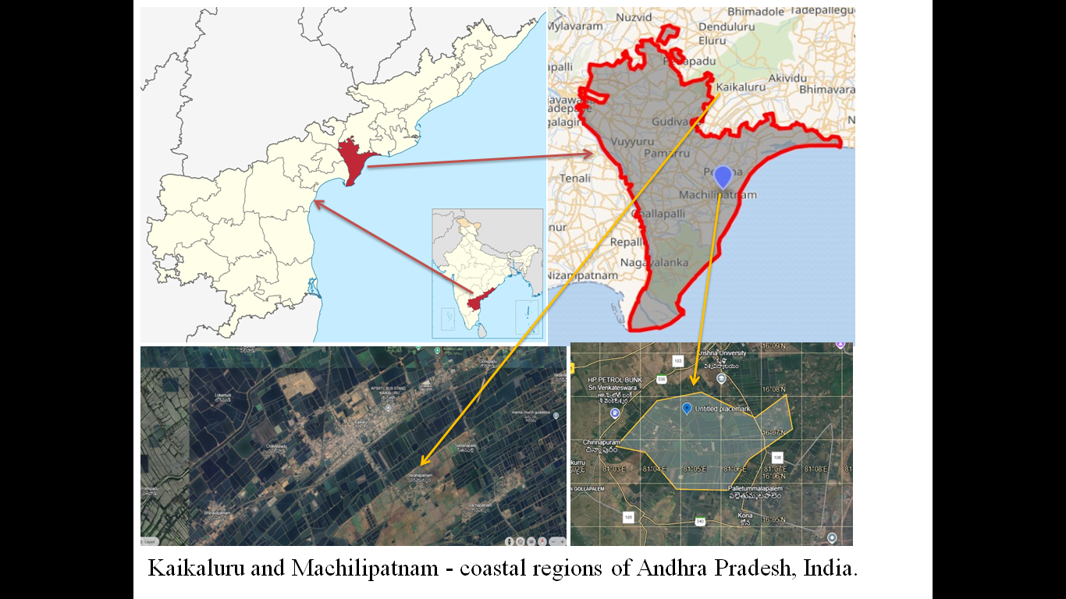

Fig. 1: Map showing two different coastal regions, Kaikaluru and Machilipatnam of Andhra Pradesh, India.

**Results:** There is little change in water quality parameters among treatments throughout the experimental period. The mean pH of a control water sample is 7.18 and the treated water mean pH is 7.26 and the values of pH remained within acceptable limits (Table 1). The mean values of DO also reported within the normal range throughout the experimental period and were 8.39 mg/litre and 8.37 mg/litre in control and treated water samples respectively. The amount of various fertilizer nutrients (mainly NPK – nitrates, nitrites, ammonia, phosphorus and potassium) also analyzed and results showed that the slightly increased in all treatments ponds over control ponds. However, the levels of all these parameters were observed within in the normal range. Due to availability of more nutrients a wide range of plankton diversity and density observed across the fertilizer treated culture ponds including phytoplankton (*Neochloris, Chlorella, Crucigenia, Chlamydomonas, Scenedesmus, Cosmarium, Chlorococcum, Coelastrum, Oocystis and Eudorina*), zooplankton (*Rotifer, Copepods, Moina, Cyclops, Calanoid, Daphnia and Nauplii*), Cyanobacteria (*Oscillatorials, Microcystis, Spirulinaceae and Merismopedia), diatoms (Cyclotell, Navicula, Thalassiosirales, Cylindrotheca, Gyrosigma, Pleurosigma, Fragilariophyceae, Cymbella and Pinnularia*) and euglnoids (*Euglena*). The significant difference was observed among results of treated ponds over control ponds.

**Table 1:** water quality parameters assessed during the experimental period.

|  |  |  |  |
| --- | --- | --- | --- |
| **Water quality parameter** | **Sampling (August, October and December)** | **Treated water sample (fertilizer)** | **Control** |
| **pH** | August | 6.58 | 6.53 |
| October | 7.53 | 7.45 |
| December | 7.68 | 7.58 |
| **Dissolved oxygen**  **(mg/litre)** | August | 8.33 | 8.41 |
| October | 8.37 | 8.39 |
| December | 8.40 | 8.38 |
| **Nitrates (NO3-)**  **(mg/litre)** | August | 0.04 | 0.037 |
| October | 0.03 | 0.028 |
| December | 0.4 | 0.02 |
| **Nitrites (NO2-)**  **(mg/litre)** | August | 0.5 | 0.1 |
| October | 0.7 | 0.2 |
| December | 0.6 | 0.2 |
| **Ammonia (NH3)**  **(mg/litre)** | August | 0.41 | 0.002 |
| October | 0.42 | 0.001 |
| December | 0.42 | 0.001 |
| **Phosphorus (PO4)**  **(mg/litre)** | August | 1.8 | 0.13 |
| October | 2.6 | 0.25 |
| December | 5.4 | 0.24 |
| **Potassium (K)**  **(mg/litre)** | August | 0.76 | 0.76 |
| October | 1.25 | 1.11 |
| December | 3.22 | 0.21 |

**Table 1 showing** Mean comparison of various water quality parameters in fertilizer treated and control pond. Water samples collected in the month of August, October and December. Data expressed in mean ± SEM and significance is p<0.05 is considered between control and treated ponds.

**Table 2:** Phytoplankton & Zooplankton species observed in treated and control ponds.

|  |  |  |  |  |  |  |
| --- | --- | --- | --- | --- | --- | --- |
| **S.No.** | **Name of plankton observed** | **Plankton type** | **Treated water sample**  **Mean (No. of organism/ml)** | **Control water sample**  **Mean (No. of organism/ml)** | **Density** | **Inference** |
| 1 | *Neochloris* | Green algae | 0.8 | 0.6 | Medium | Useful |
| 2 | *Lauderia* | Diatoms | 0.9 | 0.8 | Medium | Harmful |
| 3 | *Chlorella* | Green algae | 1.1 | 0.9 | Medium | Useful |
| 4 | *Cyclotella* | Diatoms | 1.0 | 0.8 | Medium | Useful |
| 5 | *Navicula* | Diatoms | 0.4 | 0.3 | Low | Harmful |
| 6 | *Euglena* | Protozoa | 0.5 | 0.3 | Low | Harmful |
| 7 | *Oscillatorials* | BGA | 1.3 | 0.9 | High | Harmful |
| 8 | *Thalassiosirales* | Diatoms | 1.2 | 1.1 | High | Useful |
| 9 | *Cylindrotheca* | Diatoms | 0.7 | 0.5 | Low | Harmful |
| 10 | *Gyrosigma* | Diatoms | 0.8 | 0.4 | Low | Harmful |
| 11 | *Crucigenia* | Green algae | 0.7 | 0.5 | Low | Harmful |
| 12 | *Pleurosigma* | Diatoms | 1.1 | 0.6 | Medium | Harmful |
| 13 | *Rotifer* | Zooplankton | 0.8 | 0.7 | Low | Useful |
| 14 | *Microcystis* | BGA | 0.7 | 0.6 | Low | Harmful |
| 15 | *Chlamydomonas* | Green algae | 0.6 | 0.4 | Low | Useful |
| 16 | *Scenedesmus* | Green algae | 0.5 | 0.3 | Low | Useful |
| 17 | *Fragilariophyceae* | Diatoms | 0.5 | 0.4 | Low | Useful |
| 18 | *Cosmarium* | Green algae | 0.4 | 0.3 | Low | Useful |
| 19 | *Copepods* | Zooplankton | 0.5 | 0.3 | Low | Useful |
| 20 | *Cymbella* | Diatoms | 0.9 | 0.8 | High | Harmful |
| 21 | *Spirulinaceae* | BGA | 0.4 | 0.3 | Low | Useful |
| 22 | *Pinnularia* | Diatoms | 0.5 | 0.4 | Low | Useful |
| 23 | *Chlorococcum* | Green algae | 0.6 | 0.4 | Low | Useful |
| 24 | *Coelastrum* | Green algae | 0.5 | 0.3 | Low | Useful |
| 25 | *Merismopedia* | BGA | 0.6 | 0.4 | Low | Harmful |
| 26 | *Moina* | Zooplankton | 1.1 | 1.4 | Medium | Useful |
| 27 | *Cyclops* | Zooplankton | 0.5 | 0.4 | Low | Useful |
| 28 | *Calanoid* | Zooplankton | 0.7 | 0.8 | Low | Useful |
| 29 | *Daphnia* | Zooplankton | 3.4 | 2.7 | High | Useful |
| 30 | *Oocystis* | Green algae | 0.9 | 0.6 | Low | Useful |
| 31 | *Eudorina* | Green algae | 0.8 | 0.3 | Low | Useful |
| 32 | *Nauplii* | Zooplankton | 0.7 | 0.4 | Low | Useful |
| 33 | *Trachelomonas* | Protozoa | 0.4 | 0.3 | Low | Harmful |

**Table 2** **showing** Mean comparison of various phytoplankton & Zooplankton species identified and their abundance in fertilizer treated pond and control pond. Statistical analysis of Plankton abundances analyzed through ANOVA & t-test and results expressed in mean ± SEM and significance was p<0.05.

Fig. 2 The common species of planktons observed under microscope.

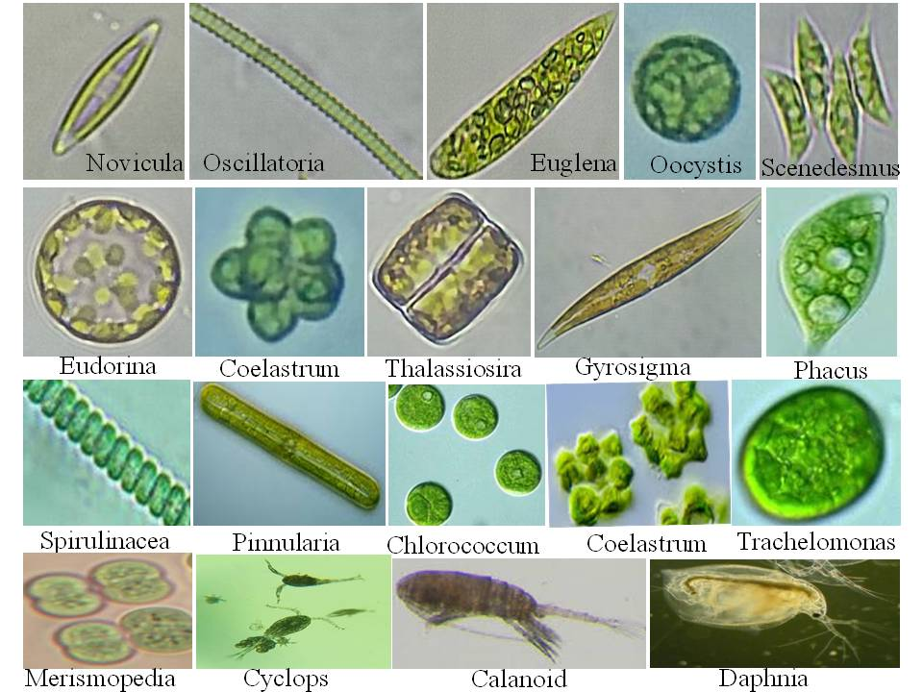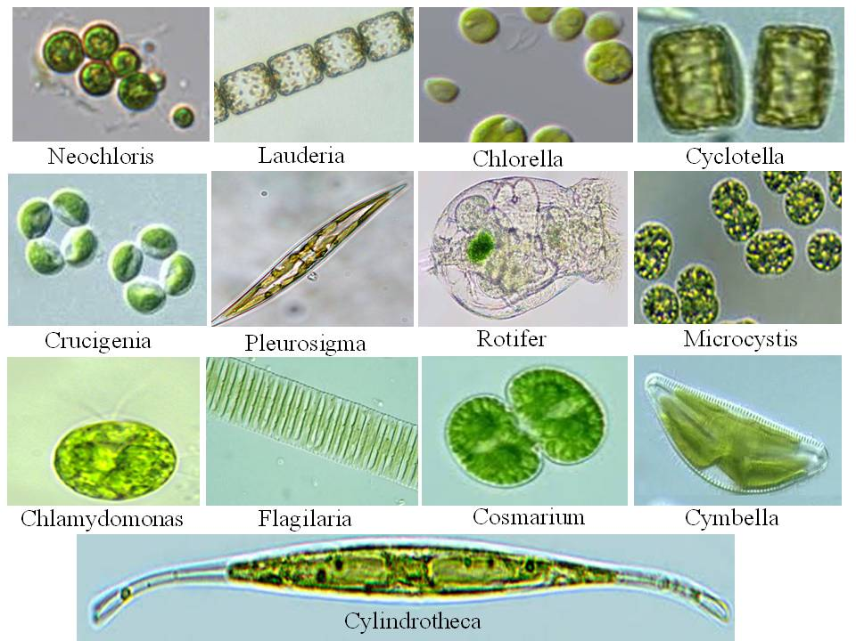

Fig. 2 showing Plankton species observed and identified under microscope with different magnification (10X, 40X and 100X).

**Discussion:**

Application of agricultural fertilizers to the culture ponds significantly improved the quantity and quality of phytoplankton and zooplankton communities. The growth of large blooms of phytoplankton was due to the increased availability of nutrients which in turn promote the growth of zooplankton and it generally depends on the type and amount of fertilizer applied. Over usage of fertilizers leads to an imbalance between pond ecosystem by means of excessive phytoplankton growth may result in oxygen depletion at night, alter other aquatic organisms (Mischke, 2019).

The application of organic or synthetic fertilizers in aquaculture ponds has been using for centuries to supply essential nutritional ingredients required for rapid growth of plankton. As a result, the increased primary productivity following fertilization which in terms results in increased zooplankton abundance (Yakubu *et al.,* 2018). Generally, application of fertilizers in the cultured ponds has a positive impact on overall food chain by increasing phytoplankton productivity and thus the total shrimp or fish production. However, the increased fertilization also has a negative effect on dissolved oxygen which was inversely proportional to fertilizer concentration, water quality deterioration at different levels of organic fertilizers and also showed negative results by increasing the emergence and development of harmful phytoplankton species or harmful algae (Sharma *et al.,* 1987; Yakubu *et al.,* 2018). Additionally Qin *et al.*, (1995a) reported that some kinds of organic manure delivered low nitrogen to phosphorus ratio, which support the growth of non-edible blue-green algae, leading to a diminish in fertilizing competence on the final productivity of fish yield (Hossen *et al.,* 2018). Therefore the usage of organic fertilizers should be tested in order to assurance the advantageous increase in fish yield. The present study data showed slightly lowered mean values of nutrients in the control ponds compared to fertilizer treated ponds. The study also reported that a significant decrease in gross plankton primary production in control ponds over fertilized ponds. The similar results were observed by Kalchav (2007).

The study results showed almost similar data on water quality parameters in both treated and control ponds. Although, a significant difference was observed in these parameters due course of experimental period from August to December, the mean pH and DO of water samples remained within acceptable limits (Table 1). The other physic-chemical parameters like nitrates, nitrites, ammonia, phosphorus and potassium were analyzed and found the results within the acceptable limits; however, results showed that a little increased in all fertilized ponds than control ponds. In addition, plentiful availability of essential nutrients promoted a wide variety of plankton species and their abundance across the fertilizer treated culture ponds. The most repeatedly observed phytoplankton species were *Neochloris, Chlorella, Crucigenia, Chlamydomonas, Scenedesmus, Cosmarium, Chlorococcum, Coelastrum, Oocystis* and *Eudorina*, zooplankton species like *Rotifer, Copepods, Moina, Cyclops, Calanoid, Daphnia* and *Nauplii, Cyanobacteria including Oscillatorials, Microcystis, Spirulinaceae and Merismopedia*. And most commonly reported diatoms including *Cyclotell, Navicula, Thalassiosirales, Cylindrotheca, Gyrosigma, Pleurosigma, Fragilariophyceae, Cymbella and Pinnularia* and *Euglnoids* in Euglena. A significant difference was observed in terms of diversity and density of species reported in fertilizer applied ponds over control ponds.

Growth and distribution of plankton communities in ponds are also depends on seasonal variations in environmental conditions like temperature, light, and water chemistry including DO, ammonia and phosphorus, availability of food, and predation by larval fish. In culture ponds, interactions between all these environmental and water quality factors shows impact on growth and density of plankton species (Geiger, 1983). The species of phytoplankton and zooplankton communities can also be influenced by pH (Alibone and Fair, 1981), water hardness (Lewis and Maki, 1981), and dissolved oxygen (Heisey and Porter, 1977). The types and concentrations of phytoplankton species also have an effect on the composition of the zooplankton community (McCauley and Kalff, 1981).

The combination applies of both organic and liquid inorganic fertilizers optimize all aspects of zooplankton nutrition by enhancing the production of aquatic bacteria, phytoplankton, protozoans, and small detrital particles. The organic fertilizer is supposed to have a low carbon: nitrogen ratio to allow rapid decomposition (Geiger, 1983).

**Conclusion:** In conclusion, fertilization of ponds with either organic or inorganic fertilizer improved the growth of plankton population by providing additional nutrients, especially the NPK fertilizers. When the fertilizers applied in combination, the maximum plankton production was observed. Phytoplankton and zooplankton are considered the main natural food for fish culture especially during the early stages. However, over usage of fertilizers also has a negative effect on dissolved oxygen which was inversely proportional to fertilizer concentration, water quality deterioration at different levels of organic fertilizers and also showed negative results by increasing the emergence and development of harmful phytoplankton species or harmful algae.

**Conflicts of interests:** No conflicts of interests.

**Disclaimer (Artificial Intelligence):**

Authors hereby declared that NO generative AI technologies such as Large Language Models (ChatGPT, COPILOT, etc) and text-to-image generators have been used during writing or editing of this manuscript.

**References:**

1. Abo-Taleb, H. (2019). “Importance of plankton to fish community”. Biological Research in Aquatic Science. Intech Open p. 83.
2. Adeyemo, A.A. (1991). “The Taxa composition abundance and distribution pattern of zooplankton fauna of rivers and streams in Central Nigeria” M.Sc. Thesis, Obafemi Awolowo University Ile-Ife. 156pp.
3. Alibone, M.R. and Fair, P. (1981. “The effects of low pH on the respiration of Daphnia magna Straus”. *Hydrobiologia*, 85: 185-188.
4. Charles C. Mischke. (2019). “Fertilizing Fish Ponds”. SRAC Publication No. 0469.
5. Das, P.C., Ayappan, S. and Jena, J. (2005). “Comparative changes in water quality and role of pond soil after application of different levels of organic and inorganic inputs”. Aquaculture Research, 36 (8): 785-798. https://doi.org/10.1111/j.1365- 2109.2005.01288.x.
6. Davidson, R.G. and Boyd, C.E. (1981). “Phytoplankton response to liquid fertilizers”. *Prog. Fish Cult.* 43(3): 126-129.
7. Geiger, J. G. (1983). “A review of pond zooplankton production and fertilization for the culture of larval and fingerling striped bass”. *Aquaculture*, 35:353–369. doi:10.1016/0044-8486(83)90106-0
8. Heisey, D. and Porter, K.G. (1977). “The effect of ambient oxygen concentration on filtering and respiration rates of Daphnia galeata mendotae and Daphnia magna”. *Limnol Oceanogr*, 22: 839-845.
9. Heisig, G. (1979). “Mass cultivation of Daphnia pulex in ponds: the effect of fertilization, aeration, and harvest on the population development”. In: E. Stycznska-Jurewicz, T. Backiel, E. Jaspers and G. Persoone (Editors), European Mariculture Society Special Publication No. 4. Proceedings at a Conference held 23-28 September 1977, at Szymbark, Poland, pp. 335-359.
10. Hoque, M.M., Motin, M.A., Maya, M., Sarkar, M.R.U., Islam, M.R., Chowdhury, M.T.H. and Chowdhury, A.J.K. (2014). “Water Quality and Plankton Composition of Amblypharyngodon mola Monoculture Fish Pond in Bangladesh”. International Journal of Emerging Trends in Science and Technology, 1(7): 1005-1014.
11. Hossen, M.R., Sultana, S. and Kabiraj, M. (2018). “Effect of commercial inorganic fertilizer on abundance of plankton in pond polyculture system”. Khulna University Studies, 15(1&2): 49-59. https://doi.org/10.53808/KUS.2018.15.1and2.1808-L.
12. Januszko, M. (1977). “The influence of fertilization on phytoplankton in ponds with varied development of biocoenose”. *Ekol. Pol.* 25: 625-634.
13. Kalchav R. (2007). “Effect of organic fertilizer on plankton primary productivity in fish ponds”. *Aquacult Int* 15:181–190. DOI 10.1007/s10499-007-9086-1.
14. L B R Ritonga, Nasuki, K Primasari, P N Rizky, M H Edy and T Harijono. (2023). “The effect of using different types of fertilizer on plankton abundance and growth rate of backyard shrimp farm”. *IOP Conf. Ser.: Earth Environ. Sci.* 1273 012060. doi:10.1088/1755-1315/1273/1/012060.
15. Lewis, M.A. and Maki, A.W. (1981). “Effects of water hardness and diet on productivity of Daphnia magna Straus in laboratory culture”. *Hydrobiologia*, 85: 175-179.
16. McCauley, E. and Kalff, J. (1981). “Empirical relationships between phytoplankton and zooplankton biomass in lakes”. *Can. J. Fish. Aquat, Sci.,* 38: 458-463.
17. Paffenhofer, G.A. and Harris, R.P. (1976). “Feeding, growth, and reproduction of the marine planktonic copepods Pseudoclanus elongatus Boeck”. *J. Mar. Biol. Assoc. K.* 50: 237-344.
18. Pal M, Yesankar PJ, Dwivedi A, Qureshi A. (2020). “Biotic control of harmful algal blooms (HABs): A brief review”. *J Environ Manage*. 15; 268:110687. doi: 10.1016/j.jenvman.2020.110687.
19. Qin J, D.Culver, N.Yu. (1995a). “Effect of organic fertilizer on heterotrophs and autotrophs: implications for water quality management”. *Aquaculture Research.* 26: 911-920.
20. Sharma, O.P, Rajbanshi, V.K., Sharma, L.L. (1987). “Water quality and zooplankton Production in waters fertilized on the basis of P.N. ratios”. *J. Hydrobiology* 3(5): 25 – 28.
21. Sinha, Rita & Kawsar, Md & Sunny, Atiqur & Mazumder, Sabuj & Alam, Dr Md. (2023). “Assessing the effect of nutrient management on the plankton community: a substantial aquaculture approach”. *Journal of Bangladesh Agricultural University*. 21. 363. 10.5455/JBAU.143647.
22. Tavares, Lucia & Santeiro, Rachel & Pinto-Coelho, Ricardo & Braga, Francisco. (2009). “Effect of fertilization in water quality and in zooplankton community in open plankton-culture ponds”. Bioscience Journal. 25. 172-180.
23. Ulumiah M, Lamid M, Soepranianondo K, Al-arif M A, Alamsjah M A dan Soeharsono S. (2020). *Jour of Aquac and Fis Heal* 9(2) 95-103.
24. Utermöhl H. (1958). “Zur Vervollkomnung der quantitativen Phytoplankton”-*Methodik. Mitt. int. Ver. ther. angew. Limnol*. 9: 1-38.
25. Yakubu, A. F, Adams T. E, Olaji E. D, Adebote. E.E and Okabe, O.R. (2018). “Effect of Inorganic Fertilization on the Zooplankton Production in Fresh Water Pond”. *Int. Journal of Env. Agri. and Biotech*. 3(6). http://dx.doi.org/10.22161/ijeab/3.6.22.
26. Zurek, R. (1974). “The zooplankton biomass and production of some species of rotifers and cladocerans in three ponds with different second-year carp fry stocking”. *Acta Hydrobiol., Krakow*. 16(3-4): 299-317.