**Review Article**

**METHODS FOR THE ESTIMATION OF BIRD DIVERSITY IN URBAN AREAS**

**ABSTRACT**

Urbanization has significantly altered natural habitats, leading to shifts in bird diversity. Accurately estimating bird diversity in urban areas is crucial for conservation efforts, urban planning and ecological research. Various methodologies, including point counts, transect surveys, mist netting, acoustic monitoring and citizen science programs, have been developed to assess avian diversity. Each method has its own set of advantages, limitations and applicability depending on habitat type, observer expertise and environmental conditions. This review synthesizes findings from several sources, offering insights into the best practices for bird diversity estimation in urban landscapes. Understanding these methods is essential for policymakers, conservationists and researchers working towards sustainable urban biodiversity management. This review critically examines these techniques, highlighting their advantages, limitations and applicability in diverse urban settings with a particular focus on their use in India. Additionally, the reliability and effectiveness of each method is discussed. The integration of multiple methods is recommended to improve data accuracy and to ensure a comprehensive assessment of avian biodiversity.

**Keywords:** Bird diversity, avifauna, point count, line transect, mist netting, acoustic monitoring, citizen science programmes

1. **INTRODUCTION**

Birds serve as bioindicators, providing valuable insights into the ecological integrity of urban areas (Lemoine-Rodríguez et al., 2024; Mörtberg, 2004; Mekonen, 2017). Understanding bird diversity in urban areas can provide insights into ecosystem health and the effectiveness of conservation measures (Liu et al., 2023). The rapid expansion of urban landscapes poses significant challenges for avian species, affecting their distribution, abundance and behavioural patterns (Seress and Liker, 2015). Urbanization leads to habitat fragmentation, pollution and changes in food availability, all of which impact bird populations (Isaksson, 2018).

Studying bird diversity in urban environments is crucial for understanding ecosystem health, assessing the effectiveness of conservation measures and informing urban planning strategies (Canedoli et al., 2018). With increasing urbanisation, it is vital to identify safe refuges for birds. Urban parks and University campuses are home to hundreds of species of birds (Patel et al., 2025). As cities continue to grow, it becomes increasingly important to develop and implement reliable methods for monitoring avian diversity (Shih, 2018).

Several methodologies have been developed to estimate bird diversity, each with unique strengths and limitations. Traditional methods such as point counts and transect surveys provide valuable population data but may be influenced by observer heterogeneity (Cunningham et al., 1999) and environmental conditions (Buckland et al., 2008). More advanced techniques, including acoustic monitoring and mist netting, offer detailed insights into species composition and behaviour but require specialized expertise and resources (Tattoni and LaBarbera, 2022). Additionally, citizen science programs, such as eBird, enable large-scale data collection and public engagement in conservation efforts (Callaghan and Gawlik, 2015). The effectiveness and reliability of these methods vary across different urban landscapes, necessitating a comparative evaluation. It is essential to critically examine the advantages and disadvantages of each technique, evaluate their reliability and understand the potential for integrating multiple methods to enhance accuracy and to develop a comprehensive understanding of avian monitoring methodologies and their role in sustainable urban biodiversity management (Urfi et al., 2005).

This review explores different methods for studying avian biodiversity in urban areas, discussing their merits, demerits and reliability, with a particular focus on their application in India. A thorough evaluation of these techniques is essential for policymakers, conservationists and urban planners to develop effective strategies for biodiversity conservation in urban settings.

1. **Methods for Estimating Bird Diversity**

Point count method, line transect surveys, mist netting, acoustic monitoring and community-based citizen science programs have been employed to estimate bird diversity in urban areas (Gregory et al., 2004). We field tested the methods mentioned in this review (except mist netting) in city park, Aligarh fort botanical garden of AMU and densely populated urban areas in Aligarh, Uttar Pradesh. We found that each method has its own set of advantages, limitations and challenges which have been discussed in this review.

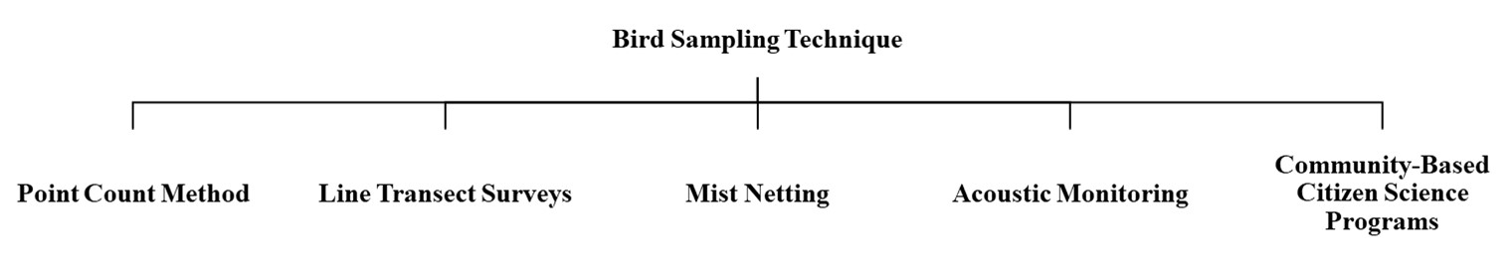

**Fig 1: Types of Bird Sampling Techniques**

**2.1 Point Count Method**

The Point count method is a widely used technique for estimating bird diversity and abundance. Point count surveys involve recording birds at fixed locations for a specified duration. Observers select fixed locations called “points,” within the study area where they remain stationary for a predetermined period (e.g., 5-10 minutes) and note all birds detected within a predefined radius. Typically, a radius of 50-100 meters is chosen and birds are detected visually or aurally. The process is repeated at multiple points to ensure broader coverage. Surveys are usually conducted during early morning hours when bird activity is highest (Ralph et al., 1995). To minimize bias, standardized protocols such as fixed-radius counts and double-observer approaches (Nichols et al., 2000) may be used. These methods improve data reliability and comparability across different studies. The point count method is commonly used to estimate species abundance and diversity over time, making it suitable for monitoring population trends (Cavarzere et al., 2013).

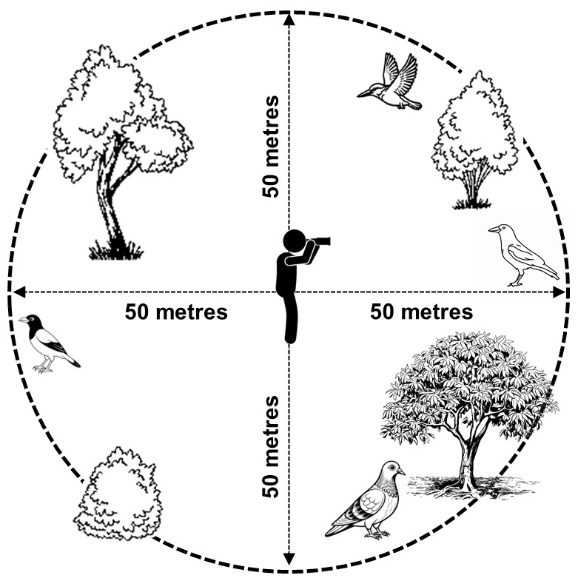

**Fig 2: Point Count Method**

**2.1.1 Pros and Cons of Point Count Method**

The point count method offers several advantages, making it one of the most widely adopted bird survey techniques. It is a cost-effective, simple and standardized approach that requires minimal equipment (Martin et al., 2010). It enables long-term monitoring and is suitable for a variety of open habitats, including urban parks, wetlands and gardens (Marsden, 1999; Van Heezik and Seddon, 2017). Additionally, it can be conducted by both professional ornithologists and trained citizen scientists, thereby expanding the reach of avian studies.

However, this method has some limitations. Environmental factors such as wind, rain and background noise (e.g., traffic or human activity in urban areas) can significantly impact detection rates, leading to underestimation of certain species (Ralph et al., 1995). Observer bias and skill variability can influence detection accuracy, leading to inconsistencies in data collection. Point count method is less effective for detecting nocturnal, cryptic or highly mobile species (Marsden, 1999). Birds that remain hidden within vegetation or do not vocalize are difficult to detect by this method. Such birds may be underrepresented in the data. Furthermore, noise pollution and urban infrastructure can interfere with accurate bird detection (Benítez-López et al., 2010). Despite these drawbacks, the point count method remains a reliable tool when standardized protocols are followed and multiple observers are employed to reduce bias.

**2.1.2 Use of Point Count Method in India**

Point counts have been widely used in Indian urban areas, such as Bangalore University Campus (Rajashekara and Venkatesha, 2017), Aravalli Biodiversity Park, Vasant Vihar, Delhi (Tarannum et al., 2022) and rural-urban gradients in Aligarh (Siddiqui et al., 2019), to study the impact of green spaces on bird diversity. Researchers frequently employ this method in urban parks, wetlands and lakes to assess seasonal variations in avian populations (Ghosh et al., 2022). Yadav et al. (2024) have used the point count method to document bird species on the Nalanda University campus.

**2.1.3 Reliability**

The point count method has moderate to high reliability, depending on observer experience, environmental conditions and survey design (Bergen et al., 2023). When conducted with well-trained observers using standardized protocols, point counts yield highly reliable data on bird abundance and diversity. However, the method is susceptible to human error, particularly if observers lack experience in bird identification (Kepler and Scott, 1981) or if there are inconsistencies in detecting cryptic species (Pascoe et al., 2019). To enhance reliability, researchers may employ double-observer approaches and repeated surveys (Bergen et al., 2023) and statistical adjustments to account for detection probability (Diefenbach et al., 2007; Van Wilgenburg et al., 2017). Large-scale studies require multiple observers to minimize bias (Buckland et al., 2001). Additionally, integrating point counts with complementary methods, such as acoustic monitoring or mist netting, can provide a more comprehensive assessment of bird diversity (Van Wilgenburg et al., 2017). Despite its limitations, the point count method remains a widely accepted and valuable tool for urban avian studies, particularly when applied with rigorous methodological consistency.

**2.2 Line Transect Surveys**

Line transect surveys require observers to walk along predetermined paths, recording birds seen or heard within a defined distance. This method is particularly effective for detecting birds in larger study areas and along habitat gradients. Observers follow a straight line or pre-mapped route and record all bird species encountered within a fixed distance from the transect line. The data collected often include bird species, number of individuals and their location relative to the transect (Gregory et al, 2004). Surveys are typically conducted during early morning hours to coincide with peak bird activity (Buckland, 2006). To improve accuracy, researchers may use distance sampling techniques to estimate bird densities (Marques et al., 2007). This method is widely used in both urban and natural settings and provides valuable information on species distribution and habitat preferences.

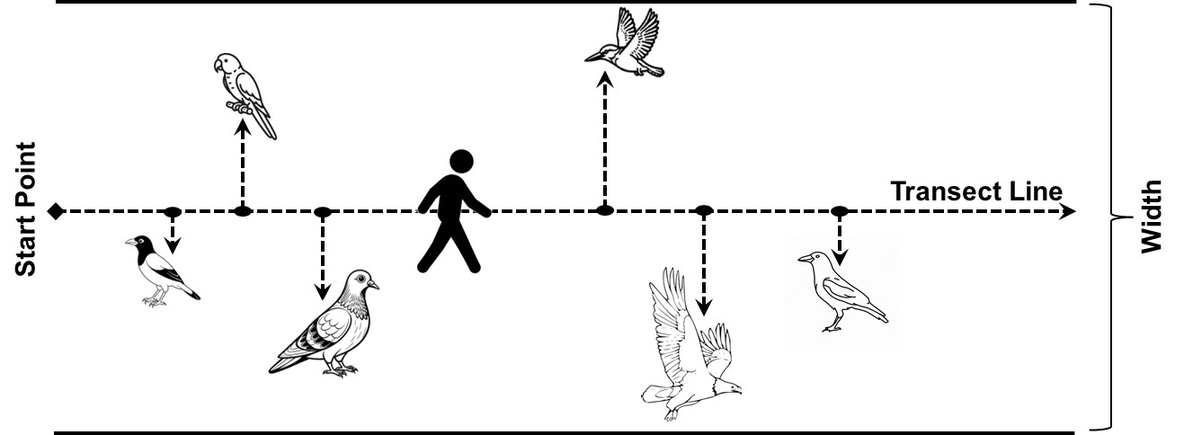

**Fig 3: Line Transect Survey**

**2.2.1 Pros and Cons of Line Transect Surveys**

Line transect survey method permits systematic data collection over a larger area than point counts and is well suited for the sampling of bird diversity in diverse habitat types (Järvinen and Väisänen, 1975; Thomas et al., 2007; Gregory et al., 2004). This technique reduces observer bias by ensuring the movement of the observer through different microhabitats (Buckland, 2006). It is useful for detecting species with wide-ranging behaviour if some basic assumptions are met (Anderson, 1976). Another important advantage of this method is that it provides estimates of bird density by incorporating distance sampling techniques, reducing the risk of overestimating populations (Buckland et al., 2015; Navarro and Díaz-Gamboa, 2015).

One of the biggest drawbacks of the line transect method is that it is time-consuming and labour-intensive. Secondly, the movement of the observer may disturb birds. Moreover, line transects are also susceptible to observer bias and detection probability decreases with distance from the transect line. This technique requires careful estimation of distance to avoid over- or under-counting. Additionally, detection probability at the same distance varies with differences in terrain and vegetation. Environmental conditions such as vegetation density and urban noise may also obscure bird sightings, affecting data accuracy (Buckland et al., 2008).

* + 1. **Use of Line Transect Surveys** **in India**

Transect surveys have been employed to study bird diversity in urban greenspaces (Khera et al., 2009) and 5 urban sampling sites in Delhi (Kumar et al., 2022), in a natural urban habitat in Mumbai (Kushwaha and Kulkarni, 2013), Fergusson college campus, Saras Baug, Panchawati, Nigdi and Sinhagad valley in Pune (Shinde et al., 2024), urbanised area, industrial area and reserve forest in Amravati (Kale et al., 2012) and two parks in Kolkata (Chowdhury et al., 2014) to assess urban bird community structures. This method has been particularly effective in large urban green spaces Khera et al., 2009; Kushwaha and Kulkarni, 2013; Chowdhury et al., 2014).

**2.2.3 Reliability**

Line Transect surveys have moderate reliability. The reliability of the survey depends on various factors, including habitat type, observer experience and the adherence of observer to survey protocol. In dense urban environments, detection probability is lower due to obstructions such as buildings, trees and traffic noise. Conversely, in open green spaces such as parks and wetlands, birds are more visible, leading to higher detection probabilities (Rosenstock et al., 2002). Observer training is crucial, as inexperience can lead to missed detections or misidentifications, affecting data accuracy. Additionally, employing distance sampling techniques and repeated surveys enhances reliability by adjusting for detection biases. Overall, point counts are more appropriate in built up urban areas but line transect surveys may also provide reliable estimates of bird diversity across urban landscapes when applied consistently and with proper methodological rigor (Rosenstock et al., 2002).

**2.3 Mist Netting**

Mist netting involves capturing birds using fine nets to collect data on species, age, sex and health. Researchers set up nearly invisible nets in known bird movement corridors, such as near feeding sites or along migration routes. Birds flying into the nets are gently removed, identified, measured and banded before being released (Dunn and Ralph, 2004). Mist netting can be used in urban parks and green spaces to study resident and migratory species, helping researchers understand avian health and population dynamics in changing urban environments (Santos et al., 2023).

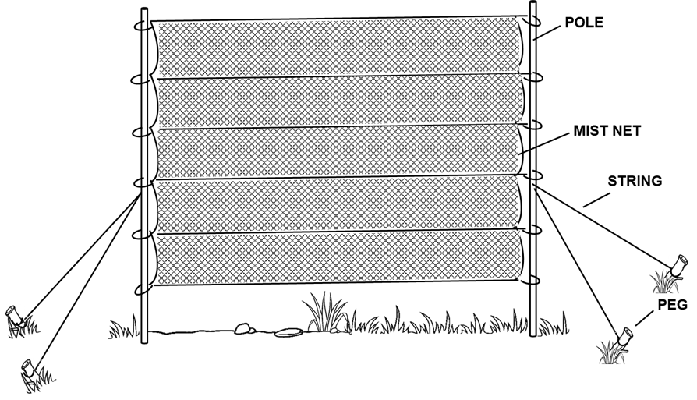

**Fig 4: Mist Net**

**2.3.1 Pros and Cons of Mist Netting**

Mist netting method is particularly useful for obtaining detailed demographic information and studying bird morphology, behaviour, long-term migration studies and genetics. The method provides individual-level biological data. It allows the assessment of physiological health indicators like parasite loads and feather quality. Mist netting permits the detection of cryptic species that are difficult to observe using visual or auditory methods.

Though it has some advantages, mist netting requires significant expertise to handle birds safely and ethically, ensuring minimal stress and harm to the captured individuals. It is labour-intensive and requires permits to set up nets and to handle birds. The method is not suitable for large-scale diversity estimation and has the potential for causing stress or injury to birds (Karr, 1981).

**2.3.2 Use of Mist Netting** **in India**

Mist netting has been used in agricultural areas of Tamil Nadu in southern India (Senthilkumar et al., 2001), Mupparthipadu village (Mahesh and Lanka, 2022), forests in eastern ghats (Beehler et al., 1987) and Kalakad-Mundanthurai Tiger Reserve (Ramachandran and Ganesh 2012). There are very few reports of the use of mist netting to study avifauna in urban areas of India. Mist netting has been used in the Delhi Ridge Forest for studying specific species (Gaston, 1978; Gaston, 2024).

**2.3.3 Reliability:**

Mist netting is highly reliable for obtaining demographic data as it provides direct information on species identity, age structure, sex ratios and individual health conditions. However, it is less effective for estimating population size and overall species diversity because it depends on bird movement patterns and net placement (Ralph et al., 2004). Some species are more likely to be captured than others, leading to potential sampling bias. Additionally, mist netting requires repeated sampling over extended periods to produce accurate population estimates, as short-term data collection may not capture seasonal variations in bird presence. Factors such as weather conditions, net visibility and researcher handling efficiency can also influence the success of mist netting studies (Dunn and Ralph, 2004). Mist netting is also prone to capture height bias. Capture height bias in turn is reported to vary with bird species, season of study and feeding behaviour (Tattoni and LaBarbera, 2022).

**2.4 Acoustic Monitoring**

Acoustic monitoring involves using automated recording devices to capture bird vocalizations over extended periods, allowing researchers to identify species through sound analysis. This method is particularly useful for detecting elusive, nocturnal or cryptic species that might not be visually observed in surveys (Brandes, 2008).

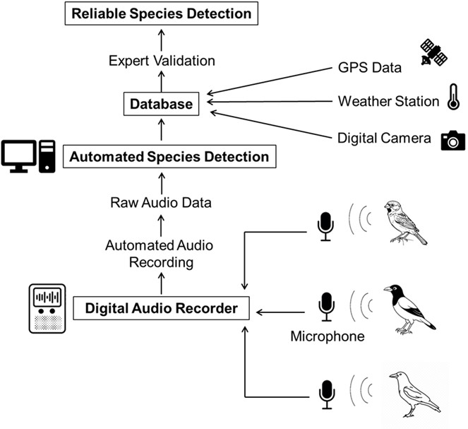

**Fig 5: Process of Acoustic Monitoring**

**2.4.1 Pros and Cons of Acoustic Monitoring**

Acoustic monitoring technique provides long-term, non-invasive insights into urban bird diversity and vocalization patterns. By deploying recorders in various urban habitats, researchers can collect continuous, large-scale data without direct human presence, minimizing disturbance to birds. The recordings are later analyzed using specialized software, such as machine learning algorithms or spectrogram analysis, to distinguish bird calls and songs accurately. Acoustic monitoring is especially advantageous in noisy urban settings where birds may be heard but not seen. Since the data is analyzed using specialized software, this technique reduces observer bias. The use of recorders permits long-term data collection and the monitoring of nocturnal species. The technique is especially useful for detecting rare or shy species that are difficult to observe. Another advantage of acoustic monitoring is that recorders can be deployed in multiple locations simultaneously. This permits data collection from several sites without the need for the physical presence of the researcher at the sampling site (Blake, 2021; Kułaga and Budka, 2019).

However, challenges include background noise interference, the need for expertise in bioacoustics for data analysis, extensive call libraries for species identification and the high cost of recording equipment and data processing. Secondly, it may be difficult to distinguish between the sound of individual birds of the same species which in turn makes it difficult to estimate population size (Sugai et al., 2019; Burfin, 2022).

**2.4.2 Use of Acoustic Monitoring in India**

Acoustic monitoring has been used for monitoring birds in an urban park of Ernakulam (Rajan et al., 2018), Vetal Tekdi Biodiversity Park in Pune (Krishnan, 2019; Chitnis et al., 2020) and Himachal Agricultural University campus (Kumar, et al., 2024). It has also been used for studying the ecology of crows by studying their call characteristics in Bangalore (Kumar and Sukumar, 2012).

**2.4.3 Reliability**

Acoustic monitoring is highly reliable for vocal species. However, its use is limited for less vocal or for rare species for which acoustic data is lacking. The technique can be improved with AI-based automated identification software (Funosas et al., 2024).

**2.5** **Citizen Science Programmes**

Community-based programs such as eBird (Sullivan et al., 2014) and the Great Backyard Bird Count leverage public participation to collect large-scale data on bird diversity. Volunteers, ranging from amateur birdwatchers to expert ornithologists, submit bird observations via mobile apps or online platforms. These records contribute to vast databases that researchers use to analyze species distribution, abundance and migration patterns (Couvet et al., 2008; Lepczyk, 2005).

**2.5.1 Pros and Cons of Citizen Science Programmes**

Citizen science is an essential tool for urban bird diversity estimation by complementing structured surveys and increasing public awareness of avian conservation. Their advantages include large-scale data collection at low cost, extensive spatial coverage, cost-effectiveness, real-time data sharing, collaboration and public participation in conservation (Dickinson et al., 2010; Devictor et al., 2010).

However, data reliability can be influenced by observer skill levels, misidentifications and inconsistent effort. Some participants may overreport common species or misidentify rare ones, leading to potential biases in datasets (Pocock et al., 2014). Moreover, observer effort is often concentrated in easily accessible urban parks, while less accessible areas remain underrepresented (Dickinson et al., 2010). Rigorous data validation techniques, statistical modelling and expert verification can help to mitigate these limitations and biases to some extent (Bird et al., 2014). Despite its limitations, citizen science remains an essential tool for large-scale biodiversity monitoring (Greenwood, 2007; Lepczyk, 2005).

**2.5.2 Use of Citizen Science Programmes in India**

Programs like eBird India and the Great Backyard Bird Count have contributed extensive urban bird data in Durgapur (Adhurya and Bhandary, 2019). Birdwatchers contributed to citizen science data in India during the COVID-19 pandemic (Thrikkadeeri and Viswanathan, 2023). Such initiatives continue to create awareness about birds amongst citizens. The annual Big Bird Day in Delhi encourages birdwatchers to document species in the region (Das, 2025).

**2.5.3 Reliability:**

The reliability of citizen science programs is moderate. Reliability depends largely on observer skill, species identification accuracy and the effectiveness of data validation processes. The reliability of citizen science programs can be improved by cross-referencing data with expert observations (Moussa and Mohan, 2024).

Novice participants may introduce misidentifications (Chesser, 2012) or incomplete records which in turn may reduce accuracy. Moreover, Callaghan et al. (2021) reported that large birds are over represented in citizen science data. To improve data reliability, modern citizen science platforms implement rigorous validation techniques (Johnston et al., 2018), such as expert reviews, automated error detection and statistical modelling (Swanson et al., 2016). Additionally, large sample sizes and repeated observations help balance out individual errors (Callaghan et al., 2017) and provide valuable long-term trends in bird populations. When integrated with professionally conducted surveys, citizen science data can significantly enhance the overall understanding of urban bird diversity while promoting public engagement in conservation efforts (Kosmala et al., 2016).

* 1. **CONCLUSION**

Some urban areas are hotspots of bird diversity (Callaghan et al., 2019). The bird diversity in urban areas is influenced by the adjacent landscape (Clergeau et al., 2001). Khera et al (2009) reported a negative correlation between woody exotic trees in parks of Delhi and bird diversity. Kaushik et al. (2022) have reported that the area of urban parks, richness of plant species were important predictors of bird diversity in urban areas. A knowledge of urban bird diversity and factors that play a role in promoting the diversity of avifauna can help in planning habitat islands to conserve birds in urban areas (Fernandez-Juricic and Jokimäki, 2001).

Several techniques are available for studying bird diversity in urban areas. Point count method and line transect method are the most preferred methods used for studying bird diversity in urban areas in India and citizen science programs are also becoming increasingly important. With the development of technology passive sound monitoring is likely to become a major tool for studying bird diversity (Joachin Godinez, 2024). Integrating multiple techniques can improve the reliability of bird diversity estimates. For example, volunteers in citizen science programs can be trained to use point count and line transect studies and they can be aided in bird identification by passive acoustic techniques. The data collected by these studies can then be validated by experts (McCaffrey, 2005).

**Disclaimer (Artificial intelligence)**

**Option 1:**

Author(s) hereby declare that NO generative AI technologies such as Large Language Models (ChatGPT, COPILOT, etc.) and text-to-image generators have been used during the writing or editing of this manuscript.

**REFERENCES**

1. Adhurya, S., & Bhandary, S. (2019). Report of five interesting avian species from Durgapur ecoregion, West Bengal, India by citizen science effort. *Journal of Threatened Taxa*, *11*(12), 14496-14502.
2. Anderson, D. R., Laake J. L., Crain B. R. &Burnham K. P. (1976). Guidelines for line transect sampling of biological populations. *Journal of Wildlife Management*, *43*, 70–78.
3. Beehler, B. M., Raju, K. K., & Ali, S. (1987). Avian use of man‐disturbed forest habitats in the Eastern Ghats, India. *Ibis*, *129*, 197-211.
4. Benítez-López, A., Alkemade, R., & Verweij, P. A. (2010). The impacts of roads and other infrastructure on mammal and bird populations: a meta-analysis. *Biological conservation*, *143*(6), 1307-1316.
5. Bergen, N., De Ruyck, C. C., & Koper, N. (2023). Effects of observer skill and survey method on forest bird abundance data: Recommendations for citizen science conservation monitoring in the Caribbean. *Journal of Caribbean Ornithology*, *36*, 45-61.
6. Bird, T. J., Bates, A. E., Lefcheck, J. S., Hill, N. A., Thomson, R. J., Edgar, G. J., ... & Frusher, S. (2014). Statistical solutions for error and bias in global citizen science datasets. *Biological Conservation*, *173*, 144-154.
7. Blake, J. G. (2021). Acoustic monitors and direct observations provide similar but distinct perspectives on bird assemblages in a lowland forest of eastern Ecuador. *PeerJ*, *9*, e10565.
8. Brandes, T. S. (2008). Automated sound recording and analysis techniques for bird surveys and conservation. *Bird Conservation International*, *18*(S1), S163-S173.
9. Buckland, S. T. (2006). Point-transect surveys for songbirds: robust methodologies. *The Auk*, *123*(2), 345-357.
10. Buckland, S. T., Anderson, D. R., Burnham, K. P., Laake, J. L., Borchers, D. L., & Thomas, L. (2001). *Introduction to distance sampling: estimating abundance of biological populations*. Oxford university press.
11. Buckland, S. T., Marsden, S. J., & Green, R. E. (2008). Estimating bird abundance: making methods work. *Bird Conservation International*, *18*(S1), S91-S108.
12. Buckland, S. T., Rexstad, E. A., Marques, T. A., & Oedekoven, C. S. (2015). *Distance sampling: methods and applications* (Vol. 431). Springer.
13. Burfin, T. W. (2022). *Passive acoustic monitoring and audio subsampling: optimizing autonomous methods for avian biodiversity assessments* [Master's thesis, University of Lisbon]. https://repositorio.ulisboa.pt/bitstream/10451/54427/1/TM_Thomas_Burfin.pdf
14. Callaghan, C. T., & Gawlik, D. E. (2015). Efficacy of eBird data as an aid in conservation planning and monitoring. *Journal of Field Ornithology*, *86*(4), 298-304.
15. Callaghan, C. T., Bino, G., Major, R. E., Martin, J. M., Lyons, M. B., & Kingsford, R. T. (2019). Heterogeneous urban green areas are bird diversity hotspots: insights using continental-scale citizen science data. *Landscape Ecology*, *34*, 1231-1246.
16. Callaghan, C. T., Poore, A. G., Hofmann, M., Roberts, C. J., & Pereira, H. M. (2021). Large-bodied birds are over-represented in unstructured citizen science data. *Scientific reports*, *11*(1), 19073.
17. Callaghan, C., Lyons, M., Martin, J., Major, R., & Kingsford, R. (2017). Assessing the reliability of avian biodiversity measures of urban greenspaces using eBird citizen science data. *Avian Conservation and Ecology*, *12*(2), 120212.
18. Canedoli, C., Manenti, R., & Padoa-Schioppa, E. (2018). Birds biodiversity in urban and periurban forests: environmental determinants at local and landscape scales. *Urban Ecosystems*, *21*, 779-793.
19. Cavarzere, V., Moraes, G. P., Roper, J. J., Silveira, L. F., & Donatelli, R. J. (2013). Recommendations for monitoring avian populations with point counts: a case study in southeastern Brazil. *Papéis Avulsos de Zoologia*, *53*, 439-449.
20. Chesser, M. (2012). An investigation of human-error rates in wildlife photographic identification; implications for the use of citizen scientists. (Unpublished master’s thesis). University of Massachusetts, Amherst.
21. Chitnis, S. S., Rajan, S., & Krishnan, A. (2020). Sympatric wren-warblers partition acoustic signal space and song perch height. *Behavioral Ecology*, *31*(2), 559-567.
22. Chowdhury, R., Sarkar, S., Nandy, A., & Talapatra, S. N. (2014). Assessment of bird diversity as bioindicators in two parks, Kolkata, India. *International Letters of Natural Sciences*, *11*(2), 131-139.
23. Clergeau, P., Jokimäki, J., & Savard, J. P. L. (2001). Are urban bird communities influenced by the bird diversity of adjacent landscapes? *Journal of Applied Ecology*, *38*(5), 1122-1134.
24. Couvet, D., Jiguet, F., Julliard, R., Levrel, H., & Teyssedre, A. (2008). Enhancing citizen contributions to biodiversity science and public policy. *Interdisciplinary science reviews*, *33*(1), 95-103.
25. Cunningham, R. B., Lindenmayer, D. B., Nix, H. A., & Lindenmayer, B. D. (1999). Quantifying observer heterogeneity in bird counts. *Australian Journal of Ecology*, *24*(3), 270-277.
26. Das, A. (2025, February 22). Big bird day 2025 records 243 species across Delhi-NCR. *Hindustan Times*. Retrieved from https://www.hindustantimes.com/cities/delhi-news/big-bird-day-2025-records-243-species-across-delhincr-101740161912562.html.
27. Devictor, V., Whittaker, R. J., & Beltrame, C. (2010). Beyond scarcity: citizen science programmes as useful tools for conservation biogeography. *Diversity and distributions*, *16*(3), 354-362.
28. Dickinson, J. L., Zuckerberg, B., & Bonter, D. N. (2010). Citizen science as an ecological research tool: challenges and benefits. *Annual review of ecology, evolution, and systematics*, *41*(1), 149-172.
29. Diefenbach, D. R., Marshall, M. R., Mattice, J. A., & Brauning, D. W. (2007). Incorporating availability for detection in estimates of bird abundance. *The Auk*, *124*(1), 96-106.
30. Dunn, E. H., & Ralph, C. J. (2004). The use of mist nets as a tool for bird population monitoring. In J. T. Rotenberry (Ed.), *Studies in Avian Biology No. 29* (pp. 1-6). Cooper Ornithological Society.
31. Fernandez-Juricic, E., & Jokimäki, J. (2001). A habitat island approach to conserving birds in urban landscapes: case studies from southern and northern Europe. *Biodiversity & Conservation*, *10*, 2023-2043.
32. Funosas, D., Barbaro, L., Schillé, L., Elger, A., Castagneyrol, B., & Cauchoix, M. (2024). Assessing the potential of BirdNET to infer European bird communities from large-scale ecoacoustic data. *Ecological Indicators*, *164*, 112146.
33. Gaston, A. J. (1978). The seasonal occurrence of birds on the New Delhi Ridge. *Journal of the Bombay Natural History Society*, *75*, 115-128.
34. Gaston, A. J. (2024). Changes in the avifauna of the Delhi Ridge: comparing 1971–1974 with 2018–2022. *Indian Birds*, *20* (1), 9-17.
35. Ghosh, M., Chongder, I., Dutta, A., Saha, G. K., & Banerjee, S. (2022). Species composition and classification of guilds in birds with respect to food and feeding behavior: Evidences from suburban landscape in Hooghly district, West Bengal. *Asian Journal of Conservation Biology*, *11*(1), 143-153.
36. Greenwood, J. J. (2007). Citizens, science and bird conservation. *Journal of Ornithology*, *148*(Suppl 1), 77-124.
37. Gregory, R. D., Gibbons, D. W., & Donald, P. F. (2004). Bird census and survey techniques. *Bird ecology and conservation*, 17-56.
38. Isaksson, C. (2018). Impact of urbanization on birds. In D.T. Tietze (Ed.), *Bird species* (pp. 235-257), Springer.
39. Järvinen, O., & Väisänen, R. A. (1975). Estimating relative densities of breeding birds by the line transect method. *Oikos*, 316-322.
40. Joachin Godinez, E. A. (2024). *A comparative analysis of Merlin and BirdNet applications for accurate bird species identification through passive acoustic monitoring* [Master's thesis, University of South-Eastern Norway].
41. Johnston, A., Fink, D., Hochachka, W. M., & Kelling, S. (2018). Estimates of observer expertise improve species distributions from citizen science data. *Methods in Ecology and Evolution*, *9*(1), 88-97.
42. Kale, M., Dudhe, N., Kasambe, R., Chakane, S., & Bhattacharya, P. (2012). Impact of urbanization on avian population and its status in Maharashtra state, India. *International Journal of Applied Environmental Sciences*, *7*(1), 59-76.
43. Karr, J. R. (1981). Surveying birds with mist nets. *Studies in Avian Biology*, *6*, 62-67.
44. Kaushik, M., Tiwari, S., & Manisha, K. (2022). Habitat patch size and tree species richness shape the bird community in urban green spaces of rapidly urbanizing Himalayan foothill region of India. *Urban Ecosystems*, *25*(2), 423-436.
45. Kepler, C. B., & Scott, J. M. (1981). Reducing bird count variability by training observers. *Studies in Avian Biology*, *6*(366-371).
46. Khera, N., Mehta, V., & Sabata, B. C. (2009). Interrelationship of birds and habitat features in urban greenspaces in Delhi, India. *Urban Forestry & Urban Greening*, *8*(3), 187-196.
47. Kosmala, M., Wiggins, A., Swanson, A., & Simmons, B. (2016). Assessing data quality in citizen science. *Frontiers in Ecology and the Environment*, *14*(10), 551-560.
48. Krishnan, A. (2019). Acoustic community structure and seasonal turnover in tropical South Asian birds. *Behavioral Ecology*, *30*(5), 1364-1374.
49. Kułaga, K., & Budka, M. (2019). Bird species detection by an observer and an autonomous sound recorder in two different environments: Forest and farmland. *PLoS One*, *14*(2), e0211970.
50. Kumar, K. & Sukumar, R. (2012). A comparative study between the call characteristics of the Indian jungle crow and the house crow at some urban habitat sites in Bangalore, India. *Bioacoustics*, *21*(1), 41.
51. Kumar, P., Parmar, B., & Kumar, P. (2024). Checklist and comparison of the bird diversity from the Himachal Pradesh Agricultural University, India. *Journal of Threatened Taxa*, *16*(4), 25069-25081.
52. Kumar, V., Jolli, V., & Babu, C. R. (2022). Landuse patterns, air quality and bird diversity in urban landscapes of Delhi. *Zoodiversity*, *56*(1).
53. Kushwaha S. C. & Kulkarni N. S. (2013). Bird diversity of Betawade, Thane, a Natural urban habitat. In *National Conference on Biodiversity: Status and Challenges in Conservation,* 39-46. https://vpmthane.org/sci/FAVEO/r4.pdf
54. Lemoine-Rodríguez, R., García-Arroyo, M., Gómez-Martínez, M. A., Back, M., Lindeman, T., & MacGregor-Fors, I. (2024). Unveiling urban ecological integrity: spatially explicit assessment in contrasting environments. *Urban Ecosystems*, *27*(4), 1167-1174.
55. Lepczyk, C. A. (2005). Integrating published data and citizen science to describe bird diversity across a landscape. *Journal of Applied Ecology*, *42*(4), 672-677.
56. Liu, X., Zhao, Y., Zeng, D., Yang, Y., Li, W., Kang, Y., ... & Si, X. (2023). Characterizing bird species for achieving the win-wins of conserving biodiversity and enhancing regulating ecosystem services in urban green spaces. *Urban Forestry & Urban Greening*, *87*, 128064.
57. Mahesh, V., & Lanka, S. (2022). Successive re-establishment of introduced house sparrow (*Passer domesticus*) at a remote village: Mupparthipadu, India. *Indian J. Applied & Pure Bio. Vol*, *37*(2), 449-458.
58. Marques, T. A., Thomas, L., Fancy, S. G., & Buckland, S. T. (2007). Improving estimates of bird density using multiple-covariate distance sampling. *The Auk*, *124*(4), 1229-1243.
59. Marsden, S. J. (1999). Estimation of parrot and hornbill densities using a point count distance sampling method. *Ibis*, *141*(3), 327-390.
60. Martin, T. E., Blackburn, G. A., & Simcox, W. (2010). An assessment of the effectiveness of two methods in describing a neotropical cloud forest bird community. *Ornitologia Neotropical*, *21*, 131-147.
61. McCaffrey, R. E. (2005). Using citizen science in urban bird studies. *Urban habitats*, *3*(1), 70-86.
62. Mekonen, S. (2017). Birds as biodiversity and environmental indicator. *Journal of Natural Sciences Research*, *7*(21), 28-34.
63. Mörtberg, U. (2004). *Landscape ecological analysis and assessment in an urbanising environment-forest birds as biodiversity indicators* [Doctoral dissertation, KTH Royal Institute of Technology].
64. Moussa, L. G., & Mohan, M. (2024). Exploring Citizen Science Applications for Wildlife Monitoring. *Science*, *1*, 100005.
65. Navarro, A. A. J., & Díaz-Gamboa, R. (2015). Line transect sampling. *Introduction to ecological sampling*, 47-61.
66. Nichols, J. D., Hines, J. E., Sauer, J. R., Fallon, F. W., Fallon, J. E., & Heglund, P. J. (2000). A double-observer approach for estimating detection probability and abundance from point counts. *The Auk*, *117*(2), 393-408.
67. Pascoe, B. A., Schlesinger, C. A., Pavey, C. R., & Morton, S. R. (2019). Effectiveness of transects, point counts and area searches for bird surveys in arid Acacia shrubland. *Corella*, *43*(1), 31-35.
68. Patel, Z., Patel, M., & Vyas, T. K. Diversity of Avifauna in the Campus of Navsari Agricultural University, Navsari, Gujarat, India. *Asian Journal of Environment & Ecology*, *24*(1), 36-48.
69. Pocock, M. J., Chapman, D. S., Sheppard, L. J., & Roy, H. E. (2014). *Choosing and Using Citizen Science: a guide to when and how to use citizen science to monitor biodiversity and the environment*. NERC/Centre for Ecology & Hydrology.
70. Rajan, S. C., Athira, K., Jaishanker, R., Sooraj, N. P., & Sarojkumar, V. (2019). Rapid assessment of biodiversity using acoustic indices. *Biodiversity and Conservation*, *28*, 2371-2383.
71. Rajashekara, S., & Venkatesha, M. G. (2017, December). Seasonal incidence and diversity pattern of avian communities in the Bangalore University Campus, India. In *Proceedings of the Zoological Society, 70*(2), 178-193.
72. Ralph, C. J., Dunn, E. H., Peach, W. J., & Handel, C. M. (2004). Recommendations for the use of mist nets for inventory and monitoring of bird populations. *Studies in Avian Biology 29,* 187-*196*.
73. Ralph, C. J., Sauer, J. R., & Droege, S. (Eds.) (1995). *Monitoring bird populations by point counts*. General Technical Report PSW-GTR-149. Albany, CA: U.S. Department of Agriculture, Forest Service, Pacific Southwest Research Station. Available at https://research.fs.usda.gov/treesearch/31461
74. Ramachandran, V., & Ganesh, T. (2012). Habitat structure and its effects on bird assemblages in the Kalakad-Mundanthurai Tiger Reserve (KMTR), India. *Journal of the Bombay Natural History Society*, *109*(1), 87-95.
75. Rosenstock, S. S., Anderson, D. R., Giesen, K. M., Leukering, T., & Carter, M. F. (2002). Landbird counting techniques: current practices and an alternative. *The Auk*, *119*(1), 46-53.
76. Santos, E. G., Pompermaier, V. T., & Wiederhecker, H. C. (2023). It’s time to open our mist nets over concrete: Sampling experiences within a big city. *The Wilson Journal of Ornithology*, *135*(2), 287-294.
77. Senthilkumar, K., Kannan, K., Subramanian, A., & Tanabe, S. (2001). Accumulation of organochlorine pesticides and polychlorinated biphenyls in sediments, aquatic organisms, birds, bird eggs and bat collected from South India. *Environmental Science and Pollution Research*, *8*, 35-47.
78. Seress, G., & Liker, A. (2015). Habitat urbanization and its effects on birds. *Acta Zoologica Academiae Scientiarum Hungaricae*, *61*(4), 373-408.
79. Shih, W. Y. (2018). Bird diversity of greenspaces in the densely developed city centre of Taipei. *Urban ecosystems*, *21*(2), 379-393.
80. Shinde, A., Bhendekar, G., & Wankhade, V. (2024). A comparative study of bird diversity and guild structure of bird communities in urban green patches of Pune metropolitan region, India. *Asian Journal of Conservation Biology*, *13*(1), 75-87.
81. Siddiqui, A., Ahmed, T., & Afifullah, K. (2019). Avifaunal assemblage along rural-urban gradients in Aligarh, Uttar Pradesh, India. *Notulae Scientia Biologicae*, *11*(4), 421-427.
82. Sugai, L. S. M., Silva, T. S. F., Ribeiro Jr, J. W., & Llusia, D. (2019). Terrestrial passive acoustic monitoring: review and perspectives. *BioScience*, *69*(1), 15-25.
83. Sullivan, B. L., Aycrigg, J. L., Barry, J. H., Bonney, R. E., Bruns, N., Cooper, C. B., ... & Kelling, S. (2014). The eBird enterprise: An integrated approach to development and application of citizen science. *Biological conservation*, *169*, 31-40.
84. Swanson, A., Kosmala, M., Lintott, C., & Packer, C. (2016). A generalized approach for producing, quantifying, and validating citizen science data from wildlife images. *Conservation Biology*, *30*(3), 520-531.
85. Tarannum, H., Sultana, A., Ilyas, O., & Hussain, M. S. (2022). Bird community structure in restored and unrestored areas in Delhi, India. In Ilyas, O. & Khan A. (Eds.) *Case Studies of Wildlife Ecology and Conservation in India* (pp. 155-164). Routledge.
86. Tattoni, D. J., & LaBarbera, K. (2022). Capture height biases for birds in mist-nets vary by taxon, season, and foraging guild in northern California. *Journal of Field Ornithology*, *93*(1).
87. Thomas, L. E. N., Williams, R. O. B., & Sandilands, D. (2007). Designing line transect surveys for complex survey regions. *J. Cetacean Res. Manage.*, *9*(1), 1-13.
88. Thrikkadeeri, K., & Viswanathan, A. (2023). Birdwatchers’ resilience to perturbation in India buffers citizen science from pandemic-induced biases. *International Journal of Clinical and Medical Case Reports*, 2(5). DOI:10.31579/2834-8664/033.
89. Urfi, A. J., Sen, M., Kalam, A., & Meganathan, T. (2005). Counting birds in India: Methodologies and trends. *Current Science*, 1997-2003.
90. Van Heezik, Y., & Seddon, P. J. (2017). Counting birds in urban areas: a review of methods for the estimation of abundance. *Ecology and conservation of birds in urban environments*, 185-207.
91. Van Wilgenburg, S., Sólymos, P., Kardynal, K., & Frey, M. (2017). Paired sampling standardizes point count data from humans and acoustic recorders. *Avian Conservation and Ecology*, *12*(1).
92. Yadav, H., Pansari, S., & Phartyal, S. S. (2024). Bird Diversity on an Under-Constructed Educational Campus: A Case Study of Nalanda University, Rajgir, India. *International Journal of Ecology and Environmental Sciences*, *50*(6), 909-920.