***Original Research Article***

**Correlation of *Rhopilema hispidum* with hydrobiological parameters from coastal waters of South Konkan, West Coast of India**

**Abstract**

Present study was conducted along the coastal waters of Ratnagiri, West coast of India from October 2023 to May 2024. Total 15 individuals of *Rhopilema hispidum* belonging to genus *Rhopilema* were caught in trawl net. Spearmen correlation was done to correlate *Rhopilema hispidum* with hydrobiological parameters. Result showed significant positive correlation with water pH and nutrients such as phosphate and silicate, while negative correlation was observed with nitrate, nitrite and water temperature. Positive correlation was observed with fish species such as *Arius maculatus, Alepes djedaba, Cynoglossus arel, Epinephelus diacanthus, Gerres filamentos* and otherfish species.High abundance of *Rhopilema hispidum* was recorded when high nutrient concentration of phosphate and silicate were recoded.

**Keywords:** *Rhopilema hispidum,* South Konkan coast, Jellyfish, Maharashtra.

1. **Introduction**

The Indo-West Pacific area, which extends from the Gulf of Aden north to Japan and east to the Pacific, is home to the sand jellyfish, or *Rhopilema hispidum*. According to their ecology, these jellyfish usually live in coastal waters, bays, and estuaries at depths of pelagic-neritic zones in tropical climates (Kramp PL, 1961). The existence and effects of this jellyfish species have been seen along the Indian coast, and it is widely distributed (Kramp PL, 1961; Ramkumar et al., 2024; Gul and Morandini, 2015). The number, distribution, and effects of *R. hispidum* blooms on commercial fishing activities in the Arabian Sea, namely along the Palghar coast, have been the subject of recent studies. These blooms take place at depths of 10 to 40 meters throughout the two main seasons of October to December and March to May. Jellyfish population growth may make fishing more difficult, resulting in financial losses and changes to fishing tactics (Ramkumar et al., 2024).

*Rhopilema hispidum* mostly consumes particulate organic matter, small crustaceans, and zooplankton (Uye et al., 2007). Jellyfish, *R. hispidum* mainly resides at the second trophic level in optimized aquaculture models that include fish, prawns, shellfish, and jellyfish, feeding on plankton and particulate organic matter (Guo et al., 2014). Ecological and financial concerns have been highlighted by the growing number of *Rhopilema hispidum* blooms along the Indian coast as they compete with other marine species for resources and change the dynamics of the food chain, these blooms have the potential to upset marine ecosystems. By destroying nets, decreasing catch, and raising operating expenses, they can economically harm the fishing sector. Developing successful management methods to lessen the effects of these bloom events on the coastal environment and nearby populations requires an understanding of the elements that cause them, including as pollution, overfishing, and environmental changes. Addressing the issues raised by *R. hispidum* and guaranteeing the sustainable use of marine resources along the Indian coast require ongoing study and observation.

1. **Material and Methods**

From October 2024 to May 2024, a motorized commercial trawl fishing boat was used for monthly sampling along south Konkan coast of Maharashtra. Trawl samling was conducted in monsoon season due to fishing ban and rough weather conditions (From June 2023 to September 2024). Samples of sea surface water were taken during each trawling operation in order to examine hydrobiological characteristics. Study area was divided into two sampling stations which are located at 18 meters and 36 meters depth respectively, which falls between the coordinates 17°16'49"N, 73°10'54"E and 17°16'56"N, 73°10'38"E (Figure 1). Monthly water samples were collected from surface waters at fixed station. Collection of jellyfish, *Rhopilema hispidum* was done using the trawling operation (Figure 2). Hydrobiological parameters like sea surface temperature, salinity, dissolved oxygen, phosphate, silicate, nitrate, nitrite and ammonia were also collected. Sea water samples were collected using a Niskin sampler (2.5L), and a standard calibration mercury thermometer with precision of 0.1℃ was used for measurement of the surface water temperature (Figure 3). Water quality parameters and nutrient analysis were done for each water samples, nutrient analysis was done with standard procedure prescribed by Strickland and Parson (1972). Spearmen correlation was obtained for *R. hispidum* and hydrobiological parameters including trawl catch composition (Table 1 and Table 2).

1. **Result and Discussion:**

*Rhopilema hispidum* is a large jellyfish from the family Rhizostomatidae, frequently located in the Gulf of Kutch (Kumawat et al., 2022). During overall study period fifteen individuals of *Rhopilema hispidum* (Figure 1) were collected via trawl nets, having bell diameters ranging from 29 cm (min) to 90 cm (max) and wet weights ranging from 110 g to 10,440 g. The jellyfish possesses a dome-shaped bell characterized by a thin mesoglea at the center and a textured exumbrella with two varieties of warts: small, rounded, colorless warts and bigger, brownish pointy warts mostly located at the periphery. The medusa exhibits a palewhite coloration, characterized by inflated, rough, brownish, wart-like formations on the upper surface and periphery of the exumbrella, resulting in a characteristic look. The bell margin consisted of 80 lappets, consisting of eight large circular velar lappets and two little pointy rhopaliar lappets per octant, featuring minute vertical ridges on their surfaces. The species contains eight rhopalia (sensory organs) and lacks central mouth opening, and has eight J-shaped, three-winged mouth arms united halfway along their length, with 16 scapulets and many digitate, club-shaped appendages, and long whip-like filaments at the arm disk. The gastrovascular system has 16 radial canals. Ring canal was absent. It has four subgenital ostia, each with one big and two little papillae.

Jellyfish belonging to family Rhizostomatidae have mouth arms with three wings that are joined at the base. Scapulate medusae with terminal fusiform and/or filamentous appendages on the mouth arms set the genus *Rhopilema* apart within this family (Martellos et al., 2016; Jarms and Morandini, 2019; Kumawat et al., 2022). *Rhopilema hispidum* is one of six recognized species in the genus *Rhopilema*. As reported in earlier studies (Vanhoffen, 1888; Kishinouye, 1899; Light, 1914; Jarms and Morandini, 2019), the morphological characteristics of *R. hispidum* medusae reported in this study are consistent with others. Distribution of *R. hispidum* was reported from Hong Kong (Vanhoffen, 1888), Nagasaki (Kishinouye, 1899), the Philippines (Light, 1914), the Red Sea (Vine, 1986), and Pakistani waters (Gul and Morandini, 2015) while from Indian waters its distribution was reported from Maharashtra - Mumbai (Dagha et al., 2021), Gujarat: Off Gujarat coast (Chakrapany, 1984), Odisha - Puri (Rao, 1931), Gulf of Mannar (Menon, 1936; Saravanan et al., 2016; Ramesh et al., 2020) Tamil Nadu - Chennai (Chakrapany, 1984; Menon, 1930), Palk Bay (Panikkar and Prasad, 1952; Saravanan et al., 2016; Saravanan & Laxmanan, 2022); Porto Novo (Kanagaraj et al., 2008), Kerala - Thiruvananthapuram (Ramakrishna & Sankar, 2003; Chinnadurai et al., 2019).

Excess of nutrients in the water causes hypoxic conditions, which cause fish to disperse from the region and increase the number of jellyfish (Officer et al., 1984; Rosenberg et al., 1990). The main factors influencing the jellyfish population's richness are the amount of food consumed and the high nutritional input (Arai, 2001). The podocysts of *Rhopilema* sp. can endure harsh environmental circumstances such hypoxia and low salinity (Fu et al., 2019). Rising jellyfish abundance in several regions of the world happens owing to severe hypoxic conditions, which could be attributable to the nutrient enrichment more than a rising water temperature (Boero et al. 2016). In the present study the abundance of *Rhopilema hispidum* was recorded highest when the phosphate and silicate concentration was high. Most of the jellyfish species feed on fish eggs, fish larvae, and zooplanktivorous fish species, which may have potential effect on fish populations (Volovik et al. 1993). A study on Rhopilema hispidum blooms in the dol net fishery in India found two primary bloom seasons, October to December and March to May, with biomass ranging from 22.57 to 135.86 kg/hr/net. The blooms caused increased catch sorting time, stings, changes in fishing grounds, temporary closures, net clogging, and reduced fish catches. However, the study suggests they could provide new livelihood opportunities for local fishers (Ramkumar et al., 2024). Jellyfish species change the seasonal cycle of plankton production in addition to having a detrimental effect on prey populations (Greve, 1994; Huntley and Hobson, 1978). The majority of cnidarians (Scyphozoa) consume a variety of benthic organisms, including tunicates, gastropods, arthropods, annelids, mollusks, teleostes, branchiopods, echinodermas, and others (Gregorin et al. 2024). In the present study *Rhopilema hispidum* showed significant positive correlation (P<0.05) with variety of fish species such as *Arius maculatus, Alepes djedaba, Cynoglossus arel, Epinephelus diacanthus, Gerres filamentos, Muraenesox cinereus, Pomadasys maculata, Pseudorhombus elevates,* and *Sphyraena jello.*

**Conclusion**

The present study showed the correlation of *Rhopilema hispidum* with majority of fish species and few water quality parameters, though further correlation studies are required to get clear idea on how the abundance of *Rhopilema hispidum* fluctuate with changing water quality parameters along the coastal waters.

**Acknowledgement**

I would like to thanks to Associate dean, College of Fisheries, Ratnagiri for granting me the permission to carry out my research work and providing me with all the necessary facilities.

Disclaimer (Artificial intelligence)

Option 1:

Author(s) hereby declare that NO generative AI technologies such as Large Language Models (ChatGPT, COPILOT, etc.) and text-to-image generators have been used during the writing or editing of this manuscript.

Option 2:

Author(s) hereby declare that generative AI technologies such as Large Language Models, etc. have been used during the writing or editing of manuscripts. This explanation will include the name, version, model, and source of the generative AI technology and as well as all input prompts provided to the generative AI technology

Details of the AI usage are given below:

1.

2.

3.

**References:**

Arai MN (2001) Pelagic coelenterates and eutrophication: a review. Hydrobiologia. 451:69–87.

Boero F, Brotz L, Gibbons MJ, Piraino S and Zampardi S (2016) Impacts and effects of ocean warming on jellyfish. In: Laffoley D, Baxter JM, editors. Explaining ocean warming: causes, scale, effects and consequences. Full report. Gland: IUCN; 213

Chakrapany, S. (1984). Studies on Marine invertebrates Scyphomedusae of the Indian and Adjoining seas (Doctoral dissertation, University of Madras).

Chinnadurai. S., Renjith. R. K., Jha. P. N & Lekshmi, N. M. (2019). Association of the jellyfish Rhopilema hispidum with ophiuroid brittle star Ophiocnemis marmorata. Fishtech Reporter, 5, 3-4.

Dagha, R. C., Kumari, K. A., Pawan-Kumar, A., & Shah, N. (2021). Morphological and molecular documentation of Jellyfish Rhopilema hispidum (Vanhöffen, 1888)(Scyphozoa: Rhizostomatidae) from Mumbai coast, India. Indian Journal of Geo-Marine Sciences. 50(3), 246-249.

Fu Z, Xing Y, Liu C and Gu Z (2019) Effects of temperature, salinity and dissolved oxygen on excystment of podocysts in the edible jellyfish *Rhopilema esculentum* Kishinouye, 1891. Indian Journal of Fisheries. 66. 69-77.

Gregorin C, Fernandez V, Tomas, Camillo D, Cristina, Musco, Luigi, Puce, and Stefania (2024) Big enough for an extra-large meal: a review on predation upon large animals by benthic cnidarians. Hydrobiologia. 1-17.

Greve W (1994) The 1989 German Bight invasion of *Muggiaea atlantica*. ICES Journal of Marine Science. 51:355–358.

Gul, S. and Morandini, A. C. 2015. First record of the jellyfish *Rhopilema hispidum* (Cnidaria: Scyphozoa) from the coast of Pakistan. Mar. Biodivers. Rec., 8(e30): 1-4. https://dx.doi.org/10.1017/S175526721500007X.

Guo, K., Zhao, W., Wang, S., & Dong, S. L. (2014). Study of food web structure and trophic level in the sea ponds of an optimized culture model (jellyfish–shellfish–fish–prawn). *Aquaculture International, 22*(5), 1783–1791. https://doi.org/10.1007/s10499-014-9782-6

Huntley ME and Hobson LA (1978) Medusae predation and plankton dynamics in a temperate fjord, British Columbia. Journal of the Fisheries Research Board of Canada 35:257–261.

Jarms, G. and Morandini, A. C. 2019. World atlas of jellyfish. Dolling und Galitz Verlag GmbH Munich, Hamburg, Germany, 816 pp.

Jarms, G. and Morandini, A. C. 2019. World atlas of jellyfish. Dolling und Galitz Verlag GmbH Munich, Hamburg, Germany, 816 pp.

Kanagaraj, G., Kumar, P. S., & Morandini, A. C. (2008). The occurrence of Ophiocnemis marmorata (Echinodermata: Ophiuroidea) associated with the rhizostome medusa Rhopilema hispidum (Cnidaria: Scyphozoa). Journal of Ocean University of China, 7(4), 421-424

Kishinouye, K. 1899. Edible medusae. Zool. Jahrb., 12: 205-210.

Kumawat, Tarachand & Saravanan, Raju & Vinod, Kavungal & Jaiswar, A. & Deshmukhe, Geetanjali & Shenoy, Latha & Divu, Damodaran & Joshi, Kunnummel & Gopalakrishnan, Dr. (2023). Jellyfish fisheries along the Gujarat coast, India: Status and challenges. Marine Policy. 150. 10.1016/j.marpol.2023.105554.

Light, S. F. 1914. Some Philippine Scyphomedusae, including two new genera, five new species and one new variety. Philipp. J. Sci., 9: 195-231.

Martellos, S., Ukosich, L. and Avian, M. 2016. JellyWeb: An interactive information system on Scyphozoa, Cubozoa and Staurozoa. Zookeys, 554: 1-25. <https://dx.doi.org/10.3897/zookeys.554.6745>.

Menon, M. G. K. (1930). The Scyphomedusae of Madras and the neighbouring coast. Bulletin of the Madras Government Museum, 3, 1-28

Menon, M. G. K. (1936). Scyphomedusae of Krusadai Island. Bulletin of the Madras Government Museum. New series. Natural history section, 1, 1-9.

Officer C, Biggs R, Taft J, Cronin L, Tyler M, and Boynton W (1984) Chesapeake Bay Anoxia: Origin, Development, and Significance. Science (New York, N.Y.). 223. 22-7.

Panikkar, N. K., & Raghu Prasad, R. (1952). Interesting association of ophiuroids, fish and crab with the jellyfish Rhopilema hispidum. Journal of the Bombay Natural History Society, 51, 295-296.

Ramakrishna & Sarkar, J. (2003). On the Scyphozoa from East Coast of India, Including Andaman & Nicobar Islands. Records of the Zoological Survey of India, 101(1-2), 25-56.

Ramesh, C. H., Koushik, S., Shunmugaraj, T., & Murthy, M. R. (2020). Current biodiversity of Mandapam group of Islands in Gulf of Mannar Marine Biosphere Reserve, Southeast coast of Tamil Nadu, India. Regional Studies in Marine Science, 39, 101429.

Rao, H. S. (1931). Notes on Scyphomedusae in the Indian Museum. Records of the Indian Museum, 33, 25-62.

Rosenberg R, Elmgren R, Fleischer S, Jonsson P, Presson H, and Dahlin (1990) Marine eutrophication case studies in Sweden: a synopsis, Ambio, 19, 102-108.

Saravanan, R & Laxmanan, R. (2022). Diversity and Distribution of Jellyfishes along Palk Bay coast. 12th Indian Fisheries & Aquaculture Forum, Chennai. pp 523.

Saravanan, R., Ranjith, L., Joshi, K. K., Jasmine, S., Nazar, A. A., Sadiq, I. S., & Kingsly, H. J. (2016). Scyphozoan Jelly fish Diversity in the Gulf of Mannar and Palk bay with an account on the Invasive Jelly fish Phyllorhiza punctata.1st International Agrobiodiversity Congress 2016, New Deilhi.

Strickland JDH & Parsons,T R & Canada, Fisheries & Ottawa, & Ontario .(1972). A Practical Handbook of Seawater Analysis. XF2006171452. 167.

Sugumar Ramkumar, Vaibhav Dinkar Mhatre, Punam Ashok Khandagale, Umesh Hari Rane, Lakshmanan Ranjith and Raju Saravanan. Jellyfish bloom: Abundance, distribution and impact analysis in the commercial dol net fishing ground of Northwest coast of India, Arabian Sea. Int. J. Adv. Biochem. Res. 2024;8(9S):384-393. DOI: [10.33545/26174693.2024.v8.i9Se.2126](https://doi.org/10.33545/26174693.2024.v8.i9Se.2126)

Uye, Shin-ichi & Lo, Wen‐Tseng. (2007). Anthropogenic cause of jellyfish blooms and their direct consequences for humans: A review. Marine Ecology Progress Series. 350. 153-174. 10.3354/meps07093.

Vanhoffen, E. 1888. Studies on semiostome and rhizostome medusae. Bibliotheca Zoologica, 1: 1-52 (In German).

Vine, P. 1986. Red Sea invertebrates. Immel Publishing, London, UK, 224 pp.

Volovik S, Myrzoyan Z, Volovik G, and Mnemiopsis l (1993) Biology, population, Washington D.C., pp. 77–97.

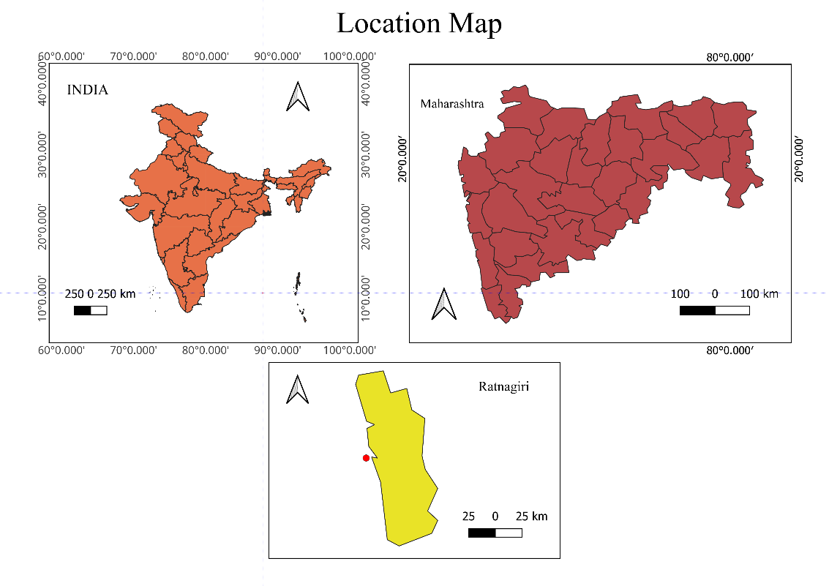

**Figure 1.** Study Area

a. 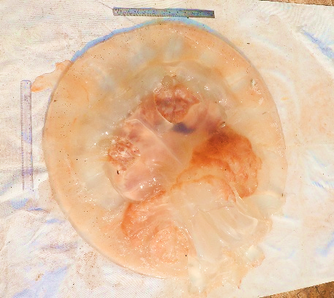 b. 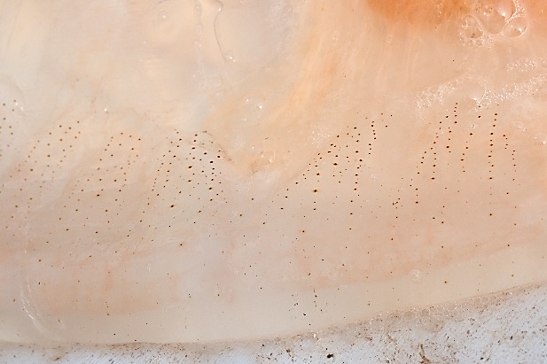

c.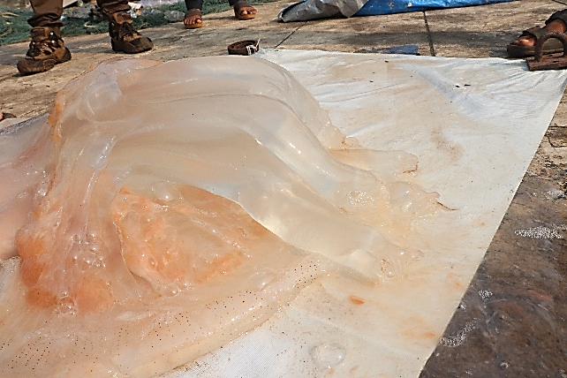 d. 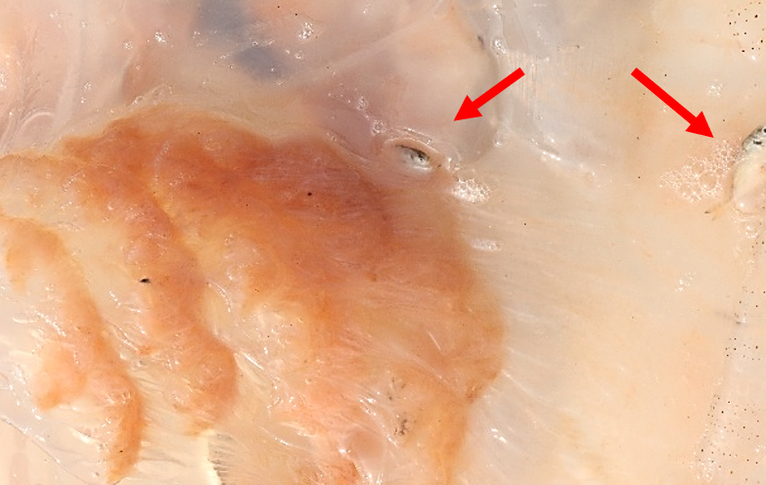

**Figure 2**. a. *Rhopilema hispidum* (Vanh ̈ffen, 1888). Specimen from South Konkan Coast, Maharashtra. b. Closer view of exumbrellar surface showing irregular stripes on rhopalar and velar lappets. c. Arms united halfway along their length. d. Arrows indicating presence of fishes inside the stomach of *Rhopilema hispidum.*

a. b.

c. d. 

e. f.

g.

**Figure 3.** Box-whisker plot (a-g) illustration for distribution of water quality parameters in post-monsoon and pre-monsoon season at coastal waters of South Konkan Coast.

**Table 1.** Correlation with water quality parameters

|  |  |  |  |  |
| --- | --- | --- | --- | --- |
| **Jellyfish** | **Correlation with water quality parameters** | | | |
| **Significant Positive Correlation**  **(P < 0.05)** | **r** | **Significant Negative Correlation**  **(P < 0.05)** | **r** |
| ***Rhopilema hispidum*** | Water pH  Phosphate  Silicate | 0.409  0.882  0.739 | Nitrate  Nitrite  Water temperature | -0.807  -0.383  -0.171 |

**Table 2:** Correlation with Fish species.

|  |  |  |
| --- | --- | --- |
| **Jellyfish** | **Correlation with Fish species** | |
| **Significant Positive Correlation**  **(P < 0.05)** | **r** |
| ***Rhopilema hispidum*** | *Arius maculatus* | 0.647 |
| *Alepes djedaba* | 0.666 |
| *Cynoglossus arel* | 0.666 |
| *Epinephelus diacanthus* | 0.81 |
| *Gerres filamentos* | 0.674 |
| *Muraenesox cinereus* | 0.754 |
| *Pomadasys maculata* | 0.666 |
| *Pseudorhombus elevates* | 0.666 |
| *Sphyraena jello* | 0.666 |