***Original Research Article***

**Diversity and Habitat Ecology of Freshwater Edible Snails, Essence in Food Security and Ethno-Medicine in Bihar, India**

**ABSTRACT**

Molluscs are the second most diverse animal phylum after arthropods, with over 50,000 living species. Some freshwater mollusc species are particularly consumed and economically beneficial for middle-and working-class families in rural areas of Bihar. Certain molluscs are in high demand as they provide an affordable source of protein, contributing to food security, livelihoods, and medicinal uses. However, systematic studies on the nutritional and mineral value of snails, the number of species consumed, and the traditional knowledge associated with them are lacking. An investigation was carried out in north eastern Bihar state, India from May, 2020 to April, 2023. This study is the initial to document the diversity and abundance of edible freshwater molluscs sold, their locations of availability, and their uses. Information was gathered through field and market surveys, as well as informal interactions with vendors selling molluscs. A total of three families-Ampullariidae, Viviparidae, and Unionidae and six species Pila globosa, Pila virens, Bellamya bengalensis, Parreysia spp., and Lamellidens spp. of freshwater edible shellfish (snails) were recorded during our study. All of these species are significant for nutritional food security and medicinal.

Thus, it is essential to document these species to ensure their conservation and sustainable management. We also advocate for snail farming to promote conservation efforts and enhance nutritional and food security for tribal communities. This approach will support the sustainable use of natural resources.

**Keywords:** Ethnozoology, mollusc, gastropod, livelihoods, tribes, food security.

**INTRODUCTION**

Mollusca is the most diverse animal phylum after Arthropoda, encompassing approximately 93,000 species distributed globally (Escoubas et al., 2016). Sharma *et al.,* (2012), reported comprehensive overview on molluscan diversity and compiled to a pictorial guide of seven wetlands in the area of Patna Bihar. Meanwhile, Ahirwal *et al.,* (2023) reported a biometric evaluation of freshwater snail *Pila globosa* from the river Ganga in Bihar. Considerable work has been done by Prabhakar and Roy, 2008; Chandravanshi *et al.,* (2023), they reported on habitat ecology and shellfish diversity of North Bihar, India. Molluscs provide numerous nutritional, health, and environmental benefits (Prabhakar and Roy, 2009), making them a sustainable option as aquatic crops, similar to *Makhana* (*Euryale ferox)* and *Singhara* (*Trapa natans*) Prasad and Sinha, (2024). Freshwater shellfish are considered an important food resource in developing regions of India and other countries due to their high protein content, medicinal properties, and nutritional value (Shathi and Rahman, 2022). The freshwater apple snail, belonging to the genus *Pila*, is a major species of mollusc found in freshwater and grassland ecosystems. These snails are consumed for both food and medicinal purposes and contribute to the development of aquatic environments (Borkakti *et al.,* 2009). Snails also play a vital role in the aquatic food chain, serving as a food source for various bird and fish species (Patel and Kurhe, 2023). Additionally, mollusc shells and meat are used as feed in diverse applications (Ghosh, 2022; Jadhav *et al.,* 2023). However, factors such as climate change, water pollution, water scarcity, overexploitation of molluscs, and the unregulated use of pesticides-particularly during the cultivation of fox nuts and water chestnuts have significantly contributed to the decline in snail populations and production (Prasad and Sinha, 2024). Snails are known for their high nutritional value, being rich in vitamins, fats, proteins, and essential minerals such as calcium, phosphorus, and iron (Baby *et al.,* 2010; Ghosh *et al.,* 2016). Globally, the demand for snail meat is growing, particularly in developing countries (Patel and Kurhe, 2023). In Bihar, the snail marketing system is still in its developmental stages and is not as well-established as the fisheries sector. Freshwater gastropods are in high demand due to their accessibility and ease of collection, contributing to the economic well-being of tribal communities who sell them Prabhakar and Roy, (2009). These gastropods serve as an affordable source of protein for impoverished and marginalized tribal communities in India. Even with their importance as food and medicine, there is currently no comprehensive list of species harvested or detailed documentation of the traditional exploitation of each species. Some molluscan species also command lucrative overseas markets, benefiting certain local communities economically. Almost very scanty information is available on the shellfisheries potential of Bihar and the uses of Shellfishes as medicines to cure various as inland of the local people

Therefore, the present study is to provide information on the diversity and abundance of freshwater molluscs harvested in this wetland Bihar and also try to preserve the traditional knowledge associated with their exploitation.

**METHODOLOGY**

**Study area**

The study was carried out in the agroecological zone II, in northeastern Bihar, that covering nine (9) districts such as Purnea, Madhepura, Supaul, Araria, Kishanganj, Madhubani, Katihar, Khagaria, and Saharsa. North Bihar has vast lentic resources in the form of tanks, ponds, oxbow lake, chaur, flood plains and these water bodies have enormous potential for fish culture(Jha *et al.,* 2014). The study theme was identified through preliminary discussions with personnel from the Department of Fisheries (Govt. of Bihar) in Purnea and Dumraon (Buxar), followed by field and market survey work conducted over three consecutive years (2020-2023). Using a Rapid Market Appraisal (RMA) approach, as described by Holtzman (2002), this region, which receives heavy rainfall during the monsoon season, was thoroughly examined.

**Snail collection and identification**

Month wise snail collection was carried out from May 2020 to April 2023. The snail collection was done using a scoop net and hand picking (Atsawe *et al.,* 2019). Structured interviews and informal interactions were carried out with vendors selling molluscs in markets, as well as with local residents in these districts. Collected information on the local names, uses, harvesting methods, prices, and collection habitats or sites of edible freshwater molluscs. Some snail samples were collected as live along with shell cover and brought to the entomology department laboratory at BPS Agricultural College, Purnea, Bihar for biological study and identification using relevant pictorials & literature (Subba Rao and Day, 1989; Prabhakar and Roy, 2008).

**Data Analysis**

All the data were analyzed using MS Office (Excel), 2010 edition. The structure, order, family, genus, and species of each shellfish individual were recorded, and tabular presentations of the data were created for ease of understanding.

**RESULTS AND DISCUSSION**

**Shellfish Wetland Resources**

Bihar boasts a rich network of wetlands that support diverse aquatic biodiversity. These aquatic resources play a crucial role in sustainable development of aquaculture, fish & fisheries and agricultural potential, enhancing fish and shellfish as well as aqua crop like Makhana or Fox nuts, (*Euryale ferox)* & Singhara or Water Chestnut (*Trapa natans*) production for both national and international markets Prasad and Sinha, (2024). Wetlands are known for their unique ecological features, providing numerous products and services to humanity (Bassi et al., 2014; Prasad et al., 2020). Northeastern Bihar, in particular, is home to numerous water bodies, including ponds, small reservoirs, rivers, and permanent and semi-permanent wetlands such as *maun*, river oxbow lakes, and *chaur* (Jha *et al.,* 2014). Bihar's abundant aquatic resources include approximately 3,200 hectares of rivers, 500,000 hectares of floodplain wetlands, 9,000 hectares of oxbow lakes or *mauns*, 25,000 hectares of reservoirs, and 80,000 hectares of ponds and tanks. These water bodies retain water year-round, enabling local fishermen to catch fish almost continuously throughout the year (Chand and Prasad, 2021).

**Snail Collection and Demand**

The snail collection is periodic and limited to six months of the year, from May–June to October–November (Prasad and Sinha, 2024). The peak season for snail assemblage lasts for three months, from June–July to August–September, during the rainy season (June–July), when snails are typically found in high abundance in natural wetlands. During the summer and winter seasons, harvesters find it difficult or impossible to collect snails, as they burrow into the mud. The demand for snail meat remains consistent, with similar observations reported by Navan and Kathay (2019). Despite this abundance, the shellfish supply in Bihar consistently falls short of demand. Out of the 38 districts of Bihar, surveys were conducted in 15 districts with active snail markets and abundant aquatic resources. These districts were identified as key regions where freshwater molluscs are sold and produced in large quantities. Among all the surveyed districts, the highest number of molluscs sold in markets was observed in Muzaffarpur, followed by Samastipur, Vaishali, Saran, Begusarai, Khagaria, and Purnea

(Fig.-1).

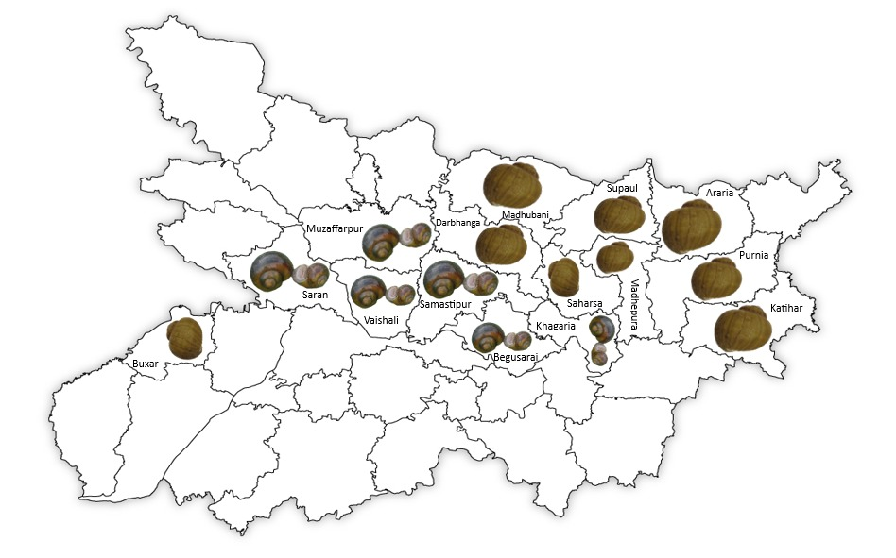

**Fig:1. Showing district wise active snail availability and marketing in of Bihar**

**Diversity of Edible Molluscs**

Our findings revealed that local communities exclusively utilize freshwater molluscs. A total of six species of freshwater molluscs (three gastropods and three bivalves) belonging to two families were identified (Table-1 & 2). These species include Pila globosa (Swainson), Bellamya bengalensis (Lamarck), Parreysia spp., and Lamellidens spp. Additionally, our recent study documented over 20 significant species of natural shellfish in these aquatic ecosystems. Notable indigenous species include Pila globosa, Bellamya bengalensis, *Lamellidens* spp., Parreysia spp., crabs, and Macrobrachium spp. (Prasad, 2023). Freshwater snails (Bellamya bengalensis), apple snails (Pila globosa), and freshwater pearl mussels (Lamellidens marginalis) are naturally abundant in North Bihar. Gastropods such as B. bengalensis and P. globosa have spirally coiled, single-tufted shells, whereas bivalves like L. marginalis possess a pair of lateral shells (Table-1 & Fig-2). The perennial wetlands of the Mahananda and Kosi regions in North Bihar play a vital role in fish farming and the cultivation of crops such as makhana (Fox nuts) and Singhara (Water Chestnuts). These aquatic areas also support the growth and breeding of various snail species, particularly in the fields of Makhana and Singhara.

**Table 1. Edible Molluscan Diversity, and Habitat ecology in Bihar**

|  |  |  |  |
| --- | --- | --- | --- |
| **S. N.** | **Species/family** | **Characteristics** | **Habitat-ecology** |
| 1 | *Pila globosa*  (Ampullariidae) | Shell large, moderately thick, globose, spirally coiled around the columella. Spire less depressed, whorls 3–4, well-developed, less inflated. Habitat is quite abundant in water with succulent aquatic vegetation on which it feeds. | Found in paddy fields and ponds (Purnea, Khagaria, Samastipur, Begusarai, Supaul, and Saharsa). Lives in both aquatic and terrestrial environments. During prolonged droughts, they enter diapause for extended periods and return to normalcy after rains. |
| 2 | *Pila Virens*  (Ampullariidae) | Spine more strongly depressed about 1/4th of total length of shell. | Smaller than *P. globosa* Habitat same as *Pila globosa* |
| 3 | *Bellamya bengalensis*  (Viviparidae) | Shell thick, globosely turbinate, with transverse reddish-brown stripes; whorls 4–5 regularly increasing, convex, with spaced spiral striae. | Collected from rivers Koshi (Kursela) and Saura (Purnea), as well as ponds and *chaurs* in North Bihar. Found in abundance on algal mats and in detritus-rich environments with microvegetation. Lays eggs on *Makhana*, *Singhara*, and *Eichhornia*. |
| 4 | *Lamellidens corrianus*  (Unionidae) | Shell strongly inequilateral, transverse, large, and thinner. Left valve has a single thin lamella-like cardinal tooth; right valve has two elongated, straight lateral teeth. Umbos slightly elevated with coarse ridges. | Found in ponds, rivers, and floodplain wetlands in Purnea, Supaul, and Madhubani. Bottom-dwelling, burrows shallowly in mud using its large ventral foot. The posterior extremities of the valves remain exposed for respiratory water currents. Omnivorous and found in vegetation-rich mud. |
| 5 | *Lamellidens marginalis*  (Unionidae) | Shell transversely oblong, ovate to oval. The umbos are swollen and knob-like, placed near the anterior end of each valve, with coarse ridges. Two pseudo cardinals present on both left and right valves | Found in ponds, rivers, and floodplain wetlands in Purnea, Khagaria, and Madhubani. Bottom-dwelling, burrows shallowly (1.5 inches deep) in mud at the bottom of ponds. Surrounded by various aquatic vegetation. Omnivorous in nature. |
| 6 | *Parreysia favidens*  (Unionidae) | Shell rounded, oval to elliptical, broad in proportions, thick, shorter compared to *Lamellidens*. Cardinal teeth narrowed. Umbos elevated with a strong ridge. | Found in muddy areas of floodplain wetlands and the mud beds of rivers in Supaul, Madhubani, Madhepura, and Khagaria. Inhabits mud beds, positioning itself upside-down and obliquely at depths of 1-1.5 inches. Surrounded by algal mats. Omnivorous in nature. |

**Brief history of snail marketing in Bihar**

Freshwater snails form an important part of the aquatic ecosystem, helping to control algae growth and serving as a food source for humans as well as various aquatic animals such as fish, turtles, and some birds (Hasan *et al.,* 2024; Prasad and Sinha, 2024). We have interviewed 50-year-old Kailu Sahni in Purnia, who sells snails at the Khushkibagh market. According to Sahni, snail collection and marketing began in Purnia about two decades ago. Earlier, snails were available year-round, but now they are available for only eight months of the year and in much smaller quantities. To meet the demand, snails are brought from other districts such as Khagaria, Begusarai, Samastipur, Muzaffarpur, and Saharsa and sold in Purnia. A more or less similar experience was shared by 55-year-old Shri Santosh Kumar, also known as Lambu ji, from the Bhojpur fish market in Dumraon, Buxar. According to Kumar, snail collection and marketing began in Dumraon a decade ago. Snails are also enjoyed by local residents with great enthusiasm.

**Monetary Profits and Food Source**

Snails provide a reliable source of income for men and women involved in the marketing chain, from harvesters to consumers. Small groups, typically consisting of 5–8 people, most of whom are women, engage in snail-related activities in North Bihar. However, in Dumraon, (Buxar) only men were found to be involved in snail-related activities. Snail meat is considered a superior source of protein, second only to fish and prawns. Both the leg and hepatopancreas of Pila globosa are consumed as food. In Purnia, snails, especially the Pila and Bellamya species, are marketed from July to March. From April to June, the market remains closed due to a lack of availability. In different parts of Bihar, P. globosa is commonly referred to as Ghongha or *D*okka in the local language. Snails, particularly P. globosa, are a popular gastropod species consumed by tribal and low- to middle-income groups in Bihar. In Purnia district, due to the high demand for snails, they are often imported from other districts of Bihar, such as Samastipur and Khagaria. Among the Pila and Bellamya species, these snails are in high demand and are frequently purchased by middle- and lower-class families at an average retail price of ₹140 per kilogram (Prasad and Sinha, 2024).

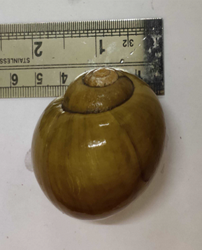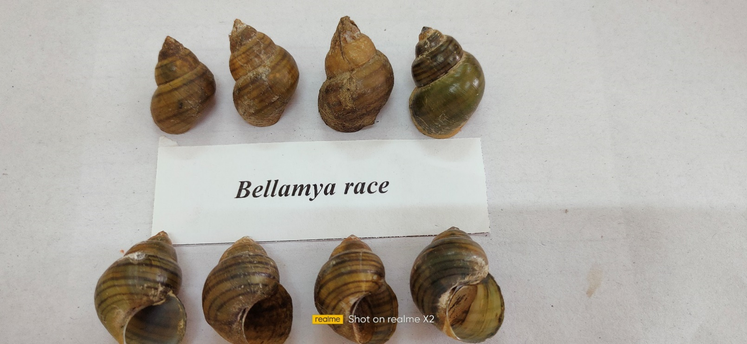

**a**

**b**

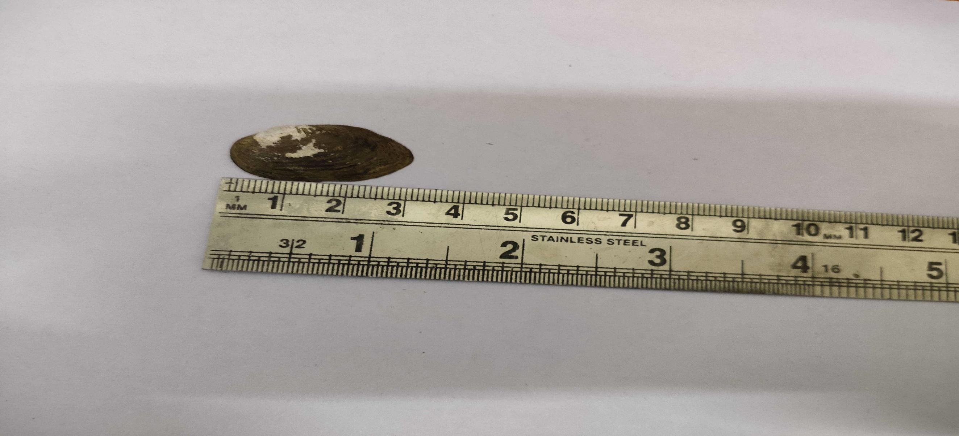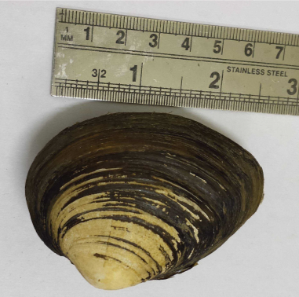

**d**

**c**

**Fig:2. Morphological observations snails : a. *Pila globosa*, b. *Bellamya bengalensis*,**

**c. *Parresia fevidence*** (Benson)**, d. *Lamellidens marginalis*** (Lamarck)

A survey conducted in Purnia revealed that snail sales significantly impact the income of local people involved in the trade. On average, a seller earns a net profit of ₹1,000–1,500 per day (Prasad and Sinha, 2024). The meat of shellfish (snails) serves not only as a human protein supplement but also plays a role in aquaculture and traditional medicine for treating various diseases. The flesh of Lamellidens marginalis is finely chopped, cooked with salt and turmeric, and softened for use. Small-scale catfish (Clarias magur) farmers frequently use chopped mollusc flesh as feed in grow-out and broodstock ponds, often combined with other ingredients. Some snail species are malacophilous, contributing to the pollination of Makhana (*Euryale ferox)* and Singhara (*Trapa natans*) crops during the rainy season. Khoisnam *et al.,* (2007) reported a similar observation, noting that snails sometimes serve as the primary pollinators on rainy days when honeybees are not active. In addition to being a significant source of protein, snails are also rich in iron, calcium, vitamins, and several other minerals (Baby *et al.,* 2010). Apart from human consumption these snail species are harvested commercially as shrimp/prawn farms, hatcheries in certain areas of Bangladesh and India (Baby *et al,* 2010: Prasad, 2020).

**Traditional medicine and Ethnic Benefits**

Evidence of malacophagy among the numerous ethnic groups in Bihar is rarely documented, except for a handful of localized studies that, while not exhaustive, have recognized molluscs as a food source in this region (Prabhakar and Roy, 2009). Present study represents the first comprehensive documentation of the diversity and cultural uses of edible freshwater molluscs in Bihar, India. This research has also documented the use of these species as remedies for common eye-related ailments. In the tribal-populated and flood-affected districts of Araria, Kishanganj, Katihar, and Purnia in North Bihar, freshwater molluscs are a crucial component of rural diets due to their rich nutritional value and health benefits. Local communities believe that snail meat possesses healing properties and use it to treat a range of conditions, including hypertension, heart disease, anxiety, and nervous disorders. It is also used to manage high body temperatures, improve blood circulation, and address digestive ailments such as constipation, dysentery, and diarrhoea. A detailed overview of these treatments is presented in Table 2.

**Table-2. List of freshwater molluscs sold in the market of Bihar, uses and red list status**

|  |  |  |  |
| --- | --- | --- | --- |
| **Family** | **Species name** | **Uses** | **ICUN Red List**  Jadhav, et al., 2023 |
| Ampullariidae | *Pila globosa*  *Pila virens* | Food, medicine, catfish, shrimp and poultry feed | LC |
| Viviparidae | *Bellamya bengalensis* | Food and medicine | LC |
| *Unionidae* | *Parreysia spp.* | Food and medicine | NA |
| *Lamellidens spp.* | Food, medicine, catfish, prawn and poultry feed | LC |

In traditional medicine, snail flesh is soaked in freshwater kept in earthen pots for several hours, and the water is then used as eye drops to treat conjunctivitis. Snail flesh soup is considered medicinal and is believed to alleviate joint inflammation, pain, high blood pressure, heart disease, gynaecological issues, asthma, arthritis, and promote wound healing. Local experts attribute cancer-preventive and skin-healing properties to the slimy extract and flesh of these molluscs, which are said to contain essential vitamins, allantoin, elastin, lectin proteins, and minerals. Among the elderly in various districts of North Bihar, particularly Scheduled Tribe and Scheduled Caste communities, a unique practice has been observed. Upon waking, they remove the flesh of Bellamya bengalensis and apply the clear blue sticky liquid (4-5 drops per snail) directly to their eyes. This practice is believed to enhance vision. Such knowledge is orally transmitted from ancestors to elders and subsequently to younger generations. These practices, collectively referred to locally as "Horopathy," highlight the cultural and medicinal significance of shellfish in the wetland areas of North Bihar.

**Livelihoods and Nutritional Security**

All mollusc species are collected from wild populations, which are widely distributed and locally abundant. However, the rate of consumption varies depending on the availability and abundance of each species (Prasad and Sinha, 2024). Small-scale shellfisheries play a significant role in sustaining the economic livelihoods of rural communities. For instance, a family involved in snail farming and marketing can earn more than ₹1,000 per day (Prasad and Sinha, 2024). This demonstrates the potential of snail culture in uplifting and economically developing rural populations. Among the mollusc families, Ampullariidae and Viviparidae are the most consumed in Bihar, India. Molluscs are a staple in the diets of tribal and economically disadvantaged communities in Southeast Asia, Bihar, Bengal, and Northeast India (Prabhakar and Roy, 2009; Ghosh, 2022; Prasad and Sinha, 2024; Tripathy and Mukhopadhyay, 2015; Jadhav et al., 2023). In these regions, including Bihar, West Bengal, and Northeast India, freshwater molluscs are also used in traditional medicine (Borkakti *et al.,* 2009; Jamir and Lal, 2005; Tripathy and Mukhopadhyay, 2015; Prabhakar and Roy, 2009; Prasad and Sinha, 2024; Bhattacharya *et al.,* 2014). The flesh of Pila, Bellamya, Lamellidens, and Parreysia species is rich in protein, vitamins (A, B, D), and minerals, making it a primary nutrient source for tribal and low- to middle-income families in the Kosi region of North Bihar (Prabhakar and Roy, 2009). Numerous studies have documented the nutrient content of freshwater molluscs in India (Baby *et al.,* 2010), emphasizing their potential as "mini-livestock" (Ghosh *et al.,* 2016; Diarra, 2015). Their role as both a dietary staple and a medicinal resource underscores the importance of conserving and sustainably managing these shellfish to support local livelihoods. Countries such as Mexico, Thailand, the Philippines, and Taiwan, where freshwater snails are a regular part of the diet, have developed successful methods for rearing these snails (Ghosh *et al.,* 2016; Flores Garza *et al.,* 2012; FAO, 2018). Focused research is needed to develop specialized studies and refine such technologies. The government should formulate a formal policy to promote "Heliciculture" programs, which would aid in conserving wild populations while creating employment opportunities for impoverished communities.

**CONCLUSION**

Snail production addresses local protein demands by providing affordable, high-quality protein accessible to both high- and low-income groups. Additionally, profitable snail species thrive alongside crops like paddy, makhana, and water chestnut, offering an efficient means of expanding animal protein sources in a protein-deficient world. Advancements in snail seed production and rearing technologies could open up new economic opportunities in the future.

**Disclaimer (Artificial intelligence)**

Author(s) hereby declare that NO generative AI technologies such as Large Language Models (ChatGPT, COPILOT, etc.) and text-to-image generators have been used during the writing or editing of this manuscript.

**REFERENCES**

Ahirwal, SK., Sharma, K., Singh, J., Kumar, T., Bharti, V., Narayan, D. and Kumar, A. (2023). Biometric evaluation of freshwater snail *Pila globosa* (Swainson-1822 ) from the river Ganga in Bihar, India. Indian J. Fish. 70 (1): 18-24.

Atsuwe, T. S., J. I. Chikwendu, and V. U. Obisike. (2019). Survey of Fresh Water Snails in Vandeikya Local Government Area, Benue State Nigeria. *Asian Journal of Research in Zoology* 2 (3):1-8. https://doi.org/10.9734/ajriz/2019/v2i330066.

Baby RL, Hasan I, Kabir KA, Naser MN (2010) Nutrient analysis of some commercially important molluscs of Bangladesh, *J. Sci. Res.*, 2 (2) (2010) 390-396.

Bassi N, Kumar MD, Sharma A, Saradhi P (2014) Status of wetland in India: A review of extent ecosystem benefits-threatens and management strategies. Journal of Hydrobiology Regional Studies 2: 1-19

Bhattacharya S, Chakraborty M, Bose M, Mukherjee D, Roychoudhury A *et al*. (2014) Indian freshwater edible snail *Bellamya bengalensis* lipid extract prevents T cell mediated hypersensitivity and inhibits LPS induced macrophage activation, *J Ethno pharmacol*, 157: 320-329.

Borkakati RN, Gogoi R, Borah BK (2009) Snail: from present perspective to the history of Assam, *Asian Agri-History*, 1 (3) 227-234.

Chandravanshi, S., Mogalekar, HS., Sahu, O., Sudhan, C., Ram, R.K., and Kumar, S. (2023), Habitat ecology and shellfish diversity of river Burhi Gandak, North Bihar, India. Pakistan Journal of Zoology, 1-7.

Chand GB, Prasad S (2021) Present Status, Potentials and Future Prospects of Fisheries Development in Bihar. *Environment & Ecology*,39(01), 10-15.

Diarra SS (2015) Utilisation of snail meal as a protein supplement in poultry diets, *World's Poultry Sci J*, 71 (3) 547-554.

Escoubas JM, Gozirbal B, Duval D, Green JJ, Charriere GM, Garzon DD, Montag Nani C (2016) Immunity in molluscs; Encyclopaedia of Immunobiology. 1: 417-436.

FAO (2018) The State of World Fisheries and Aquaculture 2018, Meeting the sustainable development goals (FAO, Rome).

Flores-Garza R, Lores-Rodríguez P, Torreblanca-Ramírez C, Galeana-Rebolledo L, Valdés-González A, *et al*. (2012) Commercially important marine molluscs for human consumption in Acapulco, México, *Nat Resour*, 3-11.

Ghosh S (2022) Collection of freshwater molluscs and sale of meat by women in Purba Medinipur, West Bengal, India. Aquaculture. 26(3):15-22.

Ghosh S, Jung C, Meyer-Rochow VB (2016) Snail farming: an Indian perspective of a potential tool for food security, *Annals Aqua. Res*, 3 (3) 1-6.

Hasan, N., Singh. Y., and Khanam, Y. 2024. Diversity and population density of freshwater snail in Darbari and Kodamdeswar village pond in Bikaner District, Rajasthan, Uttar Predesh Journal of Zoology, 45 (18):346-353.

Holtzman JS (2002) Rapid appraisals of commodity subsectors. In: Giovannucci D. (ed.), A guide to developing agricultural markets and agro enterprises. World Bank: Washington DC. USA.

Jadhav A, Das NK, Sil M, Arvind NA (2023) Snails on the plate: Edible freshwater molluscs of Northeast India. Indian Journal of Traditional Knowledge Vol 22(2), pp 409-419.

Jha, V., Verma, AB., Jha, P., and Jha, M,(2014). Wetlands in north Bihar provide a basic to its sustainable development, Journal of Aquatic Biology and Fisheries (2): 843-851.

Jamir NS, Lal P, (2005) Ethnozoological practices among Naga tribes, *Indian Journal of Traditional Knowledge,* 4 (1) 100-104.

Khoisnam, S., Tondon, R., Shivanua, KR., and Mohan Ram, HY, (2007)Snail Pollination in *Volvulopsis nummularium*, Research Communication. *Current Science,*93(6): 826-831.

Navan, A., and Kathay, G. 2019. Worth chain examination of freshwater apple snail (*Pila globosa*) utilized for on-homestead feeds in the freshwater prawn cultivation segment in Bangladesh Journal of Applied Science and Advanced Engineering, 15 (2):39-48.

Patel RJ, Kurhe AR (2023) Freshwater shellfish, *Pila globosa*: a review on its ecological and economical importance, nutritive and ethno-medicinal values. *Environmental and Experimental Biology* 21: 61–66. <http://doi.org/10.22364/eeb.21.08>.

Prabhakar AK, Roy SP (2009) Ethno-medicinal uses of some shell fishes by people of Kosi River basin of North-Bihar, India, *Stud Ethno-Med*, 3 (1) 1-4.

Prabhakar AK, Roy SP (2008) Taxonomic diversity of shellfishes of Kosi region of north Bihar (India), The Ecoscan, 2 (2):149-156.

Prasad, S. 2020. Maturation and Fecundity of large freshwater prawn *Macrobrachium malcolmsonii* and *Macrobrachium gengeticum* in the Ganga River system in India. *Current Journal of Applied Science and Technology*, 39 (21): 148-155.

Prasad S (2023) Bio-ecology and management of shell fishes in aqua crop of Bihar, File. No. *BAU/SNP/NRM/Rabi/2019-23* Project Completion Report (PCR) submitted, 10/07/23. BAU Sabour. 1-37.

Prasad S, Kumar MU, Kumar A (2021) Freshwater Shellfish *Pila globosa* (Gastropod) favourable endeavours for rural nutrition. Agriculture Letters. 2(1):32-35.

Prasad S, Kumar S, Gorai T, Kumar A (2020) To Determine the Structure and Function of Bhagar Oxbow Lake in Dumraon, Buxar, South Bihar, India, *Current Journal of Applied Science and Technology,* 39(28): 145-153.

Prasad S, Sinha M K (2024) Progression of Marketing and Utilization Pattern of Fresh Water Molluscan in Bihar. *Uttar Pradesh Journal of Zoology Volume 45* (18):402-409.

Shathi, UH., and Rahman, R. 2022. Ecology and Bio-economics of freshwater apple snail Pila globosa in Natore District of Bangladesh, Journal of Sustainability and Environmental Management, 1(3):332-338.

Sharma, G., Neeman, H., and Sardana, M., (2012) Molluscan diversity of temporary and permanent Wetlands in and around Patna, Bihar. *Biological Forum-An International Journal,* Spl. Issue 4(1): 165-170.

Subba Rao, N and Day, A., 1989. Freshwater molluscs in aquaculture, in Handbook of freshwater molluscs of India, Zoological Survey of India, Calcutta, 225-232.

Tripathy B, Mukhopadhyay A (2015) Freshwater molluscs of India: an insight of into their diversity, distribution and conservation, in: *Aquatic Ecosystem: Biodiversity, Ecology* *and Conservation,* edited by M Rawat, S Dookia & C Sivaperuman, (Springer, New Delhi), p. 163-195.