STUDIES ON DIVERSITY AND ECOLOGY OF ANTS IN SATARA DISTRICT OF MAHARASHTRA, INDIA
Abstract: Ants are considered to be the most prominent hymenopteran social insects. Ants are dominating due to their immense biomass, and this influences species composition, manipulates tropic interaction, and shapes both the abiotic and biotic matrix of community interactions. The current study intends to investigate the diversity of ants in various agricultural environments and impact of the ant on ecological parameters in Satara district Maharashtra between Jan 2023 and Dec 2023.
Keywords: Ecology, Biodiversity, Ant diversity, Satara, Agroecosystems.
Introduction: Ecology helps to understand the interaction of living thing with their environment. Biodiversity sampling is a core process in community ecology. Ants can be utilized for ecological studies species interaction climate change interpretation etc. Changes in environment may affect ant diversity, making it advantageous for bio-monitoring. (Perfecto and Vandermeer, 1996). According to Rameshkumar A (2024), a total of 10,804 species from 69 families within two suborders of Hymenoptera have been documented in India. Eusocial ants, which belong to the superfamily Vespoidea, are becoming increasingly recognized for their diverse contributions to ecosystems. According to recent data from www.antweb.org (accessed on 11.04.2023), there are currently 17,139 valid ant species and subspecies worldwide, distributed across 516 genera and 22 subfamilies. In India specifically, www.antwiki.org (accessed on 11.04.2023) reports the presence of 864 species from 110 genera and 10 subfamilies. Ants are integral components of terrestrial ecosystem, owing to their manifold interactions with other organisms. The diversity of ant species in an ecosystem can serve as an indicator of its environmental conditions, offering insights into the overall health and stability of the habitat. The research area's rich variety of plant life creates favorable environments for numerous ant species to thrive (Goswami et al., 2020). Kayande and Chavan (2024) studied ability to adopt environment by Myrmicinae most dominant subfamily in different agricultural habitats in Satara district. Ants are crucial for maintaining ecosystem diversity and stability. They contribute to biodiversity conservation by regulating microclimates and preserving habitats. Ant diversity in scattered and undistributed environments varies according to of species richness, abundance, and composition. In arid regions, the scarcity of freshwater resources is a significant concern. Climate change-induced alterations in precipitation patterns or increased evaporation can exacerbate water shortages, subsequently impacting ecosystems and biodiversity. Consequently, understanding how biodiversity in these dry areas will respond to the key drivers of global change is of critical importance. (Moradmand & Yousefi, 2022). While it is widely believed that the relationship between environmental factors and diversity follows similar patterns worldwide, these models have not been extensively studied for insects (Jenkins et al 2011). Effective ant management in tree-based agricultural systems requires understanding both the beneficial and detrimental effects on crops and pest populations Kayande and Chavan (2022).
The assumption that correlative models linking environment and diversity operate uniformly across the globe remains largely untested in the insect realm (Ricklefs 2007). It is challenging to comprehend how rainfall affects the variety and structure of ant communities across extensive geographic regions (Delsinne et al., 2010). As temperature drops and precipitation rises, it affects ant species diversity by increasing it. This change in climate conditions enhances the accessibility of energy and resources, which in turn promotes the growth of ant colonies in both size and density as productivity increases (Suber Sadeghi et al., 2024). Chate, S. (2021), demonstrated that ants possess the capability to alter the chemical composition of soil and established a link between ant species diversity and soil characteristics. A statistical technique used to evaluate the potential linear relationship between two continuous variables is known as correlation. Correlation coefficients come in two primary forms: Pearson's product moment and Spearman's rank. The appropriate selection of coefficient type is determined by the nature of the variables under examination (M.M Mukaka, 2012). The present study investigations were calculated to find out the correlation coefficient between ecological parameters in Satara district and ant diversity.
Material and methods:
During the present study techniques like hand collecting and pitfall traps were used for sampling ants. Manual collection was conducted to ensure comprehensive coverage of the study sites. Sampling was carried out from 9 am to 12 pm in the morning and 4 pm to 6 pm in the evening, avoiding high temperatures and periods of reduced ant activity. The collected specimens were subsequently processed, labeled, and preserved in the laboratory. The study examined precipitation data (in mm) across three distinct periods: winter (October, November, December, and January), summer (February, March, April, and May), and monsoon (June, July, August, and September), as well as post-monsoon rainfall and total yearly precipitation. Additionally, the distribution patterns of four ant subfamilies: Myrmicinae, Dolichoderinae, Pseudomyrmecinae, and Formicinae was also investigated. The soil samples underwent an overnight air-drying process before being filtered through a 2 mm screen the next day. The District Soil Lab in Satara conducted analyses on various physio-chemical parameters, including nitrogen, phosphorus, potassium, organic carbon, boron, Cu, Mn, Zn, EC, Fe, S, and pH. These tests followed established protocols described by Trivedy, R. K., Goel, P. K., & Trisal, C. L. (1987). Meteorological data, encompassing rainfall, temperature, and relative humidity, was accessed from the Government of Maharashtra's website (www.maharain.com).
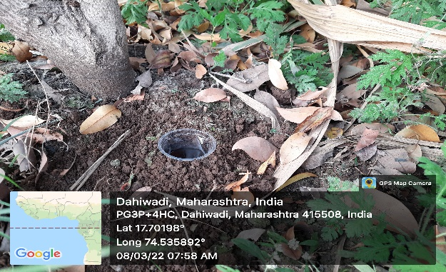
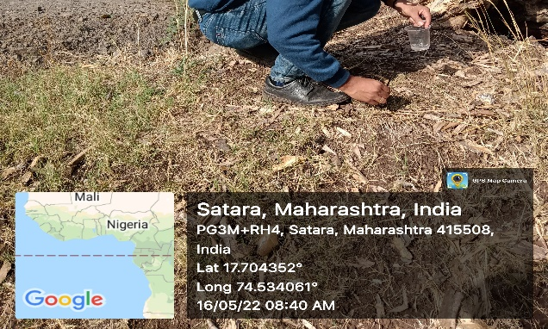
- (b)
Figure 1 Collection methods: a) Hand picking method b) Pitfall trap method

]

Results and Discussion: Ecological factors, such as climate change, can significantly impact insect diversity by altering their habitats, food sources, and reproductive patterns. These changes can lead to shifts in insect populations, distribution, and behavior. (González et al., 2024). Precipitation plays a crucial role in determining the geographic distribution of terrestrial species. This research sought to examine how rainfall impacts the ant subfamilies found in India. The study revealed that pre-monsoon and winter precipitation independently exerted significant influence on the species diversity of ant subfamilies. In contrast, monsoon and post-monsoon rainfall, when considered separately, did not demonstrate a significant predictive effect on the richness of ant subfamily species (Kritish De et al., 2023).

Table 1 Month wise soil parameter in Agriculture habitat during Jan 2023 -Dec 2023. (Soil District Lab, Satara).
Month | B  (ppm) | OC  (%) | S  (ppm) | P  (kg ha-1) | N  (kg ha-1) | K  (kg ha-1) | pH  (1:2.5) | EC  (mS/cm) | Cu  (ppm) | Fe  (ppm) | Mn  (ppm) | Zn  (ppm)
January | 0.062 | 0.143 | 5.167 | 28.05 | 283.65 | 510.45 | 8.0 | 0.44 | 3.66 | 11.03 | 15.66 | 1.11
February | 0.063 | 0.237 | 3.816 | 20.16 | 250.10 | 437.90 | 8.0 | 0.35 | 3.33 | 9.01 | 11.86 | 0.93
March | 0.038 | 0.155 | 5.553 | 35.93 | 236.44 | 426.19 | 8.0 | 0.58 | 3.54 | 6.37 | 13.01 | 1.00
April | 0.049 | 0.190 | 2.450 | 25.03 | 236.94 | 405.58 | 8.0 | 0.47 | 3.26 | 9.20 | 13.06 | 0.92
May | 0.051 | 0.171 | 4.657 | 23.00 | 244.82 | 467.26 | 8.0 | 0.54 | 3.52 | 8.21 | 13.77 | 0.98
June | 0.045 | 0.187 | 2.033 | 25.75 | 261.71 | 501.28 | 8.0 | 0.65 | 3.83 | 10.53 | 16.55 | 1.10
July | 0.047 | 0.168 | 3.821 | 31.64 | 257.72 | 488.47 | 7.9 | 0.49 | 4.02 | 8.99 | 13.34 | 0.97
August | 0.040 | 0.180 | 2.685 | 28.63 | 233.95 | 395.05 | 8.0 | 0.43 | 3.95 | 10.19 | 17.37 | 0.97
September | 0.052 | 0.151 | 4.957 | 29.14 | 238.93 | 475.24 | 8.0 | 0.42 | 3.49 | 6.85 | 14.25 | 0.93
October | 0.058 | 0.171 | 4.835 | 26.33 | 230.73 | 442.74 | 8.0 | 0.41 | 3.77 | 9.89 | 14.88 | 0.70
November | 0.042 | 0.181 | 3.100 | 38.55 | 298.65 | 512.82 | 8.0 | 0.58 | 3.68 | 8.60 | 16.76 | 0.95
December | 0.047 | 0.175 | 2.303 | 30.03 | 229.03 | 527.84 | 8.0 | 0.54 | 4.13 | 9.63 | 15.51 | 1.00

Table 2 Ant distribution in agriculture field from Satara district.
Subfamily | Genus | Species
Dolichoderinae | Dolichoderus | Dolichoderus Bispinosus
Formicinae | Componotus | Componotus Compressus
Formicinae | Componotus | Componotus Angustiocollis
Pseudomyrmecinae | Tetraponera | Tetraponera Nigra
Myrmicinae | Solenopsis | Solenopsis Geminata
Myrmicinae | Crematogaster | Crematogaster Subnuda
Myrmicinae | Pheidole | Pheidole Ghatica
Myrmicinae | Crematogaster | Crematogaster Rhogenferi
Myrmicinae | Pheidole | Pheidole Morrisi
Myrmicinae | Monomorium | Monomorium Indicum
Myrmicinae | Aphenogaster | Aphenogaster Smythiesii
Formicinae | Anoplolepis | Anoplolepis Gracillipes
Formicinae | Paratrechina | Paratrechina Longicornis
Myrmicinae | Monomorium | Monomerium Destructor
Pseudomyrmecinae | Tetraponera | Tetraponera Allaborans
Myrmicinae | Cataulacus | Cataulacus Latus
Formicinae | Polyrachis | Polyrachis Rupicapra
Formicinae | Polyrachis | Polyrachis Laevissima
Formicinae | Lepisiota | Lepisiota Frauenfeldi
Myrmicinae | Monomorium | Monomerium Pharaonis
Myrmicinae | Pheidole | Pheidole Spathifera
Formicinae | Tapinoma | Tapinoma Sessile

Table 3 Month Wise Climatic Parameter in Agricultural habitat during Jan 2023-Dec 2023
Months | Rainfall (mm) | RH (%) | Temperature (⁰ C)
January | 0.8 | 67 % | 28 ⁰ C
February | 0.9 | 86 % | 25 ⁰ C
March | 3.2 | 81 % | 25 ⁰ C
April | 12.4 | 83 % | 25 ⁰ C
May | 31.6 | 71 % | 26 ⁰ C
June | 225.8 | 74 % | 24 ⁰ C
July | 428.6 | 72 % | 21 ⁰ C
August | 309.9 | 67 % | 20 ⁰ C
September | 185.9 | 52 % | 23 ⁰ C
October | 101.2 | 55 % | 24 ⁰ C
November | 28.2 | 53 % | 28 ⁰ C
December | 7.8 | 56 % | 29 ⁰ C

During the present study we examined the association between ant populations and various environmental parameters, including soil characteristics and weather conditions, in a cultivated field over a 12-month period in 2023. The strength of these relationships was quantified using the correlation coefficient (r). Copper exhibited the strongest positive correlation with Formicinae (r = 0.758), followed by Manganese (r = 0.593) and Rainfall (r = 0.530). Ant behaviour and distribution can be significantly influenced by Potassium, potentially resulting in positive correlation with Formicinae (r = 0.661) and Temperature (r = 0.571). Nitrogen showed the highest positive correlation with Potassium (r = 0.552). Electrical conductivity displayed a positive correlation with Pseudomyrmecinae (r = 0.608). Implies a very weak negative relationship between rainfall and temperature (r = -0.831), suggesting that temperature has little impact on rainfall. The amount of precipitation can impact ant species diversity by influencing the accessibility of food sources, nesting locations, and the viability of various ant populations. like Myrmicinae positive correlation with rainfall (0.220).
Boron exhibited a negative correlation with both Electrical Conductivity (r = -0.671) and Phosphorus (r = -0.654). Organic carbon more negative correlations with Sulphur (r = -0.500) and Phosphorus (r = -0.500). Potassium negative corelated with Humidity (r = -0.497). p^{H} negative corelated with Rainfall (r = -0.693). Disturbances to the soil can disrupt ant populations the same as Manganese (Mn) negative corelated with Myrmicinae (r = -0.531) and Humidity (r = -0.589). Formicinae negative corelated with Humidity (r = -0.625). some species may become more active in warmer conditions, while extreme temperatures could lead to a decrease in overall ant diversity like Myrmicinae negative corelated with temperature ( -0.463). This analysis examined how various ecological aspects, such as soil parameters, temperature and rainfall, relate to ant species diversity in a given area.

Figure 2 Graphical representation of Correlation coefficient (r) of ant population with soil properties and climatic factors.
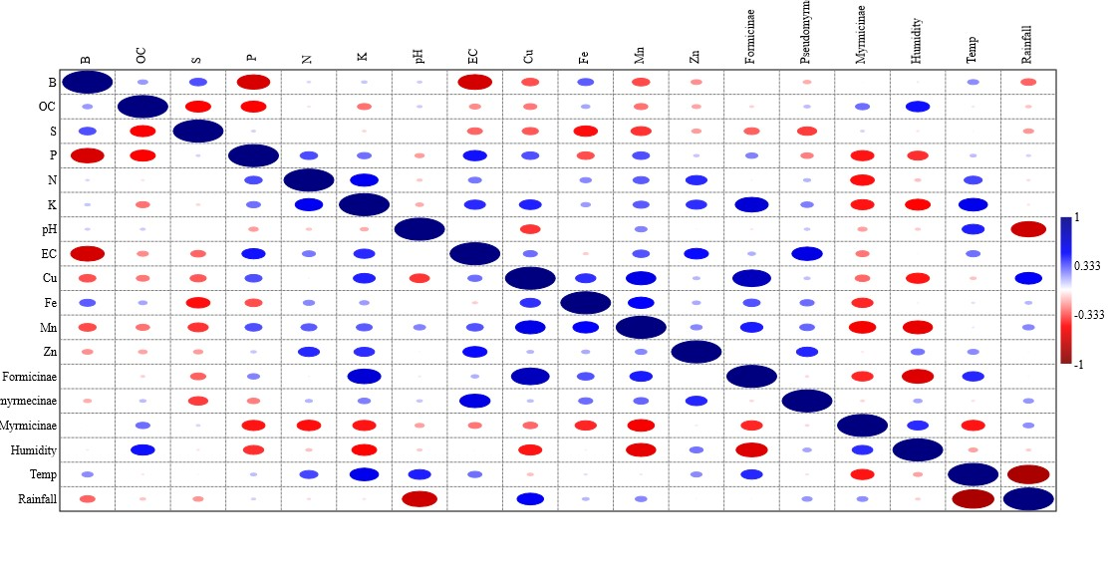
 | B | OC | S | P | N | K | pH | EC | Cu | Fe | Mn | Zn | Formi | Pseudo | Myrmi | Humidity | Temp | Rainfall
B |  | 0.199 | 0.343 | -0.654 | 0.078 | 0.112 | 0.097 | -0.672 | -0.344 | 0.319 | -0.354 | -0.216 | -0.014 | -0.158 | -0.016 | 0.040 | 0.225 | -0.302
OC |  |  | -0.500 | -0.500 | -0.058 | -0.276 | 0.102 | -0.226 | -0.266 | 0.174 | -0.276 | -0.177 | -0.089 | 0.131 | 0.285 | 0.470 | -0.052 | -0.116
S |  |  |  | 0.087 | -0.008 | -0.080 | -0.010 | -0.301 | -0.327 | -0.473 | -0.404 | -0.190 | -0.309 | -0.384 | 0.084 | -0.054 | 0.020 | -0.205
P |  |  |  |  | 0.352 | 0.282 | -0.190 | 0.466 | 0.345 | -0.345 | 0.344 | 0.113 | 0.245 | -0.251 | -0.460 | -0.407 | 0.129 | 0.089
N |  |  |  |  |  | 0.552 | -0.108 | 0.264 | -0.023 | 0.232 | 0.323 | 0.423 | 0.026 | 0.145 | -0.475 | -0.123 | 0.362 | -0.071
K |  |  |  |  |  |  | -0.161 | 0.420 | 0.438 | 0.193 | 0.323 | 0.412 | 0.662 | 0.253 | -0.461 | -0.497 | 0.572 | -0.056
pH |  |  |  |  |  |  |  | 0.006 | -0.395 | 0.012 | 0.242 | -0.020 | -0.050 | 0.113 | -0.187 | -0.103 | 0.443 | -0.693
EC |  |  |  |  |  |  |  |  | 0.285 | -0.101 | 0.338 | 0.482 | 0.154 | 0.608 | -0.267 | -0.019 | 0.280 | -0.010
Cu |  |  |  |  |  |  |  |  |  | 0.407 | 0.594 | 0.140 | 0.758 | 0.125 | -0.296 | -0.462 | -0.122 | 0.531
Fe |  |  |  |  |  |  |  |  |  |  | 0.513 | 0.166 | 0.341 | 0.287 | -0.425 | -0.034 | 0.064 | 0.140
Mn |  |  |  |  |  |  |  |  |  |  |  | 0.235 | 0.447 | 0.299 | -0.532 | -0.589 | 0.044 | 0.236
Zn |  |  |  |  |  |  |  |  |  |  |  |  | 0.006 | 0.427 | -0.044 | 0.272 | 0.226 | 0.019
Formi. |  |  |  |  |  |  |  |  |  |  |  |  |  | -0.076 | -0.425 | -0.626 | 0.425 | -0.022
Pseudo. |  |  |  |  |  |  |  |  |  |  |  |  |  |  | -0.081 | 0.173 | -0.062 | 0.205
Myrmi. |  |  |  |  |  |  |  |  |  |  |  |  |  |  |  | 0.414 | -0.463 | 0.220
Humi. |  |  |  |  |  |  |  |  |  |  |  |  |  |  |  |  | -0.181 | -0.096
Temp. |  |  |  |  |  |  |  |  |  |  |  |  |  |  |  |  |  | -0.831
Rainfall
Table 4 Correlation coefficient (r) between ant abundance and environmental factors in an agricultural habitat from January to December 2023

Conclusion:
The analysis of relationships between ant diversity and various ecological factors in Satara district unveils notable trends that illuminate the complex interplay between these ants and their surroundings. The findings demonstrate either a positive or negative association between ant diversity and crucial environmental variables, including temperature, humidity, plant coverage, and soil characteristics. These connections emphasize the significance of particular environmental conditions in influencing ant populations within the area.
DISCLAIMER (ARTIFICIAL INTELLIGENCE)
Authors hereby declare that generative AI technologies such as Quill Bot software has been used during the writing or editing of manuscripts for grammar checking and summarizing.
References:
- Perfecto, I., & Vandermeer, J. (1996). Microclimatic changes and the indirect loss of ant diversity in a tropical agroecosystem. Oecologia, 108, 577-582.
- www.antweb.org
- www.antwiki.org
- Kayande H.G., Chavan R.J., Muley E.D., & Naphade S.R. (2024). Studies on ant diversity at different agricultural habitats in Satara district, Maharashtra, International Journal of Entomology Research Volume 9, Issue 4, Page No. 71-73.
- Moradmand, M., & Yousefi, M. (2022). Ecological niche modelling and climate change in two species groups of huntsman spider genus Eusparassus in the Western Palearctic. Scientific reports, 12(1), 4138.
- Jenkins, C. N., Sanders, N. J., Andersen, A. N., Arnan, X., Brühl, C. A., Cerda, X., ... & Dunn, R. R. (2011). Global diversity in light of climate change: the case of ants. Diversity and Distributions, 17(4), 652-662.
- Goswamı, A., Chatterjee, A., & Saroj, S. (2020). Diversity of ants species in different habitat mosaics of Acharya Jagadish Chandra Bose Indian Botanical Garden (Howrah, West Bengal, India).
- H.G. Kayande and R.J. Chavan (2022) review on ecological aspects of ants with special reference to agricultural habitats. Volume - 11 | Issue - 05 | May - 2022 | PRINT ISSN No. 2277 – 8179.
- Ricklefs, R. E. (2007). History and diversity: explorations at the intersection of ecology and evolution. The American Naturalist, 170(S2), S56-S70.
- Delsinne, T., Roisin, Y., Herbauts, J., & Leponce, M. (2010). Ant diversity along a wide rainfall gradient in the Paraguayan dry Chaco. Journal of Arid Environments, 74(10), 1149-1155.
- Hajian, M., Sadeghi, S., Eslami Barzoki, Z., Moradmand, M., Gholamhosseini, A. & Ebrahimi, M. (2024) Ant diversity and species assemblages along an elevational gradient in the arid area of Central Iran. Journal of Insect Biodiversity and Systematics, 10 (1), 143–159.
- Chate, S. (2022). Correlations between soil properties and ant population in agricultural habitat at Aurangabad Maharashtra, India. Applied Ecology and Environmental Research, 20, 1103-1111.
- Webster's Online Dictionary
- Mukaka, M. M. (2012). A guide to appropriate use of correlation coefficient in medical research. Malawi medical journal, 24(3), 69-71.
- Trivedy, R. K., Goel, P. K., & Trisal, C. L. (1987). Practical methods in ecology and environmental science. Enviro Media Publications.
- https://maharain.maharashtra.gov.in/
- González-Tokman, D., & Dáttilo, W. (Eds.). (2024). Effects of climate change on insects: physiological, evolutionary, and ecological responses. Oxford University Press.
- De, K., Sangela, V., & Singh, A. P. (2023). Rainfall as Correlate of Species Richness of Indian Ants (Hymenoptera: Formicidae). Indian Journal of Ecology, 50(1), 185-191.
- Rameshkumar, A., Kazmi, S.I., Sheela, S., Girish Kumar, P., Rajmohana, K., Mazumdar, P.C., Sardar, S., Ahmed, I., Majumder, B., Anand, N., Dey, S., Chattopadhyay, B., Singh, L.R.K., Basak, N., Ghosh, D., Mandi, A., Debnath, R., Patra, S. and Theertha, P.V. (2023). Fauna of India Checklist: Arthropoda: Insecta: Hymenoptera. Version 1.0. Zoological Survey India. DOI: https://doi.org/10.26515/Fauna/1/2023/ Arthropoda: Insecta: Hymenoptera.

