**Impacts of Monosodium Glutamate on Male Reproductive Health: A Study on experimental Albino Rats**

**Abstract**

**Background:** Monosodium glutamate (MSG), a common food additive, has been linked to hormonal imbalances and reproductive toxicity. This study examines its effects on body weight, organ weight, testicular structure, and hormone levels in albino rats.

**Methods:** The rats were categorized into a control group and an MSG-treated group. Body weight, testis weight, and serum testosterone levels were measured, and testicular tissue was analyzed histologically.

**Results:** MSG-treated rats showed reduced weight gain, lower testis weights, and decreased testosterone levels. Histological analysis revealed structural damage to the testes.

**Conclusion:** MSG exposure negatively impacts male reproductive health by altering hormone levels and testicular structure. Further research is needed to assess its relevance to human health.

**Keywords:** Monosodium Glutamate (MSG), Albino Rats, Testis, histology, Reproductive toxicity, Degenerative Changes

1. **Introduction**

Monosodium glutamate (MSG) known as AJI-NOMOTO is the sodium salt of glutamic acid8. Monosodium glutamate (MSG) is a commonly used additive that enhances the flavor of foods16. It can often be found in packaged products, sometimes without being explicitly listed on the label12. Initially discovered and isolated in a lab many years ago, it was identified as MSG, which has since become a popular ingredient in the food industry. Modern commercial MSG is commonly synthesized through the fermentation of starch, sugar, beet sugarcane, or molasses21. Other studies suggest that MSG may have toxic effects on both humans and experimental animals. Its consumption has been associated with symptoms like numbness, weakness, flushing, sweating, dizziness, and headaches. Additionally, MSG intake has been linked to the aggravation of various health conditions, including asthma, hives, atopic dermatitis, irregular heartbeats, nerve disorders, and abdominal discomfort9. MSG can elicit male reproductive impairment by different mechanisms as studies indicated that it causes oxidative damage, histopathological alterations, hormonal disruption, and diminished sperm quality20. Proved that the subcutaneous injection of male rats with MSG at a level dose of 4 mg/kg for 120 days leads to decline levels of FSH and testosterone and a decrease in sperm counts in addition to a reduction of reproductive organs weights5. The reproductive system is one of the targets of ROS due to the presence of adipose tissue within those organs11. Given the widespread use of MSG as a flavor enhancer, this study investigates its potential adverse effects on male reproductive health. Research suggests that MSG induces oxidative stress and hormonal imbalances, leading to reduced sperm quality and organ weight. Understanding these impacts is crucial for assessing the broader health risks of prolonged MSG consumption. This study may also aid in developing guidelines for safer use of MSG. This study is significant as it addresses the growing concern surrounding the widespread use of monosodium glutamate (MSG) in food products. By investigating its effects on male reproductive health, the findings provide valuable insights into potential risks associated with MSG consumption. Understanding these impacts is crucial for promoting awareness and guiding safer dietary practices. This research may also contribute to future studies exploring preventive measures or treatments for MSG-induced reproductive toxicity.

1. **Objectives**

This study examines the impact of monosodium glutamate (MSG) on the reproductive health of male albino rats. Specifically, it investigates changes in body weight, testicular organ weight, histopathological alterations, and hormonal profiles following MSG administration. Rats were treated with varying doses of MSG, and the results revealed a dose-dependent reduction in testicular weight, along with significant histological disruptions in the testis tissue. Hormonal assays showed decreased levels of testosterone, indicating impaired reproductive function. These findings suggest that MSG exposure may induce reproductive toxicity and disrupt endocrine function in male albino rats.

1. **Materials and** **Methods**

**Animal**

Albino rats are known for their strong breeding capabilities. They have distinct physical features, including a broad head, elongated ears, and a tail that is shorter than their body length. These rats are easy to handle and are widely utilized in various medical and biological research studies.

**Chemical**

**Monosodium glutamate**

Monosodium glutamate is a white, odorless crystalline powder that resemble table salt or sugar. It is a taste enhancer frequently used in Chinese cuisine, canned vegetables, soups, and processed meats. It has a specific taste known as umami.

**Animal collection and maintenance**

In the present study, healthy albino rats weighing between 180-200 grams and aged 6-8 weeks were purchased from an animal house and acclimatized prior to the experiment. During the acclimatization, the rats were provided with a standard laboratory diet and had free access to water. They were housed under controlled conditions, including stable temperature, proper ventilation, and optimal humidity. A 12-hour light/12-hour dark cycle was maintained using natural daylight. The room had adequate exposure to natural light during the day, while windows were covered with curtains in the evening to create a controlled dark phase. This method effectively ensured a consistent light-dark cycle throughout the study period. All procedures involving animals were conducted in accordance with the guidelines set by the Institutional Animal Ethics Committee.

**Experimental design**

In this study, the rats were divided into four groups, with each group consisting of six healthy rats, making a total of 24 rats included in the studyto evaluate the effects of monosodium glutamate (MSG) at different doses for 17 days durations. The control group received saline water and a standard laboratory diet for 17 days. Three treated groups were received MSG at doses of 35, 70 and 105 mg/kg body weight (bw), for 17 days, respectively. All groups were monitored for body weight, food and water intake, and clinical signs daily.

**Body and organ weight**

Body weight was recorded on the first day of the experimental protocol and again upon its completion. After the animals were sacrificed, the weights of both the right and left testes were measured.

**Collection of blood and tissue**

After the completion of duration of exposure, rats were anesthetized by using ethyl-ether. After anesthetization, blood was drawn by cardiac puncture with 2ml sterile syringe in the tubes containing EDTA as anticoagulating agent. Immediately testes were excised and used for histological study.

**Histological study of testis**

The reproductive organ testis, were rinsed in buffer saline before being fixed in freshly prepared Bouin’s fixative. The tissue samples were dehydrated using increasing concentrations of ethyl alcohol, cleared with the samples were processed with xylene and then embedded in paraffin wax. Thin 5 μm thickness sections of were prepared, mounted on glass slides, and stained using haematoxylin and eosin before being examined under a light microscope.

**Reproductive hormone assay**

Testosterone hormone was analysed by using enzyme-linked immunoassay (ELISA) kit purchased from Hi-media. All procedures adhered to the standard protocol supplied**.**

**Statistical analysis**

The body weight and testes data of control and treated animals were statistically analyzed using the Student’s t-test to determine significant differences between the MSG-treated group and the control group.

1. **Results**

**Body weight**

Table 1 shows the effects of MSG on body weight of rats over 17 days. The control group, which received no MSG, had minimal weight gain. Rats treated with 35 mg/kg of MSG showed moderate weight gain, while those given 70 mg/kg and 105 mg/kg experienced significant increases in body weight. These results suggest a dose-dependent effect, with higher doses of MSG leading to more pronounced weight gain.

**Organ weights**

Table 2 shows the effects of different MSG doses on rat testicular weight after 17 days. The control group had normal right and left testes weights, while MSG-treated groups experienced a decrease. The lowest dose caused a slight reduction, but higher doses resulted in more pronounced declines, particularly at the highest dose. This indicates a dose-dependent decrease in testes weight with increasing MSG levels.

**Hormonal study**

Table 3 shows the effects of MSG on testosterone levels in rats after 17 days. The control group had normal testosterone levels. The lowest MSG dose caused a slight, non-significant reduction, but higher doses led to more substantial and significant decreases. The highest dose showed the greatest decline, indicating a dose-dependent reduction in testosterone levels with increasing MSG.

**Histological study**

The histological images show the structure of rat testis. In the control group (Fig 1.A), seminiferous tubules have intact basement membranes, with different stages of sperm development visible, supported by Sertoli cells and Leydig cells responsible for testosterone production. (Fig 1.B) provides a closer view, showing healthy spermatogenesis. In the treatment groups (Fig 2. A), seminiferous tubules appear irregular, with fewer sperm cells and changes in tissue density, suggesting disrupted spermatogenesis. The magnified view (Fig 2.B) highlights a reduced presence of mature sperm cells, indicating damage from MSG exposure. Further images (Fig 3. B) reveal similar changes, with ongoing spermatogenesis but signs of disruption. (Fig 4.) compares the control and high-dose MSG group, where the latter shows significant structural damage, including a disorganized basement membrane, enlarged lumens, and impaired sperm production, indicating testicular degeneration.

|  |  |  |  |
| --- | --- | --- | --- |
| **Table 1:**  **Body weight of albino rats in control and MSG-treated groups over 17-days.** | | | |
| **Group and dose** | **Duration** | **Body weight (gm)** | |
| **Initial** | **Final** |
| Group I (Control) | 17 days | 200.8±3.2 | 202.5±3.1 |
| Group II (Treated) Low dose MSG 35mg/kg bw | 17 days | 187.5±3.1 | 201.8±4.8* |
| Group II (Treated) Low dose MSG 70mg/kg bw | 17 days | 190±2.89 | 214.1±4.1*** |
| Group II (Treated) Low dose MSG 105mg/kg bw | 17 days | 190±3.6 | 235±4.2*** |
| **Data are expressed as Mean ± SE; N = 6 per group. Statistical significance: *p < 0.05, **p < 0.01, ***p < 0.001; NS = Not significant.** | | | |

|  |  |  |  |
| --- | --- | --- | --- |
| **Table 2: Organ weight of control and MSG treated albino rats for 17 days duration** | | | |
| **Group and dose** | **Duration** | **Testes weight (gm)** | |
| **Right** | **Left** |
| Group I (Control) | 17 days | 1.28±0.01 | 1.39±0.025 |
| Group II (Treated) Low dose MSG 35mg/kg bw | 17 days | 1.23±0.01** | 1.34±0.026NS |
| Group III (Treated) Low dose MSG 70mg/kg bw | 17 days | 1.17±0.012*** | 1.27±0.025** |
| Group IV (Treated) Low dose MSG 105mg/kg bw | 17 days | 1.10±011*** | 1.20±0.022*** |
| **Data are expressed as Mean ± SE; N = 6 per group. Statistical significance: *p < 0.05, **p < 0.01, ***p < 0.001; NS = Not significant.**   |  |  |  | | --- | --- | --- | | **Table 3: Hormonal level of control and MSG treated albino rats for 17 days duration** | | | | **Group and dose** | **Duration** | **Testosterone concentration** | | Group I (Control) | 17 days | 3.650±0.128 | | Group II (Treated) Low dose MSG 35mg/kg bw | 17 days | 3.350±0.165NS | | Group III (Treated) Low dose MSG 70mg/kg bw | 17 days | 2.7883±0.190** | | Group IV (Treated) Low dose MSG 105mg/kg bw | 17 days | 2.000±0.203*** | | **Data are expressed as Mean ± SE; N = 6 per group. Statistical significance: *p < 0.05, **p < 0.01, ***p < 0.001; NS = Not significant.** | | | | | | |

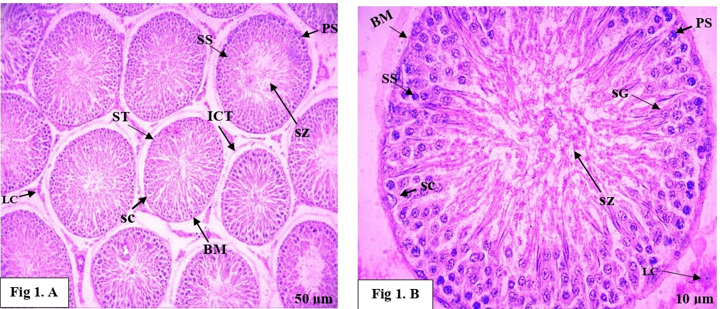**Histopathological study**

**Fig. 1 (A and B):** Photograph of transverse section of rat testis in control group for 17 days duration showing normal histological structure of seminiferous tubules (ST), basement membrane (BM), inter connecting tissue (ICT), Primary spermatocyte (PS), Secondary spermatocyte (SS), spermatozoa (SZ), Sertoli cell (SC), Leydig cells (LC). At higher magnification 40x, the seminiferous epithelium consisting of spermatogonia (SG), basement membrane (BM), Primary spermatocyte (PS), Secondary spermatocyte (SS), spermatozoa (SZ), Sertoli cell (SC), Leydig cells (LC). can be observed clearly. (HE staining, SCALE: 50µm and 10µm).

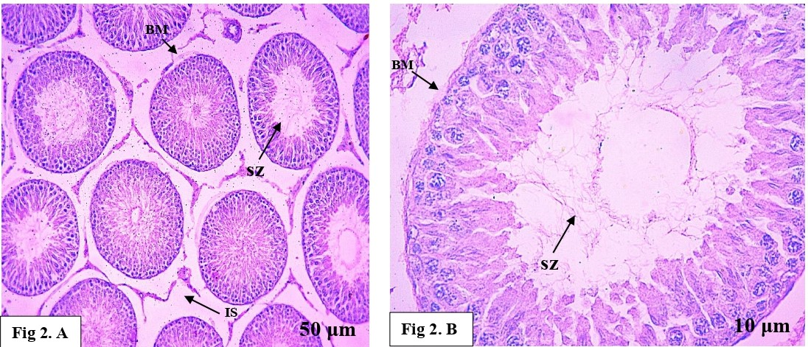

**Fig. 2 (A and B):** Photomicrographs of transverse sections of the male albino rat testis testis treated with MSG at 35 mg/kg body weight for 17 days. **Fig. 2 (A)** shows slight dilation of the interstitial spaces (IS) and a decrease in the number of spermatozoa (SZ). The basement membrane (BM) appears slightly ruptured. **Fig. 2 (B)** shows a higher magnification of a single seminiferous tubule, highlighting a reduced number of spermatozoa (SZ) and slight rupture of the basement membrane (BM) (HE staining, SCALE: 50µm and 10µm).

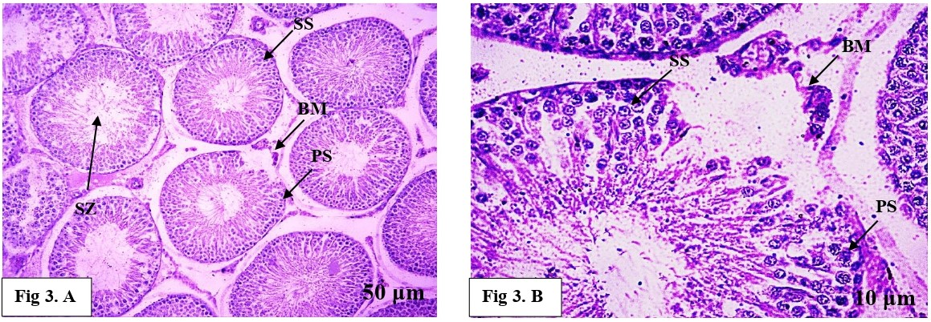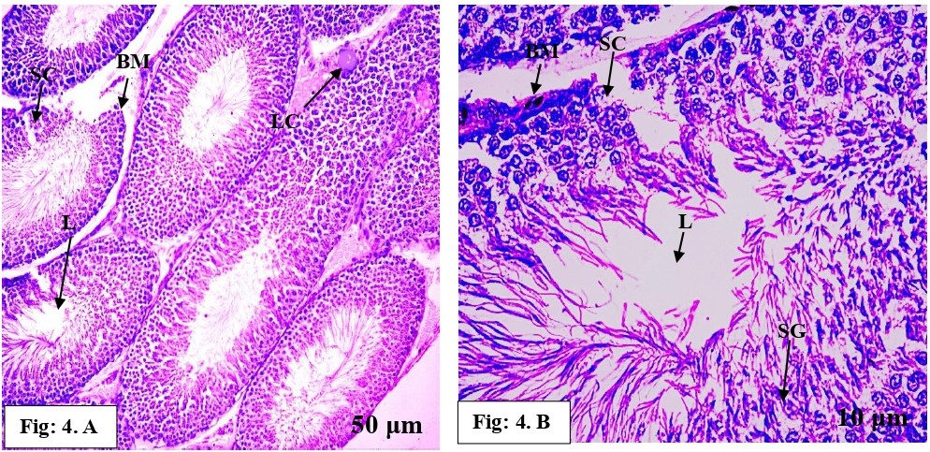

**Fig. 3 (A and B):** Photomicrographs of transverse sections of the male albino rat testis testis from a rat treated with MSG at 70 mg/kg body weight for 17 days. **Fig. 3 (A)** shows degeneration in the stages of spermatogenesis, with visible spermatocytes (PS, SS), reduced spermatozoa (SZ), and a ruptured basement membrane (BM). **Fig. 3 (B)** is a higher magnification showing further details of the seminiferous tubule, highlighting the disruption of the basement membrane (BM) and spermatogenesis stages (PS, SS) (HE staining, SCALE: 50µm and 10µm).

**Fig. 4 (A and B):** Photomicrographs of transverse sections of the male albino rat testis testis from a rat treated with MSG at 105 mg/kg body weight for 17 days. **Fig. 4 (A)** shows elongated seminiferous tubules (ST) with signs of degeneration in the stages of spermatogenesis. The basement membrane (BM) is ruptured, and the lumen (L) is empty, lacking spermatozoa (SZ). **Fig. 4 (B)**, a higher magnification, shows further details of a ruptured basement membrane (BM) and an empty lumen (L). Sertoli cells (SC) are visible but not ruptured (HE staining, scale: 50 µm and 10 µm).

1. **Discussion**

Many researchers have studied the impact of monosodium glutamate (MSG) on male reproductive health, with global recognition that MSG can negatively impact male fertility3,19. In this study, rats treated with low, medium, and high doses of MSG showed a significant increase in body weight compared to control rats. This weight gain is likely due to increased food consumption following MSG intake, aligning with the findings of1,17. A reduction in testicular weight was observed in the experimental groups compared to controls. This decrease in weight is linked to a reduction in the number of spermatogenic cells, which play a crucial role in testicular mass. The loss of germ cells caused by MSG treatment may contribute to the reduction in testicular weight, consistent with previous research by6,14,15.

The decrease in blood testosterone levels found in this study could be a result of direct damage to Leydig cells, which are responsible for testosterone production. This observation is supported by studies from18,7,2. Additionally, histopathological changes in the male reproductive organs were evident, with high MSG concentrations likely overstimulating glutamate receptors in spermatogenic cells. This overstimulation leads to various pathological alterations, including epithelial detachment, azoospermia, and damage to the interstitial tissue, which affects androgen synthesis. These findings align with those of13,10,4.

**Conclusion**

The findings from this study reinforce the evidence that MSG has a dose-dependent negative impact on male reproductive health, leading to increased body weight, reduced testicular weight, decreased testosterone levels, and significant structural damage to testicular tissues. These results raise concerns about the long-term effects of MSG on reproductive health.

Disclaimer (Artificial intelligence)

Option 1:

I Harshada B. Pawar hereby declare that NO generative AI technologies such as Large Language Models (ChatGPT, COPILOT, etc.) and text-to-image generators have been used during the writing or editing of this manuscript.

**Refrences**

# Abd-elaziz M.S., and I. S. Ashoush (2007). *Egyptian Journal Basic Application Physiology*,6 (1), 101-110.

1. Abdul‑Hamid M., S.R. Galaly., R.R. Ahmed and Hamdalla H.M., (2021). Beni-Suef Univ. J. Basic Appl. 10: 73.
2. Abolanle A. A. K., D.O. Tomilola and S. A. Oluyomi (2020) *Toxics*, 8 (1), 7.
3. Al-Husseini A.M.H., L.A.M. Al-Waely., A.A.A. Kazem., and N.R. Mashkoor (2022). *Earth and Environmental Science*, 1029.
4. Biodun D. and A. Biodun (1993). Spice or poison? Is monosodium glutamate safe for human consumption? *National Concord*, 4, 5.
5. Chinta G., Coumar M.S., and Periyasamy L., (2017). *Pharmacognosy Magazine*, 13(3), S525-S532.
6. El Kotb S.M., El-sayed D., El-ghazouly D.E., and Ameen O., (2020). *Alexandria Journal of Medicine*, 56 (1), 134-147.
7. Eweka A.O. (2007). *The Internet Journal of Health*, 6(2).
8. Geha R.S.,  A. [Beiser](https://pubmed.ncbi.nlm.nih.gov/?term=Beiser+A&cauthor_id=10736382).,   C. [Ren](https://pubmed.ncbi.nlm.nih.gov/?term=Ren+C&cauthor_id=10736382)., R. [Patterson](https://pubmed.ncbi.nlm.nih.gov/?term=Patterson+R&cauthor_id=10736382).,  [P.A. Greenberger](https://pubmed.ncbi.nlm.nih.gov/?term=Greenberger+PA&cauthor_id=10736382)., L.C. [Grammer](https://pubmed.ncbi.nlm.nih.gov/?term=Grammer+LC&cauthor_id=10736382)., A.M.  [Ditto](https://pubmed.ncbi.nlm.nih.gov/?term=Ditto+AM&cauthor_id=10736382)., K.E. [Harris](https://pubmed.ncbi.nlm.nih.gov/?term=Harris+KE&cauthor_id=10736382).,  M.A. [Shaughnessy](https://pubmed.ncbi.nlm.nih.gov/?term=Shaughnessy+MA&cauthor_id=10736382).,  [P.R. Yarnold](https://pubmed.ncbi.nlm.nih.gov/?term=Yarnold+PR&cauthor_id=10736382).,  J. [Corren](https://pubmed.ncbi.nlm.nih.gov/?term=Corren+J&cauthor_id=10736382) and A. [Saxon](https://pubmed.ncbi.nlm.nih.gov/?term=Saxon+A&cauthor_id=10736382) (2001). *Journal of Nutrition*, 130 (4),1058S–62S.
9. Hamza, R.Z., S. Mohammad and AL. Harbi (2014). *Toxicology Reports*,1, 1037-1045.
10. Hanipah E.N.A., N.J. Yahya., E.M. Ajik., N. A. Yuso and I.S. Taib (2018). *Jurnal Sains Kesihatan Malaysia*, 16, 67–73.
11. Hashem H.E., El. Din., M.D. Safwat and S. Algaidi (2012). *Journal of Molecular Histology*, 43(2),179–186.
12. Jubaidi F.F., R.D. Mathialagan., M.M. Noor., I.S. Taib and Budin S.B. (2019). *Systems Biology in Reproductive Medicine*, 65(3): 194-204.
13. Katoh C., Kitajima S., Saga Y., Kanno J., Horii I., and Inoue T. (2002). *Journal of Toxicology Science*, 27: 87-96.
14. Kianifard D., Shoar S.M., Karkan M.F., and Aly A. (2020). *International Journal of Reproductive Bio Medicine*, 19, 169-180.
15. Leung, A.Y. and S. Foster (2003). Monosodium Glutamate. Encyclopedia of Common Natural Ingredients: Used in Food, Drugs, and Cosmetics (2nd ed.). New York: Wiley. pp. 373–375. ISBN 978-0-471-47128-8.
16. Mohamed A. A., H. Z., Thabet Abdel-hafez A.M., (2017). *The Egyptian Journal Forensic Science Applied Toxicology*,17 (1), 129-146.
17. Movahed E., Sadrkhanlou R., Ahmadi A., Nejati V., and Zamani Z., (2013). *International Journal of Fertility & Sterility*, 7(1), 49-56
18. Ochiogu I.S., Ogwu, D., Uchendu, C. N., Okoye, C. N., Ihedioha, J.I., and Edmund C. Mbegbu E.C. (2015). *Acta Veterinaria Hungarica*, 63 (1), 125-139.
19. Omowumi T.K., E.R. Damilare., A.A.K. Abolanle., D.O. Tomilola and S.A. Oluyomi (2020). *Toxics,* 8(7), 1-7.
20. Walker R. and J.R. Lupien (2000). Journal of Nutrition, 130, 1049S-1052S.