**Sublethal exposure to urea induces changes in erythrocyte morphology in *Rhacophorus maximus* tadpoles**

**Abstract**

Nitrogen-based fertilizers used in agriculture can impact aquatic organisms when they enter water bodies, affecting the development, behavior, and survival. Haematological studies showed that limited information exists on how nitrogen fertilizers specifically affect the blood of anuran tadpoles. To investigate this, urea (CO(NH2)2), a commonly used fertilizer in Meghalaya, was studied to understand if there is any potential effect on the red blood cell morphology of *Rhacophorus maximus* tadpoles. The experiment involved exposing laboratory reared tadpoles at Gosner stage 27 to varying sub-lethal doses of urea (1, 5, and 10 g/L) over a 14-day period. Analysis of the red blood cells using light microscopy and scanning electron microscopy revealed some noticeable changes in cell shape, including membrane internalization and membrane disintegration, lobopodial projections, ruptured, oblong, crenulated and contracted cells. Statistical analysis confirmed differences in the percentage of abnormal shaped red blood cells, indicating the potential stress induced by the fertilizer on this anuran species. These findings emphasize the need for conservation efforts to protect the breeding habitats of these organisms against such stressors.

**Keywords** Amphibians, Conservation, Meghalaya, Nitrogen-based fertilizers, Red blood cells.

**Introduction**

Amphibians are crucial environmental indicators, notably due to their susceptibility to pollutants. Their permeable skin and habitat diversity make them ideal for studying environmental pollution caused by agricultural chemicals like fertilizers and pesticides [1]. Sensitivity of amphibians to agricultural pollutants as well as environmental contaminants is well documented [2] especially during their larval stages [3]. Pesticides, chemical fertilizers, and additional agricultural pollutants pose significant threats to amphibian populations [4]. Freshly hatched amphibian larvae, typically confined to aquatic environments, face substantial vulnerability to pollutants introduced into water bodies [5]. Due to their permeable skin, they are highly susceptible to absorbing toxic pollutants [6]. Fertilizers used in agriculture are the primary source of nitrogenous pollutants found in nature [7] and are known to exert an influence on larval amphibians. After application, nitrogen-based fertilizers increase in surface waters during the initial rainfall [8] which coincides with the breeding season of numerous amphibian species [9]. Clearly, nitrogenous compounds such as ammonia and nitrite significantly impact the toxicology of amphibian larvae, acting as chemical stressors [10]. Recorded data suggests that nitrogen-based fertilizers applied in agricultural areas might negatively affect the behavior [11-12], growth [13-14] survival and development [15] of amphibians.

Urea, a widely used fertilizer, stands as a fundamental nitrogen source for most crops and is cost-effective [17]. Its extensive use in Meghalaya prompted this study to explore its potential impact on larval amphibians. Anuran tadpole larvae rely on cutaneous respiration, possessing highly permeable skin susceptible to urea and ammonia pollution [15]. Recently, some researchers such as Nafagha-Lawal et al. (2018), Donmez and Sisman (2021), Sisman et al. (2021), and Zhelev et al. (2021) have explored the impact of pollutants on the blood profiles of amphibians [18-20].

Yet, literature reviews highlight a scarcity of information regarding hematological investigations of amphibian tadpoles exposed to urea fertilizer. *Rhacophorus maximus* (Nepal flying frog, Günther's tree frog, giant treefrog) is a large arboreal frog in the family Rhacophoridae. It is found in southwestern China, northeastern India, Nepal, western Thailand, and northern Vietnam, possibly Bangladesh. Inhabiting lowland to submontane moist evergreen forests at elevations of 500–2000 meters, it breeds in foam nests above pools and ponds adjacent to agricultural fields [21, 22]. Hence, our aim is to assess the impact of urea on the red blood cells of the tree frog, *Rhacophorus maximus* tadpoles as haematological biomarkers in anurans are essential for evaluating physiological responses to environmental stressors, detecting pollution impacts, and assessing ecosystem health, making them valuable tools in ecotoxicological studies for conservation and management.

These tadpoles also breed near agricultural fields in Meghalaya. *R. maximus,* a frog species belonging to the Rhacophoridae family, is categorized as being at the lowest risk of extinction according to the IUCN, as per information retrieved from www.amphibiaweb.org on May 28th, 2024. Consequently, our focus lies in examining the erythrocyte morphology of *R. maximus* tadpoles in correlation with varying urea concentrations.

**Materials and methods**

Foam egg nest of *R. maximus* was collected from a breeding site (temporary rainfed pool) located near agricultural field at Mawsynram (25° 18’ N, 91° 35’ E; 1,413 m asl, recorded using a Garmin etrex 30X GPS), East Khasi Hills District, Meghalaya, North East India (Fig. S1a). The collection was done during the breeding period (March to April). It was brought to the laboratory, kept in a plastic tray, maintained at water temperature ranging between 20 to 22°C and pH ranged from 6 to 7 (as in the field conditions) and reared under laboratory light conditions (Fig. S1b) until they hatched and reached Gosner stage 27 (Gosner 1960) [23] (Fig. S1c). During maintenance, the tadpoles were fed with boiled spinach *ad libitum*. Urea fertilizer (IIFCO, Urea N 46%) was purchased from the local market. LC50 determination involved exposing *R. maximus* tadpoles to varying urea concentrations for 96 hours, recording mortality rates across five replicates. Urea concentrations were selected based on LC50 value, environmental relevance, dose-response gradient, survivability for 14 days, and comparative toxicological studies. Three sub-lethal urea concentrations (1, 5 and 10) were prepared in g/L of water in glass bowls (200 x 100 mm). In this study, ten tadpoles (Gosner stage 27) were exposed to each urea concentration for 14 days, with a control group of ten tadpoles also monitored, ensuring a complete daily water change.

After completion of the treatment, the tadpoles of the control and treated groups were anaesthetized with tricaine methane sulfonate-MS 222 and collection of blood was done by amputating the mid tail of the tadpoles. For processing under light microscopy, the blood sample was smeared on a clean slide using push slide technique and air dried overnight, followed by fixation in absolute methanol for 10 minutes. The blood sample was then stained with Wright-Giemsa stain for 20 minutes and rinsed with distilled water. The blood smear was then observed under Magnus MLX- B Plus microscope attached with photographic facilities.

To assess the presence of normal and abnormal morphology in the red blood cells of *R. maximus*, sixty fields were observed and recorded from blood smears obtained via tail amputation from six tadpoles. Ten fields were examined from each tadpole smear, making a collective total of 60 fields for both the control and each treated group (Table S1). The blood sample was also viewed at a higher resolution using scanning electron microscopy following standard protocol [19]. A small amount of blood sample was fixed with 0.1 M 2.5% glutaraldehyde buffered with sodium cacodylate in separate centrifuge tubes for 30 minutes. The sample was centrifuged for 5 minutes at 1,500 rpm, washed and resuspended in distilled water. The process was repeated three times. The supernatant was decanted and a thin film was applied on a clean cover slip. The samples were subsequently air dried, prepared for gold coating in a JFC-1100 (JEOL, Tokyo, Japan) ion sputter, and viewed on a SEM (JEOL), Model No. JSM 6360, at an accelerating voltage of 15-20 kV. The data of percent abnormality was represented as Mean ± SEM which is subjected to one-way ANOVA followed by Tukey’s multiple comparisons test. The statistical analysis was performed using Graph Pad Prism version 8.0.1 (244) for windows, Graph pad Software, San Diego California, USA, www.graphpad.com.

**Results**

The LC50 value of *Rhacophorus maximus* tadpoles at Gosner stage 25 was found to be 24.84 g/L. Light microscopy study revealed that erythrocytes observed in the control group of *R. maximus* tadpoles displayed either oval or round cells with centrally and eccentrically placed nucleus (Fig. S2a). When viewed with scanning electron microscopy, erythrocytes displayed oval cells (Fig. S3a) and at a higher resolution, round and oval cells were also observed (Fig. S4a & 4b). However, erythrocytes of the treated groups exhibited some forms of morphological alterations when compared with control groups (Table S1).

The morphological changes at 1 g/L of urea seen by light and scanning electron microscopy include a few ruptured cells, oblong cells, membrane disintegration marked by displacement of nucleus towards the periphery (Fig. S2b) and membrane internalization (Fig. S2b & S3b), apart from the normal round and oval erythrocytes (Fig. S2a, S4a & 4b) (Table S1). Some unique morphological alterations of the erythrocytes of *R. maximus* have been revealed at each higher concentration. For instance, at a concentration of 5 g/L of urea, besides the oblong cells, the morphological alterations observed include spindle shaped cell (Fig. S2c) (Table S1). At 10 g/L, *R. maximus* tadpole erythrocytes showed abnormalities such as lobopodial projections which appeared as teardrop shaped (Fig. S2d) and contracted cell (Fig. S2d & S3d) (Table S1).

In addition, other common marked morphological changes that were observed at 1 g/L and 10 g/L include membrane disintegration (Fig. S2b & 2d) whereas membrane internalization occurred in all the three urea sub-lethal concentrations (Fig. S2b & 2d, S3b, S3c & 3d) (Table S1). While those which were observed at 5 g/L and 10 g/L include crenulated with crenations on the membrane characterized by spiny projections giving it a rough appearance and enucleated cells (Fig. S2c & 2d) (Table S1). The scanning electron micrographs of the different types of red blood cells of *Rhacophorus maximus* tadpoles when viewed at higher resolutions showed some features such as round and oval shaped cells, crenulated, contracted, membrane disintegration and membrane internalization (Fig. S4a-g).

Statistical analysis of the percent abnormality in the red blood cells of *R. maximus* showed that there were significant differences when compared among the treated groups. The total number of red blood cells counted per field in the control as well as in the three treated groups i.e., 1, 5 and 10 g/L, were found to be 44.9±1.22, 32.4±0.41, 32.6±0.54 and 32.5±0.81 (Mean ± SEM; n=60) respectively and the total percent abnormality were recorded to be 2.19±0.13, 19.72±0.41, 32.32±0.80 and 37.39±0.55 respectively (Mean ± SEM; n=60) (Table S1) (Fig. S5). Statistically, significant differences occurred between the control and each treated group (p<.001), where F3, 236 = 875.0 (Fig. S5). The red blood cells of *R. maximus* tadpoles subjected to urea exposure showed increased percent abnormality in the shape with the increase in concentration.

**Discussion**

The conservation of species depends heavily on having a thorough grasp of the variables related to pollution that have an impact on biodiversity and can cause species to become extinct or see a decline in population. At this stage, selecting the right organisms is crucial for assessing the health of aquatic ecosystems [19]. The easiest and less intrusive method to assess the state of the animal's health is a blood examination [24]. Haematological investigations become important because through such studies, we can infer health and immune status of different species. The availability of the surface of red blood cells for exchange of gases is indicated by the relative shape and size of the cells [25]. Amphibian erythrocytes are nucleated and their shape is usually oval. It was reported that the deviations from this shape were detected in the amphibians living in anthropogenic pollution sources [26]. In environmentally polluted conditions, damaged cells often respond to the need of their renewal by replacing with new ones and therefore changing the oxygen and carbon dioxide tension [27]. The red blood cells in the anuran tadpole coincided with the observations made by Hota et al. (2013), Das and Mahapatra (2014), Das and Mahapatra (2015) and Kharkongor and Hooroo (2017) [28-31]. Present investigation showed how chronic exposure to urea has a role in distorting the shapes of the red blood cells in *R. maximus* tadpoles as the concentration increases. This distortion of red blood cells may result from alterations in the membrane's lipid composition brought forth by chemical contaminants. It may be noted that among the morphological abnormalities seen in the study, membrane disintegration and membrane internalization occurred most frequently in all the three sub-lethal urea treated tadpoles. The membrane damage on the red blood cells occurred as a result of direct or indirect cascading effects of toxicants. Membrane internalization in the treated groups of *R. maximus* erythrocytes might be attributed to the combining effects of ion imbalances such as calcium, magnesium and ATP [32]. Whereas the appearance of enucleated cells may be due to abnormal cell division. Moreover, studies indicate that oxidative stress which ultimately affects the blood flow and oxygen intake may be the cause of changes in erythrocyte shape [33].

**Conclusion**

The field study revealed that urea exposure (100 kg N/ha) over five days impacted survival and feeding behavior in four amphibian species [34]. In parallel, the laboratory experiment quantified toxicity in *Rhacophorus maximus* tadpoles, establishing an LC50 of 24.84 g/L and detecting erythrocyte abnormalities at sub-lethal concentrations. Together, these findings emphasizes urea's harmful effects, with the field study demonstrating ecological consequences and the laboratory analysis elucidating cellular toxicity mechanisms. Further, long term exposure of tadpoles to high urea concentration might induce the morphological alterations of the red blood cells. Comprehensive studies should consider specific species characteristics and environmental conditions to gain a precise understanding of the fertilizer's impact on amphibian populations. This study may also provide baseline information to generate more realistic conservation strategies of the potential breeding sites of amphibians which are of societal relevance.

Disclaimer (Artificial intelligence)

Author(s) hereby declare that NO generative AI technologies such as Large Language Models (ChatGPT, COPILOT, etc.) and text-to-image generators have been used during the writing or editing of this manuscript.

**References**

1. Sisman, T., Keskin, M. C., Dane, H., et al. (2021). Marsh Frog (*Pelophylax ridibundus*) as a Bioindicator to Assess Pollution in an Agricultural Area*.* *PJZ*, 53, 337–349. <https://doi.org/10.17582/journal.pjz/20190103130130>

2. Krishnamurthy, S. V., Meenakumari, D., Gurushankara, H. P., & Vasudev, V. (2008). Nitrate-induced morphological anomalies in the tadpoles of *Nyctibatrachus major* and *Fejervarya limnocharis* (Anura: Ranidae). *Turk J Zool*, 32, 239–244.

3. Venturino, A., Rosenbaum, E., Caballero de Castro, A., et al. (2003). Biomarkers of effect in toads and frogs. *Biomarkers*, 8, 167–186. <https://doi.org/10.1080/1354700031000120116>

4. Rouse, J. D., Bishop, C. A., & Struger, J. (1999). Nitrogen pollution: An assessment of its threat to amphibian survival. *Environ Health Perspect*, 107, 799–803. <https://doi.org/10.1289/ehp.99107799>

5. Berger, L. (1989*). Disappearance of amphibian larvae in the agricultural landscape.* *Ecol Int Bull,* 17, 65-73.

6. Blaustein, A. R., Romansic, J. M., Kiesecker, J. M., & Hatch, A. C. (2003). Ultraviolet radiation, toxic chemicals and amphibian population declines. *Divers Distrib,* 9, 123–140. <https://doi.org/10.1046/j.1472-4642.2003.00015.x>

7. Bilaloglu, G., Kalayci, T. E., & Ozdemir, N. (2019). Acute toxicity of ammonium sulfate fertilizer to *Bufo bufo* tadpoles from Turkey. *J Anatol Environ Animal Sci,* 4, 139-144. <https://doi.org/10.35229/jaes.551720>

8. Ritter, W. F., Scarborough, R. W., & Chirnside, A. E. M. (1993). Nitrate leaching under irrigated corn. *J Irrig Drain Eng*, 119, 544–553. <https://doi.org/10.1061/(ASCE)0733-9437(1993)119:3(544)>

9. Ortiz‐Santaliestra, M. E., Marco, A., Fernández, M. J., & Lizana, M. (2006). Influence of developmental stage on sensitivity to ammonium nitrate of aquatic stages of amphibians. Environ Toxicol Chem, 25, 105–111. <https://doi.org/10.1897/05-023R.1>

10. Schuytema, G. S., & Nebeker, A. V. (1999a). Effects of ammonium nitrate, sodium nitrate, and urea on red-legged frogs, Pacific treefrogs, and African clawed frogs*.* *Bull Environ Contam Toxicol,* 63, 357–364. <https://doi.org/10.1007/s001289900988>

11. Hatch, A. C., Belden, L. K., Scheessele, E., & Blaustein, A. R. (2001). Juvenile amphibians do not avoid potentially lethal levels of urea on soil substrate. *Environ Toxicol Chem,* 20, 2328–2335. <https://doi.org/10.1897/1551-5028(2001)0202328:jadnap2.0.co;2>

12. Zhao, T., Wang, X., Wang, X., et al. (2019). Effects of urea on behavior and functional traits of Asiatic toad (*Bufo gargarizans*) tadpoles*.* *Aquat Ecol,* 53, 9–19. <https://doi.org/10.1007/s10452-018-9669-0>

13. Karaoglu, H. (2021). Effects of environmentally relevant ammonium nitrate levels caused by agricultural activities on four amphibian species in the Eastern Black Sea region. *Turkish JAF SciTech,* 9, 2604–2617. <https://doi.org/10.24925/turjaf.v9isp.2604-2617.4981>

14. Garriga, N., Montori, A., & Llorente, G. A. (2017). *Impact of ammonium nitrate and sodium nitrate on tadpoles of Alytes obstetricans.* Ecotoxicol, 26, 667–674. <https://doi.org/10.1007/s10646-017-1799-y>

15. Xie, L., Zhang, Y., Qu, Y., et al. (2019). Effects of nitrate on development and thyroid hormone signaling pathway during *Bufo gargarizans* embryogenesis. *Chemosphere*, 235, 227–238. <https://doi.org/10.1016/j.chemosphere.2019.06.177>

16. Trenkel, M. E. (2010). Slow- and controlled-release and stabilized fertilizers: An option for enhancing nutrient use efficiency in agriculture. IFA, International Fertilizer Industry Association, Paris.

17. Marco, A., Quilchano, C., & Blaustein, A. R. (1999). Sensitivity to nitrate and nitrite in pond‐breeding amphibians from the Pacific Northwest, USA. *Environ Toxicol Chem*, 18, 2836–2839. <https://doi.org/10.1002/etc.5620181225>

18. Nafagha‐Lawal, M. O., Sikoki, F. D., & Georgewill, O. A. (2018). The effect of crude oil on hematological indices of the frog, *Ptychadena mascariensis* in the Niger Delta, Nigeria*.* *IOSR J Environ Sci Toxicol Food Technol,* 12, 61–64.

19. Dönmez, M., & Şişman, T. (2021). The morphometric and erythrometric analyses of *Pelophylax ridibundus* living in anthropogenic pollution resources. *Turk J Zool*, 45, 314–328. <https://doi.org/10.3906/zoo-2104-16>

20. Zhelev, Z. M., Arnaudova, D. N., Popgeorgiev, G. S., & Tsonev, S. V. (2021). Determinations of erythrocyte sizes in adult *Pelophylax ridibundus* (Amphibia: Anura: Ranidae) inhabiting industrial area in Southern Bulgaria. *Water Air Soil Pollut*, 232, 125. <https://doi.org/10.1007/s11270-021-05072-9>

21. Gupta BK, Vasudevan K, Taply B & Goetz M (2015). Ex situ Management of Amphibians. Assam State Zoo cum Botanical Garden, Guwahati, p. 72.

22. Khongwir S, Hooroo RNK & Dutta SK (2016). Breeding and nesting behaviour of Rhacophorus maximus (Anura: Rhacophoridae) in Meghalaya, North East India, Curr Sci, 110, 1102–1105.

23. Gosner, K. L. (1960). *A simplified table for staging anuran embryos and larvae with notes on identification.* *Herpetologica,* 16, 183–190.

24. Chen, X., Wu, Y., Huang, L., et al. (2022). *Morphology and cytochemical patterns of peripheral blood cells of tiger frog (Rana rugulosa).* *PeerJ,* 10, e13915. <https://doi.org/10.7717/peerj.13915>

25. Hartman, F. A., & Lessler, M. A. (1964). *Erythrocyte measurements in fishes, amphibia, and reptiles.* *Biol Bull,* 126, 83–88. <https://doi.org/10.2307/1539418>

26. Omelykovets, Y. A., & Berezyuk, M. (2009*).* Research of change of morphometrical index of red corpuscles tales amphibious in different periods of ontogenesis. *Zoology*, 9, 83–88.

27. Ben-Bassat, I., Bensch, K. G., & Schrier, S. L. (1972). Drug-induced erythrocyte membrane internalization. *J Clin Invest*, 51, 1833–1844. <https://doi.org/10.1172/JCI106985>

28. Barni, S., Boncompagni, E., Grosso, A., et al. (2007). Evaluation of *Rana snk esculenta* blood cell response to chemical stressors in the environment during the larval and adult phases. Aquat Toxicol, 81, 45–54. https://doi.org/10.1016/j.aquatox.2006.10.012

29. Das, M., & Mahapatra, P. K. (2014). Hematology of wild caught Dubois’s tree frog *Polypedates teraiensis,* Dubois, 1986 (Anura: Rhacophoridae). *Sci World J,* 2014, 1–7. https://doi.org/10.1155/2014/491415

30. Das, M., & Mahapatra, P. K. (2015). Blood cell profile of the Indian tree frog *Polypedates maculatus* (Gray, 1830), during larval development until metamorphosis*.* *Herpetozoa*, 27, 123–135.

31. Hota, J., Das, M., & Mahapatra, P. K. (2013). Blood cell profile of the developing tadpoles and adults of the ornate frog, *Microhyla ornata* (Anura: Microhylidae). *Int J Zool,* 2013, 1–14. https://doi.org/10.1155/2013/716183

32. Kharkongor, M., & Horroo, R. N. K. (2017). Microscopic studies on the effects of chlorpyrifos on the erythrocytes of *Duttaphrynus melanostictus* (Schneider, 1799) tadpoles and its physiological significance. *Pranikee - Journal of Zoological Society of Orissa,* 29, 15–25.

33. Youdim, K. A., Shukitt-Hale, B., MacKinnon, S., et al. (2000). Polyphenolics enhance red blood cell resistance to oxidative stress: in vitro and in vivo. *Biochim Biophys Acta,* 1523, 117–122. <https://doi.org/10.1016/S0304-4165(00)00109-4>

34. Hatch, A.C., Belden, L.K., Scheessele, E., Blaustein, A.R. (2001). Juvenile amphibians do not avoid potentially lethal levels of urea on soil substrate. *Environ Toxicol Chem*, 20(10): 2328-35. doi: 10.1897/1551-5028(2001)020<2328:jadnap>2.0.co;2. PMID: 11596767.

**(Supplementary files)**

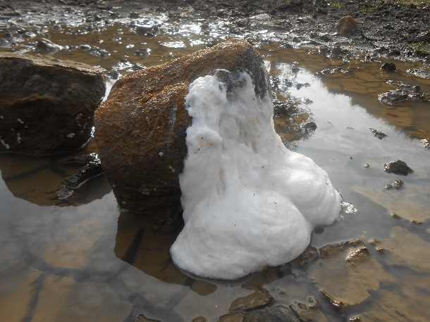

**Fig. 1a** Foam egg nest of *R. maximus* at a breeding site (temporary rainfed pool) located at Mawsynram (25° 18’ N, 91° 35’ E; 1,413 m asl).

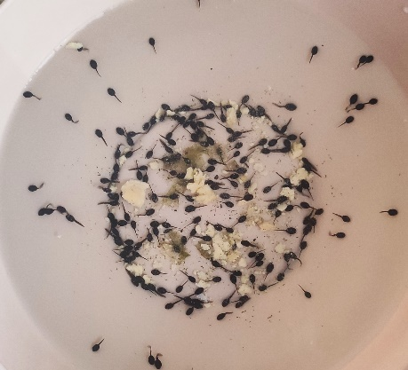

**Fig. 1b** Tadpoles reared under laboratory conditions

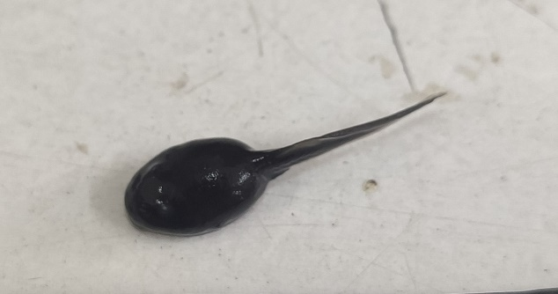

**Fig. 1c** Tadpole at Gosner stage 27 (Gosner, 1960)

**Fig. 2** (a) Light micrograph showing erythrocytes of control *Rhacophorus maximus* tadpoles. (a) Control group displaying normal red blood cells. Round cell (R), Oval cell (O), Round cell with centrally placed nucleus (RC), Round cell with eccentrically placed nucleus (RE), Oval cell with centrally placed nucleus (OC), Oval cell with eccentrically placed nucleus (OE), Centrally placed nucleus (CN).

(b-d) Light micrograph showing erythrocytes of treated *Rhacophorus maximus* tadpoles displaying abnormal red blood cells subject to exposure to sub-lethal dose of urea (1, 5, 10) in g/L. Membrane internalization (MI), Oblong cell with dislocation of nucleus towards periphery (Ob), Membrane disintegration (MD), Enucleated cell (E), Crenulated cell (Cr), Lobopodial projection (Lp), Contracted cell (Co), Spindle shaped cell (Sp). (Scale bar = 10 µm).



**Fig. 3** (a) Scanning electron micrograph showing erythrocytes of control *Rhacophorus maximus* tadpoles displaying normal red blood cells. Abbreviation: (OC) Oval cell.

(b-d) Scanning electron micrograph showing round (RC) and oval erythrocytes of treated *Rhacophorus maximus* tadpoles displaying abnormal red blood cells subject to exposure to sub-lethal dose of urea (1, 5, 10) in g/L. Membrane internalization (MI), Lobopodial projection (LP), Contracted cell (Co). (Scale bar = 20 µm).

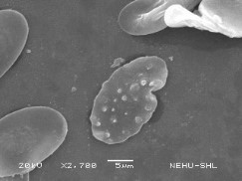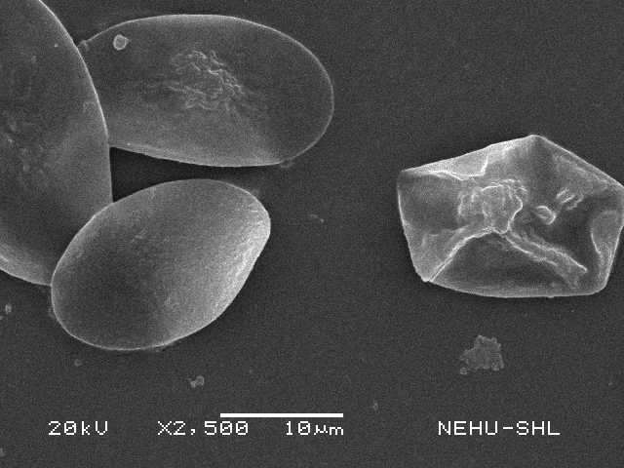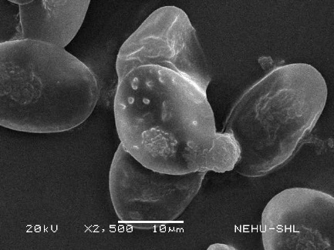

d

e

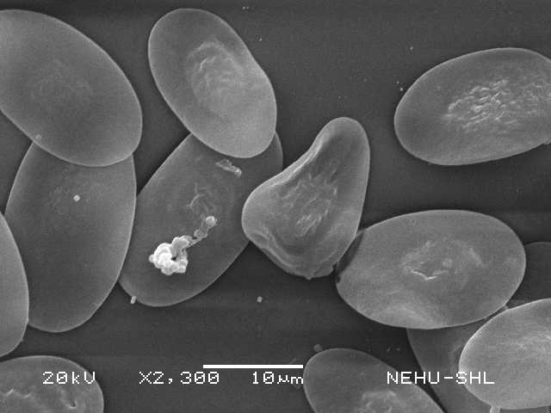

g

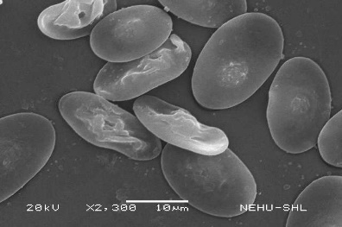

f

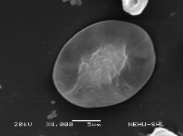

a

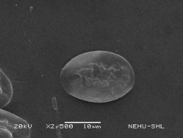

b

c

**Fig. 4** Scanning electron micrograph showing different types of red blood cells of *R. maximus* tadpoles at higher magnification.

1. Round cell (RC) (b) Oval cell (c) Crenulated cell (Cr) (d) Contracted cell (Co) (e) Membrane disintegration (MD) (f) and (g) Membrane internalization (MI)



**Fig. 5** Percent abnormality in the shape of red blood cells of *R. maximus* tadpoles exposed to sub-lethal concentrations of urea. * indicates significant differences between the groups, *** <0.001. All values are taken as Mean ± SEM.

**Table 1** The table displays the count of red blood cells (normal and abnormal RBCs shape) and total percent abnormality seen in the control group and the three treated groups (1, 5 and 10 g/L) of *Rhacophorus maximus* tadpoles when exposed to urea fertilizer. All values are given in Mean ± SEM (n=60)

|  |  |  |  |  |
| --- | --- | --- | --- | --- |
| **Number of red blood cells observed in *R. maximus* tadpoles** | **Concentration of urea (in g/L)** | | | |
| **Control** | **1** | **5** | **10** |
| Total number of red blood cells counted | 44.9±1.22 | |  | | --- | | 32.4±0.41 | | |  | | --- | | 32.6±0.54 | | |  | | --- | | 32.5±0.81 | |
| Total number of abnormal red blood cells (a-i) | 1.7±0.21 | |  | | --- | | 6.6±0.31 | | |  | | --- | | 10.3±0.76 | | |  | | --- | | 12.4±0.4 | |
| |  | | --- | | a. Membrane disintegration with displacement of nucleus towards periphery | | 0.1±0.10 | 1.8±0.25 | 1.8±0.33 | 2±0.21 |
| b. Lobopodial projection | 0.6±0.16 | 0.5±0.22 | 0.3±0.15 | 1.3±0.21 |
| c. Contracted cells | 0.4±0.16 | 0.4±0.17 | 0.4±0.13 | 1.6±0.16 |
| d. Ruptured cells | 0.1±0.10 | 0.4±0.16 | 0.6±0.31 | 0.3±0.21 |
| e. Membrane internalization | 0 | 1.9±0.28 | 1.8±0.25 | 2.4±0.16 |
| f. Crenulated cells | 0 | 0.3±0.15 | 1.2±0.29 | 1.6±0.16 |
| g. Enucleated cells | 0.3±0.15 | 0.3±0.15 | 2±0.15 | 1.7±0.15 |
| h. Oblong cells | 0.2±0.13 | 0.6±0.16 | 1.4±0.27 | 1.1±0.28 |
| i. Spindle shaped cells | 0 | 0.3±0.15 | 1±0.26 | 0.4±0.16 |
| Total percent abnormality (%) | 2.19±0.13 | 19.72±0.41 | 32.32±0.80 | 37.39±0.55 |