**Phytoplankton diversity and distribution in relation to hydro biological factors in three industrial hotspots of the Northern Gulf of Kachchh, Gujarat, India**

**Abstract**:

Phytoplankton serve as crucial indicators of environmental health, reflecting changes in water quality. By monitoring water quality parameters, we can assess the overall status of the coastal/marine ecosystem hence the diversity, distribution, and abundance of phytoplankton and their relationship to hydro-biological factors were investigated at three industrial hotspots in the Northern Gulf of Kachchh. The density of phytoplankton species ranged from 237*103 to 1115*103 No/lit. The Shannon wiener diversity index, Margalef richness index, and Pielou's evenness index, respectively, were 2.498 to 3.746, 4.941 to 7.531 and 0.259 to 0.9 during the study. 78 taxa from three phyla and three classes were reported throughout the study period. *Chaetoceros* was the most dominant genus among other groups. The study was carry out for 2 years and planktons were collected from study sites by using plankton net.

During all seasons, taxa such as *Fragilariopsis oceanica, Nitzschia* sp*, Biddulphia* sp*, Asterionella japonica, Ditylum sol, Pleurosigma* sp, and *Trieres mobiliensis* were documented from all sites during all seasons. The influence of dissolved oxygen, turbidity, temperature, salinity, pH, total suspended solid, nitrites, nitrates, and phosphate on plankton distribution and abundance has been discussed. The areas were selected based on the presence of industrial establishments, coastal characteristics and the study will serve as a baseline database for future research. The various industrial activities may have adverse effect on the plankton diversity.

**Key words**

Diversity indices, Hydrological parameters, Phytoplankton, Industrial activities,

**Introduction**:

In terms of taxonomy, size, and growth form, phytoplankton is a very diverse group of organisms that includes unicellular, pseudocellular, colonial, and multicellular organisms. It also includes nonphotosynthetic ciliates, nonphotosynthetic eukaryotes with photosynthetic symbionts, cyanobacterial endosymbionts, and diazotrophic cyanobacterial endosymbionts (Beardall et al., 2020) Some marine plants, whether unicellular or multicellular, attached to substrata or free-floating, spend some of their life cycle as phytoplankton. However, organisms that always remain planktonic throughout their life cycle are Diatoms, Dinoflagellates, Coccolithophores, selective blue-green algae species, and some green algae. (Mitra *et* *al*., 2006) It is the base of the food web and serves as prey for zooplankton and other commercially significant marine creatures. It plays a significant role in the food web, the carbon cycle, and the sedimentation process that transfers organic materials from the ocean floor. It contributes less than 1% of photosynthesis biomass but contributes nearly 50% of global primary production (Falkowski, 2012; Pal and Chaudhary, 2014).

Phytoplankton is also a good source of minerals, vitamins, amino acids, proteins, omega-3 essential fatty acids, antioxidants, carotenoids, phytonutrients, chlorophyll, trace minerals and phytochemicals. Phytoplankton biodiversity is very crucial for ecosystem stability and marine biogeochemistry (Dutkiewicz *et al.,* 2020).

The spatial mapping of phytoplankton helps in determining the hotspots area based on abundance and diversity of phytoplankton (Nassar and Gharib, 2014). Phytoplankton contains high species diversity (over 20,000 species) and a wide range of sizes and trophic modes that play an integral role in marine ecosystems worldwide (Faiza and Saburova 2019). There may be 100,000-200000 diatom species worldwide (Wang *et al*., 2022), but only a small proportion of them (i.e. 1400-1800) are considered as marine. So far, more than 4300 phytoplankton species have been described (Sournia *et al.*,1991), and possibly more than 10000 as per de Vargas *et al.*, 2015. Leblanc*et al* (2012) compiled a global map of diatom distribution, abundance, and biomass.

Dinoflagellates are another important group of phytoplankton, with an estimated 2,000 living species and 2,500 named fossil species worldwide (Taylor, 2008). Gómez (2005) listed 1555 species (117 genera) of free-living marine dinoflagellates (excluding Phytodiniales Christensen ex Loeblich III), whereas Young *et al*. (2005) estimated extant coccolithophore diversity to be between 200 and 500 (excluding holococcolithophores).

The diversity and distribution of phytoplankton have been extensively studied in India, both on the east and west coasts. Information on the phytoplankton diversity, seasonal variations and spatial distribution, productivity characteristics and hydro-biological factors as well as their relationship to plankton are well documented (Sawant and Madhupratap, 1996).

In Gujarat, the study of plankton diversity, abundance, primary productivity and its relation to water quality is mostly confined to Gulf of Kachchh (Dhawan, 1970; Nair, 2002; Thakur *et al*., 2015) while few studies conducted along the coast of Saurashtra (Temkar *et al.,* 2015; Vase *et al.,* 2018) and the Gulf of Khambhat including South Gujarat (Subir Kumar, 2004); Vachhrajani and Mankodi, 2007: Bhavsar and Pandya , 2018).

Except for Kharo creek and Kandla, the phytoplankton community structure has not been studied recently. Hence the current study on the spatial distribution and diversity of phytoplankton is proposed to determine the state of the ecosystem structure and functioning along the Northern coast of Gulf of Kachchh. The relationship between phytoplankton community and hydrobiological parameters is also being investigated. This will work as a baseline data for future research. All three study sites are industrial hotspots as well as ecological very important.

**Materials and methods**

**Study area**: The research was carried out at three different locations along the northern coast of the Gulf of Kachchh in Gujarat, India. The locations were chosen based on their various coastal characteristics and industrial establishments. The Mundra coast (22.762702, 69.618471) is crisscrossed by creek systems that form extensive mudflats and also harbors luxurious mangroves having a very dense mangrove vegetation at surrounding areas, The Mandvi coast (22.836455, 69.215100) is distinguished by sandy beaches, open sea, and partly rocky outcomes. Mandvi emerge as a tourist place due to its sandy beach and Sanghi Creek (23.388244, 68.557581) is one of the largest creeks in northern GOK, rich in mangrove vegetation, and has the coldest winter weather in Gujarat. It possesses various industrial establishments on its banks specially jetties. Samplings were carried out monthly during high tide and low tide. (Fig. 1).

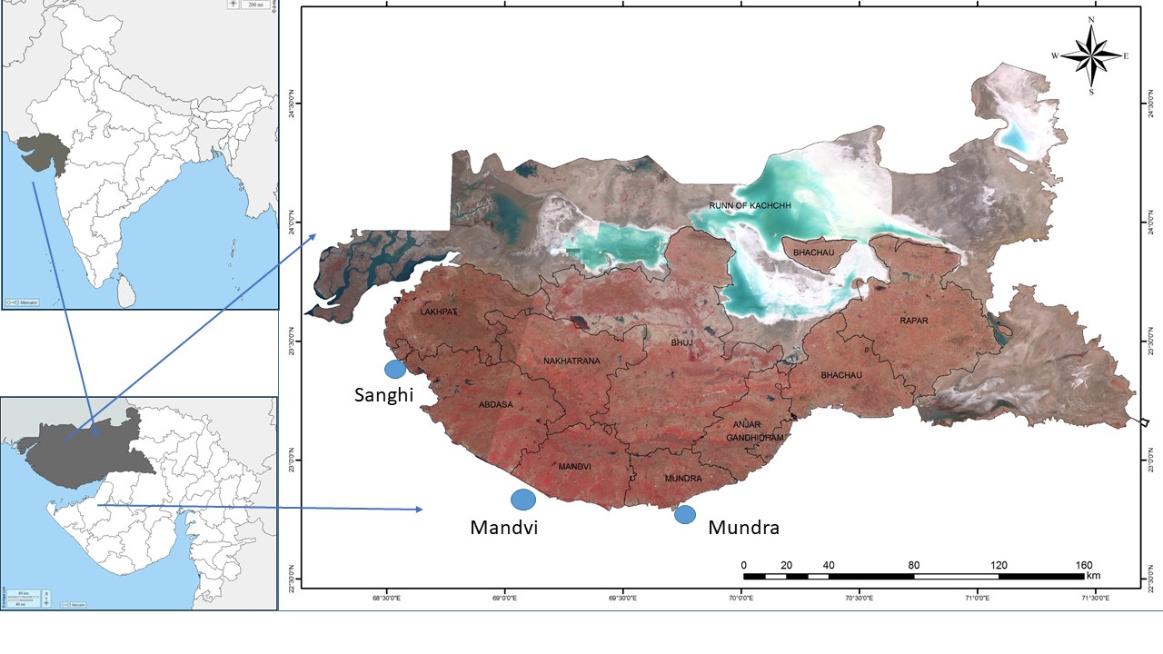

**Fig. 1 – Study area**

**Sampling**:

For the sampling of quantitative collection of plankton, we used plankton net of 51-micron mesh size having a 40 cm diameter and 135 cm length fitted with the flowmeter and towed it with a mechanized boat at a speed of 2 nautical mile/hr. The collected plankton were transferred into plastic bottles and preserved with 5% neutralized formaldehyde.

The flowmeters initial and final readings were noted for calculating the water filtered through it. One litre of seawater was also taken into a plastic bottle and allowed to settle. Overlaying water was allowed to drain and concentrated soup was used to check the density of plankton with plankton net method.

For quantitative analysis the sub sample of the phytoplankton soup were counted using Sedgwick rafter cell in the microscope. The Density of the phytoplankton were calculated using formula

$N$ =n*v/V

where N is Total number of plankton/L, n is average of no of cell in 1 ml, v is volume of concentrate and V is total volume of water filtered).

In order to counter check the density and diversity of phytoplankton the same water was estimated though settlement methods as well. Phytoplankton species were identified using standard identification monographs of Subramanian (1946,1968,1971).

Different diversity and dominance indices (Shannon -Weaver, Margalef, Pielou evenness) for species diversity, evenness and richness were computed following Magurran (1988) for all the samples. Agglomerative hierarchical cluster analysis and MDS was used to assess level of similarity among different stations in all the 3 seasons in both the years.

For hydro biological characteristics of water, in situ hydro-biological factors were noted during sampling (i.e. water temperature, air temperature, salinity and pH). Water samples were collected in duplicate in pre rinsed dried polyethylene bottle for TSS, Nitrate, Nitrite, Phosphate, Turbidity and stored in icebox at 40C. For Dissolved Oxygen water sample was estimated by Winkler method. Temperature was noted with the help of digital thermometer with accuracy of 0.10C. Water salinity were measured using raflectometer (Aatago- Japan). pH was also measured using digital pH meter with accuracy of 0.1 unit. (Weathertronics, Type 705). Nitrate and Nitrite were measured using Brucine (Spectrophotometry) method while Phosphate was measured using Blue phosphomolybdate method (spectrophotometry) by UV-VIS spectrophotometer (Shimadzu- UV 1601). Turbidity were measured using Nephelometry with the help of turbidity meter (Hanna HI 93703). TSS were measured using filtration method while TDS were measured using conductimetry with the help of Digital EC-TDS meter - Model- (Systronics 308).

**Result and Discussion**:

**Phytoplankton composition and distribution:**

Phytoplankton composition, distribution and diversity were studied for 24 months. During 1st and 2nd year, a total of 78 and 73 taxa were reported respectively. Among the recorded taxa, 2 belong to Cynobacteria, 11 belong to Myzozoa and 65 belong to the phylum Bacillariophyta.

The phylum Bacillariophyta was the most dominant phylum, consisting of 83.33 and 83.56% of recorded taxa during 1st and 2nd year respectively. The Phylum Cyanobacteria and Myzozoa contributed 2.56 % and 14.10% of the taxa during the present study.

Throughout the study period, a total of 43 genera belonging to 28 families and 24 orders were recorded. During the present study, a total of 36,42 and 39 genera were reported from Mandvi, Mundra and Sanghi. Year wise, these stations represent 31,36 and 36 genera during 1st year and 33,39 and 35 during 2nd year. (Table 1)

There was no seasonal consistency observed in the generic composition as during 1st year a total of 37, 28 and 35 genera were reported, while in 2nd year the generic composition was 33, 35 and 35 respectively for summer, monsoon and winter.

During the study period, winter had the highest species composition (72), followed by summer (70), and Monsoon (66). Mundra has the highest number of taxa (75), followed by Sanghi (73) and Mandvi (60). The number of species was higher in the first year, with 47, 60, and 67 species reported in 1st year and 57, 69, and 65 species recorded in 2nd year along Mandvi, Mundra, and Sanghi, respectively. (Table 2)

**Table 1: Phytoplankton density in different station and seasons during 1st and 2nd year(No/Lit)**

|  |  |  |  |  |  |  |  |  |  |  |  |  |
| --- | --- | --- | --- | --- | --- | --- | --- | --- | --- | --- | --- | --- |
| **Sr No** | **Species** | **1st and 2nd year (density in 1000 numbers/litre)** | | | | | | | | | | |
| **Summer** | | | **Monsoon** | | | **Winter** | | | |
| **Mandvi** | **Mundra** | **Sanghi** | **Mandvi** | **Mundra** | **Sanghi** | **Mandvi** | **Mundra** | **Sanghi** |
| 1 | *Cocconeis* sp. | 0 & 0 | 0 & 0 | 7 & 2 | 0 & 0 | 0 & 0 | 0 & 0 | 0 & 0 | 0 & 9 | 0 & 8 |
| 2 | *Nitzschia braarudii* | 0 & 0 | 0 & 0 | 0 & 2 | 0 & 1 | 0 & 4 | 0 & 0 | 0 & 0 | 0 & 3 | 1 & 0 |
| 3 | *Nitzschia distans* | 18 & 21 | 15 & 21 | 0 & 12 | 0 & 0 | 0 & 0 | 0 & 7 | 0 & 0 | 2 & 5 | 0 & 3 |
| 4 | *Nitzschia longissima* | 21 & 0 | 12 & 13 | 0 & 0 | 1 & 5 | 2 & 19 | 3 & 14 | 0 & 0 | 1 & 2 | 0 & 0 |
| 5 | *Nitzschia* sp. | 8 & 17 | 12 & 11 | 20 & 11 | 5 & 6 | 3 & 11 | 5 & 25 | 3 & 29 | 12 & 23 | 25 & 19 |
| 6 | *Pseudo-nitzschia* sp. | 0 & 0 | 1 & 0 | 0 & 0 | 0 & 0 | 0 & 0 | 0 & 0 | 0 & 0 | 4 & 0 | 5 & 0 |
| 7 | *Biddulphia* sp. | 10 & 11 | 16 & 27 | 36 & 42 | 7 & 8 | 15 & 21 | 58 & 66 | 5 & 6 | 55 & 54 | 3 & 48 |
| 8 | *Bidulphia heteroceros* | 8 & 23 | 16 & 0 | 1 & 1 | 1 & 11 | 4 & 21 | 1 & 5 | 9 & 10 | 13 & 15 | 2 & 155 |
| 9 | *Bacteriastrum sp* | 0 & 0 | 11 & 15 | 17 & 0 | 0 & 0 | 0 & 13 | 0 & 0 | 0 & 0 | 0 & 0 | 0 & 0 |
| 10 | *Chaetoceros affinis* | 9 & 12 | 11 & 23 | 0 & 0 | 0 & 12 | 0 & 12 | 0 & 0 | 0 & 6 | 0 & 11 | 0 & 10 |
| 11 | *Chaetoceros curvisetus* | 0 & 0 | 0 & 29 | 0 & 3 | 0 & 11 | 0 & 31 | 0 & 12 | 0 & 0 | 15 & 21 | 33 & 21 |
| 12 | *Chaetoceros debilis* | 0 & 0 | 0 & 0 | 0 & 0 | 0 & 0 | 0 & 9 | 0 & 0 | 0 & 0 | 58 & 39 | 43 & 0 |
| 13 | *Chaetoceros didymus* | 0 & 0 | 0 & 31 | 8 & 6 | 1 & 24 | 0 & 12 | 6 & 11 | 0 & 0 | 12 & 9 | 21 & 9 |
| 14 | *Chaetoceros diversus* | 0 & 8 | 10 & 0 | 0 & 0 | 0 & 11 | 0 & 44 | 0 & 33 | 0 & 43 | 0 & 12 | 0 & 11 |
| 15 | *Chaetoceros peruvianus* | 0 & 0 | 10 & 9 | 7 & 6 | 0 & 0 | 0 & 0 | 0 & 0 | 0 & 0 | 0 & 0 | 0 & 36 |
| 16 | *Chaetoceros simplex* | 0 & 0 | 0 & 12 | 23 & 25 | 0 & 0 | 0 & 0 | 0 & 21 | 0 & 0 | 0 & 21 | 0 & 0 |
| 17 | *Chaetoceros* sp. | 0 & 0 | 33 & 27 | 57 & 46 | 0 & 27 | 2 & 8 | 4 & 28 | 0 & 21 | 219 & 167 | 321 & 144 |
| 18 | *Climacosphenia* sp. | 1 & 6 | 0 & 0 | 0 & 0 | 0 & 8 | 0 & 9 | 0 & 0 | 0 & 0 | 0 & 0 | 0 & 21 |
| 19 | *Coscinodiscus gigas* | 28 & 11 | 10 & 11 | 0 & 5 | 6 & 17 | 7 & 11 | 52 & 69 | 4 & 6 | 5 & 9 | 0 & 9 |
| 20 | *Coscinodiscus granii* | 47 & 13 | 16 & 16 | 0 & 8 | 16 & 21 | 11 & 14 | 51 & 57 | 3 & 5 | 11 & 13 | 14 & 13 |
| 21 | *Coscinodiscus lineatus* | 15 & 21 | 14 & 9 | 0 & 5 | 1 & 9 | 0 & 15 | 2 & 4 | 3 & 5 | 1 & 5 | 0 & 0 |
| 22 | *Coscinodiscus oculus* | 0 & 0 | 19 & 0 | 1 & 0 | 11 & 0 | 4 & 0 | 24 & 21 | 2 & 5 | 14 & 0 | 4 & 4 |
| 23 | *Coscinodiscus radiatus* | 7 & 13 | 12 & 23 | 0 & 0 | 0 & 0 | 1 & 9 | 0 & 0 | 4 & 5 | 1 & 6 | 8 & 4 |
| 24 | *Coscinodiscus sol* | 0 & 9 | 1 & 21 | 34 & 2 | 8 & 5 | 6 & 10 | 16 & 62 | 1 & 4 | 1 & 36 | 6 & 27 |
| 25 | Coscinodiscus sp. | 1 & 18 | 15 & 8 | 2 & 2 | 21 & 33 | 6 & 44 | 22 & 21 | 6 & 14 | 12 & 34 | 8 & 0 |
| 26 | *Coscinodiscus* sp*.*2 | 1 & 18 | 16 & 8 | 1 & 2 | 23 & 33 | 22 & 44 | 18 & 21 | 13 & 14 | 18 & 34 | 66 & 0 |
| 27 | *Cymbella* sp. | 0 & 0 | 0 & 0 | 0 & 0 | 0 & 0 | 0 & 13 | 1 & 0 | 0 & 0 | 1 & 0 | 0 & 0 |
| 28 | *Fragilaria oceanica f. oceanica* | 1 & 5 | 4 & 12 | 33 & 12 | 3 & 9 | 6 & 11 | 8 & 9 | 12 & 14 | 68 & 56 | 3 & 49 |
| 29 | *Asterionella japonica* | 7 & 15 | 11 & 12 | 29 & 28 | 5 & 12 | 5 & 18 | 25 & 26 | 3 & 4 | 7 & 9 | 5 & 7 |
| 30 | *Ceratoneis closterium* | 0 & 23 | 0 & 0 | 0 & 0 | 0 & 12 | 0 & 0 | 2 & 4 | 0 & 13 | 2 & 5 | 2 & 3 |
| 31 | *Synedra sigma* | 0 & 0 | 11 & 10 | 0 & 2 | 0 & 0 | 0 & 34 | 0 & 0 | 0 & 80 | 0 & 44 | 0 & 38 |
| 32 | *Ditylum brightwelli* | 0 & 13 | 18 & 19 | 17 & 15 | 15 & 22 | 18 & 31 | 58 & 61 | 2 & 5 | 38 & 41 | 5 & 41 |
| 33 | *Ditylum sol* | 7 & 9 | 16 & 21 | 1 & 2 | 1 & 5 | 2 & 10 | 52 & 62 | 1 & 4 | 34 & 36 | 6 & 27 |
| 34 | *Tropidoneis fusiformis* | 1 & 0 | 0 & 0 | 0 & 0 | 0 & 0 | 0 & 11 | 0 & 0 | 0 & 0 | 0 & 0 | 0 & 0 |
| 35 | *Navicula* sp. | 80 & 23 | 0 & 0 | 0 & 15 | 2 & 15 | 1 & 23 | 3 & 17 | 2 & 3 | 11 & 26 | 2 & 25 |
| 36 | *Gyrosigma balticum* | 1 & 5 | 1 & 3 | 33 & 28 | 0 & 9 | 0 & 9 | 2 & 4 | 1 & 3 | 4 & 7 | 0 & 5 |
| 37 | *Gyrosigma* sp. | 1 & 17 | 1 & 14 | 1 & 4 | 9 & 14 | 15 & 19 | 4 & 5 | 6 & 8 | 10 & 12 | 4 & 0 |
| 38 | *Pleurosigma angulatum* | 0 & 14 | 0 & 4 | 10 & 9 | 0 & 0 | 0 & 0 | 0 & 0 | 0 & 0 | 0 & 0 | 0 & 0 |
| 39 | *Pleurosigma elongatum* | 1 & 5 | 1 & 9 | 7 & 0 | 0 & 8 | 0 & 11 | 0 & 34 | 0 & 0 | 1 & 1 | 0 & 0 |
| 40 | *Pleurosigma* sp. | 2 & 7 | 2 & 31 | 2 & 11 | 46 & 39 | 17 & 23 | 10 & 27 | 5 & 23 | 15 & 14 | 5 & 11 |
| 41 | *Rhizosolenia castracanei* | 0 & 0 | 0 & 0 | 0 & 0 | 0 & 0 | 0 & 0 | 0 & 0 | 1 & 4 | 0 & 0 | 7 & 0 |
| 42 | *Rhizosolenia cochlea* | 0 & 12 | 0 & 0 | 0 & 0 | 0 & 12 | 0 & 4 | 0 & 11 | 0 & 0 | 0 & 3 | 1 & 2 |
| 43 | *Rhizosolenia* sp. | 12 & 0 | 37 & 18 | 34 & 30 | 23 & 19 | 4 & 11 | 5 & 9 | 2 & 6 | 8 & 11 | 3 & 8 |
| 44 | *Sundstroemia setigera* | 0 & 21 | 0 & 19 | 12 & 12 | 0 & 0 | 0 & 0 | 1 & 3 | 0 & 0 | 1 & 5 | 0 & 6 |
| 45 | *Grammatophora undulata* | 21 & 8 | 1 & 0 | 0 & 0 | 0 & 0 | 0 & 0 | 0 & 0 | 90 & 91 | 1 & 10 | 16 & 9 |
| 46 | *Campylodiscus* sp. | 1 & 0 | 1 & 17 | 4 & 5 | 0 & 0 | 1 & 6 | 5 & 9 | 2 & 3 | 3 & 0 | 144 & 0 |
| 47 | *Surirella* sp. | 0 & 0 | 1 & 0 | 0 & 0 | 0 & 0 | 1 & 0 | 0 & 0 | 1 & 0 | 0 & 0 | 0 & 0 |
| 48 | *Thalassiothrix* sp. | 0 & 0 | 0 & 0 | 0 & 0 | 0 & 0 | 0 & 0 | 1 & 15 | 0 & 0 | 0 & 44 | 5 & 37 |
| 49 | *Amphora* sp. | 0 & 0 | 0 & 0 | 15 & 15 | 0 & 0 | 0 & 0 | 0 & 0 | 1 & 2 | 0 & 0 | 0 & 0 |
| 50 | *Lauderia* sp. | 0 & 0 | 0 & 0 | 0 & 0 | 0 & 13 | 1 & 2 | 0 & 4 | 6 & 5 | 18 & 23 | 53 & 20 |
| 51 | *Skeletonema* sp. | 10 & 15 | 0 & 19 | 0 & 0 | 0 & 0 | 0 & 29 | 0 & 9 | 0 & 0 | 1 & 3 | 0 & 1 |
| 52 | *Thalassiosira coramandeliana* | 0 & 0 | 0 & 0 | 0 & 0 | 0 & 0 | 0 & 0 | 0 & 0 | 0 & 0 | 1 & 0 | 1 & 0 |
| 53 | *Thalassiosira eccentrica* | 0 & 0 | 11 & 23 | 28 & 31 | 0 & 12 | 0 & 21 | 0 & 0 | 0 & 0 | 0 & 0 | 0 & 0 |
| 54 | *Planktoniella blanda* | 0 & 0 | 3 & 11 | 0 & 0 | 1 & 2 | 0 & 0 | 0 & 6 | 5 & 6 | 4 & 2 | 6 & 1 |
| 55 | *Cyclotella* sp. | 0 & 0 | 1 & 0 | 1 & 0 | 1 & 3 | 1 & 4 | 12 & 10 | 5 & 7 | 0 & 0 | 7 & 0 |
| 56 | *Eupodiscus jonesianus* | 0 & 0 | 12 & 19 | 11 & 12 | 0 & 13 | 0 & 23 | 0 & 21 | 0 & 0 | 0 & 14 | 0 & 10 |
| 57 | *Hobaniella longicruris* | 0 & 0 | 0 & 12 | 0 & 2 | 0 & 0 | 0 & 0 | 6 & 16 | 0 & 0 | 0 & 0 | 1 & 0 |
| 58 | *Odontella aurita* | 7 & 0 | 10 & 21 | 0 & 14 | 2 & 8 | 0 & 12 | 1 & 3 | 22 & 23 | 1 & 4 | 4 & 3 |
| 59 | *Triceratium favus* | 1 & 6 | 10 & 28 | 1 & 1 | 2 & 2 | 3 & 11 | 7 & 4 | 4 & 12 | 31 & 29 | 0 & 25 |
| 60 | *Triceratium reticulum* | 1 & 6 | 0 & 0 | 10 & 8 | 1 & 1 | 0 & 0 | 1 & 5 | 2 & 23 | 0 & 0 | 0 & 0 |
| 61 | *Trieres mobiliensis* | 11 & 15 | 1 & 11 | 28 & 25 | 30 & 32 | 32 & 57 | 15 & 23 | 14 & 15 | 65 & 67 | 9 & 56 |
| 62 | *Eucampia* sp. | 1 & 0 | 46 & 33 | 0 & 0 | 4 & 3 | 31 & 23 | 2 & 4 | 9 & 12 | 38 & 67 | 9 & 56 |
| 63 | *Eucampia zoodiacus* | 0 & 0 | 21 & 0 | 0 & 0 | 0 & 0 | 0 & 0 | 0 & 0 | 0 & 0 | 0 & 0 | 0 & 0 |
| 64 | *Hemiaulus sinensis* | 15 & 0 | 0 & 0 | 0 & 0 | 0 & 0 | 0 & 0 | 0 & 0 | 0 & 0 | 5 & 7 | 0 & 0 |
| 65 | *Leptocylindrus* sp. | 22 & 31 | 23 & 28 | 9 & 9 | 0 & 26 | 1 & 4 | 0 & 13 | 0 & 0 | 0 & 0 | 0 & 15 |
| 66 | *Anabaena* sp. | 0 & 0 | 1 & 0 | 0 & 0 | 0 & 0 | 0 & 0 | 0 & 0 | 0 & 0 | 0 & 0 | 0 & 0 |
| 67 | *Oscillatoria* sp. | 0 & 0 | 0 & 0 | 0 & 0 | 40 & 40 | 13 & 11 | 20 & 28 | 1 & 5 | 0 & 0 | 2 & 0 |
| 68 | *Dinophysis caudata* | 0 & 0 | 0 & 22 | 1 & 1 | 0 & 0 | 0 & 0 | 0 & 8 | 0 & 0 | 0 & 0 | 0 & 12 |
| 69 | *Dinophysis miles* | 0 & 0 | 0 & 0 | 1 & 0 | 0 & 0 | 0 & 11 | 0 & 0 | 1 & 3 | 0 & 0 | 3 & 0 |
| 70 | *Tripos brevis* | 0 & 0 | 0 & 0 | 7 & 7 | 0 & 6 | 0 & 13 | 0 & 14 | 0 & 0 | 0 & 7 | 0 & 6 |
| 71 | *Tripos declinatus* | 0 & 0 | 0 & 0 | 0 & 8 | 0 & 0 | 0 & 0 | 0 & 9 | 0 & 0 | 0 & 9 | 1 & 8 |
| 72 | *Tripos falcatiformis* | 0 & 11 | 1 & 9 | 1 & 3 | 0 & 7 | 0 & 0 | 0 & 0 | 0 & 0 | 0 & 0 | 2 & 0 |
| 73 | *Tripos falcatus* | 0 & 0 | 0 & 0 | 0 & 0 | 0 & 0 | 0 & 13 | 0 & 0 | 0 & 0 | 0 & 11 | 2 & 10 |
| 74 | *Tripos furca* | 0 & 0 | 9 & 17 | 1 & 0 | 3 & 3 | 2 & 19 | 1 & 5 | 0 & 23 | 6 & 0 | 3 & 0 |
| 75 | *Tripos kofoidii* | 0 & 0 | 1 & 0 | 1 & 2 | 0 & 0 | 0 & 7 | 0 & 0 | 0 & 0 | 1 & 4 | 2 & 3 |
| 76 | *Tripos macroceros* | 0 & 0 | 0 & 8 | 0 & 0 | 0 & 0 | 0 & 0 | 0 & 3 | 0 & 0 | 0 & 0 | 1 & 0 |
| 77 | *Tripos muelleri* | 0 & 0 | 0 & 0 | 3 & 4 | 0 & 0 | 0 & 18 | 2 & 11 | 0 & 0 | 1 & 12 | 5 & 11 |
| 78 | *Protoperidinium depressum* | 23 & 12 | 1 & 11 | 0 & 0 | 0 & 0 | 0 & 0 | 0 & 0 | 0 & 0 | 3 & 4 | 5 & 0 |

Station wise, generic and species composition were observed higher in Mundra compared to Mandvi and Sanghi. However seasonal inconsistency between first and second year among stations could be seen.

During this study, 57 species (73%) showed substantial temporal distribution and were observed in all three seasons, whereas species such as *Anabaena* sp*., Eucampia zoodiacus,* and *Pleurosigma angulatum* were only reported during the summer season, and *Rhizosolenia castracanea* and *Thalassiosira coramandeliana* were only reported during the winter season.

In the present study, 34 and 45 species had more than 50% relative frequency of occurrence during 1st and 2nd year respectively.

There were a total of 28 families reported in this study. The Chaetocerataceae family was the most diverse, with nine species, followed by the Ceratiaceae and Coscinodiscaceae families, each with eight species. A total of 14 families were represented by a single taxon.

In the present study, a total of 24 orders were reported. Among them, Chaetoceratanae were the most diverse, with nine species, followed by Coscinodiscales and Gonyaulacales, each with eight species (Fig. 2).

**Fig. 2 - Percentage share of orders**

Mandvi (60) would have less phytoplankton diversity and abundance due to its open coastal nature with high turbulent waters and high turbidity. Mundra (75) and Sanghi (73), on the other hand, reported higher diversity and abundance due to the presence of a mangrove-lined creek and nutrient influx from nearby Mangrove areas. Seasonally, the monsoon season had slightly less diversity than the winter and summer seasons, which could be due to accelerated TSS levels brought in by terrestrial runoff. Usually, higher diversity dominated by diatoms exhibits higher photosynthetic rates and is related to water temperature and salinity (Duarte *et al.,* 2006).

The high species diversity (78 taxa) reported during the study could be attributed to the low water speed and high stability of the water column, which is consistent with other notable studies conducted along the Gujarat coast, such as Nair (2002), Saravanakumar *et al*. (2008), Thakur *et al* (2015) and Joshi *et al.,* (2019).

**K dominance curve:**

Multiple K dominance plots were created for all samples, stations, and seasons in this investigation. Fig. 3 depicts the results of all the samples gathered throughout the investigation. The greatest faunal population was 52 in Mundra during the monsoon 20208-09 and winter 2008-09. During the monsoon 2008, the lowest species count (29) was recorded at Mandvi.



**Fig. 3 - K Dominance curve for phytoplankton**

**Cluster analysis**

To evaluate how similar, the stations were, cluster analysis was utilised. The most resemblance was found between Summer Sanghi 1st year and Summer Sanghi 2nd year (76.83 %) (Fig. 4). In the first year, the highest similarity (66.15 %) was found between Mandvi Monsoon and Munda Monsoon, and in the second year, the highest similarity (75.77) was found between Sanghi Winter and Mundra Winter. The same is true for MDS ordination.

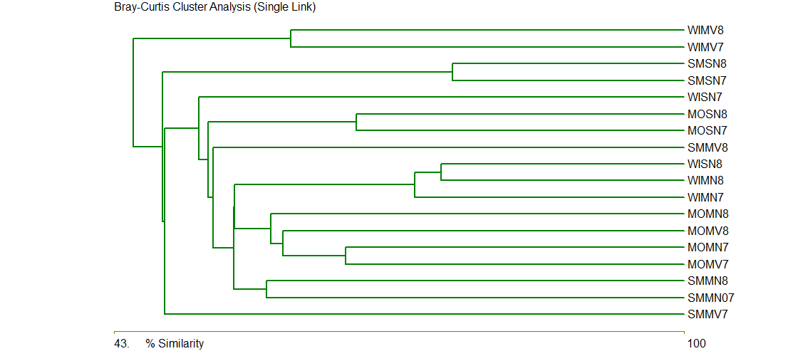

**Fig. 4 - Cluster analysis (Bray Curtis) among stations**

**Multi-dimensional scaling**

The pattern of grouping was confirmed using non-metric multi-dimensional scaling among stations. This attempts to satisfy all the conditions imposed by the rank (dis) similarity matrix (Fig. 5). The trend that was visible in cluster analysis was also visible here. The low stress value (0.15) reported in MDS shows a good representation of the plankton interaction between the stations examined. Seasonal as well as temporal similarities are visible between the stations and among the stations.



**Fig. 5 – MDS analysis among stations**

**Density**

Phytoplankton density varied from 237000 cells/L to 1115000 cells/L among seasons and stations in the current study. The density in the first year was 491000 cells/L, whereas in the second year it was 767000 cells/L. Sanghi has the highest density of 736000 cells per litre, followed by Mundra (723000 cells/L) and Mandvi (428000 cells/L). During the overall study period, phytoplankton density values were found to be greater during winter (783000 cells/L) followed by monsoon (577000 cells/L) and summer (527000 cells/L). The density of phytoplankton did not differ substantially between stations (F-3.2, p 0.039) as well as seasons. (F-1.53, p 0.21). *Chaetoceros* sp.*, Trieres mobiliensis* and *Biddulphia* sp. were the most dominant species among all recorded species during the entire study. (Table 1)

Phytoplankton density was low (237000 to 1115000 cells/L) during the current study, which could be attributed to low precipitation, high salinity and flash floods caused by terrestrial runoff, which exposes them to abrupt changes in governing parameters and renders them highly vulnerable. Similarly, to the current study, Nair (2002) reported low phytoplankton density (112000 cells/L) at Mundra and Jakhau (171000 cell/L). In contrast to the current study, Saravanakumar *et al*. (2008) reported high phytoplankton density in creek waters of mangrove-dominated coastal regions in western India.

**Species diversity, Evenness and Richness:**

Species diversity is a basic measure of community structure and organization and an important tool for assessing the environmental health. The index gives a measure of how individuals in a community are distributed.

Shannon diversity indices (H') values for phytoplankton ranged from 2.498 to 3.736 over the entire study period (Table 2, Fig. 6). The second year's diversity values were higher than the first year's. Mundra (3.931) had the highest value, followed by Mandvi (3.882) and Sanghi (3.825), while Summer (4.069) had the highest value, followed by Monsoon (3.867) and Winter (3.578). The recorded values show that phytoplankton is distributed evenly across the study stations. The diversity value did not differ significantly between seasons or stations, but it did differ significantly between years (F 24.52, p 0.0001). The species diversity index (H’) positively correlate with water nitrate (0.49) and phosphate (0.54) value. The Shannon's diversity index was strongly and positively correlated with Pielou's Evenness Index (0.87) and Margalef diversity index (0.57) which is consistent with other notable studies by france *et al.(*2021). To access the effect of hydrobiological parameters (physico-chemical parameters and nutrients) on plankton abundance, richness, Shannon, evenness index PCA analysis was performed (Fig. 7).

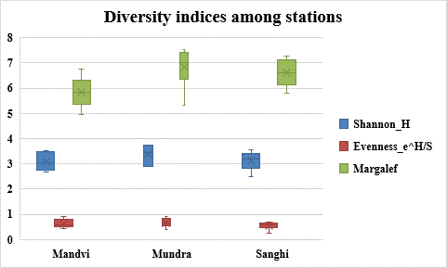

**Fig. 6 Diversity indices among stations**

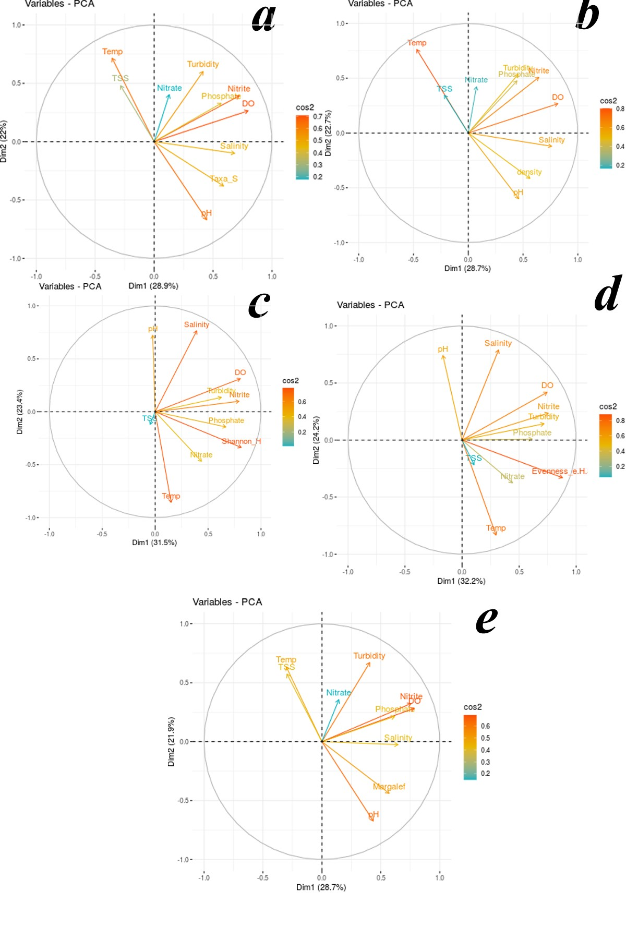

**Fig. 7 Effect of Hydrobiological parameters on number of taxa, plankton density, Shannon, Evenness and Margalef (a,b,c,d,e respectively)**

**Table 2: Species richness and diversity indices at Stations**

|  |  |  |  |  |  |  |  |  |  |
| --- | --- | --- | --- | --- | --- | --- | --- | --- | --- |
| **1st year** | **MVS78** | **MNS78** | **SNS78** | **MVM78** | **MNM78** | **SNM78** | **MVW78** | **MNW78** | **SNW78** |
| **Phylum** | 2 | 3 | 2 | 3 | 3 | 3 | 3 | 2 | 3 |
| **Class** | 2 | 3 | 2 | 3 | 3 | 3 | 3 | 2 | 3 |
| **Order** | 16 | 17 | 16 | 13 | 15 | 16 | 15 | 16 | 18 |
| **Family** | 17 | 18 | 17 | 15 | 17 | 17 | 18 | 19 | 21 |
| **Genus** | 23 | 28 | 23 | 19 | 21 | 24 | 23 | 28 | 28 |
| **Species** | 34 | 47 | 40 | 29 | 30 | 37 | 35 | 46 | 47 |
| **Shannon_H** | 2.898 | 3.449 | 3.161 | 2.765 | 2.898 | 2.951 | 2.676 | 2.882 | 2.498 |
| **Evenness_e^H/S** | 0.5337 | 0.6696 | 0.5896 | 0.5478 | 0.6043 | 0.5168 | 0.415 | 0.3881 | 0.2586 |
| **Margalef** | 5.508 | 7.388 | 6.246 | 4.941 | 5.304 | 5.782 | 6.153 | 6.691 | 6.78 |
| **2nd year** | **MVS89** | **MNS89** | **SNS89** | **MVM89** | **MNM89** | **SNM89** | **MVW89** | **MNW89** | **SNW89** |
| **Phylum** | 2 | 2 | 2 | 3 | 3 | 3 | 3 | 2 | 2 |
| **Class** | 2 | 2 | 2 | 3 | 3 | 3 | 3 | 2 | 2 |
| **Order** | 15 | 16 | 16 | 15 | 18 | 17 | 17 | 16 | 18 |
| **Family** | 16 | 17 | 17 | 18 | 22 | 21 | 20 | 19 | 21 |
| **Genus** | 21 | 27 | 25 | 25 | 30 | 29 | 26 | 28 | 29 |
| **Species** | 35 | 46 | 45 | 44 | 52 | 51 | 40 | 52 | 46 |
| **Shannon_H** | 3.45 | 3.724 | 3.379 | 3.512 | 3.748 | 3.556 | 3.157 | 3.437 | 3.238 |
| **Evenness_e^H/S** | 0.8997 | 0.9004 | 0.6518 | 0.7616 | 0.8159 | 0.6869 | 0.5876 | 0.5982 | 0.5539 |
| **Margalef** | 5.518 | 6.764 | 7.092 | 6.741 | 7.531 | 7.271 | 6.146 | 7.268 | 6.471 |

MV- Mandvi, MN- Mundra, SN- Sanghi, W- Winter, S-Summer, M- Monsoon,78- 2007-2008, 89-2008-2009

The values for evenness (e ^H/S) ranged from 0.259 to 0.9 (Fig. 6). Evenness values were higher in the second year (0.721) compared to the first year (0.668). While station wise Mandvi having the highest (0.765), followed by Mundra (0.699), and Sanghi (0.646). Summer had the highest evenness value (0.814), followed by the monsoon (0.735), and winter (0.511). The Evenness value did not differ significantly between seasons or stations, but significantly differed among years (F 12.262 p 0.003). Evenness value also positively correlate with Nitrate (0.54), Nitrite (0.49) and Phosphate (0.41). It also correlates with Dissolved oxygen and turbidity.

During the current study, the Margalef index ranged from 4.9 to 7.5 (Fig. 6). The mean of index was higher in the second year (6.76) compared to the first year (6.08), and no significant differences were found between stations, seasons, or years. Seasonally, winter (6.58) had the highest value, followed by summer (6.41) and monsoon (6.26), while station wise, Mundra (6.82) had the highest value, followed by Sanghi (6.60) and Mandvi (5.83). Margalef diversity index also positively correlated with nutrients such as Nitrate (0.189), Nitrite (0.231) and Phosphate (0.467).

The changes in diversity indices, evenness, and Margalef indicated that taxa were not distributed uniformly across stations, seasons, and years. The presence or absence of mangrove ecosystems appears to have a significant impact on faunal components. The diversity values in present study well match with previous studies in GoKas well as in India (Shruthi and Rajashekhar (2013); Motwani *et al*., (2014).

**Hydro-biological parameters:**

Nine important hydrobiological parameters which overwhelmingly influence phytoplankton abundance and species composition were studied in the present study.

**Dissolved oxygen:**

Dissolved oxygen is used as a water quality indicator. DO ranged from 3.03 to 7.651 mg/L in the current study. The values did not differ significantly between stations or seasons, but they did differ significantly between years (F 23.735 p 0.000006). Do was higher in the second year (5.34 mg/L) than in the first (4.19 mg/L). Dissolved oxygen had a positive correlation with turbidity (0.58), but a negative correlation with pH (-0.47) and temperature (-0.15) (Table 3 fig 8). Dissolved oxygen is also positively co related to species richness (0.307), abundance (0.378), density (0.444), Shannon index (0.605) and Evenness (0.555)**.**

**Table 3: Hydro biological parameters**

|  |  |  |  |  |  |  |  |  |  |  |
| --- | --- | --- | --- | --- | --- | --- | --- | --- | --- | --- |
| **Month** | **Station** | **DO** | **Turbi**  **dity** | **Temp** | **Salinity** | **pH** | **TSS** | **Nitrite** | **Nitrate** | **Phosphate** |
| 1 | Mandvi | 3.4 | 18 | 31.5 | 36 | 7.5 | 1570 | 0.3 | 4.9 | 0.5 |
| Mundra | 3.35 | 20 | 32 | 35.5 | 7.3 | 1390 | 0.4 | 4.8 | 0.4 |
| Sanghi | 3.03 | 14.6 | 31.75 | 36 | 7.6 | 1325 | 0.5 | 5 | 0.6 |
| 2 | Mandvi | 4.9 | 28 | 31.5 | 35 | 7.5 | 2950 | 0.4 | 4.4 | 0.4 |
| Mundra | 4.2 | 18.6 | 32 | 34 | 7.5 | 1390 | 0.6 | 6.5 | 0.5 |
| Sanghi | 4.53 | 22 | 31 | 35 | 7.6 | 1325 | 0.7 | 6.2 | 0.55 |
| 3 | Mandvi | 4.15 | 22 | 32.5 | 36 | 7.6 | 1240 | 0.03 | 5.3 | 1.2 |
| Mundra | 4.95 | 26 | 33 | 34 | 7.8 | 1800 | 0.8 | 5.7 | 1.5 |
| Sanghi | 4.45 | 19 | 32.5 | 35.5 | 7.7 | 1175 | 0.6 | 5 | 0.8 |
| 4 | Mandvi | 4.15 | 25 | 32.5 | 35.5 | 7.7 | 1370 | 0.3 | 5.7 | 3.4 |
| Mundra | 4.1 | 18 | 32 | 35.5 | 8 | 980 | 0.4 | 6 | 3.2 |
| Sanghi | 4.25 | 18 | 30 | 36.5 | 7.8 | 1040 | 0.1 | 7.1 | 0.8 |
| 5 | Mandvi | 4.3 | 23 | 31.5 | 37.5 | 7.8 | 1490 | 0.05 | 5.5 | 1.6 |
| Mundra | 4.85 | 14 | 30.75 | 35.5 | 8.1 | 680 | 0.05 | 5.8 | 2.4 |
| Sanghi | 5.95 | 22 | 28 | 37 | 7.9 | 1425 | 0.1 | 0.35 | 0.6 |
| 6 | Mandvi | 3.5 | 26 | 23.5 | 37 | 8.1 | 1920 | 0.4 | 6.2 | 1 |
| Mundra | 4.85 | 25 | 27.25 | 36 | 8 | 1580 | 0.3 | 2.2 | 1.1 |
| Sanghi | 3.7 | 24 | 26.5 | 35.5 | 8.2 | 1320 | 0.3 | 1.5 | 1.3 |
| 7 | Mandvi | 4.4 | 25 | 22 | 36 | 8.1 | 1860 | 0.2 | 1.4 | 0.9 |
| Mundra | 4.85 | 22 | 25 | 36 | 8 | 1200 | 0.4 | 3.4 | 0.4 |
| Sanghi | 4.3 | 18 | 20 | 37 | 8.1 | 1160 | 0.6 | 2.9 | 0.9 |
| 8 | Mandvi | 6.4 | 25 | 23 | 35 | 8.1 | 1520 | 0.1 | 0.3 | 2.4 |
| Mundra | 4.55 | 10.2 | 23.25 | 36 | 8.1 | 1450 | 0.1 | 3.8 | 2.3 |
| Sanghi | 5.25 | 15 | 18 | 39.5 | 8.1 | 1290 | 0.1 | 1.5 | 1.9 |
| 9 | Mandvi | 4.5 | 18 | 19 | 37 | 8.2 | 1370 | 0.2 | 8.8 | 1.3 |
| Mundra | 3.9 | 20 | 22 | 37 | 8.3 | 1200 | 0.2 | 3.8 | 4.9 |
| Sanghi | 4.2 | 15 | 19.25 | 40.5 | 8.3 | 670 | 0.3 | 0.3 | 1.7 |
| 10 | Mandvi | 3.6 | 24 | 23 | 39.5 | 8.3 | 1420 | 0.4 | 5.2 | 0.7 |
| Mundra | 4.5 | 18 | 25.25 | 41.25 | 8.2 | 1200 | 0.8 | 1.9 | 0.6 |
| Sanghi | 3.8 | 20 | 29 | 38.5 | 8.35 | 1320 | 0.8 | 0.3 | 0.5 |
| 11 | Mandvi | 3.3 | 19 | 32.5 | 40 | 8.2 | 1410 | 0.6 | 3.2 | 0.8 |
| Mundra | 3.2 | 20 | 32 | 41 | 8.3 | 1200 | 0.7 | 4.1 | 0.9 |
| Sanghi | 3.1 | 15 | 32 | 42 | 8.3 | 1260 | 0.6 | 1.6 | 0.8 |
| 12 | Mandvi | 3.7 | 18 | 31.5 | 41 | 8.3 | 1470 | 0.4 | 8.3 | 1.2 |
| Mundra | 3.5 | 17 | 32 | 40 | 8.2 | 1100 | 0.6 | 5 | 1 |
| Sanghi | 3.35 | 17 | 31 | 42 | 8.3 | 1120 | 0.4 | 3.2 | 0.9 |
| 13 | Mandvi | 6.4 | 50 | 31 | 39.5 | 7.8 | 1700 | 2.2 | 3 | 4.4 |
| Mundra | 6.2 | 52 | 30.5 | 39 | 7.85 | 1450 | 2.3 | 3.6 | 4.8 |
| Sanghi | 6.7 | 40 | 30 | 39.5 | 7.85 | 1580 | 1.7 | 6 | 4.6 |
| 14 | Mandvi | 5.65 | 31 | 32 | 35.25 | 7.6 | 1580 | 1.8 | 14.9 | 5.4 |
| Mundra | 4.6 | 22 | 31 | 36.5 | 7.7 | 980 | 0.4 | 3.3 | 3.4 |
| Sanghi | 5.95 | 24 | 30.5 | 35 | 7.8 | 1200 | 0.6 | 4.5 | 1.1 |
| 15 | Mandvi | 5.2 | 28 | 31 | 35.25 | 8.1 | 1250 | 0.1 | 4.2 | 4 |
| Mundra | 5.2 | 31 | 30 | 34.5 | 8.1 | 1580 | 0.4 | 3.3 | 1 |
| Sanghi | 4.85 | 25 | 30.5 | 36 | 8.1 | 1600 | 0.7 | 5.3 | 1.1 |
| 16 | Mandvi | 3.4 | 25 | 31 | 34 | 8.2 | 1125 | 0.4 | 5.1 | 0.8 |
| Mundra | 4.2 | 25 | 30.75 | 35.5 | 8 | 1200 | 0.05 | 5.5 | 4.6 |
| Sanghi | 4.15 | 23 | 30.5 | 34.75 | 8.1 | 1400 | 0.1 | 4.7 | 4.9 |
| 17 | Mandvi | 4.4 | 18 | 30.5 | 37.25 | 7.9 | 1300 | 0.1 | 13 | 3.6 |
| Mundra | 5.4 | 18 | 31 | 36 | 7.7 | 1625 | 0.03 | 15.2 | 1.7 |
| Sanghi | 4.6 | 22 | 29.5 | 38 | 7.7 | 1220 | 0.05 | 21 | 2.3 |
| 18 | Mandvi | 4.95 | 26 | 28.5 | 37 | 7.8 | 1425 | 0.05 | 18.2 | 0.8 |
| Mundra | 4.3 | 25 | 23 | 36.75 | 7.8 | 1500 | 0.4 | 17.2 | 1.3 |
| Sanghi | 3.6 | 26 | 24.5 | 37.5 | 7.9 | 1175 | 0.7 | 21.39 | 1.6 |
| 19 | Mandvi | 3.55 | 26 | 21 | 38 | 8.1 | 1225 | 0.7 | 21 | 0.235 |
| Mundra | 7.2 | 21 | 19 | 37 | 7.8 | 1380 | 0.2 | 2.1 | 1.05 |
| Sanghi | 7.651 | 36 | 17.5 | 39.75 | 7.7 | 1560 | 0.4 | 1.9 | 1.1 |
| 20 | Mandvi | 5.7 | 27 | 21 | 36 | 7.8 | 2200 | 0.2 | 1 | 1.1 |
| Mundra | 5.6 | 16 | 20.25 | 35 | 7.7 | 1700 | 0.2 | 2.1 | 1.95 |
| Sanghi | 4.65 | 20 | 19 | 37.5 | 7.7 | 1490 | 0.3 | 2.1 | 1.85 |
| 21 | Mandvi | 4.15 | 19 | 23.5 | 36 | 8.2 | 1225 | 0.2 | 1 | 1.9 |
| Mundra | 4.9 | 25 | 23 | 35 | 8.1 | 1100 | 0.15 | 3.2 | 1.25 |
| Sanghi | 4.45 | 20 | 22.5 | 36.5 | 8.2 | 690 | 0.2 | 3.4 | 1.3 |
| 22 | Mandvi | 3.4 | 19 | 22 | 38 | 8.2 | 800 | 0.2 | 2 | 1.2 |
| Mundra | 6.7 | 20 | 25 | 38 | 8 | 1100 | 0.4 | 4.7 | 1.15 |
| Sanghi | 5.8 | 35 | 25.5 | 39 | 8.1 | 1350 | 1 | 4 | 1.6 |
| 23 | Mandvi | 6.9 | 76.36 | 28 | 38 | 8 | 2010 | 0.4 | 6 | 1.4 |
| Mundra | 6.85 | 28 | 29 | 38 | 8 | 1400 | 2.5 | 12.3 | 5.85 |
| Sanghi | 6.7 | 25 | 28.5 | 39 | 7.9 | 1000 | 1.2 | 6 | 7.462 |
| 24 | Mandvi | 7.6 | 72 | 31 | 39 | 7.9 | 2500 | 0.9 | 6.4 | 1.7 |
| Mundra | 5.7 | 51 | 30.5 | 39 | 8.3 | 1580 | 2.9 | 4.2 | 5.1 |
| Sanghi | 5.2 | 39 | 31 | 39 | 7.9 | 1325 | 2 | 6.1 | 5 |

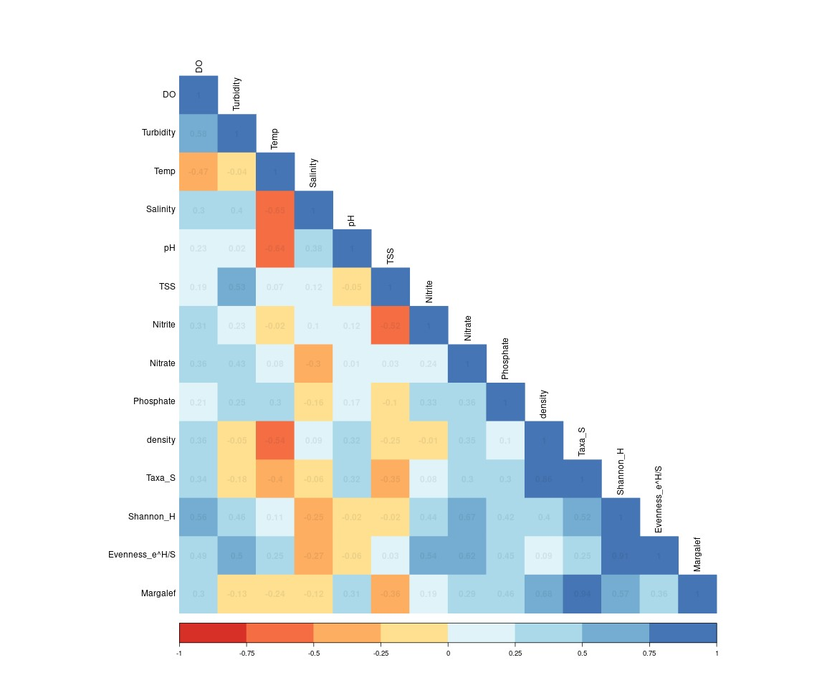

**Fig. 8 Correlogram of hydrobiological data and plankton indices**

**Turbidity**

The turbidity ranged from 10.2 to 76.36 NTU during the present study (Table 3). Turbidity does not vary substantially between stations or seasons, but rather throughout the year (F 17.23, p 0.00005). Summer had the highest turbidity (30.33 NTU), followed by Monsoon (22.81) and Winter (22.09). Mandvi (28.68) had higher turbidity levels than Munda (23.45) and Sanghi (23.10). This could be due to Mandvi's open coast and wave action, whereas Sanghi and Mundra's stations are surrounded by creeks and mangroves. Turbidity has a strong relationship with TSS (0.499) and salinity (0.481), nitrite (0.314). Higher values during the summer may be due to increased wave action, which is also reflected in TSS values. Turbidity values also exhibits negative correlation with species richness (-0.213) and abundance (-0.17).

**Water Temperature**

Water temperature is an important factor in water quality and has a large impact on aquatic biota. The temperature of the water ranged from 17.5 to 33o C during the current study (Table 3). Temperature did not differ significantly between sta or years, but seasons did (F 120 t 0.001). Temperature has a negative relationship with pH (-0.655) and salinity (-0.502) Temperature also exhibits negative co-relationship with species richness (-0.209) and abundance (-0.303) and plankton density (-0.489) while positive correlation with nutrients like nitrite (0.191), nitrate (0.187) and phosphate (0.300).

**Salinity:**

During the current study, the salinity ranged from 34 to 42 ppt (Table 3). Salinity did not differ significantly by station or year, but it did vary by season (F 19.2 p 0.001). Sanghi had the highest salinity during April and May, while Mundra had the lowest salinity during July and August. The higher salinity at Sanghi is due to arid conditions, while the lower salinity at Mundra could be due to runoff in the monsoon. Salinity does not seem to have any significant correlation either with species richness or abundance. Salinity only shows positive correlation with salinity (0.430) and pH (0.311).

**pH:**

The hydrogen ion concentration in sea water is very crucial for marine life. During the present study, the water in all the three stations was found to be slightly alkaline in nature and ranged from 7.3 to 8.35 (Table 3). There was no significant variation observed among years, stations and seasons. pH also shows correlation with phytoplankton species abundance (0.365) and species richness(0.396).

**Total Suspended Solid:**

During the study, total suspended solids ranged from 670 to 2950 mg/L (Table 3). The TSS value does not differ significantly across stations, seasons, or years. TSS was highest in Mandvi (1580 mg/L), followed by Mundra (1323 mg/L) and Sanghi (1250 mg/L). The higher tss value along the Mandvi could be attributed to the open coast and wave action. TSS also has a positive relationship with dissolved oxygen which could be because high wave action helps oxygen dissolve in water, which increases TSS in the water column. TSS has also demonstrated a negative correlation with species richness (-0.535) and abundance (-0.523).

**Nutrients:**

**Nitrite:**

Nitrogen is a critical nutrient in marine water that has a large impact on productivity. Nitrite levels in the current study ranged from 0.03 to 2.9 μg/L (Table 3). Nitrite levels do not differ significantly between stations or years, but seasons do (F 17.36 p 0.0001). Mundra had the highest nitrite value (0.636 μg/L), followed by Sanghi (0.58 μg/L) and Mandvi (0.44 μg/L). Nitrite has no significant relationship with either species richness (0.231) or abundance (0.176) but reflects positive correlation with Shannon (0.462) and Evenness index (0.498).

**Nitrate:**

During the current study, the nitrate concentration showed wide variation with a minimum of 0.3 μg/L at Mandvi to maximum of 21.39 μg/L at Sanghi (Table 3).Nitrate levels do not differ significantly across stations, seasons, or years. Mandvi had the highest nitrate value (6.45 μg/L), followed by Mundra (5.40 μg/L) and Sanghi (5.05 μg/L). Nitrate has a positive co relationship with species richness (0.189), abundance (0.197), Shannon (0.608) and Evenness (0.541) and negative correlation with salinity (-0.248) and pH(-0.170).

**Phosphate:**

Another important nutrient that influences primary productivity in seawater is inorganic phosphorus. The phosphorus concentration in the present study ranged from 0.235 to 7.462 g/L (Table 3). Phosphate values did not differ between stations or seasons, but they did vary significantly from year to year. (F 14.27, p 0.0003) Summer had the highest phosphate value (2.21 g/L), followed by the monsoon (2.11 g/L) and winter (2.11 g/L). Phosphorus value also shows a positive correlation with species richness (0.467) as well as abundance (0.377).

The species richness values show a positive correlation with abundance (0.956), dissolved oxygen (0.307), pH (0.396), nitrite (0.231), Nitrate (0.189) and Phosphate (0.467) while a negative correlation was observed between turbidity (-0.213), temperature(-0.209) and total suspended solids(-0.535).

The values of hydrobiological factors and nutrients during the present study are well matched with previous studies along Gujrat Coast (Temker *et al*., 2015, Thorrington-Smith, 1971, Vachhrajani and Mankodi (2007) and Vase *et al* (2018).

**Conclusion:**

The current state of the phytoplankton community indicates that the planktonic community is in good health. Recent molecular tools should be used to check for changes in the planktonic community and species confirmation. Regular planktonic studies are recommended for assessing the health of these industrial hotspot locations.

Disclaimer (Artificial intelligence)

Option 1:

Author(s) hereby declare that NO generative AI technologies such as Large Language Models (ChatGPT, COPILOT, etc.) and text-to-image generators have been used during the writing or editing of this manuscript.

**References:**

Beardall, J., Allen, D., Bragg, J., Finkel, Z. V., Flynn, K. J., *et al*. (2020) Allometry and stoichiometry of unicellular, colonial and multicellular phytoplankton, *New Phytol., Tansley Review*, 181:295–309.

Bhavsar, D. O. and Pandya, H. A. (2018) Phytoplnkton diversity and physico – chemical analysis of water in coastal talukas of Gulf of Cambay, Gujarat, *J Global Biosciences,* 7(9):5685-5694.

De Vargas, C., Audic, S., Henry, N., Decelle, J., Mahe, F., *et al.* (2015) Eukaryotic plankton diversity in the sunlit ocean, *Science*, 348 (6237).

Dhawan, R. M. (1970) Plankton and hydrological factors at Kandla in the Gulf of Kutch during 1960-1963, *Indian f Fish*, 17:122-131

Duarte, P., Macedo, M. F. and Fonseca, L. C. D. (2006) The relationship between phytoplankton diversity and community function in a coastal lagoon, *Hydrobiologia*, 555: 3-18.

Dutkiewicz, S., Cermeno, P., Jahn, O., Follows, M. J., Hickman, A. E., Taniguchi, D. A., & Ward, B. A. (2020). Dimensions of marine phytoplankton diversity. *Biogeosciences*, *17*(3), 609-634.

Faiza, Y. A. and Saburova, M. A. (2019) *Marine phytoplankton of Kuwait’s waters Volume i: cyanobacteria, dinoflagellates, flagellates,* 467 p.

Falkowski, P. (2012) Ocean Science: The power of plankton : do tiny floating microorganisms in the ocean's surface waters play a massive role in controlling the global climate? *Nature,* 483 S17–S20.

Gómez, F. (2005) A list of dinoflagellates in the world oceans, *Acta Bot Croatica,* 84:129–212.

Joshi, A. M., Desai, A. Y., Bhatt, A. J., Yusufzai, S. I., & Kardani, H. K. Checklist of diatoms species available along the Narara and Poshitra Island, Marine National Park, Jamnagar, Gujarat.

Leblanc, K., Arístegui, J., Armand, L., Assmy, P., Beker, B., *et al.* (2012) A global diatom database – abundance, biovolume and biomass in the world ocean, *Earth Syst Sci Data*, 4: 149–165.

Mitra, A., Banerjee, K. and Bhattacharyya, D. P. (2006), *Introduction to Marine Phytoplankton,* 138 p.

Motwani, G., Raman, M., Matondar, P., Parab, S., Pednekar, S. *et al*. (2014) Ecological study of phytoplankton from dahanu creek west coast of India, *Indian J Geo-Mar Sci*, 43(8) :1513-1518.

Nair, V. R. (2002) *Status of Fauna and Flora in Gulf of Kutch,* National Institute of Oceanography, Goa,157 p.

Nassar, M. Z. A. and Gharib, S. M. (2014) Spatial and temporal patterns of phytoplankton composition in Burullus Lagoon, Southern Mediterranean Coast, *Egypt Egypt J Aquat Res*, 40 :133–42.

Pal, R. and Choudhury, A. K (2014) A Brief Introduction to Phytoplanktons. In: An Introduction to Phytoplanktons: Diversity and Ecology. Springer, New Delhi. 41 p.

Saravanakumar, A., Rajkumar, M., Thivakaran, G. A., & Serebiah, J. S. (2008). Abundance and seasonal variations of phytoplankton in the creek waters of western mangrove of Kachchh-Gujarat. *Journal of environmental biology*, *29*(2), 271.

# Sawant, S. S. and Madhupratap, M. (1996) Seasonality and composition of phytoplankton in the Arabian Sea, *Current Science*, 71: 869-873.

Shruthi, M. S. and Rajashekhar, M. (2013) Ecological observations on the phytoplankton of Nethravati - Gurupura estuary, south west coast of India, *J Mar Biol Ass India,* 55(2) :41-47

Sournia, A., Chretiennotdinet, M. J. and Ricard, M. (1991) Marine phytoplankton: how many species in the world ocean?, *J Plankton Res,* 13:1093–1099.

Subir Kumar, M. (2004) *Studies on the effect of ship scrapping industries wastes on marine phytoplankton at Alang, Gujarat*, Phd thesis, MK University, Bhavnagar.

Subrahmanyan, R. (1946) A systematic account of the marine plankton diatoms of the Madras coast, *Proc Indian Acad Sci,* 24 B: 85–197.

Subrahmanyan, R. (1968) MBAI Memoir No.2: The Dinophyceae of the Indian Seas Part I, Genus Ceratium schrank. Marine Biological Association of India, Cochin, 129 p.

Subrahmanyan, R. (1971) MBAI Memoir No.2: The Dinophyceae of the Indian Seas Part II, Family Peridiniaceae Schutt emend Lindemann. Marine Biological Association of India, Cochin, 334 p.

Taylor, F. J. R., Hoppenrath, M. and Saldarriaga, J. F. (2008) Dinoflagellate diversity and distribution *Biodivers Conserv,* 17 :407–418.

Temkar, G. S., Abdul Azeez, P., Sikotaria, K. M., Brahmane, V. T., Metar, S. Y. *et al.* (2015) Correlation of phytoplankton density with certain hydrological parameters along the coastal waters of Veraval, Gujarat, *J Mar Biol Assoc India* 57(2): 65-74.

Thakur, B., Chavda, C., & Salvi, H. (2015). Phytoplankton diversity at some selected sites of the Gulf of Kachchh, Gujarat, India. *Bulletin of Environmental and Scientific Research*, *4*(4), 7-12.

Vachhrajani, K. and Mankodi, P. (2007) Plankton diversity at Gopnath, Gulf of Khambhat, Gujarat Indian, *J Environ & Ecoplan* 14 (1-2): 101–108.

Vase V K, Dash G, Sreenath K, Temkar G, Shailendra R, *et al.* (2018) Spatio-temporal variability of physico-chemical variables, chlorophyll a, and primary productivity in the northern Arabian Sea along India coast, *Environ Monit Assess* 190:148.

Wang, Y., Liu, S., Wang, J., Yao, Y., Chen, Y., Xu, Q., Zhao, Z. and Chen, N. (2022) Diatom Biodiversity and Speciation Revealed by Comparative Analysis of Mitochondrial Genomes. Front. Plant Sci. 13:749982.

Young, J. R., Geisen, M. and Probert, I. (2005) A review of selected aspects of coccolithophore biology with implications for palaeodiversity estimation, *Micropaleontology*, 51(4): 267-288.