**Assessment of fish diversity associated with Water quality parameters of Burhi Gandak River, North Bihar, India**

**Abstract**

Burhi Gandak River is a left-banktributary of River Gangaandamajor riverine ecosystem in North Bihar. The river is home to different freshwater fish species, gastropods, bivalves, and other aquatic animals. The fish diversity and Water quality parameters data were collected in six sampling locations from the period of August 2020 to June 2021. The present study examined fish diversity and their relationship with water quality parameters. The study revealed that Burhi Gandak River is the home of 71 fish species (67 indigenous and 4 exotic species). Identified species belong to 28 families, 10 orders, and 52 genera. The Order Cypriniformes contributes (45%) and 19 fish species belonging to the family Cyprinidae constitute the major diversity of the river. The maximum number of species was documented from location S4 (Pusa) and minimum from S2 (Muzaffarpur) respectively. The four types of diversity indices i.e., Shannon–Wiener (2.886 to 3.206), Simpson’s (0.9235 to 0.9449), Margalef’s richness (4.768 to 6.82) and Pielou’s evenness (0.4935 to 0.5708) were also assessed, and values of diversity indices vary from each location. Canonical correspondence analysis (CCA) indicates that pH, free CO2, water temperature, and dissolved oxygen were the key water quality parameters in the Burhi Gandak River. Four exotic species namely [*Ctenopharyngodon*](http://researcharchive.calacademy.org/research/ichthyology/catalog/fishcatget.asp?genid=3422)[*idella*](http://researcharchive.calacademy.org/research/ichthyology/catalog/fishcatget.asp?spid=30285), *Barbonymus gonionotus, Carassius carassius* and *Cyprinus carpio* were recorded.According to theIUCN RedList, out of 71 fish species, 4 Near Threatened (NT), 1 Vulnerable (VU) and 66 Least Concern (LC).

**Keywords:** River Burhi Gandak, Fish diversity,Exotic species, Water quality parameters, Canonical Correspondence Analysis

**Introduction**

Freshwater fishes play a significant role in global biodiversity (Reid et al., 2013). Riverine ecosystems support the ecological balance of the ecosystem because they support a large range of vegetation, aquatic life, humans, and habitats for many species. Riverine fish diversity is affected by different environmental parameters such as sedimentation, velocity, water temperature, substrate, dissolved oxygen, water conductivity, depth and width, height, and distance from the source (Li et al., 2012). Despite their significant level of natural fluctuation, fish communities are indicators of an ecosystem's healthiness (Moyle and Yoshiyama, 1994). Diversity assessment of fishes plays an important role in gathering information about the anatomy, stock assessment, feeding habits, reproductive biology, habitat ecology and overall health of the ecosystem. The assessment of freshwater ecosystems like rivers, wetlands, lakes and ponds is the calculation of the overall species of fish that are available in the habitats. Fish diversity assessment is critical for conservation, management, restoration, sustainable and wise use of aquatic genetic resources and understanding the current status of fish species in water bodies.

Freshwater fishes are the most endangered vertebrate species, with extinction rates five times higher than terrestrial fauna and three times higher than marine mammals in the ecosystem (Duncan and Lockwood, 2001). Fish biodiversity of the world is declining day by day in the twenty-first century. Main regions for declines in freshwater diversity due to pollution levels (Junior et al., 2006), habitat destruction and defragmentation (Lakra et al., 2010), introduction of alien/exotic species (Pathak et al., 2013), water abstraction by dams, industries and effects of global climate variations especially rainfall (Leveque et al., 2005). The ecological sustainability of river systems is greatly threatened by the flooding of rivers, global warming, and climate change, which are also anticipated to disrupt the equilibrium of water supply and demand (Haddeland *et al*. 2014). There are 37,109 valid fish species, of which 18,896 are valid freshwater fish species worldwide (Fricke and Eschmeyer, 2025). About 3247 fish species are found in India belonging to 1044 genera, 256 families and 57 orders (NBFGR, 2025).

According to the Bihar State Irrigation Commission (1994),14 river basins in Bihar are as follows: Ganga (the longest river in India with 2525 km total length, of which 445 km in Bihar state), Ghaghra, Sone, Mahananda, Gandak, Kosi, Bagmati-Adhwara, Burhi Gandak, Kamla-Balan, Karmnasa, Punpun, Badua, Kiul-Harohar, and Chandan River. The catchment area of Burhi Gandak is 12,180 km2, of which 1,810 km2 is in Nepal and around 10370 km2 in Bihar. The river ecosystem plays an important role in crop irrigation, drinking water for people and animals, safeguarding ecological health, supporting biodiversity, flood control during monsoon season, food and nutritional security and the livelihood of people in Bihar.

Studies on the biodiversity of freshwater fish in rivers of Bihar, wetlands, and streams have been reported by many researchers. However, the study about the total number of fish species with relation to water quality parameters of the River Burhi Gandak has not been well studied. The present study aimed was to assessing the environmental parameters relationship with freshwater fish diversity, IUCN conservation status, and exotic and native species. This river supports mostly small-scale fisheries and provides nutritional foods, food security, employment, and income to thousands of people in Bihar. The findings of this study might be used by fisheries managers, scientists, and biodiversity conservationists to develop proactive plans and policies at the local and national levels for the sustainable utilization and surviving fish populations of rivers.

**Materials and methods**

**Study area**

The River Burhi Gandak flows about 410 km in North Bihar and runs in a south-east direction. This river is majorly meandering in nature. At an elevation of 300 meters, the spring of the Someshwar hills is where the River Burhi Gandak originates in the West Champaran district of Bihar, located at east longitude 84°8" and north latitude 27°29". River mainly flows in districts of North Bihar like West Champaran, East Champaran, Muzaffarpur, Samastipur, Darbhanga, Begusarai, Munger, and Khagaria. The river drains directly into the River Ganges in Khagaria district. The study area was divided into six sampling sites, i.e., S1 (Chakiya), S2 (Muzaffarpur), S3 (Abdulpur Raini), S4 (Pusa), S5 (Samastipur) and S6 (Khagaria) for assessing the water quality parameters and fish diversity. The map of the study area and their locations of sample collection are shown in Fig. 1.



**Figure 1.** Map showing the study area and sample collection sites in River.

**Fish Sampling and Identification**

The fish specimens were collected directly from local fishermen. The fish specimen was collected every month from six sampling locations. Different types of fishing gear namely gill nets, trap nets, lift nets, cast nets, scoop nets, and drag nets, were used to catch the fish. After collecting photos of fresh-caught fish specimens and local name of each fish was recorded. For identification, fish were preserved in a 10% formalin solution. Fish species were identified by standard literature (Talwar and Jhingran, 1991; Jayaram, 2010).

**Water quality parameter analysis**

Water samples were collected to analyze the water quality parameters, and a Mercury Thermometer was used to measure the water temperature at the sampling sites. Water was collected in BOD bottles for analysis of dissolved oxygen and at the same time water was collected in plastic bottles and brought into the laboratory for further study. All studied parameterswere examined using standard methods (APHA, 2017).

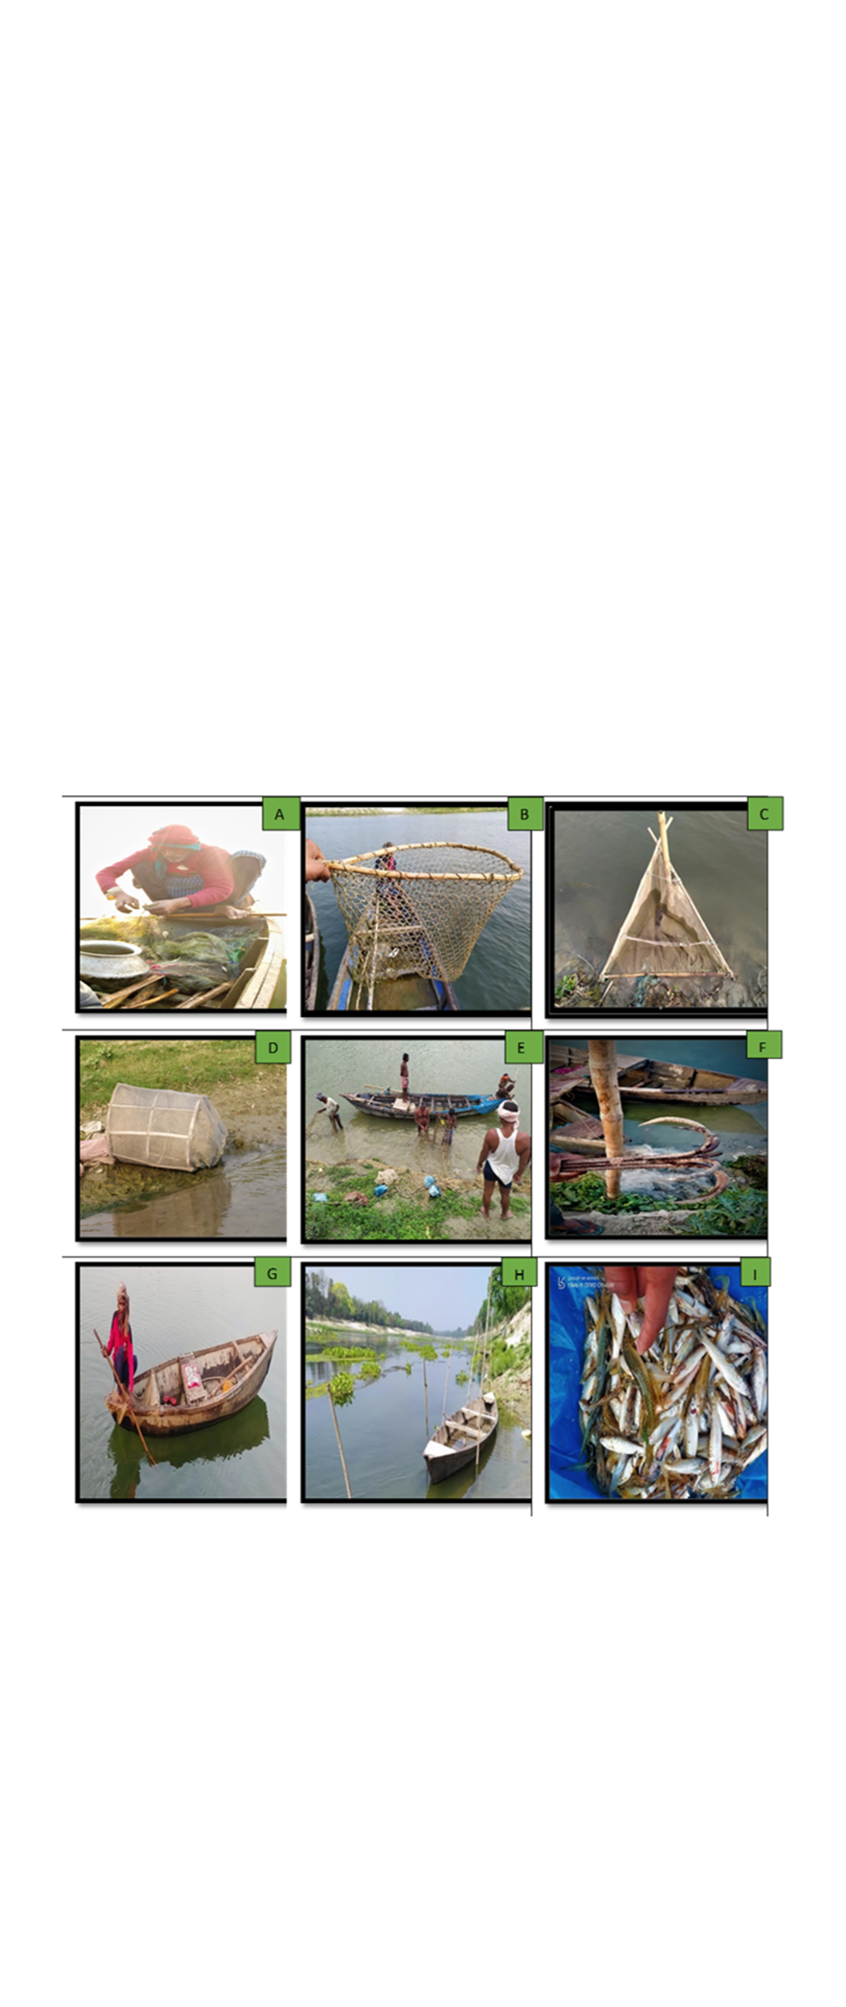**Figure 2.** Different types of fishing activities in Burhi Gandak River. **A)** gill net fishing **B)** scoop net **C)** lift net **D)** trap net **E)** preparing for drag net fishing **F)** anchor for holding boat **G)** fishing boat **H)** common method of holding fishing boat **I)** a haul of fish catch.

Fish diversity indices and Canonical Correspondence Analysis were calculated using PAST Software (Version 4.13). Microsoft Excel was used for all other statistical analyses (2021).

**Results and Discussions**

**Environmental Parameters**

The average environmental parameters of River Burhi Gandak were examined during the study period and summarized in Table 1. The range of Dissolved oxygen (DO) 5.84 mg/l (S2) to 8.21 mg/l (S4). The water pH has found highest at S4 (8.24) and lowest at S2 (7.11). The water temperature was found high at S6 (250C) and the lowest at S5 (220C). Total hardness was recorded between 132.26 mg/l (S3) and 151.24 mg/l (S2). Alkalinity was found maximum at S3 (186.57 mg/l) and minimum at S1 (168.32 mg/l). Free CO2 was calculated as highest at S2 (6.62mg/l) and lowest at S4 (2.15 mg/l).

|  |  |  |  |  |  |  |
| --- | --- | --- | --- | --- | --- | --- |
| **Sampling Sites** | **Dissolved Oxygen (mg/l)** | **pH** | **Water temperature, (0C)** | **Total Hardness (mg (mg/l)** | **Alkalinity (mg (mg/l)** | **Free Co2 ((mg/l)** |
| S1 | 7.13 | 7.56 | 22.5 | 141.5 | 168.32 | 2.87 |
| S2 | 5.84 | 7.11 | 23.5 | 151.24 | 171.84 | 6.62 |
| S3 | 6.42 | 7.83 | 23 | 132.26 | 186.57 | 6.43 |
| S4 | 8.21 | 8.24 | 24.5 | 144.21 | 168.39 | 2.15 |
| S5 | 7.84 | 8.15 | 22 | 139.42 | 171.78 | 3.98 |
| S6 | 7.43 | 7.83 | 25 | 134.53 | 169.26 | 3.58 |

**Table 1.** Average environmental parameters of River Burhi Gandak.

**S1**: Chakiya; **S2:** Muzaffarpur; **S3:** Abdulpur Raini; **S4:**Pusa; **S5:** Samastipur; **S6:** Khagaria

**Fish species diversity**

The Present study reported, 71 fish species representing 10 orders, 28 families, and 52 genera were identified from six sampling sites of Burhi Gandak River (Table 3). With a 45% contribution of Cypriniformes order was the most dominant among all fish species, followed by the Siluriformes (25%), Anabantiformes (11%), Perciformes and Synbranchiformes (4%), Clupeiformes and Osteoglossiformes (3%), Gobiformes and Beloniformes (2%) and Tetraodontiformes (1%) (Figure 3). The Cyprinidae family represents the maximum 19 fish species, followed by the Danionidae (6), bagridae (5), Siluridae, Sisoridae, Mastacembelidae, Botiidae and Channidae (3 species each family), Cobitidae, Ambassidae, Osphronemidae, Schilbeidae, Notopteridae, Ailiidae (2 species each family) and remaining other 13 families Xenocyprididae Engraulidae, Nemacheilidae, Heteropneustidae, Pangasidae, Clupeidae, Gobidae, Anabantidae, Nandidae, Badidae, Belonidae, Tetraodontidae, and Sciaenidae constituted only one fish species each. This study revealed that *Amblypharyngodon mola* (13.56%) was the most dominant fish species followed by *Pachypteruss atherinoides* (9.16%) and *Parambassis ranga* (7.39%). *Puntius sophore* (7.21%), *Chanda nama* (6.51%), *Cirrhinus reba* (6.43%), *Mystus cavasius* (6.22%), *Securicula gora* (3.80%) and *Mystus vittatus* (3.60%) were the major fishery resources of Burhi Gandak River.

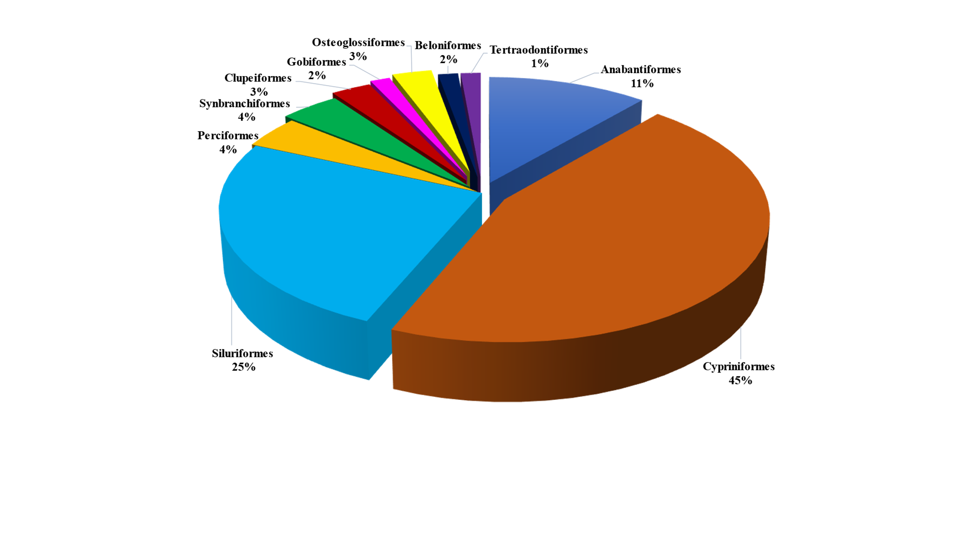

**Figure 3.** Distribution of fish species based on their order.

The present study, sample site S4 observed the maximum number of fish species (50 sp.) followed by S5 and S6 (43 sp.) each, Chakiya (42 sp.), S3 (39 sp.) and the lowest number of species in S2 (33 sp.). Low species richness at sites S2 and S3 may be caused by high pollution discharge from Muzaffarpur city, high sediment in water due to heavy runoff from urban areas, sand mining, exotic species and industrial effluents. It is alarming that the Indian Major Carps (*Cirrhinus mrigala*, *Labeo catla* and *Labeo rohita*) catch has declined sharply in the study while small cyprinids and catfishes are increasing in the river. The decreased catch of IMCs in the river may be due to the heavy flood occurrence in the river during the monsoon season and these fishes generally breed in this season.

According to the global database on fishes (FishBase), of the 71 fish species that have been recorded, four were exotic and sixty-seven were native. IUCN status of fishes based on the IUCN Red list are 4 species Near Threatened (NT), 1 species Vulnerable (VU) and 66 species are Least concern (LC). Exotic fish species are a serious risk to aquatic biodiversity. Four exotic species i.e., *Ctenopharyngodon idella*, *Barbonymus gonionotus*, *Carassius carassius*, and *Cyprinus carpio* were also recorded.According to Hermoso et al. (2011) and Avlijas et al. (2018),indigenous species are seriously threatened by the large number of exotic species abundance due to predatory behavior, the transmission of disease, competition between them, hybridization and gene pool degradation.The environmental factors of a riverine habitat are less important than the negative impact of non-native species on the diversity of indigenous fish (Gavioli et al., 2018).

The same results were observed from River Gomti and 56 fish species identified by Bano and Serajuddin (2016) came under the 9 orders, 21 families and 41 genera. The maximum number of species was recorded under the Order Cypriniformes (33.91%) followed by Siluriformes (30.32%). Some other researchers also recorded fish diversity from different rivers in India i.e., 112 fish species from River Yamuna (Joshi et al.,2016); 89 fish species from River Ken and 81 fish species from Betwa River (Joshi et al., 2017); 57 fish species from the river Mahanadi (Singh et al*.*, 2020); 14 species from Chittar River (Sajen et al., 2022) and 190 fish species (182 Indigenous and 8 exotics) from River Ganga (Das et al.,2023). No published information is available on the fish diversity of the Burhi Gandak River.

**Fish Diversity Indices**

Four diversity indices i.e. Shannon-Wiener, Margalef species richness, Pielou’s evenness and Simpson’s diversity index were examined based on the sampling sites and summarized in Table 2. The value of the Shannon-Wiener (H) index from six different sampling sites revealed a strong correlation with all species richness and values ranging from 2.886 (S2) to 3.206 (S4). The highest Simpson index value was recorded from S6 (0.9449) and low S2 (0.9235). The Pielou’s evenness index value was found to be maximum from S6 (0.5708) and minimum S4 (0.4935). Margalef richness index was recorded as highest from S4 (6.82) and lowest S2 (4.768). The higher values of fish diversity, Margalef richness and Shannon-Wiener index from the S4 site (Pusa) may be related to good environmental variables while lower values from site S2 (Muzaffarpur) may be due to unfavourable environmental conditions.

**Table 2.** The total number of taxa and fish diversity indices of River Burhi Gandak.

|  |  |  |  |  |  |  |
| --- | --- | --- | --- | --- | --- | --- |
| **Sampling Sites** | **S1** | **S2** | **S3** | **S4** | **S5** | **S6** |
| **Taxa_S** | 42 | 33 | 39 | 50 | 43 | 43 |
| **Simpson_D** | 0.9395 | 0.9235 | 0.9363 | 0.9425 | 0.9404 | 0.9449 |
| **Shannon-Wiener_H** | 3.13 | 2.886 | 3.082 | 3.206 | 3.153 | 3.2 |
| **Pielou's Evenness_e^H/S** | 0.5445 | 0.5433 | 0.5591 | 0.4935 | 0.5441 | 0.5708 |
| **Margalef_d** | 6.045 | 4.768 | 5.37 | 6.82 | 6.02 | 6.102 |

**S1**: Chakiya; **S2:** Muzaffarpur; **S3:** Abdulpur Raini; **S4:**Pusa; **S5:** Samastipur; **S6:** Khagaria

**Relationship with Fish Abundance and Water Quality Parameters**

The first (47.18%) and second (20.59%) axes of environmental parameters and fish abundance relationship data were plotted in Fig. 4. The length and direction of the arrows show the associated significance of the environmental parameters with fish species. The CCA ordination shows the positive correlation of *Puntius chola*, *Rita rita*, *Parambassis ranga*, *Mystus cavasius* and *Amblypharyngodon mola* with dissolved oxygen and pH. Fish species such as *Puntius sophore, Securicula gora, Mystus bleekeri, Glossogobius giuris, Pachypterus atherinoides, Cirrhinus reba* and *Labeo calbasu* were positively associated with water temperature and free CO2. In the present study, dissolved oxygen, pH, water temperature and free CO2 are important factors for surviving the fish species in the river. A study by Kamboj et al (2023) revealed that fish assemblage was significantly correlated with environmental factors such as dissolved oxygen, water temperature, depth, velocity, turbidity, stones, sand, and gravel in River Ganga. Akhi et al. (2020) reveal the significant role of total dissolved solids (TDS), dissolved oxygen, alkalinity and electrical conductivity in the Karatoya River (Bangladesh).

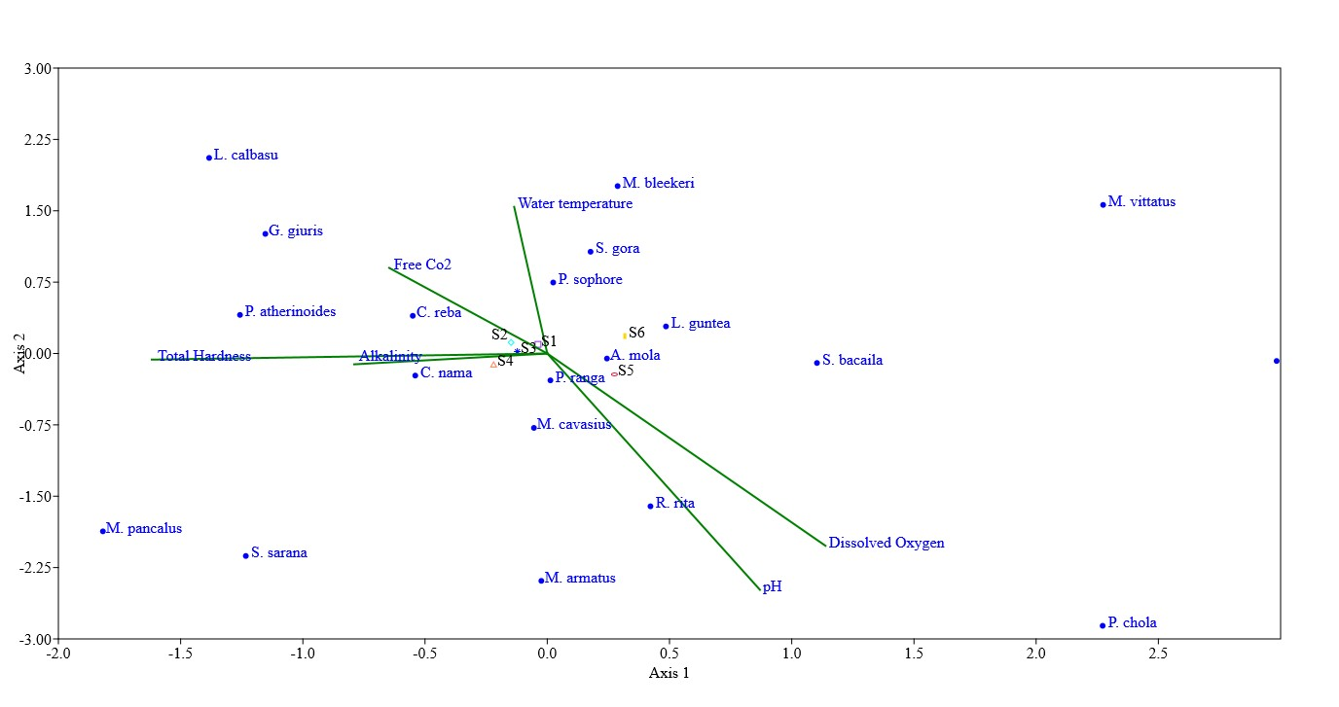

**Figure 4.** CCA plot of top 20 fish species and water quality parameters **(S:** Chakiya, **S2:** Muzaffarpur, **S3:** Abdulpur Raini, **S4:** Pusa, **S5:** Samastipur and **S6:** Khagaria)

**Table 3.** List of identified fish species and their Order, family, common name, IUCN status, exotic and native fishes of River Burhi Gandak.

|  |  |  |  |  |  |
| --- | --- | --- | --- | --- | --- |
| **Order** | **Family** | **Fish species** | **Common name** | **IUCN Status** | **Native/**  **Exotic** |
| Cypriniformes | Cyprinidae | [*Cirrhinus*](http://researcharchive.calacademy.org/research/ichthyology/catalog/fishcatget.asp?genid=869)[*mrigala*](http://researcharchive.calacademy.org/research/ichthyology/catalog/fishcatget.asp?spid=2050)(Hamilton[, 1822)](http://researcharchive.calacademy.org/research/ichthyology/catalog/getref.asp?id=2031) | Mrigal/Nain | LC | Native |
|  |  | [*Cirrhinus*](http://researcharchive.calacademy.org/research/ichthyology/catalog/fishcatget.asp?genid=869)[*reba*](http://researcharchive.calacademy.org/research/ichthyology/catalog/fishcatget.asp?spid=2051)[(Hamilton, 1822)](http://en.wikipedia.org/wiki/Francis_Buchanan-Hamilton) | Reba carp | LC | Native |
|  |  | *Bangana dero* [(Hamilton,](http://en.wikipedia.org/wiki/Francis_Buchanan-Hamilton)[1822)](http://researcharchive.calacademy.org/research/ichthyology/catalog/getref.asp?id=2031) | Kalabans | LC | Native |
|  |  | *Labeo catla (Hamilton, 1822)* (Hamilton, 1822) | Catla/Bhakur | LC | Native |
|  |  | [*Labeo*](http://researcharchive.calacademy.org/research/ichthyology/catalog/fishcatget.asp?genid=863)[*rohita*](http://researcharchive.calacademy.org/research/ichthyology/catalog/fishcatget.asp?spid=2263)[(Hamilton,](http://en.wikipedia.org/wiki/Francis_Buchanan-Hamilton) [1822)](http://researcharchive.calacademy.org/research/ichthyology/catalog/getref.asp?id=2031) | Rohu | LC | Native |
|  |  | [*Labeo*](http://researcharchive.calacademy.org/research/ichthyology/catalog/fishcatget.asp?genid=863)[*calbasu*](http://researcharchive.calacademy.org/research/ichthyology/catalog/fishcatget.asp?spid=2192)[(Hamilton, 1822)](http://en.wikipedia.org/wiki/Francis_Buchanan-Hamilton) | Orangefin labeo | LC | Native |
|  |  | [*Labeo*](http://researcharchive.calacademy.org/research/ichthyology/catalog/fishcatget.asp?genid=863)[*bata*](http://researcharchive.calacademy.org/research/ichthyology/catalog/fishcatget.asp?spid=29299)[(Hamilton,](http://en.wikipedia.org/wiki/Francis_Buchanan-Hamilton)[1822)](http://researcharchive.calacademy.org/research/ichthyology/catalog/getref.asp?id=2031) | Bata | LC | Native |
|  |  | [*Labeo*](http://researcharchive.calacademy.org/research/ichthyology/catalog/fishcatget.asp?genid=863)[*dyocheilus*](http://researcharchive.calacademy.org/research/ichthyology/catalog/fishcatget.asp?spid=2215)[(McClelland, 1839)](http://en.wikipedia.org/wiki/John_McClelland_(doctor)) | Boalla | LC | Native |
|  |  | [*Labeo*](http://researcharchive.calacademy.org/research/ichthyology/catalog/fishcatget.asp?genid=863)[*gonius*](http://researcharchive.calacademy.org/research/ichthyology/catalog/fishcatget.asp?spid=2223)(Hamilton[, 1822)](http://en.wikipedia.org/wiki/Francis_Buchanan-Hamilton) | Kuria labeo | LC | Native |
|  |  | [*Cyprinus*](http://researcharchive.calacademy.org/research/ichthyology/catalog/fishcatget.asp?genid=148) *carpio* ([Linnaeus, 1758](http://en.wikipedia.org/wiki/Carl_Linnaeus)) | Common carp | LC | Exotic |
|  |  | *Carassius carassius* ([Linnaeus, 1758](http://en.wikipedia.org/wiki/Carl_Linnaeus)) | Crucian carp | LC | Exotic |
|  |  | *Barbonymus gonionotus* (Bleeker, 1850) | Silver barb | LC | Exotic |
|  |  | [*Osteobrama*](http://researcharchive.calacademy.org/research/ichthyology/catalog/fishcatget.asp?genid=1741) *cotio* [(Hamilton, 1822)](http://en.wikipedia.org/wiki/Francis_Buchanan-Hamilton) | Hafo | LC | Native |
|  |  | *Chagunius chagunio* [(Hamilton,1822)](http://en.wikipedia.org/wiki/Francis_Buchanan-Hamilton) | Chaguni | LC | Native |
|  |  | [*Puntius*](http://researcharchive.calacademy.org/research/ichthyology/catalog/fishcatget.asp?genid=1036) *sophore* [(Hamilton, 1822)](http://en.wikipedia.org/wiki/Francis_Buchanan-Hamilton) | Pool barb | LC | Native |
|  |  | [*Puntius*](http://researcharchive.calacademy.org/research/ichthyology/catalog/fishcatget.asp?genid=1036)[*chola*](http://researcharchive.calacademy.org/research/ichthyology/catalog/fishcatget.asp?spid=31142)(Hamilton[, 1822)](http://en.wikipedia.org/wiki/Francis_Buchanan-Hamilton) | Swamp barb | LC | Native |
|  |  | [*Pethia*](http://researcharchive.calacademy.org/research/ichthyology/catalog/fishcatget.asp?genid=11223)[*ticto*](http://researcharchive.calacademy.org/research/ichthyology/catalog/fishcatget.asp?spid=2625)[*(Hamilton, 1822)*](http://en.wikipedia.org/wiki/Francis_Buchanan-Hamilton) | Ticto barb | LC | Native |
|  |  | *Pethia conchonius*  [(Hamilton,](http://en.wikipedia.org/wiki/Francis_Buchanan-Hamilton) [1822)](http://researcharchive.calacademy.org/research/ichthyology/catalog/getref.asp?id=2031) | Rosy barb | LC | Native |
|  |  | *Systomus sarana* [(Hamilton, 1822)](http://en.wikipedia.org/wiki/Francis_Buchanan-Hamilton) | Olive barb | LC | Native |
|  | Xenocyprididae | [*Ctenopharyngodon*](http://researcharchive.calacademy.org/research/ichthyology/catalog/fishcatget.asp?genid=3422)[*idella*](http://researcharchive.calacademy.org/research/ichthyology/catalog/fishcatget.asp?spid=30285)[(Valenciennes, 1844)](http://en.wikipedia.org/wiki/Achille_Valenciennes) | Grass carp | LC | Exotic |
|  | Danionidae | *Chela cachius* (Hamilton 1822) | Silver hatchet chela | LC | Native |
|  |  | *Salmostoma phulo* [(Hamilton, 1822)](http://en.wikipedia.org/wiki/Francis_Buchanan-Hamilton) | Finescale razorbelly minnow | LC | Native |
|  |  | *Salmostoma bacaila* (Hamilton, 1822) | Large razor belly minnow | LC | Native |
|  |  | *Securicula gora* (Hamilton, 1822) | Gora-chela | LC | Native |
|  |  | *Amblypharyngodon* [*mola*](http://researcharchive.calacademy.org/research/ichthyology/catalog/fishcatget.asp?spid=3214)[(Hamilton, 1822)](http://en.wikipedia.org/wiki/Francis_Buchanan-Hamilton) | Mola carplet | LC | Native |
|  |  | *Esomus danrica* [(Hamilton](http://en.wikipedia.org/wiki/Francis_Buchanan-Hamilton)[, 1822)](http://researcharchive.calacademy.org/research/ichthyology/catalog/getref.asp?id=2031) | Flying barb | LC | Native |
|  | Botiidae | *Botia Dario* (Hamilton, 1822) | Bengal loach | LC | Native |
|  |  | *Botia lohachata (Chaudhuri*[*, 1912*](http://researcharchive.calacademy.org/research/ichthyology/catalog/getref.asp?id=14837)*)* | Reticulate loach | LC | Native |
|  |  | *Botia birdi (Chaudhuri,* [*1909*](http://researcharchive.calacademy.org/research/ichthyology/catalog/getref.asp?id=14837)*)* | Birdi loach | LC | Native |
|  | Cobitidae | *Canthophrys gongota* [(Hamilton](http://en.wikipedia.org/wiki/Francis_Buchanan-Hamilton), 1822) | Gongota loach | LC | Native |
|  |  | *Lepidocephalichthys guntea* [(Hamilton, 1822)](http://en.wikipedia.org/wiki/Francis_Buchanan-Hamilton) | Guntea loach | LC | Native |
|  | Nemacheilidae | *Acanthocobitis botia* (Hamilton, 1822) | Mottled loach | LC | Native |
| Clupeiformes | Clupeidae | *Gudusia chapra* (Hamilton, 1822) | Indian river shad | LC | Native |
|  | Engraulidae | *Setipinna phasa* (Hamilton, 1822) | Gangetic hair fin anchovy | LC | Native |
| Osteoglossiformes | Notopteridae | *Chitala chitala* (Hamilton, 1822) | Clown knifefish | NT | Native |
|  |  | *Notopterus notopterus* ([Pallas](http://en.wikipedia.org/wiki/Peter_Simon_Pallas), 1769) | Bronze featherback | LC | Native |
| Siluriformes | Bagridae | *Mystus bleekeri* [(Day, 1877)](http://en.wikipedia.org/wiki/Francis_Day) | Day's mystus | LC | Native |
|  |  | *Mystus cavasius* [(Hamilton,](http://en.wikipedia.org/wiki/Francis_Buchanan-Hamilton) [1822)](http://researcharchive.calacademy.org/research/ichthyology/catalog/getref.asp?id=2031) | Gangetic mystus | LC | Native |
|  |  | [*Mystus*](http://researcharchive.calacademy.org/research/ichthyology/catalog/fishcatget.asp?genid=301)[*vittatus*](http://researcharchive.calacademy.org/research/ichthyology/catalog/fishcatget.asp?spid=4594)[(Bloch, 1794)](http://en.wikipedia.org/wiki/Marcus_Elieser_Bloch) | Striped dwarf catfish | LC | Native |
|  |  | [*Mystus*](http://researcharchive.calacademy.org/research/ichthyology/catalog/fishcatget.asp?genid=301) *tengra* [(Hamilton, 1822)](http://en.wikipedia.org/wiki/Francis_Buchanan-Hamilton) | Tengara catfish | LC | Native |
|  |  | *Sperata seenghala* (Sykes[, 1839)](http://researcharchive.calacademy.org/research/ichthyology/catalog/getref.asp?id=18720) | Giant river-catfish | LC | Native |
|  | Ritidae | *Rita rita* (Hamilton[, 1822)](http://en.wikipedia.org/wiki/Francis_Buchanan-Hamilton) | Ritha | LC | Native |
|  | Siluridae | *Ompok pabda* (Hamilton[, 1822)](http://en.wikipedia.org/wiki/Francis_Buchanan-Hamilton) | Pabdah catfish | NT | Native |
|  |  | *Ompok bimaculatus* [(Bloch,](http://en.wikipedia.org/wiki/Marcus_Elieser_Bloch)1794) | Butter catfish | NT | Native |
|  |  | *Wallago attu* [(Bloch](http://en.wikipedia.org/wiki/Marcus_Elieser_Bloch) & Schneider[,](http://en.wikipedia.org/wiki/Johann_Gottlob_Theaenus_Schneider) [1801)](http://researcharchive.calacademy.org/research/ichthyology/catalog/getref.asp?id=471) | Barali | VU | Native |
|  | Heteropneustidae | *Heteropneustes fossilis* (Bloch, 1794) | Stinging catfish | LC | Native |
|  | Pangasiidae | *Pangasius pangasius* [(Hamilton, 1822)](http://en.wikipedia.org/wiki/Francis_Buchanan-Hamilton) | Yellowtail catfish | LC | Native |
|  | Schilbeidae | *Eutropiichthys vacha* [(Hamilton](http://en.wikipedia.org/wiki/Francis_Buchanan-Hamilton), 1822) | Batchwa vacha | LC | Native |
|  |  | *Pachypterus atherinoides* [(Bloch,](http://en.wikipedia.org/wiki/Marcus_Elieser_Bloch) [1794)](http://researcharchive.calacademy.org/research/ichthyology/catalog/getref.asp?id=463) | Indian potasi | LC | Native |
|  | Sisoridae | *Gagata cenia* (Hamilton, 1822) | Indian gagata | LC | Native |
|  |  | *Gogangra viridescens* (Hamilton, 1822) | Huddah nangra | LC | Native |
|  |  | *Glyptothorax telchitta* (Hamilton[, 1822)](http://en.wikipedia.org/wiki/Francis_Buchanan-Hamilton) | Telchitta | LC | Native |
|  | Ailidae | *Clupisoma garua* (Hamilton, 1822) | Garua bachcha | LC | Native |
|  |  | *Ailia coila* (Hamilton, 1822) | Gangetic ailia | NT | Native |
| Gobiformes | Gobidae | *Glossogobius giuris* (Hamilton, 1822) | Tank goby | LC | Native |
| Anabantiformes | Anabantidae | *Anabas testudineus* (Bloch, 1792) | Climbing perch | LC | Native |
|  | Osphronemidae | *Trichogaster fasciata (*[Bloch](http://en.wikipedia.org/wiki/Marcus_Elieser_Bloch) & Schneider, 1801) | Banded gourami | LC | Native |
|  |  | *Trichogaster lalius* (Hamilton, 1822) | Dwarf gourami | LC | Native |
|  | Channidae | *Channa punctata* (Bloch, 1793) | Spotted snakehead | LC | Native |
|  |  | *Channa striata* [(Bloch](http://en.wikipedia.org/wiki/Marcus_Elieser_Bloch), 1793) | Striped snakehead | LC | Native |
|  |  | *Channa marulius* [(Hamilton, 1822)](http://en.wikipedia.org/wiki/Francis_Buchanan-Hamilton) | Great snakehead | LC | Native |
|  | Nandidae | *Nandus nandus* (Hamilton, 1822) | Gangetic leaffish | LC | Native |
|  | Badidae | *Badis badis* (Hamilton, 1822) | Dwarf chameleonfish | LC | Native |
| Perciformes | Ambassidae | *Chanda nama* (Hamilton, 1822) | Elongate glass-perchlet | LC | Native |
|  |  | [*Parambassis*](http://researcharchive.calacademy.org/research/ichthyology/catalog/fishcatget.asp?genid=3749)[*ranga*](http://researcharchive.calacademy.org/research/ichthyology/catalog/fishcatget.asp?spid=15821)[(Hamilton, 1822)](http://en.wikipedia.org/wiki/Francis_Buchanan-Hamilton) | Indian glassy fish | LC | Native |
|  | Sciaenidae | *Johnius coitor* [(Hamilton, 1822)](http://en.wikipedia.org/wiki/Francis_Buchanan-Hamilton) | Coitor croaker | LC | Native |
| Tertraodontiformes | Tetraodontidae | *Leiodon cutcutia* (Hamilton, 1822) | Ocellated pufferfish | LC | Native |
| Beloniformes | Belonidae | *Xenentodon cancila* (Hamilton, 1822) | Freshwater garfish | LC | Native |
| Synbranchiformes | Mastacembelidae | *Macrognathus acculeatus* (Bloch,1786) | Lesser spiny eel | LC | Native |
|  |  | *Macrognathus pancalus* (Hamilton,1822) | Barred spiny eel | LC | Native |
|  |  | *Mastacembelus armatus* (Lacepède,1800) | Zig-zag eel | LC | Native |

**Conclusion**

In conclusion, the Burhi Gandak River plays an important role in flood control, groundwater recharge, water for irrigation purposes, supporting food and fisheries, and socio-economic development of the local community. Monitoring of aquatic health, environmental parameters, fish diversity and exotic and alien species assessment is essential. The minimum fish diversity reported in Muzaffarpur may be due to high pollution loads and sedimentation in the water. This river is also home to threatened species like *Ailia coila, Ompok pabda, Ompok bimaculatus, Wallago attu* and *Chitala chitala.* The author suggests ranching of the Indian major carps to maintain their diversity in the river. To conserve fish biodiversity before disappears, it is necessary to evaluate the invasion threat from introduced species in Bihar and implement restrictive management regulations relating to exotic aquatic animals. To ensure the sustainability of fish genetic resources in the river, the strategy should be comprehensive and cooperative efforts for conservation and restoration including scientists, conservationists, government, and non-government organizations (local, state, national and international levels), communities and stakeholders.

**DISCLAIMER (ARTIFICIAL INTELLIGENCE)**

Authors hereby declare that no generative AI technologies such as large language, models (ChatGPT, COPILOT, etc.) and text-to-image generators have been used during the writing or editing of this manuscript.

**ACKNOWLEDGMENTS**

This research work is a part of the M.F.Sc. dissertation of the first author. The authors would like to thank the Vice-Chancellor, Dr. Rajendra Prasad Central Agricultural University (RPCAU), Pusa, Samastipur and the Dean, College of Fisheries Dholi, Bihar, India for providing the necessary facilities to carry out the work during the study. The first author is highly grateful to the ICAR, New Delhi for providing the National Talent Scholarship (ICAR-NTS). The authors thank to local fishermen in Burhi Gandak River for their assistance in sample collection.

**COMPETING INTERESTS**

The authors have declared that no competing interests exist.

**References**

Akhi, M.M., Jewel, M.A.S., Haque, M.A., Sarker, B.K., Khatun, M.S., Paul, A.K., Islam, M.S. and Das, S.K., 2020. Multivariate approaches to determine the relationship between fish assemblage structure and environmental variables in Karatoya River, Bangladesh. *Community Ecology*, *21*, pp.171-181.

Avlijas S, Ricciardi A, Mandrak N., 2018. Eurasian Tench (*Tinca tinca*): the next Great Lakes invader*. Canadian Journal of Fisheries and Aquatic Sciences,* 75: 169–179

APHA (2017). Standard Methods for the Examination of Water and Wastewater (23rd ed.). Washington DC: American Public Health Association.

Bano, F. and Serajuddin, M. 2016. Biodiversity, Threat Status and Conservation Priority of Icthyo-fauna of River Gomti at Lucknow Region, India. *Biodiversity Journal*, 7(4): 913-922.

Das, B.K., Ray, A., Johnson, C., Verma, S.K., Alam, A., Baitha, R., Manna, R.K., Roy, S. and Sarkar, U.K., 2023. The present status of ichthyofaunal diversity of river Ganga India: Synthesis of present v/s past. *Acta Ecologica Sinica*, *43*(2), pp.307-332.

Duncan, J.R. and Lockwood, J.L., 2001. Extinction in a field of bullets: a search for causes in the decline of the world's freshwater fishes. Biological Conservation, 102(1), pp.97-105.

Fricke R, Eschmeyer WN, Van der Laan R. 2025. Eschmeyer’s catalog of fishes: Genera, species, references.

Froese, R. and D. Pauly. Editors. 2024. FishBase. World Wide Web electronic publication. www.fishbase.org, version (10/2024).

Gavioli, A., Mancini, M., Milardi, M., Aschonitis, V., Racchetti, E., Viaroli, P. and Castaldelli, G., 2018. Exotic species, rather than low flow, negatively affect native fish in the Oglio River, Northern Italy. *River Research and Applications*, *34*(8), pp.887-897.

Haddeland, I., Heinke, J., Biemans, H., Eisner, S., Flörke, M., Hanasaki, N., Konzmann, M., Ludwig, F., Masaki, Y., Schewe, J. and Stacke, T., 2014. Global water resources affected by human interventions and climate change. *Proceedings of the National Academy of Sciences*, *111*(9), pp.3251-3256.

Hermoso V, Clavero M, Blanco-Garrido F, Prenda J., 2011. Invasive species and habitat degradation in Iberian streams: an analysis of their role in freshwater fish diversity loss. *Ecological Applications* 21: 175–188

Jayaram, K.C. (2010). The Freshwater Fishes of the Indian Region. Second Edition. Narendra Publishing House, Delhi, 616pp.

Joshi, K.D., Alam, A., Jha, D.N., Srivastava, S.K. and Kumar, V., 2016. Fish diversity, composition and invasion of exotic fishes in river Yamuna under altered water quality conditions. *Indian Journal of Animal Sciences*, *86*(8), pp.957-963.

Joshi, K.D., Alam, M.A., Jha, D.N., Srivastava, K., Srivastava, S.K., Kumar, V. and Sharma, A.P., 2017. Studies on ecology, fish diversity and fisheries of Ken–Betwa Rivers (India): Proposed for inter-linking. *Aquatic Ecosystem Health & Management*, *20*(1-2), pp.71-85.

Kamboj, V., Kamboj, N., Sharma, A.K. and Bisht, A., 2023. Fish diversity associated with environmental parameters in impacted area of Ganga River, India. *Proceedings of the National Academy of Sciences, India Section B: Biological Sciences*, *93*(1), pp.79-90.

Kumar, S.T., Kumar, S.S. and Charan, G.B., 2020. Fish diversity of Mahanadi River (Odisha part), threats and conservation measures. *International Journal of Life Sciences*, *8*(2), pp.355-371.

Lakra, W.S., Sarkar, U.K., Kumar, R.S., Pandey, A., Dubey, V.K. and Gusain, O.P., 2010. Fish diversity, habitat ecology and their conservation and management issues of a tropical River in Ganga basin, India. *The Environmentalist*, *30*, pp.306-319.

Lévêque, C., Balian, E.V. and Martens, K., 2005. An assessment of animal species diversity in continental waters. *Hydrobiologia*, *542*, pp.39-67.

Li, J., Huang, L., Zou, L., Kano, Y., Sato, T. and Yahara, T., 2012. Spatial and temporal variation of fish assemblages and their associations to habitat variables in a mountain stream of north Tiaoxi River, China. *Environmental Biology of Fishes*, *93*, pp.403-417.

Lima‐Junior, S.E., Cardone, I.B. and Goitein, R., 2006. Fish assemblage structure and aquatic pollution in a Brazilian stream: some limitations of diversity indices and models for environmental impact studies. *Ecology of Freshwater Fish*, *15*(3), pp.284-290.

Moyle, P.B. and Yoshiyama, R.M., 1994. Protection of aquatic biodiversity in California: a five-tiered approach. *Fisheries*, *19*(2), pp.6-18.

NBFGR, 2025. Aquatic Genetic Information System of India (AqGRISI): Fish database at a glance.

Pathak, R.K., Gopesh, A. and Dwivedi, A.C., 2011. Alien fish species, *Cyprinus carpio var. communis* (common carp) as a powerful invader in the Yamuna River at Allahabad, India. *National Academy Science Letters-India*, *34*(9-10), pp.367-373.

Reid, G.M., Contreras MacBeath, T. and Csatádi, K., 2013. Global challenges in freshwater‐fish conservation related to public aquariums and the aquarium industry. *International Zoo Yearbook*, *47*(1), pp.6-45.

Report of the Second State Irrigation Commission (1994).  [Bihar](https://library.niti.gov.in/cgi-bin/koha/opac-search.pl?q=pl:%22Bihar%22) [Government Press](https://library.niti.gov.in/cgi-bin/koha/opac-search.pl?q=Provider:Government%20Press).

Sajen, S., A. Sabaridasan, K. Sabari Sorna Devi, M. Kanthimathi, R. Palanikani, and R. Soranam. 2022. “Environmental Factors Associated with Fish Diversity in Two Tributaries of River Chittar, Southern Western Ghats, Tamil Nadu, India”. *Asian Journal of Fisheries and Aquatic Research* 20 (2):10-23.

Talwar, P.K. and Jhingran, A.G., 1991. *Inland fishes of India and adjacent countries* (Vol. 2). CRC press.