Original Research Article

IMPACT OF MALATHION TOXICITY ON ACETYL CHOLINE ESTERASE ACTIVITY IN ‘CARASSIUS AURATUS’ (LINNAEUS, 1758) AND BOTIA STRIATA (NARAYAN RAO, 1920)

Abstract
Fishes are considered the bio-indicator species to monitor water pollution. Malathion, an organophosphatepesticide widely utilized in agriculture across Kerala and other Indian states, is a potent insecticidal agent. This study aims to assess the impact of malathion on acetylcholinesterase (AchE) activity in various tissues of Carassiusauratus and Botiastriata. Separately, both fish species were subjected to a sub-lethal concentration of 0.34 ppm malathion for 48, 72, and 96 hours, followed by a recovery period of 10 days.The quantification of AchE activity was done using Ellman’s method. In the control group, highest activitywas observed in brain and muscle, with moderate activity in liver, and kidney. In C. auratus, following 72 hours of exposure, AchE activity significantly declined from 7.2 to 1.8 in the brain and in B.striata, the value declined from 5.7 to 1.4.In C. auratus, there was a gradual recoverywith activity reaching 5.26, and in B.striatarecovery activity reached 4.46 by the end of the 15-days.In the case of kidney in C. auratus, the AchE activity was found to show variation with fluctuating values while in B.striata an abnormal AchE activity was found in recovery period. The findings highlight the severe neurotoxic effects of malathion on aquatic organisms and its potential risks to environmental health and biodiversity. Moreover, the persistent use of another organophosphate pesticide, endosulfan in Kasaragod district, Kerala, has led to detrimental effects on human populations, including children. These poses the concern on the prolonged usage of malathion on human population. Reports indicate chromosomal abnormalities and genetic mutations, with the possibility of these defects being transmitted across generations. This study underscores the urgent need for regulatory measures to mitigate the environmental and public health risks posed by malathion.

Key words
Acetyl choline esterase, Botiastriata, Carassiusauratus, malathion pesticide, sublethal toxicity.

Introduction
Pesticides are chemical agents widely used to control insect pests in agricultural fields, particularly in paddy and wheat cultivation. Though pesticides play a critical role in achieving large-scale agricultural yields, their adverse effects on the environment and human health cannot be ignored.One prominent example is the pesticide pollution reported in Kasaragod district, Kerala, where endosulfan exposure has caused severe chromosomal aberrations, leading to cancer and other health abnormalities. The impact extends beyond human populations, as pesticides often contaminate nearby water bodies through rainfall or wind, significantly affecting aquatic biodiversity (Almeida et al., 2005).The harmful consequences of pesticides have led to the banning of certain compounds, such as DDT and endosulfan. However, their prohibition has often resulted in the increased use of alternative chemicals, including organophosphates and carbamates, which remain prevalent in India and globally. Despite their utility in enhancing agricultural productivity, the ecological and health risks associated with these chemicals underscore the need for more sustainable pest control solutions.
Biological markers are measurable cellular, biochemical, or molecular alterations in biological media such as tissues, cells, or fluids. These markers play a crucial role in medicine, environmental health, developmental biology, toxicologyand scientific research. Acetylcholinesterase (AchE), a member of the choline esterase family, is a specialized carboxylic ester hydrolase responsible for breaking down esters of choline. AchE is predominantly located at neuromuscular junctions and cholinergic synapses in the central nervous system, where it terminates synaptic transmission by hydrolyzing the neurotransmitter acetylcholine into choline and acetic acid, preventing continuous nerve firings (Lionetto et al., 2013).Organophosphorous pesticides exert their toxic effects by inhibiting AchE, leading to excessive stimulation of cholinergic nerves, tremors, convulsions, and, in severe cases, death of aquatic organisms (Walker, 2003; Adedeji, 2011). While many organophosphates and carbamates degrade rapidly in the environment, their inhibitory effects on esterases can persist for days or weeks (Fulton and Key, 2001).
Malathion (C10H19O6PS2), developed in 1950 and first used by United States Department of Agriculture (USDA), is now regulated by the United States Environmental Protection Agency (USEPA, 2006). It is an organophosphorus insecticide and is widely used in pest control in India. Malathion's (chemical name: O, O-dimethyl dithiophosphate of diethyl) International Union of Pure and Applied Chemistry (IUPAC) name is Diethyl 2-dimethoxyphosphinothioylsulfanylbutanedioate (Deka&Mahanta, 2016).
Since fishes are very sensitivity to changes in their aquatic ecosystem they are known to be bio indicators to monitor the water pollution and physical structure of the water bodies. The cypriniformes (cyprinids) are the most diverse fish order consisting of fresh water fishes or teleosts belonging to the class, actinopterygii, and the bony fishes. They are finned fish, with 4400 different species and include true minnows and carps (Tan &Armbruster, 2018). The gold fish, one of the popular aquarium fish belongs to Cyprinidae family of Cypriniformes order and is seen widely in Asia. Gold fish breeds vary in shape and color and are used as food in East Asia.Botiastriata commonly called Zebra Loach comes under family Cobitidae under Cypriniformes order. These peaceful fishes, commonly called zebra loaches are also suitable for aquariums.

Ache inhibition studies in fishes
Studies have demonstrated significant AchE inhibition in various fish species. For example, Chandra Sekhara and Pathiratne (2005) reported reduced AchE activity in the brain and liver of Oreochromisniloticus exposed to chlorpyrifos and carbosulfan, while Adedeji (2011) observed diazinon-induced AchE inhibition in the brain of Clariasgariepinus, which impaired respiratory functions and produced neurological symptoms. Earlier investigations by Kabeer et al. (1981) on Tilapia mossambica revealed AchE inhibition in various tissues at 12-hour intervals, with maximum inhibition observed at 36 to 48 hours of malathion exposure. Recovery occurred after 72 hours, likely due to pesticide degradation. Similarly, Halappa and David (2009) studied the behavioral responses of Cyprinuscarpio exposed to sub-lethal concentrations of chlorpyrifos for 96 hours, observing irregular swimming patterns, hyperexcitability, and equilibrium loss.AchE activity was analyzed by exposing fishes to different concentrations of malathion, and abnormal fish behavior at low concentration (0.1 mg/L) of malathion was reported (El-Nahhal, 2018).

Impact of malathionon fishes
Sahidul et al (2019) studied the toxic effect of malathion in three fresh-water fishes and analyzed mortality as well as physical behaviors and found that the mortality rate was high at 72 hours of exposure. In another study, it was observed that even sub lethal exposure tomalathion caused histological, biochemical, and haematological changes in different tissues (Verma et al., 2024).The impact of malathion brought changes in the histology of gills and kidney in an hybrid of C.auratus, Carassiusauratusgibeliand cytoplasm vacuolization and changes in cell and nuclear volumes were found (Staicu et al., 2008). In another study equilibrium loss, hyperexcitability and medium irreversible toxicity were reported in C.auratus (ShahbaziNaserabad et al., 2015). Roopavathy and Sukumaran (2021) studied the effect of malathion toxicity on the histology of fresh water fish Oreochromismossambicus and observed that toxicity of this pesticide in various tissues causes necrosis, lamellar shortening, clubbing in gill, liver, and kidney tissues. The effect of malathion toxicity in the fresh water fish Ophiocephaluspunctatuswas observed, analyzed and showed that histological changes occur in brain, liver, and ovary tissues. The serious changes occur are hypertrophy of the cells and their nuclei, liver tissues on the whole showed distantappearance, vaculation, and fragmentation of ova were also recorded(Narendiran et al., 2009).
While numerous studies have been carried out on the impact of malathionon different fish species, few are available in C.auratusand no reports in B. striata.As an essential protein source, fish play a vital role in human diets. However, the widespread use of organophosphate pesticides, such as malathion, in agriculture poses significant threats to aquatic ecosystems and non-target organisms, causing severe metabolic disturbances. This study investigates the effects of malathion on AchE activity in different tissues of Carassiusauratus and Botiastriata shedding light on its toxic impact on aquatic biodiversity.

Materials and Methods
Healthy adult Carassiusauratusand Botiastriatawere procured from a local aquarium shop and carefully transported to the laboratory. The fishes were acclimatized under laboratory conditions providing feed twice per day with artificial fish food pelletsthat werehalted beforetesting toxicity. Experiments were conducted in 80liters capacity glass aquariumswith specimens of uniform size, approximately 6.5–7 cm in length and weight, 10–15 gm. The general behavior of fishes was recorded continuously before testing.

Determination of Lethal Concentration (LC50)
A stock solution of malathion was prepared by dissolving 5 mg of the pesticide (50% EC, manufactured by Kalyani Industries Limited, Mumbai) in 1 litredistilled water.Stock solution converted to different concentrationsof malathionsuch as 3, 4, 5, 6, and 7parts per million (ppm) solutions were introduced to five separate tanks with 50 Litre water. To this twenty fishes each were introduced and were observed for 24 hours to identify the LC50.Pesticide-free control fishes were also maintained in separate tanks during thisexperiments.

Determination of sub lethal concentration
To determine the sub lethal concentration above procedure was repeated with concentrations of Malathionwith different concentrations of 3.2. 3.4, 3.6, 3.8 and 4 ppm.Sub-lethal toxicity analysis was done for 30 days.

Acetyl choline esterase assay
Twenty acclimatized experimental fishes in four replicates were added into sub lethal concentration of 3. 4 ppm malathionmixed with 50 L water. Fishes were introduced for 48, 72, and 96 hrs for toxicity testing. The control set was also run simultaneously. At different stages of the exposure periods, tissues such as brain, muscle, gill, liver and kidney were carefully dissected and removed for AchE assay analysis. Using mortar and pestle, 100 mg of the dissected tissues were homogenized. This was then centrifuged twice at 6000 RPM for 15 min to obtain the extracts and kept at -20ºC for further analysis.The variation of AchE activity in the tissues dissected from fishes kept for the recovery period of 15 days was also observed.
Total protein in different tissues was determined according to Lowry (1951) to express the specific AchE activity. AchE activity was determined according to Ellman’s method (1961). This method was conducted by using acetyl thiocholine iodide as substrate and by hydrolyzing acetyl choline to acetic acid and tricholine by the action of AchE. The absorbent was measured in 412 nm. All the AchE values were expressed as m moL/min/mg/protein. At different stages of the exposure periods, the behavioral changes were noticed.

Statistical analysis
Statistical analysis of the observation was done using online Jeffreys's Amazing Statistics Program (JASP),a free softwareprovided by the University of Amsterdam (Love et al., 2019).

Results

LC₅₀ and sub lethal concentration
In 7, 6, 5, 4, and 3ppm concentrations of Malathion, the mortality rate observed was 90, 50, 20, 10, and 5%. The LC₅₀ of malathion for C.auratus and B.striata was found to be6 ppm. For 3.6 ppmand above malathionconcentrations, the mortality rate observed 10% while for 3.4 and 3.2 the mortality rate observed was 5%, hence the sub lethal concentration was estimated as 3.4 ppm.

AchE activity in malathion treated C.auratus
Normally C. auratus are calm fishes without any aggressiveness in behavior, solitary in nature. After the fishes were exposed to malathion, the fishes remained calm with normal behavior for nearly half an hour. After this, the fishes showed abnormal behavior with erratic swimming, jumping, and gulping air showing difficulty in breathing. Hyper activeness was also observed along with the loss of equilibrium. During the later hours, the fishes stopped its movement and started to aggregate at the bottom of the tanks slowing down the breathing process. They were found to undergo hemorrhage, slight color variation from orange to light yellow and was covered with secreted mucus.
These fishes are kept in icepacks and are later dissected. The dissected tissues such as brain, muscle, gill, liver and kidney were carefully removed andAchE assay analysis was carried out.The AchE activity responses on exposure to malathion in different tissues in Carassiusauratus show variations. The result of present investigation shows that the inhibition of AchE activities in the brain, muscle, gill, liver, and kidney were significantly high at control and 48 hrs.ofmalathion pesticide exposure.
Compared to the control a significant reduction of AchE activity was observed in all tissues. The enzyme activity in the brain of the treated fish shows an initial drop from 7.2 to 1.8 at 72 hrs.following a gradual increase in the activity reaching 3.4 at 96 hours and reached 5.2 in the recovery stages though below the control level. In muscle the AchE activity dropped to 2.1 at 48 hours and remained in the same stage at 72 hrs and recovering at 96 hrs. In liver and gill tissues, there were only slight variations in the activity, and in kidney there was aninstablevariation found though the activity was regained in the recovery period. The mean and the standard error of mean of the toxicity effect on AchE of brain, muscle, liver, gill and kidney in C.auratusin control, recovery and at various time intervals are given in Table 1.
Hrs | BRAIN | MUSCLE | LIVER | GILL | KIDNEY
CONTROL | 7.220±0.037 | 7.160±0.024 | 4.720±0.037 | 4.180±0.037 | 4.260±0.051
48 HRS | 2.460±0.024 | 2.180±0.037 | 4.180±0.037 | 3.740±0.024 | 3.840±0.024
72 HRS | 1.860±0.024 | 2.180±0.037 | 3.760±0.024 | 3.140±0.024 | 4.260±0.610
96 HRS | 3.460±0.024 | 3.400±0.032 | 4.140±0.024 | 3.260±0.024 | 3.680±0.037
RECOVERY | 5.260±0.024 | 5.180±0.037 | 4.460±0.024 | 3.860±0.024 | 4.140±0.024

Table 1. Malathion toxicity effect on AchE of brain, muscle, liver, gill and kidney in C.auratus in control, recovery and at various time intervals. The mean ±standard error of mean are given as values for each time intervals.

Malathion toxicity effect on AchE of brain, muscle, liver, gill and kidney in C.auratus
The mean values of AchE activity observed in brain, muscle, gill, liver and kidney at different time intervals are represented in Figure 1. From this figure we can see that in brain (Figure 1. a), from the increased AchE activity in the control the activity drops and then increases 96 hrs.In case of muscle (Figure 1.b) the values drops and remains same at 72 hours and then increases. In liver and gill (Figure 1.c and Figure 1.e) the values slightly drops then regain the activity while in kidney the activity fluctuates (Figure 1.d).From 72 to 96 hrs of exposure, the effect of malathion decreases due to its degradation.
Malathion toxicity effect on AchE in different tissues in C. auratus
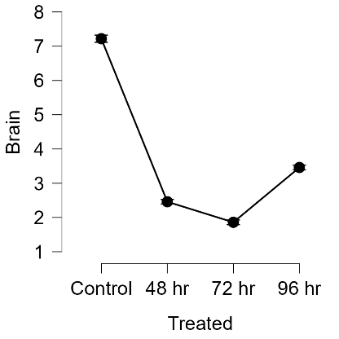 | 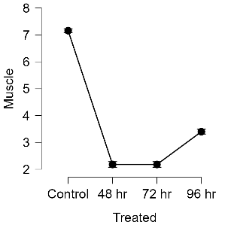 | 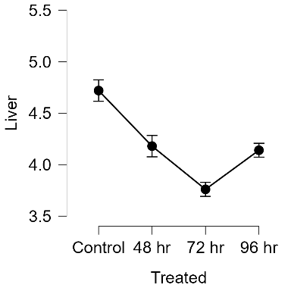
Figure1.aMalathion toxicity effect on AchE of brainin C.auratus in control, and at various time intervals. | Figure1.b Malathion toxicity effect on AchE of muscle in C.auratus in control, and at various time intervals. | Figure1.cMalathion toxicity effect on AchE of liver in C.auratus in control, and at various time intervals.
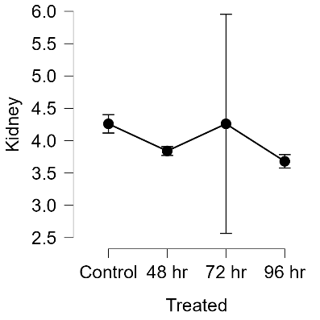 | 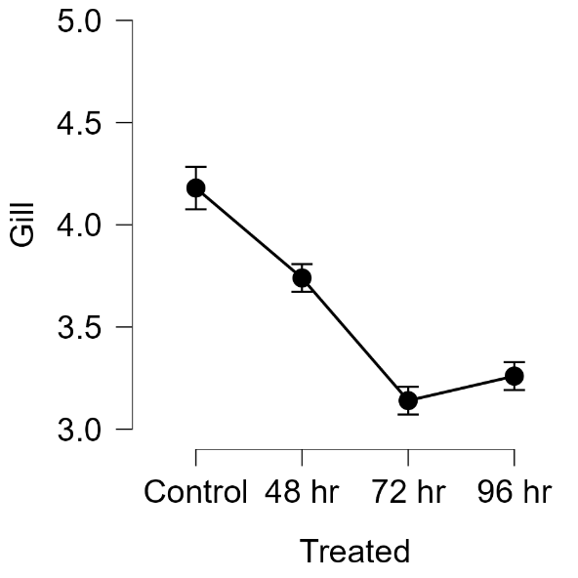
Figure1.dMalathion toxicity effect on AchE of kidney in C.auratus in control, and at various time intervals. | Figure1.eMalathion toxicity effect on AchE of gill in C.auratus in control, and at various time intervals.

Figure 1. Mean values of AchE activity observed in brain, muscle, gill, liver and kidney

The mean values of AchE activity occurred at different time intervals including control, and recovery are depicted in Figure 2. Here we can see that AchE activity are very high in brain and muscle and are represented by dark blue and red bars, while the activity are lesser in other tissues in the control set. At 48 and 72 hrs, activity decreases and increases and at 96 hrs, and also in the recovery period it increases. Compared to gill liver and kidney, brain and muscle tissues have higher Ache activity. In the gill, and liver, the AchE activity are low in the control and shows little variation, and increasing slightly in the recovery period for liver and gill while in the case of kidney, activity reaches control at 72 hrs, then decreases and resumes.

Figure 2. Malathion toxicity effect on AchE of brain, muscle, liver, gill and kidney in C.auratus in control, recovery and at various time intervals. In the X axis, control, time intervals and recovery is given and in Y axis, the meanvalues of the effect of malathion in AchE at each time intervals is expressed in moL/min/mg/protein unit.

ANOVA of Carassiusauratus
The analysis of variance (ANOVA) result of the assay observations is given in Table 2.F value is calculated to determine difference between the means of multiple groups being compared and a higher F value designates significant differences between groups. P value is the probability and value less than 0.001 is highly significant. There were significant variations found in brain, muscle, gill and liver tissues and no significant variation was observed in kidney.

Results of ANOVA on the malathion toxicity effect on AchEin the brain, muscle, liver, gill and kidney in C.auratus
Tissue | Cases | Sum of Squares | df | Mean Square | F | p
Brain | Treated | 86.806 | 3 | 28.935 | 7233.833 | < .001
 | Residuals | 0.064 | 16 | 0.004
Muscle | Treated | 83.394 | 3 | 27.798 | 5054.182 | < .001
 | Residuals | 0.088 | 16 | 0.006
Liver | Treated | 2.340 | 3 | 0.780 | 156.000 | < .001
 | Residuals | 0.080 | 16 | 0.005
Gill | Treated | 3.408 | 3 | 1.136 | 284.000 | < .001
 | Residuals | 0.064 | 16 | 0.004
Note. Type III Sum of Squares
Table 2. ANOVA results of the malathion toxicity effect on AchE of brain, muscle, liver, gill and kidney in C.auratus in control, recovery and at various time intervals. Significance of variations was observed in brain, muscle, gill and liver. In kidney no significant variation is observed.

AchE activity in malathion treated B.striata
B. striata are calm fishes showing social behavior and prefer to exist in groups. These fishes are bottom dwellers. Though they are calm, they show aggressiveness while in a tank with other bottom feeders. After malathion exposure the fishes remained calm for nearly half an hour, later showing abnormal behavior in swimmingand gulping air. Hyper activeness, and loss of equilibrium were also observed. Later stages of the fishes were static in nature with slow breathing. Fishes were also found to be covered with secreted mucus.
From the fisheskept in icepacks, tissues were carefully dissected and AchE assay analysis was performed. Compared to the control, a reduction of AchE activity was observed in all tissues. In brain and muscle there was significant decrease while in liver and gill, only slight variation was observed due to the low AchE activity in the control. In kidney there was an unusual variation found with increased activity at 96 hrsthough the activity was slightly dropped in the recovery period. The mean and standard error of mean of the toxicity effect on AchEin different tissues in B. striatain the control, recovery period and at different time intervals are given in Table 3.

Hrs | BRAIN | MUSCLE | LIVER | GILL | KIDNEY
CONTROL | 5.780±0.058 | 5.660±0.051 | 4.220±0.037 | 3.360±0.075 | 3.220±0.037
48 HRS | 2.720±0.037 | 3.460±0.024 | 3.300±0.084 | 3.140±0.024 | 2.680±0.073
72 HRS | 1.540±0.024 | 2.220±0.037 | 2.140±0.024 | 2.160±0.024 | 2.160±0.024
96 HRS | 2.140±0.024 | 2.860±0.024 | 3.140±0.024 | 3.160±0.024 | 3.320±0.037
RECOVERY | 4.460±0.024 | 4.260±0.024 | 3.720±0.037 | 3.180±0.037 | 3.280±0.037
Malathion toxicity effect on AchE of brain, muscle, liver, gill and kidney in B.striata
Table 3. Malathion toxicity effect on AchE of brain, muscle, liver, gill and kidney in B.striata in control, recovery and at various time intervals. The mean±standard error of mean are given as values for each time intervals.
The result of present investigation shows that the inhibition of AchE activities in the brain, muscle, gill, liver, and kidney were high in the control and 48 hrs of malathion pesticide exposure. As seen in C.auratus, the differential inhibition of AchE activity in all tested tissues may be due to presence of isoenzymes.The mean values of AchE activity observed in brain, muscle, gill, liver and kidney at different time intervals are represented separately in Figure 3. In brain and muscle (Figure 3. a. and 3.b.), the malathion toxicity has a similar effect, the values drops and reaches minimum at 72 hours and then increases slightly at 96 hours. In gill and liver (Figure 3.e and Figure 3.c) the decreased activity is somewhat regained and reaches that was at 48 hours while in kidney (Figure 3.d) the activity increases sharply and goes higher at 96 hours than in control.

Malathion toxicity effect on AchE in different tissues in B.striata
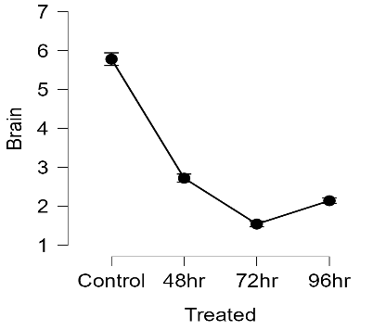 | 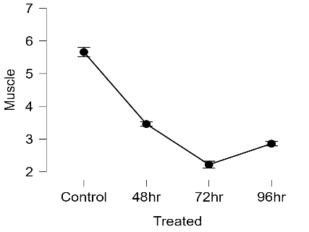 | 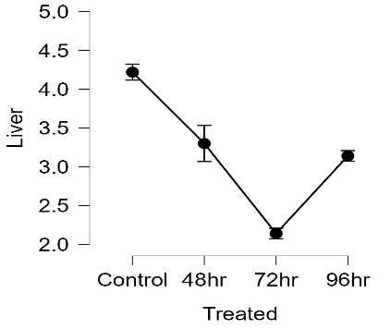
Figure3.a Malathion toxicity effect on AchE of brainin B.striatain control, and at various time intervals. | Figure3.b Malathion toxicity effect on AchE of muscle in B.striatain control, and at various time intervals. | Figure3.c Malathion toxicity effect on AchE of Liver in B.striatain control, and at various time intervals.
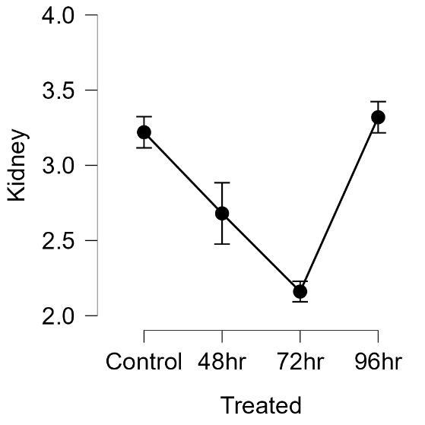 | 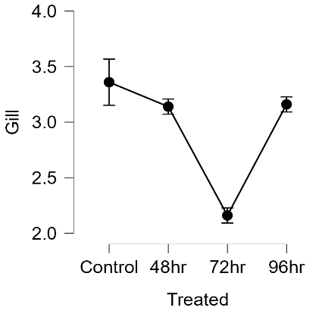
Figure3.d Malathion toxicity effect on AchE of Kidney in B.striatain control, and at various time intervals | Figure3.e Malathion toxicity effect on AchE of Gill in B.striatain control, and at various time intervals
Figure 3. Mean values of AchE activity observed in brain, muscle, gill, liver and kidney of B.striata.In the X axis, control, time intervals and recovery is given and in Y axis, the meanvalues of the effect of malathion in AchE at each time intervals is expressed in moL/min/mg/protein unit.
The mean values of AchE activity in B. striata occurred at different time intervals including control, and recovery are depicted in Figure 4. The high AchE activity in brain and muscle represented by dark blue and red bars are dropped in 48 and 72 hours. The decrease in higher in the brain tissue compared to that of other tissues. At 48 hrs the activity decreases but at 72 hrs, the toxic activity on AchE seems to be reaching a similar value in all tissues.

Figure 4. Malathion toxicity effect on AchE of brain, muscle, liver, gill and kidney in B.striata in control, recovery and at various time intervals. In the X axis, control, time intervals and recovery is given and in Y axis, the mean values of the effect of malathion in AchE at each time intervals is expressed in moL/min/mg/protein unit.

ANOVA of Botiastriata
The analysis of variance (ANOVA) of effect of malathion on the AchE activity was carried out and significant variations was observed in all tissues. The results obtained for the activity in all tissues at different time intervals in B.striataare given in Table 4.

ANOVA on the malathion toxicity effect on AchEin the brain, muscle, liver, gill and kidney in B.striata

Tissue | Cases | Sum of Squares | Degrees of freedom (df) | Mean Square | F value | P value
Brain | Treated | 53.349 | 3 | 17.783 | 2371.089 | < .001
 | Residuals | 0.120 | 16 | 0.008
Muscle | Treated | 33.526 | 3 | 11.175 | 1719.282 | < .001
 | Residuals | 0.104 | 16 | 0.007
Liver | Treated | 10.888 | 3 | 3.629 | 302.444 | < .001
 | Residuals | 0.192 | 16 | 0.012
Kidney | Treated | 4.314 | 3 | 1.438 | 130.712 | < .001
 | Residuals | 0.176 | 16 | 0.011
Gill | Treated | 4.362 | 3 | 1.454 | 157.171 | < .001
 | Residuals | 0.148 | 16 | 0.009
Note. Type III Sum of Squares
Table 4. ANOVA results of Malathion toxicity effect on AchE of brain, muscle, liver, gill and kidney in B.striata in control, recovery and at various time intervals. Significant results were obtained for all tissues

Discussions
AchE are the enzymes facilitating neurotransmitter modulation at synapses and are highly active in brain and muscle (Reddy et al, 1992). In the present study, the highest AchE activity was found in the brain tissues of both control fishes followed by muscle. The differential inhibition of AchE activity in the tested tissues may be due to the presence of isoenzymes with different affinities for the substrate and inhibitor. The differences in the activity of isoenzymes may be due to the functional specificity and impact of nerve innervations.Brain is the control and commanding center, the seat of millions of neuronal activity requires highest AchE activity.The muscular tissues occupies second position due to the neuron muscle synapses for muscle contractions concerned with movements.
In both fishes liver has highest activity than gill and kidney, and in C.auratus kidney has more AchE activity than in gill and in B.striata gill has more AchE activity than in kidney. This may be due to the least type of neuronal innervations in these tissues compared to that of brain and muscle.
Similar results were obtained in the same tissues of the fresh water teleost Tilapia mossambica when exposed to malathion and methyl parathion(Sahib and Rao, 1980).Similarly, inhibition of AchE in the Lagodonrhomboidesfish brain exposed to sub lethal concentrations of malathion at 72hrs of exposure was observed (Coppage et al., 1975).
In cartilaginous fishes urea is the excretory product while in teleosts, it is ammonia. In teleost kidney plays least role in ammonia excretion since major part is excreted through diffusion. In teleosts, kidney plays a major role in regulation of osmotic balance. The effect of malathion pesticide disrupt the normal functioning of kidney leading to the shrinkage of glomerulus and degeneration of renal tubules. The accumulation of waste products in the blood stream disrupts the ultra-filtration process and cause kidney damage. The fluctuating functioning of AchE activity in the kidney of C.auratus and the abnormal functioning of kidney in B.striata is an indication of this disruption of normal kidney function. Similar observations were obtained in the study of Sivanandan et al (2021) in fresh water fish Labeorohita. The histological studies of kidney in Labeorohita shows the shrinkage of glomerulus and increase in the spaces of bowmans capsule (Uikey, 2015). Nisha and Geetha (2018) studied the effect of malathion in the metabolic and respiratory activities of fresh water fish Labeorohita and observed that high and low concentration of malathion causes alterations in vital organs.
The present study shows the neurotoxic effect of malathion pesticide. This pesticide causes the behavioural changes in fish as well as altered AchEactivity.Thebehavioural changes noticed in the fishes are lose of equilibrium, irregular swimming, and altered sensory process. This agrees with the observations of Sana ullah et al (2025) in Labeorohita. Considering the health problems caused due to malathion, the organophosphorus insecticide, they are studied immensely. Though they are less toxic than endosulphan, the laeding death and disease causing pesticide the widespread use of Malathion exposure may cause severe damages. Moreover, its toxic effects on liver, pancreas, kidney, and lungs, are reported (Amira, 2020).
After recovery period, in C.auratus and B.striata, the AchE activity shows an increased value showing the degradation of malathion effect on AchE. Similar observations were obtained in the studies on kidney, liver and muscle focusing on mortality and biochemical changes in Labeorohita (Thenmozhi et al., 2011). Malathion is a broad-spectrum, non-systemic organophospherous pesticide used in various types of crops and on various type of non-crop sites including green-houses, nurseries, and public health. The organophosphate pesticides are widely used in various types of fields due to their highest insecticidal property, low persistence and degradability in the ecosystem.

Conclusion
The present study deals with the acute toxic effect of an organo phosphorous pesticide malathion. Acetylcholine, the important neuro transmitter in the brain shows highest activity in the muscle because of highest neural innervations also takes place there but shows least activity in liver, gill, and kidney. At the time of acute exposure the AchE activity slow down and after 72 hrs its activity increases due to the degradation effect of these pesticides. The present study focused on the toxic and dangerous effect of these pesticide on the aquatic ecosystem as well as mankind.
The persistent use of endosulfan indicates genetic mutations that can be transmitted across generations. Referring to these, pesticide toxicity was studied by many researchers and its toxic effects including oxidative damage, histopathological changes and carcinogenicity are reported. Prolonged exposure to malathion can lead to severe physiological and biochemical disturbances in aquatic organisms. The accumulation of such toxic substances in water bodies poses a significant threat to the entire food chain. Therefore, regular monitoring and strict regulations on pesticide use are essential to prevent irreversible ecological damage. Considering the adverse effects that it causes on fishes and other organisms, there is vital need for stringent rules preventing indiscriminate malathion usage. Unless preventive measures are taken for this dangerous hazard endangering of aquatic biodiversity is inevitable.

Acknowledgements
The authors are thankful to Prof. (Dr.) G. Prasad, Head, Department ofZoology, University of Kerala,Thiruvananthapuram, andProf. (Dr.) ShiburajSugathan, Head, Department of Computational Biology and Bioinformatics, University of Kerala, Thiruvananthapuram, for providing the facilities.
Conflict ofinterest
The authors declare that they have no conflict of interest.

Disclaimer (Artificial intelligence)
Option 1:
Author(s) hereby declare that NO generative AI technologies such as Large Language Models (ChatGPT, COPILOT, etc.) and text-to-image generators have been used during the writing or editing of this manuscript.
Option 2:
Author(s) hereby declare that generative AI technologies such as Large Language Models, etc. have been used during the writing or editing of manuscripts. This explanation will include the name, version, model, and source of the generative AI technology and as well as all input prompts provided to the generative AI technology
Details of the AI usage are given below:
1.
2.
3.

References
- Adedeji, O.B., 2011. Response of acetylcholinesterase activity in the brain of ClariasGariepinus to sublethal concentration of Diazinon. Journal of Applied Sciences in Environmental Sanitation, 6(2).
- Almeida, L. C. D., Aguiar, L. H., &Moraes, G. (2005). Effect of methyl parathion on the muscle and brain acetylcholinesterase activity of matrinxã (Bryconcephalus). Ciência Rural, 35, 1412-1416
- Badr, A. M. (2020). Organophosphate toxicity: updates of malathion potential toxic effects in mammals and potential treatments. Environmental Science and Pollution Research, 27(21), 26036-26057.
- Chandrasekara, H. U., &Pathiratne, A. (2005). Influence of low concentrations of Trichlorfon on haematological parameters and brain acetylcholinesterase activity in common carp, Cyprinuscarpio L. Aquaculture research, 36(2), 144-149.
- Coppage, D. L., & Matthews, E. (1975). Brain-acetylcholinesterase inhibition in a marine teleost during lethal and sublethal exposures to 1, 2-dibromo-2, 2-dichloroethyl dimethyl phosphate (Naled) in seawater. Toxicology and Applied Pharmacology, 31(1), 128-133.
- Das, B. K., Nayak, K. K., & Kumar, V. (2024). Alteration of haematological and biochemical biomarkers after sub-lethal chronic malathion (Elathion®) intoxication in freshwater fish, Labeorohita (Hamilton, 1822). Comparative Biochemistry and Physiology Part C: Toxicology & Pharmacology, 277, 109844.
- Deka, S., &Mahanta, R. (2016). Malathion toxicity on fish-a review. Int J Curr Res, 8(12), 44120-44128.
- Ellman, G. L., Courtney, K. D., Andres Jr, V., & Featherstone, R. M. (1961). A new and rapid colorimetric determination of acetylcholinesterase activity. Biochemical pharmacology, 7(2), 88-95.
- El-Nahhal, Y. (2018). Toxicity of some aquatic pollutants to fish. Environmental monitoring and assessment, 190, 1-15.
- Filice, M., Cerra, M. C., &Imbrogno, S. (2022). The goldfish Carassiusauratus: an emerging animal model for comparative cardiac research. Journal of Comparative Physiology B, 192(1), 27-48.
- Fulton, M. H., & Key, P. B. (2001). Acetylcholinesterase inhibition in estuarine fish and invertebrates as an indicator of organophosphorus insecticide exposure and effects. Environmental Toxicology and Chemistry: An International Journal, 20(1), 37-45.
- Halappa, R., & David, M. (2009). In vivo inhibition of acetylcholinesterase activity in functionally different tissues of the freshwater fish, Cyprinuscarpio, under chlorpyrifos exposure. Drug Metabolism and Drug Interactions, 24(2-4), 123-136
- Kabeer, I. A. S., Rao, K. S. J. and Rao, K. V. R. 1981. Effect of malathion exposure on some physical parameters of whole body and on tissue cations of teleost, Tilapia mossambica (Peters). J. Biosci., 3 (1) pp 17-21.
- Lionetto, M. G., Caricato, R., Calisi, A., Giordano, M. E., &Schettino, T. (2013). Acetylcholinesterase as a biomarker in environmental and occupational medicine: new insights and future perspectives. BioMed research international, 2013(1), 321213.
- Love, J., Selker, R., Marsman, M., Jamil, T., Dropmann, D., Verhagen, J., ...&Wagenmakers, E. J. (2019). JASP: Graphical statistical software for common statistical designs. Journal of Statistical Software, 88, 1-17.
- Lowry, O. H., Rosebrough, N. J., Farr, A. L., & Randall, R. J. (1951). Protein measurement with the Folin phenol reagent. J biolChem, 193(1), 265-275.
- Narendiran, N.J., Kumaran, S.S., Nagar, A., & Nadu, T. (2009). Effect of Malathion Toxicity in the Freshwater Fish Ophiocephaluspunctatus-A Histological and Histochemical Study.
- Nisha, S. N., &Geetha, B. (2018). To determine the acute toxicity pesticide of malathion and metabolic activities and respiratory responses in freshwater fish Labeorohita. International Review of Business and Economics, 1(3), 48.
- OECD. (1994). OECD Guidelines for the Testing of Chemicals. Oecd.
- Pugazhvendan, S. R., Narendiran, N. J., Kumaran, R. G., Kumaran, S., &Alagappan, K. M. (2009). Effect of malathion toxicity in the freshwater fish Ophiocephaluspunctatus-A histological and histochemical study. World Journal of Fish and Marine Sciences, 1(3), 218-224.
- Reddy, P. M., Philip, G. H., &Bashamohideen, M. (1992). Regulation of AChE system of freshwater fish, Cyprinuscarpio, under fenvalerate toxicity. Bulletin of environmental contamination and toxicology, 48, 18-22.
- Roopavathy, J., &Sukumaran, M. (2021). Effect of Malathion Toxicity on the Histology of Commercial Important Freshwater FishOreochromismossambicus. Indian Journal of Natural Sciences, 12(65), 30186-30198.
- Sahib, I. K. A., & Rao, K. R. (1980). Toxicity of malathion to the freshwater fish Tilapia mossombica. Bulletin of environmental contamination and toxicology, 24, 870-874.
- ShahbaziNaserabad, S., Mirvaghefi, A., Gerami, M. H., &GhafariFarsani, H. (2015). Acute toxicity and behavioral changes of the gold fish (Carassiusauratus) exposed to malathion and hinosan. Iranian Journal of Toxicology, 8(27), 1203-1208.
- Sivanandan, J. M. (2021). Acute and sublethal intoxication of malathion in an Indian major carp, Labeorohita: haematological and biochemical responses. Environmental analysis, health and toxicology, 36(3), e2021016.
- Staicu, A. C., Munteanu, M. C., &Dinischiotu, A. (2008). Malathion induced histological modifications in gills and kidney of Carassiusauratusgibelio. Scientific Papers Animal Science and Biotechnologies, 41(1), 448-448.
- Tan, M., &Armbruster, J. W. (2018). Phylogenetic classification of extant genera of fishes of the order Cypriniformes (Teleostei: Ostariophysi). Zootaxa, 4476(1), 6-39.
- Thenmozhi, C., Vignesh, V., Thirumurugan, R., &Arun, S. (2011). Impacts of malathion on mortality and biochemical changes of freshwater fish Labeorohita.
- Uikey, S. (2015). Effect of malathion toxicity on fresh water fish Labeorohita. International Journal of Applied and Universal Research, 2(4), 10-15.
- Ullah, S., Ahmad, S., Ashraf, M. K., Bilal, M., Iqbal, T., &Azzam, M. M. (2025). Exposure to Acute Concentration of Malathion Induced Behavioral, Hematological, and Biochemical Toxicities in the Brain of Labeorohita. Life, 15(2), 158.
- Verma, N., Yadav, V. K., &Khare, R. K. (2024). A Review on Malathion Induced Toxicity in Freshwater Fishes. FLORA AND FAUNA, 30(1), 127-130
- Walker, C. H. (2003). Neurotoxic pesticides and behavioural effects upon birds. Ecotoxicology, 12, 307-316.

